Supplementary Information

DAP12 enhances CAR-NK cell function via NR4A2-mediated upregulation of 4-1BB expression
Yueting Qiu ^{1,2,5}, Chang Gao ^{1,5}, Qi Wang^{1,2}, Changjie Lou^{3,}*, Jie Lan^{4,}*, Hui Chen^{1,2,}*
¹ State Key Laboratory of Epigenetic Regulation and Intervention, Institute of Biophysics, Chinese Academy of Sciences, Beijing, 100101, China
² University of Chinese Academy of Sciences, Beijing, 100049, China
³ Department of Gastrointestinal Medical Oncology, Harbin Medical University Cancer Hospital, Harbin 150001 Heilongjiang, China
⁴ Department of Bioinformatics, College of Artificial Intelligence Medicine，Chongqing Medical University，Chongqing 400016, China
⁵ These authors contributed equally.
*Correspondence: 601245@hrbmu.edu.cn (C. L.); jielan@cqmu.edu.cn (J. L.); cdchenhui@ibp.ac.cn (H. C.)

Supplementary figures: Figure 1 - Figure 5
Supplementary Tables: Table 1- Table 4

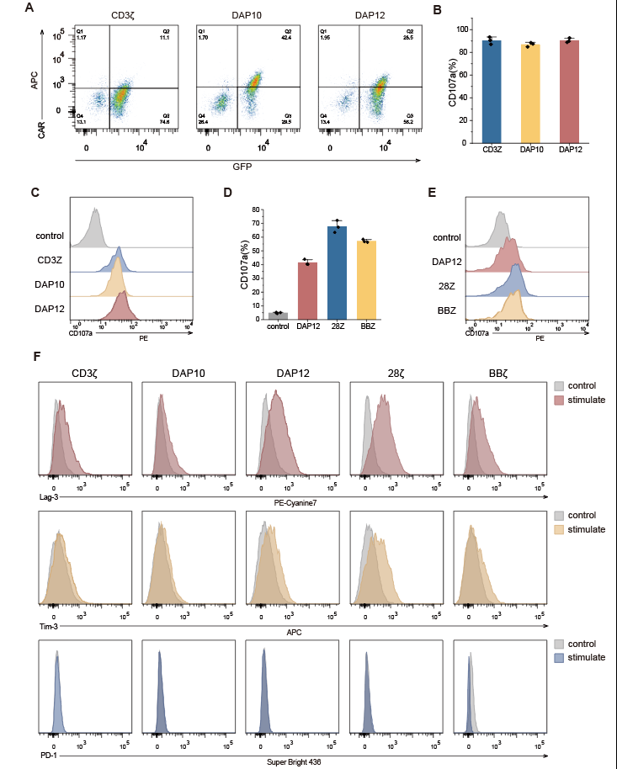
Supplementary Figure 1 | Construction of CAR-NK cells and their effector functions and exhaustion status
A. Flow cytometry analysis of CD19-CAR expression in NK-92MI cells. The panels display the positive cell populations of CD19-CAR constructs with CD3ζ (left panel), DAP10 (middle panel), and DAP12 (right panel) intracellular signaling domains, respectively.
B-C. Flow cytometry to evaluate cellular degranulation capacity measured by CD107a expression. Quantification of CD107a-positive cell percentage (B) and Representative flow cytometry histograms (C) in CD3ζ, DAP10, and DAP12 CAR-NK cells. Data are presented as mean ± standard deviation (SD) from independent experiments.
D-E. Flow cytometry to evaluate cellular degranulation capacity measured by CD107a expression. Quantification of CD107a-positive cell percentage (D) and Representative flow cytometry histograms (E) in DAP12, 28Z, and BBZ CAR-NK cells. Data are presented as mean ± standard deviation (SD) from independent experiments.
F. Representative flow cytometry histograms showing the expression of immune exhaustion markers (Lag-3, Tim-3, and PD-1) in NK-92MI cells engineered with CD3ζ, DAP10, DAP12, 28Z, or BBZ CAR, under resting (control, gray) and Raji cells stimulation (stimulate, colored) conditions. All plots are representative of at least 3 independent experiments.

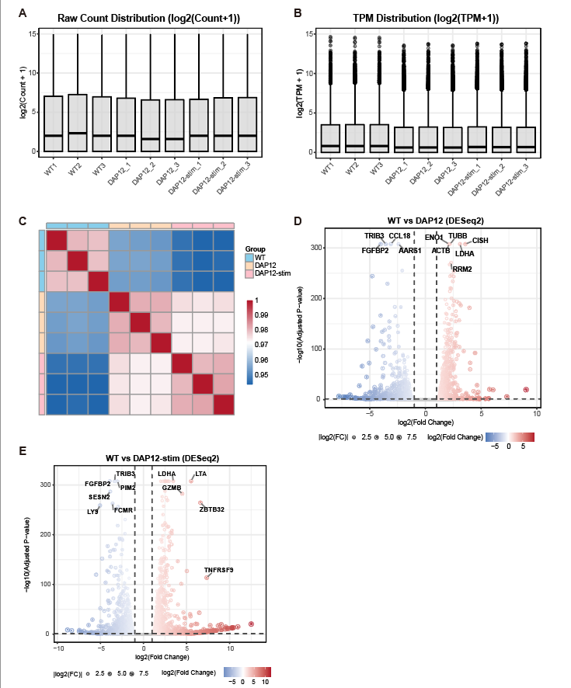
Supplementary Figure 2 | RNA-seq quality control and differential expression analysis.
A. Boxplot of log2(raw count +1) values across all samples after filtering.
B. Boxplot of log2(transcripts per million (TPM) +1) values across all samples after filtering low-expressed genes (retaining genes with CPM ≥ 1 in at least one sample.
C. Heatmap of sample-to-sample Pearson correlation coefficients calculated from the log2(TPM +1) expression matrix. Samples are ordered by experimental group (WT, DAP12, DAP12-stim).
D-E. Volcano plots of differentially expressed genes (DEGs) for DAP12 vs WT (D) and DAP12-stim vs WT (E). DEGs were defined by |log2FC| ≥ 1 and adjusted P value (padj) < 0.05.
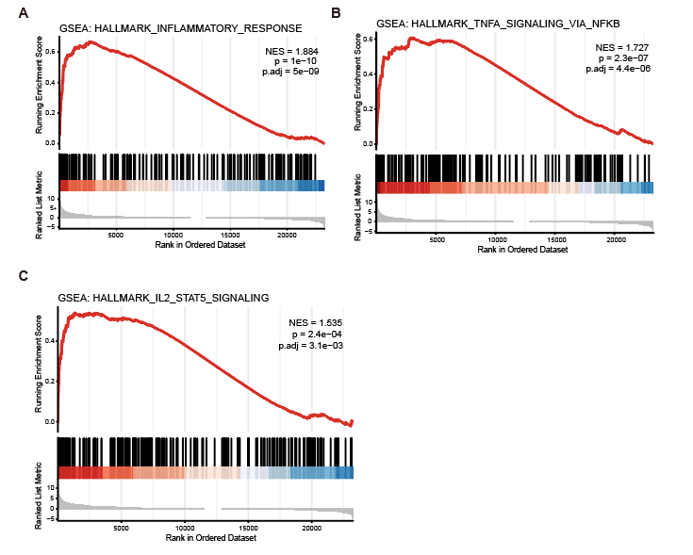
Supplementary Figure 3 | TNFRSF9 is a leading-edge gene in DAP12-induced inflammatory and cytokine signaling pathways.
A-C. Gene Set Enrichment Analysis (GSEA) running score plots for HALLMARK_ INFLAMMATORY_RESPONSE (A), HALLMARK_TNFA_SIGNALING_VIA_NF KB (B), and HALLMARK_IL2_STAT5_SIGNALING (C) in the DAP12 vs DAP12-stim comparison. Normalized enrichment score (NES) and adjusted P value (padj) are indicated.

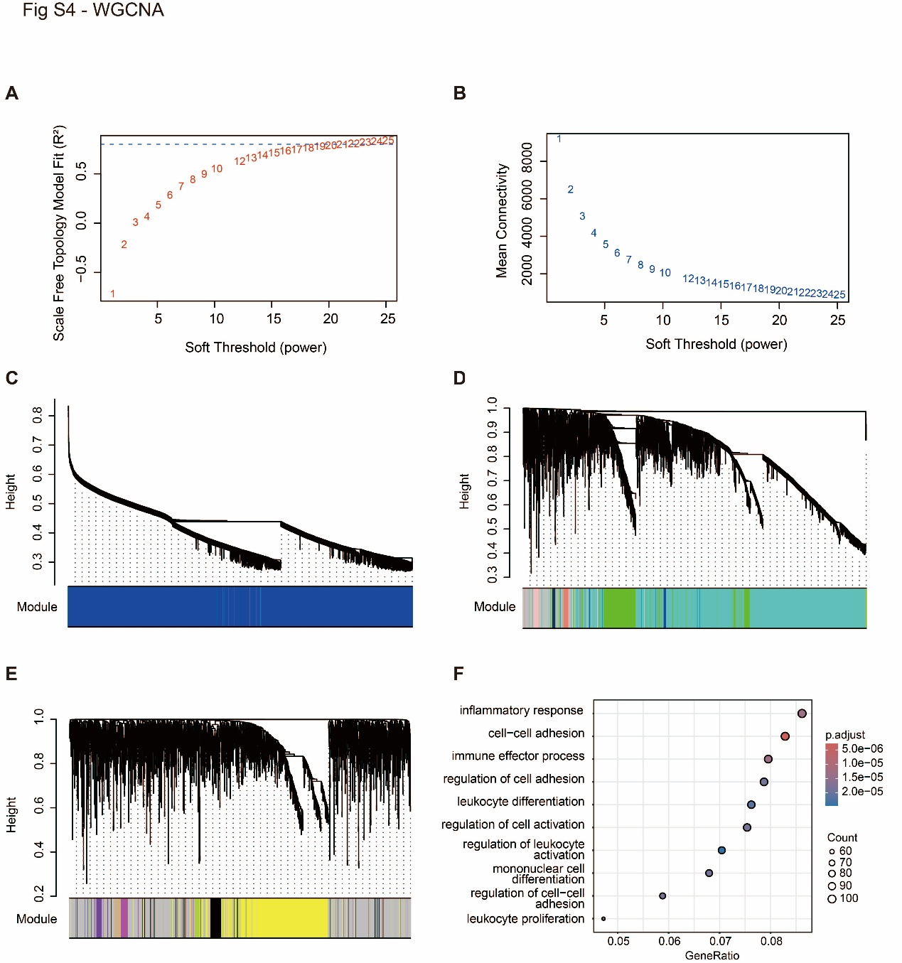
Supplementary Figure 4 | Weighted gene co-expression network analysis (WGCNA) parameter selection and brown module Gene Ontology (GO) enrichment.
A. Scale-free topology model fit (R²) as a function of soft-thresholding power (β). The red horizontal line indicates R² = 0.8. A power of β = 23 was selected to approximate scale-free topology.
B. Mean connectivity across different soft-thresholding powers.
(C–E) Gene clustering dendrograms for the remaining blocks from blockwise WGCNA.
F. Gene Ontology (GO) enrichment analysis of genes in the brown module. The top significantly enriched terms (padj < 0.05) spanning Biological Process, Cellular Component, and Molecular Function categories are shown. Dot size represents gene count; color gradient indicates adjusted P value.

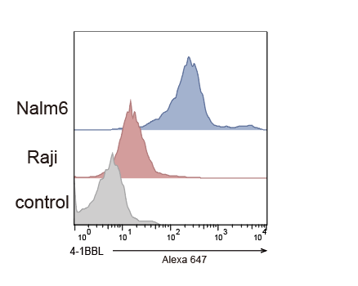
Supplementary Figure 5 | Representative flow histograms of 4-1BBL expression in Nalm6, Raji cell lines, and unstained cells as the negative control, detected with Alexa 647-conjugated anti-4-1BBL antibody.

Supplementary Table 1. Eight common DEGs (IL18RAP, LTA, PAX5, GZMB, ATP10A, SLFN5, ZBTB32, ZBP1) across WT, DAP12, and DAP12-stim NK cells (DESeq2, |log2FC| ≥ 1, padj < 0.05).
Gene | Comparison | Log2FC | padj
IL18RAP | DAP12 vs WT | 2.537 | 1.832×10⁻¹⁹
LTA | DAP12 vs WT | 3.952 | 2.975×10⁻¹⁸²
PAX5 | DAP12 vs WT | 3.301 | 1.533×10⁻⁰⁹
GZMB | DAP12 vs WT | 2.139 | 3.015×10⁻³⁰
ATP10A | DAP12 vs WT | -2.804 | 6.331×10⁻²⁷
SLFN5 | DAP12 vs WT | -1.900 | 2.833×10⁻⁵¹
ZBTB32 | DAP12 vs WT | 4.021 | 1.571×10⁻⁷³
ZBP1 | DAP12 vs WT | -2.295 | 1.235×10⁻²⁰
IL18RAP | DAP12-stim vs WT | 4.393 | 3.749×10⁻¹⁰²
LTA | DAP12-stim vs WT | 5.525 | 0.000
PAX5 | DAP12-stim vs WT | 5.461 | 6.379×10⁻³⁷
GZMB | DAP12-stim vs WT | 4.495 | 5.250×10⁻²⁸³
ATP10A | DAP12-stim vs WT | -5.010 | 7.555×10⁻⁵³
SLFN5 | DAP12-stim vs WT | -3.176 | 1.447×10⁻²⁵²
ZBTB32 | DAP12-stim vs WT | 6.609 | 4.034×10⁻²⁶⁵
ZBP1 | DAP12-stim vs WT | -3.880 | 1.454×10⁻⁶⁴
IL18RAP | DAP12-stim vs DAP12 | 1.856 | 1.670×10⁻¹³
LTA | DAP12-stim vs DAP12 | 1.573 | 2.770×10⁻⁰⁸
PAX5 | DAP12-stim vs DAP12 | 2.160 | 6.855×10⁻⁰⁸
GZMB | DAP12-stim vs DAP12 | 2.356 | 7.033×10⁻⁴³
ATP10A | DAP12-stim vs DAP12 | -2.206 | 8.148×10⁻⁰⁴
SLFN5 | DAP12-stim vs DAP12 | -1.276 | 1.677×10⁻⁰³
ZBTB32 | DAP12-stim vs DAP12 | 2.588 | 3.706×10⁻⁹³
ZBP1 | DAP12-stim vs DAP12 | -1.585 | 3.842×10⁻⁰²

Supplementary Table 2. Hub transcription factors (|kME| > 0.5) in the brown module
Gene | kME | padj | Gene | kME | padj
NFKB2 | 0.996 | 1.460×10⁻⁰⁶ | FOXP3 | 0.923 | 9.280×10⁻⁰⁴
HOXB4 | -0.990 | 1.334×10⁻⁰⁵ | RUNX2 | 0.913 | 1.271×10⁻⁰³
ZBTB32 | 0.983 | 4.703×10⁻⁰⁵ | ESRRB | 0.904 | 1.604×10⁻⁰³
MAX | -0.981 | 5.731×10⁻⁰⁵ | ZNF416 | -0.902 | 1.726×10⁻⁰³
EOMES | -0.980 | 5.731×10⁻⁰⁵ | NFYC | -0.891 | 2.306×10⁻⁰³
XBP1 | -0.980 | 5.842×10⁻⁰⁵ | HOXB7 | -0.887 | 2.576×10⁻⁰³
POU2F3 | 0.975 | 8.090×10⁻⁰⁵ | FOXK1 | 0.880 | 3.002×10⁻⁰³
PAX5 | 0.975 | 8.090×10⁻⁰⁵ | HOXA1 | -0.871 | 3.645×10⁻⁰³
RBPJ | 0.962 | 1.882×10⁻⁰⁴ | HES1 | 0.871 | 3.660×10⁻⁰³
ETV3 | -0.961 | 1.955×10⁻⁰⁴ | NFYA | -0.869 | 3.795×10⁻⁰³
ZNF652 | -0.956 | 2.553×10⁻⁰⁴ | BHLHE40 | 0.868 | 3.896×10⁻⁰³
ELK4 | -0.949 | 3.405×10⁻⁰⁴ | MSC | 0.859 | 4.726×10⁻⁰³
HINFP | -0.946 | 3.908×10⁻⁰⁴ | ZNF317 | 0.858 | 4.773×10⁻⁰³
NR2C1 | -0.936 | 5.654×10⁻⁰⁴ | ETV1 | -0.856 | 4.971×10⁻⁰³
IKZF1 | 0.933 | 6.299×10⁻⁰⁴ | NR4A2 | 0.834 | 7.391×10⁻⁰³
PITX1 | 0.925 | 8.862×10⁻⁰⁴ | MAFF | -0.809 | 1.113×10⁻⁰²
SPIB | 0.924 | 9.007×10⁻⁰⁴ | MZF1 | -0.766 | 1.976×10⁻⁰²
PATZ1 | -0.923 | 9.240×10⁻⁰⁴ | RFX1 | -0.751 | 2.322×10⁻⁰²

Supplementary Table 3. NR4A2 and ZBTB32 expression changes in WT, DAP12, and DAP12‑stim NK cells (|log2FC| ≥ 0.5, padj < 0.05), a permissive cutoff chosen to accommodate the modest expression changes frequently observed for transcriptional regulators.
Gene | Comparison | Log2FC | padj | Significance
NR4A2 | DAP12 vs WT | -0.227 | 1.000 | Not significant
ZBTB32 | DAP12 vs WT | 4.021 | 3.583×10⁻¹⁰⁰ | Upregulated
NR4A2 | DAP12-stim vs WT | 0.969 | 3.250×10⁻⁰² | Upregulated
ZBTB32 | DAP12-stim vs WT | 6.609 | 0.000 | Upregulated
NR4A2 | DAP12-stim vs DAP12 | 1.196 | 7.866×10⁻⁰³ | Upregulated
ZBTB32 | DAP12-stim vs DAP12 | 2.588 | 3.069×10⁻¹⁶² | Upregulated

Supplementary Table 4. Integrated metrics (JASPAR score, correlation with TNFRSF9, DAP12‑stim vs DAP12 log2FC, brown‑module kME) for the candidate transcription factors.
TF | kME | cor r | cor padj | log2FC | DE padj | JASPAR Score | JASPAR  Sites
ZBTB32 | 0.983 | 0.918 | 9.02×10⁻³ | 2.59 | 3.07×10⁻¹⁶² | 0.989 | 8
XBP1 | -0.98 | -0.92 | 9.02×10⁻³ | -0.82 | 3.48×10⁻¹⁵ | 0.812 | 3
NFKB2 | 0.996 | 0.968 | 1.56×10⁻³ | 0.98 | 3.27×10⁻²³ | 0.927 | 14
PAX5 | 0.975 | 0.904 | 1.16×10⁻² | 2.16 | 6.64×10⁻¹⁷ | 0.823 | 3
ZNF652 | -0.956 | -0.88 | 1.97×10⁻² | -0.89 | 1.14×10⁻⁰³ | 0.822 | 6
NR4A2 | 0.834 | 0.882 | 1.91×10⁻² | 1.2 | 7.87×10⁻⁰³ | 0.892 | 31
POU2F3 | 0.975 | 0.973 | 1.39×10⁻³ | 4.44 | 1.28×10⁻⁰⁵ | 0.965 | 5
PITX1 | 0.925 | 0.914 | 9.15×10⁻³ | 3.79 | 9.36×10⁻⁰³ | 0.995 | 20

