Table A1. PICO Framework
Element | Description
Population (P) | Populations in malaria-endemic regions of sub-Saharan Africa between 2011 and 2025, including diverse ecological, demographic, and health system contexts across countries.  SSA: Africa South of the Sahara, Tropical Africa, or Equatorial Africa  Region: Central Africa, East Africa, Southern Africa, and West Africa.  Countries: Angola, Benin, Botswana, Burkina Faso, Burundi, Cabo Verde (Cape Verde)  Cameroon, Central African Republic, Chad, Comoros, Democratic Republic of the Congo  Republic of the Congo, Côte d'Ivoire (Ivory Coast), Djibouti, Equatorial Guinea, Eritrea, Eswatini, Ethiopia, Gabon, Gambia, Ghana, Guinea, Guinea-Bissau, Kenya, Lesotho, Liberia, Madagascar, Malawi, Mali, Mauritania, Mauritius, Mozambique, Namibia, Niger  Nigeria, Rwanda, São Tomé and Príncipe, Senegal, Seychelles, Sierra Leone, Somalia, South Africa, South Sudan, Sudan, Tanzania, Togo, Uganda, Zambia, Zimbabwe
Intervention (I) | Pre-SNT interventions (2011–2018): LLINs, IRS, SMC, RDTs, IPT, and ACTs. Post-SNT interventions (2019–2025): Sub-National Tailoring (SNT) strategies under WHO’s HBHI initiative, involving stratified and context-specific mixes of existing interventions adapted to local epidemiological, demographic, and operational realities.
Comparison (C) | Uniform national strategies implemented during the pre-SNT period (2011–2018) compared with stratified, sub-nationally tailored approaches in the post-SNT period (2019–2025). Studies conceptualized or initiated before 2018 but published later are classified as pre-SNT to avoid misclassification bias.
Outcome (O) | Primary outcomes: malaria incidence, prevalence, parasitemia rates, test positivity rates, and malaria-attributable mortality. Secondary outcomes: anaemia prevalence, entomological indices (vector density, transmission intensity), and indicators of improved resource allocation and operational efficiency.

Table A2. Literature Search Strategy Framework
Category | Details
Databases searched | PubMed/MEDLINE, Embase, Web of Science Core Collection, Scopus, Cochrane CENTRAL
Timeframe | October 2011 – October 2025
Language restriction | English only
Population scope | Human studies in sub-Saharan Africa
Concept domains (Boolean logic) | 1. Malaria 2. Malaria interventions 3. Comparative study designs 4. Geographic focus
Malaria terms | MeSH: “Malaria,” “Plasmodium falciparum,” “Plasmodium vivax”; Free-text: malaria, Plasmodium
Intervention terms | MeSH/Emtree: “Malaria Control,” “Malaria Prevention,” “Insecticide-Treated Bednets,” “Indoor Residual Spraying,” “Seasonal Malaria Chemoprevention,” “Intermittent Preventive Treatment,” “Artemisinin-Based Combination Therapy”; Free-text: LLIN, ITN, IRS, SMC, IPTp, IPTi, ACT, vector control, case management, surveillance, integrated malaria intervention
Study design filter | Keywords: “Randomized Controlled Trial,” “Controlled Clinical Trial,” randomized, trial, quasi-experimental, controlled before-after, interrupted time series, compar, evaluat, effectiveness
Geographic scope | Indexed: “Africa South of the Sahara”; Free-text: “Sub-Saharan Africa” + country names (Nigeria, Ghana, Kenya, Tanzania, Uganda, Ethiopia, Rwanda, Malawi, Senegal, Mali, Burkina Faso, Niger, Cameroon, DRC, Zambia, Mozambique)
Database syntax adaptations | PubMed: MeSH terms; Embase: Emtree terms; Web of Science/Scopus: title–abstract–keyword fields; truncation, phrase searching, proximity operators applied
Filters applied | Human studies, language (English), publication date (2011–2025)
Data management | Records downloaded into single folder, duplicates removed
Completeness checks | Manual screening of reference lists, forward citation tracking in Web of Science
Exclusions | Grey literature excluded (requirement for peer-reviewed comparative designs)
Documentation | All search strings, syntax adaptations, dates, and retrieval count archived for transparency and reproducibility

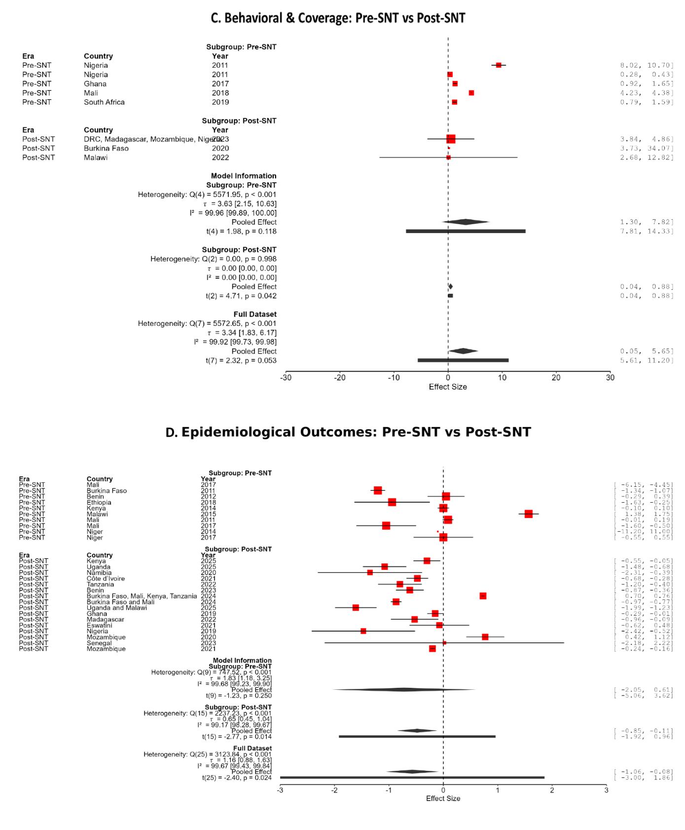
Figure A1. Funnel plots assessing publication bias across intervention domains (chemoprevention/treatment and vector control). Funnel plots of individual study effect sizes against their standard errors for (A) chemoprevention and treatment interventions and (B) vector control interventions. The vertical solid line represents the pooled effect estimate, while the diagonal lines indicate the pseudo 95% confidence limits around the summary effect. Each point corresponds to an individual study. Symmetry around the pooled effect suggests low risk of publication bias, whereas asymmetry may indicate small-study effects or selective reporting. In Panel A, mild asymmetry is observed alongside wide dispersion, consistent with substantial between-study heterogeneity. Panel B shows relatively greater symmetry, although the wide spread of studies reflects high heterogeneity across settings.

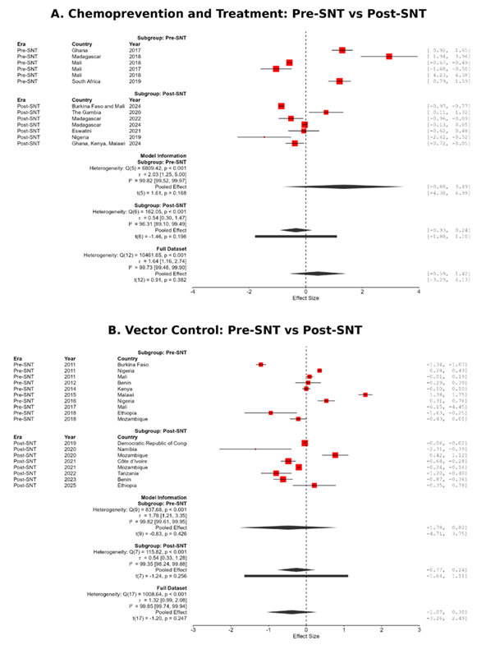
Figure A2. Funnel plots assessing publication bias across intervention domains (behavioral/coverage and epidemiological outcomes). Funnel plots of individual study effect sizes against their standard errors for (C) behavioral and coverage outcomes and (D) epidemiological outcomes. The vertical solid line represents the pooled effect estimate, and the diagonal lines denote the pseudo 95% confidence limits. Each point represents an individual study. Panel C demonstrates clear asymmetry, with clustering of studies showing positive effects, suggesting potential publication bias and small-study effects. Panel D also shows asymmetry, with fewer small studies reporting null or adverse effects, indicating possible selective reporting. In both panels, interpretation of asymmetry should consider the high levels of heterogeneity observed across studies.

Table A3. Publication bias sensitivity analysis of pooled intervention effects
Metric / Model Stage | Estimate / Value | 95% Confidence Interval | P-value | Model Scores (Heterogeneity & Fit)
Initial Pooled Effect (REML) | -0.17 | [-0.38, 0.03] | 0.095 | I² = 99.4%, τ² = 0.60, AIC = 156.9
Egger's Regression Test | t = 3.87 | Limit Est: [-0.90, -0.63] | 0.0003 | Significant funnel asymmetry
Trim-and-Fill Adjusted Effect | -0.32 | [-0.54, -0.10] | 0.004 | Imputed Studies (k) = 7, AIC = 192.6

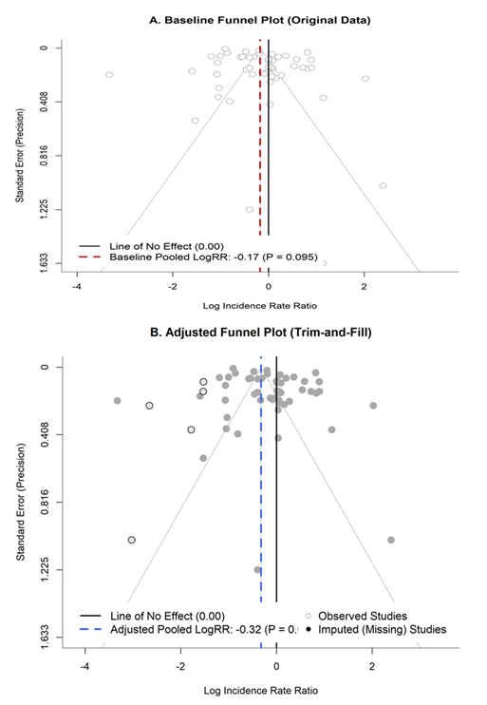
Figure A3. Funnel plots assessing publication bias before and after trim-and-fill adjustment. (A) Baseline funnel plot of observed studies showing study-specific effect sizes (log incidence rate ratios, LogRR) plotted against their standard errors (The solid vertical line represents the null effect (LogRR = 0), while the dashed red line indicates the baseline pooled estimate; LogRR = −0.17, p = 0.095). (B) Trim-and-fill adjusted funnel plot showing both observed studies (filled circles) and imputed (missing) studies (open circles) added to restore symmetry (The solid vertical line represents the null effect, and the dashed blue line indicates the bias-adjusted pooled estimate; LogRR = −0.32)

