Supplementary Information
Title:
Hemangio-organoids derived from human pluripotent stem cells support the formation of dendritic cells
Mojgan Barati, Ehsan Janzamin, Azam Samadian, Narges Sabahi Moosavi, Hossein Baharvand, Marzieh Ebrahimi, Seyedeh-Nafiseh Hassani

Supplementary Information Index:
A. Supplementary Tables
B. Supplementary Figures and Figure Legends
C. Supplementary References

A. Supplementary Tables
Supplementary Table 1. List of antibodies.
Clone | Cat# | Company | Color | Name
581 | 555822 | BD Bioscience | PE | CD34 | 1
HI30 | 555483 | BD Bioscience | PE | CD45 | 2
IG10 | 560199 | BD Bioscience | PE | CD43 | 3
M5E2 | 555398 | BD Bioscience | PE | CD14 | 4
L307.4 | 557227 | BD Bioscience | PE | CD80 | 5
2331(FUN-1) | 555658 | BD Bioscience | PE | CD86 | 6
B-ly6 | 555392 | BD Bioscience | PE | CD11c | 7
HI149 | 555807 | BD Bioscience | PE | CD1a | 8
MOPC-21 | 555749 | BD Bioscience | PE | Mouse IgG1,k | 9
HB15e | 305308 | Biolegend | PE | CD83 | 10
AB3 | R7267 | Dako | PE | HLA-DR | 11
DAK-GO5 | X0950 | Dako | PE | Mouse IgG2a | 12
L307.4 | 560926 | BD Bioscience | FITC | CD80 | 13
HB15e | 561960 | BD Bioscience | APC | CD83 | 14
GRB-1 | HLADRPP5.5-100T | Immunostep | PerCP CY5.5 | HLA-DR | 15
TUK4 | F0844 | Dako | FITC | CD14 | 16
C-10 | Sc5279 | Santa Cruz | Pure | OCT3/4 | 17
NNG-811 | N3038 | Sigma-Aldrich | Pure | NANOG | 18
Tra-1-60 | MAB4360 | Sigma-Aldrich | Pure | TRA-1-60 | 19
Cl.26 | 41-1100 | Thermo fisher | Pure | TRA-1-81 | 20
1A4 | ab7817 | Abcam | Pure | Α-SMA | 21
polyclonal | ab28364 | Abcam | Pure | CD31 | 22
Polyclonal | A10036 | Invitrogen | Alexa546 | Donkey anti-mouse IgG | 23
Polyclonal | A11037 | Invitrogen | Alexa594 | Goat anti-rabbit IgG | 24
Polyclonal | A11001 | Invitrogen | Alexa488 | Goat anti-mouse IgG | 25

Supplementary Table 2. List of primer sequences.
 | Gene | Forward | Reverse | Length (bp)
1 | GAPDH | ctcatttcctggtatgacaacga | cttcctcttgtgctcttgct | 121
2 | OCT4 | ctgggttgatcctcggacct | cacagaactcatacggcggg | 128
3 | BRYCHYURY (T) | aattggtccagccttggaat | cgttgctcacagaccaca | 112
4 | KDR | CCAGCCAAGCTGTCTCAGT | CTGCATGTCAGGTTGCAAAG | 272
5 | HOXB4 | AGACAGAAAGAGAAATAGGAGG | CGGCAGAGGAAACAAGAC | 119
6 | GPR56 | GCTACAGCCGAAGAATGTGAC | AAGCAGGATGTTTGGGTTTCTC | 126
7 | GPR65 | TGATCTGCAACCGGAAAGTCT | TCAGCAACATCACATGAAAGGG | 144
8 | DLL4 | ACAGTGACAAGAGCTTAGGAGAG | TCCTGCCTTATACCTCCGTG | 169
9 | CXCR4 | aacttcagtttgttggctgc | catttcctcggtgtagttatctg | 142
10 | NOTCH1 | cagacccacacccagta | ggcaacgtcaacacctt | 114
11 | GATA2 | AAGGCTCGTTCCTGTTCAGA | GGCATTGCACAGGTAGTGG | 102
12 | HOXA5 | GAGCCACAAATCAAGCAC | CGCCGAGTCCCTGAAT | 148
13 | HOXA9 | TCGATCCCAATAACCCAGCA | GAACCAGATCTTGACCTGCC | 191
14 | CD34 | TGGACCGCGCTTTGCT | CCCTGGGTAGGTAACTCTGGG | 92
15 | CD31 | GAGTCCTGCTGACCCTTCTG | ATTTTGCACCGTCCAGTCC | 107
16 | CD144 | CTCCAACTCCATACTCCACTC | AGTCTCAAAGCAAGGTCTCAG | 319
17 | c-KIT | ATTGTTCTGTGGACCAGGAG | GGTTGTTGTGACATTTGCTG | 359
18 | SCL1 | AGATGGAGATTACTGATG | GCCCCGTTCACATTCTGCT | 94
19 | RUNX1 | CCACTCCACTGCCTTTAACC | GGTATTGGTAGGACTGATCGT | 101
20 | SPI1 | CACAGCGAGTTCGAGAGCTT | GATGGGTACTGGAGGCACAT | 194
21 | BATF3 | TGCTCAGAGAAGTCGGAAGAA | TGGCACAAAGTTCATAGGGCA | 196
22 | CCL18 | CTGCCTCGTCTATACCTCCT | CGCTGATGTATTTCTGGACCC | 161
23 | c-MAF | CTGGCAATGAGCAACTCCGA | AGCCGGTCATCCAGTAGTAGT | 277
24 | CCR7 | TGAGGTCACGGACGATTACAT | GTAGGCCCACGAAACAAATGAT | 143
25 | IRF4 | ATCACAGCTCACGTAGAACCT | GGATTGCTGATGTGTTCTGGT | 110
26 | IRF8 | AGTAGCATGTATCCAGGACTGAT | CACAGCGTAACCTCGTCTTC | 196
27 | CD40 | ACTGAAACGGAATGCCTTCCT | CCTCACTCGTACAGTGCCA | 181
28 | CD141 | ACCTTCCTCAATGCCAGTCAG | CGTCGCCGTTCAGTAGCAA | 106

Supplementary Table 3. List of ELISA Kits
 | Name | Company | Cat#
1 | IL-12p70 | R&D System | D1200
2 | IL-10 | R&D System | D1000B
3 | IFN-γ | R&D System | DIF50

B. Supplementary Figures and Figure Legends
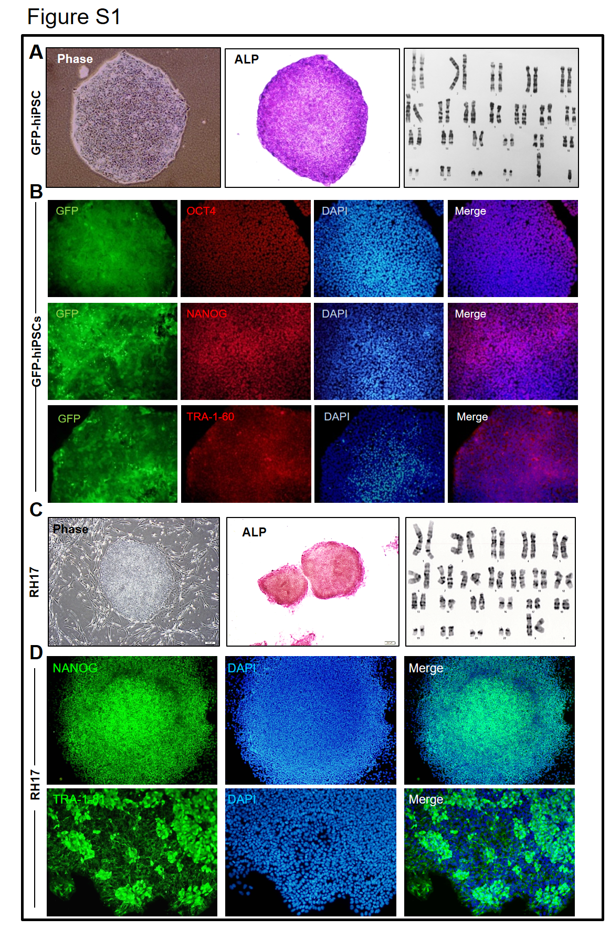
Figure S1: Characterization of human pluripotent stem cell lines.
A) Right and middle panels show the morphology and ALP staining of passage 22 GFP-hiPSCs grown for serial passages under suspension culture conditions and then cultured on Matrigel-coated plates for staining. When individual HPSpheres were plated on Matrigel, the hPSC colonies appeared and remained undifferentiated. Left: Karyotype analysis (G-banding; 46, XY).
B) Immunofluorescence staining for pluripotency-associated transcription factors and surface markers in the GFP-hiPSC line. Staining is performed with a secondary antibody conjugated to Alexa Fluor 546. The nuclei were stained with DAPI (blue). Scale bar: 100µm.
C) Right and middle panels show the morphology and ALP staining of the passage 35 RH17 line grown for serial passage under suspension culture conditions and then cultured on a feeder-coated plate for staining. When individual HPSpheres were plated on Matrigel, the hPSC colonies appeared and remained undifferentiated. Left: Karyotype analysis (G-banding; 46, XX).
D) Immunofluorescence staining for pluripotency-associated transcription factors and surface marker in the RH17 line. Staining is performed with a secondary antibody conjugated to Alexa Fluor 488. The nuclei were stained with DAPI (blue). Scale bar: 100µm.
Abbreviations: hPSC: Human pluripotent stem cell; ALP: Alkaline phosphatase; iPSC: Induced pluripotent stem cells; HPSpheres: hPSC-3D spheres.

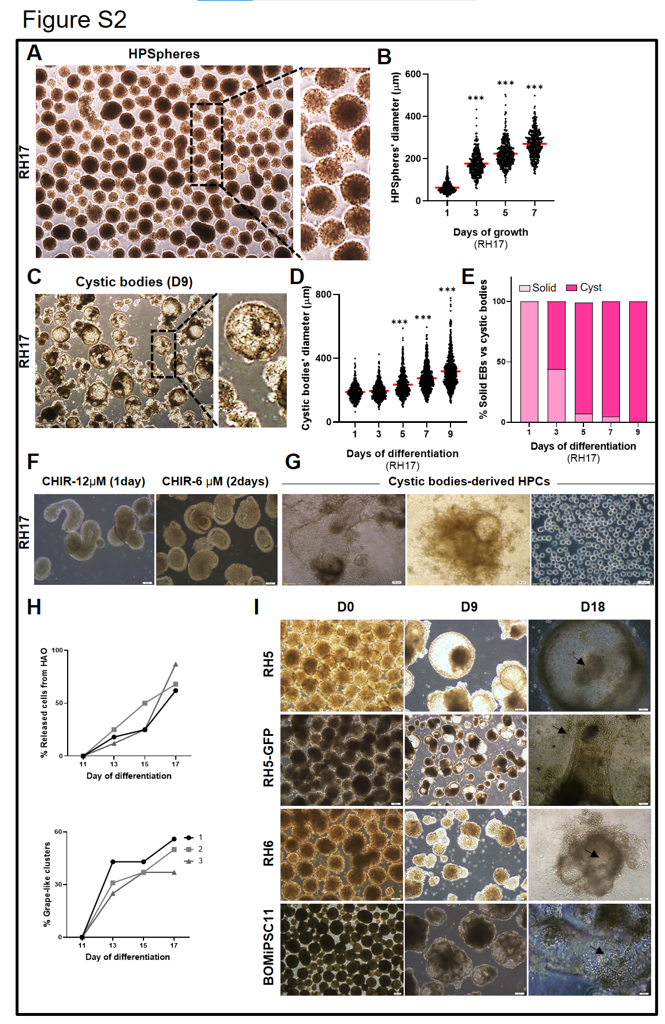

Figure S2: The formation of hemangio-organoid structures from HPSpheres and differentiation into hematopoietic lineages.
A) Morphology of RH17-HPSpheres. Scale bar: 100 µm.
B) Violin plots show the diameter of RH17-HPSpheres during 7 days of culture. The mean is shown by a horizontal line. Representative results from three biological replicates are shown. Red horizontal lines represent the median of all values (circles, n~300). Data analysis was performed using GraphPad Prism 8. ***P<0.001, one-way ANOVA with Dunnett's multiple comparison test.
C) Formation of cystic bodies. Inverted microscopy reveals characteristic features in the morphology of RH17-HPSpheres-derived EBs after 8 days of differentiation. Some EBs formed solid aggregates or small void spaces, while others were cystic (quantified in E).
D) Individual diameter of RH17-cystic bodies from day (D)1 to D9 of differentiation. Representative results from three biological replicates are shown. Red horizontal lines represent the median of all values (circles, n~400). Data analysis was performed using GraphPad Prism 8. ***P<0.001, one-way ANOVA with Dunnett's multiple comparison test. Scale bar: 100 µm.
E) The percentage of solid EBs compared to cystic bodies from D1 to D9 of differentiation is plotted using phase contrast microscopy and GraphPad Prism 8. Representative results from three biological replicates are shown.
F) The effect of different concentrations and duration of CHIR treatment on the formation of cystic bodies. A representative phase contrast image of EBs after treatment with 12 µM CHIR for 1 day (top) or 6 µM CHIR for 2days (bottom). No cystic bodies formed under these conditions.
G) Morphology of HPCs released and expanded from the hemangio-organoid after the hemangio- organoid was plated onto a thin layer of Matrigel (RH17 line).
H) Formation of grape-like structures and burst of cells within the hemangio-organoid structures. Trends show results from three biological replicates (plated cystic bodies, n=16) followed over time. Each time, the number of cystic bodies forming grape-like structures or burst cells was counted and the percentage of formation of grape-like structures or burst cells relative to 16 cystic bodies was calculated.
I) Differentiation of HPSpheres into hemangio-organoid structures and release of HPCs within them. The differentiation of the hESC lines RH5, GFP-RH5, and RH6 as well as the hiPSC line BOMiPSC11 is shown.
Abbreviations: HPSpheres: hPSC-3D spheres; EBs: Embryoid bodies; HPCs: Hematopoietic progenitor cells.

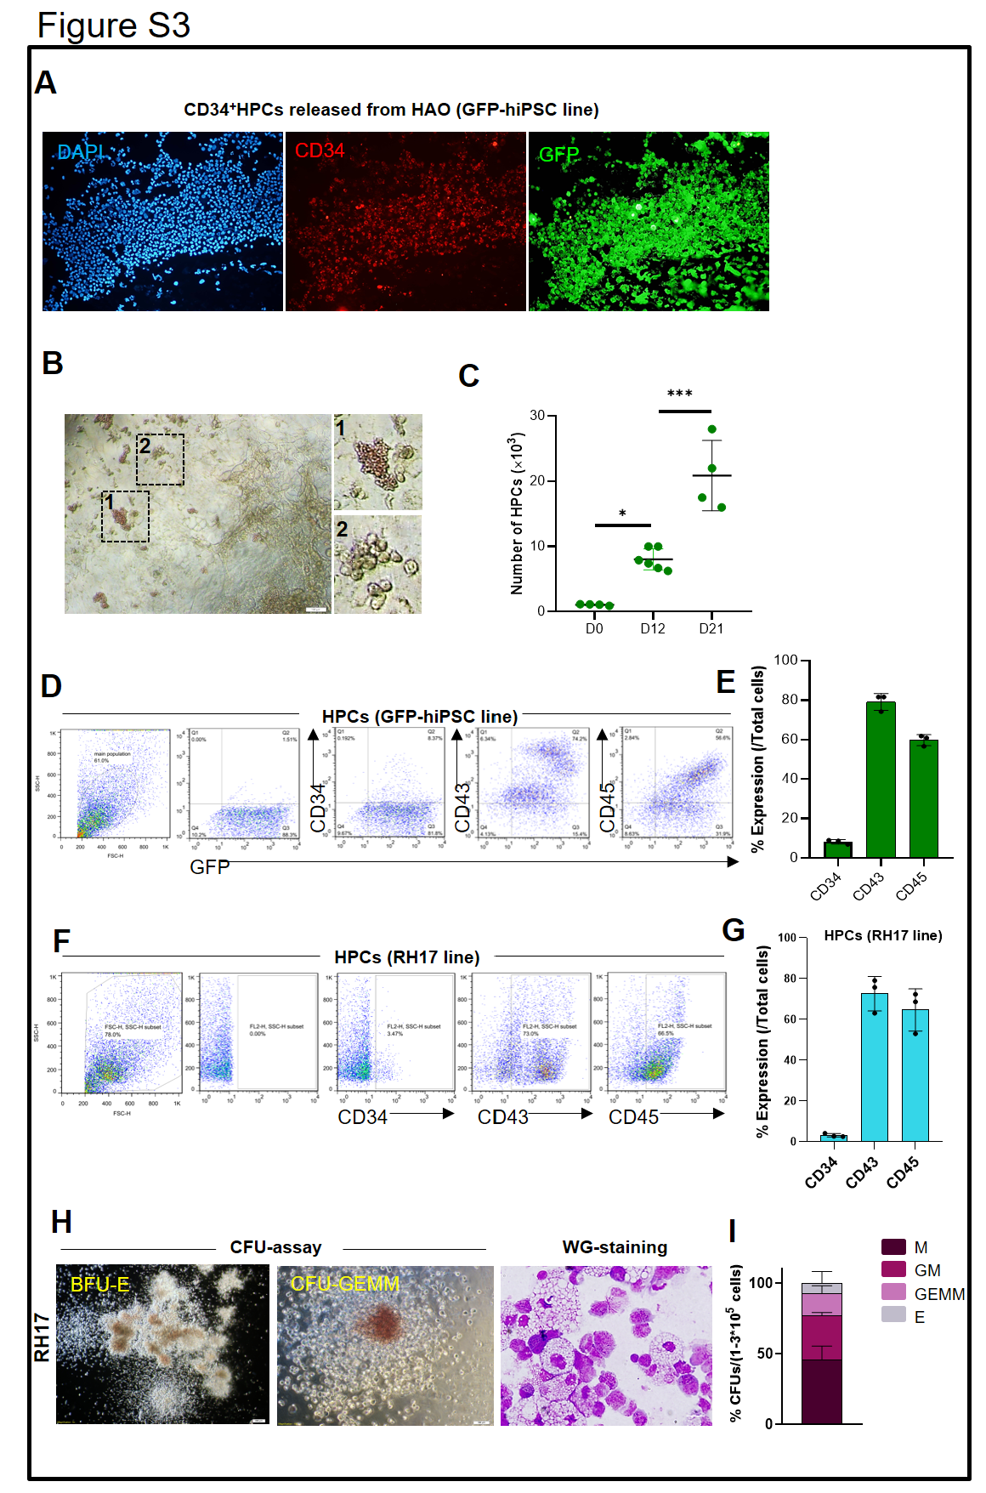

Figure S3: The characterization of HPCs released from hemangio-organoids
A) HPCs released from hemangio-organoid on D15 (related to the GFP-hiPSC line). An immunostaining assay showed that the small round cells released from the hemangio-organoid structures expressed the CD34 surface marker.
B) Hematopoietic cells differentiated from HPCs are shown at D26.
C) HPCs release and expansion trend. The dot plot shows the initial number of hPSCs (D0, each circle correspond to one EB) and the yield of released and expanded HPCs over 12 and 21 days of differentiation. Data analysis was performed using GraphPad Prism 8. Significance was calculated by one-way ANOVA and Tukey's multiple comparisons test. Horizontal bars indicate mean ± SD. Representative results from at least 3 biological replicates are shown. Black horizontal lines represent the median of all values. **P<.01 and ***P<.001 indicate statistical significance.
D) Gating strategy of flow cytometry analysis to characterize HPCs (related to the GFP-hiPSC line). CD34⁺, CD43⁺ and CD45⁺ were used as markers for HPCs.
E) Immunophenotypic analysis of differentiated HPCs (related to the GFP-hiPSC line). Representative flow cytometry plots show the expressions of CD34, CD43, and CD45 in HPC released cells from hemangio-organoid using flow cytometry analysis. Data acquisition of ~10 000 events. Analysis was performed using FlowJo software. The bar plot is drawn using GraphPad Prism 8.
F) Gating strategy of flow cytometry analysis for tthe characterization of HPCs (related to the RH17 line). CD34⁺, CD43⁺ and CD45⁺ were used as markers for HPCs.
G) Immunophenotypic analysis of differentiated HPCs (related to the RH17 line). Representative data show the expression of CD34, CD43 and CD45 in HPCs released from hemangio-organoid using flow cytometry analysis. Data acquisition of ~10,000 events. Analysis was performed using FlowJo software. The bar chart is drawn using GraphPad Prism 8.
H) Hematopoietic colony-forming unit (CFU) assay (related to the RH17 line). The HPCs formed different types of hematopoietic colonies, mainly CFU-GM, CFU-M and BFU-E or CFU-E. Scale bar: 100 and 200 µm. Cell morphology was determined microscopically after Wright/Giemsa staining of cytospin slides. The images were taken at 100x magnification.
I) Percentage of erythroid (BFU-E or CFU-E) and myeloid (CFU-GEMM, CFU-M, and CFU-GM) colonies derived from HPCs. Error bars in E, G, and H are the standard deviation (SD) of three biological replicates.
Abbreviations: hPSCs: Human pluripotent stem cells; HPC: Hematopoietic progenitor cells; CFU-GM: Colony forming unit-Granulocyte, macrophage; CFU-M: Colony forming unit-macrophage; BFU-E: Burst forming unit-erythroid; CFU-E: Colony forming unit-erythroid; CFU-GEMM: Colony forming unit-Granulocyte, erythrocyte, macrophage, megakaryocyte.

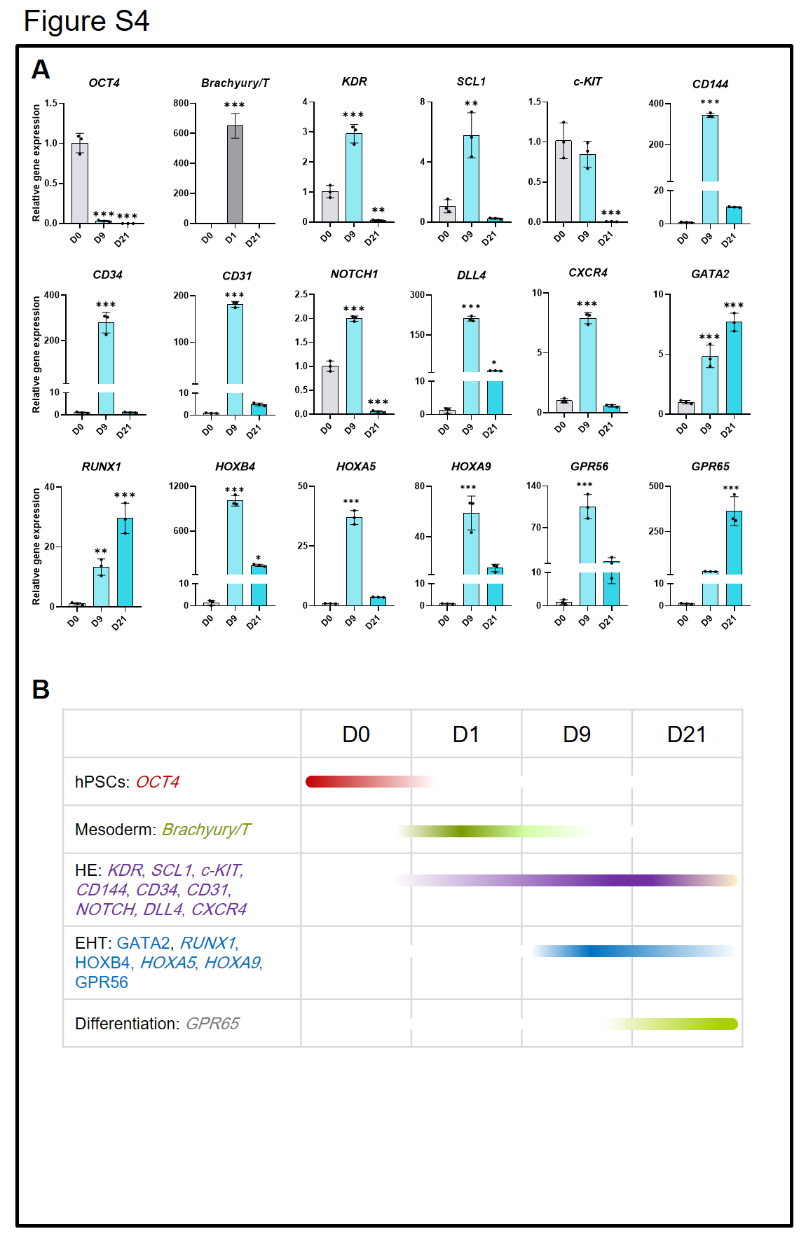

Figure S4: Molecular characterization of hemangio-organoid structures (related to the RH17 line).
A) Relative gene expression analysis (RT-qPCR) for pluripotency and differentiation markers. Data analysis was performed using GraphPad Prism 8. Expression was normalized to a housekeeping gene GAPDH. All values were compared with D0. Data analysis was performed using GraphPad Prism 8. *P<0.05, **P<0.01, ***P<0.001, one-way ANOVA with Dunnett's multiple comparison test. Representative results from three biological replicates are shown.
B) The model is based on the cellular steps and marker expressions involved in the differentiation of hPSCs to the hemangio-organoid structure and the emergence of HPCs.
Abbreviations: hPSCs: Human pluripotent stem cells; HPC: Hematopoietic progenitor cells.

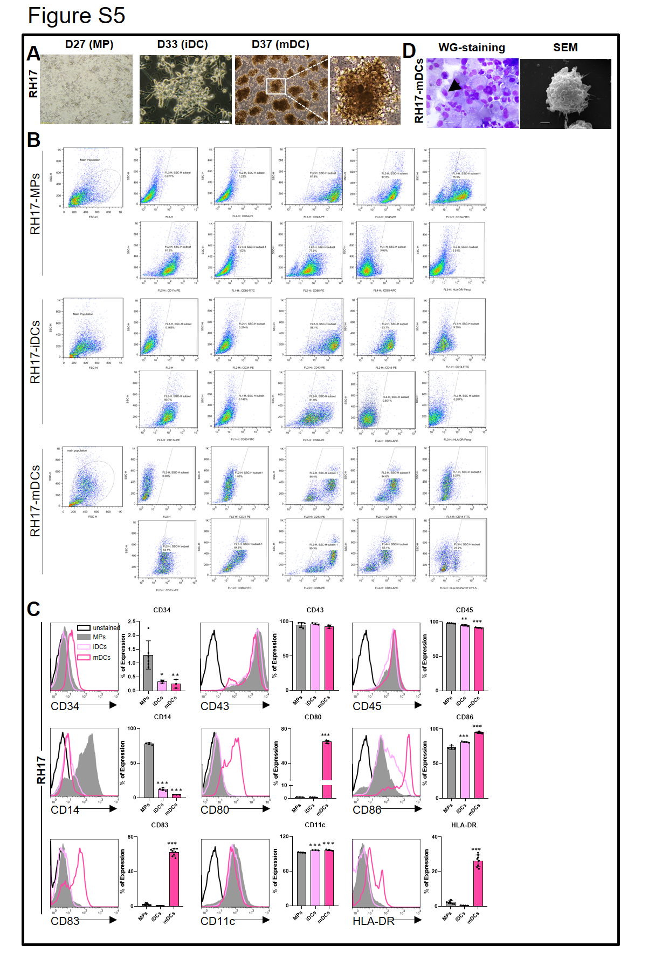

Figure S5: Dendritic cell generation from RH17-derived HPC
A) Morphological changes of cells during differentiation of RH17-HPCs into MPs and then into mDCs. Representative photographs illustrate the morphology of individual MPs and mDC clusters during the differentiation process. Microscopic visualization of MP on day (D) 27, iDCs on D33, and mDCs on D37. Scale bar: 100 µm.
B) Gating strategy for flow cytometry analysis. The dot plots show the expression pattern of the indicated surface markers on RH17-MP, iDC and mDC. In this sample gating, cells were gated in an SSC-A and FSC-A dot plot to select viable differentiated cells. The gate was further analyzed to identify the population of interest. The percentage of surface marker expression was then determined from this gated population.
C) Representative histogram overlays and bar plot showing the average expressions of surface markers CD34, CD43, CD45, CD14, CD83, CD11c, CD86, CD80 and HLA-DR on RH17-MPs (filled histogram, dark grey), RH17-iDC (unfilled histogram, bright pink line) and RH17-mDC (unfilled histogram, dark pink line) on days (D)27, D33, and D37 are shown. The expression of markers cells is compared with their expression on unstained cells (black line). Data analysis was performed using GraphPad Prism 8 (n≥2). *P<.05, **P<.01, ***P<.001, one-way ANOVA. Representative results from at least three biological replicates are shown.
D) The morphology of RH17-mDCs was determined microscopically after Wright/Giemsa staining for cytospin slides. The image was captured with a 100x numerical aperture objective (left). The SEM analysis shows extended cell projections with knob-like structures (right). The black arrow indicates the nucleus of mDC.
Abbreviations: HPC: Hematopoietic progenitors; MP: Myeloid progenitor; iDC: Immature dendritic cells; mDC: Mature dendritic cells.

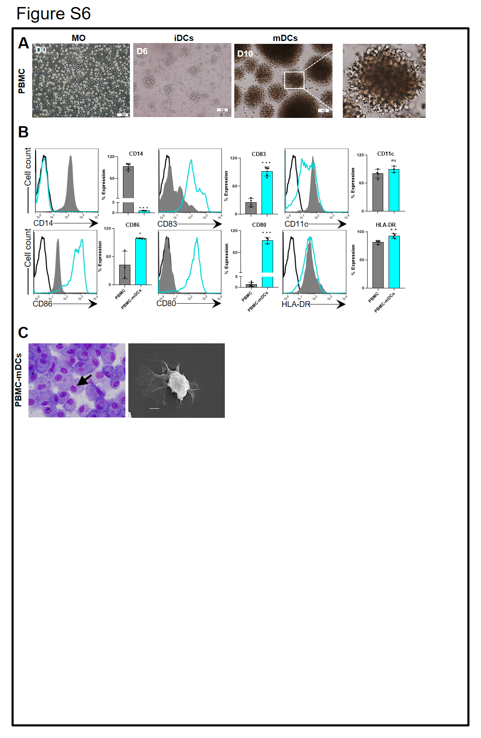

Figure S6: Dendritic cell generation from PBMC-derived MO
A) Morphological changes of cells after differentiation of PBMC-MO. Live PBMC (CD14⁺) cells were sorted, differentiated and used as a control group. Representative photographs illustrate the morphology of individual myeloid cells, iDC and mDC colonies during the differentiation process. Inverted microscopy images of PBMC-MO, iDC and mDC are shown (D0, D6, D10).
B) Phenotype of PBMC-MO and PBMC-mDCs. Representative histogram overlays and bar plot show the average expression of surface markers CD14, CD83, CD11c, CD86, CD80 and HLA-DR on PBMC-MO (filled histogram, dark gray) and after a 10-day differentiation and maturation process on PBMC-mDCs (unfilled histogram, blue line). Cells compared to unstained cells (black line). Data analysis was performed using GraphPad Prism 8. *P<.05, **P<.01, ***P<.001, Student's t-test. Representative results from at least three biological replicates are shown.
C) The morphology of PBMC-mDCs was determined microscopically after May Wright/Giemsa staining for cytospin slides. The image was captured with a 100x numerical aperture objective (left). The SEM analysis shows extended cell projections with knob-like structures (right). The black arrow indicates the nucleus of mDC.
Abbreviations: PBMC: Peripheral blood mononuclear cells; MO: Monocyte; iDC: Immature dendritic cells; mDC: Mature dendritic cells; D: Day.

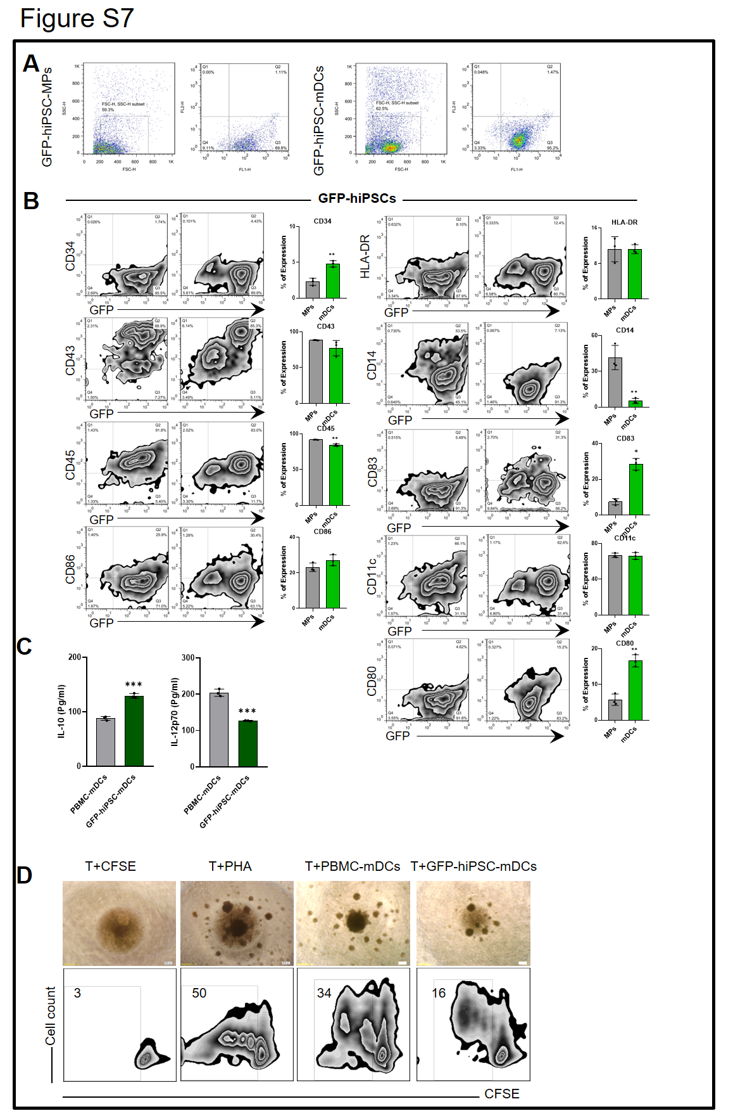

Figure S7: Dendritic cell generation from from GFP-hiPSC -derived HPC
A) Gating strategy for flow cytometry analysis. The dot plots show the expression pattern of the indicated surface markers on GFP-hiPSC-MP and mDC. In this sample gating, cells were gated in an SSC-A and FSC-A dot plot to select viable differentiated cells. The gate was further analyzed to identify the population of interest. The percentage of surface marker expression was then determined from this gated population.
B) Phenotype of GFP-hiPSC-MPs and GFP-hiPSC-mDCs. Representative zebra plot and average expression of CD34, CD43, CD45, CD14, CD83, CD11c, CD86, CD80 and HLA-DR surface markers on GFP-hiPSC-MPs at D27 and GFP-hiPSC-mDCs at D37 of differentiation. Data analysis was performed using GraphPad Prism 8. **P<.01, Student's t-test. Representative results from three biological replicates are shown.
C) Cytokine secretion assay. The expression level of IL-10 and IL12p70 in the culture medium supernatant of GFP-hiPSC-mDC after stimulation with maturation cocktail was determined by ELISA. The conditioned medium of PBMC-mDC used as a control group. Data analysis was performed using GraphPad Prism 8. ***P<.001, Student's t-test. Control and samples were tested in duplicate. Representative results from three biological replicates are shown.
D) T cell proliferation assay. Two groups of mitomycin C-treated mDCs (GFP-hiPSC-mDC and PBMC-mDC) were tested for their ability to stimulate the proliferation of CFSE-labeled allogeneic T cells. The group of T cells treated with PHA is considered a positive control. Quantification of CFSE-labeled T cells showed an increase in the number of allogeneic T cells in response to GFP-hiPSC-mDCs. Data analysis was performed using flow cytometry and the numbers in the plots indicate the percentage of the cell population in the indicated gate.
Abbreviations: HPC: Hematopoietic progenitors; MP: Myeloid progenitor; iDC: Immature dendritic cells; mDC: Mature dendritic cells.

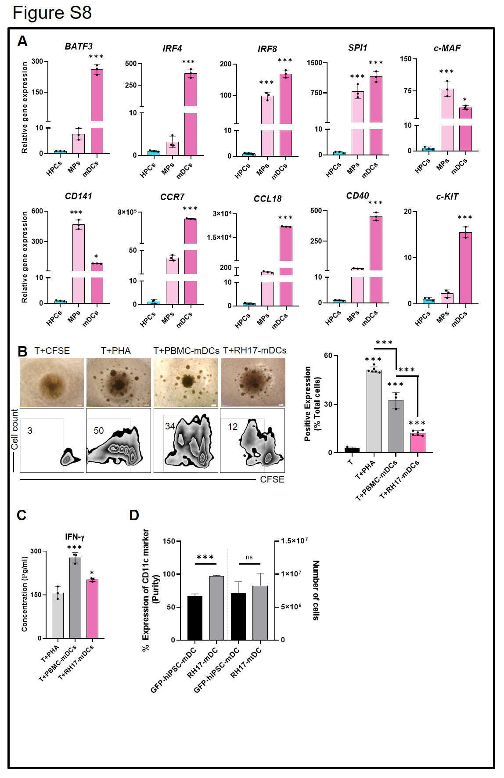

Figure S8: Molecular characterization of MP-derived mDCs in RH17.
A) Relative gene expression analysis (RT-qPCR) of transcription factors and surface marker genes SPI1, BATF3, IRF8, IRF4, c-MAF, c-KIT, CD141, CCL18, CD40 and CCR7 genes. These data reffered to cells produced from RH17 on days (D)21 (HPC), D27 (MP), and D37 (mDC). Data analysis was performed using GraphPad Prism 8. Gene expression was normalized to the housekeeping gene GAPDH. All values were compared with HPC. Significance was calculated by one-way ANOVA and Dunnett's multiple comparison test.
B) T cell proliferation assay. Two groups (RH17-mDC and PBMC-mDC) of mitomycin C-treated mDCs were tested for their ability to stimulate the proliferation of CFSE-labeled allogeneic T cells. The group of T cells treated with PHA is considered a positive control. Quantification of CFSE-labeled T cells showed an increase in the number of allogeneic T cells in response to RH17-mDCs. Each column shows the mean ± SD value of three samples. Data analysis was performed using GraphPad Prism 8. ***P<.001, one-way ANOVA. The numbers in the plots indicate the percentage of the cell population in the specified gate. Each column shows the mean ± SD and the error bars in A and B are the standard deviation (SD) of three biological replicates.
C) Cytokine secretion of T cells after stimulation with mDCs. The concentration of IFN-γ in the supernatant of allogeneic T cells cocultured with two groups of mitomycin C-treated mDCs (RH17-mDC and PBMC-mDC) was determined by ELISA. The group of T cells treated with PHA is considered a positive control. Significant IFN-γ secretion from T cells stimulated with RH17-mDCs was detected. Data analysis was performed using GraphPad Prism 8 (n=3). *P<.05, ***P<.001, one-way ANOVA. Control and samples were tested in duplicate. Representative results from three biological replicates are shown.
D) Purity and yield of hPSC-mDC. Purity data were obtained from flow cytometry analysis of CD11c marker expression and the final product counted using a hemocytometer with an Olympus microscope. Data analysis was performed using GraphPad Prism 8. ns P>.05, ***P<.001, Student's t-test. Representative results from three biological replicates are shown. A vertical dashed line separates one data set from the other.
Abbreviations: MP: myeloid progenitors; DC: dendritic cell; RT-qPCR: Real-time quantitative PCR; BATF3: Basic leucine zipper transcription factor ATF-like 3; IRF4: Interferon regulatory factor-4; MO: Monocytes; iDC: Immature dendritic cells; mDC: Mature dendritic cells; IL: Interleukin; IFN: Interferon gamma; hPSC: Human pluripotent stem cell.

