Supplementary Information (SI)
Fig. S1 Experimental setup of the agar plate assay
Fig. S2 Shoot biomass responses of rice and barley genotypes to bacterial inoculation under low-P conditions
Fig. S3 Representative scanned root images of greenhouse-grown maize under different bacterial treatments
Fig. S4 Effects of bacterial inoculation on fine root traits in agar-grown maize seedlings
Fig. S5 Qualitative screening of phosphate-solubilizing activity among Kribbella and Nocardioides isolates
Supplementary Table S1 16S rRNA gene sequences of the bacterial isolates used in the greenhouse screening experiment
Supplementary Table S2 Plant biomass, P accumulation and root phenotypic data from the greenhouse screening experiment
Supplementary Table S3 Detailed statistics of Correlation and Redundancy Analysis assessing the relationship between shoot biomass and root traits
a
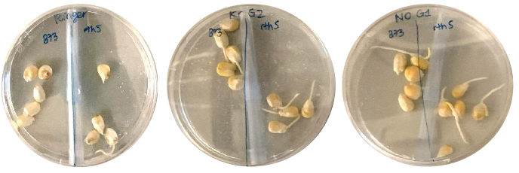
b
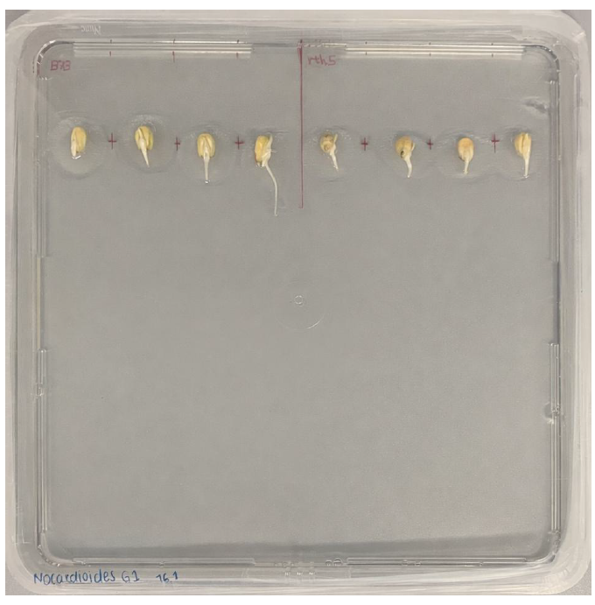
Fig. S1 Experimental setup of the agar plate assay (a) Germinated maize seedlings of B73 and the root-hair mutant rth5 during immersion in the bacterial seed-dipping suspension in 90-mm Petri dishes. (b) A 250-mm square plate containing inoculated 1/4 MS agar medium, with treated seedlings positioned on the surface before incubation.
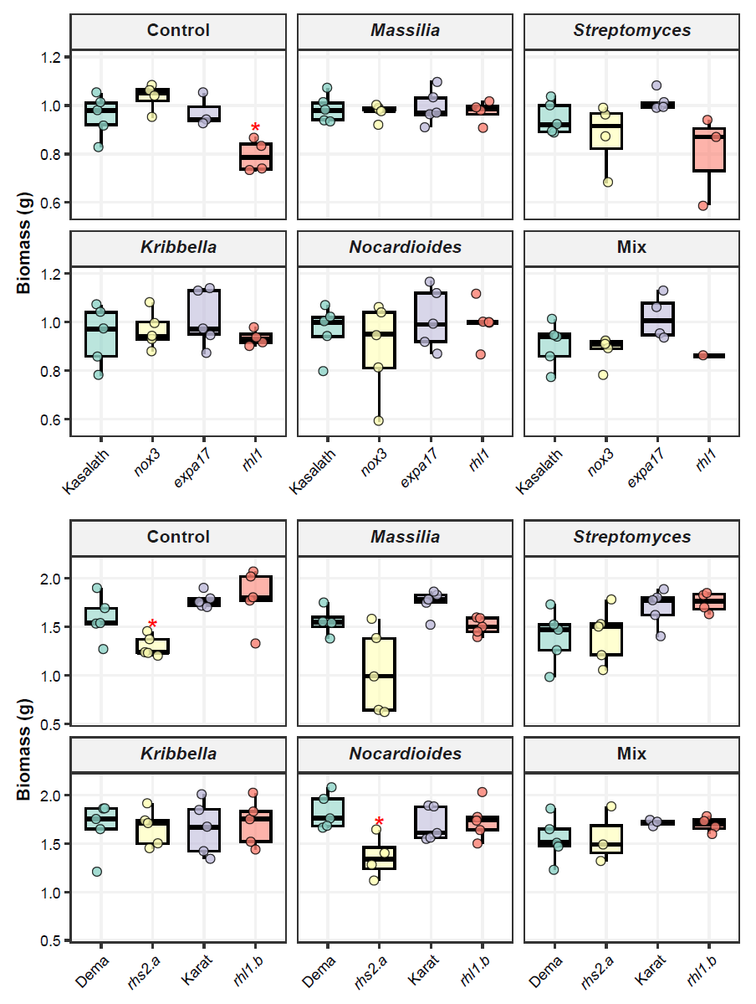
a
b
Fig. S2 Shoot biomass responses of rice and barley genotypes to bacterial inoculation under low-P conditions (a) Shoot biomass of rice genotypes (Kasalath and its related mutants nox3, expa17 and rhl1) and (b) barley genotypes (Dema vs. rhs2.a, Karat vs. rhl1.b) under uninoculated control and bacterial inoculation treatments. Data are shown as boxplots with overlaid individual biological replicates. Within each treatment, mutants were compared with their corresponding wild-type genotypes using Dunnett’s test. Red asterisks indicate significant differences from the corresponding wild type within the same treatment (* P < 0.05, ** P < 0.01, *** P < 0.001).
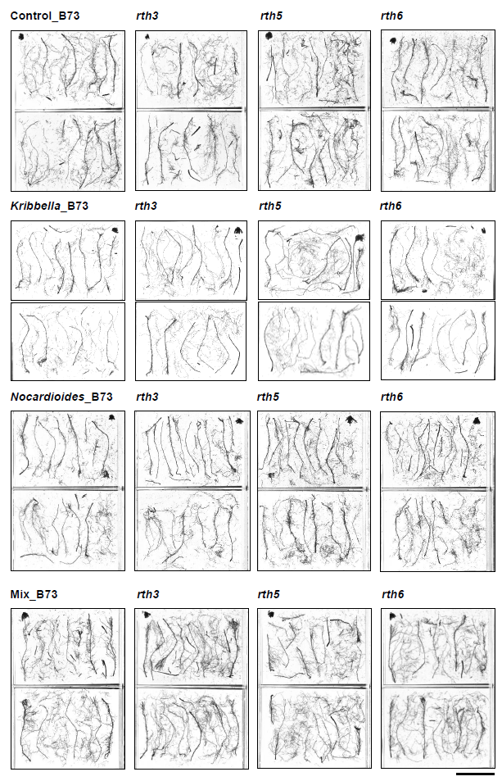
Fig. S3 Representative scanned root images of greenhouse-grown maize under different bacterial treatments One representative root system is shown for each genotype-treatment combination from five biological replicates. All scans are displayed at the same scale; scale bar = 10 cm.
a
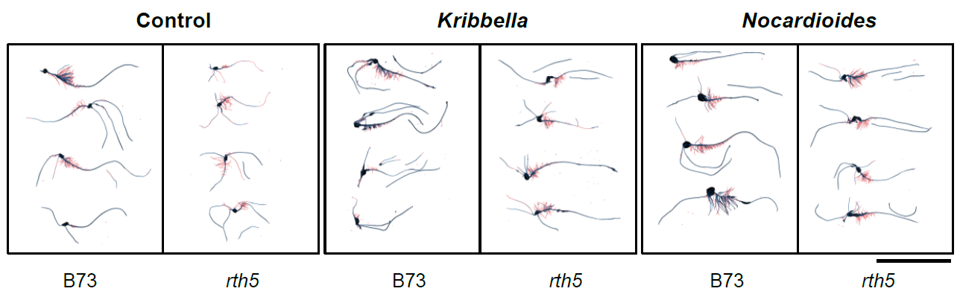
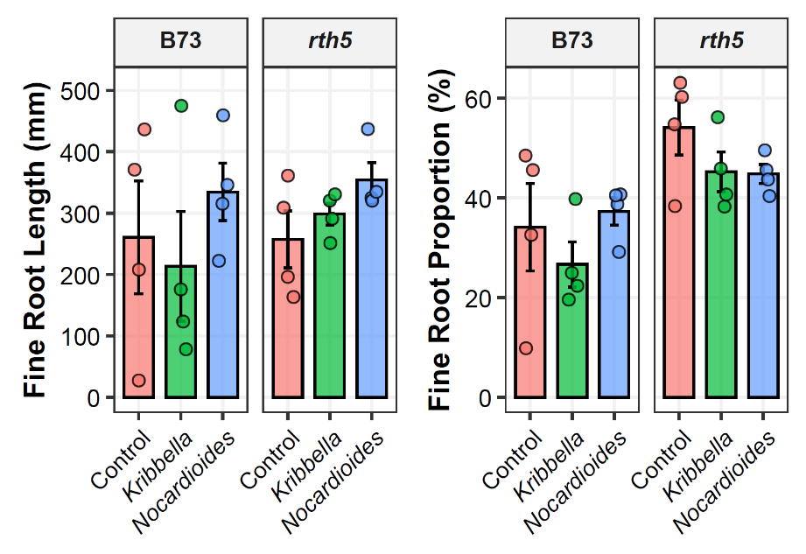
b c
Fig. S4 Effects of bacterial inoculation on fine root traits in agar-grown maize seedlings (a) Representative root scans used for fine root classification, with fine roots (diameter < 0.5 mm) highlighted in red. Scale bar = 10 cm. (b) Fine root length. (c) Fine root proportion, calculated as fine root length divided by total root length for each seedling. Bars represent means ± SE with overlaid biological replicates. No significant differences were detected among treatments within either genotype. (* P < 0.05, ** P < 0.01, *** P < 0.001).
H50 H51 H54 H56 H59 H60
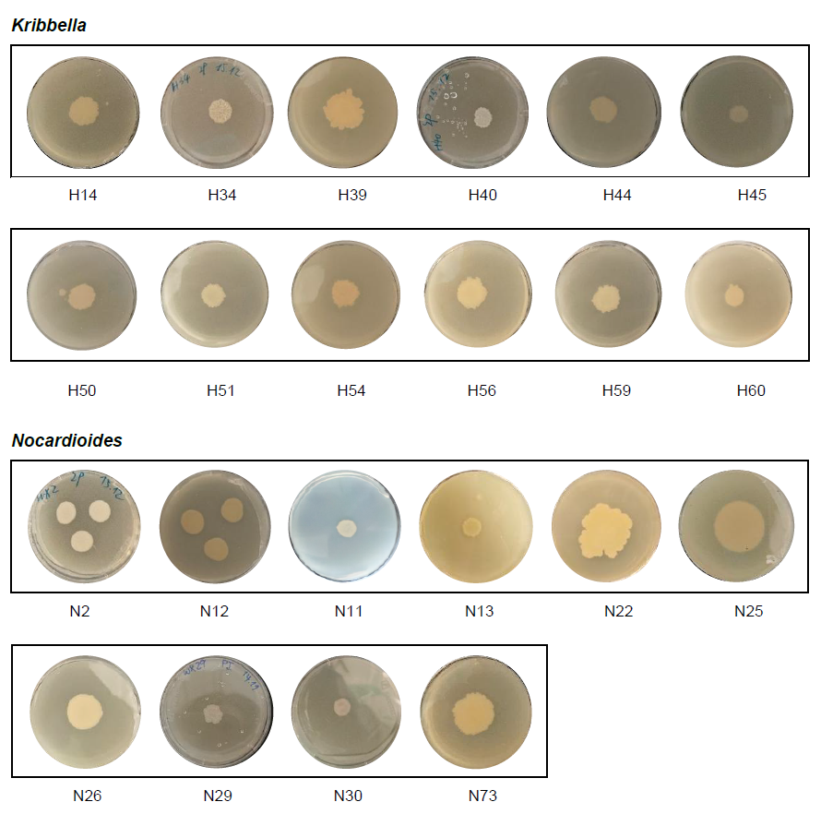Fig. S5 Qualitative screening of phosphate-solubilizing activity among Kribbella and Nocardioides isolates Representative plate images of all halo-positive isolates used for qualitative evaluation of phosphate solubilization on insoluble phosphate medium. Visible halo formation was used as an indicator of detectable phosphate-solubilizing activity. Isolates without visible halos are not shown. Isolate IDs correspond to entries in the bacterial culture collection used in this study.

