Supplementary Information of
Controllable transient coherent state reproduction in lasers

Wenhao Zhu^{1,2,6}, Laiyang Dang^{1,2,6}, Yihuan Shi^{1,2}, Feng Li², Qiwen Zhan^{3,4}, Dongmei Huang^{1,2,*}, and P. K. A. Wai⁵

¹Photonics Research Institute, Department of Electrical and Electronic Engineering, The Hong Kong Polytechnic University, Hong Kong SAR, China
²The Hong Kong Polytechnic University Shenzhen Research Institute, Shenzhen 518057, China
³Zhejiang Key Laboratory of 3d Micro/Nano Fabrication and Characterization, Department of Electronic and Information Engineering, School of Engineering, Westlake University, Hangzhou, Zhejiang 310030, China
⁴School of Optical-Electrical and Computer Engineering, University of Shanghai for Science and Technology, Shanghai 200093, China
⁵Department of Physics, Hong Kong Baptist University, Hong Kong SAR, China
⁶These authors contributed equally: Wenhao Zhu, Laiyang Dang
*Corresponding author: meihk.huang@polyu.edu.hk

This Supplementary Information consists of the following sections
S1. Principle of the transient coherent state in the FDML laser
S2. Buildup dynamics and evolution of the FDML laser
S3. Derivation and analysis of the residual phase jitter
S4. Feedback control
S5. Hybrid LiDAR
S6. Self-injection-locked DFB laser with periodic resetting
Supplementary Figures S1-S19
Supplementary References S1-S10

Supplementary note S1: Principle of the transient coherent state in the FDML laser
S1.1 Derivation of the accumulated frequency shift
Herein, the accumulated frequency shift ∆f_{as}(N,t) for the backward and the forward sweep is derived. The derivation steps are as follows:
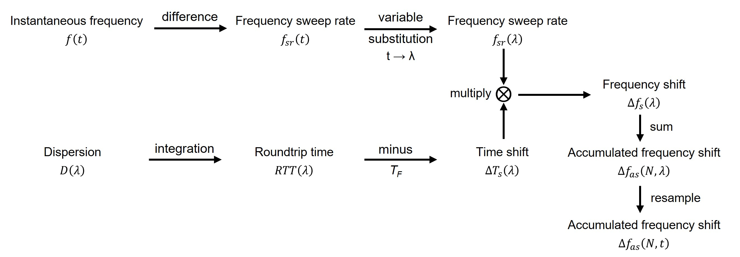
Fig. S1. Derivation steps for the accumulated frequency shift.
Dispersion D(λ) of the long fiber cavity of the FDML laser as a function of the wavelength λ in the unit of picoseconds per nanometer per kilometer (ps/nm/km) is given by the Sellmeier equation¹:
$$\begin{aligned}D\left(λ\right)=\frac{S_{0}}{4}\left[λ-\frac{λ_{0}^{4}}{λ^{3}}\right],\#(S1)\end{aligned}$$
where the zero dispersion wavelength λ₀ is 1562 nm for the long fiber in the experimental FDML laser cavity, and the zero dispersion slope S₀ is 0.08 ps/(nm²·km). Then, the roundtrip time RTT(λ) as a function of λ is derived by integrating Eq. (S1) and multiplying the cavity length L:
$$\begin{aligned}RTT\left(λ\right)=L\int_{λ_{0}}^{λ}{D\left(λ\right)dλ}=\frac{S_{0}L}{8}\left[λ^{2}+\frac{λ_{0}^{4}}{λ^{2}}-2λ_{0}^{2}\right],\#\left(S2\right)\end{aligned}$$
where L is 4.062 km, 1497 nm < λ < 1587 nm. The time shift ∆T_{s}(λ) between the tuning period of the FFP-TF T_{F} (1 / 50595.945 = 9.88 µs) and RTT(λ) is calculated by:
$$\begin{aligned}∆T_{s}\left(λ\right)=RTT\left(λ\right)-T_{F}.\#\left(S3\right)\end{aligned}$$
As shown in Fig. S2a, there are two zero-crossing points for ∆T_{s}(λ) corresponding to two perfectly mode-locked sweet spots, whose wavelengths are marked as λ_{ss1} and λ_{ss2}. In the experimental TCS-FDML laser cavity from the main context, λ_{ss1} is 1550 nm, and λ_{ss2} is 1574 nm. The instantaneous optical frequency f(t) of the FDML laser signal as a function of time t is determined by the sinusoidal voltage that drives the FFP-TF and given by:
$$\begin{aligned}f\left(t\right)=\frac{f_{swr}}{2}\sin\left(\frac{2π}{T_{F}}t-\frac{π}{2}\right)+f_{0},\#\left(S4\right)\end{aligned}$$
where the optical freqency sweep range f_{swr} is 11.4 THz and the center optical frequency f₀ is 194.6 THz. Here, t is between 0 and T_{F} / 2, and Eq. (S4) describes the backward sweep (from long to short wavelength). The instantaneous optical frequency sweep rate f_{sr}(t) is calculated by the derivative of Eq. (S4):
$$\begin{aligned}f_{sr}\left(t\right)=\frac{df\left(t\right)}{dt}=\frac{f_{swr}π}{T_{F}}\cos\left(\frac{2π}{T_{F}}t-\frac{π}{2}\right).\#\left(S5\right)\end{aligned}$$
To keep in line with ∆T_{s}(λ), which is a function of λ, f_{sr}(t) is converted to f_{sr}(λ) by using the time t(λ) as a function of λ given by:
$$\begin{aligned}t\left(λ\right)=\frac{T_{F}}{2π}\cos^{-1}\left(\frac{λ-λ_{c}}{λ_{s}/2}\right),\#\left(S6\right)\end{aligned}$$
where the center wavelength λ_{c} is 1542 nm and the wavelength sweep range λ_{s} is 90 nm. Then, f_{sr}(λ) is calculated by substituting Eq. (S6) into Eq. (S5):
$$\begin{aligned}f_{sr}\left(λ\right)=f_{sr}\left[t\left(λ\right)\right]=\frac{f_{swr}π}{T_{F}}\cos\left(\frac{2π}{T_{F}}\frac{T_{F}}{2π}\cos^{-1}\left(\frac{λ-λ_{c}}{λ_{s}/2}\right)-\frac{π}{2}\right).\#\left(S7\right)\end{aligned}$$
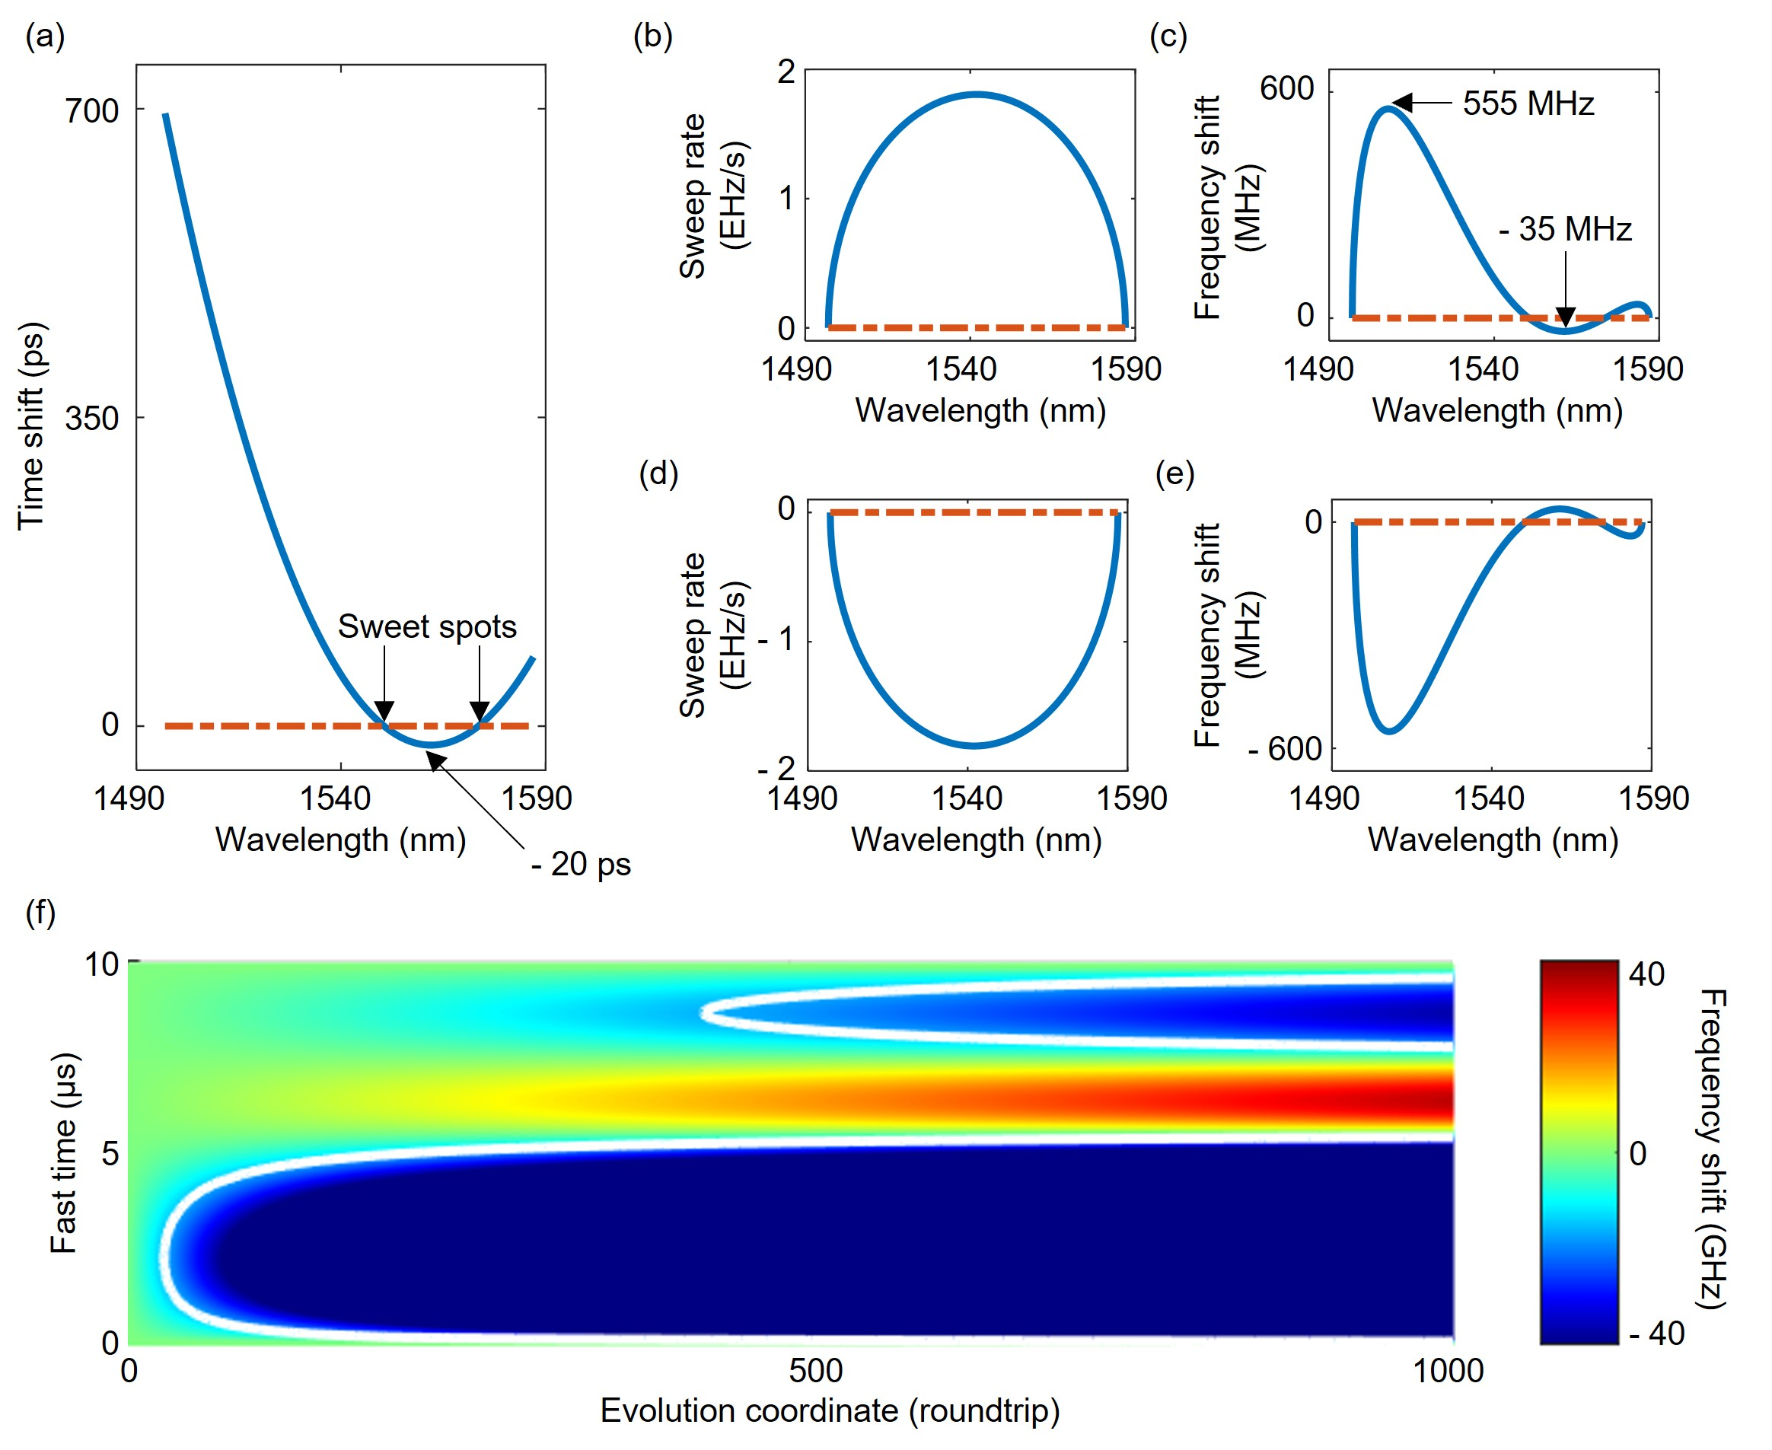
Fig. S2. Derivation of the accumulated frequency shift. a, The time shift (blue curve) relative to the tuning period of the FFP-TF is derived from the Sellmeier equation. The zero crossing (rufous dashed line) points correspond to the sweet spots. b, The instantaneous optical frequency sweep rate in the backward sweep. c, The frequency shift per roundtrip in the backward sweep. d, The instantaneous optical frequency sweep rate in the forward sweep. e, The frequency shift per roundtrip in the forward sweep. f, The accumulated frequency shift in the forward sweep.
As shown in Fig. S2b, f_{sr}(λ) is positive for the backward sweep (long to short wavelength, which is the sweep discussed in the main context). Lastly, under the linear approximation, the frequency shift ∆f_{s}(λ) per roundtrip is calculated by:
$$\begin{aligned}∆f_{s}\left(λ\right)=f_{sr}\left(λ\right)×{∆T}_{s}\left(λ\right)= \\ f_{sr}\left[t\left(λ\right)\right]×∆T_{s}\left(λ\right)=\frac{f_{swr}π}{T_{F}}\cos\left[\cos^{-1}\left(\frac{λ-λ_{c}}{λ_{s}/2}\right)-\frac{π}{2}\right]×\left\{\frac{S_{0}L}{8}\left[λ^{2}+\frac{λ_{0}^{4}}{λ^{2}}-2λ_{0}^{2}\right]-T_{F}\right\}.\#\left(S8\right)\end{aligned}$$
As shown in Fig. S2c, ∆f_{s}(λ) between the two sweet spots is negative, while ∆f_{s}(λ) out of the two sweet spots is positive. The maximum value of ∆f_{s}(λ) at λ = 1507 nm is 555 MHz, and the minimum value at λ = λ₀ = 1562 nm is -35 MHz. As the optical signal further propagates in the laser cavity, for an optical signal at λ, its frequency is modulated by the accumulated frequency shift ∆f_{as}(N,λ) as a function of the number of roundtrips N and λ, and calculated by:
$$\begin{aligned}∆f_{as}\left(N,λ\right)=\sum_{i=1}^{N}{{∆f}_{s}\left(λ\right)}=N×{∆f}_{s}\left(λ\right).\#\left(S9\right)\end{aligned}$$
To match the experimental result of the evolution of the FDML laser in the unit of N and t, the accumulated frequency shift shown in the main context (inset Fig. 1d) is resampled based on Eq. (S6) and linear interpolation to convert ∆f_{as}(N,λ) to ∆f_{as}(N,t).
Lastly, we derive ∆f_{as}(N,t) of the TCS-FDML laser in the forward sweep (from short to long wavelength). Since the cavity dispersion profile is common for both sweep directions, the laser signal in the forward sweep is subject to the same ∆T_{s}(λ) as the backward sweep discussed above. However, f_{sr}(λ), as shown in Fig. S2d, is opposite in sign compared with the backward sweep. Furthermore, ∆f_{s}(λ) and ∆f_{as}(N,λ) are also opposite in sign, as shown in Fig. S2e and Fig. S2f. The white contour line in Fig. S2f represents the position where -∆f_{as}(N,λ) equals B_{F}.
S1.2 Parametric calculation
As the FDML laser cavity is built, the dispersion profile of the laser cavity is fixed. However, the instantaneous optical frequency of the laser signal is set by the FFP-TF, which is driven by a sinusoidal voltage and contains two adjustable parameters: the tuning period (T_{F}) and voltage offset (V_{o}). T_{F} and V_{o} should be chosen to extend the vertical boundary (corresponding to the spectral Bandwidth) and the horizontal boundary (corresponding to the number of roundtrips Q_{eff} at which the optical signal between the two sweet spots experiences net gain) of the TCS-FDML region in the inset Fig. 1d. Bandwidth and Q_{eff} are calculated by:
$$\begin{aligned}Bandwidth=\left|λ_{ss1}-λ_{ss2}\right|.\#\left(S10\right)\end{aligned}$$
$$\begin{aligned}Q_{eff}=\frac{B_{F}}{-∆f_{s}\left(λ_{0}\right)}.\#\left(S11\right)\end{aligned}$$
If the cavity length of the FDML laser is shortened due to thermal contraction, RTT(λ) is decreased, and T_{F} should be decreased accordingly to restore ∆T_{s}(λ) as the same shown in Fig. S2a. Both before and after the thermal contraction, the relative time differences between T_{F} and RTT(λ₀) remains the same, which is defined as the Detuning and calculated by:
$$\begin{aligned}Detuning=T_{F}-RTT\left(λ_{0}\right).\#\left(S12\right)\end{aligned}$$
Similarly, if the cavity length of the FFP-TF is shortened due to thermal contraction, λ_{c} is decreased, and V_{o} should be increased to restore λ_{c}. Therefore, the parametric calculations for the Bandwidth and Q_{eff} are based on temperature-independent Detuning and λ_{c}, rather than on the temperature-dependent T_{F} and V_{o}.
Figures S3a and S3b show the calculated Bandwidth and Q_{eff} under different Detuning and λ_{c}. A higher Bandwidth and a higher Q_{eff} are desirable to enlarge the TCS-FDML region. Detuning and λ_{c} are selected manually according to the trade-offs from the experiment. As shown in Fig. S3a, the λ_{c} is not related to the Bandwidth. Yet, Figure S3b indicates that λ_{c} should be set away from λ₀ = 1562 nm to enlarge Q_{eff}. Considering that the center wavelength of the SOA is 1550 nm and the 3 dB bandwidth is 85 nm, λ_{c} is set to be 1542 nm to enlarge Q_{eff} while maintaining sufficient gain for the whole wavelength sweep range between 1497 nm and 1587 nm. Figure S3a shows that to enlarge the Bandwidth, the Detuning should be higher. However, as shown in Fig. S3b, the higher the Detuning is, the lower the Q_{eff} is. The trade-off between Bandwidth and Q_{eff} originates from the non-flat dispersion profile of the long fiber, which can be mitigated by combining different types of optical fiber or chirped fiber Bragg grating (CFBG)² in future work. The lower limit of Q_{eff} is determined by the 150 roundtrips required for the intrinsic linewidth of the TCS-FDML to converge to a minimum (Visualization 1). The upper limit of Q_{eff} is determined by the 1000 roundtrips offered by the record length of the oscilloscope. Therefore, the Detuning in the main context is chosen to be 20 ps, corresponding to a Q_{eff} of 450 and a Bandwidth of 20 nm.
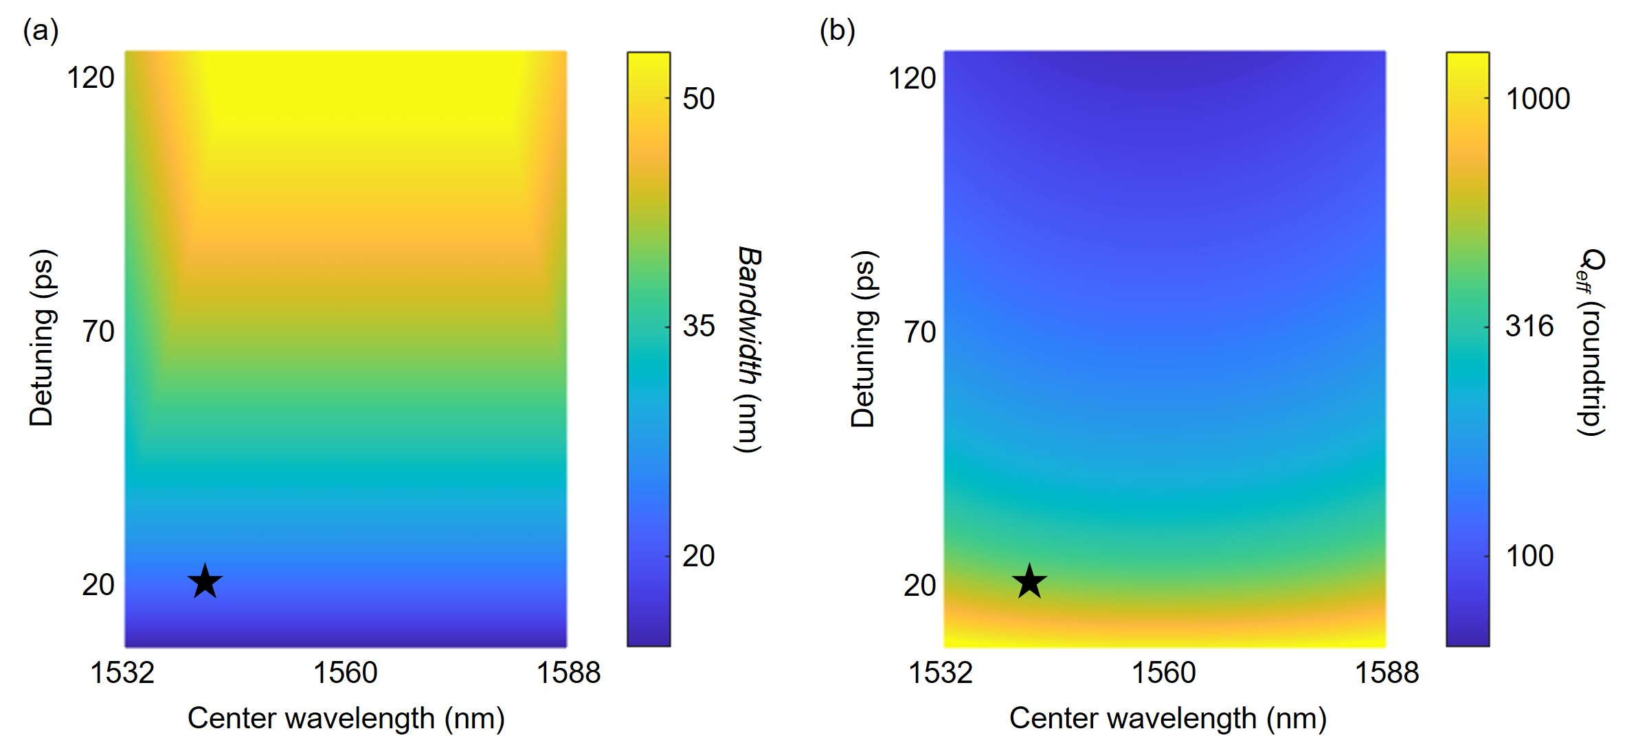
Fig. S3. Parametric calculation on the Detuning and λ_{c} of the FDML laser a, for Bandwidth, b, for Q_{eff} of the TCS-FDML region. The Z axis (color axis) for Q_{eff} is on a logarithmic scale. The black pentagram star represents the parameter setting in the main content.

Supplementary note S2: Buildup dynamics and evolution of the FDML laser
S2.1 The buildup dynamics of the laser signal during the forward sweep
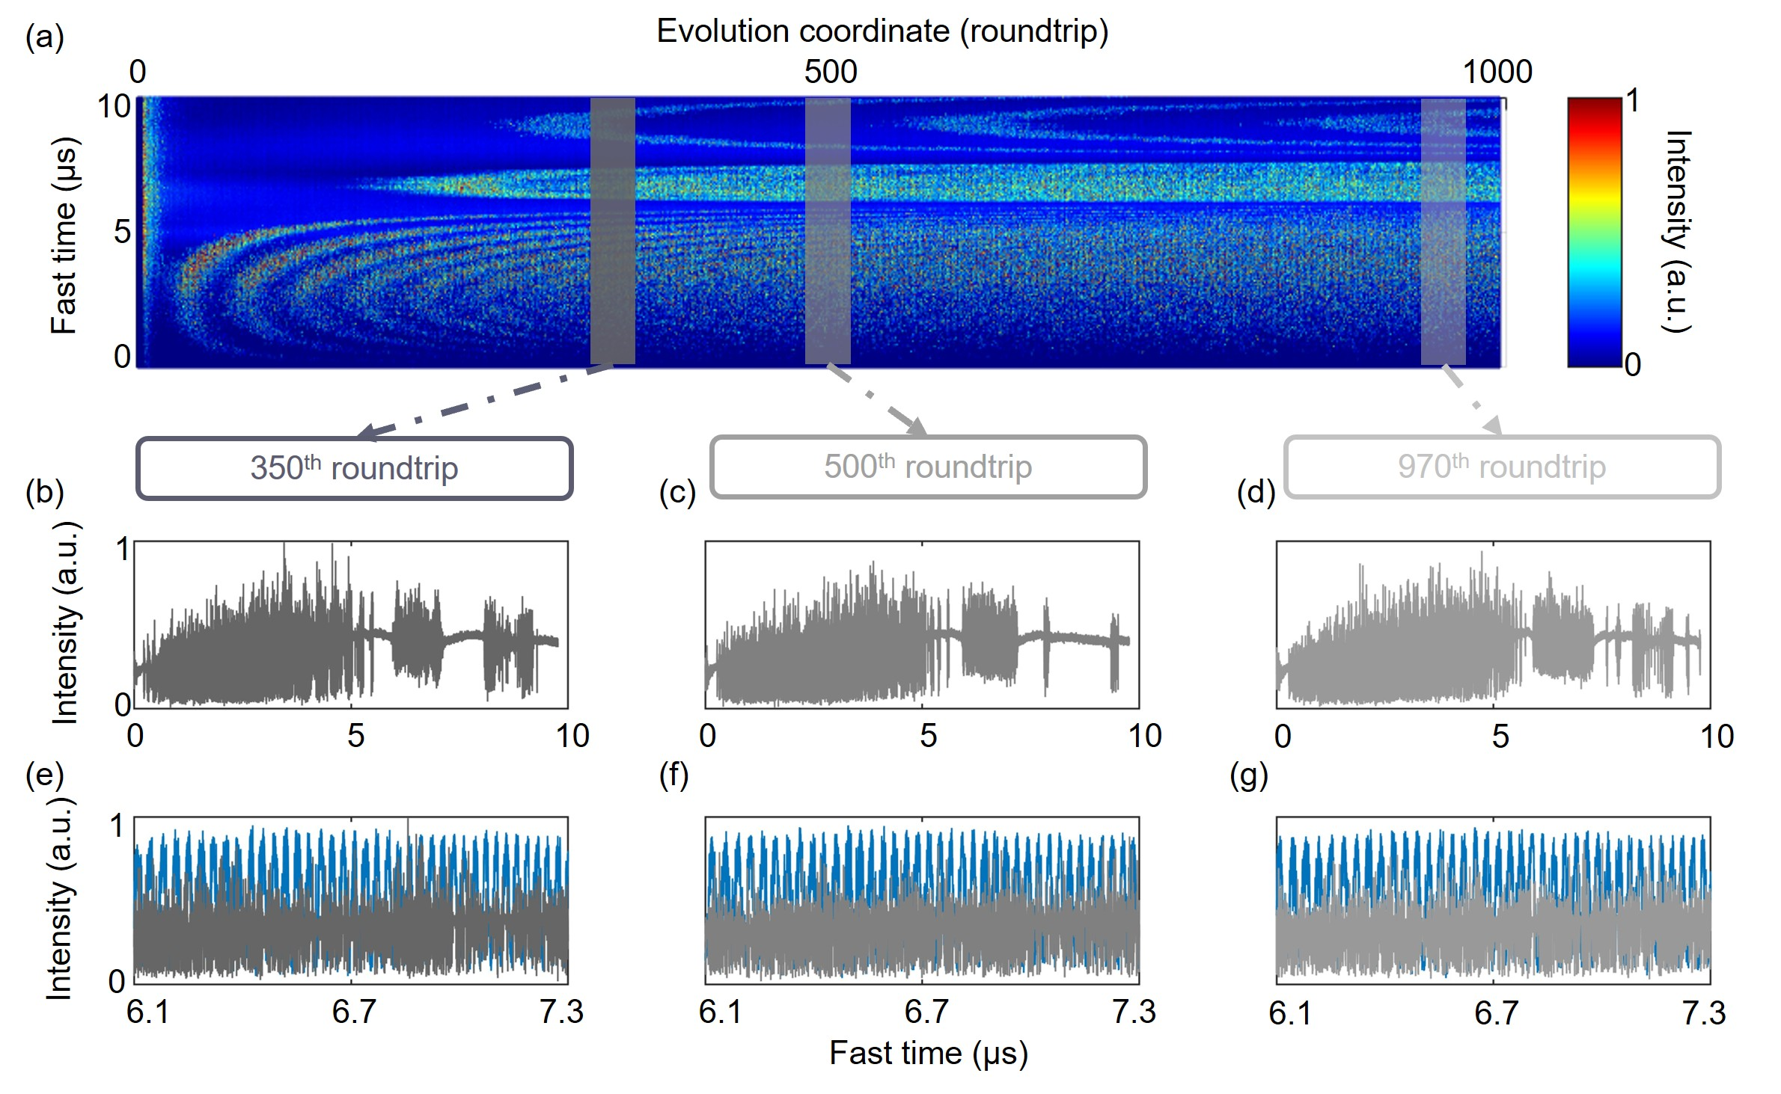
Fig. S4. Experimental buildup dynamics of the laser signal during the forward sweep in the FDML laser. a, The buildup dynamics. b-d, The temporal waveform of the laser signal at the 350th, 500th, and 970th roundtrip, respectively. e-g, The zoomed-in temporal waveform (grey) and interference signal (blue) of the laser signal between 6.1 µs and 7.3 µs at the 350th, 500th, and 970th roundtrip, respectively.
The experimental buildup dynamics of the laser signal during the forward sweep in the FDML laser under the same Detuning and λ_{c} as the main context are shown in Fig. S4a. Compared with the temporal waveforms between the two sweet spots during the backward sweep (Figs. 2b-d), the temporal waveforms during the forward sweep (Figs. S4b-d) exhibits higher intensity fluctuation after fewer number of roundtrips. Figs. S4e-g shows the zoomed-in interference signals between 6.1 and 7.3 µs at the 350th, 500th, and 970th roundtrips, respectively, where the distortion is more significant than that shown in Figs. 2e-g.
Figure S2c shows that in the backward sweep, the frequency shift is negative between the two sweet spots, while Figure S2e shows that in the forward sweep, the frequency shift is positive between the two sweet spots. The laser signal in the backward sweep with a negative frequency shift exhibits lower intensity fluctuations and higher quality. Similarly, in a short cavity sweep laser³, the sweep direction introducing a negative frequency shift is found to output higher optical power, which is attributed to the spectrum red-shifting induced by the linewidth enhancement factor of the SOA. The aforementioned asymmetry in the sweep directions in the FDML laser may also be attributed to the linewidth enhancement factor of the SOA, which hasn’t been considered in our simplified model and will be studied in future works.
S2.2 The buildup dynamics of the laser signal during the backward sweep with different Detuning
By increasing the Detuning by 194.9 ps, the experimental buildup evolution of the temporal waveform during the backward sweep is shown in Figs. S5a-d, where the temporal distance between the two sweet spots is increased, and the intensity fluctuation between the two sweet spots appears earlier. These experimental results qualitatively agree with the calculation results as shown in Figs. S3a,b, where the increase in Detuning leads to a higher Bandwidth but a lower Q_{eff} of the TCS-FDML region. Decreasing the Detuning by 5.5 ps can avoid the arising intensity fluctuation between the two sweet spots within 1000 roundtrips at the cost of lower Bandwidth, as shown in Figs. S5e-h. These results indicate that the Detuning significantly influences the TCS operation of the FDML laser.
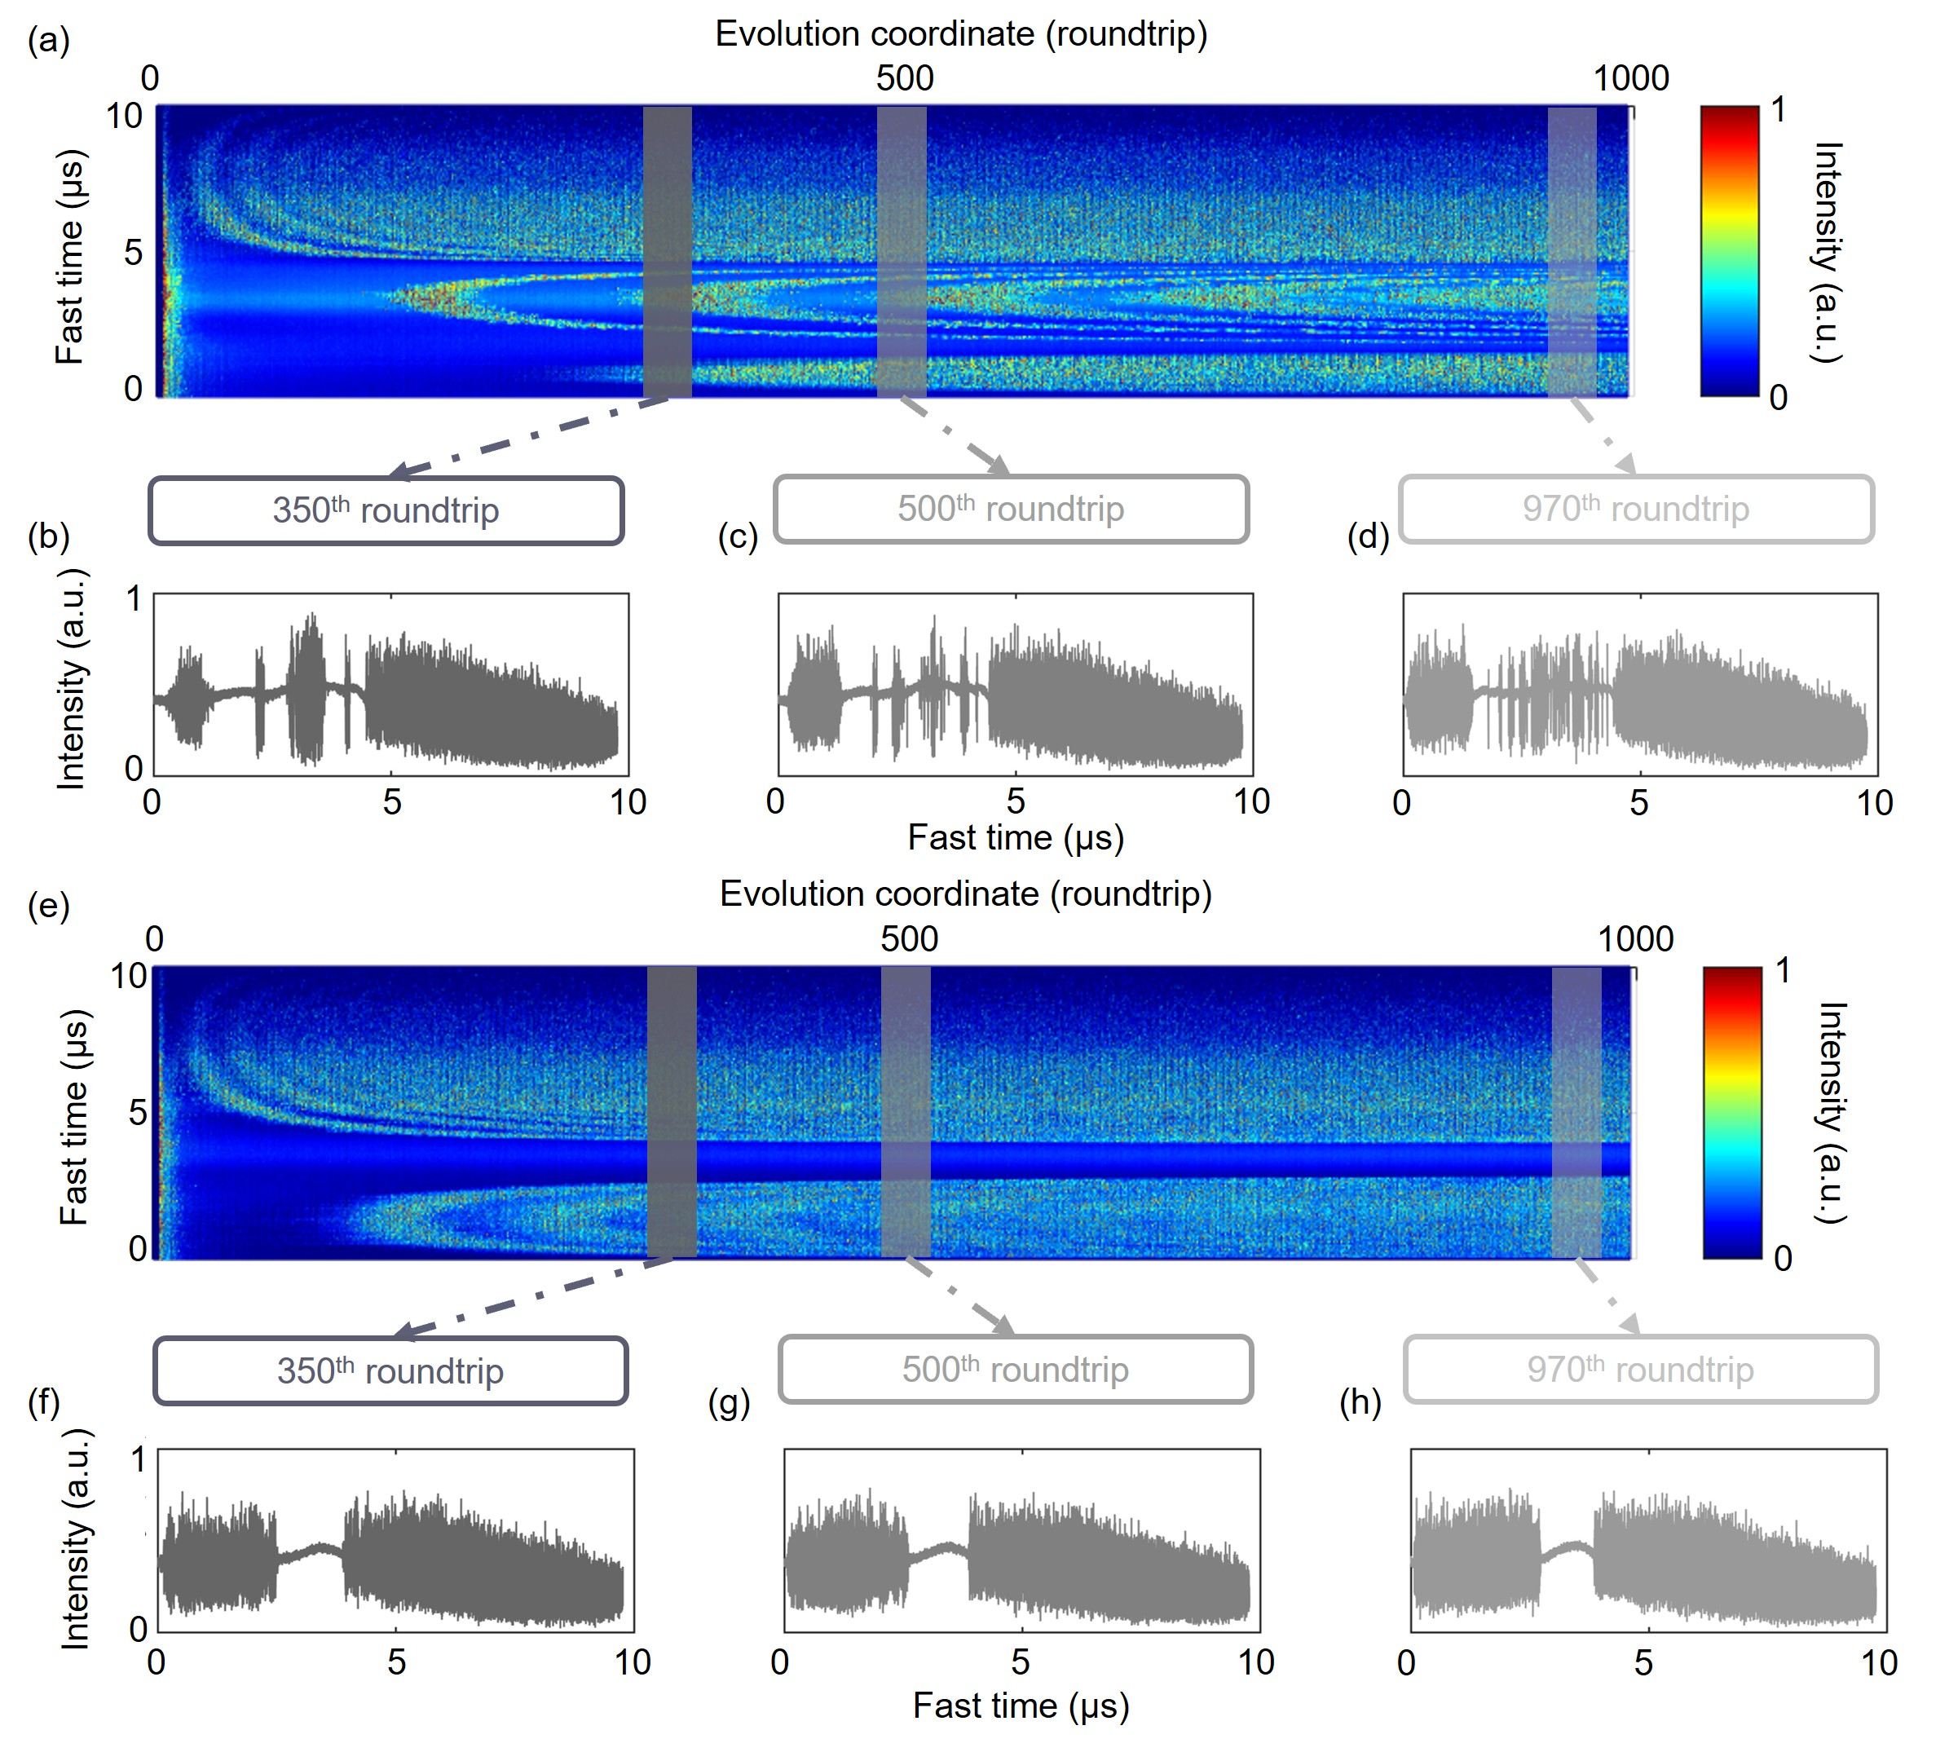
Fig. S5. Experimental buildup evolution of the laser signal during the backward sweep in the FDML laser with higher or lower Detuning. a, The buildup dynamics where the Detuning is increased by 194.9 ps so that the rebuilding event happens earlier. b-d, f-g, The temporal waveform of the laser signal at the 350th, 500th, and 970th roundtrip, respectively. e, The buildup dynamics where the Detuning is decreased by 5.5 ps so that the rebuilding event happens later than 1000 roundtrips.

S2.3 The evolution of the laser signal during the backward sweep without periodical SOA resetting
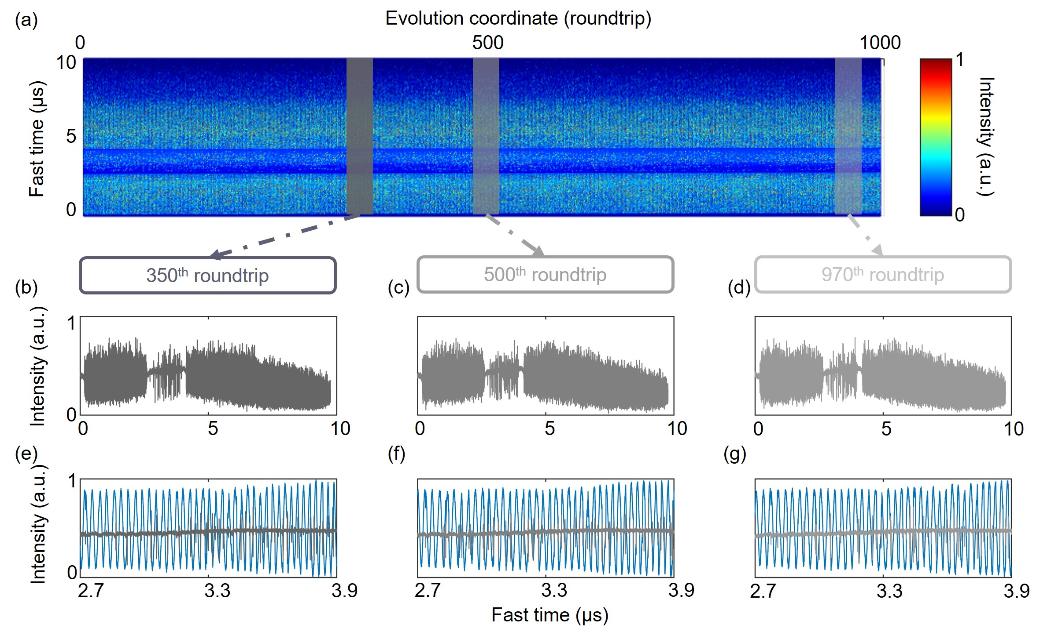
Fig. S6. Experimental intensity evolution of the laser signal during the backward sweep in the FDML laser without periodical SOA resetting. a, The intensity evolution during the backward sweep. b-d, The temporal waveform of the laser signal at the 350th, 500th, and 970th roundtrip, respectively. e-g, The zoomed-in temporal waveform (grey) and interference signal (blue) of the laser signal between 2.7 µs and 3.9 µs at the 350th, 500th, and 970th roundtrip, respectively.
The experimental evolution dynamics of a conventional FDML laser in the long-term unstable state, without SOA resetting, during the backward sweep under the same Detuning and λ_{c} as the main context, are shown in Figs. S6a-d. The intensity fluctuation between the two sweet spots is evenly distributed among the 1000 roundtrips. The interference signals, as shown in Figs. S6e-g, show clear discontinuous points. Compared with the temporal waveform without intensity fluctuation and continuous interference signal within the TCS-FDML region (Fig. 2b,e), those in a conventional FDML laser exhibit poorer quality.

Supplementary note S3: Derivation and analysis of the residual phase jitter
S3.1 Derivation of the RPJ
The residual phase jitter (RPJ) is dereivated by the average deduction method⁴ based on ten adjacent interference signals from a Mach-Zehnder interferometer (MZI). The N-th interference signal I^{N}(t) is written as:
$$\begin{aligned}I^{N}\left(t\right)=\cos\left[{2πf}_{b}^{N}\left(τ_{0},t\right)t+φ_{n}^{N}\left(t\right)-φ_{n}^{N}(t-τ_{0})\right],\#\left(S13\right)\end{aligned}$$
where φ_{n}(t) is the phase noise, time delay τ₀ is introduced by the optical path difference (OPD) in the MZI, and f_{b}(τ₀,t) is the instantaneous beat frequency of the interference signal as a function of τ₀ and time t. f_{b}(τ₀,t) is time-dependent due to the sinusoidal frequency sweeping of the FDML laser. The Hilbert transform is applied to retrieve the signal Q(t) with quadrature phase to I(t):
$$\begin{aligned}Q^{N}\left(t\right)=Hilbert\left[I^{N}\left(t\right)\right].\#\left(S14\right)\end{aligned}$$
Then, the unwrapped phase^{N}(t) of the N-th interference signal is demodulated by:
$$\begin{aligned}phase^{N}\left(t\right)={2πf}_{b}^{N}\left(τ_{0},t\right)t+φ_{n}^{N}\left(t\right)-φ_{n}^{N}\left(t-τ_{0}\right)=unwrap\left[\tan^{-1}\left(\frac{Q^{N}\left(t\right)}{I^{N}\left(t\right)}\right)\right],\#\left(S15\right)\end{aligned}$$
where the first term 2πf_{b}^{N}(τ₀,t)t is determinstic among the ten adjacent interference signals, while the second and third terms are the stochastic phase noises. Therefore, RPJ(t) is calculated as:
$$\begin{aligned}RPJ\left(t\right)=φ_{n}^{5}\left(t\right)-φ_{n}^{5}\left(t-τ_{0}\right)=phase^{5}\left(t\right)-\frac{\sum_{N=1}^{10}{phase^{N}\left(t\right)}}{10}.\#\left(S16\right)\end{aligned}$$
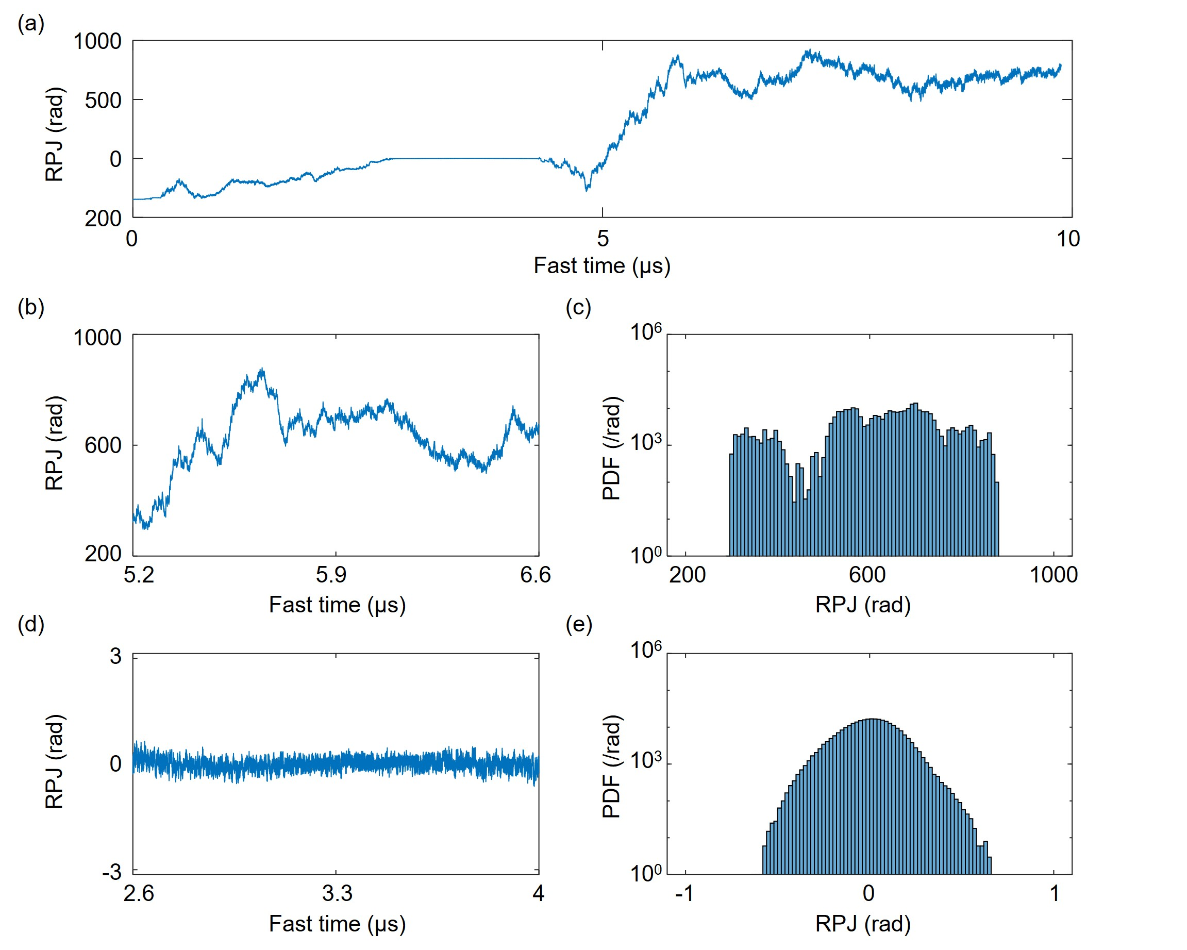
Fig. S7. Analysis of the RPJ. a, The full RPJ waveform demodulated from the interference signal with an optical path difference (OPD) of 7.2 m. b, The zoomed-in RPJ waveform out of the TCS-FDML region. c, The probability density function (PDF) of the RPJ out of the TCS-FDML region. d, The zoomed-in RPJ waveform within the TCS-FDML region. e, The probability density function of the RPJ within the TCS-FDML region.
Fig. S7a shows the RPJ in the backward sweep of the 400th roundtrip under the same setting of Detuning and λ_{c} as the main context, where the OPD is 7.2 m in optical fiber. The zoomed-in RPJ waveforms out of and within the TCS-FDML region are shown in Fig. S7b and Fig. S7d, where the fluctuation of the RPJ out of the TCS-FDML region is two orders of magnitude higher than that within the TCS-FDML region, which is further verified by the probability density functions (PDFs) as shown in Figs. S7c,e. The PDF of the RPJ within the TCS-FDML region is smoothly distributed between -1 and 1, while the distribution of the PDF of the RPJ out of the TCS-FDML region is scattered. The scattered PDF can be attributed to the discontinuous points in the interference signal out of the TCS-FDML region. Interference signals with discontinuous points do not satisfy the instantaneous single-frequency condition required by the Hilbert transform⁵. Therefore, after the unwarp algorithm and average deduction, a phase jump point will appear in the RPJ waveform, resulting in a scattered PDF.
S3.2 RPJ and the intrinsic linewidth in a conventional FDML laser
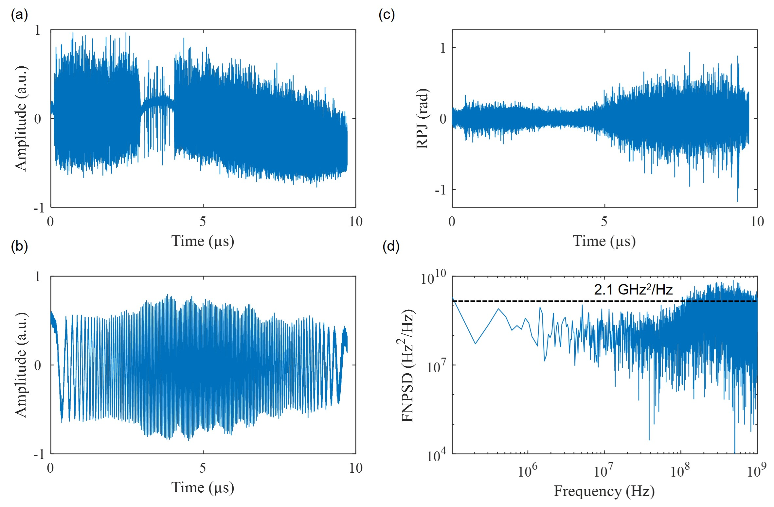
Fig. S8. RPJ and intrinsic linewidth in a conventional FDML laser. a, The temporal waveform. b, The interference signal with an OPD of 4 mm. c, The RPJ waveform. d, The instantaneous frequency noise power spectral density (FNPSD). The noise floor is around 2.1 GHz²/Hz.
Figure S8a shows the temporal waveform in a conventional FDML laser without periodic resetting. The OPD for the interference signal, as shown in Fig. S8b, is approximately 4 mm to avoid introducing discontinuous points. The RPJ waveform is shown in Fig. S8c. The distribution of the RPJ ranges from -1.25 to 1.25. Lastly, the instantaneous frequency noise power spectral density (FNPSD) is shown in Fig. S8d. The noise floor is around 2.1 GHz²/Hz, corresponding to an intrinsic linewidth of 13.2 GHz.
S3.3 RPJ of the inter-roundtrip interference
We measured the inter-roundtrip interference signal by matching the OPD in the MZI with the cavity length of the FDML laser to verify the inter-roundtrip phase coherence of the laser signal within the TCS-FDML region. Unfortunately, the kilometer-scale OPD introduces significant dispersion between the two branches of the MZI, resulting in an additional zero-frequency point on the interference signal, as shown in Figs. S9a-c, where the zero-frequency point is right-shifting as the OPD increases. To avoid the appearance of the zero-frequency point within the TCS-FDML region, on top of an OPD equal to the cavity length of the TCS-FDML laser, the OPD is further extended by 1 m in the optical fiber. The evolution of the RPJ demodulated from the interference signal is shown in Fig. S9d, where a rebuilding event occurs around the 700th roundtrip. Fig. S9e shows the RPJ out of the TCS-FDML region at the 400th roundtrip. It can be seen that, similar to Fig. S7b, the RPJ far exceeds 2π, and the PDF of the RPJ is also scattered. Fig. S9g shows the RPJ within the TCS-FDML region at the 400th roundtrip, where the PDF of the RPJ is between -1 and 1, indicating good coherence.
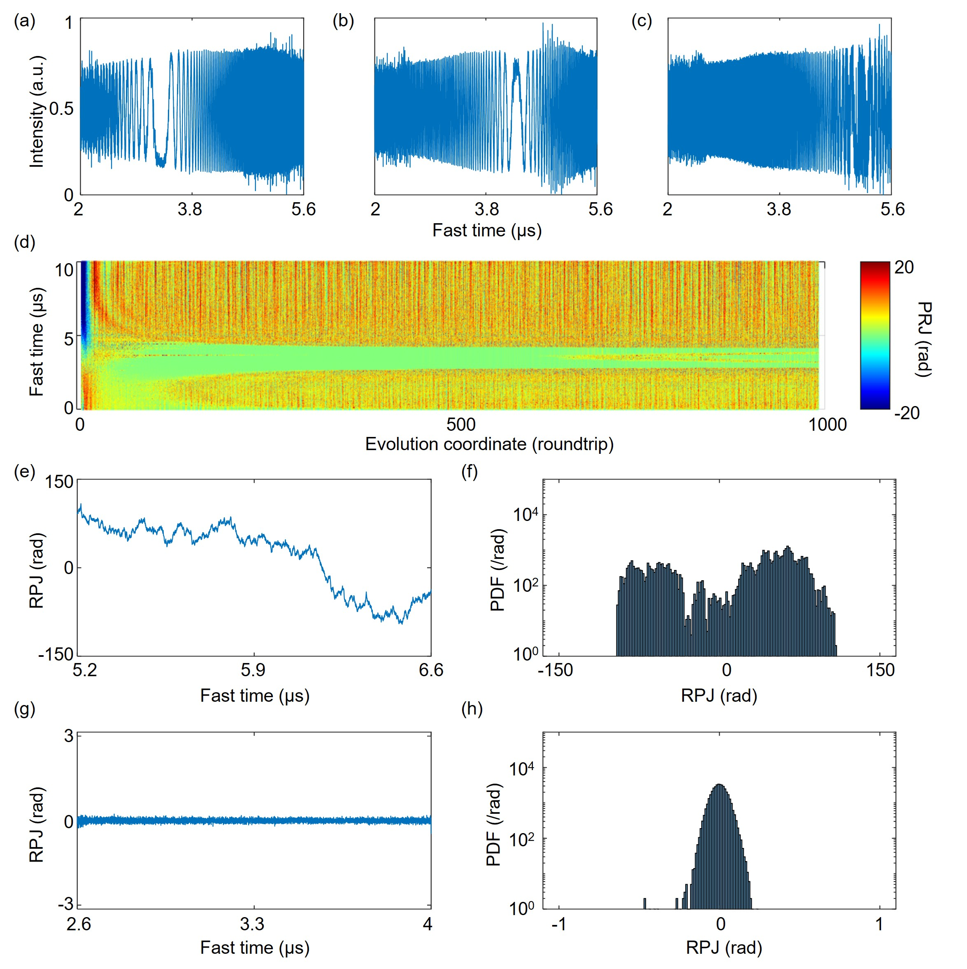
Fig. S9. Inter-roundtrip interference of the TCS-FDML laser. a-c, Three interference signals where differences of the OPDs are 10 mm. d, The evolution of the RPJ waveform demodulated from the inter-roundtrip interference signal with an additional OPD of 1 m. e, The zoomed-in RPJ waveform out of the TCS-FDML region at 400th roundtrip. f. The PDF of the RPJ out of the TCS-FDML region. g. The zoomed-in RPJ waveform within the TCS-FDML region at 400th roundtrip. h. The PDF of the RPJ within the TCS-FDML region.
Supplementary note S4: Feedback control
S4.1 Details of the feedback control
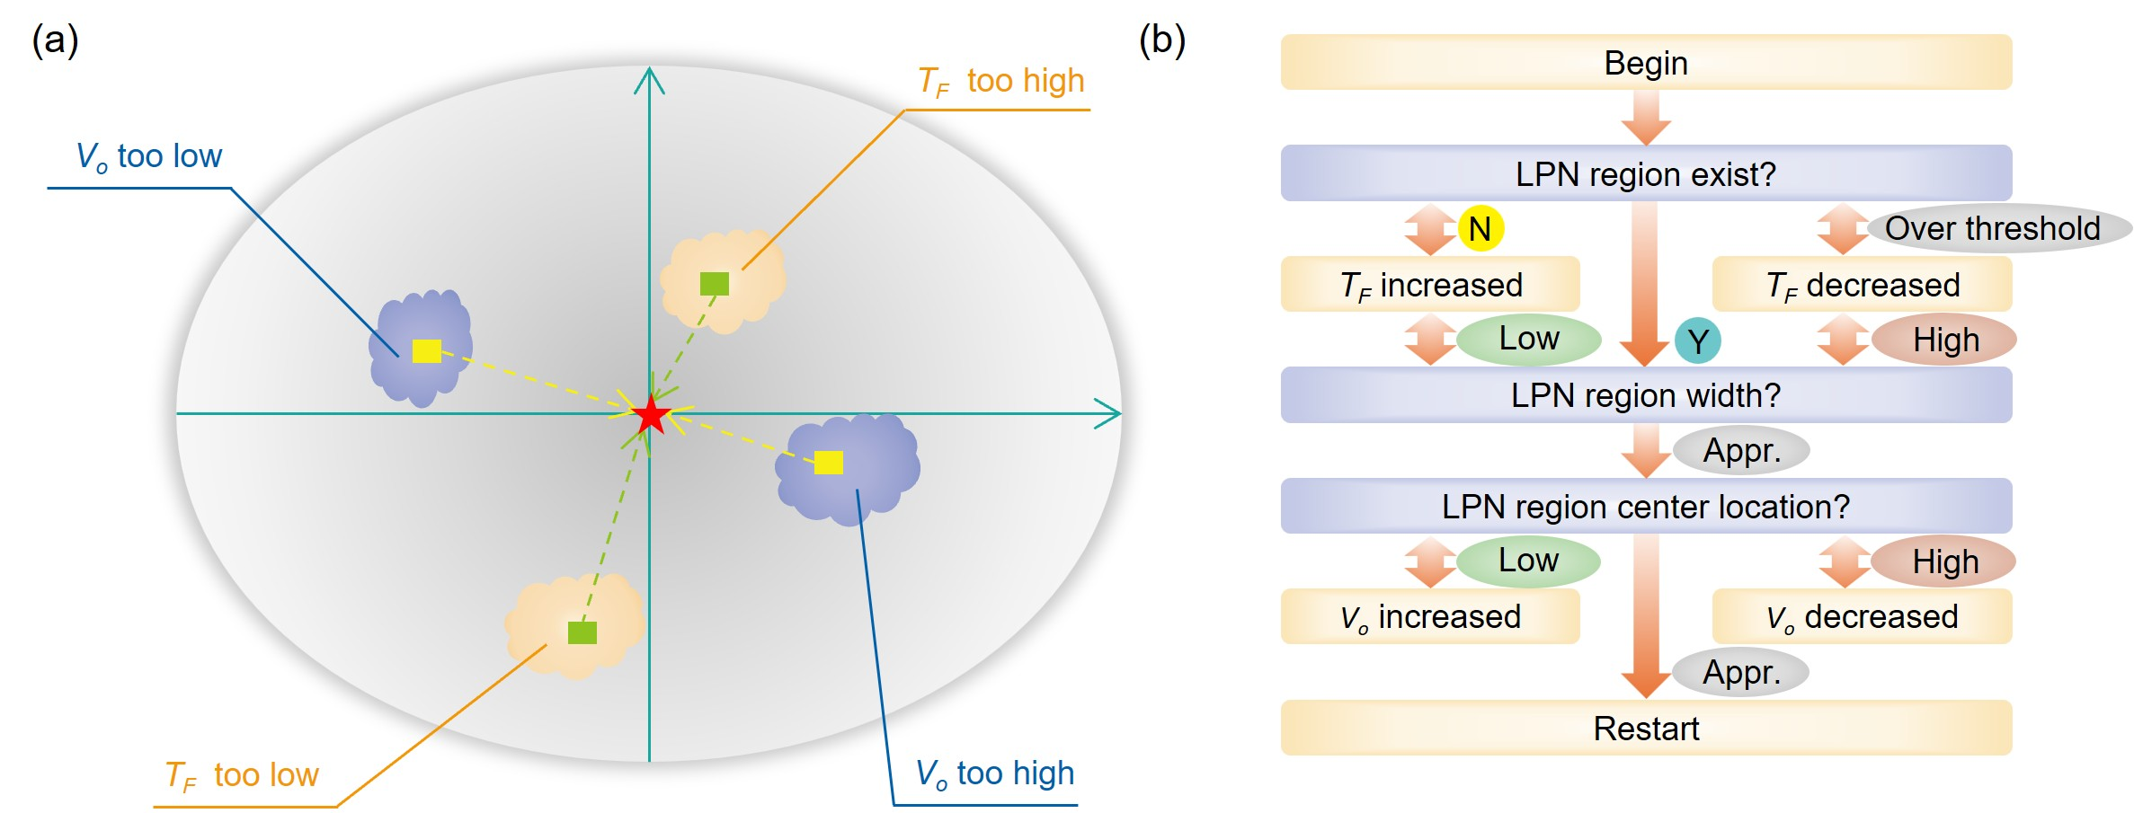
Fig. S10. Schematic of the feedback control. a, The parameter space of the FDML laser consisted of voltage offset (V_{o}) and tuning period (T_{F}). The red pentagram located at the center corresponds to the TCS-FDML point that enables the TCS operation of the FDML laser. The bluish violet and light orange islands represent the inappropriate setting of V_{o} and T_{F} relative to the TCS-FDML point. The cyan line and arrow represent the drifting of the parameter space due to thermal expansion and contraction. b, The flowchart of the feedback control algorithm. N, No. Y, Yes. Appr., Appropriate.
Figure S10a shows the space of the adjustable parameters in the FDML laser, including the voltage offset (V_{o}) and tuning period (T_{F}) of the FFP-TF. In the experiment, the cavity length of the FFP-TF and the FDML laser is drifting due to thermal expansion and contraction. The ideal settings of V_{o} and T_{F} drift accordingly so that the parameter space drifts, as indicated by the cyan lines and arrows in Fig. S10a. Moreover, each time the FDML laser is turned on, the V_{o} and T_{F} as set in the last time are likely to be either too high or too low for the current cavity length of the FDML laser and the FFP-TF, as shown by the light orange and bluish-violet islands in Fig. S10a.
Figure S10b shows the flowchart of the feedback control algorithm. To begin with, the feedback control algorithm assumes that the current V_{o} and T_{F} are far offset from the target values, and checks the existence of the low-phase noise (LPN) region in the RPJ waveform at the 400th roundtrip. If there is no LPN region, the algorithm will increase the T_{F} until an LPN region exists. The increase in T_{F} is under the assumption that T_{F} is lower than all the roundtrip times of all the wavelength buffered in the FDML laser cavity. However, chances are T_{F} is higher than all the roundtrip times of all the wavelengths, in which case increasing T_{F} will further deviate it from the target value. Therefore, a maximum T_{F} adjustment threshold of 1 Hz in T_{F} is set, after which the completed increase in T_{F} will be canceled and replaced by decreasing T_{F} until an LPN region exists. Then, according to the temporal distance between the LPN region, the feedback control algorithm will increase T_{F} if the width of the distance is lower than the target value (1.56 µs), or decrease T_{F} if the distance is higher. When the temporal distance between the LPN region reaches the target value (1.56 µs), the feedback control algorithm checks the center temporal location of the LPN region and increases V_{o} if the center location is lower than the target value (3.26 µs) or decreases V_{o} if the center location is higher. Lastly, when the center location of the LPN region reaches the target value (3.26 µs), the feedback control algorithm is restarted repeatedly to counter the continuous drifting of the parameter space induced by thermal expansion and contraction.
S4.2 Comparison of laser operation indicators
It is reported that in an FDML laser with stringent dispersion compensation and temperature control, the number of discontinuity points on the temporal waveform can serve as an internal reference for cavity length adjustment⁶. However, as shown in Figs. S11c, the relative intensity contrast at the temporal waveform of the 460th roundtrip between the discontinuity points and the background level is 1.01 dB. By comparison, as shown in Figs. S11f, the phase jump induced by the discontinuity points on the RPJ waveform shows a relative contrast of 16.21 dB over the background level. A high contrast in the internal reference is beneficial for the feedback control. Furthermore, as shown in Figs. S11a,b, the discontinuity points on the 440th and 450th temporal waveforms are hindered by the quantization noise of the high-speed oscilloscope with an 8-bit resolution. Thanks to the high contrast, the discontinuity points can be identified in the RPJ waveform (Figs. S11d,e) of the 440th and 450th roundtrip.
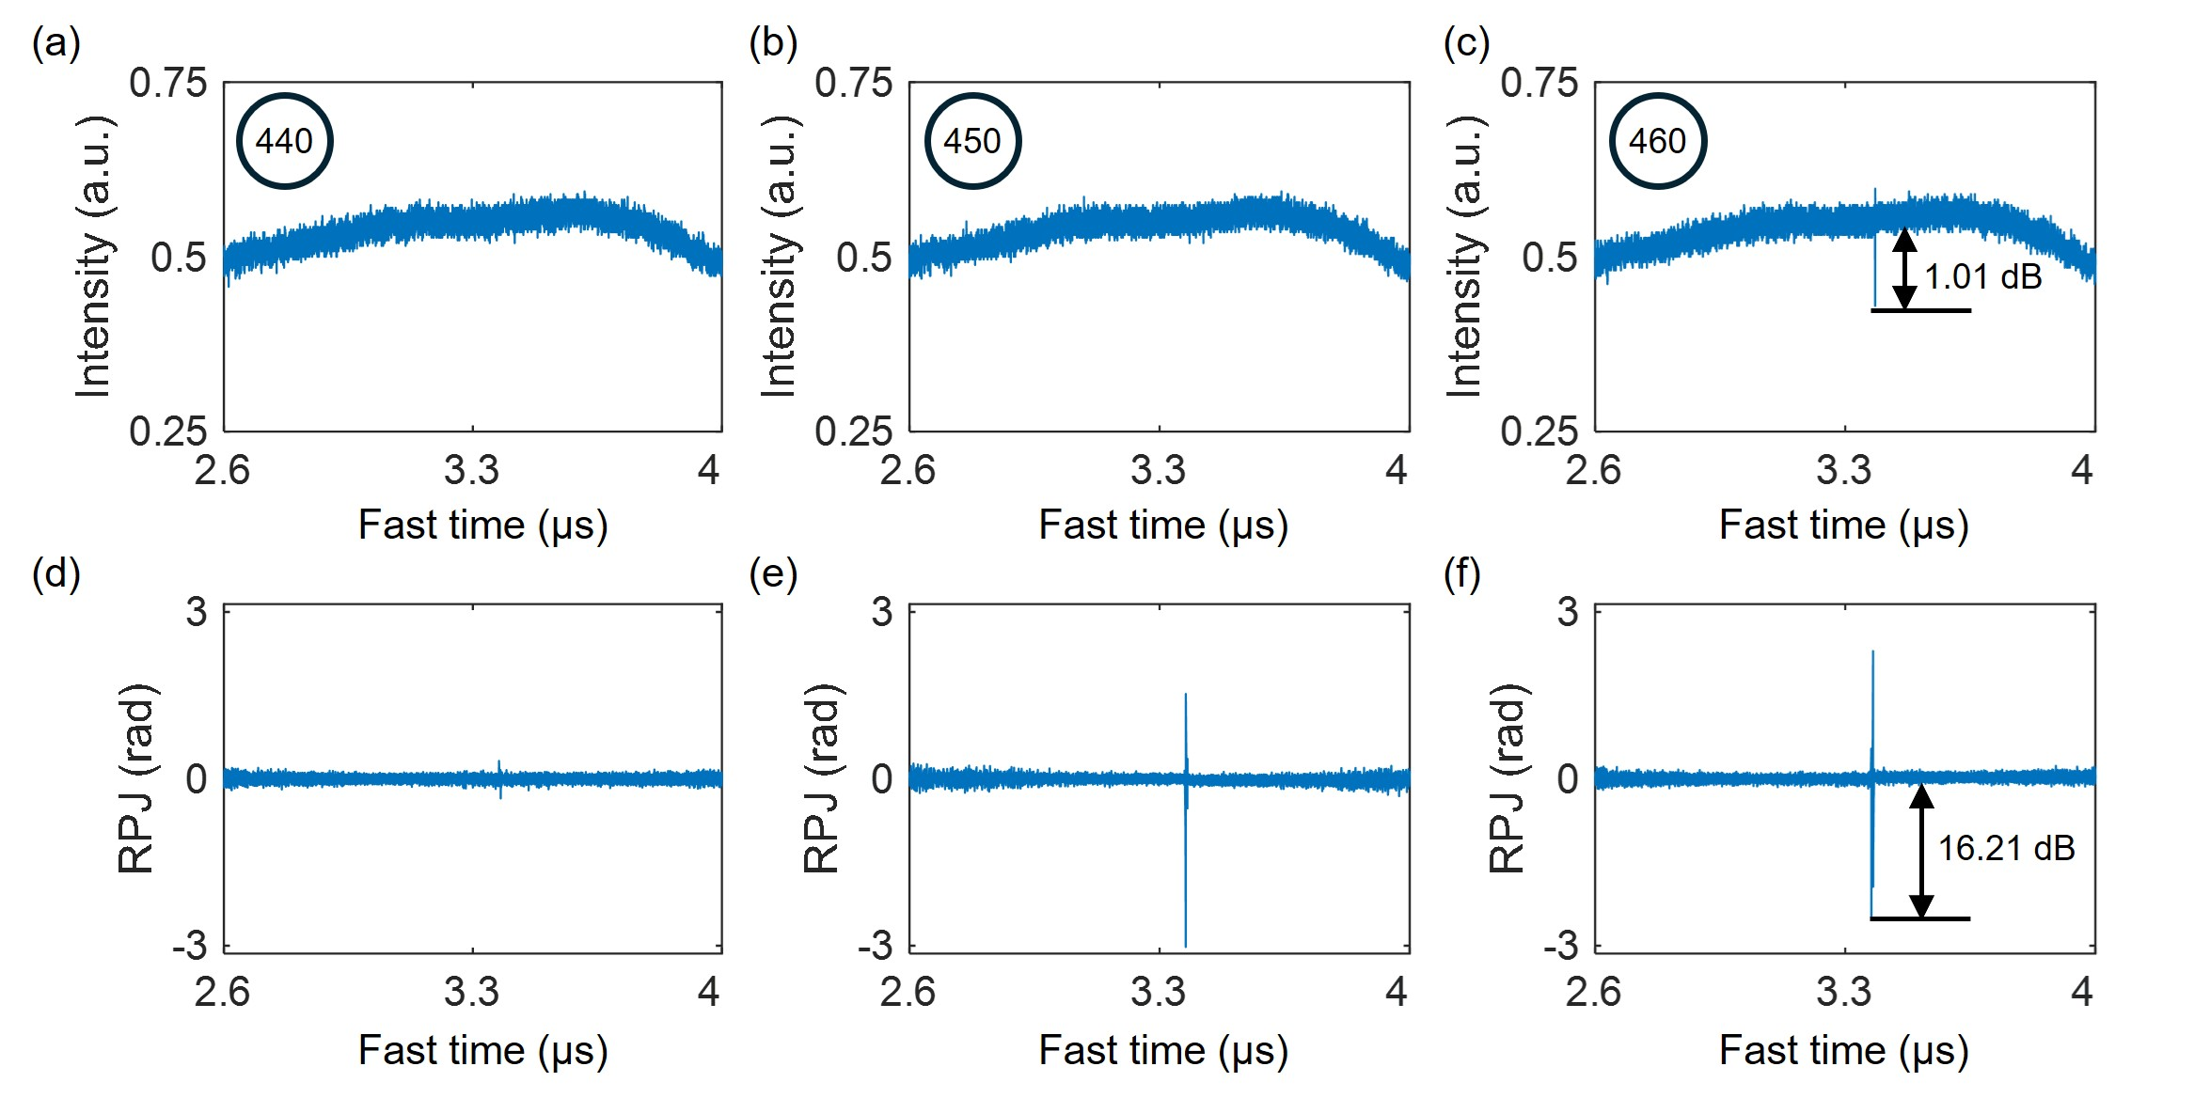
Fig. S11. Comparison of the temporal waveform and RPJ waveform as the laser operation indicator. a-c, The temporal waveform of the laser signal within the TCS-FDML region at the 440th, 450th, and 460th roundtrip, respectively. d-f, The RPJ waveform of the laser signal within the TCS-FDML region at the 440th, 450th, and 460th roundtrip, respectively.
S4.3 Process of the laser initialization
Figures S12 and S13 show the temporal waveform and the RPJ of the backward sweep at the 400th roundtrip under different Detunings to depict the process of the FDML laser initialized from a significant positive or negative detuning, respectively. As shown in Fig. S12, the positive Detuning allows the existence of a sweet spot, which corresponds to a low-phase-noise (LPN) region in the RPJ waveform and a low-intensity fluctuation region in the temporal waveform. The feedback control algorithm reduces the positive detuning in a stepwise manner, decreasing from 73 ps to 16 ps, according to the offset between the targeted value for the temporal distance between the two sweet spots and the actual value. This is adapted from the augmented random search algorithm^{7, 8}. Figure S13 shows the evolution of the temporal waveform and the RPJ waveform in the FDML laser initialized from a negative Detuning. As expected, the LPN region can’t be found in the RPJ waveform, and the low-intensity fluctuation region can’t be found in the temporal waveform. Therefore, the feedback control algorithm increases the Detuning. When the Detuning is positive, the LPN region can be found. The algorithm decreases the Detuning instead until the temporal distance between the two sweet spots reaches the targeted value.

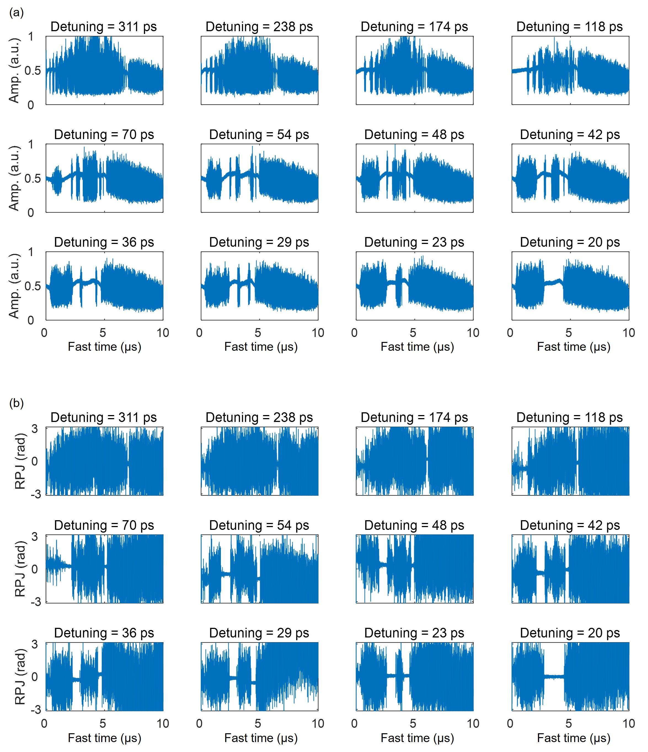
Fig. S12. Initialization of the FDML laser from a positive Detuning. a, The temporal waveform b, and RPJ under different Detuning adjusted by the feedback control.
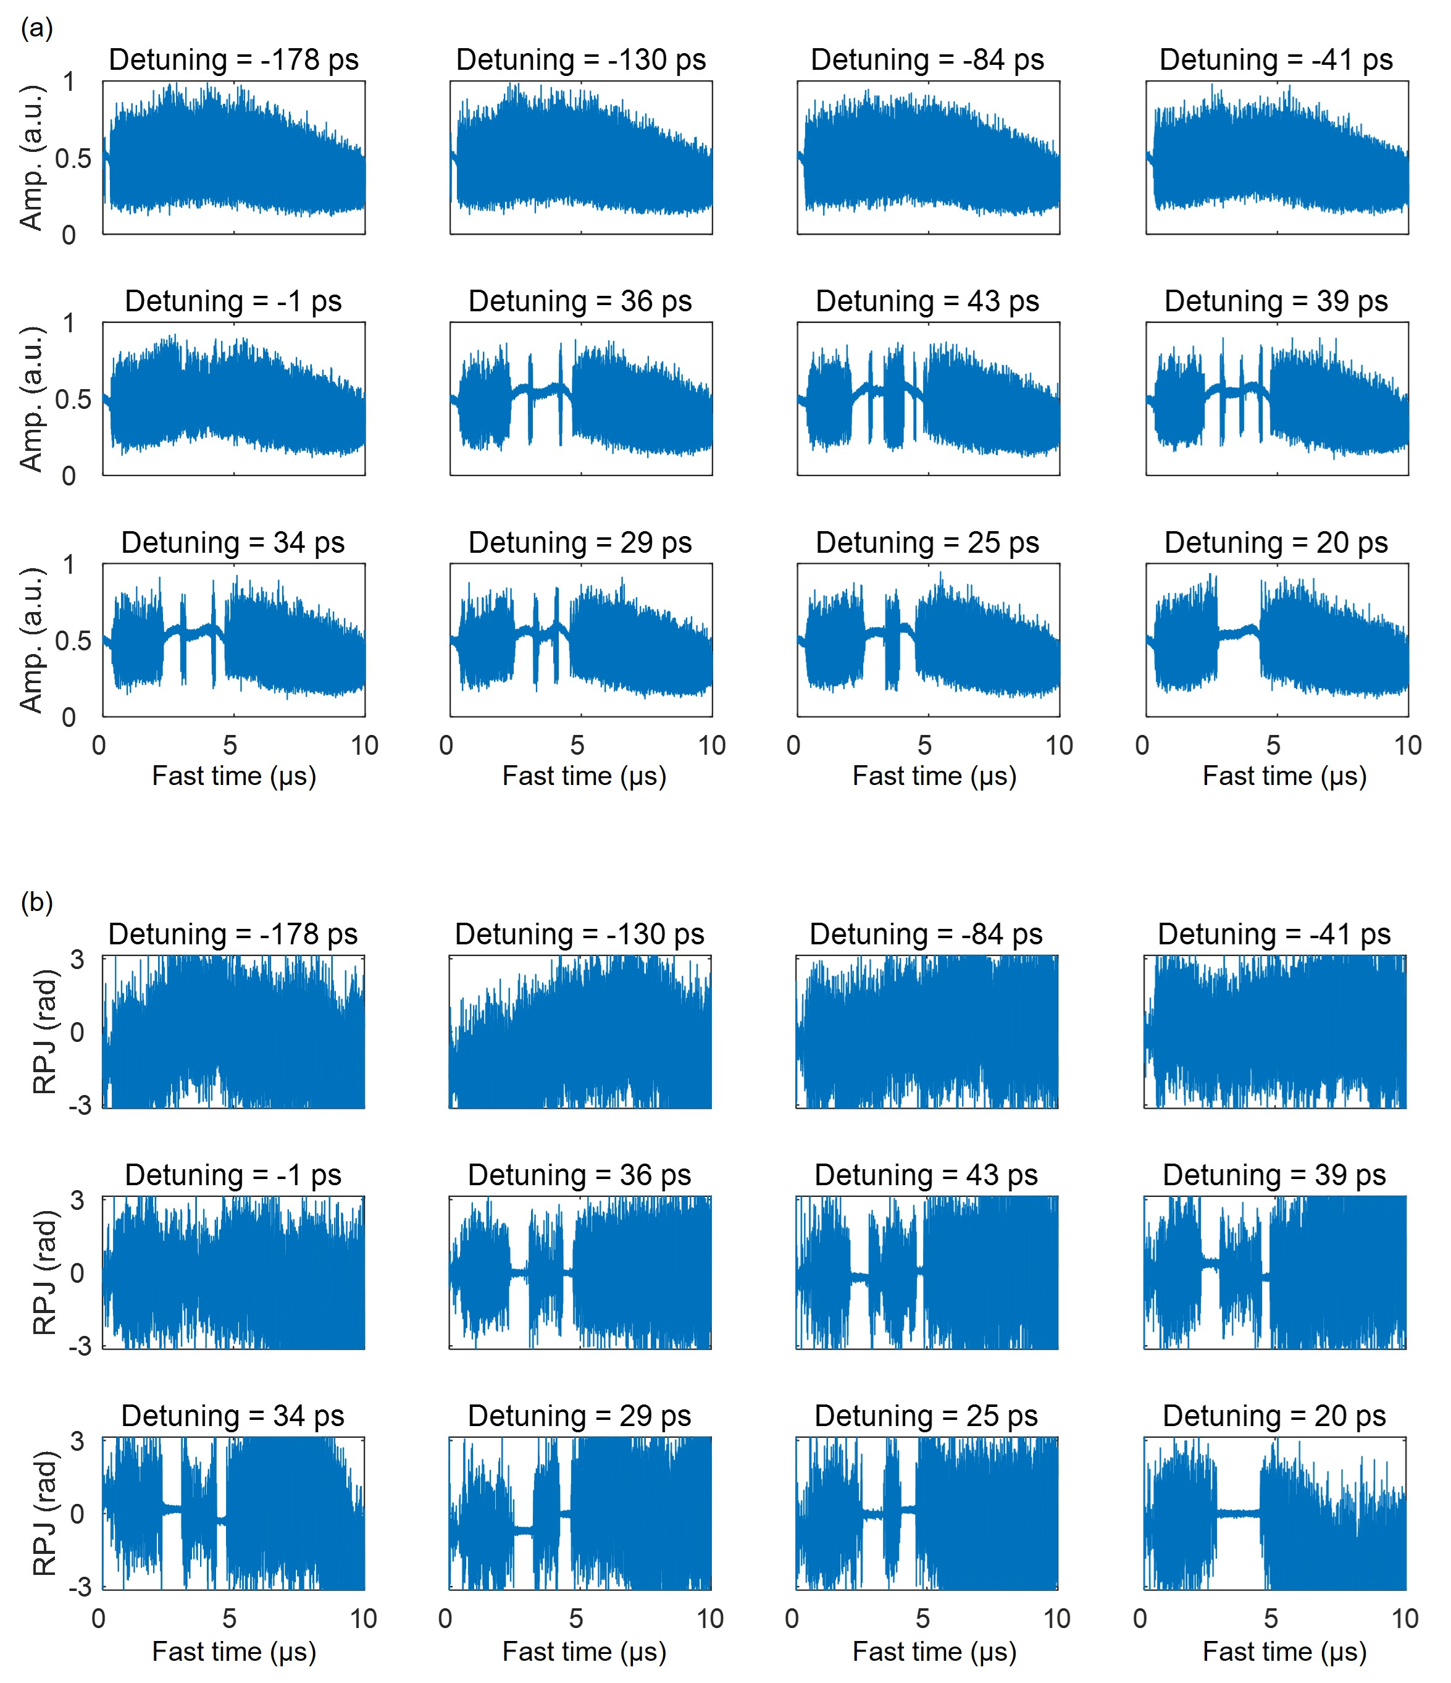
Fig. S13. Initialization of the FDML laser from a negative Detuning. a, The temporal waveform b, and RPJ under different Detuning adjusted by the feedback control.
S4.4 Analysis of long-term stability
Figure S14a illustrates the evolution of the relative error in the sweep range over 24 hours, which is over 0.2% and within 0.04% without and with the feedback control. Figure S14b shows the tuning period (T_{F}) and voltage offset (V_{o}) of the FFP-TF within 24 hours. T_{F} and V_{o} are in a similar trend. The experiment started at 6 p.m. The environmental temperature decreased for the first 14 hours. Therefore, the cavity length of the FDML laser contracted, which leads to a decreased RTT(λ), requires a decreased T_{F}, and requires a higher FFP-TF drive frequency to maintain the Detuning. Similarly, the cavity length of the FFP-TF contracted, which should be compensated for by an increased V_{o}.
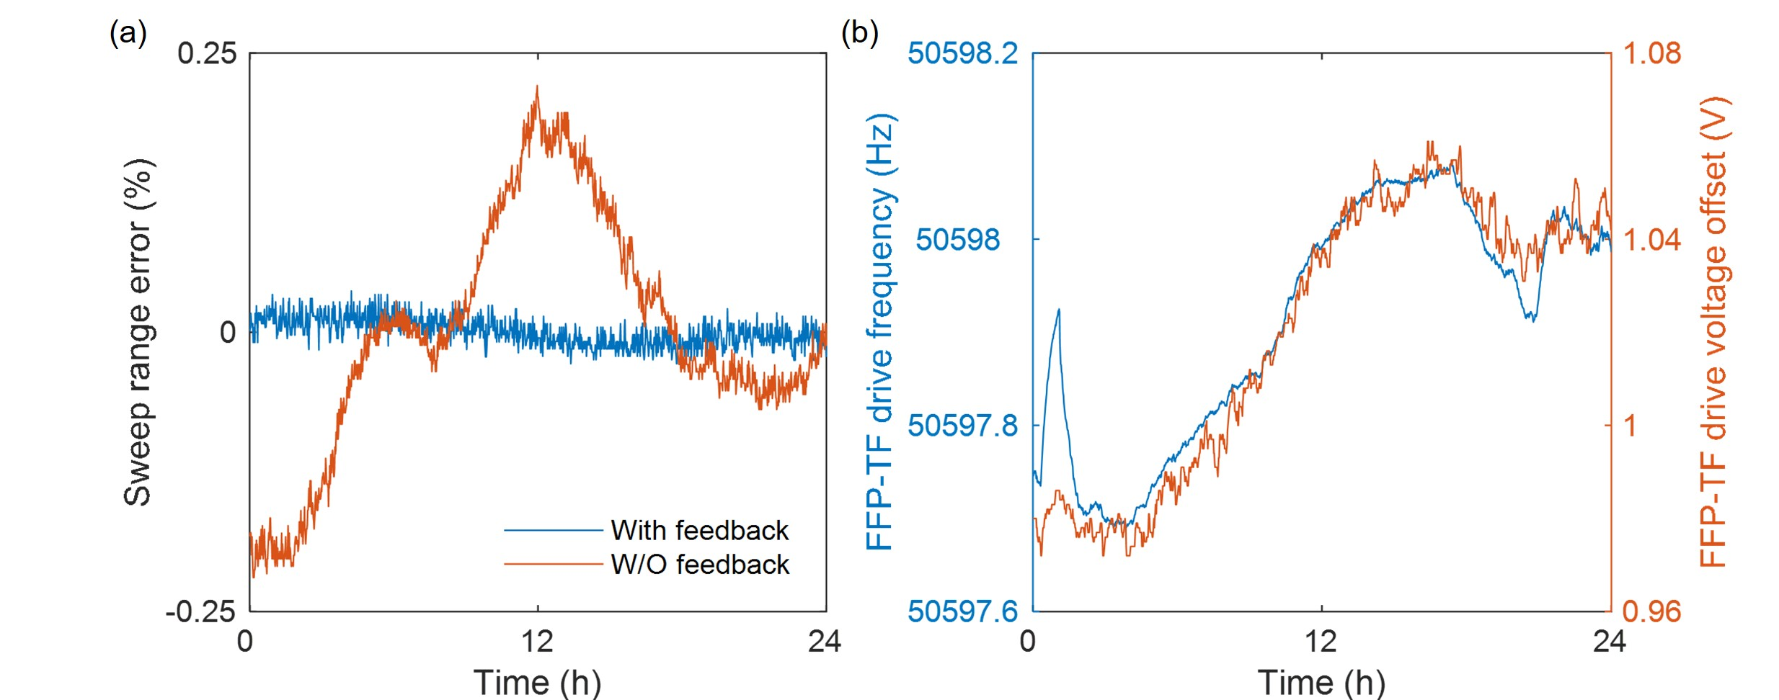
Fig. S14. Experimental results for the long-term stability in an FDML laser assisted by the feedback control. a, Comparison of the relative error in the optical frequency sweep range with and without (W/O) feedback. b, The evolution of FFP-TF drive frequency and voltage offset with time.

Supplementary note S5: Hybrid LiDAR
S5.1 Point spread functions of the RMCW-LiDAR and the FMCW-LiDAR
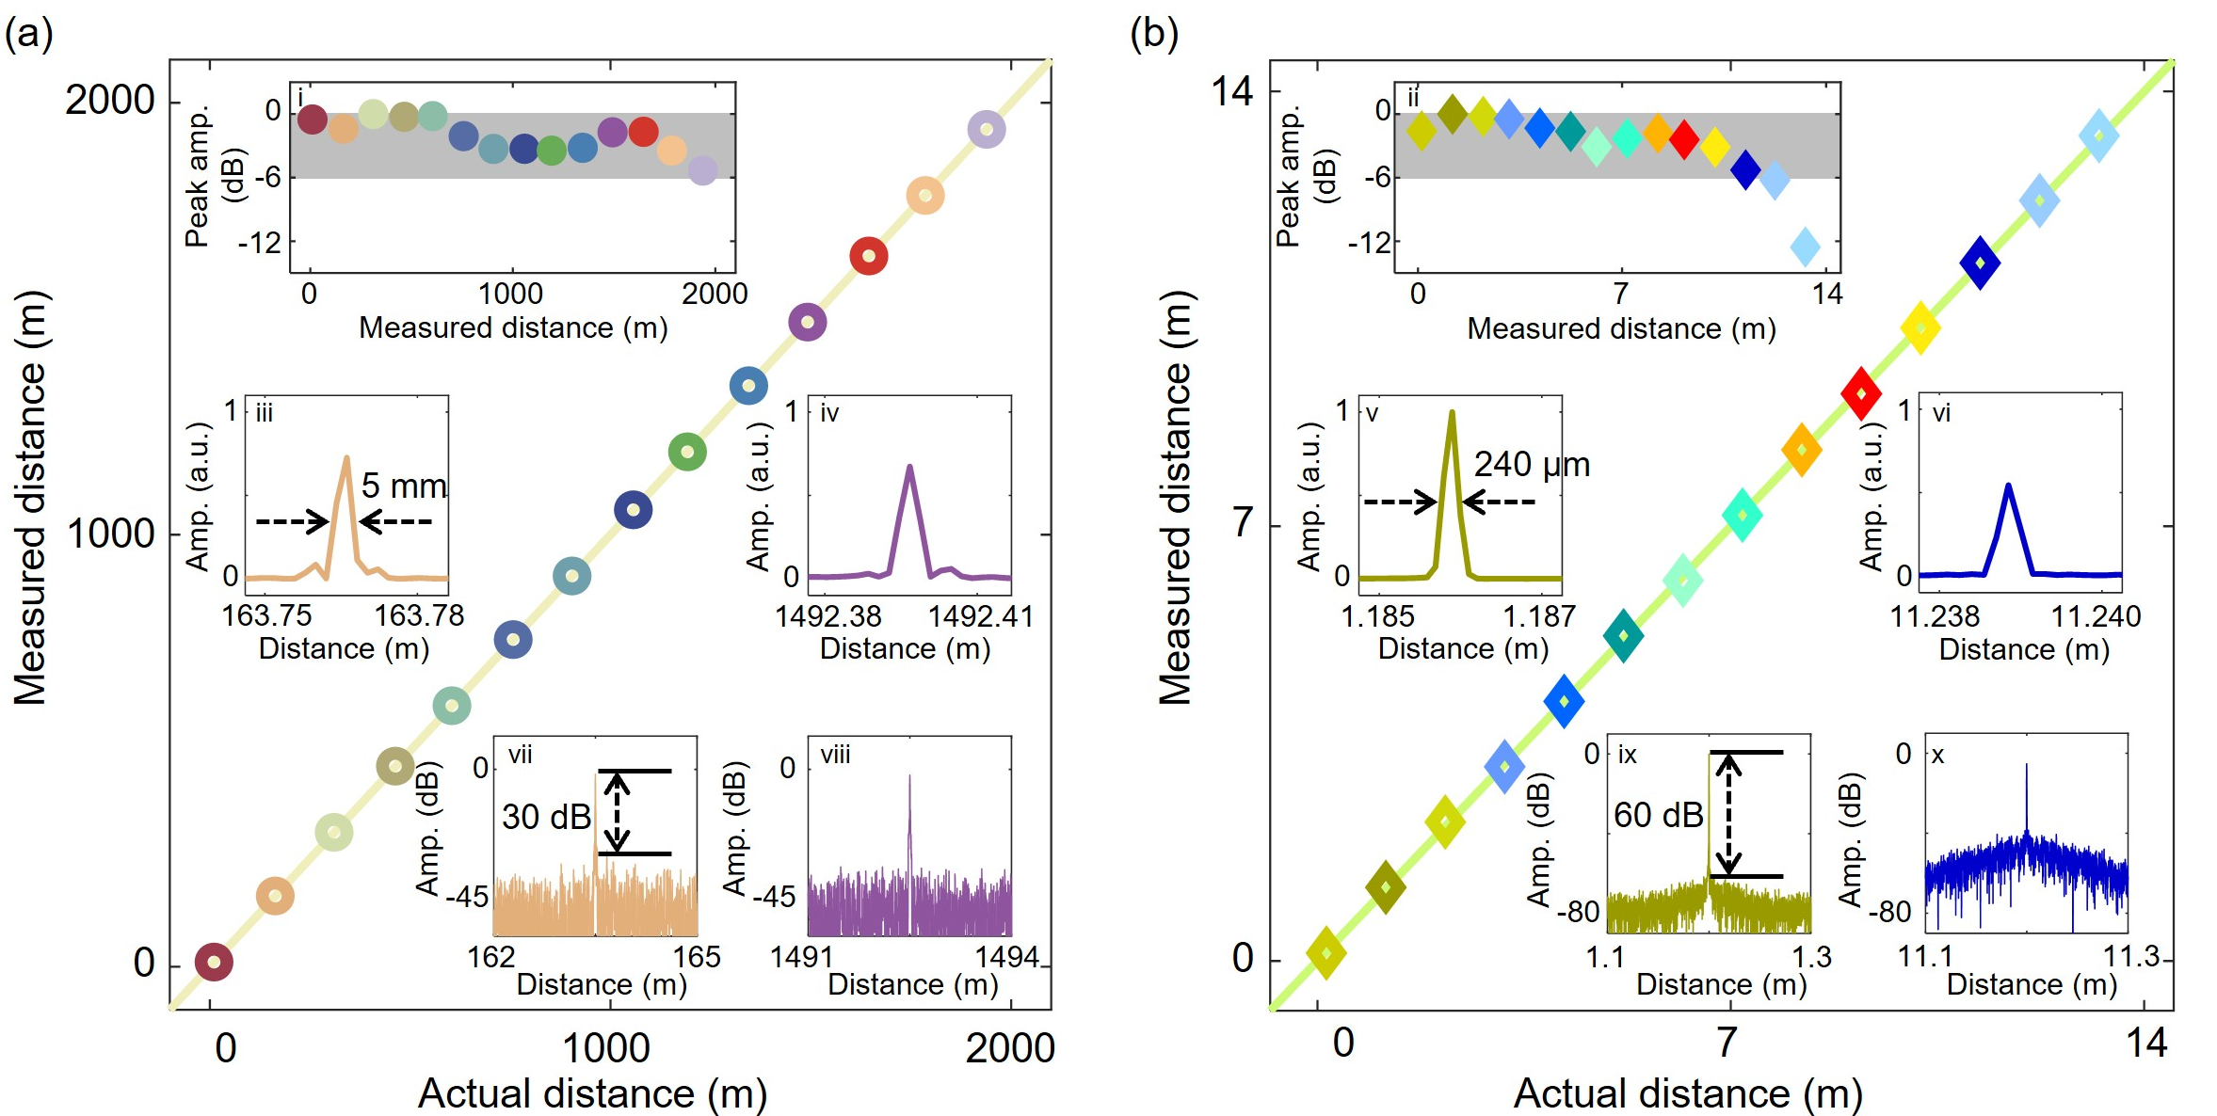
Fig. S15. Point spread functions (PSFs) of the RMCW-LiDAR and the FMCW-LiDAR. a, Measured distance versus actual distance in the RMCW-LiDAR. b, Measured distance versus actual distance in the FMCW-LiDAR. Insets: (i,ii) measured peak amplitude (amp.) at different distances. (iii-vi) measured PSFs in linear coordinates. (vii-x) measured PSFs in logarithmic coordinates.
Figures S15a,b show the measured distance from point spread functions (PSFs) of the RMCW-LiDAR and the FMCW-LiDAR, respectively. The actual distance and measured distance agree with each other in both LiDAR schemes. The peak amplitude of the PSFs in the RMCW-LiDAR is shown in the inset Fig. S15i, where the amplitude of the PSFs is fluctuating within a 6 dB range within 1400 meters. The amplitude is approximately negatively correlated with the distance, which may be attributed to the increasing amount of dispersion induced by the long fiber as the actual distance increases⁹. The peak amplitude of the PSFs in the FMCW-LiDAR is shown in the inset Fig. S15ii. The 6 dB roll-off range of the FMCW-LiDAR is 11.2 m, which is limited by the detection bandwidth (70 GHz) in our experimental setup. Inset Figures S15iii-iv and S15vii-viii show the resolution and sensitivity of the RMCW-LiDAR, which are 5 mm and 30 dB. By comparison, Inset Figures S15iii-iv and S15vii-viii show the resolution and sensitivity of the FMCW-LiDAR, which are 240 μm and 60 dB.

Supplementary note S6: Self-injection-locked DFB laser with periodic resetting
S6.1 Principle
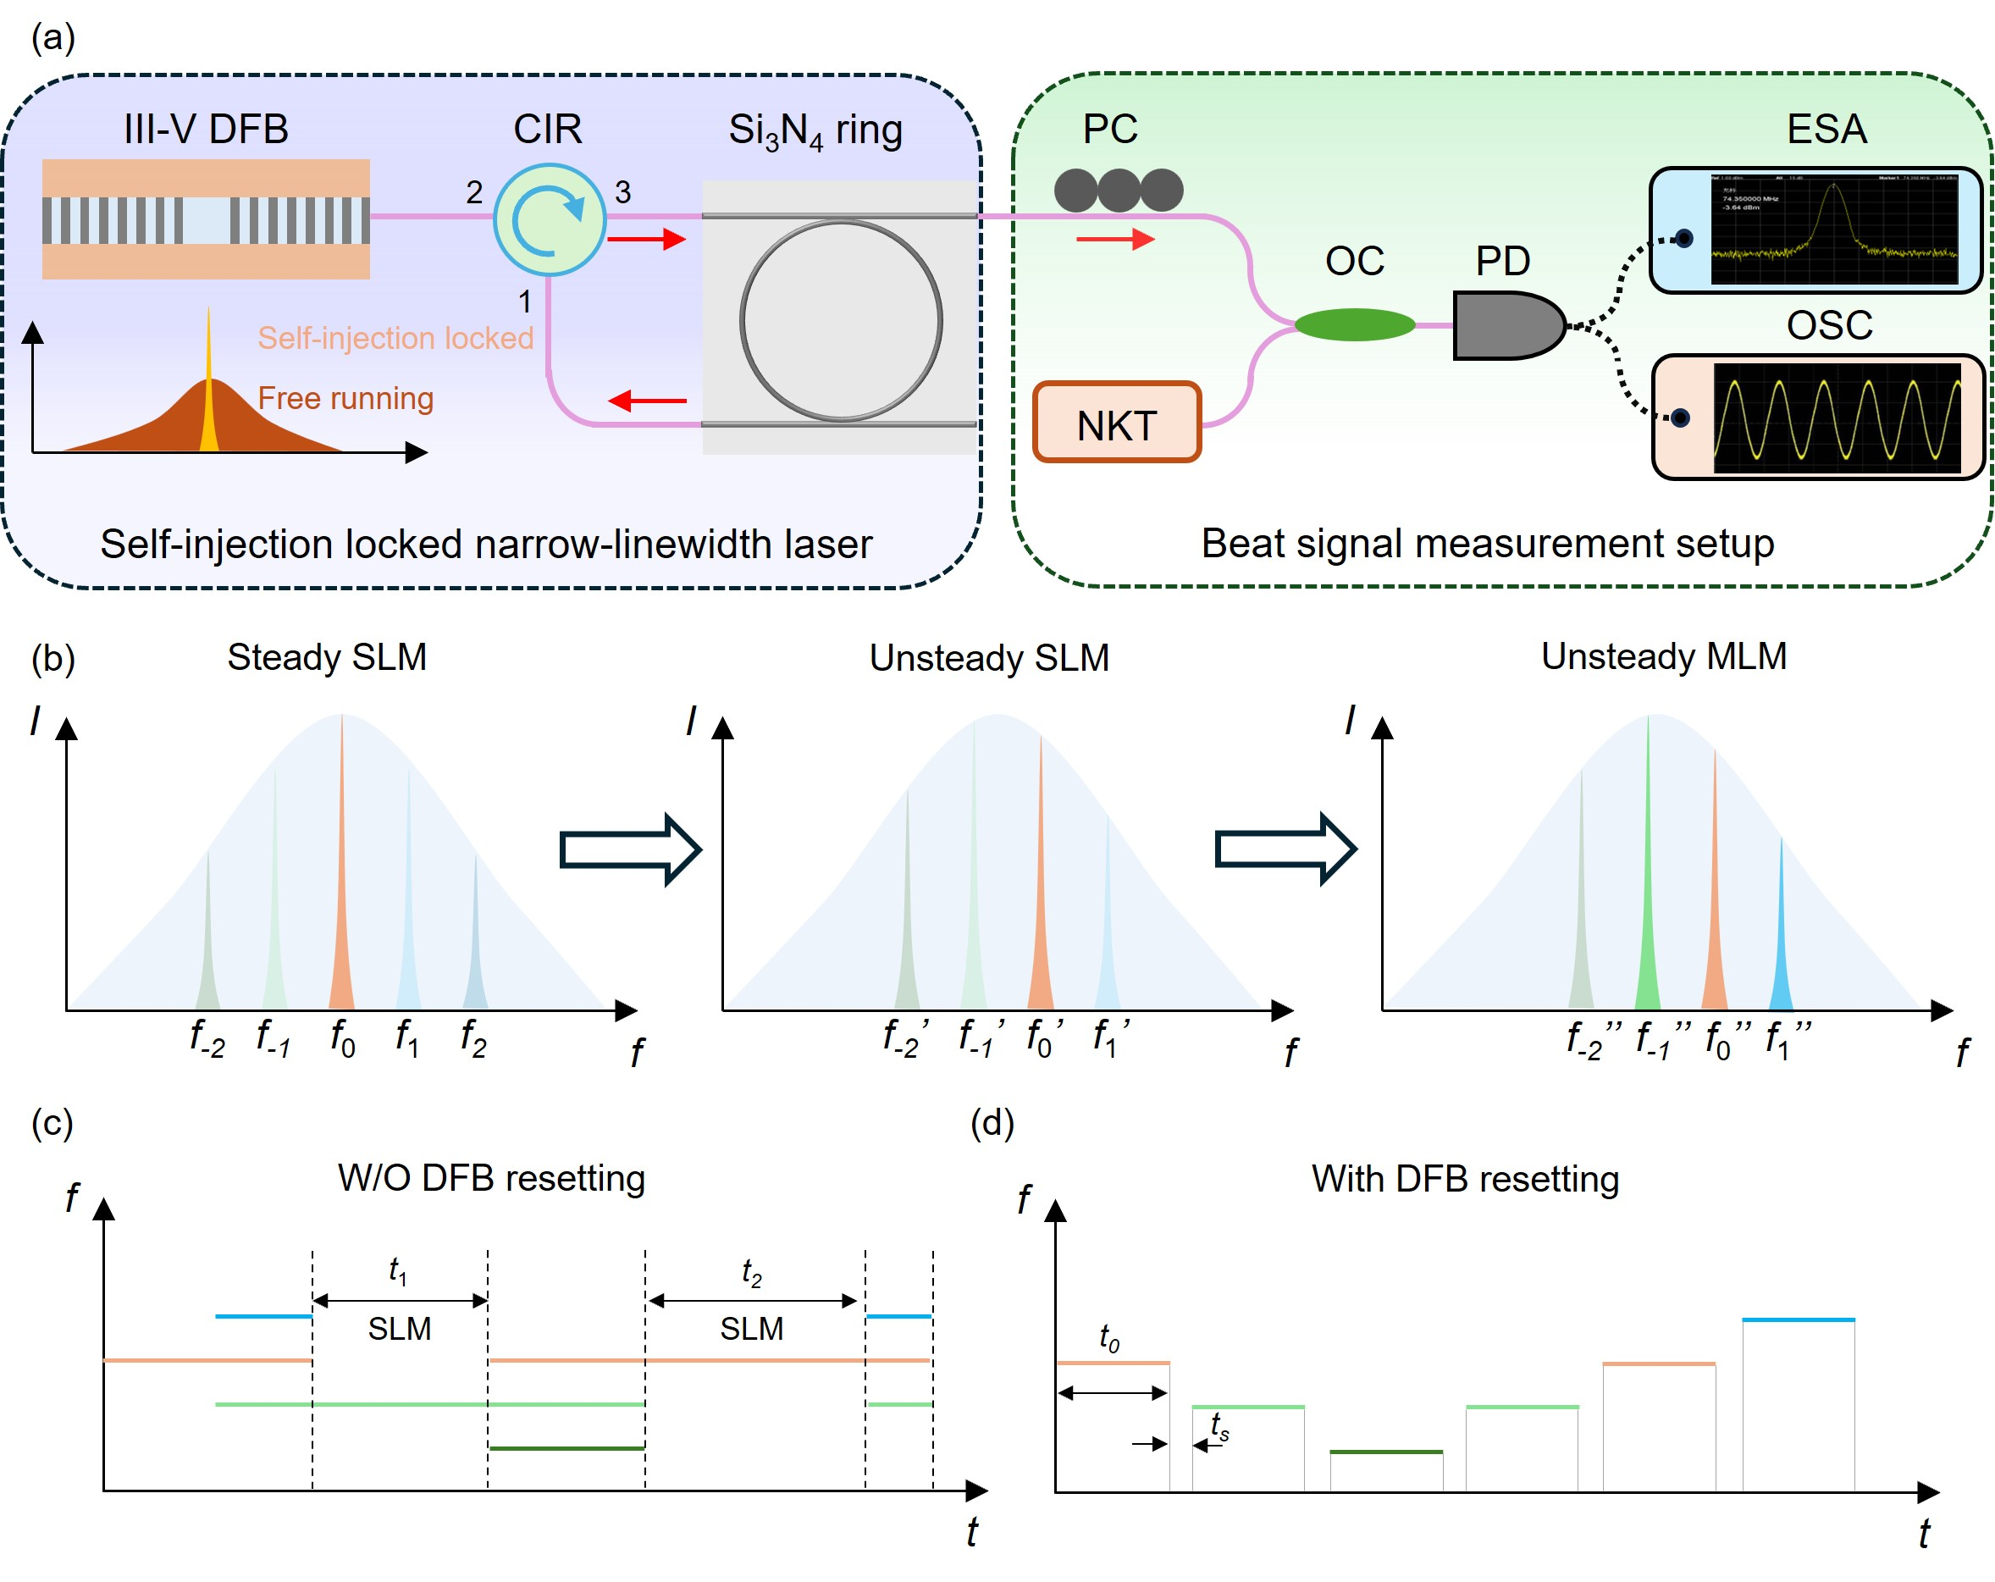
Fig. S16. Schematic of the narrow-linewidth DFB laser based on microcavity self-injection locking (SIL) and the principle of mode-hopping reduction. a, Schematic of the laser and configuration of the measurement system. CIR: circulator; PC: polarization controller; OC: optical coupler; PD: photodetector; ESA: electrical spectrum analyzer; OSC: oscilloscope. b, Evolution of the mode distribution in the feedback optical path from steady single longitudinal mode (SLM) operation, to unsteady SLM operation, and to multi-longitudinal mode (MLM) operation. c-d, Evolution of the laser frequency over time c, with or d, without (W/O) DFB resetting.
Fig. S16a shows the schematic diagram of a self-injection-locked (SIL) distributed feedback (DFB) laser based on microcavity self-injection locking. The DFB laser output is connected to the feedback optical path with a 3-port circulator (CIR). Port 3 of the CIR is connected to the input port of the high-Q microring resonator, port 1 of the CIR is connected to the drop port of the resonator, and port 2 of the CIR is connected to the DFB laser. The SIL-DFB laser output is coupled with a highly stable narrow-linewidth laser (NKT, Koheras BASIK) by an optical coupler (OC) to generate the beat signal. The beat signal is detected, analyzed, and recorded by a photodetector (PD, Max-ray Photonics, PD03), an electrical spectrum analyzer (ESA, Keysight, N9020A), and an oscilloscope (OSC, Tektronix, DPO77002SX), respectively. Fig. S16b illustrates the time-evolved laser mode distribution to explain the mechanism of mode-hopping. The free spectral range (FSR) of the laser modes is related to the length of the feedback optical path between the microring resonater and the CIR, which is 33 MHz in the experiment. Initially, one of the modes with an optical frequency f₀ locates in the maximum gain region, gains an advantage over other modes, and achieves a single longitudinal mode (SLM) laser operation. However, if the length of the feedback optical path is subject to thermal expansion and contraction, the spectral positions of all the laser modes drift. Due to the established gain advantage, the current lasing mode f₀' can tolerate a small amount of drifting, even though the f₋₁' mode has fallen into the maximum gain region, which is called the unstable SLM operation in Fig. S16b. If the drifting continues, the f₋₁' mode begins lasing while the original f₀ mode is still operating, where a multi-longitudinal mode (MLM) operation occurs. Eventually, the f₋₁' mode transits into a stable SLM operation. It is foreseeable that as the spectral positions of laser modes further drift, subsequent modes (f₋₂'' etc.) gain advantage. The laser operation state of the SIL-DFB laser transits between the SLM and the MLM, repeatedly triggers mode-hopping, and seriously affects its usability, as described in Fig. S16c.
To reduce the occurrence of mode hopping, we propose applying the concept of the TCS. In the experiment, the SIL-DFB laser is periodically reset. The principle and the time-evolved optical frequency are shown in Fig. S16d. It is expected that each time the SIL-DFB laser is initialized, one of the laser modes will gain advantage and start lasing. If the resetting period (t₀+t_{s} in Fig. S16d) is lower than the time cost (t₁ or t₂ in Fig. S16c) for the thermal expansion and contraction to cause enough spectral drifting for mode-hopping, the occurrence of the mode-hopping event can be reduced.
The static linewidth of the SIL-DFB laser is measured with the long-delay self-heterodyne interference method. Figure S17a shows that the linewidth of the free-running DFB laser is much higher than the linewidth of the SIL-DFB laser. As shown in Fig. S17b, a signal-to-noise ratio (SNR) of approximately 47 dB is measured in the range of 10 MHz, with a fitting result for the linewidth of around 1.25 kHz.
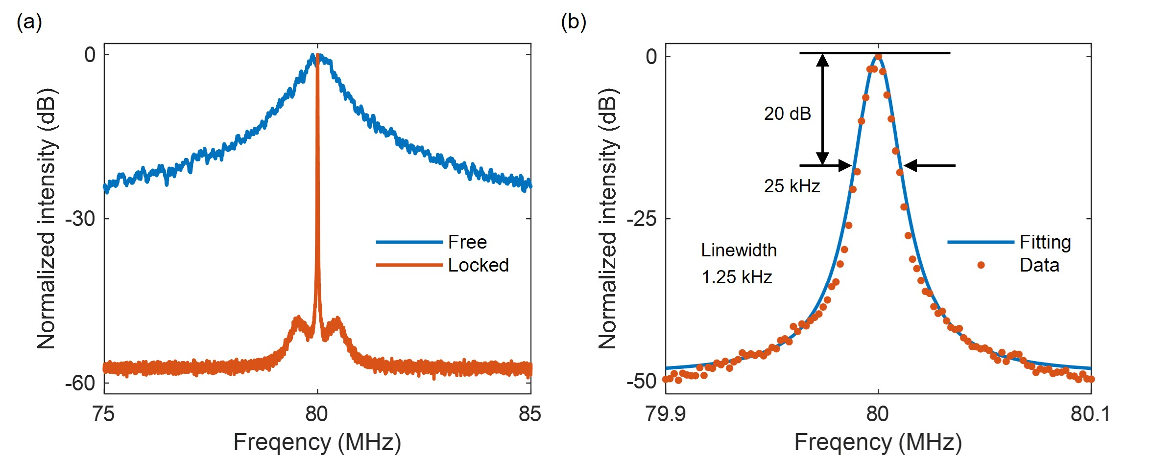
Fig. S17. Measurement of the linewidth of the DFB laser. a, Comparison of linewidth between a free-running DFB laser and a SIL-DFB laser. b, Lorentzian fitting curve of the linewidth for the SIL-DFB laser.
S6.2 Turn-on dynamics
The turn-on dynamics of the SIL-DFB laser are explored to determine the time cost for laser building and provide guidance for resetting the DFB. As shown by the envelope of the beat signal in Fig. S18a, the laser undergoes the relaxation oscillation of 0.15ms before transitioning to a stable power operation. The temporal beat signal is converted to the frequency domain using the short-time Fourier transform with a 32-μs time window to obtain the laser spectral evolution, as shown in Fig. S18b. It can be seen that the frequency distribution is relatively dispersed during the relaxation oscillation process, indicating that the laser output is dominated by spontaneous radiation. Figure S18c further statistically shows the time-evolved instantaneous center frequency of the beat signal over 1 ms. It can be seen that the frequency gradually decreases and converges at 1 ms¹⁰, which is the minimum resetting period to ensure that the SIL-DFB laser is fully built up. Figure S18d shows the time-evolved instantaneous center frequency over 75 ms. It can be observed that after the convergence, the instantaneous center frequency fluctuates, which is as expected for a laser without stringent environment control or optical frequency being locked to a reference.
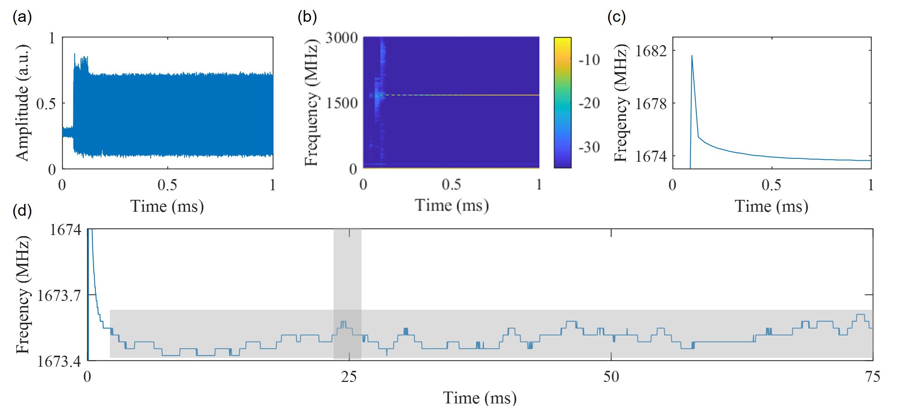
Fig. S18. Turn-on dynamics of the SIL-DFB laser. a, The beat signal in the time domain. b, The short-time Fourier transformed beat signal. c,d, The instantaneous center frequency of the laser over c, 1 ms and d, 75 ms.

S6.3 Mode-hopping suppression
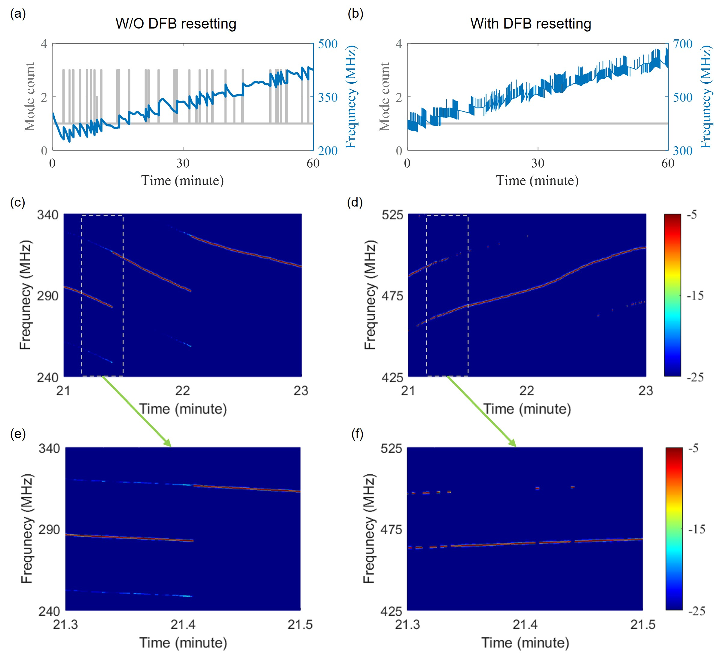
Fig. S19. Mode-hopping suppression of the SIL-DFB laser. a,b, Mode count and instantaneous center frequency of the laser a, without (W/O) and b, with periodic resetting. c,d, Time-evolved spectra c, without and d, with periodic resetting between 21 minutes and 23 minutes. e,f, Time-evolved spectra e, without and f, with periodic resetting between 21.3 minutes and 21.5 minutes.
The time-evolved spectral characteristics of the SIL-DFB laser, with and without periodic resetting, are monitored within an hour. As shown by the blue lines in Fig. S19a and Fig. S19b, the frequency of the SIL-DFB laser increases slowly by approximately 300 MHz, regardless of whether it is periodically reset, due to the drift in the length of the feedback optical path. However, without resetting the SIL-DFB laser, as shown in Fig. S19a, the mode counts jump to two or three, indicating that the operation state of the SIL-DFB laser will jump back and forth between SLM and MLM, and mode-hopping events occur. In Fig. S19b, the DFB laser is periodically reset by a square wave signal with a frequency of 10 Hz and a duty cycle of 99.99 percent. The acquisition of the beat signal is triggered by the square wave signal with a 25-ms delay. The temporal position of the recorded beat signal is shown in the grey block from Fig. S18d. The stepped blue curve in Fig. S19b indicates that the frequency of the SIL-DFB laser could jump between two adjacent resetting periods. In other words, the operating mode between two adjacent resetting periods may differ. However, the mode count of the SIL-DFB laser remains one within an hour, indicating that the occurrence of mode hopping within one resetting period is reduced.
Figures S19c and S19d show the detailed time-evolved spectra between 21 minutes and 23 minutes. Figures S19e and S19f show the spectra between 21.3 minutes and 21.5 minutes. It can be observed that without periodically resetting the SIL-DFB laser, when thermal expansion and contraction cause a spectral drift of over 33 MHz, the SLM operation transits to the MLM operation, and a mode-hopping event occurs. The MLM operation can not be observed with DFB resetting, as shown in Fig. S19f. The discontinuity in frequency occurs because the lasing mode of each resetting period may differ from the previous one. Visualization 2 and Visualization 3 show the time-evolved spectra within an hour without and with DFB resetting, respectively. No MLM operation is observed in Visualization 3, and thereby, the occurrence of mode hopping is reduced within one resetting period.

[1] See also: www.bismon.com/pdf/SMF-28e%20Bare%20Fiber.pdf.
[2] T. Pfeiffer, M. Petermann, W. Draxinger, C. Jirauschek, and R. Huber, "Ultra low noise Fourier domain mode locked laser for high quality megahertz optical coherence tomography", Biomed Opt Express, vol. 9(9), 4130-4148 (2018).
[3] A. Bilenca, S. Yun, G. Tearney, and B. Bouma, "Numerical study of wavelength-swept semiconductor ring lasers: the role of refractive-index nonlinearities in semiconductor optical amplifiers and implications for biomedical imaging applications", Optics letters, vol. 31(6), 760-762 (2006).
[4] Y. Li, D. Huang, H. Chen, F. Li, and P. K. A. Wai, "Phase Noise of Fourier Domain Mode Locked Laser Based Coherent Detection Systems", Journal of Lightwave Technology, vol. 40(3), 615-623 (2022).
[5] B. Boashash, "Estimating and interpreting the instantaneous frequency of a signal. I. Fundamentals", Proceedings of the IEEE, vol. 80(4), 520-538 (2002).
[6] S. Lotz, C. Grill, M. Gob, W. Draxinger, J. P. Kolb, and R. Huber, "Cavity length control for Fourier domain mode locked (FDML) lasers with microm precision", Biomed Opt Express, vol. 12(5), 2604-2616 (2021).
[7] D. González-Arribas, F. Baneshi, E. Andrés, M. Soler, A. Jardines, and J. García-Heras, "Fast 4D flight planning under uncertainty through parallel stochastic path simulation", Transportation Research Part C: Emerging Technologies, vol. 148(104018 (2023).
[8] P. Guo, M. Fan, H. Li, K. Liu, Y. Pu, and S. Wang, "Intelligent Laser Emitting and Mode Locking of Solid‐State Lasers Using Human‐Like Algorithms", Laser & Photonics Reviews, vol. 18(8), (2024).
[9] Y. Sun et al., "Ultrafast Chaotic Bunched Solitons Empower High‐Resolution and Long‐Range Optical Fiber Sensing", Laser & Photonics Reviews, (2025).
[10] C. Zhang et al., "Dynamic exploration of laser linewidth compression in resonant feedback external-cavity laser", Applied Physics Letters, vol. 124(19), (2024).

