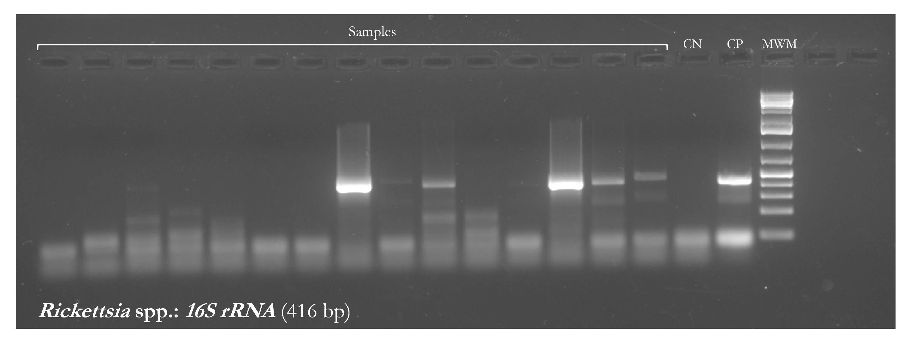
Figure S1. Agarose gel electrophoresis of PCR products of the 16S rRNA gene fragment of Rickettsia spp. MWM: molecular weight marker; CP: positive control; CN: negative control.

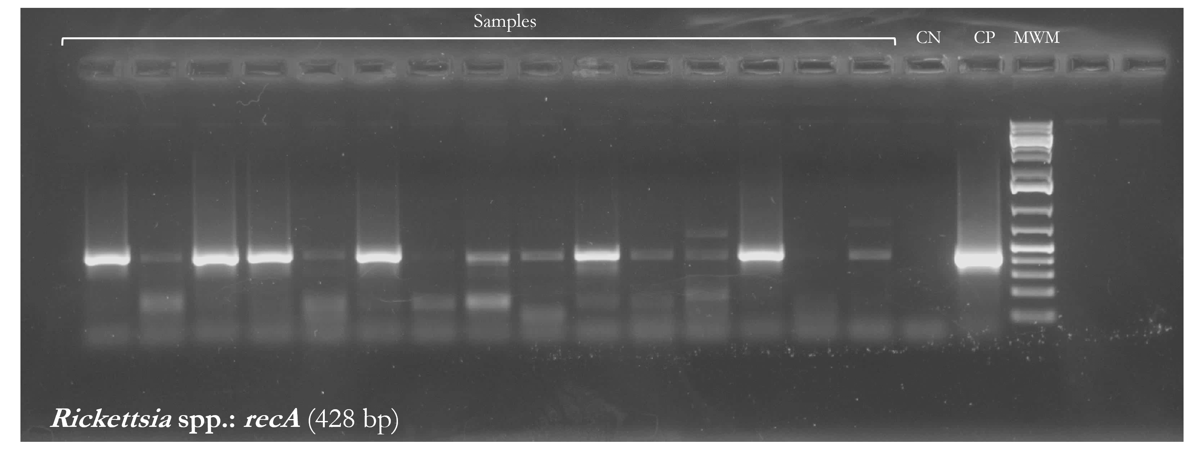
Figure S2. Agarose gel electrophoresis of PCR products of the recA gene fragment of Rickettsia spp. MWM: molecular weight marker; CP: positive control; CN: negative control.

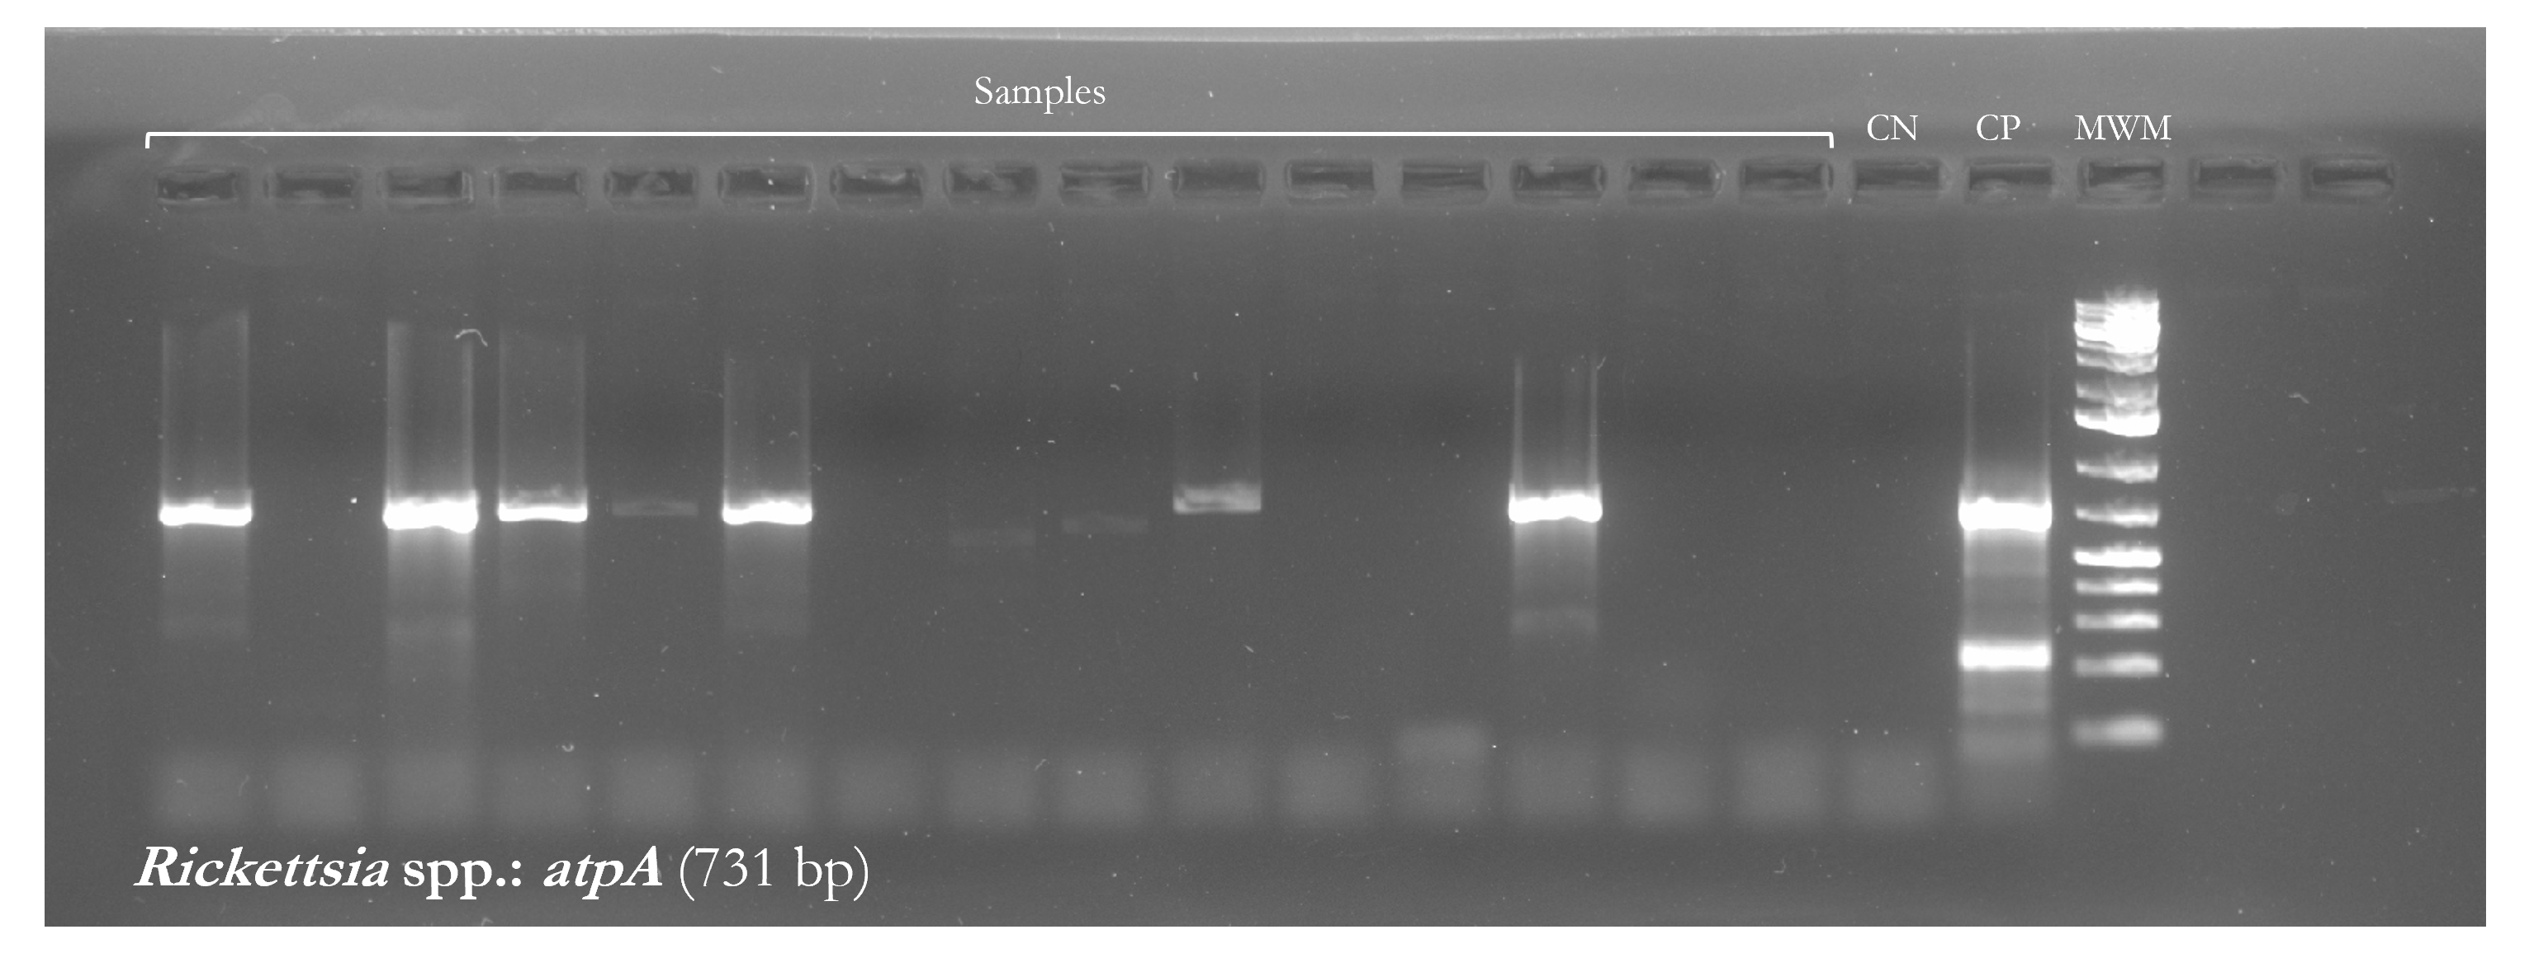
Figure S3. Agarose gel electrophoresis of PCR products of the atpA gene fragment of Rickettsia spp. MWM: molecular weight marker; CP: positive control; CN: negative control.

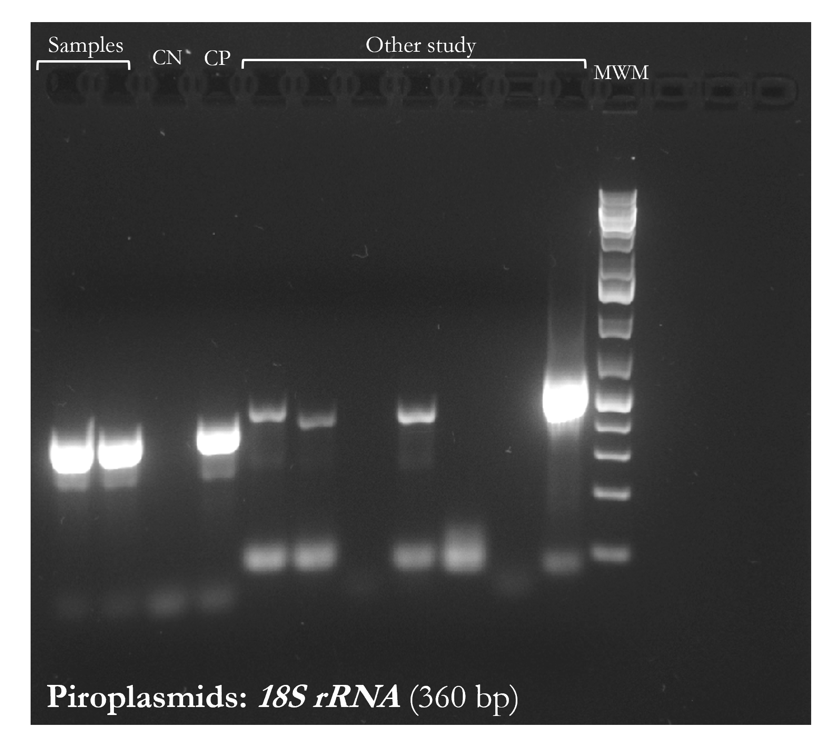
Figure S4. Agarose gel electrophoresis of PCR products of the 18S rRNA gene fragment of piroplasmids. MWM: molecular weight marker; CP: positive control; CN: negative control.

