Supporting Information
Converting waste PET plastics into automobile fuel and antifreeze components
Zhiwen Gao, Shuang Chen, Bing Ma, Jingqing Tian, Chen Zhao*
Shanghai Key Laboratory of Green Chemistry and Chemical Processes, School of Chemistry and Molecular Engineering, East China Normal University, Shanghai, China, 200062.
Email: czhao@chem.ecnu.edu.cn

Experimental section
Chemicals
The following chemicals were received from a commercial supplier and directly used without any pretreatment: nano silicon dioxide (SiO₂, Sinopharm Chemical Reagent Co., Ltd.), ammonium chloride (NH₄Cl, Sinopharm Chemical Reagent Co., Ltd.), sodium chloride (NaCl, Sinopharm Chemical Reagent Co., Ltd.), polyethylene terephthalate (PET, Sinopharm Chemical Reagent Co., Ltd.), copper nitrate (Cu(NO₃)₂·3H₂O, Sinopharm Chemical Reagent Co., Ltd.), ammonia (NH₃·H₂O, Sigma-Aldrich), lithium chloride (LiCl·H₂O, Sinopharm Chemical Reagent Co., Ltd.), chlorinated potassium (KCl, Aladdin), rubidium chloride (RbCl, Aladdin), cesium chloride (CsCl, Aladdin), cobalt nitrate (Co(NO₃)₂·3H₂O, Aladdin), nickel nitrate (Ni(NO₃)₂·3H₂O, Sinopharm Chemical Reagent Co., Ltd.), iron nitrate (Fe(NO₃)₃·9H₂O, Sinopharm Chemical Reagent Co., Ltd.), dimethyl terephthalate (C₁₀H₁₀O₄, Sigma-Aldrich), methyl 4-(hydroxymethyl)benzoate (C₉H₁₀O₃, Accela), methyl p-toluate (C₉H₁₀O₂, InnoCHEM), 4-methylbenzyl alcohol (C₈H₁₀O, InnoCHEM), titanium dioxide (TiO₂, Sinopharm Chemical Reagent Co., Ltd.), zirconium dioxide (ZrO₂, Sinopharm Chemical Reagent Co., Ltd.), and cerium dioxide (CeO₂, Sinopharm Chemical Reagent Co., Ltd.).

Catalyst preparation
Synthesis of Cu/SiO₂ using the hydrothermal method
Cu(NO₃)₂∙3H₂O was dissolved in deionized water, and a solution of NH₄Cl, NH₃∙H₂O, and SiO₂ was added to the fully dissolved solution, stirred at room temperature for 0.5 h, and ultrasonically treated for 0.5 h. The mixture was then transferred to a polytetrafluoroethylene autoclave and kept at 120°C in a homogeneous reactor for 3 h. After cooling to room temperature, the solid in the autoclave was filtered and washed with deionized water until pH = 7 was reached. The obtained precursor was dried overnight, calcined at 450°C in an air atmosphere for 4 h (air flow rate: 150 mL·min⁻¹, heating rate: 2°C·min⁻¹), and then reduced at 450°C in a hydrogen atmosphere for 4 h (hydrogen flow rate: 150 mL·min⁻¹, heating rate: 2°C·min⁻¹).
Synthesis of CuNa/SiO₂ using hydrothermal method
Cu(NO₃)₂∙3H₂O was dissolved in deionized water. NaCl and SiO₂ were added to the fully dissolved solution, which was stirred at room temperature for 0.5 h and ultrasonically treated for 0.5 h. The mixture was then transferred to a polytetrafluoroethylene autoclave and kept at 120°C in a homogeneous reactor for 3 h. After cooling to room temperature, the solid in the autoclave was filtered and washed with deionized water to pH = 7. The obtained precursor was dried overnight, calcined at 450°C in an air atmosphere for 4 h (air flow rate: 150 mL·min⁻¹, heating rate: 2°C·min⁻¹), and then reduced at 450°C in a hydrogen atmosphere for 4 h (hydrogen flow rate: 150 mL·min⁻¹, heating rate: 2°C·min⁻¹).

Activity tests
Catalyst characterization
Powder X-ray diffraction (XRD): The crystal structure of the sample was characterized using a Japanese Rigaku Ultima IV X-ray diffractometer. The scanning parameters were: Cu K_{α} X-ray source, λ = 1.5406 Å, tube voltage of 35 kV, tube current of 25 mA, scanning range of 5–80°, scanning speed of 5°·min⁻¹, and scanning step of 0.02°.

Nitrogen physical adsorption (N₂-isotherm): a Quantachrome Autosorb-3B adsorption instrument was used for nitrogen physical adsorption testing. Before the measurement, the sample was activated under vacuum at 300°C for 3 h, and then nitrogen was adsorbed at liquid nitrogen temperature (77 K). The Brunauer–Emmet–Teller method was used to calculate the specific surface area, and the pore size distribution was analyzed by the Barrett–Jovner–Halenda method.

Transmission electron microscopy (TEM): TEM images were collected on an FEI-Tecnai G2F30 field-emission transmission electron microscope.

The skeleton structures of the Fourier-Transform infrared spectroscopy (FTIR) catalyst samples were measured using a Nicolet Nexus 670 Fourier-transform infrared spectrometer. The test resolution was 4 cm⁻¹, the test wavenumber range was 400–4000 cm⁻¹, and the number of scans was 64. Before the measurement started, background collection (empty sample cell) was required.

Infrared spectroscopy (CO-FTIR): The metal species on the surface of the catalyst sample were measured by a Bruker Tensor 27 Fourier-transform infrared spectrometer (equipped with a Harrick diffuse reflectance accessory), and CO was used as the probe molecule for diffuse reflectance infrared spectroscopy. Diffuse reflectance infrared Fourier-transform infrared spectroscopy (CO-DRIFTS) was used for the measurements. Before any measurement, the sample was activated by argon (Ar) at 450°C for 30 min. After cooling to room temperature, a background scan was performed. The test wavenumber range was 600–4000 cm⁻¹, the number of scans was 64, and CO gas was used for maintenance. After 30 min, argon gas was passed in for purging, and the scan curve was recorded at the same time.

Thermogravimetric analysis (TGA): the weight loss curves of the catalyst samples were obtained on a NETZSCH STA449F3 (simultaneous TGA). The test temperature range was set to 30–1200°C, and the heating rate was 10°C·min⁻¹. High-purity air was used as the carrier gas, and the air flow rate was 50 mL·min⁻¹.

Hydrogen-temperature-programmed reduction (H₂-TPR): The calcined sample was characterized by temperature-programmed reduction on an advanced TP-5080 adsorption instrument (equipped with a thermal conductivity detector (TCD) detector). The gas product was a mixture of 5% H₂/He. The heating rate was 5°C·min⁻¹.

X-ray photoelectron spectroscopy (XPS): The valence state of the metal Cu on the surface of the catalyst was measured with a Thermo Scientific K-Alpha X-ray photoelectron spectrometer. Al Kα was selected as the X-ray emission source (hν = 1486.6 eV). The spectrum obtained by the test was calibrated based on the binding energy of carbon (C 1s = 284.8 eV).

Inductively coupled plasma atomic emission spectroscopy (ICP-AES): The content of each element in the catalyst sample was determined by a Thermo IRIS Intrepid II type inductively coupled plasma atomic emission spectrometer. The catalyst sample was dissolved in hydrofluoric acid to ensure that it was completely dissolved and in a clear state. Finally, the solution was diluted to a suitable test range.

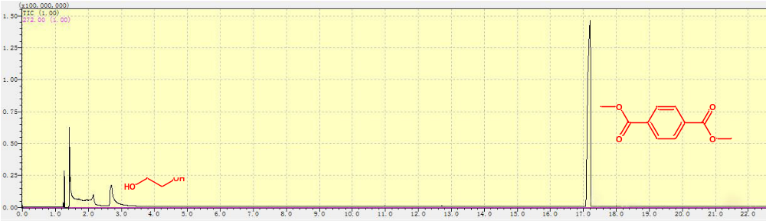

Fig. S1 Gas chromatography (GC) spectrum of the liquid products after the degradation of polyethylene terephthalate (PET). Reaction conditions: PET (0.12 g), CH₃OH (30 mL); 210 °C with stirring at 600 rpm, 0.5 h.

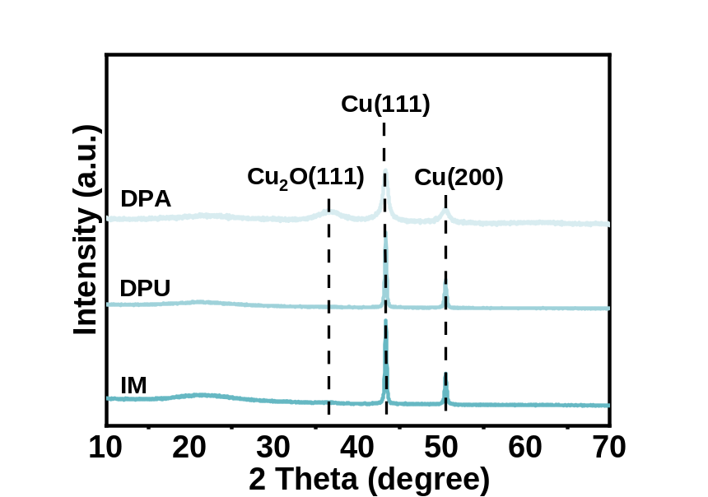
Fig. S2 X-ray diffraction (XRD) patterns of Cu/SiO₂ (reduced) prepared by deposition–precipitation with ammonia (DPA), deposition–precipitation with urea (DPU), and an impregnation method (IM).

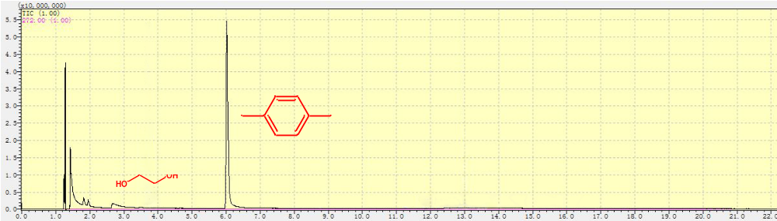
Fig. S3 GC spectrum of the liquid products after conversion of PET. Reaction conditions: PET (0.12 g), CuNa/SiO₂ (0.1 g), CH₃OH (30 mL); 210 °C with stirring at 600 rpm, 6 h.

Table. S1 Recycling tests of the conversion of PET over CuNa/SiO₂.
Run times | 1 | 2 | 3 | 4
PX yield (%) | 100 | 96.4 | 52.7 | 0
Reaction conditions: PET, 0.12 g; catalyst, 0.1 g; methanol, 30 mL; 210 °C; 6 h.

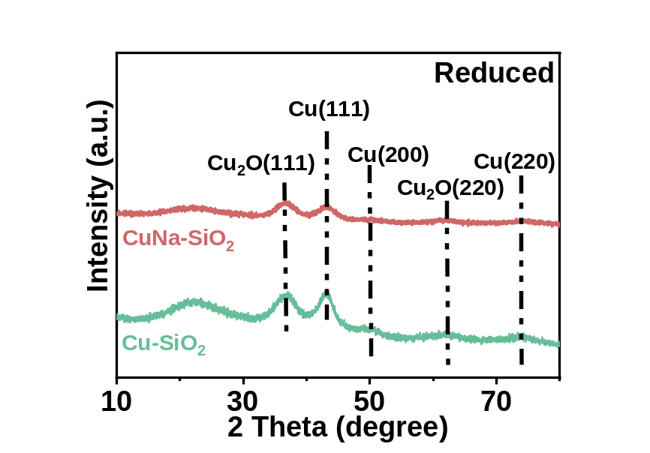
Fig. S4 XRD patterns of reduced Cu/SiO₂ and CuNa/SiO₂.

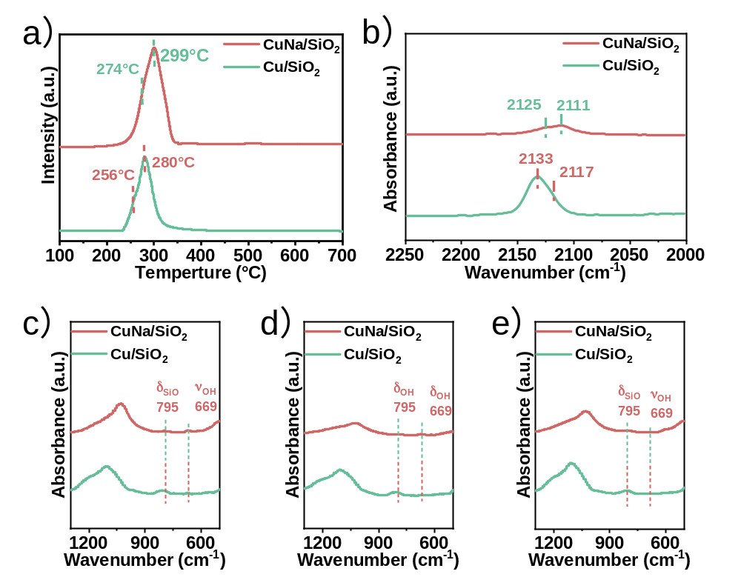
Fig. S5 (a) Hydrogen temperature programmed reduction (H₂-TPR) profiles of Cu/SiO₂ and CuNa/SiO₂. (b) Fourier-transform infrared spectroscopy (FTIR) spectra for CO adsorption on Cu/SiO₂ and CuNa/SiO₂. FTIR spectra of (c) dried, (d) calcined, and (e) reduced Cu/SiO₂ and CuNa/SiO₂.

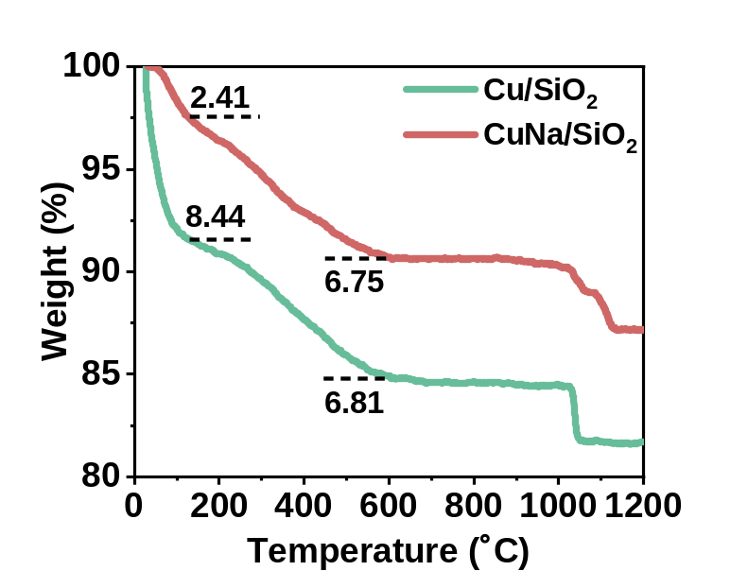
Fig. S6 Thermogravimetric analysis (TGA) patterns of dried Cu/SiO₂ and CuNa/SiO₂ samples.

Fig. S7 Scanning electron microscopy (SEM) images of: (a) Cu/SiO₂ (reduced) and (b) CuNa/SiO₂ (reduced).

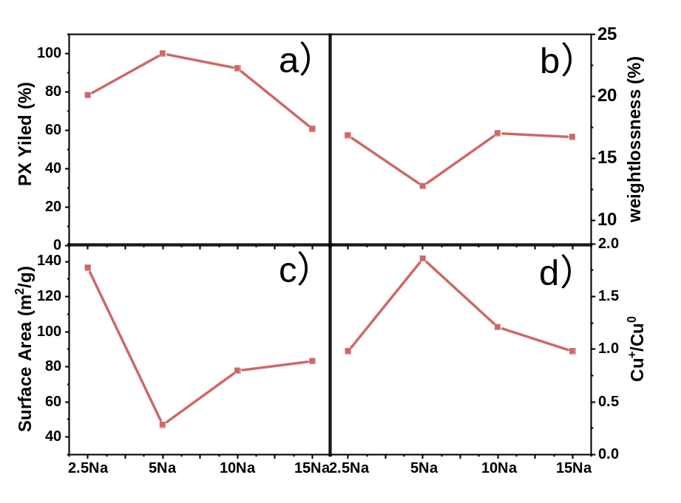
Fig. S8 Effect of different contents of introduced NaCl on: (a) p-xylene (PX) yield, (b) weight loss of the copper silicate precursor, (c) surface area of the copper silicate precursor, and (d) Cu⁺/Cu⁰ of the reduced sample. Reaction conditions: PET, 0.12 g; CuNa/SiO₂ catalyst, 0.1 g; methanol, 30 mL; 210°C; 6 h.

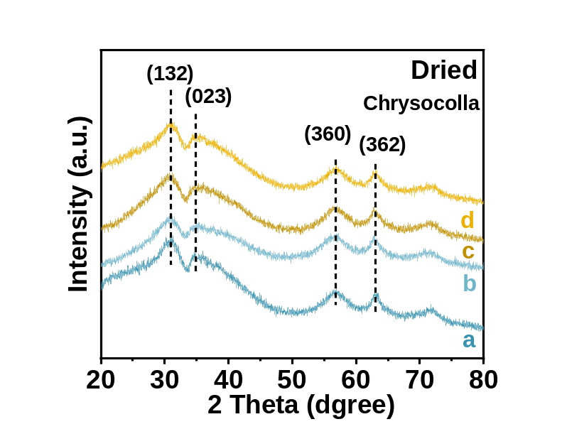

Fig. S9 X-ray diffraction (XRD) patterns of dried samples: (a) Cu-2.5Na/SiO₂, (b) Cu-5Na/SiO₂, (c) Cu-10Na/SiO₂, and (d) Cu-15Na/SiO₂.

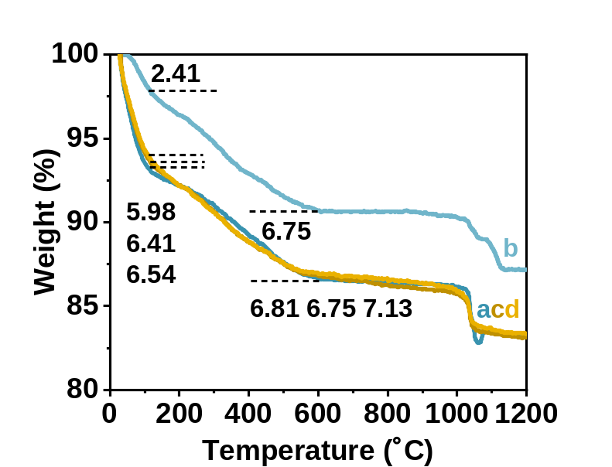
Fig. S10 TGA patterns of dried samples: (a) Cu-2.5Na/SiO₂, (b) Cu-5Na/SiO₂, (c) Cu-10Na/SiO₂, and (d) Cu-15Na/SiO₂.

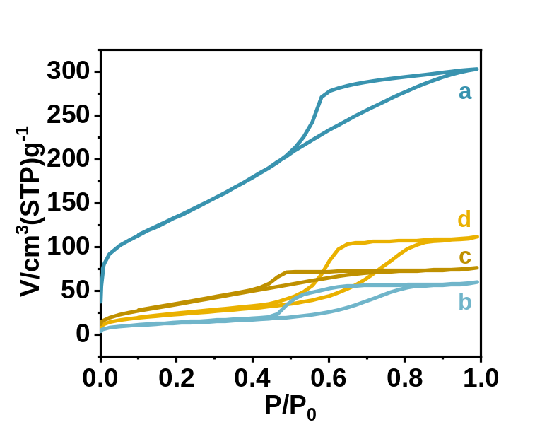

Fig. S11 N₂ adsorption–desorption of dried samples: (a) Cu-2.5Na/SiO₂, (b) Cu-5Na/SiO₂, (c) Cu-10Na/SiO₂, and (d) Cu-15Na/SiO₂.

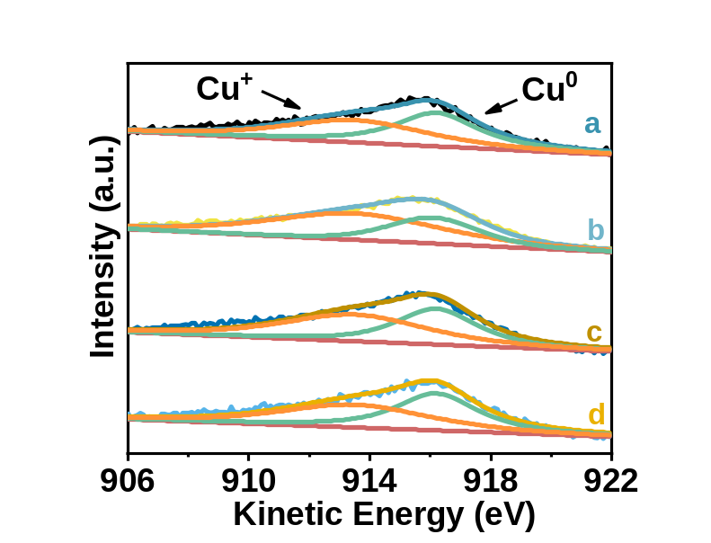

Fig. S12 Cu LMM X-ray induced Auger electron spectroscopy (XAES) spectra of reduced samples: (a) Cu-2.5Na/SiO₂, (b) Cu-5Na/SiO₂, (c) Cu-10Na/SiO₂, and (d) Cu-15Na/SiO₂.

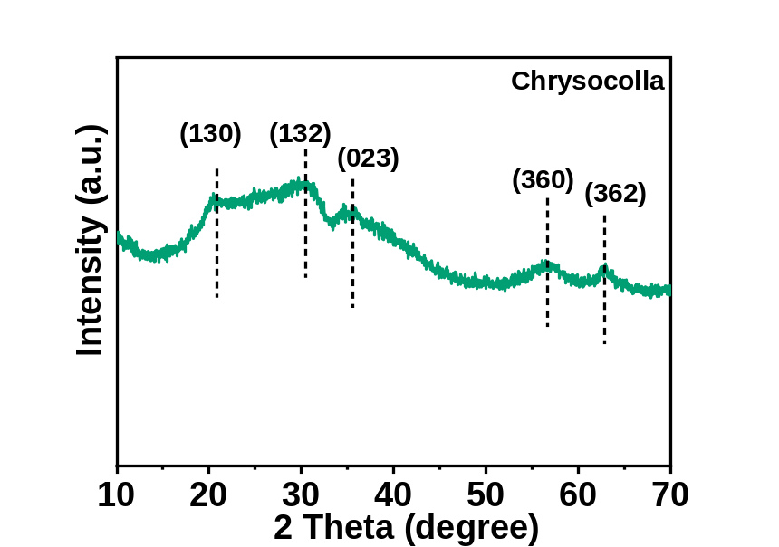
Fig. S13 XRD patterns of Cu/SiO₂-HT-Na-IM (dried).

Table. S2 Inductively coupled plasma (ICP) results of CuNa/SiO₂-HT (dried) and Cu/SiO₂-HT-Na-IM (dried).
Catalyst | Cu loading (wt.%) | Na Loading  (wt.%) | PX  yield (%) | Incremental pressure at RT (MPa)
CuNa/SiO₂-HT | 66.5 | 2.4 | 100 | 3.4
Cu/SiO₂-HT-Na-IM | 67.2 | 2.4 | 65.8 | 2.7
Reaction conditions: PET, 0.12 g; catalyst, 0.1 g; methanol, 30 mL; 210 °C; 6 h. PX: p-xylene; RT: room temperature.

