Supplementary Figures

Supplementary Figure1
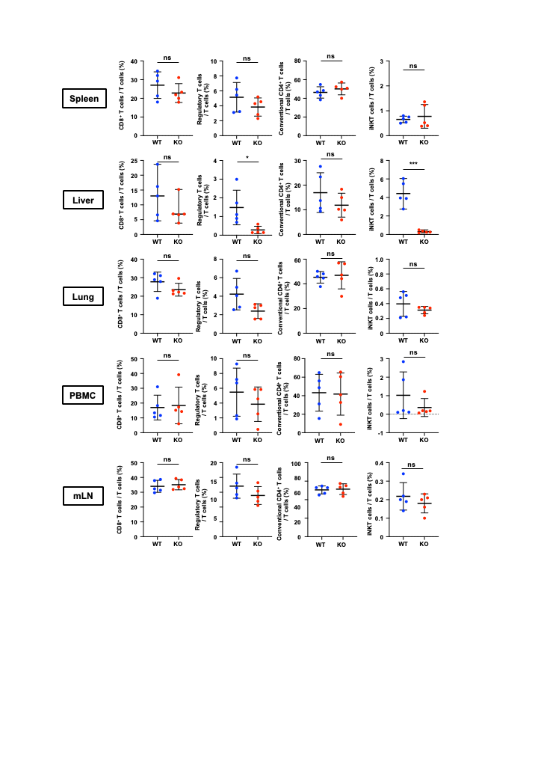
Supplementary Figure 1
Immune cell distribution in multiple tissues.
Immune cell subsets in the spleen, liver, lung, peripheral blood mononuclear cells (PBMC), and mesenteric lymph nodes (mLN) of WT and T-Pgam1 KO mice were analyzed by flow cytometry (mean ± SD, n = 5 biological replicates).
Statistical significance was determined using a two-tailed Student’s t-test.
ns, not significant; *P < 0.05, ***P < 0.001.

Supplementary Figure 2
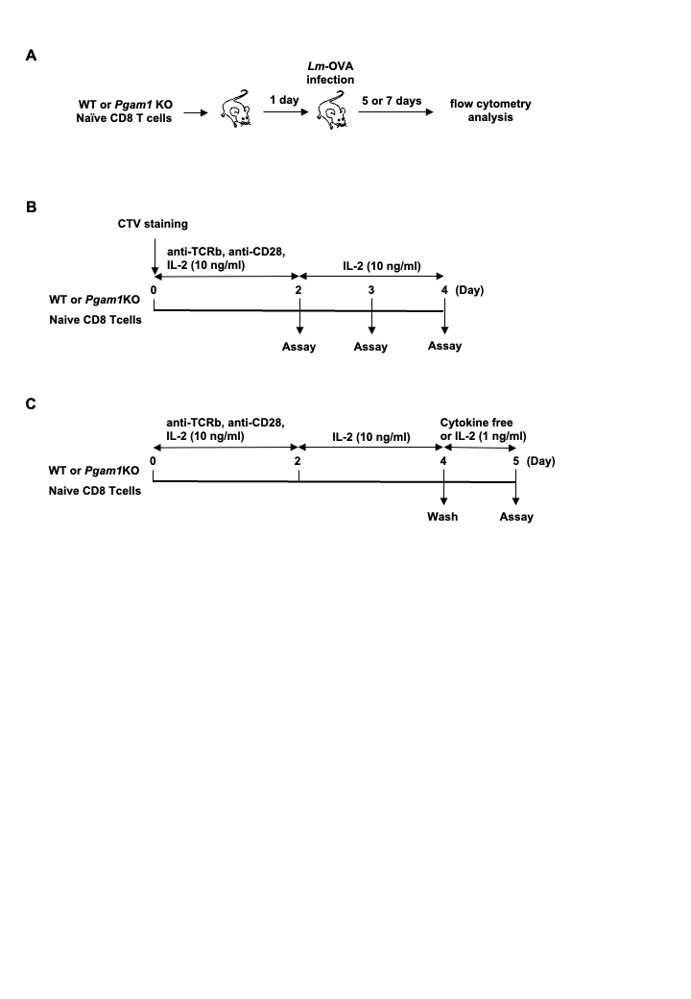
Supplementary Figure 2
A schematic representation of the experiments related to Figure 3A-3C
(A) Naïve OT-1 CD8+ T cells from WT (Thy1.1) or T-Pgam1 KO (Thy1.2) were adoptively transferred to C57BL/6 recipient mice (congenic Thy1.1/Thy1.2). The mice were infected with Lm-OVA at the following day. Cells were harvested from the spleen 5 or 7 days post-infection and analyzed by flow cytometry.
(B) Naive CD8⁺ T cells stained with CTV were activated in the presence of anti-TCRβ and anti-CD28 antibodies and IL-2 (10 ng/mL), and then cultured in the presence of IL-2. Analysis was performed on days 2, 3, and 4 of culture.
(C) Naive CD8+ T cells were activated in the presence of anti-TCRβ antibody, anti-CD28 antibody, and IL-2 (10 ng/mL), and subsequently cultured in the presence of IL-2. On day 4 of culture, the cells were washed and cultured either in the absence of cytokines or in the presence of low-concentration IL-2 (1 ng/mL); apoptosis was then analyzed on day 5 using annexin V and PI.

Supplementary Figure 3
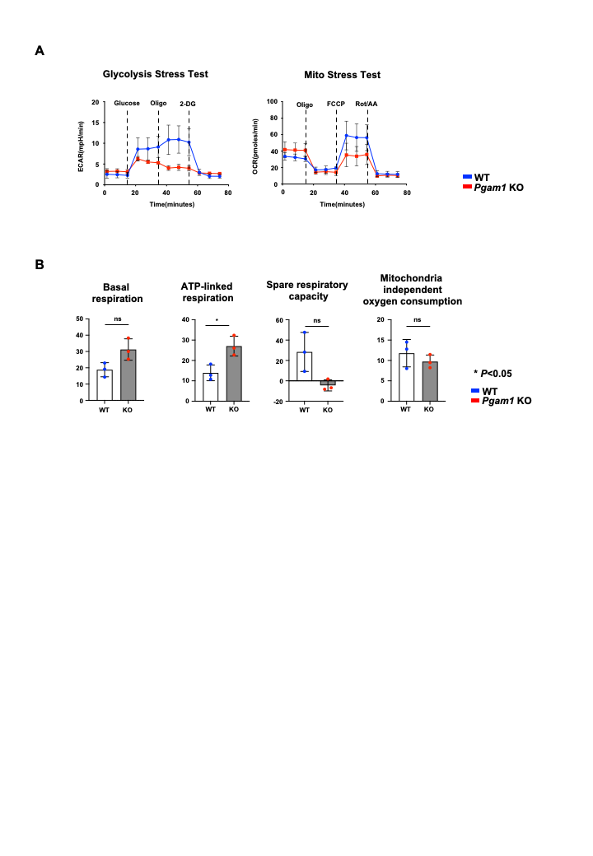
Supplementary Figure 3
Metabolic analysis of activated CD8⁺ T cells using an extracellular flux analyzer
(A) Naive CD8⁺ T cells were activated in the presence of anti-TCRβ and anti-CD28 antibodies and IL-2 (10 ng/mL) for 2 days, and analyzed on day 3. ECAR was measured by the Glycolysis Stress Test. OCR was measured by the Mito Stress Test.
(B) Quantitative analysis of the Mito Stress Test. Basal respiration, ATP-linked respiration, spare respiratory capacity, and mitochondria-independent oxygen consumption were quantified using the oxygen consumption rate (OCR) values from (A) (mean ± SD, n = 3 biological replicates). ns, not significant. *P < 0.05.

Supplementary Method
qRT-PCR primers
Primers for qRT-PCR were as follows: Srebf1: 5’-GGTTTTGAACGACATCGAAGA-3’ (forward), 5’-CGGGAAGTCACTGTCTTGGT-3(reverse), probe #78; Srebf2: 5’-GCACGGTAAGCAGGTTTGT-3’(forward), 5’-ACCTAGACCTCGCCAAAGGT-3’ (reverse), probe #74; Acaca: 5’-GGCTCAAACTGCAGGTATCC-3’(forward), 5’-TTGCCAATCCACTCGAAGA-3’(reverse), probe #103; Fasn: 5’-GCTGCTGTTGGAAGTCAGC-3’(forward), 5’-AGTGTTCGTTCCTCGGAGTG-3’(reverse), probe #58; Elovl6: 5’-GCAAAGCACCCGAACTAGG-3’ (forward), 5’-GAGCACAGTGATGTGGTGGT-3’ (reverse), probe #4; Scd1: 5’-TTCCCTCCTGCAAGCTCTAC-3’ (forward), 5’-CAGAGCGCTGGTCATGTAGT-3’ (reverse), probe #34; Hmgcs1: 5’-GGTCTGATCCCCTTTGGTG-3’ (forward), 5’-TGTGAAGGACAGAGAACTGTGG-3’ (reverse), probe #85; Hmgcr: 5’-CGTAAGCGCAGTTCCTTCC-3’ (forward), 5’-TTGTAGCCTCACAGTCCTTGG-3’ (reverse), probe #19; Mvk: 5’-GCATCACCCTCCTGAAGC-3’ (forward), 5’-CTGGTCTCCCAGCAGTCAA-3’ (reverse), probe #16 and 18 s rRNA: 5′-­ GCAAT TAT TCC CCA TGAACG-­ 3′ (forward), 5′-­ GGGAC TTA ATC AAC GCAAGC-­ 3′ (reverse), probe #48.

Measurement of the extracellular acidification rate (ECAR) and oxygen consumption rate (OCR)
The ECAR and OCR in activated T cells (1 × 10⁵ cells) were measured using an Extracellular Flux Analyzer XFp (Agilent Technologies, Santa Clara, CA, USA). Experiments were performed according to the manufacturer’s protocol. The ECAR was then measured at baseline and in response to the application of 10 mM glucose, 1 μM oligomycin, and 50 mM 2-DG (XFp glycolysis stress test kit; cat#103017-100; Agilent Technologies). The OCR was measured under basal conditions and in response to the application of 1 μM oligomycin, 2 μM FCCP and 0.5 μM rotenone/antimycin A (XFp mito stress test kit; cat#103010-100; Agilent Technologies).

