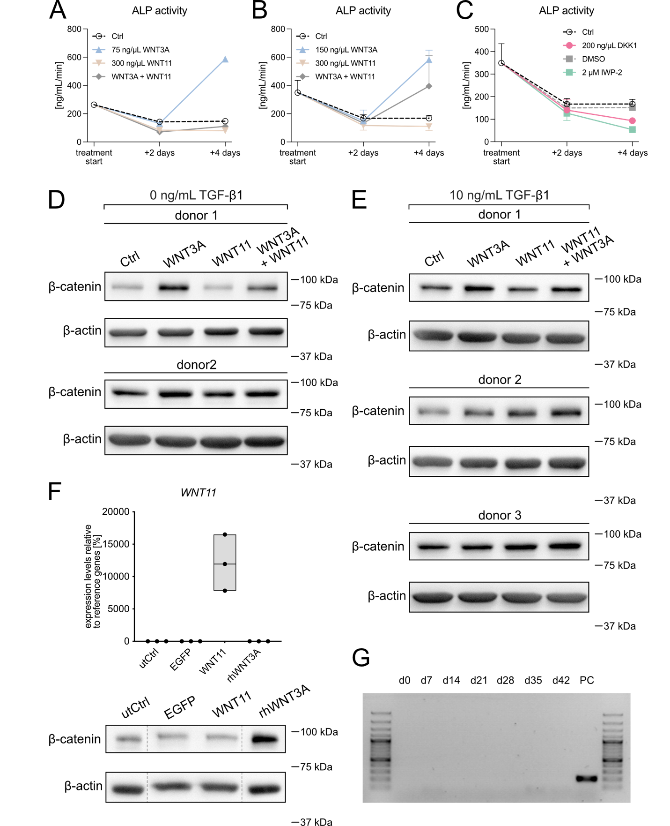

Suppl. figure S1. Model establishment. (A-C) MSC pellets were cultured in chondrogenic medium with 10 ng/mL TGFβ1 for 14 or 17 days before treatment with 300 ng/mL rhWNT11, 75 or 150 ng/mL rhWNT3A, 200 ng/mL rhDKK1, 2 μM IWP-2, or the respective amount of DMSO. Control (Ctrl) received chondrogenic medium only. Alkaline phosphatase (ALP) enzyme activity was assessed in the culture supernatants (mean ± SEM, n = 1-2). (D-E) Expanded MSCs were pelleted and treated with 300 ng/mL rhWNT11, 75 ng/mL rhWNT3A, or 200 ng/mL rhDKK1 in chondrogenic medium in (D) absence or presence (E) of 10 ng/mL TGFβ1. After 3h, membrane-depleted cell lysates were prepared and probed for β-catenin via Western blotting. (F) WNT11- or EGFP-overexpressing passage 3 MSCs or untransfected control cells (utCtrl) were cultured as monolayers for two days. Additional untransfected cells were treated at day 2 with 75 ng/mL rhWNT3A for 3h. Top: WNT11 mRNA expression relative to -RT controls (no reverse transcriptase). Bottom: β-catenin Western blot of membrane-depleted cell lysates. All samples were run on the same gel, vertical lines indicate where bands were electronically re-ordered. (G) MSC pellets were cultured in chondrogenic medium with 10 ng/mL TGFβ1 for 42 days and tested for WNT3A gene expression. The positive control (PC) was generated from human iPS cells that were induced into embryoid bodies.
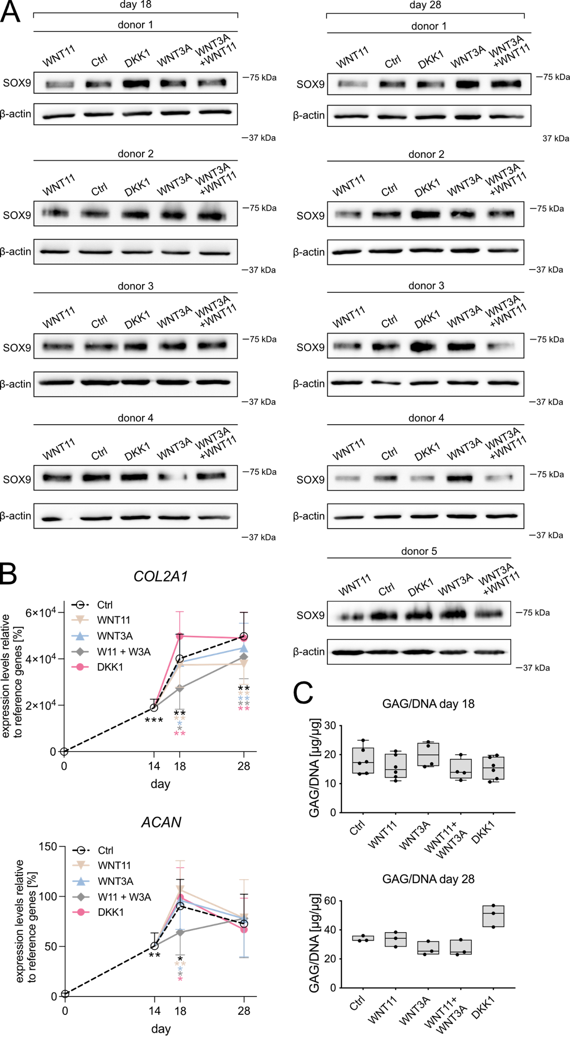
Suppl. figure S2. Additional data supporting figure 1. (A) All Western blots included in the
quantification presented in figure 1A in original sample order. (B) Expression levels of genes shown in figure 1B over time. Mean ± SEM of n=6-11 independent experiments; *p≤0.05, **p≤0.01, ***p≤0.001 vs day 0, unpaired t-test. (C) Proteoglycan per DNA content (DMMB assay, normalized to PicoGreen DNA quantification); n=6 (3 donors, day 18), n=3 (1 donor, day 28).

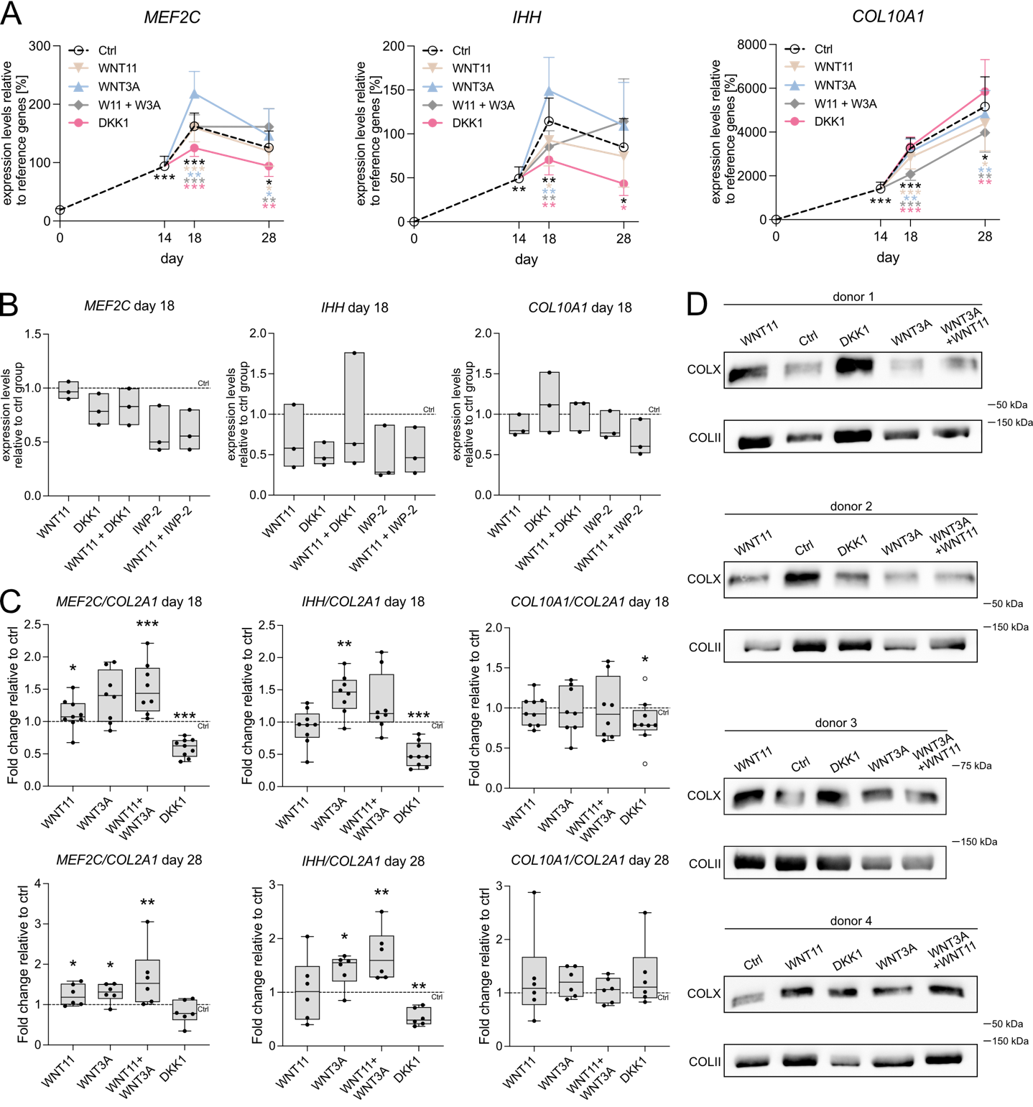
Suppl. figure S3. Additional data supporting main figure 2. (A) Expression levels of genes shown in figure 2 over time. Mean ± SEM of n=6-11 independent experiments; *p≤0.05, **p≤0.01, ***p≤0.001 vs day 0, unpaired t-test. (B) Same experimental setup as before with additional co-treatment groups with 200 ng/mL rhDKK1 or 2 μM IWP-2 as designated. (C) Expression data of figure 2 normalized to respective COL2A1 mRNA levels (Ctrl = 1; ° indicate outliers, *p≤0.05, **p≤0.01 ***p≤0.001 vs. Ctrl Mann-Whitney U test). (C) Type X and II collagen Western blots of all day 28 samples.

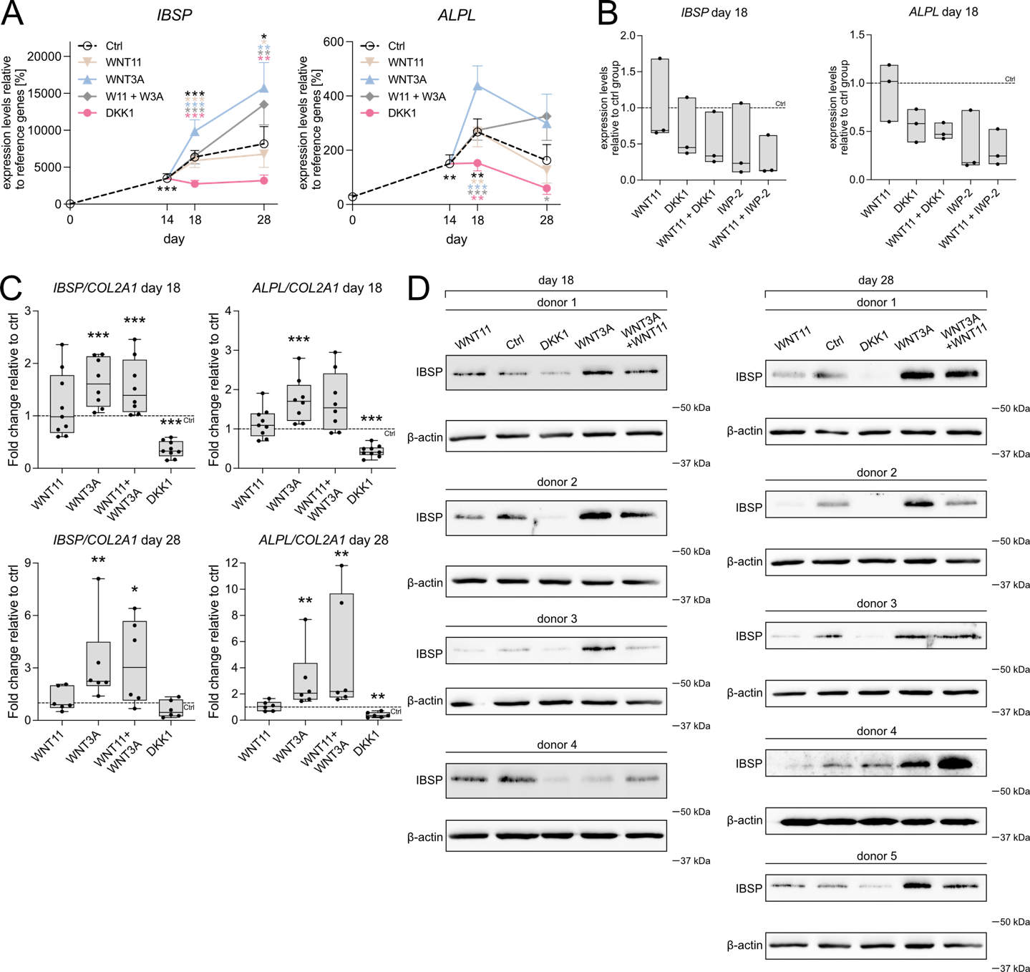
Suppl. figure S4. Additional information supporting main figure 3. (A) Gene expression over time (mean ± SEM, n=6-11, *p≤0.05, **p≤0.01, ***p≤0.001 vs day 0, unpaired t-test), (B) in presence of 200 ng/mL rhDKK1 or 2 μM IWP-2, or (C) normalized to COL2A1 mRNA levels (Ctrl = 1; *p≤0.05, **p≤0.01 ***p≤0.001 vs. Ctrl Mann-Whitney U test). (C) All IBSP Western blots included in the quantification presented in figure 3 in original sample order.

