Supplemenary file 2

Distribution of the 76 cases (13% of the cohort) with complications or bronchiolitis-associated conditions, according to epidemic season
- 2019–2020: 16 cases (16%), including 3 gastroenteritis, 1 pleuritis, 3 acute respiratory failure, 1 urinary tract infection, 6 pneumonia (2 with atelectasis), 1 pericarditis, and 1 supraglottic laryngitis.
- 2020–2021: 1 case (6%) of urinary tract infection.
- 2021–2022: 9 cases (11%), including 6 pneumonia, 1 acute respiratory failure, 1 gastroenteritis, and 1 gingivostomatitis.
- 2022–2023: 18 cases (13.5%), including 9 pneumonia, 1 pneumonia with pneumothorax, 6 acute respiratory failure, 1 urinary tract infection, and 1 seizure.
- 2023–2024: 9 cases (8%), including 2 pneumonia, 3 acute respiratory failure, 2 gastroenteritis, and 1 scabies.
- 2024–2025: 23 cases (16%), including 8 infants with pneumonia (1 aspiration-related), 6 bronchopneumonia, 1 cyanotic/apneic episode, 2 gastroenteritis, 1 supraglottic laryngitis, 1 seizure, 1 sepsis, 1 heart failure with acute renal injury, and 1 pleuritis associated with neutropenia and Clostridium difficile infection.

Prevalence and Types of Comorbidities Among Hospitalized Infants
Comorbidities were identified in 74 patients (13% of the cohort), and included the following:
2 inguinal hernia, 6 gastroesophageal reflux (one of whom also presented with Sandifer syndrome), 1 hypospadias, 1 laryngomalacia, 4 congenital CMV infections, 6 infants with hypotonia, 3 inhalant allergies, 18 congenital heart diseases (6 patent foramen ovale [PFO], 1 intermediate atrioventricular canal, 2 ventricular septal defects [VSD], 2 atrial septal defects [ASD], 3 pulmonary stenosis, 1 ASD + VSD, 1 PFO + patent ductus arteriosus, 1 atrial septal aneurysm, 1 aortic insufficiency with bicuspid aorta), 1 operated for congenital diaphragmatic hernia, 1 for esophageal atresia, 5 cow’s milk protein allergies, 1 spina bifida, 1 ex-preterm infant with chronic lung disease, 1 congenital neutropenia, 2 iron-deficiency anemia, 1 Cornelia de Lange syndrome, 1 congenital Toxoplasma infection, 4 hydronephrosis, 2 Down syndrome, 1 epileptic encephalopathy, 1 unilateral hearing loss, 1 congenital hip dysplasia, 1 pneumatocele, 2 neurodevelopmental delay/encephalopathy, and 1 Klinefelter syndrome.

Vaccination status among the study cohort, including fully vaccinated, unvaccinated, delayed vaccinations, and unknown vaccination status.
Vaccination Status | Number of Patients | Percentage (%)
Up to date | 200 | 34.5
Not vaccinated | 201 | 34.7
Delayed | 22 | 3.8
Unknown | 157 | 27.1
Total | 580 | 100

Distribution of viruses identified in patients with bronchiolitis caused by a single infectious agent across the different epidemic seasons:
During the 2019–2020 epidemic season, 88% (n = 45) of single-agent viral infections were attributed to respiratory syncytial virus (RSV), 8% (n = 4) to parainfluenza virus, and 4% (n = 2) to human metapneumovirus. In the course of the 2020–2021 epidemic season, 60% (n = 9) of single-agent bronchiolitis cases were caused by SARS-CoV-2 (COVID-19), 26% (n = 4) by rhinovirus, 7% (n = 1) by influenza A, and 7% (n = 1) by RSV. In the 2021–2022 epidemic season, 53% (n = 27) of single-agent bronchiolitis cases were associated with RSV, 19% (n = 10) with rhinovirus, 16% (n = 8) with SARS-CoV-2, 8% (n = 4) with human metapneumovirus, and 4% (n = 2) with parainfluenza virus. Along the 2022–2023 epidemic season, 60% (n = 42) of single-agent bronchiolitis cases were associated with RSV, 13% (n = 9) with rhinovirus, 13% (n = 9) with human metapneumovirus, 6% (n = 4) with influenza A, 6% (n = 4) with SARS-CoV-2, and 2% (n = 1) with influenza B. Over the course of the 2023–2024 epidemic season, 74% (n = 53) of observed bronchiolitis cases were caused by RSV, 17% (n = 12) by rhinovirus, 3% (n = 2) by influenza A, 3% (n = 2) by adenovirus, 1% (n = 1) by parainfluenza virus, 1% (n = 1) by human metapneumovirus, and 1% (n = 1) by influenza B. Finally, throughout the 2024–2025 epidemic season, 69% (n = 40) of bronchiolitis cases were associated with RSV, 17% (n = 10) with rhinovirus, 7% (n = 4) with human metapneumovirus, 5% (n = 3) with influenza A, and 2% (n = 1) with coronavirus NL63.

Distribution of viral agents in patients with bronchiolitis caused by a single infectious agent during the 2019–2020 epidemic season
Virus | Number of Patients
Respiratory syncytial virus (RSV) | 45
Parainfluenza virus | 4
Human metapneumovirus | 2
Total | 51

Distribution of viral agents in patients with bronchiolitis caused by a single infectious agent during the 2020–2021 epidemic season
Virus | Number of Patients
Respiratory syncytial virus (RSV) | 1
Influenza A | 1
Rhinovirus | 4
SARS-CoV-2 | 9
Total | 15

Distribution of viral agents in patients with bronchiolitis caused by a single infectious agent during the 2021–2022 epidemic season
Virus | Number of Patients
Respiratory syncytial virus (RSV) | 27
Rhinovirus | 10
SARS-CoV-2 | 8
Human metapneumovirus | 4
Parainfluenza virus | 2
Total | 51

Distribution of viral agents in patients with bronchiolitis caused by a single infectious agent during the 2022–2023 epidemic season
Virus | Number of Patients
Respiratory syncytial virus (RSV) | 42
Rhinovirus | 9
Human metapneumovirus | 9
Influenza A | 4
SARS-CoV-2 | 4
Influenza B | 1
Total | 69

Distribution of viral agents in patients with bronchiolitis caused by a single infectious agent during the 2023–2024 epidemic season
Virus | Number of Patients
Respiratory syncytial virus (RSV) | 53
Rhinovirus | 12
Influenza A | 2
Adenovirus | 2
Parainfluenza virus | 1
Human metapneumovirus | 1
Influenza B | 1
Total | 72

Distribution of viral agents in patients with bronchiolitis caused by a single infectious agent during the 2024–2025 epidemic season
Virus | Number of Patients
Respiratory syncytial virus (RSV) | 40
Rhinovirus | 10
Human metapneumovirus | 4
Influenza A | 3
Coronavirus NL63 | 1
Total | 58

Treatment in patients with bronchiolitis caused by a single infectious agent
Amoxicillin–Clavulanic Acid was given to 86 patients (27%), Clarithromycin to 26 (8%), Azithromycin to 1 (0.3%), Cefotaxime to 20 (6%), Ceftriaxone to 19 (6%), Cefixime to 3 (1%), Cefaclor to 1 (0.3%), and Sulfamethoxazole–Trimethoprim to 1 (0.4%). No patients received Gentamicin, Meropenem, Chloramphenicol, or Acyclovir. Nystatin was administered in 10 cases (3%). Corticosteroid therapy included Betamethasone in 184 patients (58%), Methylprednisolone in 69 (22%), and aerosolized Beclomethasone in 213 (67%). Aerosolized Salbutamol was used in 137 cases (43%), 3% received 3% hypertonic saline aerosol (n=40), aerosolized Adrenaline in 12 patients (4%), and intravenous rehydration in 110 patients (35%). Oxygen therapy was required in 134 patients (43%) at low flow, 14 (4.5%) received high-flow nasal cannula (HFNC), 1 patient (0.3%) required nasal continuous positive airway pressure (n-CPAP), and 5 (1.6%) underwent invasive mechanical ventilation.
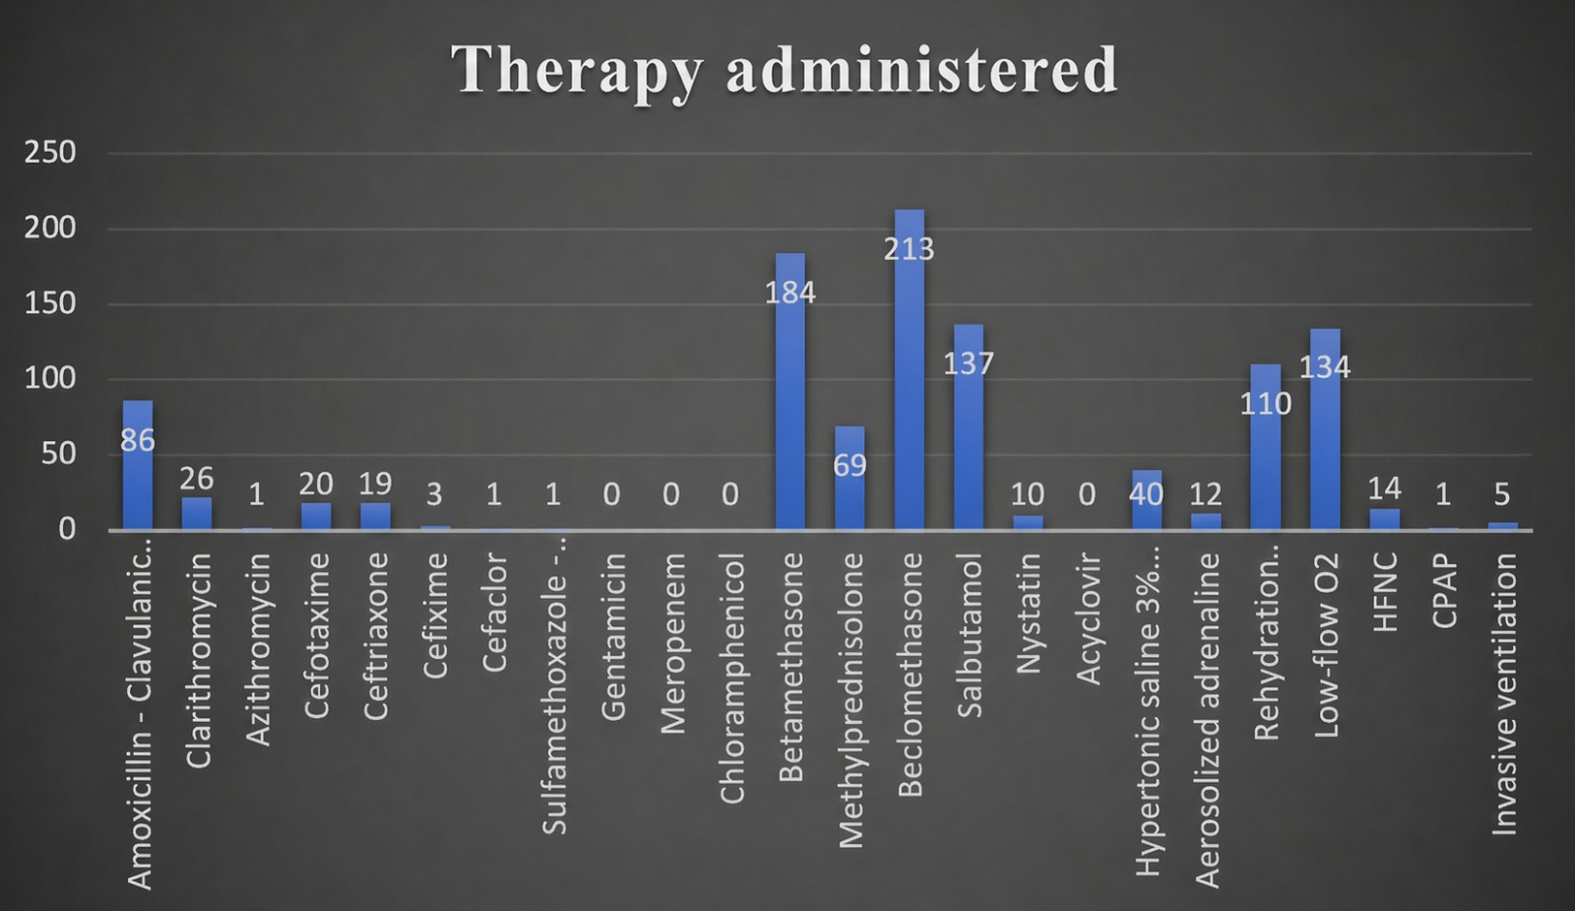
Figure S1. Treatments administered in patients with bronchiolitis caused by a single viral agent

Complications and/or associated conditions observed in patients with bronchiolitis caused by a single virus
Complications and/or Associated Conditions | Number of Patients
Respiratory failure | 8
Pericarditis | 1
Pneumonia | 6
Urinary tract infection (UTI) | 2
Enteritis | 1
Seizures | 2
Bronchopneumonia | 2
Scabies | 1
Supraglottic laryngitis | 1
Pulmonary atelectasis | 1
Pleuritis with Clostridium difficile infection | 1
Heart failure with acute renal injury (ARI) | 1
Total | 27

Comorbidities observed in patients with bronchiolitis caused by a single viral agent

Comorbidity | Number of patients
Inguinal hernia | 1
Gastroesophageal reflux disease (GERD) | 3
Laryngomalacia | 1
Hypospadias | 1
Encephalopathy / neurodevelopmental delay | 1
Inhalant allergy | 3
Iron-deficiency anemia | 1
Cornelia de Lange syndrome | 1
Cow’s milk protein allergy (CMPA) | 3
Congenital diaphragmatic hernia | 1
Macrocephaly | 1
Spina bifida | 1
Congenital heart disease (pulmonary valve dysplasia, atrial septal defect, ventricular septal defect, patent foramen ovale) | 17
Chronic lung disease | 1
Diaphragmatic hernia + esophageal atresia | 1
Congenital CMV infection | 1
Congenital Toxoplasma infection | 1
Total | 40

Microbiological profiles of co-infection patients for each epidemic season
During the 2019–2020 epidemic season, 5 cases (10%) involved infections caused exclusively by viral agents, 44 cases (88%) presented viral-bacterial coinfections, and 1 case (2%) involved a viral-fungal coinfection. The most frequently detected virus was RSV, identified in 45 cases (90%), followed by Influenza A in 12 cases (24%). Rhinovirus, Parainfluenza virus, Adenovirus, and Enterovirus were each detected in 1 patient (2%). Among bacterial pathogens, Haemophilus influenzae was most common (29 cases, 58%), followed by Streptococcus pneumoniae (15 cases, 30%), Staphylococcus aureus (9 cases, 18%), Moraxella catarrhalis (4 cases, 8%), and Pseudomonas aeruginosa (1 case, 2%). Fungal infection was limited to a single case of Candida albicans (2%).
The most frequent coinfections in this epidemic season were RSV + Haemophilus influenzae (24% of cases), followed by RSV + Streptococcus pneumoniae (14%). During the 2020–2021 epidemic season, there was a significant reduction in the overall number of bronchiolitis cases, particularly coinfections. In fact, only a single case of multiple coinfections was identified, involving RSV + Rhinovirus + Streptococcus pneumoniae + Staphylococcus aureus. Over the course of the 2021–2022 epidemic season, there was an increase in bronchiolitis cases compared to the previous year. A total of 29 cases of bronchiolitis due to co-infection were identified, of which 6 cases (20%) were viral only and 23 cases (80%) were caused by a combination of virus and bacteria. The most frequently isolated virus was RSV, found in 22 cases (76%), followed by Rhinovirus in 12 cases (41%), Metapneumovirus in 5 cases (17%), and finally Parainfluenza, Adenovirus, and SARS-CoV-2, each identified in one case (3%). The most commonly detected bacteria were Pneumococcus in 11 patients (38%), followed by Moraxella catarrhalis in 7 (24%), Haemophilus influenzae in 6 (20%), Staphylococcus aureus in 3 (10%), and Pseudomonas aeruginosa in one case (3%). The most frequent co-infections were RSV + Rhinovirus in 5 patients (17%) and RSV + Pneumococcus in 4 patients (14%). Throughout the 2022–2023 epidemic season, 64 cases of bronchiolitis caused by coinfection were observed, of which 27 (42%) were due to viral infections, and 37 (58%) were “mixed” infections, i.e., involving both virus and bacteria. The most frequently detected virus was RSV, isolated in 40 patients (62%), followed by Rhinovirus in 38 (60%), Metapneumovirus in 15 (23%), Influenza A in 3 (5%), Adenovirus in 3 (5%), SARS-CoV-2 in 3 (4%), Parainfluenza in 2 (3%), and finally Influenza B in 1 case (1%). The most frequently represented bacterium was Haemophilus influenzae, found in 23 patients (36%), followed by Streptococcus pneumoniae in 10 (15%), Moraxella catarrhalis in 10 (15%), Staphylococcus aureus in 5 (8%), Pseudomonas aeruginosa in 2 (3%), and Enterococcus faecalis and Klebsiella pneumoniae in 1 case each (1.5%). The most frequently observed coinfection was RSV + Rhinovirus, identified in 14 cases (22%).
At the time of the 2023-2024 epidemic season, 43 cases of coinfection were identified, of which 11 were caused exclusively by viruses and 32 involved both viruses and bacteria. RSV was isolated in 28 patients (65%), followed by Rhinovirus in 17 (40%), Parainfluenza virus in 5 (11%), Adenovirus in 4 (9%), Coronavirus OC43 in 3 (7%), SARS-CoV-2 in 2 (4%), and Influenza A in a single case (2%). The most frequently identified bacteria were Haemophilus influenzae, detected in 17 patients, followed by Pneumococcus in 11, Moraxella catarrhalis in 8 (18%), Bordetella pertussis in 4 (9%), Staphylococcus aureus in 3 (7%), and Pseudomonas aeruginosa in 1 (2%). The most frequent coinfection observed was RSV + Haemophilus influenzae, occurring in 6 cases (14%). Finally, amid the 2024-2025 epidemic season, 77 cases of coinfection were identified, of which 18 (23%) were viral only, and 59 (77%) were caused by viruses + bacteria. The most frequently identified virus was RSV, present in 48 cases (62%), followed by Rhinovirus in 31 patients (40%), Metapneumovirus in 9 (11%), Adenovirus also in 9 (11%), Influenza B in 5 (7%), Influenza A in 3 (4%), Coronavirus NL63 in 3 (4%), Parainfluenza in 2 (2%), and finally Coronavirus HKV1 in 1 case (1%). The most commonly isolated bacterium was Haemophilus influenzae, found in 36 cases (47%), followed by Pneumococcus in 34 (44%), Mycoplasma pneumoniae in 8 (10%), Staphylococcus aureus in 3 (4%), Moraxella catarrhalis in 2 (3%), and finally Enterobacter kobei, Klebsiella oxytoca, Chlamydia pneumoniae, and Escherichia coli, each observed in a single case (1%). The most frequently observed coinfection was RSV + Rhinovirus, identified in 12 cases (16%). The distribution of viral and bacterial agents in this patient group across each epidemic season included in the study is summarized in the tables below.

Distribution of viral and virus + bacteria coinfections in patients with bronchiolitis during the 2019–2020 epidemic season
Viral Coinfections | N. of patients | Virus + Bacteria Coinfections | N. of patients
RSV + Influenza A | 3 | RSV + Streptococcus pneumoniae | 7
RSV + Rhinovirus | 1 | RSV + Haemophilus influenzae | 12
Metapneumovirus + Influenza A | 1 | RSV + Staphylococcus aureus | 3
 |  | RSV + Moraxella catarrhalis | 3
 |  | RSV + Haemophilus influenzae + Candida albicans | 1
 |  | RSV + Staphylococcus aureus + Haemophilus influenzae | 4
 |  | RSV + Haemophilus influenzae + Streptococcus pneumoniae | 4
RSV + Adenovirus |  | RSV + Pseudomonas aeruginosa | 1
RSV + Influenza A |  | RSV + Haemophilus influenzae | 1
RSV + Influenza A |  | RSV + Staphylococcus aureus | 2
RSV + Influenza A |  | RSV + Haemophilus influenzae + Streptococcus pneumoniae | 2
RSV + Enterovirus |  | RSV + Haemophilus influenzae + Streptococcus pneumoniae | 1
Parainfluenza virus |  | RSV + Haemophilus influenzae + Moraxella catarrhalis | 1
Influenza A |  | RSV + Haemophilus influenzae + Streptococcus pneumoniae | 1
Influenza A |  | RSV + Haemophilus influenzae | 2
Total: | 5 viral-only coinfections | | 45 virus + bacteria coinfections

Viral and bacterial coinfections in patients with bronchiolitis during the 2020–2021 epidemic season. Only one case of multiple coinfection (RSV + Rhinovirus + Streptococcus pneumoniae + Staphylococcus aureus) was observed
Epidemic Season | Viral + Bacterial Coinfections | Number of Patients
2020–2021 | RSV + Rhinovirus / Pneumococcus + Staphylococcus Aureus | 1
Total |  | 1

Distribution of viral and viral + bacterial co-infections in patients with bronchiolitis during the 2021–2022 epidemic season
Viral Co-infections | Number of Patients | Viral + Bacterial Co-infections | Number of Patients
VRS + Rhinovirus | 5 | VRS + Pneumococcus | 4
SARS-CoV-2 + Rhinovirus | 1 | VRS + Staphylococcus aureus | 2
 |  | VRS + Rhinovirus + Pneumococcus | 2
 |  | Rhinovirus + Moraxella catarrhalis | 1
 |  | VRS + Haemophilus influenzae + Pneumococcus | 1
 |  | VRS + Moraxella catarrhalis | 2
 |  | VRS + Haemophilus influenzae | 3
 |  | VRS + Metapneumovirus + Moraxella catarrhalis | 1
 |  | Rhinovirus + Adenovirus + Pneumococcus + Staphylococcus aureus + H. influenzae + Pseudomonas aeruginosa | 1
 |  | Rhinovirus + Metapneumovirus + Pneumococcus + Moraxella catarrhalis | 1
 |  | Metapneumovirus + Haemophilus influenzae | 2
 |  | Parainfluenza + Moraxella catarrhalis | 1
 |  | Metapneumovirus + Pneumococcus | 1
Total | 6 | Total | 23
Overall Total |  | 29 patients

Viral and viral + bacterial coinfections identified in patients with bronchiolitis during the 2022-2023 epidemic season
Viral Coinfections | Number of patients | Viral + Bacterial Coinfections | Number of patients
Rhinovirus + Parainfluenza Virus | 1 | VRS + Pneumococcus + Moraxella Catarrhalis | 1
Rhinovirus + COVID-19 | 1 | VRS + Moraxella catarrhalis + Pseudomonas Aeruginosa | 1
VRS + Influenza A | 1 | VRS + Haemophilus influenzae | 4
VRS + Rhinovirus + Adenovirus | 1 | Rhinovirus + Haemophilus influenzae | 2
VRS + Adenovirus | 1 | Rhinovirus + Influenza A + M. Catarrhalis + S. Pneumoniae + H. influenzae | 1
VRS + Metapneumovirus | 1 | VRS + Rhinovirus + Pneumococcus | 1
VRS + COVID-19 | 1 | VRS + Pneumococcus + Pseudomonas Aeruginosa | 1
VRS + Rhinovirus | 14 | VRS + Pneumococcus + Staphylococcus Aureus | 1
Metapneumovirus + Rhinovirus | 5 | VRS + Rhinovirus + Haemophilus influenzae | 3
Metapneumovirus + Rhinovirus + Adenovirus | 1 | Metapneumovirus + Moraxella Catarrhalis + Pneumococcus | 1
 |  | Metapneumovirus + Haemophilus influenzae | 2
 |  | VRS + H. influenzae + Moraxella Catarrhalis | 1
 |  | VRS + Rhinovirus + COVID-19 + Haemophilus influenzae | 1
 |  | Rhinovirus + Pneumococcus + Staphylococcus Aureus + H. influenzae | 1
 |  | VRS + Metapneumovirus + Haemophilus influenzae | 1
 |  | VRS + Influenza A + Enterococcus faecalis | 2
 |  | Metapneumovirus + Staphylococcus Aureus | 1
 |  | VRS + Rhinovirus + Pneumococcus + Haemophilus influenzae | 1
 |  | Metapneumovirus + Rhinovirus + H. influenzae + Moraxella Catarrhalis | 2
 |  | VRS + Staphylococcus Aureus | 1
 |  | Rhinovirus + Pneumococcus | 1
 |  | Influenza B + Haemophilus influenzae | 1
 |  | Rhinovirus + Parainfluenza Virus + Haemophilus influenzae | 1
 |  | Metapneumovirus + Moraxella Catarrhalis | 1
 |  | Rhinovirus + Moraxella Catarrhalis | 1
 |  | Rhinovirus + Pneumococcus + Moraxella Catarrhalis | 1
 |  | Rhinovirus + H. influenzae + Staphylococcus Aureus | 1
 |  | VRS + Klebsiella pneumoniae | 1
Total viral cases: | 27 | Total viral + bacterial cases: | 37
 |  | Overall total: | 64

Viral and viral + bacterial coinfections observed in patients with bronchiolitis during the 2023-2024 epidemic season
Viral Coinfections | Cases | Viral + Bacterial Coinfections | Cases
Rhinovirus + Influenza A | 1 | Rhinovirus + Moraxella catarrhalis | 1
RSV + Rhinovirus | 3 | Rhinovirus + Pneumococcus + Haemophilus influenzae | 2
RSV + Rhinovirus + Adenovirus | 1 | Rhinovirus + Haemophilus influenzae | 2
RSV + Adenovirus | 1 | Rhinovirus + Pneumococcus + Moraxella catarrhalis | 1
RSV + COVID-19 | 2 | Rhinovirus + Pneumococcus | 1
RSV + Coronavirus OC43 | 2 | Rhinovirus + Coronavirus OC43 + Bordetella pertussis | 1
Parainfluenza + Rhinovirus | 1 | Rhinovirus + Parainfluenza + Pneumococcus | 1
- | - | Parainfluenza + Moraxella catarrhalis + Pseudomonas aeruginosa | 1
- | - | Parainfluenza + Staphylococcus aureus | 1
- | - | Parainfluenza + Pneumococcus + Haemophilus influenzae | 1
- | - | RSV + Pneumococcus + Haemophilus influenzae | 4
- | - | RSV + Haemophilus influenzae | 6
- | - | RSV + Bordetella pertussis | 1
- | - | RSV + Moraxella catarrhalis | 3
- | - | RSV + Pneumococcus | 1
- | - | RSV + Staphylococcus aureus | 1
- | - | RSV + Rhinovirus + Bordetella pertussis | 1
- | - | RSV + Rhinovirus + Moraxella catarrhalis + Staphylococcus aureus + Haemophilus influenzae | 1
- | - | RSV + Adenovirus + Bordetella pertussis | 1
- | - | Adenovirus + Moraxella catarrhalis | 1
Total | 11 | Total | 32
Overall Total |  |  | 43

Viral and viral + bacterial coinfections observed in patients with bronchiolitis during the 2024-2025 epidemic season
Virus Co-infections | Cases | Virus + Bacteria Co-infections | Cases
RSV + Adenovirus | 2 | Rhinovirus – Pneumococcus | 2
RSV + Rhinovirus | 12 | Rhinovirus – Pneumococcus + Haemophilus influenzae | 2
RSV + Rhinovirus + Coronavirus NL63 | 1 | Rhinovirus – Pneumococcus + Haemophilus influenzae | 1
Adenovirus + Rhinovirus | 1 | Rhinovirus – Haemophilus influenzae | 3
Influenza B + Coronavirus NL63 | 1 | Rhinovirus – Staphylococcus aureus | 1
Metapneumovirus + Rhinovirus | 1 | Rhinovirus – E. coli | 1
 |  | Rhinovirus – Staphylococcus aureus (MRSA) + Enterobacter kobei + Klebsiella oxytoca | 1
 |  | Rhinovirus + Parainfluenza – Mycoplasma pneumoniae | 1
 |  | Rhinovirus + Adenovirus – Pneumococcus + Haemophilus influenzae | 2
 |  | Rhinovirus + Coronavirus NL63 – Mycoplasma pneumoniae | 1
 |  | RSV – Mycoplasma pneumoniae + Pneumococcus + Haemophilus influenzae | 2
 |  | RSV – Mycoplasma pneumoniae | 1
 |  | RSV – Pneumococcus + Haemophilus influenzae | 6
 |  | RSV – Haemophilus influenzae | 2
 |  | RSV – Moraxella catarrhalis | 1
 |  | RSV – Pneumococcus | 7
 |  | RSV – Pneumococcus + Haemophilus influenzae + Staphylococcus aureus | 1
 |  | RSV + Rhinovirus – Pneumococcus + Haemophilus influenzae | 2
 |  | RSV + Influenza A – Haemophilus influenzae | 1
 |  | RSV + Rhinovirus – Haemophilus influenzae | 2
 |  | RSV + Adenovirus – Pneumococcus + Haemophilus influenzae | 4
 |  | RSV + Influenza B – Haemophilus influenzae | 2
 |  | RSV + Influenza B – Mycoplasma pneumoniae | 1
 |  | RSV + Coronavirus HKV1 – Pneumococcus | 1
 |  | Parainfluenza – Pneumococcus + Haemophilus influenzae | 1
 |  | Influenza A + Influenza B – Haemophilus influenzae | 1
 |  | Influenza A – Haemophilus influenzae | 1
 |  | Metapneumovirus – Pneumococcus | 2
 |  | Metapneumovirus – Mycoplasma pneumoniae | 2
 |  | Metapneumovirus – Haemophilus influenzae | 1
 |  | Metapneumovirus – Moraxella catarrhalis + Haemophilus influenzae | 1
 |  | Metapneumovirus – Pneumococcus + Haemophilus influenzae | 1
 |  | Metapneumovirus – Chlamydia pneumoniae | 1
Total | 18 | Total | 59
Overall Total |  | 77

Treatment in patients with bronchiolitis caused by co-infection
In this examined subgroup of patients, antimicrobial therapy was administered in 215 cases (81% of the sample). specifically, Amoxicillin–Clavulanic Acid was given to 133 patients (50%), Clarithromycin to 46 (17%), Azithromycin to 1 (0.4%), Cefotaxime to 12 (5%), Ceftriaxone to 27 (10%), Cefixime to 5 (2%), Cefaclor to 4 (1.5%), Sulfamethoxazole–Trimethoprim to 7 (3%), Gentamicin to 1 (0.4%), Meropenem to 5 (2%), Chloramphenicol to 1 (0.4%), and Acyclovir to 1 (0.4%). Nystatin was administered to 16 patients (6%). Steroid treatment was administered as follows: Betamethasone in 193 patients (73%), Methylprednisolone in 85 (32%), and Beclometasone via aerosol in 202 (76%). Aerosolized Salbutamol was used in 163 cases (62%), 3% hypertonic saline solution via aerosol in 29 patients (11%), aerosolized Adrenaline in 9 (4%), and intravenous rehydration in 93 (35%). Oxygen therapy at low flow was required in 111 patients (42%), HFNC in 8 (3%), n-CPAP in 1 (0.4%), and invasive mechanical ventilation in 4 (1.5%).
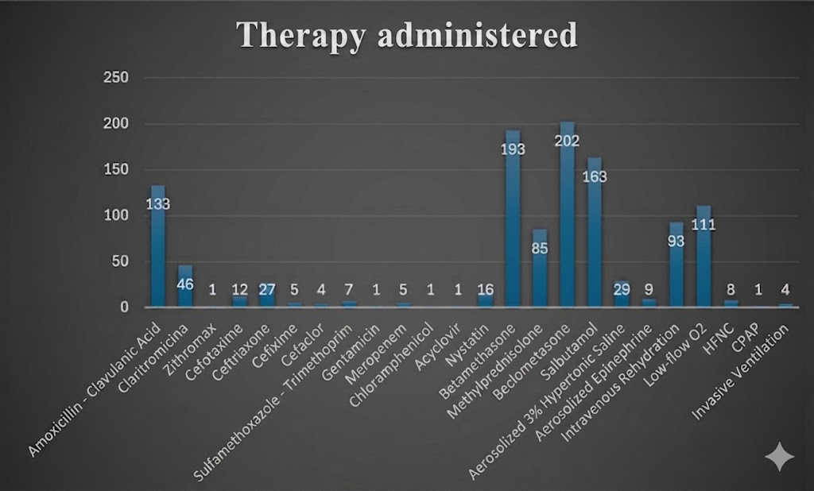
Figure S2. Therapy administered in patients with co-infection bronchiolitis

Complications and associated conditions in patients with coinfection bronchiolitis
Complications or Associated Conditions | Number of Patients
Respiratory failure | 5
Pneumonia (including 1 aspiration pneumonia) | 22
Pulmonary atelectasis | 1
Pleuritis | 1
Pneumothorax (PNX) | 1
Bronchopneumonia | 5
Supraglottic laryngitis | 1
Enteritis | 8
Urinary tract infection (UTI) | 1
Gingivostomatitis | 1
Sepsis | 1
Cyanosis and apnea episodes | 2
Total | 49

Comorbidities observed in patients with co-infection bronchiolitis
Comorbidities | Number of Patients
Inguinal hernia | 1
Gastroesophageal reflux disease (GERD) | 2
Cow’s milk protein allergy (CMPA) | 2
Congenital CMV infection | 1
Hydronephrosis | 4
Hypotonia | 2
Growth delay | 2
Epileptic encephalopathy | 1
Iron deficiency anemia | 1
Down syndrome | 2
Sandifer syndrome | 1
Hearing loss | 1
Neurodevelopmental delay | 2
Developmental hip dysplasia | 1
Pneumatocele | 1
Klinefelter syndrome | 1
Congenital heart disease (PFO, mitral insufficiency, patent ductus arteriosus, pulmonary valve stenosis, atrial septal defect, ventricular septal defect, aortic insufficiency, bicuspid aortic valve, interatrial septal aneurysm) | 9
Total | 34

Sex distribution of infants hospitalized for bronchiolitis according to Nirsevimab immunoprophylaxis status (2024–2025 season)
 | Nirsevimab – Yes | Nirsevimab – NO
Males | 37 | 41
Females | 20 | 37

Distribution of neonates by gestational age categories at the two study centers: appropriate for gestational age (AGA), large for gestational age (LGA), and small for gestational age (SGA). Percentages are shown in parentheses
Center | AGA (n, %) | LGA (n, %) | SGA (n, %)
“Paolo Giaccone” University Hospital, Palermo | 236 (81.4%) | 20 (6.9%) | 34 (11.7%)
“Salvatore Cimino” Hospital, Termini Imerese | 136 (81.9%) | 12 (7.2%) | 18 (10.8%)

