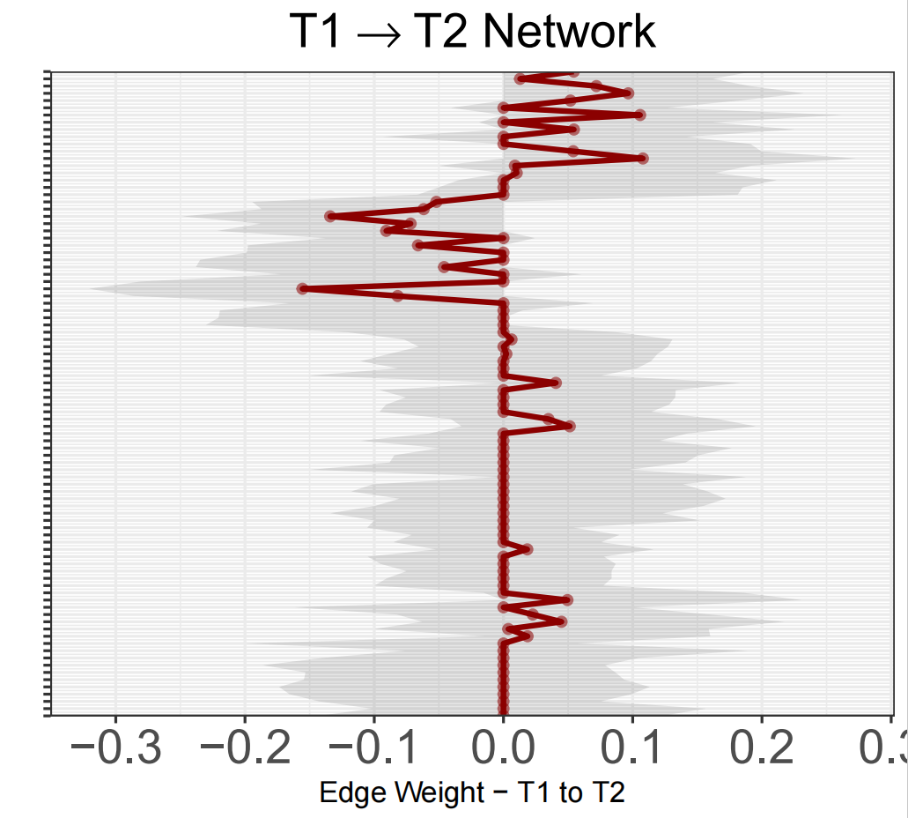
Supplementary Figure 1. Bootstrapped confidence intervals of edge weights (T1 → T2) in the cross-lagged panel network for adolescents with anxiety and depression.
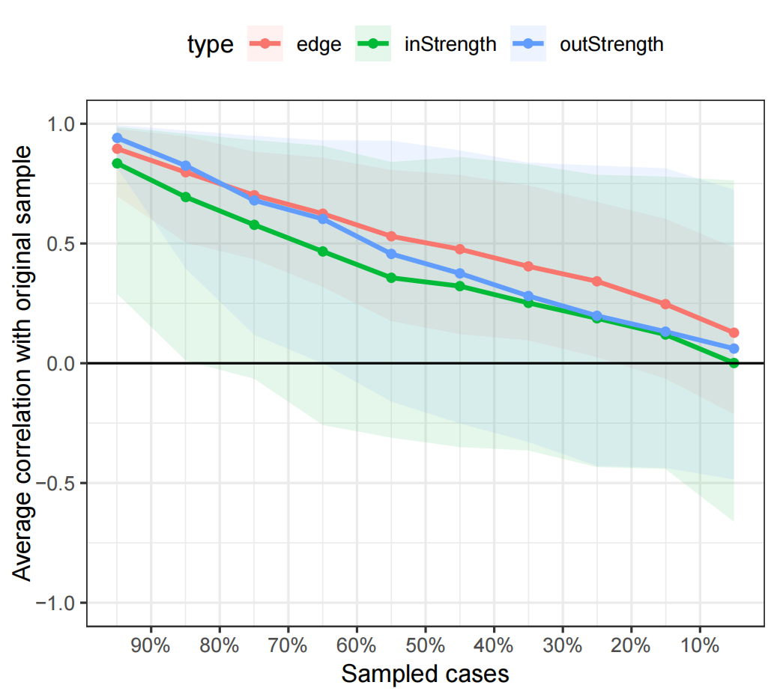
Supplementary Figure 2. Stability of centrality indices in the cross-lagged panel network of SCL-90 symptom dimensions from T1 to T2 in adolescents with anxiety and depression
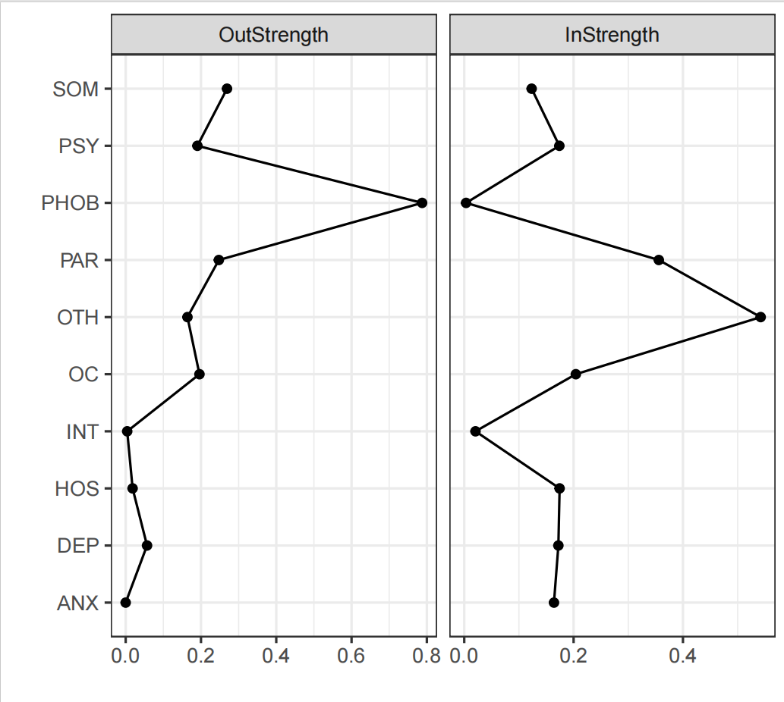
Supplementary Figure 3.Node strength predictive indices of SCL-90 symptom dimensions from T1 to T2 in adolescents with anxiety and depression

Supplementary Table 1. Edge weights of SCL-90 symptom dimensions at T1 in adolescents with anxiety and depression
From | To | Weight
INT | PAR | 0.383
SOM | ANX | 0.323
PAR | PSY | 0.268

Supplementary Table 2. Edge weights of SCL-90 symptom dimensions at T2 in adolescents with anxiety and depression
From | To | Weight
SOM | ANX | 0.322
INT | PAR | 0.279
PAR | PSY | 0.256

