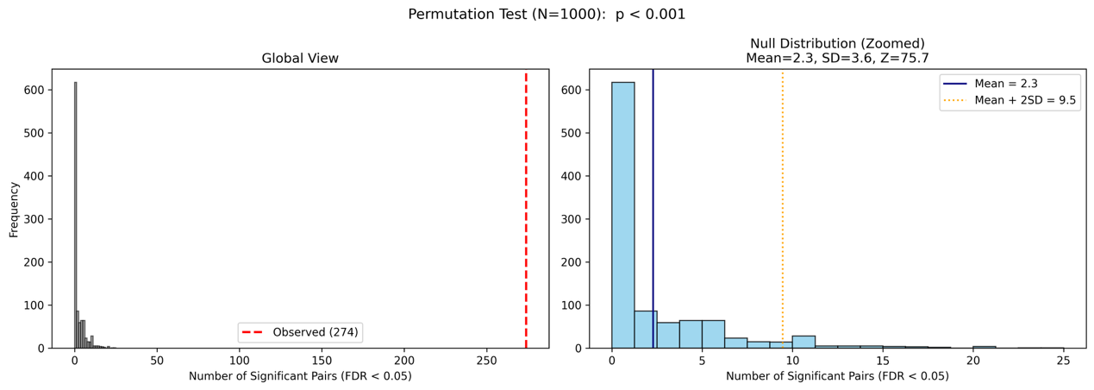
Fig. S1. Permutation test validating biological specificity of identified dependencies.
Left panel (global view): Histogram of significant pair counts across 1,000 label-permutation iterations, with the observed value (274 pre-selectivity-filtered pairs) shown as a red dashed line. Right panel (zoomed null distribution): The null distribution is concentrated near zero (mean = 2.3, SD = 3.6, maximum = 25), yielding an empirical p-value < 0.001 and Z-score = 75.7, supporting the interpretation that identified dependencies are not attributable to label-permutation artifacts. The permutation benchmark was performed on the pre-stringency-filter candidate set (274 pairs), supporting the overall specificity of the statistical framework prior to the final selectivity refinement step.

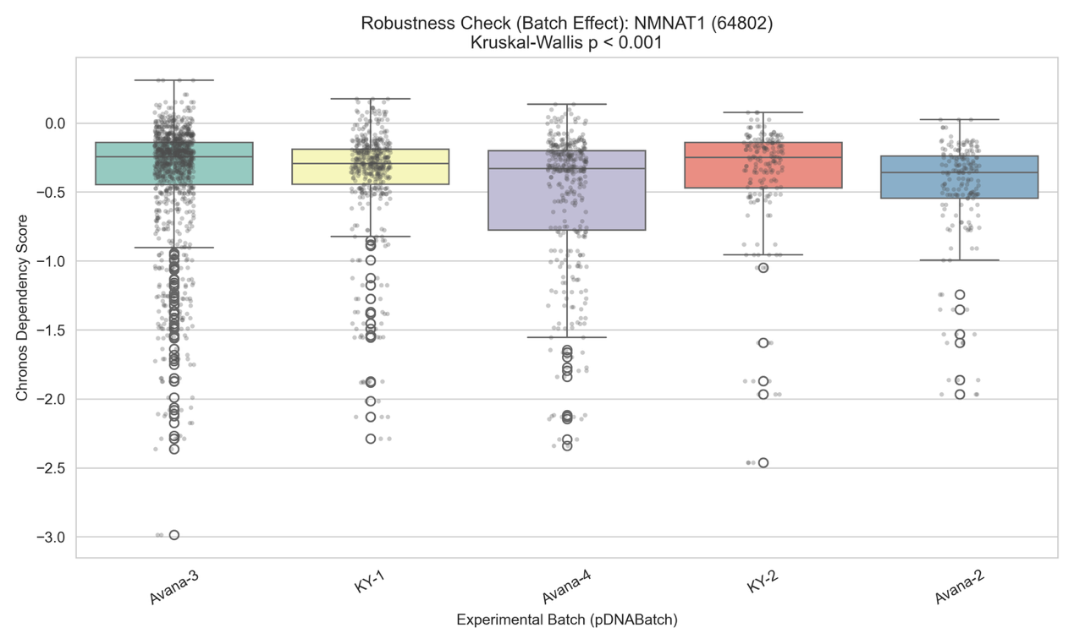
Fig. S2. Batch effect assessment for NMNAT1 across experimental batches.
Boxplots with individual data points showing the distribution of NMNAT1 (Entrez ID 64802) Chronos scores across the five major DepMap experimental batches (pDNABatch: Avana-3, KY-1, Avana-4, KY-2, Avana-2). Although the Kruskal-Wallis test detected statistically significant between-batch differences (p = 1.22 × 10⁻¹⁶), the effect size was small (η² = 0.036, indicating that batch variation accounts for approximately 3.6% of total score variance), and median dependency scores across batches fell within a narrow range (approximately −0.25 to −0.35), suggesting that batch variation is unlikely to materially confound the identified lineage-specific dependency signals..

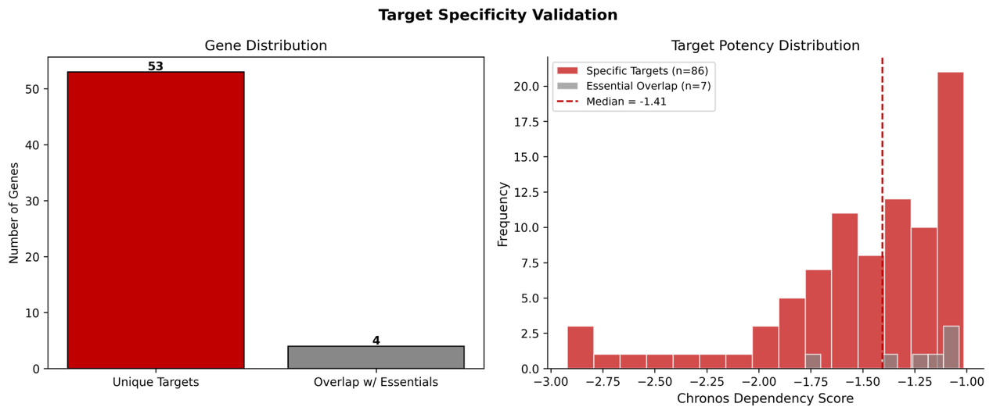
Fig. S3. Comparison of target genes against DepMap Common Essentials.
Left panel: Bar chart showing unique target genes with no overlap with Common Essentials (n = 53 genes, red) versus genes overlapping with the Common Essentials list (n = 4 genes, grey). Note that the 4 overlapping genes correspond to 7 gene–lineage pairs, as some genes are associated with dependencies in more than one lineage. Right panel: Histogram of Chronos dependency scores for lineage-specific dependency pairs from non-overlapping genes (n = 86 pairs, red) and pairs involving genes with any Common Essential overlap (n = 7 pairs, grey). The low gene-level overlap rate (4/57, 7%) and median Chronos score of −1.41 are consistent with the interpretation that identified targets represent lineage-restricted rather than universally cytotoxic vulnerabilities.

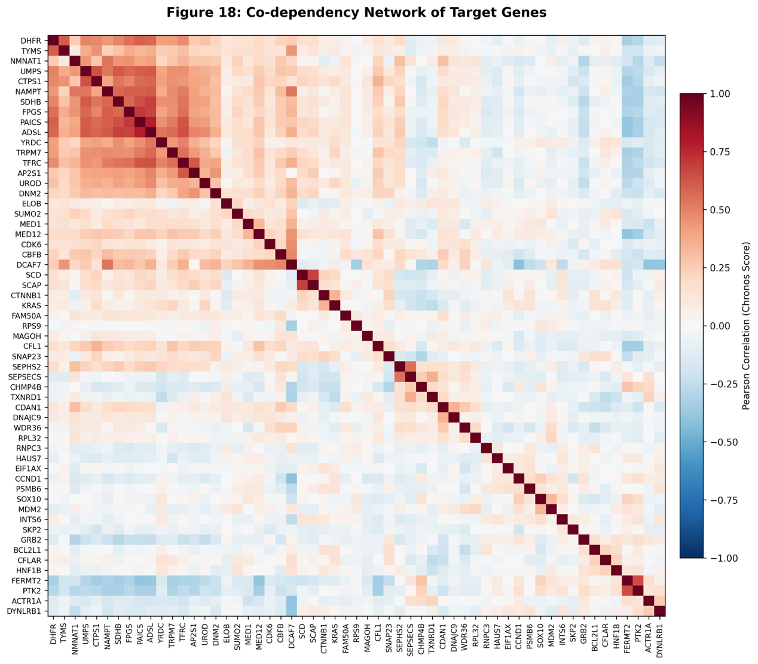
Fig. S4. Co-dependency heatmap of 57 lineage-specific target genes.
Pearson correlation matrix of Chronos scores across 1,208 cell lines for all 57 unique target genes, ordered by hierarchical clustering (Ward linkage). A prominent metabolic gene module is evident in the upper-left cluster, comprising DHFR, TYMS, NMNAT1, UMPS, CTPS1, NAMPT, SDHB, FPGS, PAICS, ADSL, and YRDC (Pearson r > 0.5). A functionally distinct cluster including SOX10, MDM2, CCND1, and PSMB6 shows low or negative correlations with the metabolic module, indicating mechanistically independent lineage-specific vulnerability programs. Color scale: red = positive correlation, blue = negative correlation.

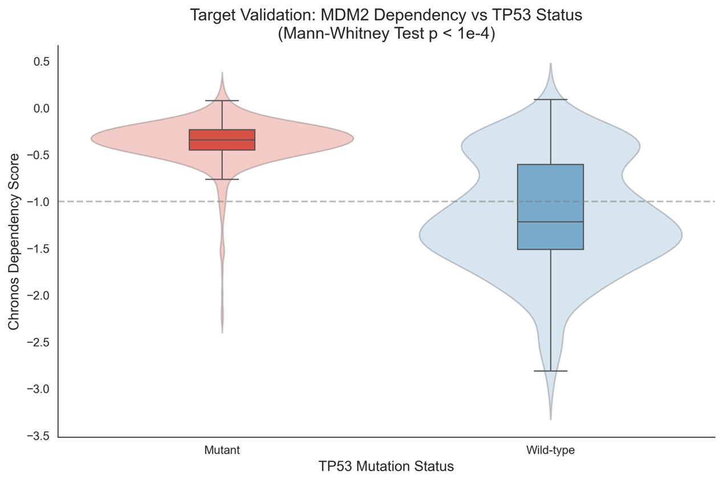
Fig. S5. MDM2 dependency stratified by TP53 mutation status.
Violin plots with embedded boxplots showing MDM2 Chronos dependency scores in TP53-mutant versus TP53 wild-type cell lines, based on OmicsSomaticMutations data. TP53 wild-type cells exhibit significantly deeper MDM2 dependency (lower Chronos scores, median ≈ −1.1) compared to TP53-mutant cells (median ≈ −0.35; Mann-Whitney p < 1 × 10⁻⁴). This result is mechanistically consistent with known TP53 biology: in TP53 wild-type cancers, MDM2 is the primary suppressor of p53-mediated apoptosis, rendering these cells highly dependent on MDM2 activity. Dashed line indicates the essentiality threshold (Chronos = −1.0).

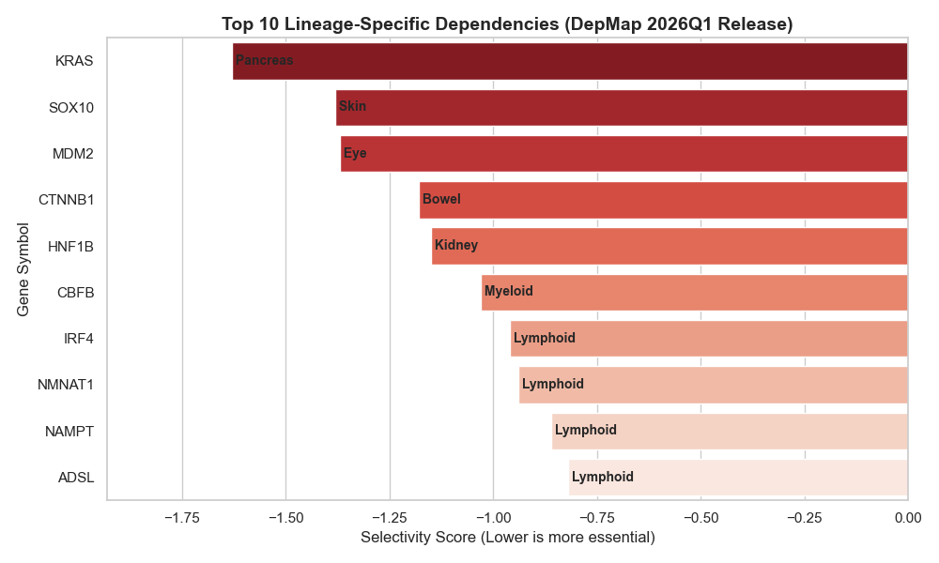
Fig. S6. Top 10 lineage-specific dependencies from DepMap 26Q1 release.
Horizontal bar chart displaying the 10 gene--lineage pairs with the strongest selectivity scores (most negative) among the 93 high-confidence pairs identified in this study. Bar color gradient (dark red to light red) reflects selectivity magnitude. Lineage labels are shown within each bar. KRAS (Pancreas, selectivity = −1.63) ranks first, followed by SOX10 (Skin) representing an established lineage-defining transcription factor, and MDM2 (Eye) reflecting a TP53-related dependency in uveal melanoma. NMNAT1, NAMPT, IRF4, and ADSL in Lymphoid lineage reflect the coordinated NAD and nucleotide metabolism vulnerability of hematological malignancies.

Table 1. High-confidence gene–lineage essentiality pairs identified by selectivity-based screening.
The table summarizes the top-ranked gene–lineage dependency pairs (Confidence: High/Medium). Selectivity scores represent the degree of lineage-restricted growth inhibition relative to the pan-cancer median Chronos score. P-values were adjusted using the Benjamini–Hochberg procedure (BH-FDR). (See Supplementary Table S1 for the full list of 93 pairs.)

Table 2. Clinical and survival metadata of the TCGA-PAAD cohort for dependency validation.
Note: This table presents the comprehensive clinical follow-up records for 183 patients with pancreatic adenocarcinoma (PAAD) obtained from the TCGA database.
Abbreviations: OS, Overall Survival; DSS, Disease-Specific Survival; DFI, Disease-Free Interval; PFI, Progression-Free Interval.
Data Integrity: Columns containing empty cells (particularly DFI and DFI.time) represent cases where specific clinical endpoints were not achieved (e.g., patients who did not reach a disease-free state post-treatment) or instances of incomplete longitudinal follow-up.
Usage: These data served as the clinical gold standard for validating the impact of identified lineage-specific dependency genes on patient prognosis using Kaplan-Meier survival analysis.

