Supplementary
Supplementary Table 1. Treatment-Related Adverse Events
System Organ Class / Preferred Term | All Grades  n (%) | Grade 1-2  n (%) | Grade 3-4  n (%)
Hematologic disorders
Platelet count decreased | 3 (14.3) | 3 (14.3) | 0
Neutrophil count decreased | 1 (4.8) | 1 (4.8) | 0
Vascular disorders
Hypertension | 5 (23.8) | 4 (19.0) | 1 (4.8)
Metabolism/Nutrition disorders
Hyperuricemia | 1 (4.8) | 1 (4.8) | 0
Gastrointestinal disorders
Diarrhea | 5 (23.8) | 5 (23.8) | 0
Skin/Subcutaneous disorders
Palmar-plantar erythrodysesthesia | 2 (9.5) | 2 (9.5) | 0
Rash | 2 (9.5) | 1 (4.8) | 1 (4.8)
Endocrine disorders
Hypothyroidism | 3 (14.3) | 3 (14.3) | 0
Respiratory disorders
Pneumonitis | 3 (14.3) | 2 (9.5) | 1 (4.8)
Hepatobiliary disorders
Hepatic function abnormal | 3 (14.3) | 3 (14.3) | 0
Investigations
Creatinine increased | 3 (14.3) | 3 (14.3) | 0
Weight decreased | 2 (9.5) | 2 (9.5) | 0
General disorders
Pyrexia | 2 (9.5) | 2 (9.5) | 0

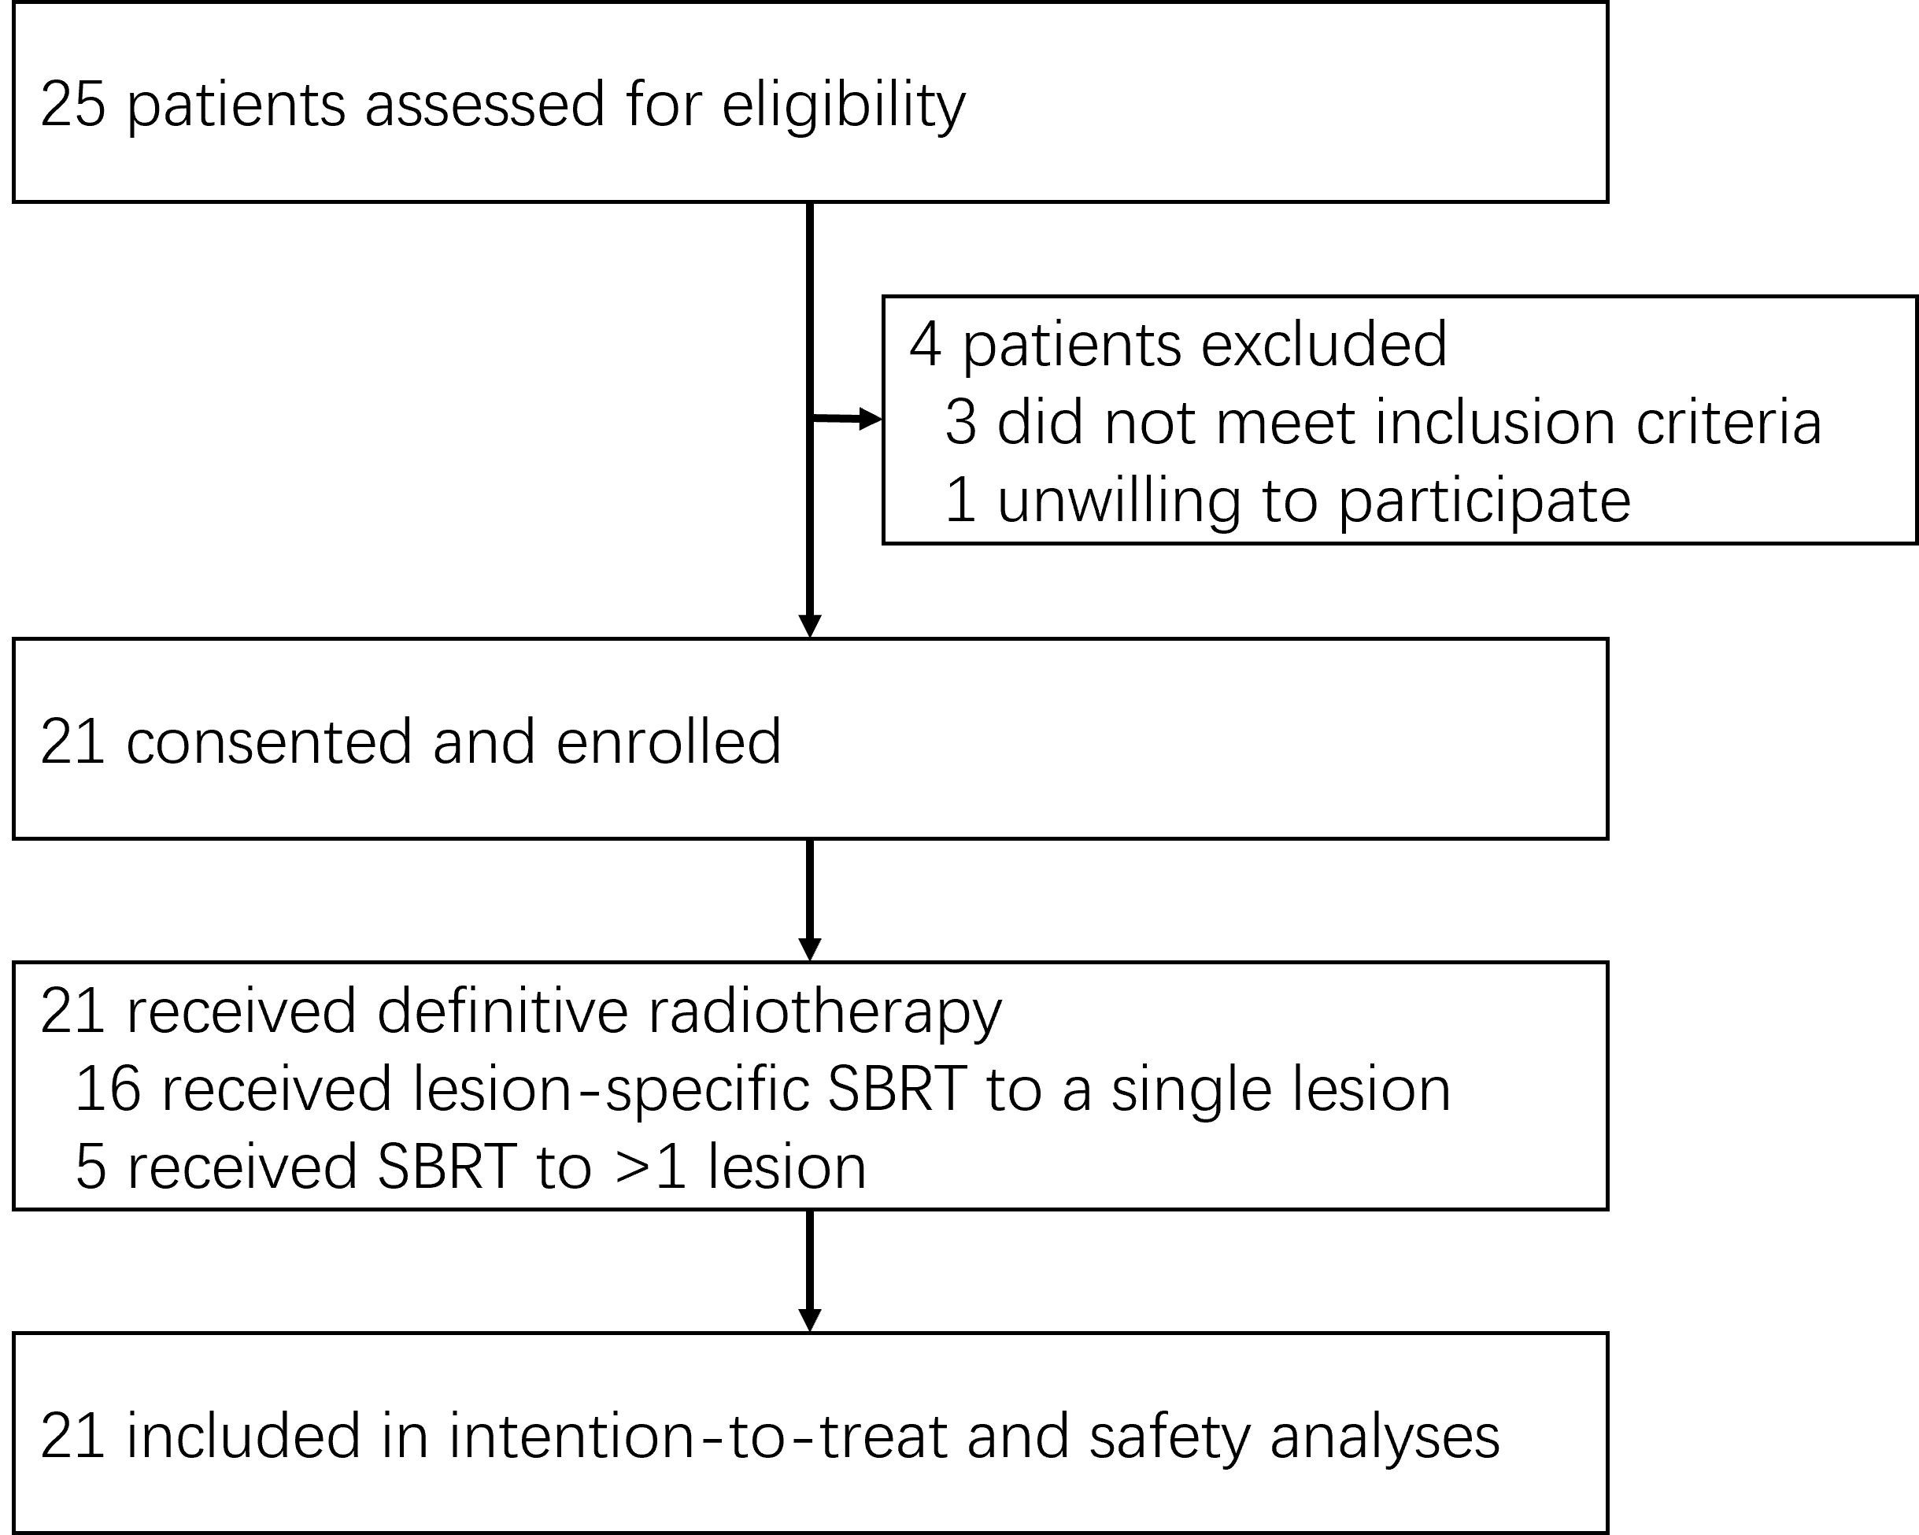
Supplementary Figure 1. Trial profile

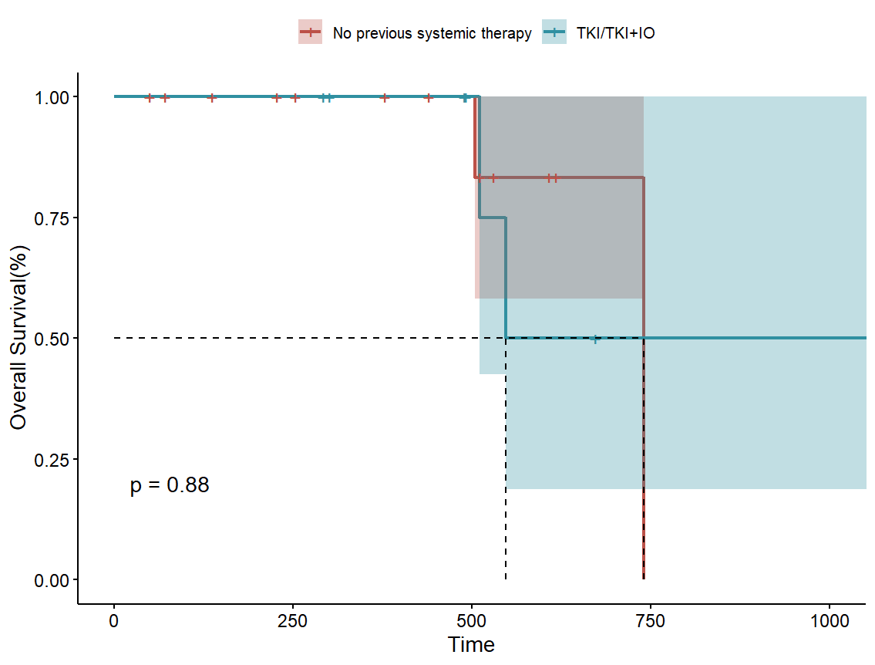
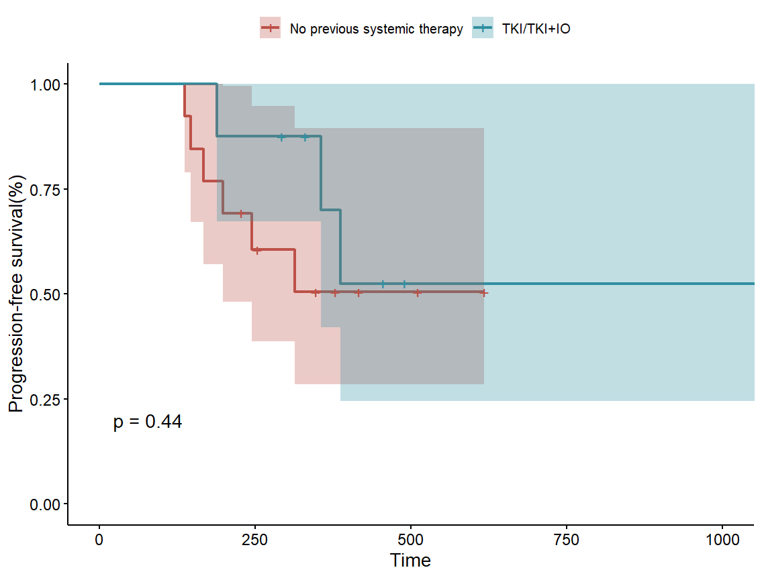
Supplementary Figure 2. Kaplan-Meier plots of (A) progression-free survival and (B) overall survival stratified by previous systemic therapy.
B
A

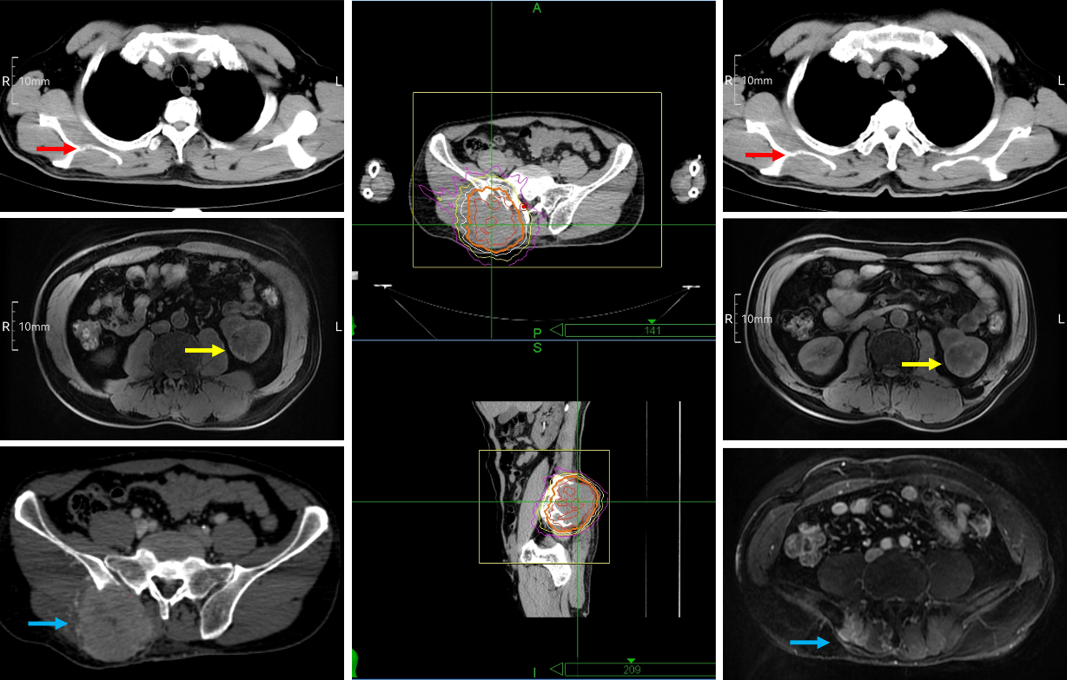
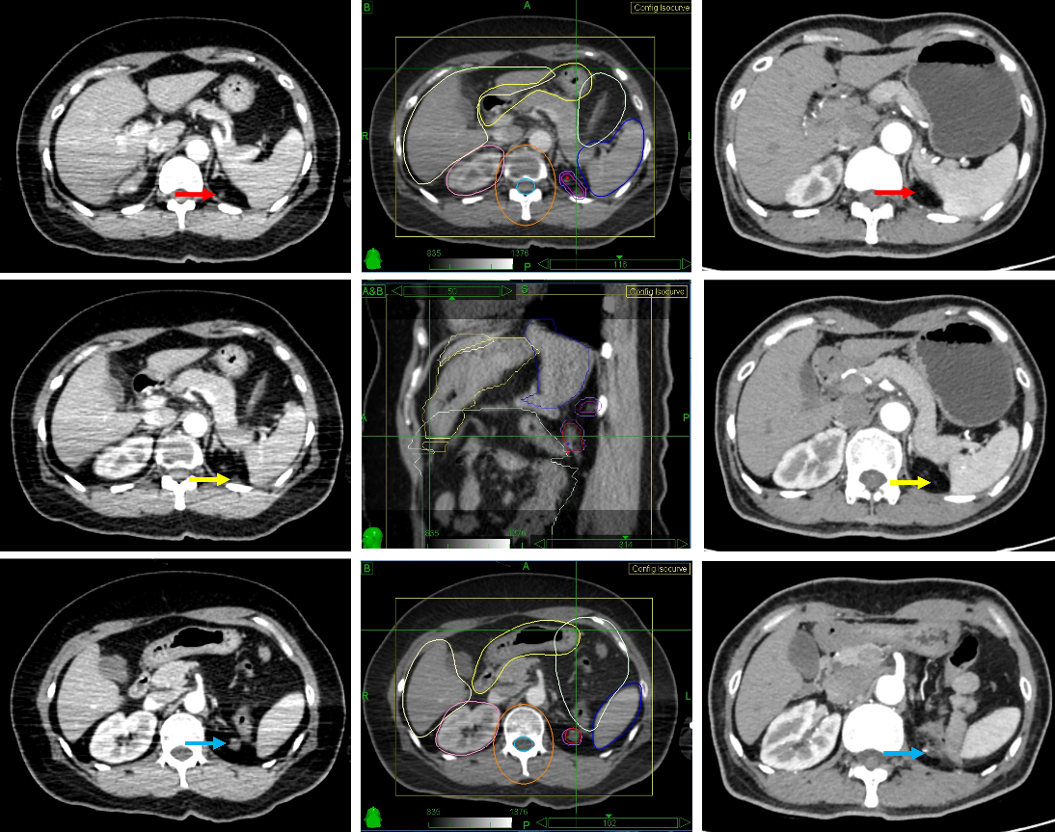
Supplementary Figure 3. Representative cases.
B. 59-year-old male demonstrating PR in an irradiated right sacroiliac metastasis (indicated by blue arrow), PR in a non-irradiated right scapular metastasis (indicated by red arrow), and SD in the primary renal tumor (indicated by yellow arrow) (Left: Pre-treatment; Center: Radiation dose distribution; Right: Post-treatment).
A. 48-year-old female with three lesions in the left renal post-nephrectomy bed: Two achieved CR (indicated by red and yellow arrows) and one SD (indicated by blue arrows) following SBRT and systemic therapy, with no distant progression (Left: Pre-treatment; Center: Radiation dose distribution; Right: Post-treatment).

