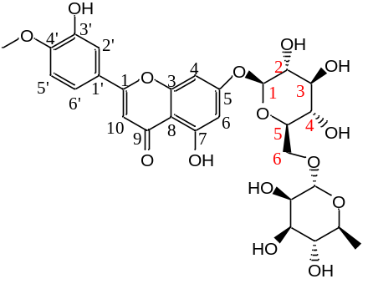
Fig. S1 The molecular structure of diosmin. Diosmin is a flavonoid glycoside. It is comprised of diosmetin and rutinose by linkage of the C5-hydroxyl group of diosmetin and C1-hydroxyl group of glucose.

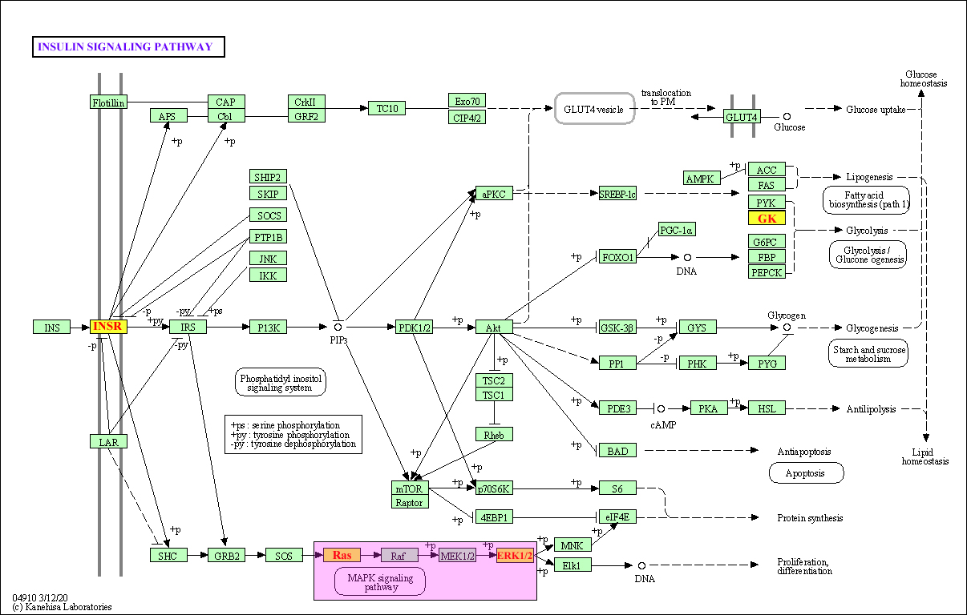
(B)
(A)
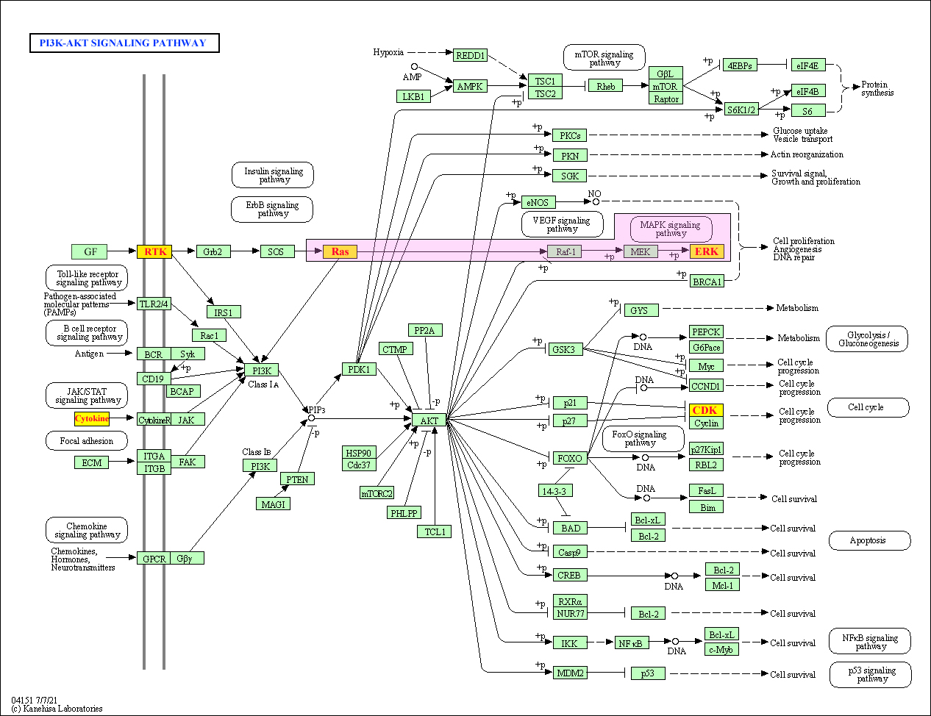
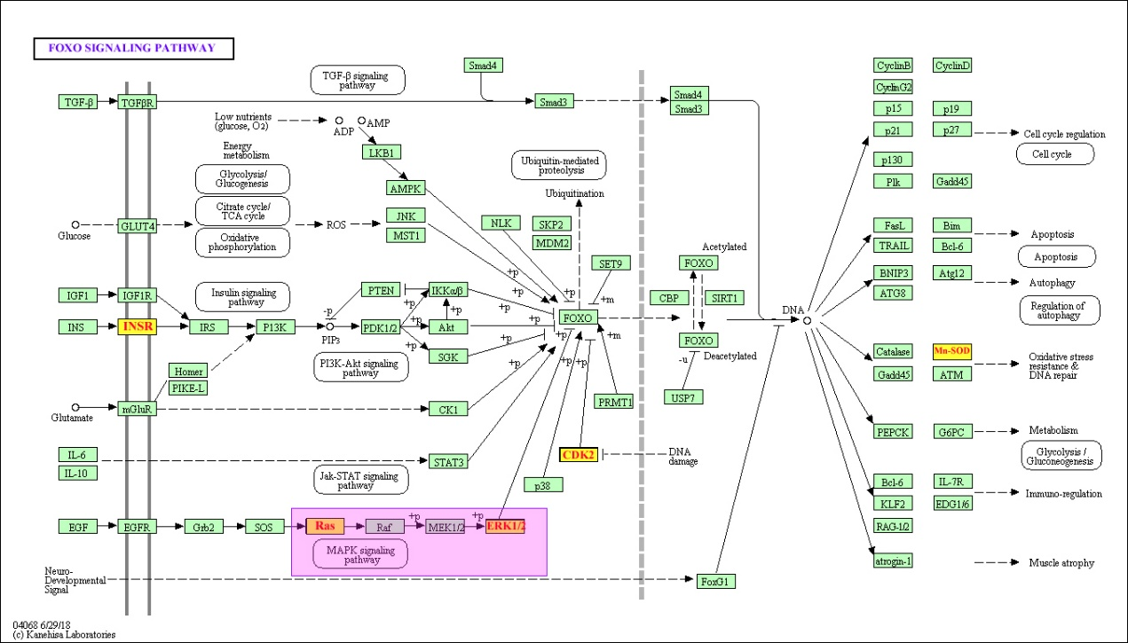
(C)
Fig. S2 Three significant pathways identified by KEGG analysis. (A) Insulin signaling pathway, (B) PI3K-Akt signaling pathway, (C) FOXO signaling pathway

