Supporting information
Design Principles for Methane Valorization Catalysts From Zeolite Topology and Aluminum Siting

Peipei Xiao,ª Hiroto Toyoda,ª Lizhuo Wang,^{b} Yuqin Sun,ª Jun Huang,^{b} Yong Wang,ª Toshiyuki Yokoi*^{a,c}

ª Institute of Integrated Research, Institute of Science Tokyo, 4259 Nagatsuta, Midori-ku, Yokohama 226-8501, Japan
^{b} School of Chemical and Biomolecular Engineering, the University of Sydney, Sydney, New South Wales 2006, Australia
^{c} iPEACE223 Inc., Konwa Building, 1-12-22 Tsukiji, Chuo-ku, Tokyo, 104-0045, Japan

E-mail: yokoi.t.d435@m.isct.ac.jp

Experimental Section
Catalyst preparation
Aluminosilicate FER zeolites with varying SiO₂/Al₂O₃ molar ratios (SAR) were synthesized following a reported procedure using pyridine as the organic structure-directing agent (OSDA).¹ The following raw materials were used as received: sodium aluminate (NaAlO₂, Wako Pure Chemical Industries, Ltd.) as the aluminum source, sodium hydroxide (NaOH, Wako Pure Chemical Industries, Ltd.) as the alkali source, Cab-O-Sil M5 (Cabot) as the silica source, pyridine (99.5 wt%, Wako Pure Chemical Industries, Ltd.) as the OSDA, and sodium fluoride (NaF, 99.0 wt%, Wako Pure Chemical Industries, Ltd.) as the fluoride source. The solid product was recovered by centrifugation, washed repeatedly with deionized water, and dried at 100 °C overnight. The as-synthesized samples were denoted as-FER(Py)-SAR, where SAR corresponds to the Na₂O/SiO₂ molar ratio in the initial gel. Pyridine was removed by calcining as-FER(Py)-SAR at 550 °C for 10 h to obtain calcined samples denoted as cal-FER(Py)-SAR. The protonated form, FER(Py)-SAR, was prepared by ion-exchanging cal-FER(Py)-SAR with 2.5 M NH₄NO₃ solution at 80 °C (solid-to-liquid ratio of 1 g per 100 mL), followed by calcination at 550 °C for 5 h in air.
TON-type zeolites were prepared according to a literature procedure to investigate morphology effects.² A bundle-shaped ZSM-22 zeolite was synthesized hydrothermally using ethanol as a co-solvent. In a typical synthesis, potassium hydroxide and aluminum sulfate were dissolved in deionized water under stirring to form a clear solution. Then, a solution of 1,6-diaminohexane (DAH) and silica sol were successively added, and the mixture was stirred for 30 min. Ethanol was subsequently introduced and stirring continued for an additional hour. The resulting homogeneous gel, with a molar composition of 1.0 SiO₂ : 0.12 K₂O : 0.0125 Al₂O₃ : 0.3 DAH : 40 H₂O : 3 EtOH, was transferred into a stainless-steel autoclave and subjected to hydrothermal treatment at 160 °C for 48 h under stirring. After crystallization, the solid product was recovered by filtration, washed thoroughly with deionized water, dried overnight at 100 °C, and calcined at 550 °C for 10 h in air. The protonated form, ZSM-22(EtOH), was obtained via ion exchange with 2.5 M NH₄NO₃ solution at 80 °C, followed by calcination at 550 °C in air for 5 h.
For comparison, a conventional ZSM-22 zeolite was also synthesized through hydrothermal treatment of an aluminosilicate gel with the composition 1.0 SiO₂ : 0.12 K₂O : 0.014 Al₂O₃ : 0.3 DAH : 40 H₂O (without ethanol).³ The synthesis was carried out at 160 °C for 48 h in a stirred autoclave under autogenous pressure. The solid product was filtered, washed extensively with deionized water, and dried at 100 °C. The template was removed by calcination in air at 550 °C for 10 h, yielding the calcined sample denoted as cal-ZSM-22(DAH). The protonic form, ZSM-22(DAH), was obtained by ion exchange with 2.5 M NH₄NO₃ solution at 80 °C, followed by drying at 100 °C overnight and final calcination at 550 °C for 5 h.
The ZSM‑5 zeolite was synthesized according to our previously reported procedure.⁴ In a typical synthesis, colloidal silica (Ludox HS‑40, Sigma‑Aldrich), aluminum nitrate nonahydrate (Al(NO₃)₃.9H₂O, Wako, 99.9%), and tetrapropylammonium hydroxide (TPAOH, 40% aqueous solution, Alfa Aesar) were used as the silica source, aluminum source, and structure‑directing agent, respectively. A precursor gel with a molar composition of 1.0 SiO₂ : 0.02 Al₂O₃ : 0.25 TPAOH : 27 H₂O was prepared. The gel was aged at 80 °C for 24 h, followed by crystallization at 170 °C for 7 days under static conditions. The resulting solid product was recovered by centrifugation, washed thoroughly with deionized water, and dried overnight at 100 °C. The organic template was removed by calcination in static air at 550 °C for 10 h, yielding the calcined sample denoted as cal-ZSM-5(TPA). The protonic form, ZSM-5(TPA), was subsequently obtained through three repeated ion-exchange steps with a 2.5 M NH₄NO₃ solution (80 °C, 3 h each), followed by drying at 100 °C overnight and a final calcination at 550 °C for 5 h in air.

Catalyst characterization
The XRD pattern was collected using a Rint-Ultima III (Rigaku) with a Cu Kα X-ray source (40 kV, 40 mA).
Elemental analyses of the samples were conducted using an inductively coupled plasma-atomic emission spectrometer (ICP-AES, Shimadzu ICPE-9000).
The Na content of the products was determined using an atomic absorption spectrometer (AAS, Shimadzu AA-6200).
Field-emission scanning electron microscopy (FE-SEM) images of the powder samples were obtained using a SU9000 microscope (Hitachi) operating at 1 kV.
High-angle annular dark field scanning transmission electron microscopy (HAADF-STEM) imaging, integrated differential phase contrast STEM (STEM-iDPC) imaging, and energy dispersive spectrometry (EDS) mapping were conducted using a FEI Themis Z microscope equipped with an XFEG field electron source and a double aberration corrector, operating at 300 keV. The HAADF-STEM images were acquired with a camera length of 115 mm while the beam convergence was 25.1 mrads. The pixel size is 37 pm, and the dwell time is 2 us/pixel. The collection angle of the HAADF detector was set to 48–200 mrads. High-resolution transmission electron microscopy (HRTEM) images were acquired on the same instrument operated at 300 keV.
Solid-state ²⁷Al MAS NMR spectra were measured on a JEOL ECA-600 spectrometer at a resonance frequency of 156.4 MHz using a 4 mm sample rotor with a spinning rate of 15.0 kHz. The ²⁷Al chemical shift was referenced to -0.54 ppm of AlNH₄(SO₄)₂·12H₂O.
²⁷Al MQMAS NMR spectra were measured using the same equipment and obtained through a three-pulse sequence employing a z-filter. The lengths of the triple quantum excitation and conversion pulses were optimized to 3.4 and 1.8 μs, respectively, while the length of the selective pulse was set to 15.0 μs. A series of 512 t1 slices were collected using 2000 FIDs with a recycling delay of 0.1 s for each slice. The ²⁷Al single pulse MAS spectra were decomposed into three components, and the fitting values, including the averaged isotropic chemical shift δ_{iso}, the width of the Gaussian distribution of δ_{iso} (ΔCS), and the averaged quadrupolar coupling constant CQ were determined using the ‘‘Dmfit’’ program applying a simple Czjzek model.
The solid-state ²⁹Si MAS NMR and ²⁹Si CP MAS NMR spectra were acquired using a JEOL ECA-600 spectrometer (14.1 T) equipped with an additional 1 kW power amplifier. The ²⁹Si chemical shift was referenced to −34.12 ppm of polydimethylsiloxane (PDMS). The samples were spun at 15 kHz by using a 4 mm ZrO₂ rotor.
The solid-state ¹H MAS NMR spectra were acquired using a JEOL ECA-600 spectrometer (14.1 T) equipped the Hahn-echo pulse sequence (π/2−τ–π–τ–acquisition) with π/2 pulse length of 5 μs and echo delay τ of 200 μs was applied, and 16 scans were acquired with a 60 s repetition delay.
The ¹³C CP MAS NMR spectra of the spent zeolites after the valorization of methane were acquired using a JEOL ECA-600 spectrometer equipped with an additional 1 kW power amplifier. The chemical shifts were referenced to adamantane with the unfiled methine peak at 28.5 ppm. 65536 scans were accumulated with a p/4 pulse width of 1.8 ms and a 4 s recycle delay.
Temperature-programmed ammonia desorption (NH₃-TPD) profiles were recorded using Multitrack TPD equipment (Japan BEL). Typically, 25 mg of catalyst was pretreated at 600 ºC in a helium flow (50 mL min⁻¹) for 1 h and then cooled to 100 ºC. Before the adsorption of NH₃, the sample was evacuated at 100 ºC for 1 h. Approximately 2500 Pa of NH₃ was allowed to contact the sample at 100 °C for 10 min. Subsequently, the sample was evacuated at the same temperature for 30 min to remove weakly adsorbed NH3. Finally, the sample was cooled to 100 ºC and then heated from 100 to 600 ºC at a ramping rate of 10 ºC min⁻¹ in a He flow (50 mL min⁻¹). A thermal conductivity detector (TCD) was used to monitor desorbed NH₃. The amount of acid sites was determined by fitting the peak area of the profiles.
Nitrogen adsorption and desorption measurements were conducted at -196 °C on a Belsorp-mini II (MicrotracBEL) to obtain information on micro- and mesoporosities.
The amount of carbon deposited in the spent samples was determined by measuring the weight loss from 250 to 800 °C using a thermogravimetric (TG) profile. This analysis was conducted on a thermogravimetric-differential thermal analyzer (TG-DTA, Rigaku Thermo plus EVO II).
The CO adsorption Fourier-transform infrared (FTIR) spectroscopy was conducted using a JASCO 4100 FTIR spectrometer equipped with a triglycine sulfate (TGS) detector. Infrared (IR) spectra of the clean disk were recorded in a vacuum at -120 °C to obtain the background spectrum. The sample was pressed into a self-supporting disk (20 mm in diameter, weighing 30−60 mg) and placed in an IR cell connected to a closed gas circulation system. The sample was pretreated by evacuation at 500 °C for 1 h, followed by adsorption of CO at pressures ranging from 5 to 500 Pa at -120 °C.
The IR spectra of adsorbed pyridine were recorded as follows: a self-supported wafer (9.6 mg cm⁻² in thickness and 2 cm in diameter) was set in a quartz IR cell, sealed with CaF2 windows, and then was evacuated at 773 K for 1 h before the pyridine adsorption. The adsorption was carried out by exposing the wafer to pyridine vapor (0.3 kPa) at 423 K for 0.5 h. The physiosorbed pyridine was then removed by evacuation at 423 K for 1 h. The FTIR spectrum was recorded at 423 K.
The in-situ diffuse reflectance infrared Fourier transform spectroscopy (DRIFTS) experiment was performed using an FTIR spectrometer (JASCO, FTIR-4600) with an MCT detector. First, the catalyst was treated under Ar flow (500 mL/min) at 500°C for 1 h, then cooled to 350°C. The background spectrum was obtained at 350 ºC in Ar flow. Then, the catalyst sample was exposed to a CH₄/N₂O/Ar mixture (5 mL/min CH₄, 5 mL/min N₂O, 500 mL/min Ar), and the spectrum was recorded at 0-20 min.

Catalytic tests

Direct oxidation of methane reaction
Continuous methane oxidation was conducted in a fixed-bed flow reactor. Typically, 100 mg of catalyst pellets (500–1000 μm) were loaded into a quartz tube reactor (ID 4 mm) housed in an electric furnace. After pretreatment in flowing air at 500 °C for 1 h, reactions were performed at 350 °C. Effluent gases were analyzed using two online GC systems (Shimadzu GC-2014):
- GC-TCD: Equipped with a Shincarbon ST 50/80 packed column (3 mm × 6 m) and TCD with methanizer, quantifying H₂, N₂O, CO, CO₂, and CH₄.
- GC-FID: Equipped with an HP-PLOT Q capillary column (0.53 mm × 30 m × 40 μm) and FID, quantifying CH₄, methanol (MeOH), dimethyl ether (DME), olefins/alkanes.
Carbon-based metrics were calculated as follows:
Methane Conversion (X_{CH4}):
X_{CH4} =$\frac{∑\left(ni​⋅Ci​\right)}{∑\left(ni​⋅Ci​\right)+nCH4​}×100\%$
where ni= carbon number in product i, Ci = molar flow rate of i (μmol·min⁻¹), n_{CH4} = unconverted CH₄ flow rate.
N₂O Conversion (X_{N2O}):
X_{N2O} =$\frac{nN2O,in-nN2O, out}{nN2O,in}×100\%$
Product Selectivity (Si):
S_{i} =$\frac{ni*Ci}{\sum{(nj*Cj)}}×100\%$
Product Yield (Yi):
Y_{i} =$\frac{ni*Ci}{\sum{(nj*Cj)+nCH4}}×100\%=$X_{CH4}⋅S_{i}
Formation Rate (ri):
r_{i} =$\frac{Yi *FCH4}{mcat}$
where F_{CH4}, in = inlet CH₄ flow rate (μmol·min⁻¹), m_{cat} = catalyst mass (g), r_{hydrocarbons}= 2*(r_{C2}⁼ + r_{C2}) + 3*(r_{C3}⁼ + r_{C3}) + 4*(r_{C4}⁼ + r_{C4}) + 5*(r_{C5}⁼ + r_{C5}).

Catalytic test in the methanol to olefins (MTO) reaction
The MTO reaction was performed using a fixed-bed reactor connected to an online gas chromatograph (GC-2014, Shimadzu) equipped with an HP-PLOT/Q capillary column and a flame ionization detector. The 100 mg 50/80 mesh zeolite pellets without a binder were placed in a 6 mm quartz tubular flow reactor. The pretreatment was conducted at 500 °C for 30 min under Ar (20 mL·min⁻¹). After the pretreatment, the reactor was cooled to 350 °C, and the MTO reaction commenced. The pressure of methanol was set at 10 kPa with Ar gas as the carrier; the weight-to-feed ratio (W/F) for methanol was set at 34 g·h·mol⁻¹. The product stream was analyzed using a system that automatically injected the product into a gas chromatograph connected directly to the outlet of the reactor via a heated transfer line.
The conversion and selectivity were calculated as follows:
𝐶𝑜𝑛𝑣𝑒𝑟𝑠𝑖𝑜𝑛 𝑜𝑓 𝑚𝑒𝑡ℎ𝑎𝑛𝑜𝑙 [%] = 1 ‒ 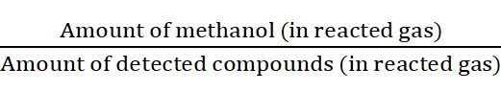 × 100
𝑃𝑟𝑜𝑑𝑢𝑐𝑡 𝑠𝑒𝑙𝑒𝑐𝑡𝑖𝑣𝑖𝑡𝑦 [%] = 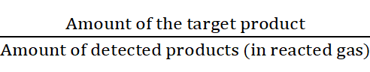 × 100

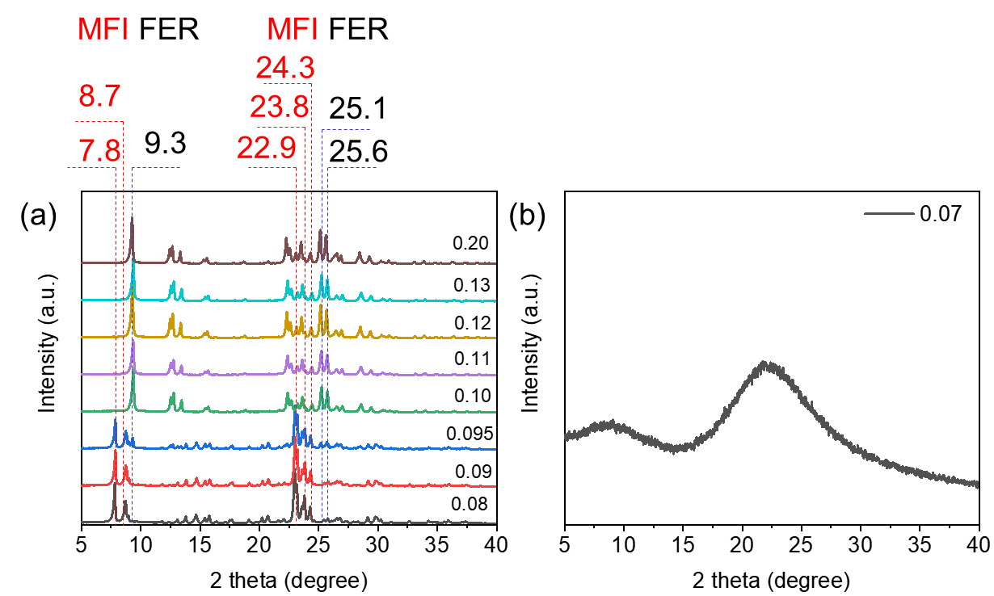
Supplementary Fig. S1 (a) XRD patterns of the as-synthesized zeolites with Na₂O/SiO₂ ratio in the synthesis gel varied from 0.08 to 0.20. (b) XRD pattern of the as-synthesized zeolite with Na₂O/SiO₂ ratio in the synthesis gel of 0.07.
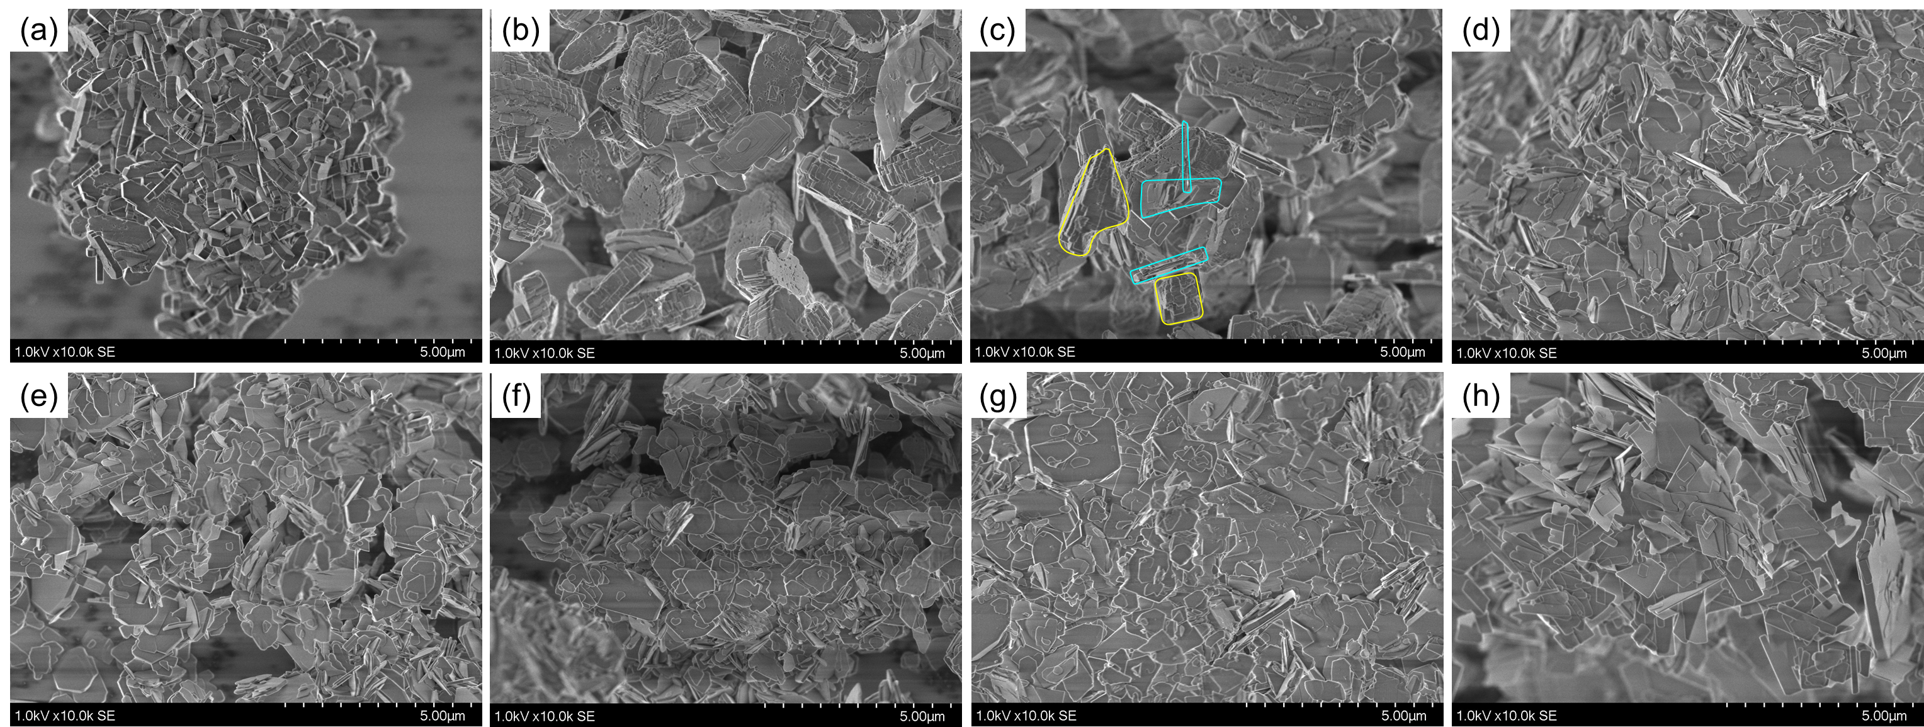
Supplementary Fig. S2 SEM images under smaller magnification for zeolites with Na₂O/SiO₂ ratios in the synthesis gel of (a) 0.08, (b) 0.09, (c) 0.095, (d) 0.10, (e) 0.11, (f) 0.12, (g) 0.13, and (h) 0.20.
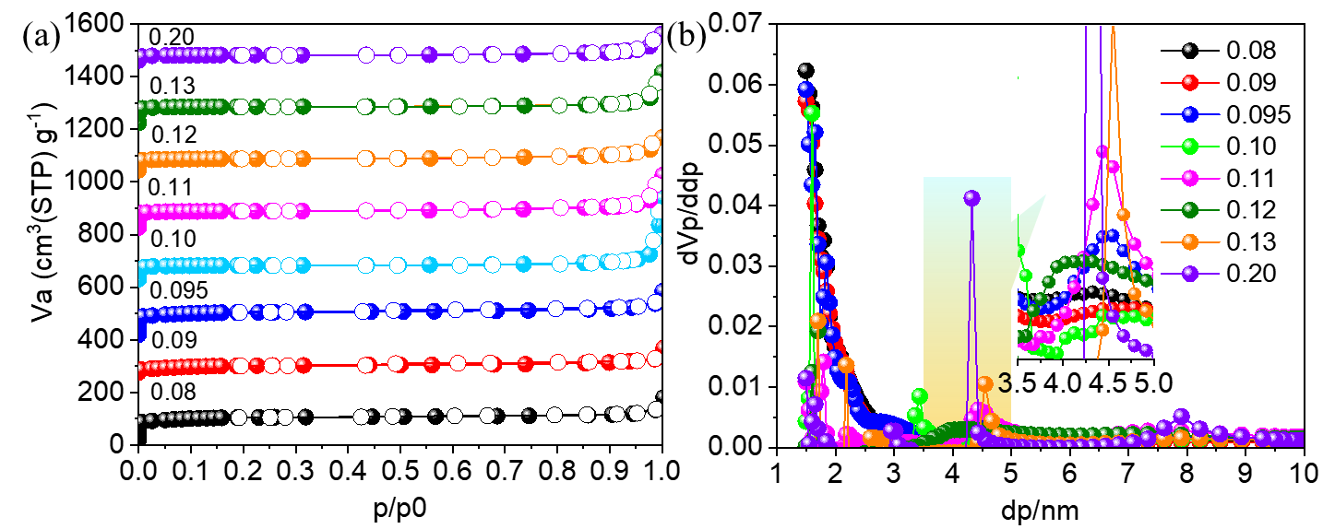
Supplementary Fig. S3 (a) N₂ adsorption and desorption isotherms and (b) pore size distributions calculated from the adsorption branch of the isotherms by the BJH method for zeolites with Na₂O/SiO₂ ratios varying from 0.08 to 0.20. The isotherms for Z(Py)-0.09, Z(Py)-0.095, Z(Py)-0.10, Z(Py)-0.11, Z(Py)-0.12, Z(Py)-0.13, Z(Py)-0.20 were offset vertically by 200, 400, 600, 800, 1000, 1200 and 1400 cm³·g⁻¹, respectively.
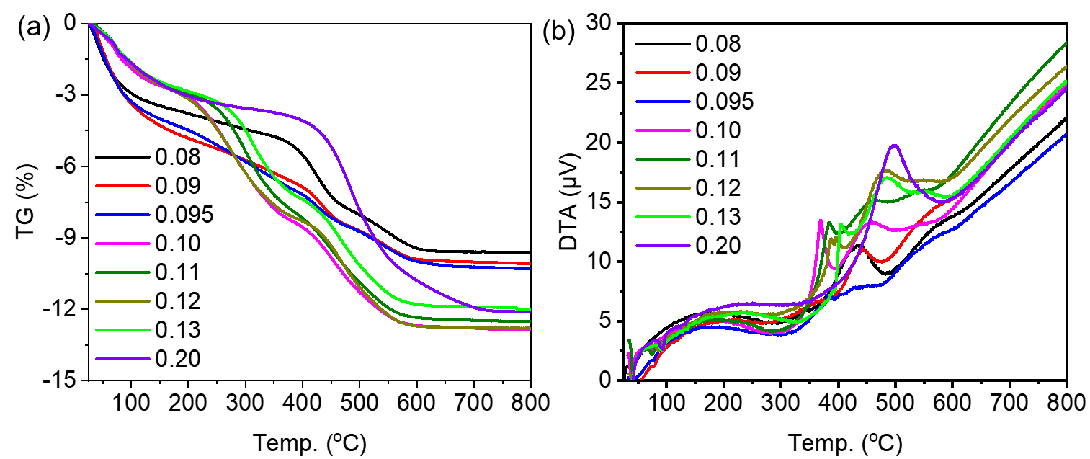
Supplementary Fig. S4 (a) TG analysis and (b) DTA curves of the as-synthesized zeolites.
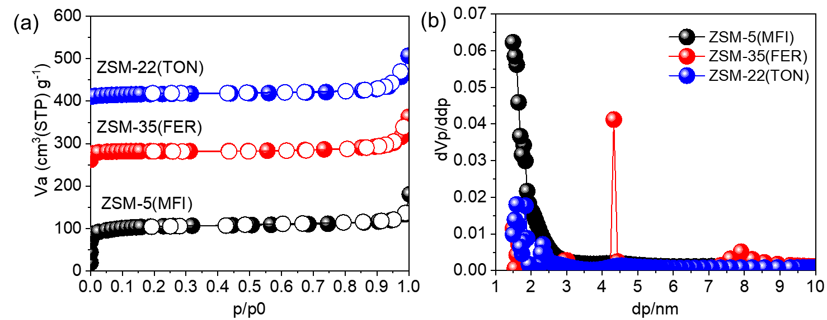
Supplementary Fig. S5 (a) N₂ adsorption and desorption isotherms and (b) pore size distributions calculated from the adsorption branch of the isotherms by the BJH method for ZSM-5, ZSM-35, and ZSM-22 zeolites. The isotherms for ZSM-35 and ZSM-22 were offset vertically by 200 and 400 cm³·g⁻¹, respectively.
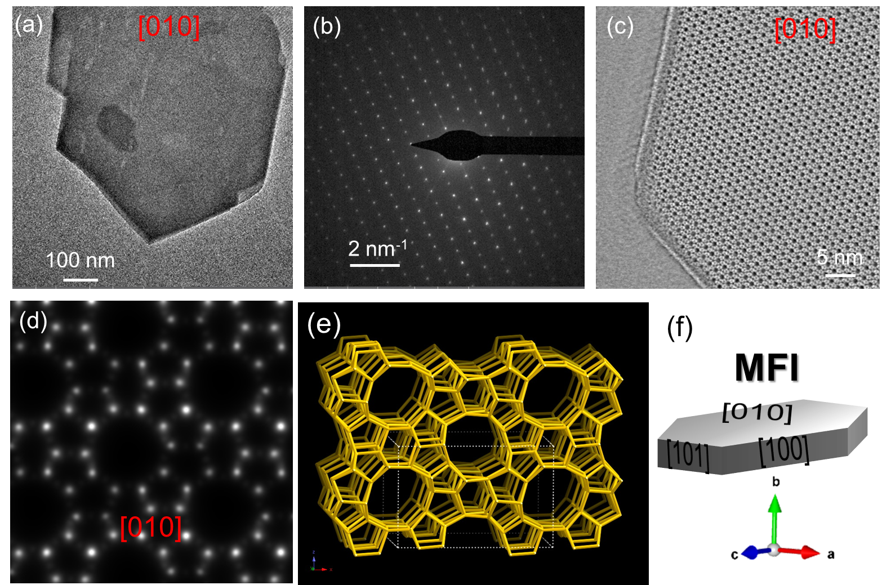
Supplementary Fig. S6 (a) HRTEM image with exposed facets of [010] plane, (b) SAED pattern corresponding to the [010] plane, and (c) iDPC-STEM image on the [010] plane of the ZSM-5 sample. (d) Simulated [010] projection of the MFI framework structure. (e) framework type MFI viewed along [010]. (f) Schematic model of ZSM-5(MFI) crystal.
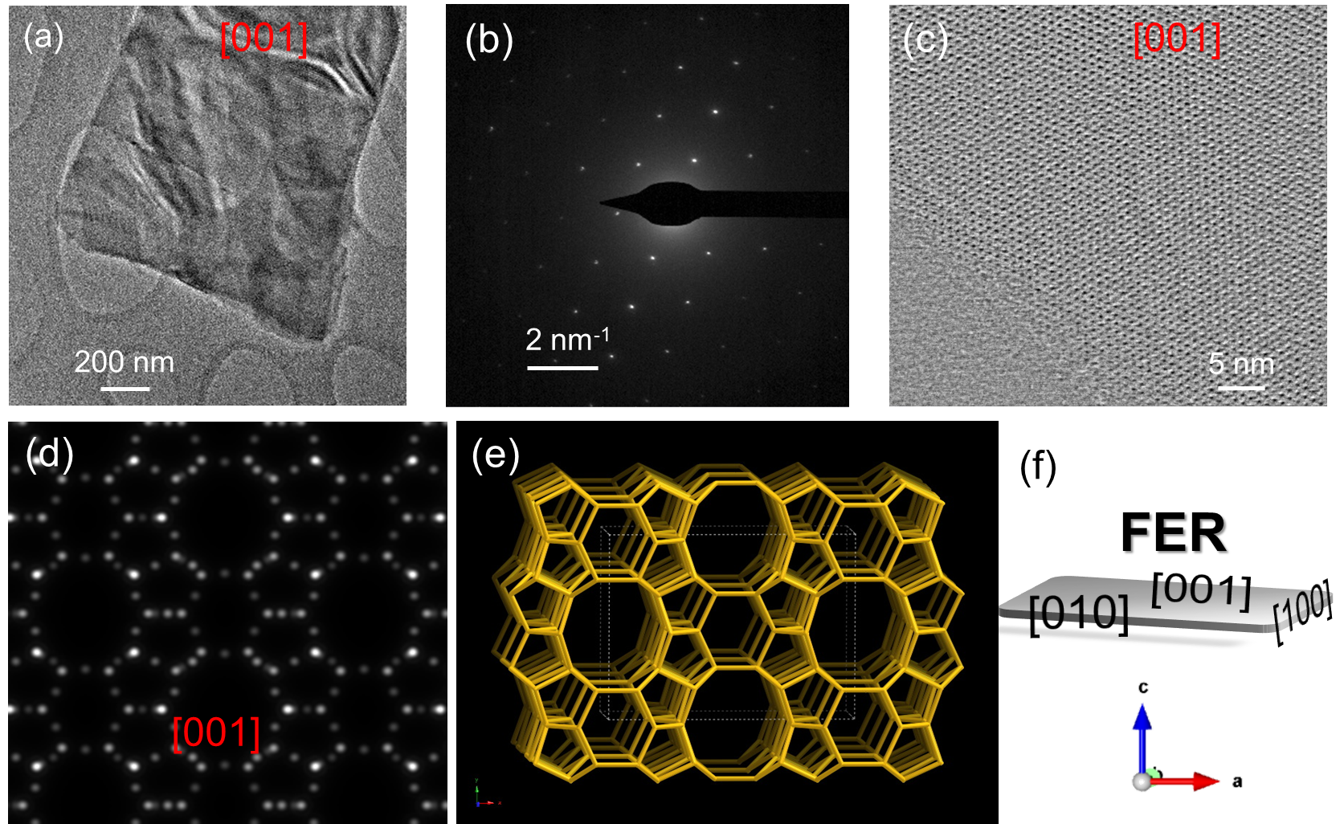
Supplementary Fig. S7 (a) HRTEM image with exposed facets of [001] plane, (b) SAED pattern corresponding to the [001] plane, and (c) iDPC-STEM image on the [001] plane of the ZSM-35 sample. (d) Simulated [001] projection of the FER framework structure. (e) framework type FER viewed along [001]. (f) Schematic model of ZSM-35 (FER) crystal.
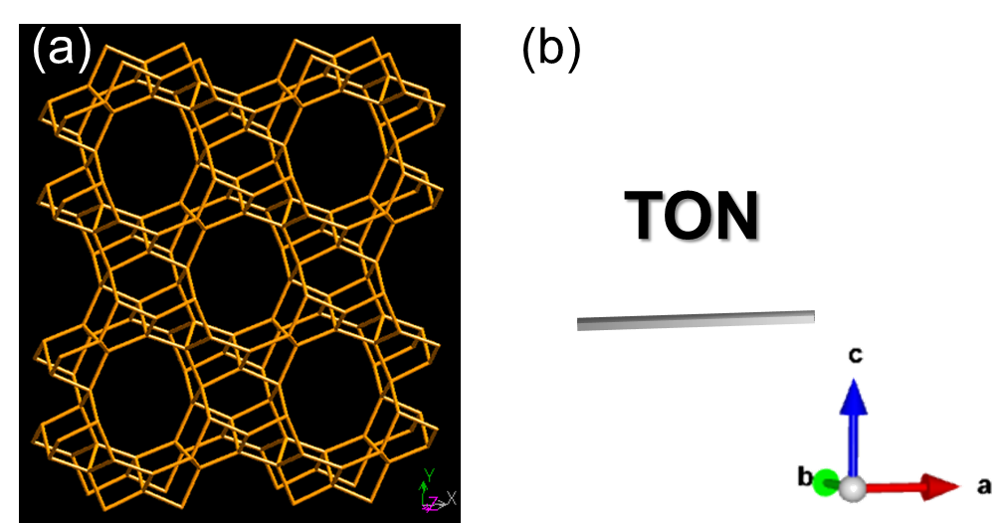
Supplementary Fig. S8 (a) framework type TON viewed along [001]. (b) Schematic model of ZSM-22 (TON) crystal.
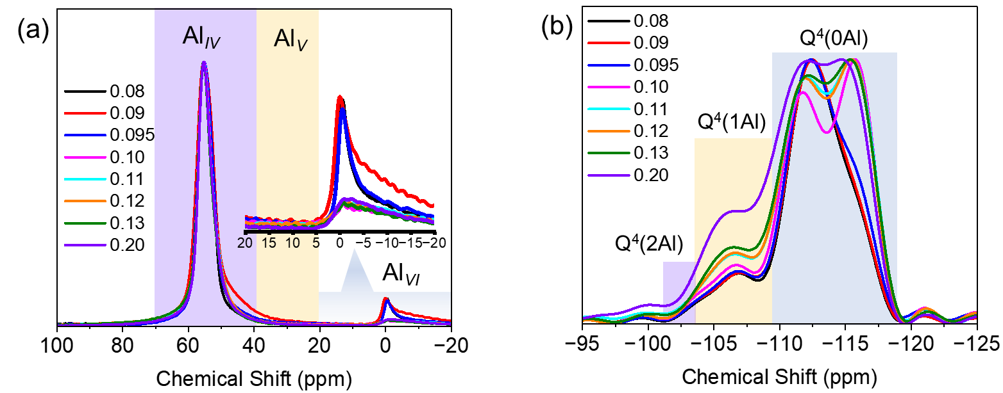
Supplementary Fig. S9 (a) ²⁷Al MAS NMR spectra and (b) ²⁹Si MAS NMR spectra of as-Z(Py)-x zeolites synthesized with Na₂O/SiO₂ ratios ranging from 0.08 to 0.20.
Supplementary Fig. S10 ²⁹Si CPMAS NMR spectra for as-synthesized zeolites with varied Na₂O/SiO₂ ratios in the synthesis gel of 0.08, 0.095, and 0.12.
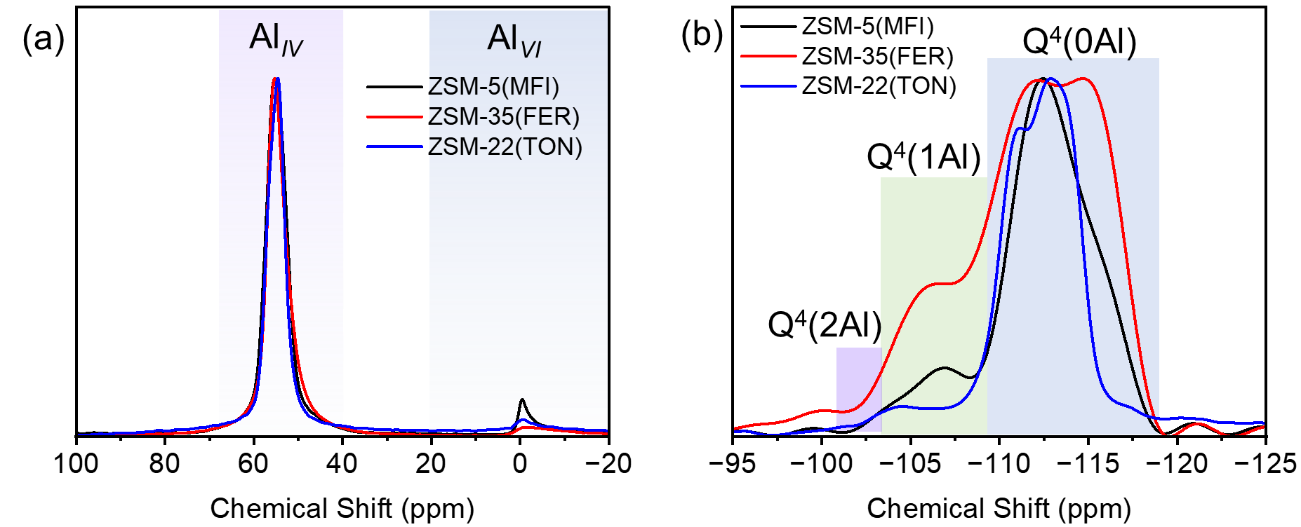
Supplementary Fig. S11 (a) ²⁷Al MAS NMR spectra and (b) ²⁹Si MAS NMR spectra of H-form zeolites.
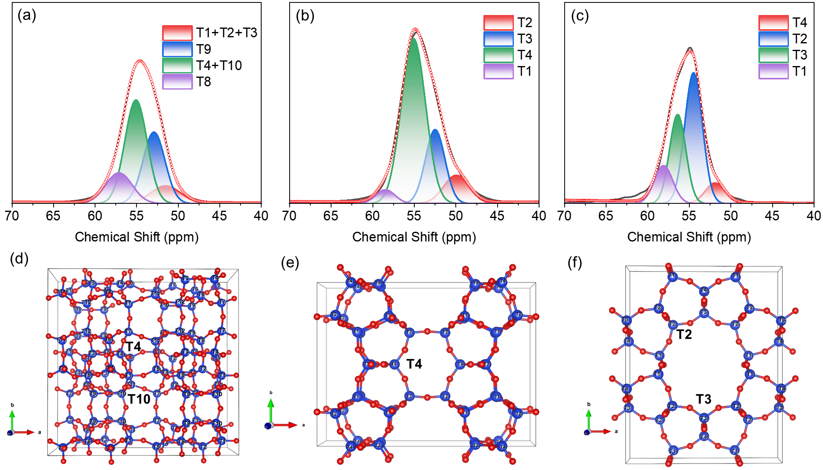
Supplementary Fig. S12 Deconvolution of ²⁷Al MAS NMR spectra for (a) ZSM-5, (b) ZSM-35, and (c) ZSM-22. The preferential location of Al atoms in (d) ZSM-5, (e) ZSM-35, and (f) ZSM-22 zeolites.
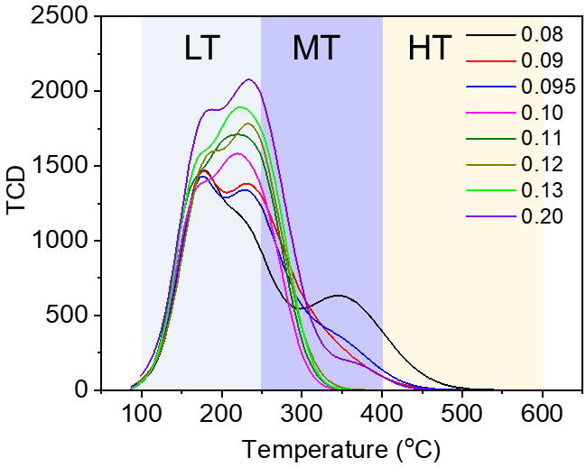
Supplementary Fig. S13 NH₃-TPD curves of calcined zeolites with Na₂O/SiO₂ ratios in the synthesis gel varying from 0.08 to 0.20.
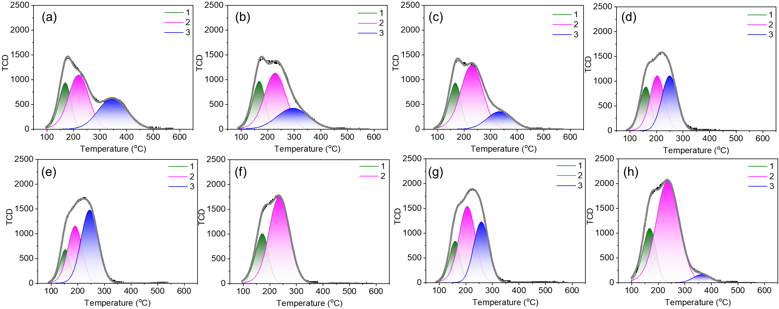
Supplementary Fig. S14 Deconvolution of NH₃-TPD curves for calcined zeolites with varied Na₂O/SiO₂ ratios in the synthesis gel of (a) 0.08, (b) 0.09, (c) 0.095, (d) 0.10, (e) 0.11, (f) 0.12, (g) 0.13 and (h) 0.20.

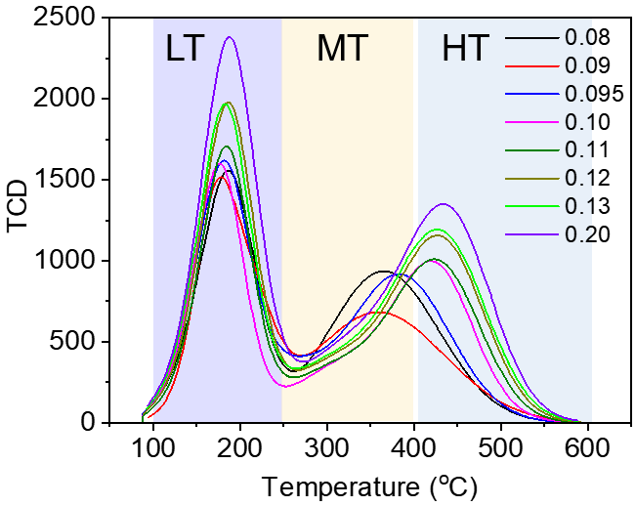
Supplementary Fig. S15 NH₃-TPD curves of H-form zeolites with Na₂O/SiO₂ ratios in the synthesis gel varying from 0.08 to 0.20.
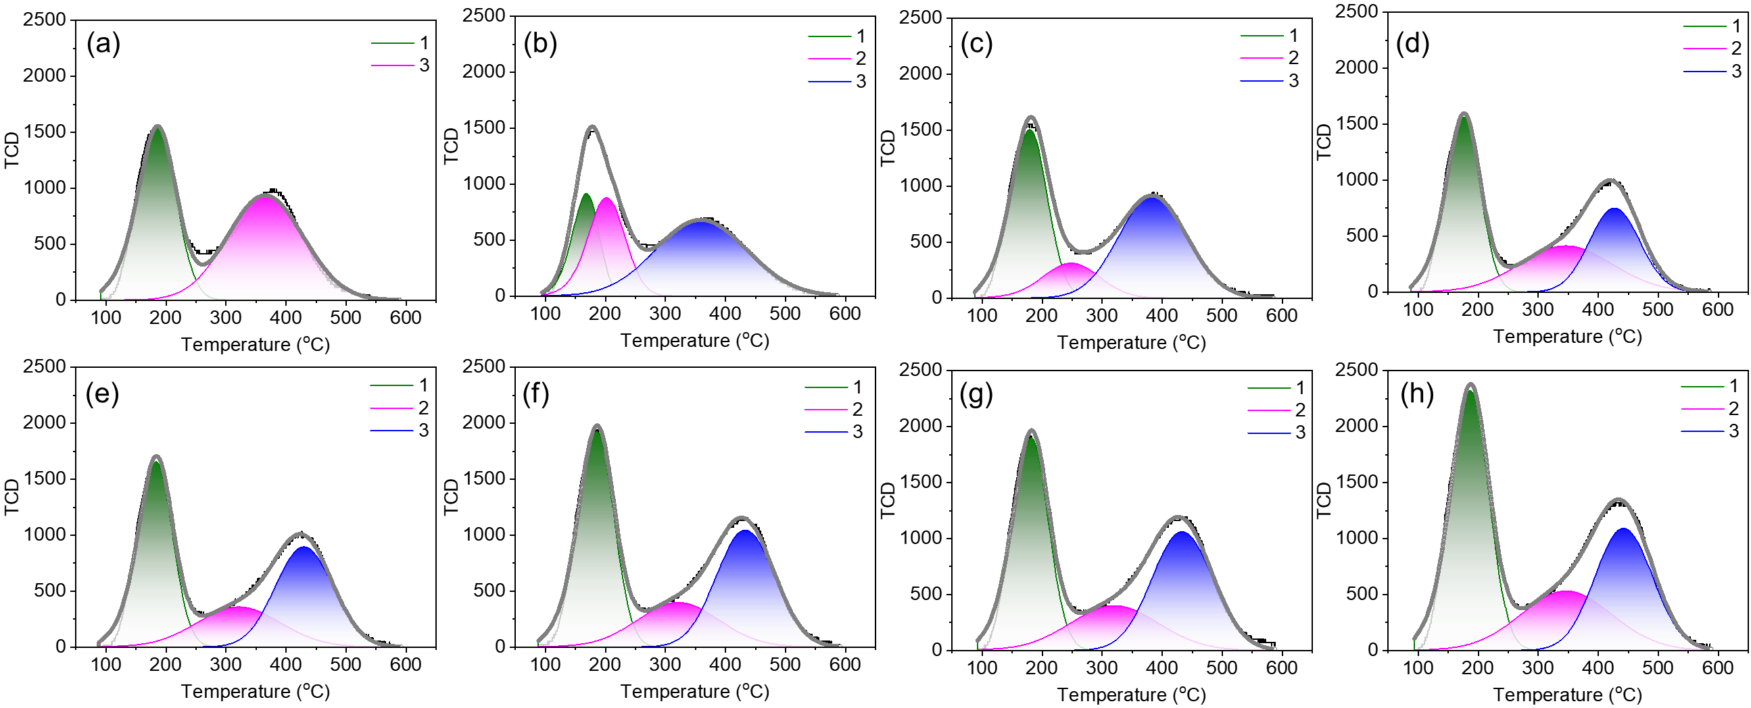
Supplementary Fig. S16 Deconvolution of NH₃-TPD curves for H-type zeolites with varied Na₂O/SiO₂ ratios in the synthesis gel of (a) 0.08, (b) 0.09, (c) 0.095, (d) 0.10, (e) 0.11, (f) 0.12, (g) 0.13 and (h) 0.20.
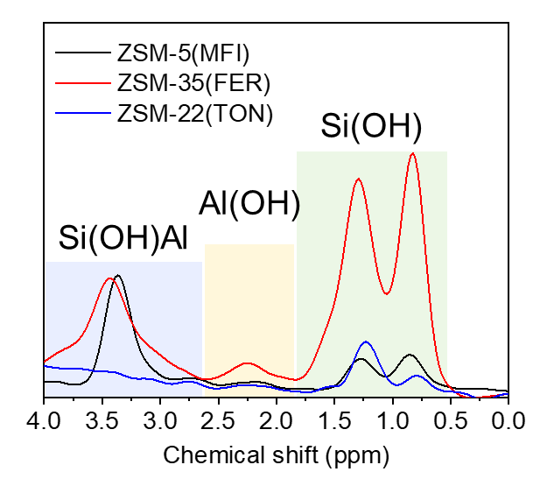
Supplementary Fig. S17 ¹H MAS NMR spectra of ZSM-22, ZSM-35, and ZSM-5.
Supplementary Fig. S18 Catalytic activity of H-Z(Py)-x zeolites at 250 ºC. Reaction conditions: 100 mg catalyst, CH₄/N₂O/H₂O/Ar = 10/10/2/3 ml·min⁻¹, WHSV =15000 ml·g⁻¹·h⁻¹, TOS=0.16 h.
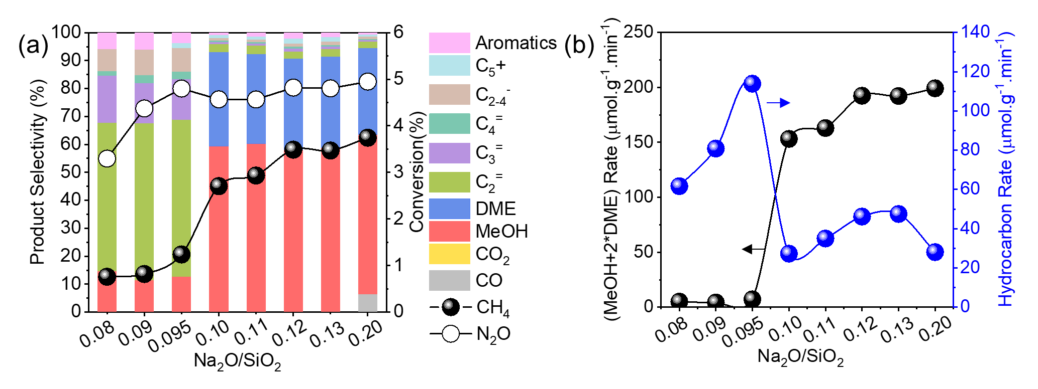
Supplementary Fig. S19 Catalytic activity of H-Z(Py)-x zeolites at 350 ºC (a) reactant conversion and product distribution, (b) production formation rate. Reaction conditions: 100 mg catalyst, CH₄/N₂O/H₂O/Ar = 10/10/2/3 ml·min⁻¹, WHSV =15000 ml·g⁻¹·h⁻¹, TOS=0.16 h. r_{hydrocarbons}= 2*(r_{C2}⁼ + r_{C2}⁰) + 3*(r_{C3}⁼ + r_{C3}⁰) + 4*(r_{C4}⁼ + r_{C4}⁰) + 5*(r_{C5}⁼ + r_{C5}⁰) + 6*r_{C6}.

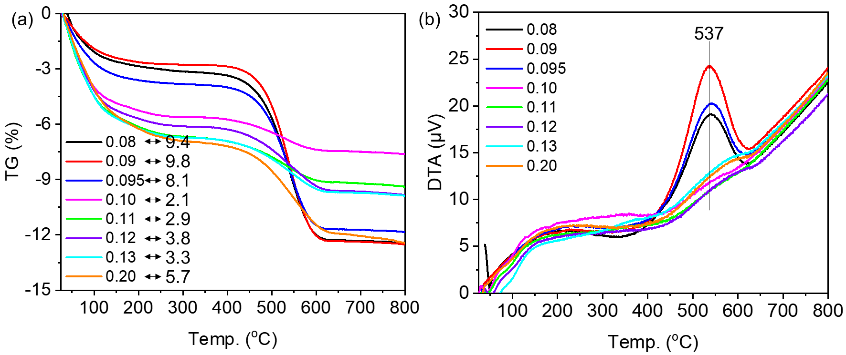
Supplementary Fig. S20 (a) TG analysis and (b) DTA curves of the H-Z(Py)-x zeolites after methane reaction at 350 ºC.
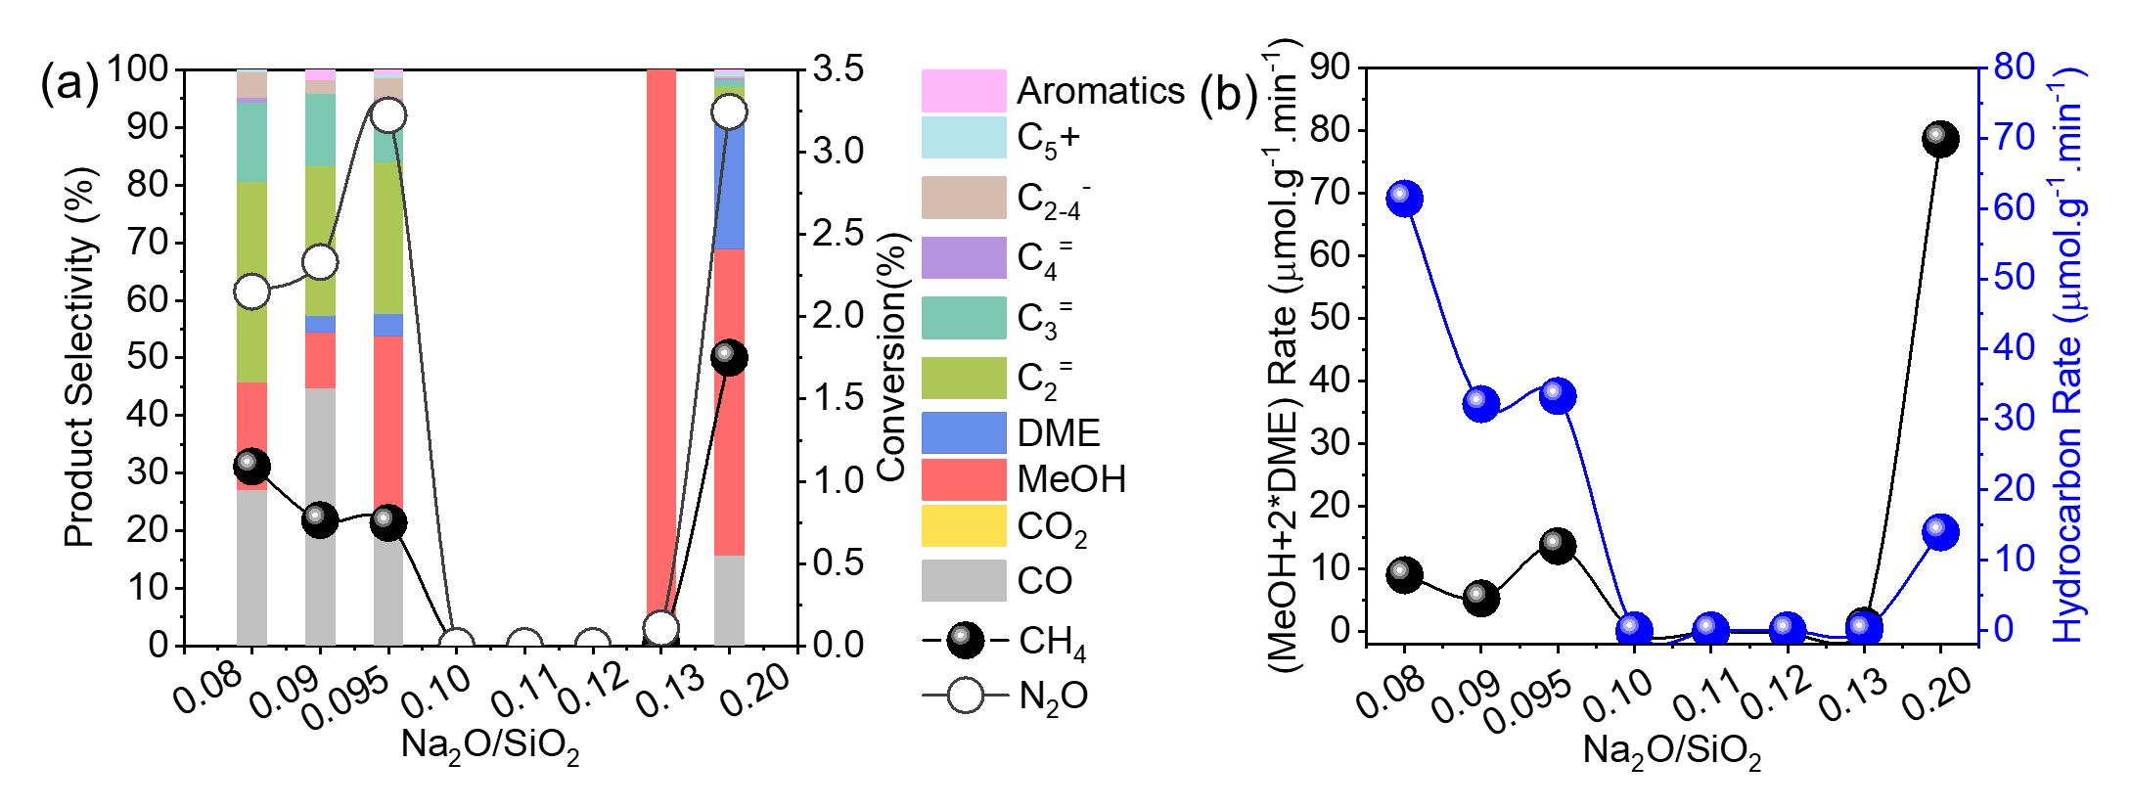
Supplementary Fig. S21 (a) Product distribution and reactant conversion, and (b) product formation rate for calcined zeolites with Na₂O/SiO₂ ratios in the synthesis gel varying from 0.08 to 0.20. r_{hydrocarbons}= 2*(r_{C2}⁼ + r_{C2}⁰) + 3*(r_{C3}⁼ + r_{C3}⁰) + 4*(r_{C4}⁼ + r_{C4}⁰) + 5*(r_{C5}⁼ + r_{C5}⁰) + 6*r_{C6}.

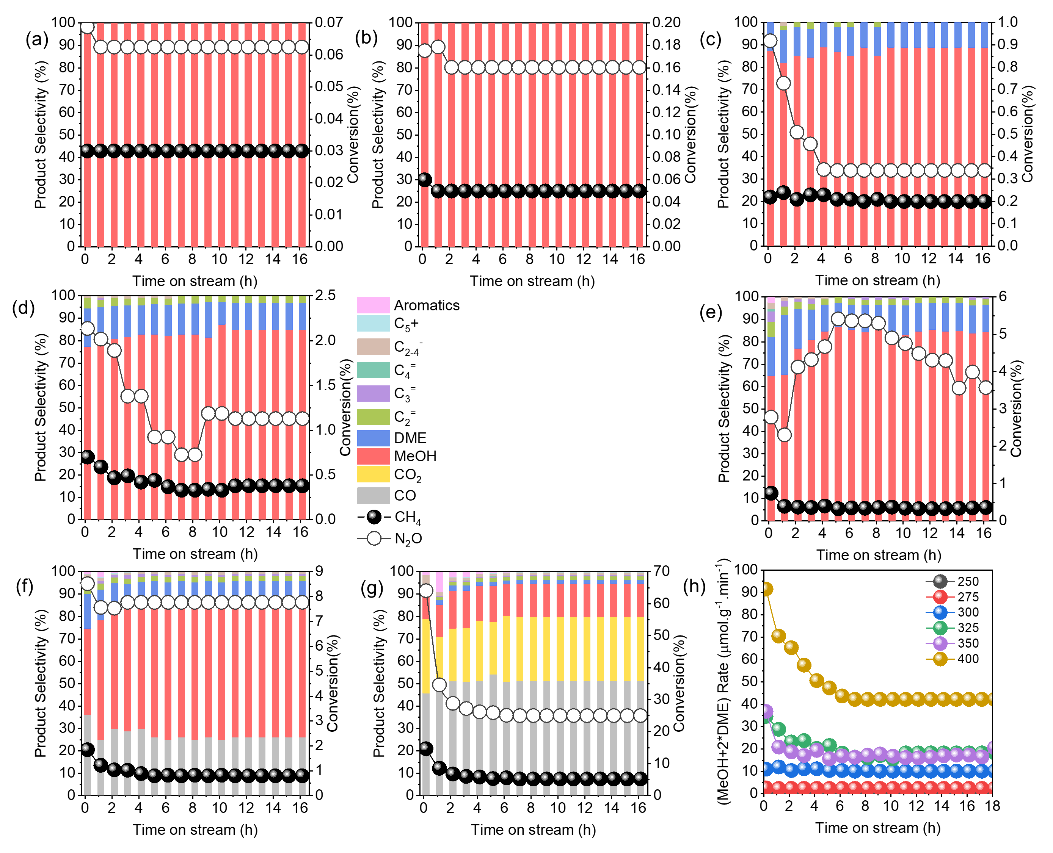
Supplementary Fig. S22 Product distribution and reactant conversion of ZSM-22(TON) zeolite at (a) 250, (b) 275, (c) 300, (d) 325, (e) 350, (f) 375, (g) 400 ºC. (h) Compare the (MeOH+2*DME) rate of ZSM-22 at 25-400 ºC. Reaction conditions: 100 mg catalyst, CH₄/N₂O/H₂O/Ar = 10/10/2/3 ml·min⁻¹, WHSV =15000 ml·g⁻¹·h⁻¹.
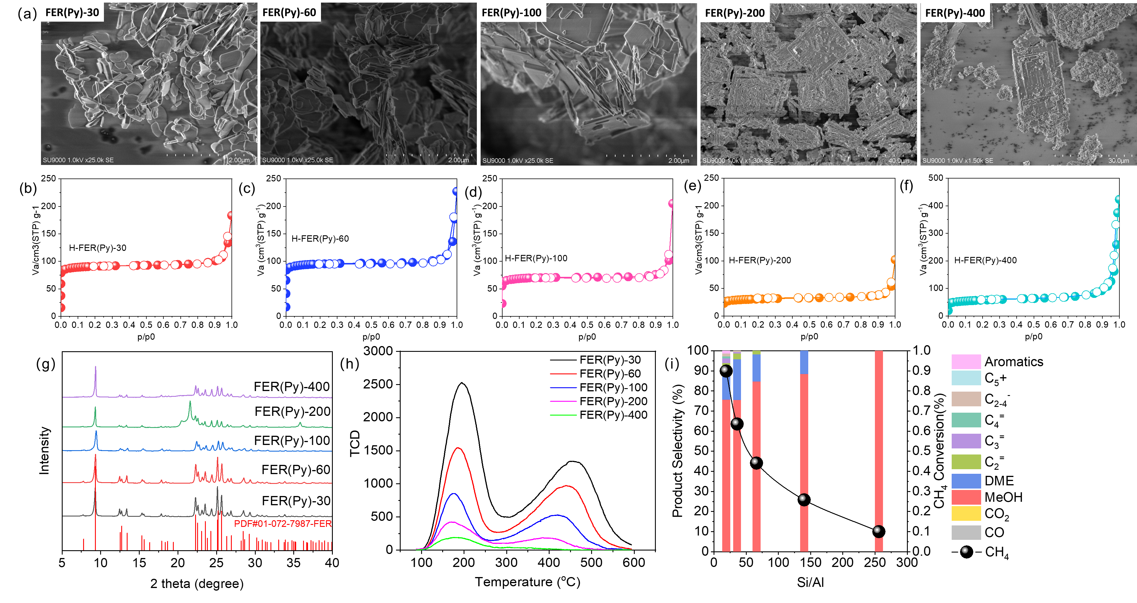
Supplementary Fig. S23 (a) SEM images of FER(Py)-SAR zeolites. N₂ adsorption and desorption isotherms for (b) FER(Py)-30, (c) FER(Py)-60, (d) FER(Py)-100, (e) FER(Py)-200, and (f) FER(Py)-400. (g) XRD patterns and (h) NH₃-TPD profiles of FER(Py)-SAR zeolites. (i) Catalytic performance in methane valorization as a function of Si/Al ratio. Reaction conditions: 350 °C, CH₄/N₂O/H₂O/Ar = 10/10/2/3 mL·min⁻¹; 100 mg catalyst, WHSV = 15,000 mL·g⁻¹·h⁻¹.

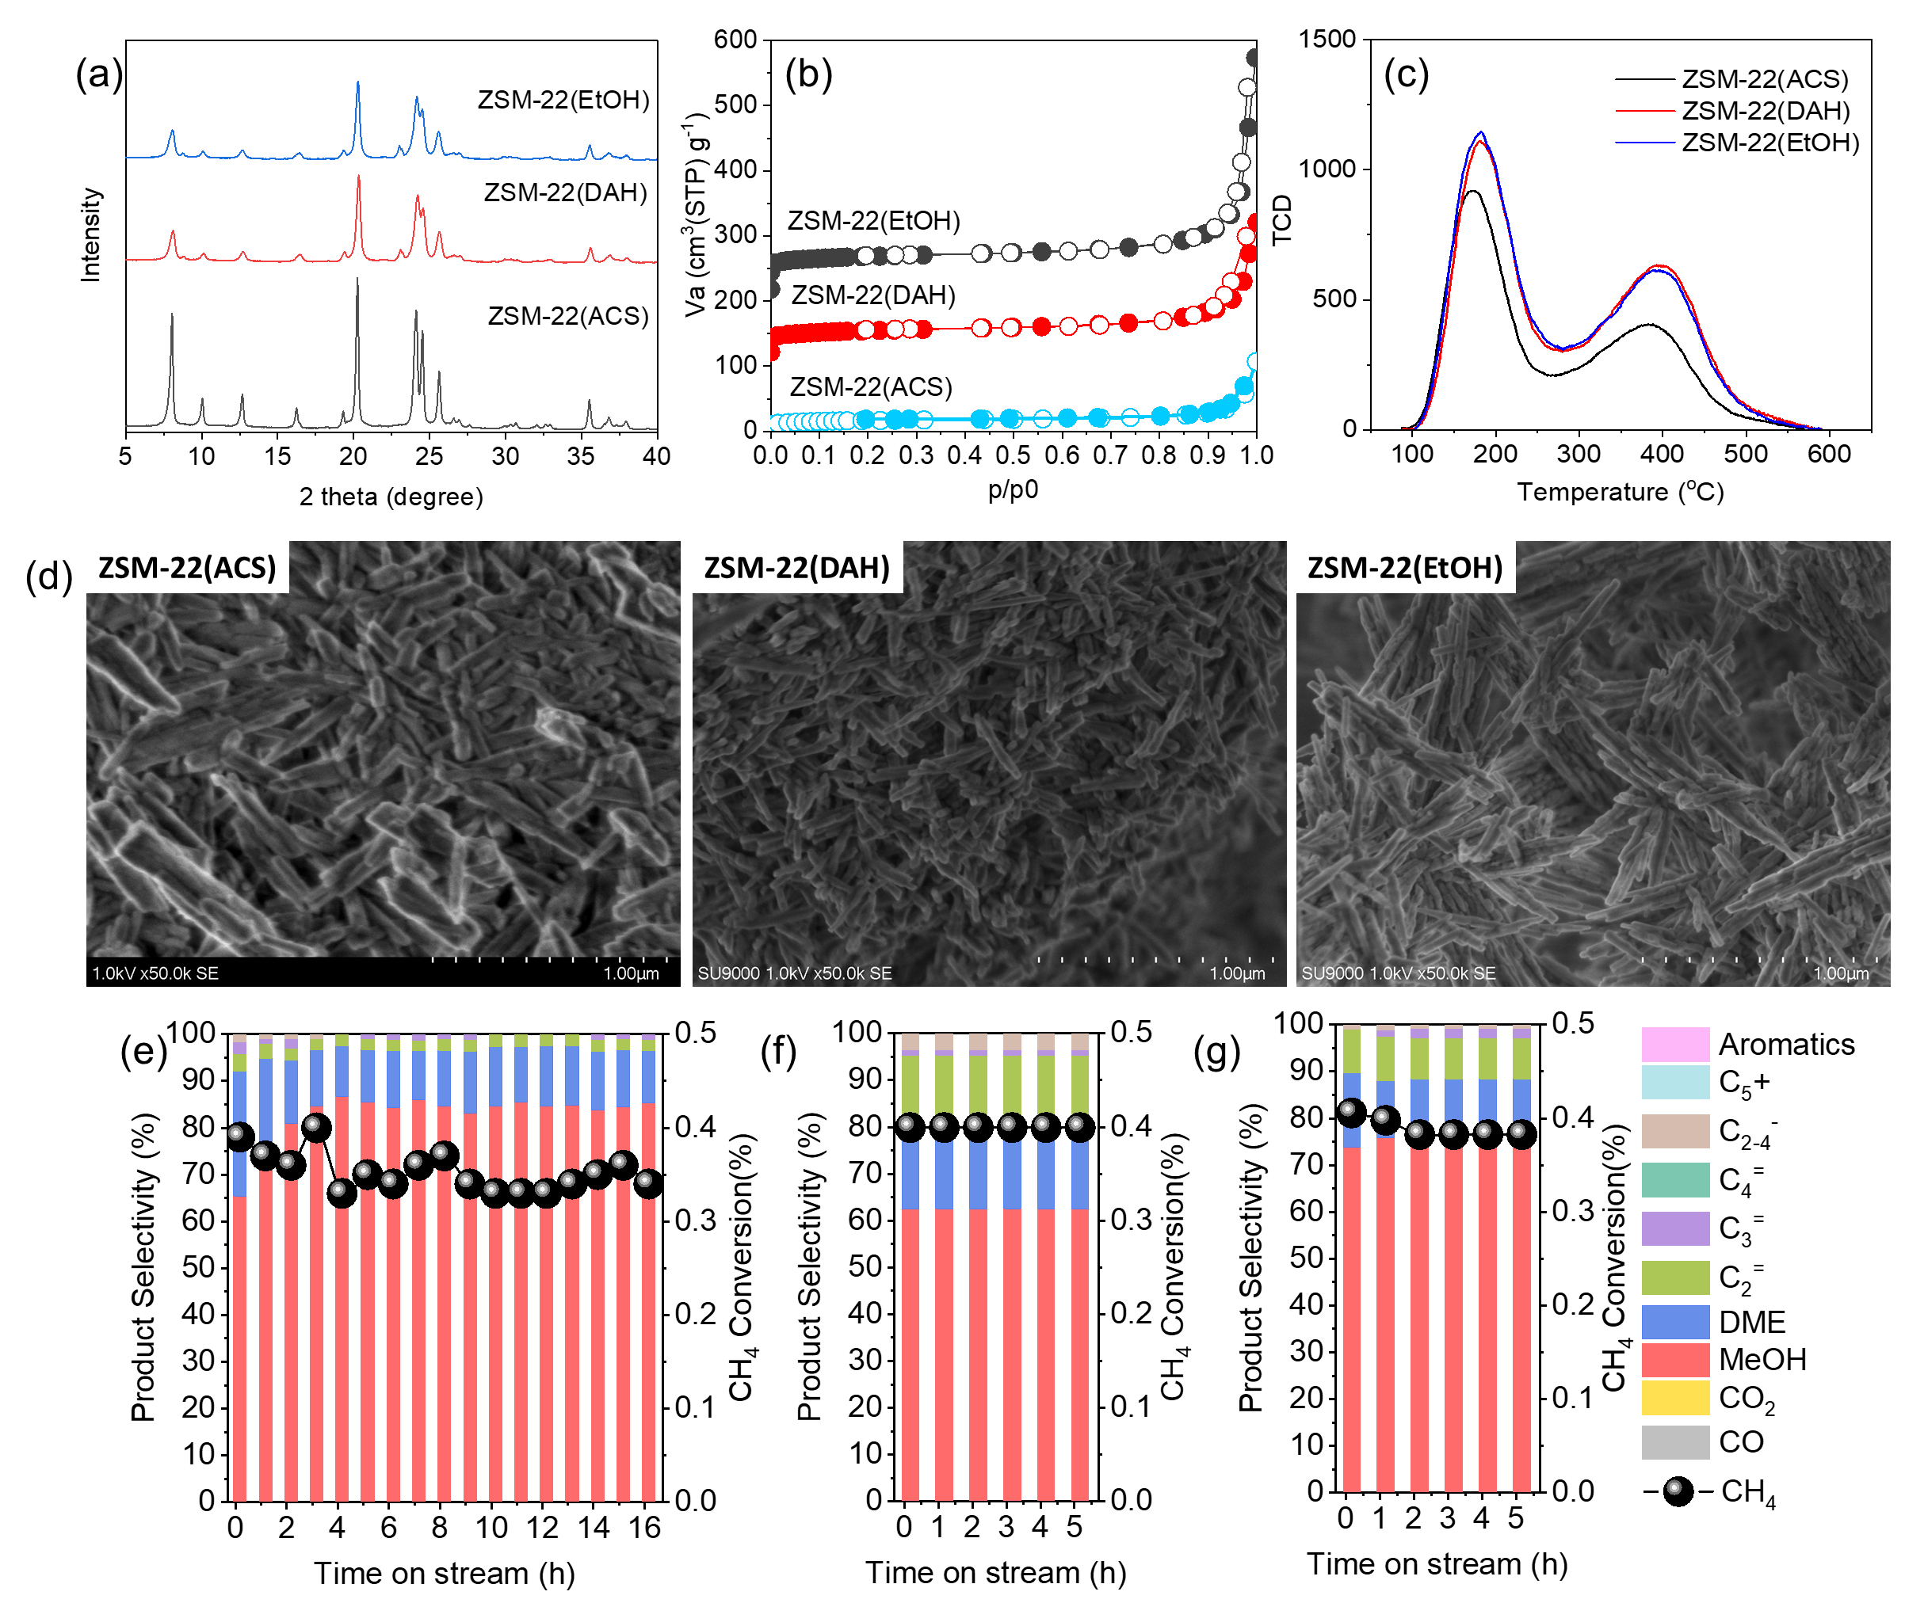Supplementary Fig. S24 (a) XRD patterns, (b) N₂ adsorption and desorption isotherms, and (c) NH₃-TPD profiles of ZSM-22 zeolites. (d) SEM images of ZSM-22(ACS), ZSM-22(DAH), and ZSM-22(EtOH) zeolites. Catalytic performance of (e) ZSM-22(ACS), (f) ZSM-22(DAH), and (g) ZSM-22(EtOH) zeolites in methane valorization. Reaction conditions: 350 °C, CH₄/N₂O/H₂O/Ar = 10/10/2/3 mL·min⁻¹; 100 mg catalyst, WHSV = 15,000 mL·g⁻¹·h⁻¹.
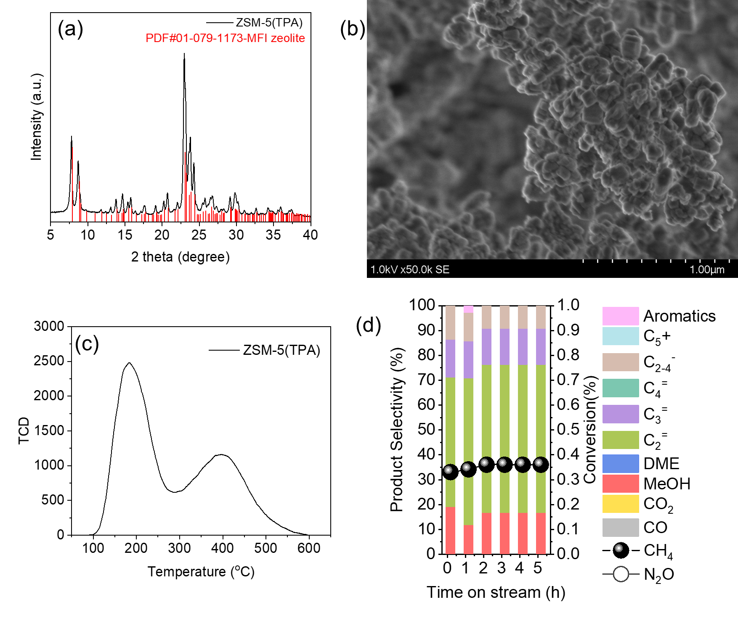Supplementary Fig. S25 (a) XRD pattern, (b) SEM image, (c) NH₃-TPD profile, and (d) catalytic performance of ZSM-5(TPA) zeolite. Reaction conditions: 350 °C, CH₄/N₂O/H₂O/Ar = 10/10/2/3 mL·min⁻¹; 100 mg catalyst, WHSV= 15,000 mL·g⁻¹·h⁻¹.
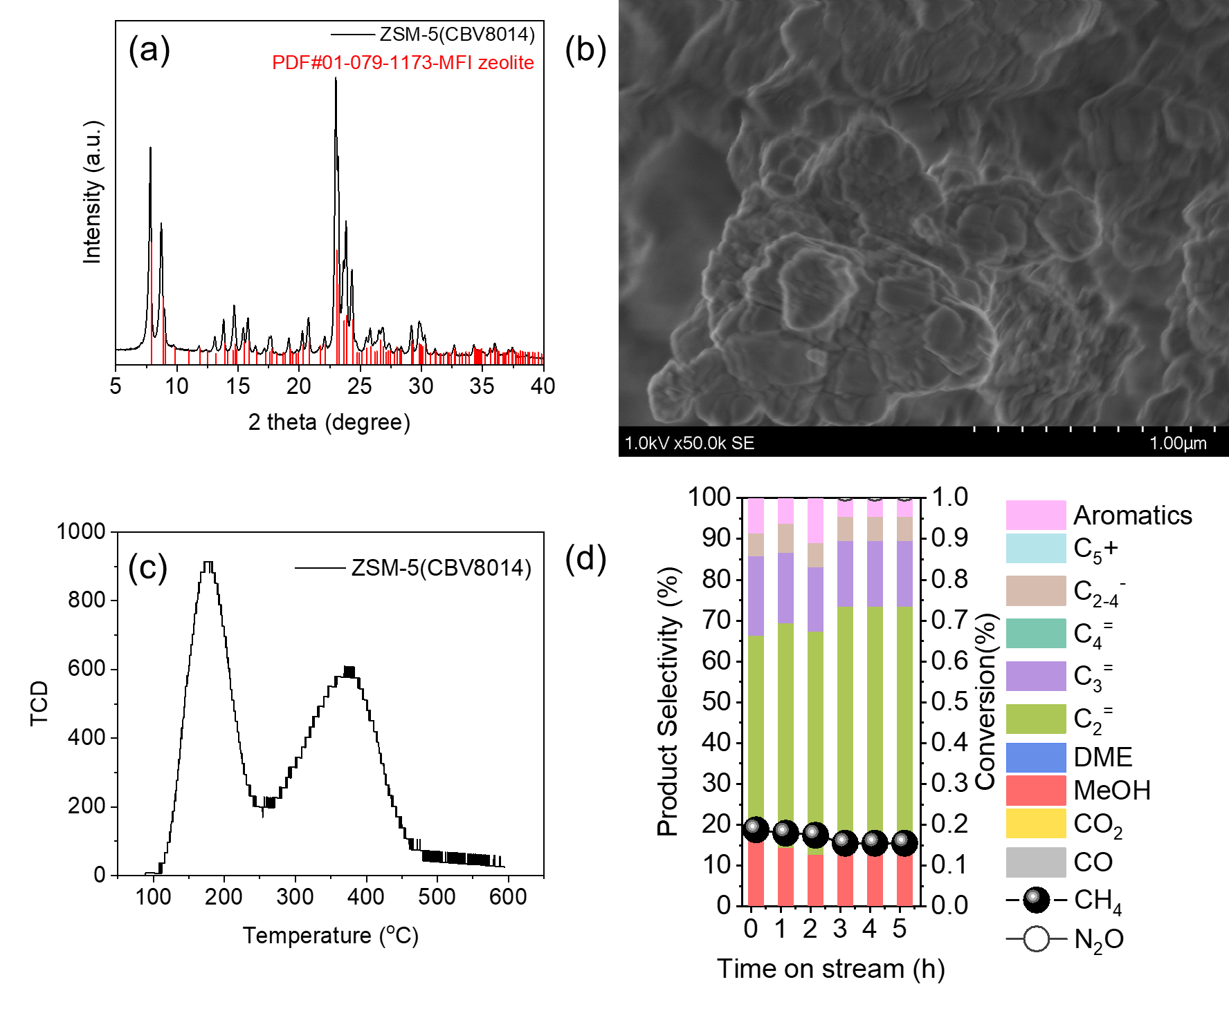
Supplementary Fig. S26 (a) XRD pattern, (b) SEM image, and (c) NH₃-TPD profile, and (d) catalytic performance of ZSM-5(CBV8014) zeolite. Reaction conditions: 350 °C, CH₄/N₂O/H₂O/Ar = 10/10/2/3 mL·min⁻¹; 100 mg catalyst, WHSV = 15,000 mL·g⁻¹·h⁻¹.
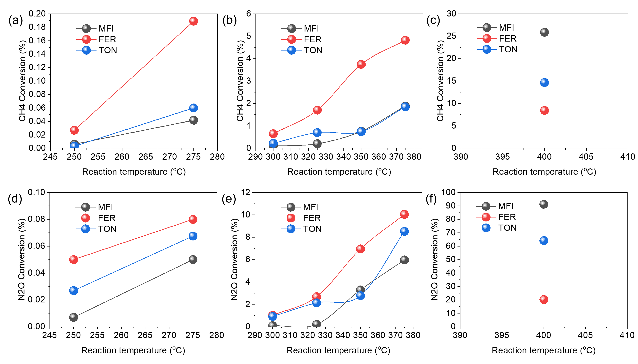Supplementary Fig. S27 Compare the CH₄ conversion of MFI, FER, and TON zeolites at (a) 250-275 ºC, (b) 300-375 ºC, (c) 400 ºC. Compare the N₂O conversion of MFI, FER, and TON zeolites at (d) 250-275 ºC, (e) 300-375 ºC, (f) 400 ºC. Reaction conditions: 100 mg catalyst, CH₄/N₂O/H₂O/Ar = 10/10/2/3 ml·min⁻¹, WHSV =15000 ml·g⁻¹·h⁻¹, TOS=0.16 h.
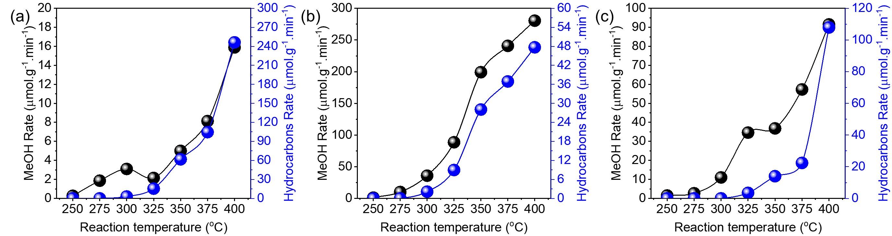Supplementary Fig. S28 Product formation rate of (a) ZSM-5(MFI), (b) ZSM-35(FER), (c) ZSM-22(TON) at 250-400 ºC. Reaction conditions: 100 mg catalyst, CH₄/N₂O/H₂O/Ar = 10/10/2/3 ml·min⁻¹, WHSV =15000 ml·g⁻¹·h⁻¹, TOS=0.16 h. r_{hydrocarbons}= 2*(r_{C2}⁼ + r_{C2}⁰) + 3*(r_{C3}⁼ + r_{C3}⁰) + 4*(r_{C4}⁼ + r_{C4}⁰) + 5*(r_{C5}⁼ + r_{C5}⁰) + 6*r_{C6}.

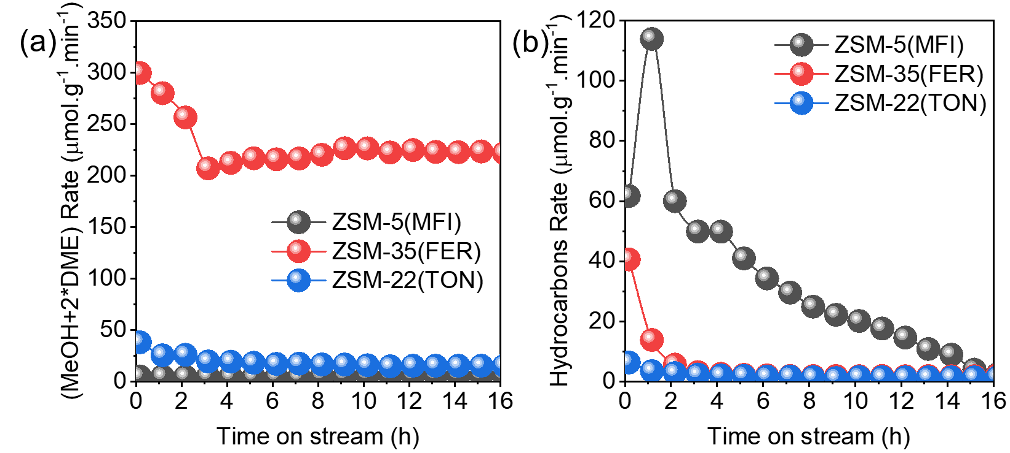Supplementary Fig. S29 Compare (a) (MeOH+2*DME) rate and (b) hydrocarbons rate of ZSM-5(MFI) (100 mg), ZSM-35(FER) (61 mg), and ZSM-22(TON) (150 mg). Reaction condition: 350 ºC, CH₄/N₂O/H₂O/Ar = 10/10/2/3 ml·min⁻¹. r_{hydrocarbons}= 2*(r_{C2}⁼ + r_{C2}⁰) + 3*(r_{C3}⁼ + r_{C3}⁰) + 4*(r_{C4}⁼ + r_{C4}⁰) + 5*(r_{C5}⁼ + r_{C5}⁰) + 6*r_{C6}.

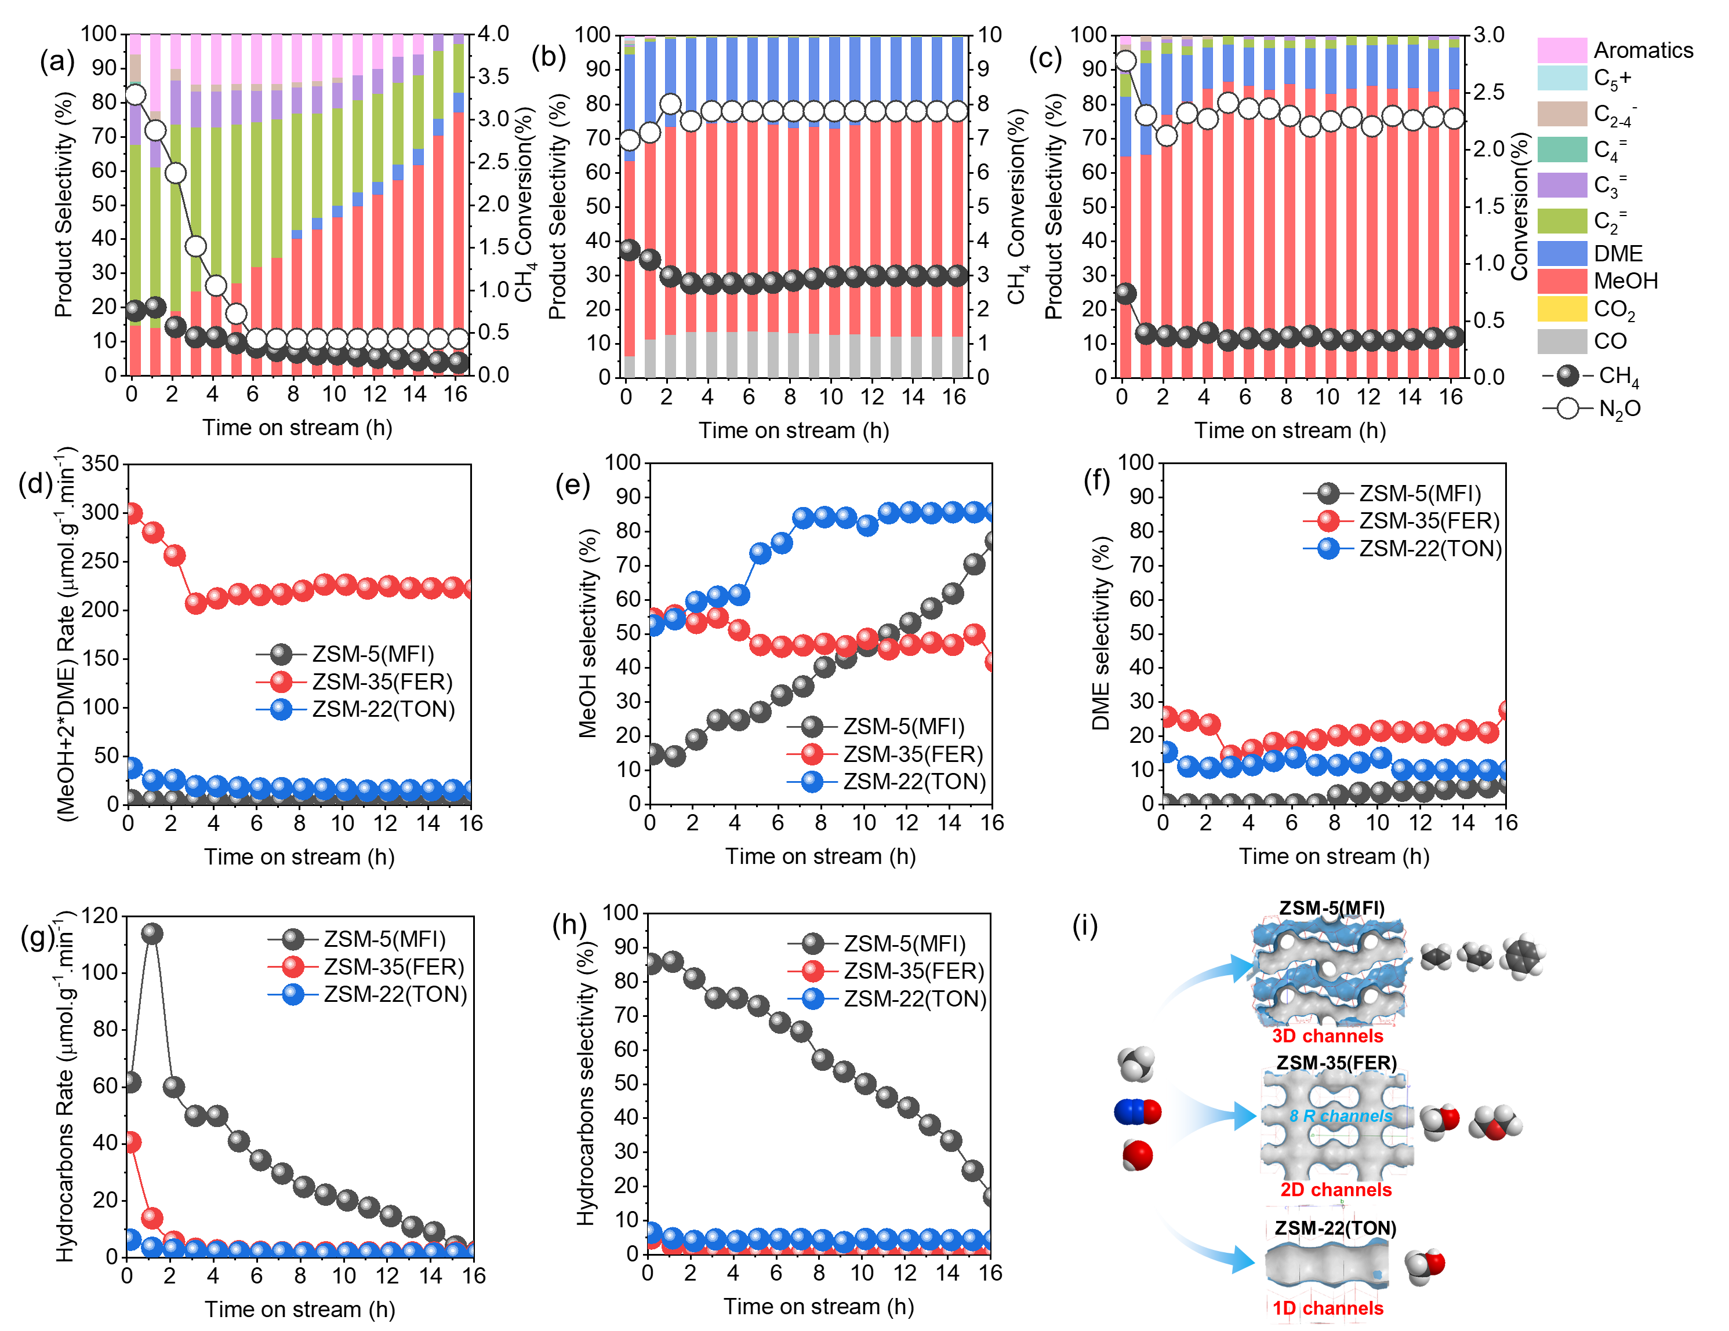Supplementary Fig. S30 Stability test for (a) ZSM-5(MFI), (b) ZSM-35(FER), and (c) ZSM-22(TON), compare (d) (MeOH+2*DME) rate, (e) MeOH selectivity, (f) DME selectivity, (g) hydrocarbons rate, and (h) hydrocarbons selectivity of ZSM-5(MFI), ZSM-35(FER), and ZSM-22(TON). Reaction condition: 350 ºC, 100 mg zeolite, CH₄/N₂O/H₂O/Ar = 10/10/2/3 ml·min⁻¹. r_{hydrocarbons}= 2*(r_{C2}⁼ + r_{C2}⁰) + 3*(r_{C3}⁼ + r_{C3}⁰) + 4*(r_{C4}⁼ + r_{C4}⁰) + 5*(r_{C5}⁼ + r_{C5}⁰) + 6*r_{C6}. S_{hydrocarbons}= r_{C2}⁼ + r_{C2}⁰ + r_{C3}⁼ + r_{C3}⁰ + r_{C4}⁼ + r_{C4}⁰ + r_{C5}⁼ + r_{C5}⁰ + 6*r_{C6}. (j) Schematic diagram for CH₄ and N₂O valorization on 3D MFI, 2D FER, and 1D TON pore channels.17
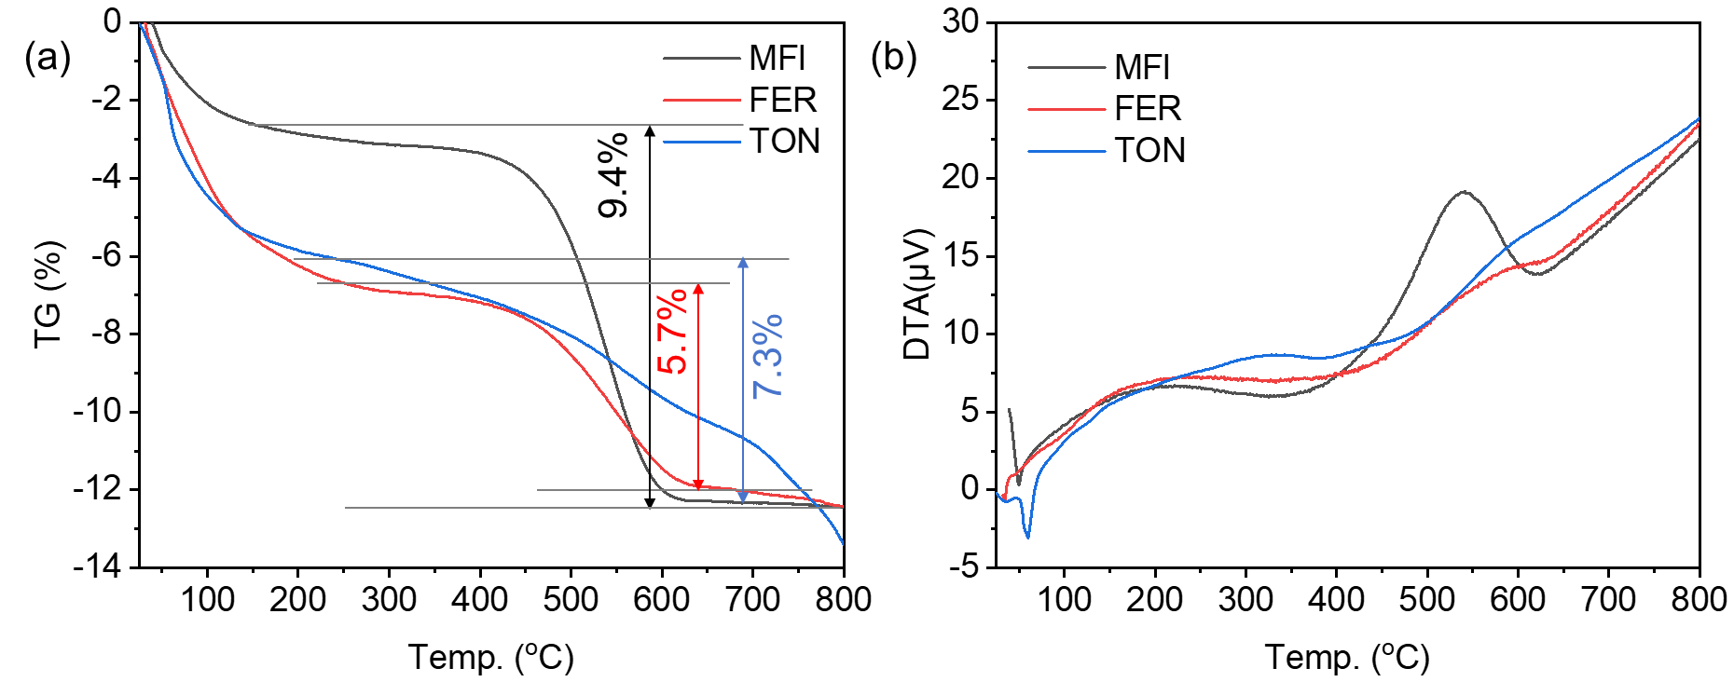
Supplementary Fig. S31 (a) TG analysis and (b) DTA curves of MFI, FER, and TON zeolites after methane oxidation reaction at 350 ºC using 100 mg zeolite as a catalyst.
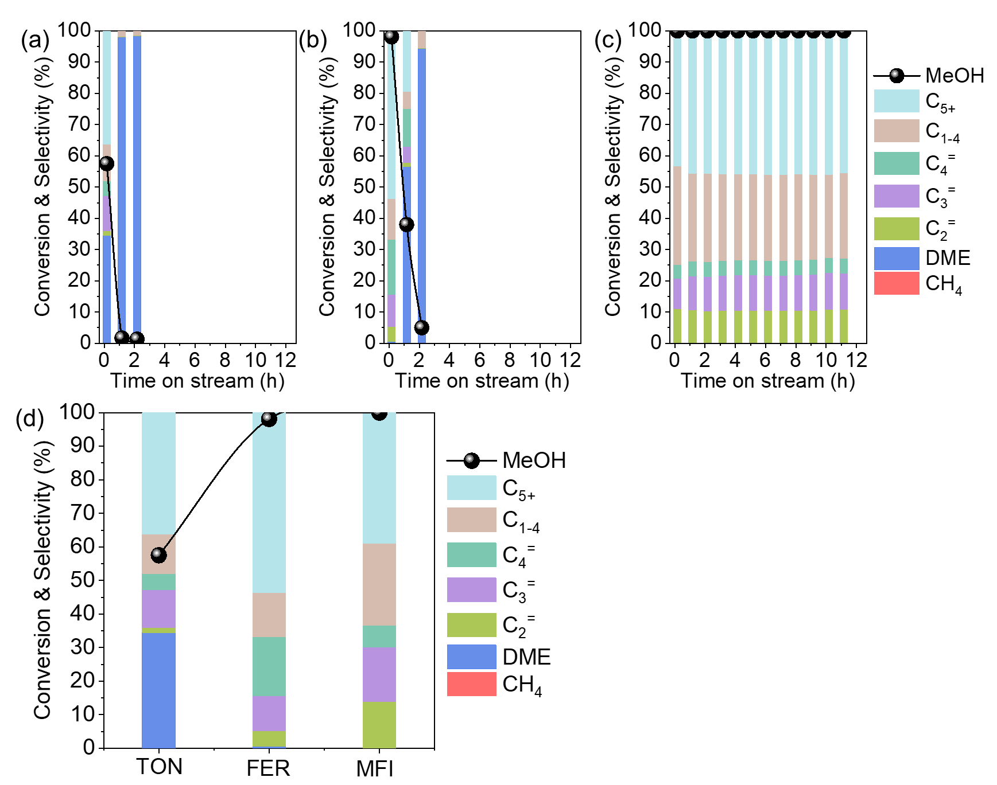
Supplementary Fig. S32 Time courses of the methanol to hydrocarbon reaction at 350 °C on (a) ZSM-22(TON), (b) ZSM-35(FER), and (c) ZSM-5(MFI). Reaction condition: 100 mg catalyst, 10 vol% methanol in Ar gas, W/F_{MeOH} = 34 g·h·mol⁻¹. Compare the products distribution and methanol conversion of TON, FER, and MFI in MTO reaction at 350 ºC and TOS =0.16 h.
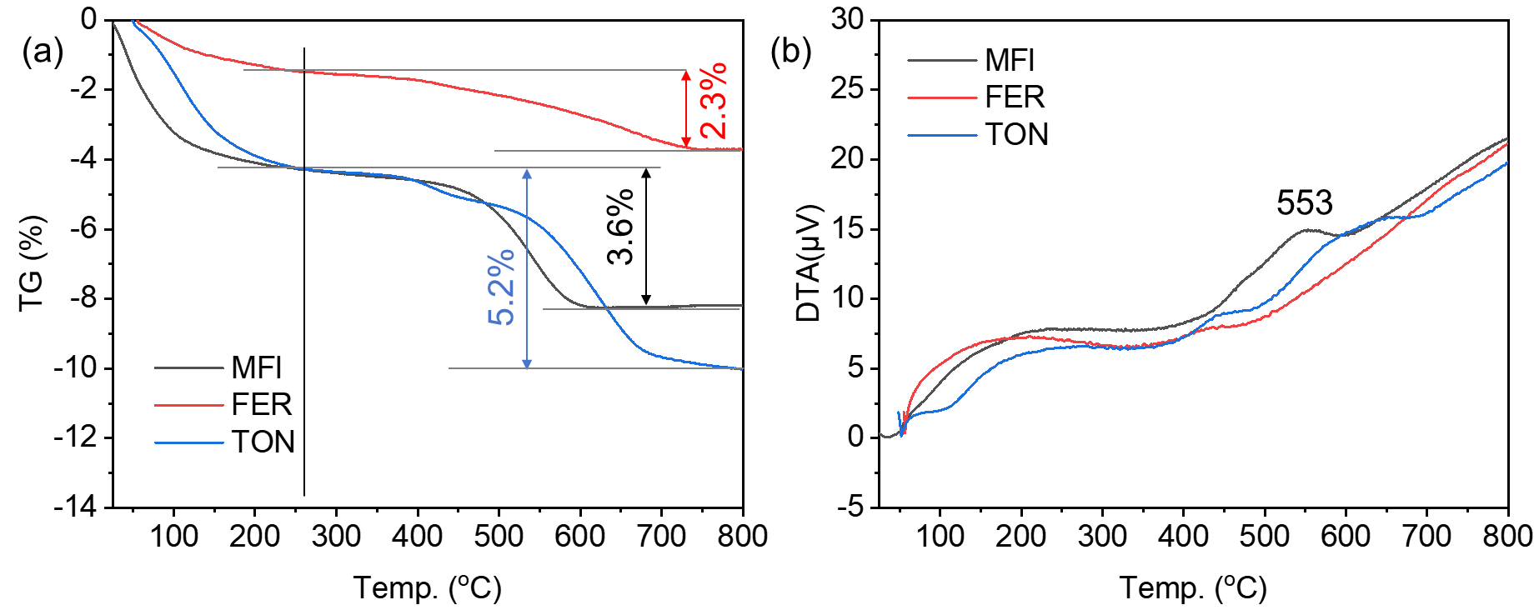
Supplementary Fig. S33 (a) TG analysis and (b) DTA curves of MFI, FER, and TON zeolites after MTO reaction at 350 ºC.
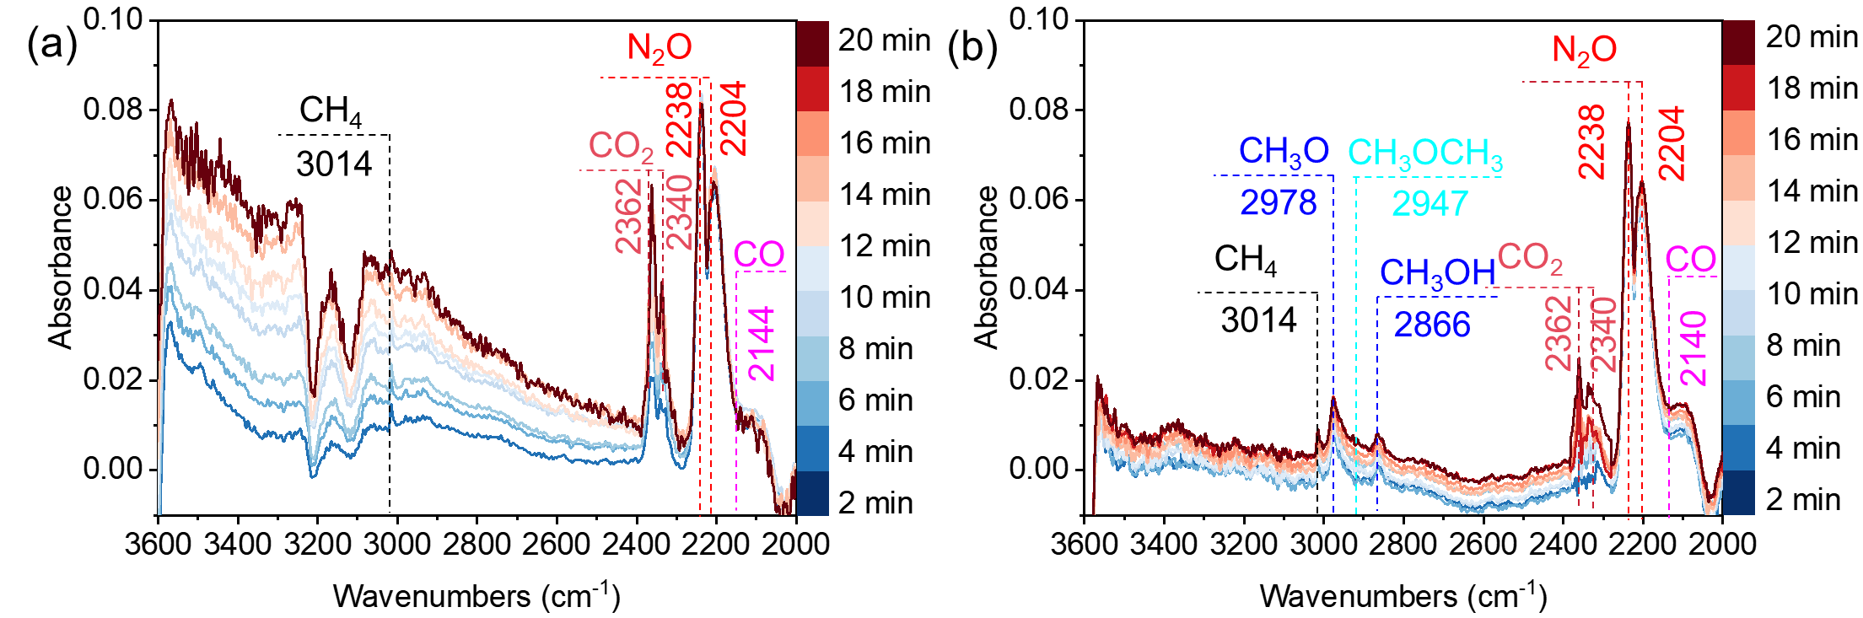
Supplementary Fig. S34 In situ DRIFTS spectra of co-feeding of CH₄ (5 mL·min⁻¹), N₂O (5 mL·min⁻¹), and Ar (500 mL·min⁻¹) at 450 °C for (a) ZSM-5 and (b) ZSM-35.
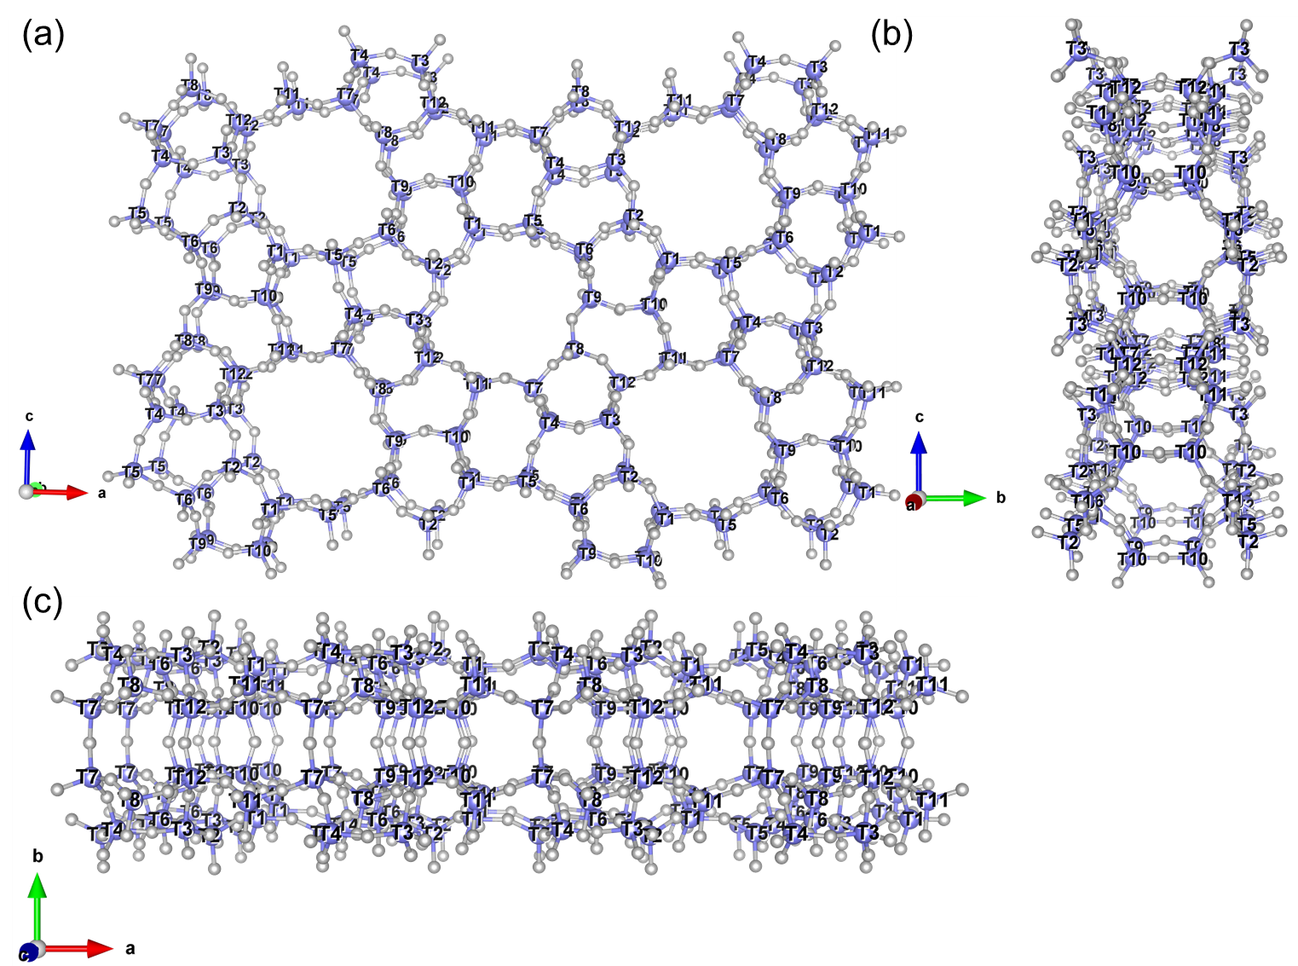
Scheme S1 T sites in the framework of MFI zeolite viewed along (a) [010], (b) [100], and (c) [001]. 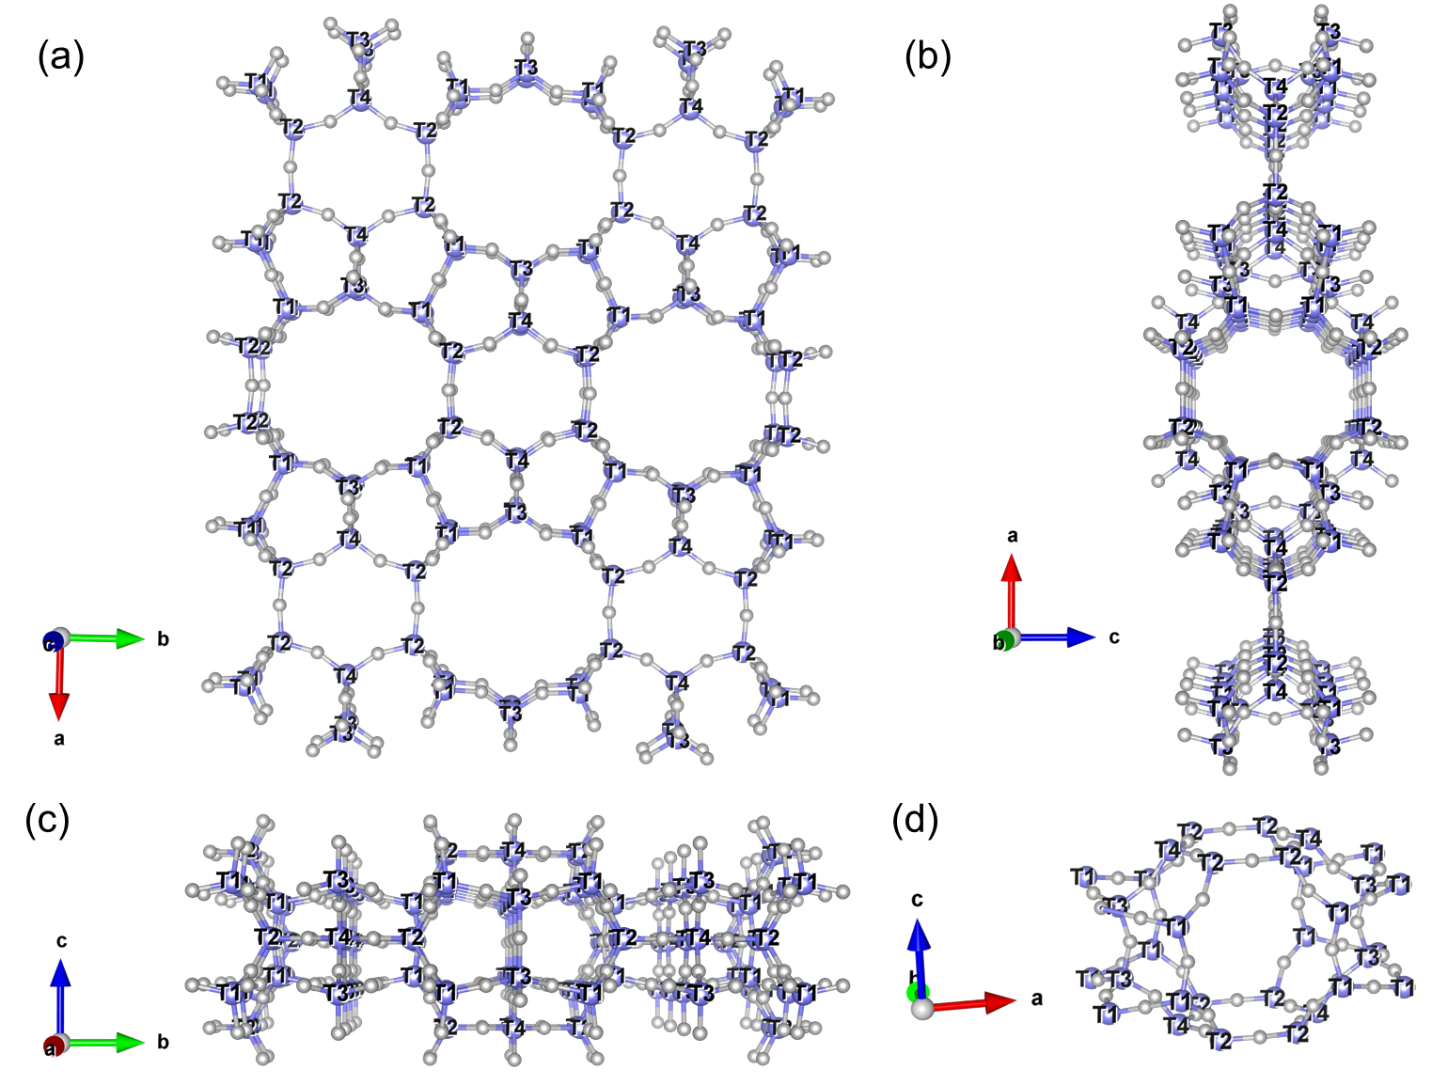
Scheme S2 T sites in the framework of FER zeolite viewed along (a) [001], (b) [010], (c) [100], (d) T sites in the FER cage.

Table S1. Effects of the Na₂O/SiO₂ molar ratio on the product phase composition and solid yield.
Na₂O/SiO₂ ª | Sample name | Product phase compositions ^{b} | Solid yield (%) ^{c}
0.08 | as-Z(Py)-0.08 | 100% MFI | 94
0.09 | as-Z(Py)-0.09 | 77% MFI+ 23% FER | 93
0.095 | as-Z(Py)-0.095 | 68% MFI + 32% FER | 92
0.10 | as-Z(Py)-0.10 | 100% FER | 92
0.11 | as-Z(Py)-0.11 | 100% FER | 87
0.12 | as-Z(Py)-0.12 | 100% FER | 88
0.13 | as-Z(Py)-0.13 | 100% FER | 81
0.20 | as-Z(Py)-0.20 | 100% FER | 55
ª Na₂O/SiO₂ ratio in the synthesis gel.
^{b} Calculated by characteristic peaks of MFI (2θ =7.8, 8.7, 22.9, 23.8, 24.3º) and FER (2θ =9.3, 25.1, 25.6º).
^{c} S$olid yied=\frac{solid product}{Si source + Al source +Na source+ OSDA in solid}*100\%$
Table S2 Chemical composition and acid amount of H-Z(Py)-x zeolites.
Sample | Si/Al ª | Acid amount (mmol/g) (Temperature (ºC)) ^{b} |  |  | Total amount (mmol/g) ^{b} | Reference
Sample | Si/Al ª | Ⅰ | Ⅱ | Ⅲ | Total amount (mmol/g) ^{b} | Reference
H-Z(Py)-0.08 | 22.3 | 0.43(183) |  | 0.54(364) | 0.97 | This work
H-Z(Py)-0.09 | 21.6 | 0.17(170) | 0.24(206) | 0.46(362) | 0.87 | This work
H-Z(Py)-0.095 | 21.7 | 0.43(179) | 0.14(249) | 0.50(384) | 1.07 | This work
H-Z(Py)-0.10 | 21.3 | 0.41(177) | 0.31(346) | 0.31(426) | 1.03 | This work
H-Z(Py)-0.11 | 20.9 | 0.43(183) | 0.24(324) | 0.40(434) | 1.07 | This work
H-Z(Py)-0.12 | 20.1 | 0.49(186) | 0.24(323) | 0.45(433) | 1.18 | This work
H-Z(Py)-0.13 | 18.0 | 0.50(183) | 0.27(324) | 0.48(436) | 1.25 | This work
H-Z(Py)-0.20 | 14.2 | 0.68(186) | 0.39(348) | 0.49(442) | 1.56 | This work
ZSM-22(ACS) | 36.0 | 0.17(180) | 0.12(280) | 0.24(380) | 0.53 | This work
ZSM-22(EtOH) | 35.0 | 0.31 | 0.16 | 0.29 | 0.75 | J. Catal. 2018, 361, 177
ZSM-22(DAH) | 35.0 | 0.26 | 0.14 | 0.34 | 0.74 | J. Catal. 2016, 335, 11
FER(Py)-30 | 19.0 | 0.85 | 0.42 | 0.57 | 1.84 | Micro. Meso. Mater. 2013, 181, 154
FER(Py)-60 | 36.0 | 0.45 | 0.25 | 0.38 | 1.08 | Micro. Meso. Mater. 2013, 181, 154
FER(Py)-100 | 66.0 | 0.22 | 0.14 | 0.22 | 0.58 | Micro. Meso. Mater. 2013, 181, 154
FER(Py)-200 | 140.0 | 0.05 | 0.11 | 0.11 | 0.27 | Micro. Meso. Mater. 2013, 181, 154
FER(Py)-400 | 256.0 | 0.02 | 0.05 | 0.03 | 0.10 | Micro. Meso. Mater. 2013, 181, 154
ZSM-5(TPA) | 21.2 | 0.26 | 0.61 | 0.77 | 1.64 | J. Catal. 2017, 353, 1
ZSM-5(CBV8014) | 40.0 | 0.23 | 0.24 | 0.13 | 0.60 | This work
ª by ICP-AES.
^{b} by NH₃-TPD.

Table S3 Textual properties of zeolite catalysts.
Sample | Sample | Structure | S_{BET}(m²·g⁻¹) ª | V_{Total}(cm³·g⁻¹) ª | S_{EXT}(m²·g⁻¹) ^{b} | V_{Mic}(cm³·g⁻¹) ^{b} | Reference
H-Z(Py)-0.08 | ZSM-5 | MFI | 365 | 0.22 | 19 | 0.16 | This work
H-Z(Py)-0.09 |  | MFI+FER | 353 | 0.21 | 22 | 0.15 | This work
H-Z(Py)-0.095 |  | MFI+FER | 362 | 0.23 | 25 | 0.15 | This work
H-Z(Py)-0.10 |  | FER | 283 | 0.32 | 30 | 0.11 | This work
H-Z(Py)-0.11 |  | FER | 305 | 0.28 | 37 | 0.12 | This work
H-Z(Py)-0.12 |  | FER | 300 | 0.23 | 31 | 0.12 | This work
H-Z(Py)-0.13 |  | FER | 295 | 0.27 | 24 | 0.12 | This work
H-Z(Py)-0.20 | ZSM-35 | FER | 282 | 0.22 | 27 | 0.11 | This work
ZSM-22 | ZSM-22(ACS) | TON | 62 | 0.14 | 21 | 0.02 | This work
ZSM-22(EtOH) | ZSM-22(EtOH) | TON | 259 | 0.49 | 21 | 0.02 | J. Catal. 2018, 361, 177
ZSM-22(DAH) | ZSM-22(DAH) | TON | 204 | 0.29 | 51 | 0.06 | J. Catal. 2016, 335, 11
FER(Py)-30 | FER(Py)-30 | FER | 350 | 0.25 | 17 | 0.13 | Micro. Meso. Mater. 2013, 181, 154
FER(Py)-60 | FER(Py)-60 | FER | 367 | 0.30 | 15 | 0.14 | Micro. Meso. Mater. 2013, 181, 154
FER(Py)-100 | FER(Py)-100 | FER | 259 | 0.25 | 10 | 0.10 | Micro. Meso. Mater. 2013, 181, 154
FER(Py)-200 | FER(Py)-200 | FER | 112 | 0.12 | 10 | 0.04 | Micro. Meso. Mater. 2013, 181, 154
FER(Py)-400 | FER(Py)-400 | FER | 209 | 0.58 | 62 | 0.06 | Micro. Meso. Mater. 2013, 181, 154
ZSM-5(TPA) | ZSM-5(TPA) | MFI | 443 | 0.41 | 169 | 0.16 | J. Catal. 2017, 353, 1
ZSM-5(CBV8014) | ZSM-5 | MFI | 443 | 0.30 | 46 | 0.17 | This work
ª by the Brunauer–Emmett–Teller (BET) equation on the N₂ adsorption isotherms.
^{b} by the t-plot method based on the adsorption isotherms.
Table S4 The weight loss and corresponding exothermic temperature of as-Z(Py)-x zeolites.
Sample | TG(%) | Temp.(ºC)
as-Z(Py)-0.08 | 5.5 | 432
as-Z(Py)-0.09 | 4.8 | 442
as-Z(Py)-0.095 | 5.2 | 380
as-Z(Py)-0.10 | 8.4 | 454
as-Z(Py)-0.11 | 8.9 | 383
as-Z(Py)-0.12 | 8.6 | 374
as-Z(Py)-0.13 | 8.7 | 386
as-Z(Py)-0.20 | 8.8 | 481

Table S5 Chemical composition and acid amount of cal-Z(Py)-x zeolites.
Sample | Chemical Compositions ª |  | Acid amount (mmol/g)  (temperature ºC) ^{c} |  |  | Total amount (mmol/g)^{b}
Sample | Si/Al ª | Na/Si ^{b} | Ⅰ | Ⅱ | Ⅲ | Total amount (mmol/g)^{b}
cal-Z(Py)-0.08 | 22.7 | 0.03 | 0.19(171) | 0.39(220) | 0.33(350) | 0.91
cal-Z(Py)-0.09 | 21.6 | 0.04 | 0.19(168) | 0.42(229) | 0.23(298) | 0.84
cal-Z(Py)-0.095 | 20.5 | 0.04 | 0.19(169) | 0.52(231) | 0.17(339) | 0.88
cal-Z(Py)-0.10 | 21.9 | 0.08 | 0.17(160) | 0.30(204) | 0.33(250) | 0.80
cal-Z(Py)-0.11 | 21.0 | 0.08 | 0.13(156) | 0.38(191) | 0.35(243) | 0.86
cal-Z(Py)-0.12 | 21.7 | 0.09 | 0.21(171) | 0.63(248) | - | 0.84
cal-Z(Py)-0.13 | 18.7 | 0.09 | 0.14(160) | 0.43(207) | 0.32(259) | 0.89
cal-Z(Py)-0.20 | 17.6 | 0.13 | 0.24(169) | 0.85(238) | 0.05(369) | 1.14
ª by ICP-AES.
^{b} by AAS.
^{c} by NH₃-TPD.
Table S6. Zeolite catalysts with different topological structures and sources applied in methane valorization at 350 ºC.
Structure | Dimension | Sample | Source | Al siting | Si/Al | X_{CH4} ^{[a]} | S_{CH3OH} | S_{DME} | S_{HC} | Reference
TON | 1D | ZSM-22(ACS) | ACS | T2+T3 | 36.0 | 0.40 | 65.4 | 26.7 | 7.9 | This work
TON | 1D | ZSM-22(EtOH) | Homemade | - | 35.0 | 0.41 | 73.9 | 16.0 | 10.1 | J. Catal. 2018, 361, 177
TON | 1D | ZSM-22(DAH) | Homemade | - | 35.0 | 0.40 | 62.6 | 16.9 | 20.5 | J. Catal. 2016, 335, 11
FER | 2D | H-Z(Py)-0.20 | Homemade | T4 | 14.2 | 3.70 | 57.0 | 31.0 | 5.5 | This work
FER | 2D | H-Z(Py)-0.10 | Homemade | T4 | 21.3 | 2.70 | 59.4 | 33.9 | 6.9 | This work
FER | 2D | FER(Py)-30 | Homemade | T4 | 19.0 | 0.90 | 75.8 | 16.0 | 8.2 | Micro. Meso. Mater. 2013, 181, 154
FER | 2D | FER(Py)-60 | Homemade | T4 | 36.0 | 0.64 | 75.6 | 20.3 | 4.2 | Micro. Meso. Mater. 2013, 181, 154
FER | 2D | FER(Py)-100 | Homemade | T4 | 66.0 | 0.44 | 84.8 | 13.5 | 1.7 | Micro. Meso. Mater. 2013, 181, 154
FER | 2D | FER(Py)-200 | Homemade | T4 | 140.0 | 0.26 | 88.5 | 11.5 | 0.0 | Micro. Meso. Mater. 2013, 181, 154
FER | 2D | FER(Py)-400 | Homemade | T4 | 256.0 | 0.10 | 100.0 | 0.0 | 0.0 | Micro. Meso. Mater. 2013, 181, 154
FER | 2D | CP914C | Zeolyst | T4 | 28.0 | 2.10 | 50.8 | 36.6 | 2.7 | J. Am. Chem. Soc. 2024, 146, 10014.
FER | 2D | H-FER(Diox) | Homemade | T4 | 10.0 | 2.20 | 65.7 | 21.3 | 6.7 | Angew. Chem. Int. Ed. 2025, e202506023
FER | 2D | H-FER(Pyrr) | Homemade | T3 | 9.3 | 2.70 | 7.8 | 0.6 | 91.6 | Angew. Chem. Int. Ed. 2025, e202506023
FER | 2D | 720NHA | Tosoh | T4 | 9.0 | 3.60 | 48.0 | 28.0 | 4.0 | This work
MFI | 3D | H-Z(Py)-0.08 | Homemade | T4+T9+T10 | 22.3 | 0.80 | 15.0 | 0.0 | 85.0 | This work
MFI | 3D | Z5(TPA) | Homemade | - | 21.2 | 0.33 | 19.1 | 0.0 | 80.9 | J. Catal. 2017, 353, 1
MFI | 3D | CBV2314 | Zeolyst | - | 11.5 | 0.40 | 5.1 | 5.1 | 89.8 | This work
MFI | 3D | CBV3024E | Zeolyst | - | 15.0 | 0.30 | 4.8 | 0.0 | 95.2 | This work
MFI | 3D | CBV8014 | Zeolyst | - | 40.0 | 0.19 | 18.6 | 0.0 | 81.4 | This work
^{[a]} Reaction condition: 350 ºC, CH₄/N₂O/H₂O/Ar = 10/10/2/3 mL·min⁻¹; 100 mg catalyst, WHSV = 15,000 mL·g⁻¹·h⁻¹.

References
1 Kamimura, Y. et al. Synthesis of hydrophobic siliceous ferrierite by using pyridine and sodium fluoride. Microporous Mesoporous Mater. 181, 154-159 (2013). https://doi.org/10.1016/j.micromeso.2013.07.029
2 Chen, Z. et al. Synthesis and characterization of bundle-shaped ZSM-22 zeolite via the oriented fusion of nanorods and its enhanced isomerization performance. J. Catal. 361, 177-185 (2018). https://doi.org/10.1016/j.jcat.2018.02.019
3 Liu, S. et al. Synthesis, characterization and isomerization performance of micro/mesoporous materials based on H-ZSM-22 zeolite. J. Catal. 335, 11-23 (2016). https://doi.org/10.1016/j.jcat.2015.12.009
4 Biligetu, T. et al. Al distribution and catalytic performance of ZSM-5 zeolites synthesized with various alcohols. J. Catal. 353, 1-10 (2017). https://doi.org/10.1016/j.jcat.2017.06.026

