Supplementary Information for
Texture Similarity Network Uncover Schizophrenia Subtypes with Unique Molecular Signatures
catalogue
Supplementary Figure S1 2
Supplementary Figure S2 3

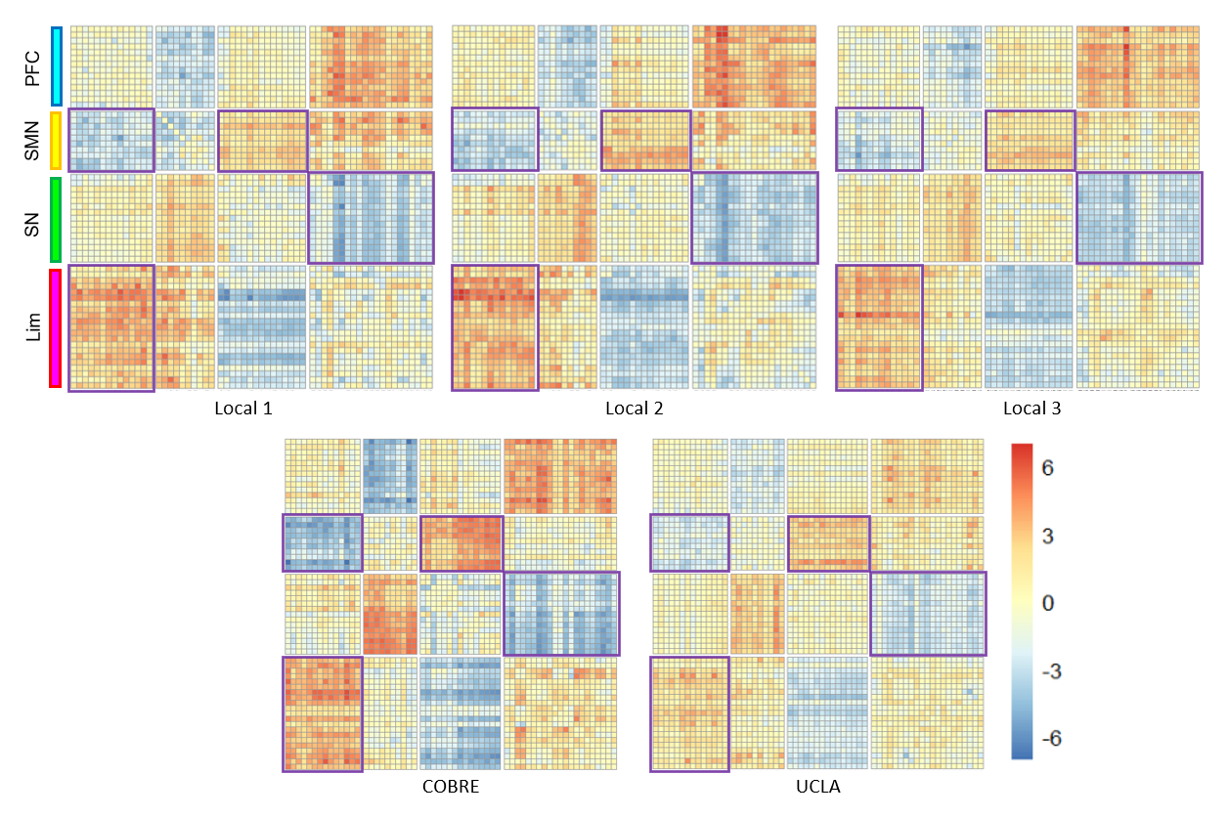
eFigure S2: T-map of the differences in the two subtypes of TSN across 5 sites. Heat maps show TSN dysconnectivities of the top 60 brain regions in five sites across subtypes. Consistent inter-regional connectivity patterns and four prominent modules are observed across centers. Abbreviations: Lim, paralimbic system; PFC, prefrontal cortex; SMN, sensorimotor network; SN, subcortical nucleus; TSN, texture similarity network.

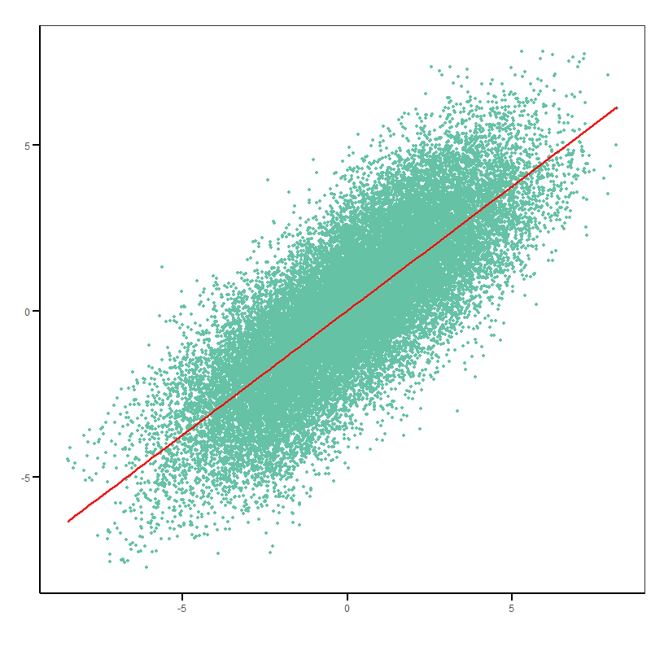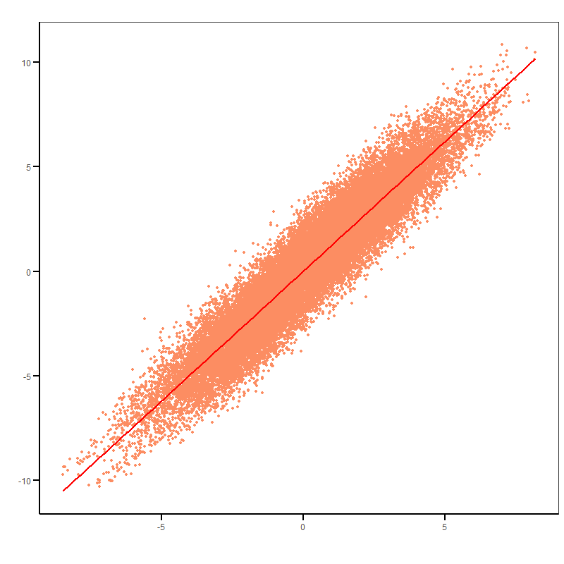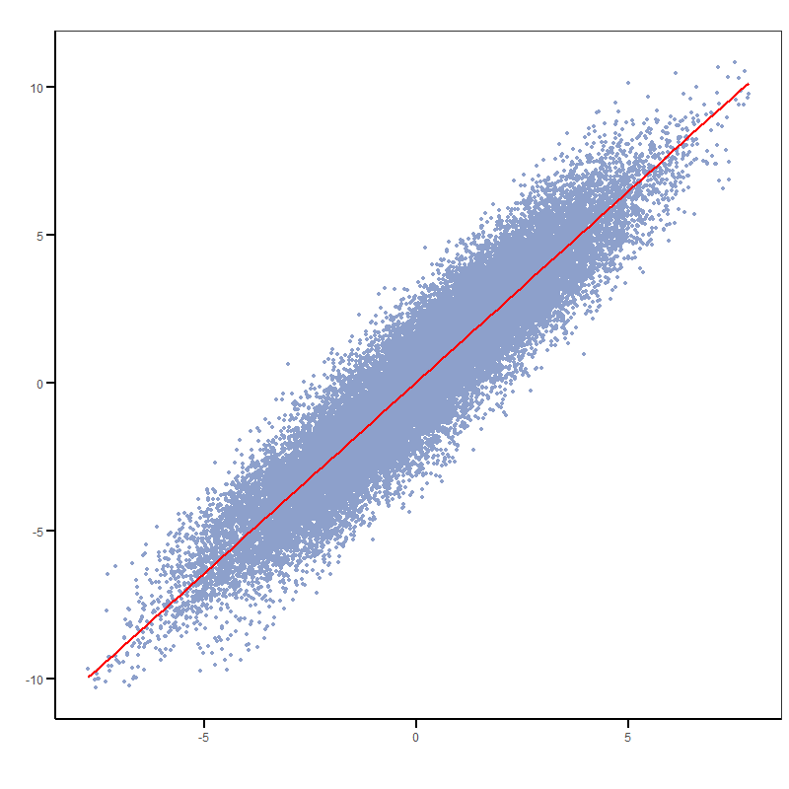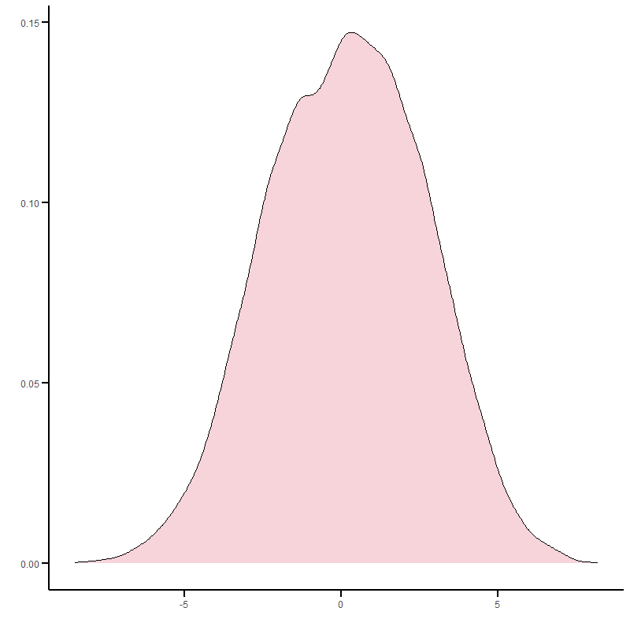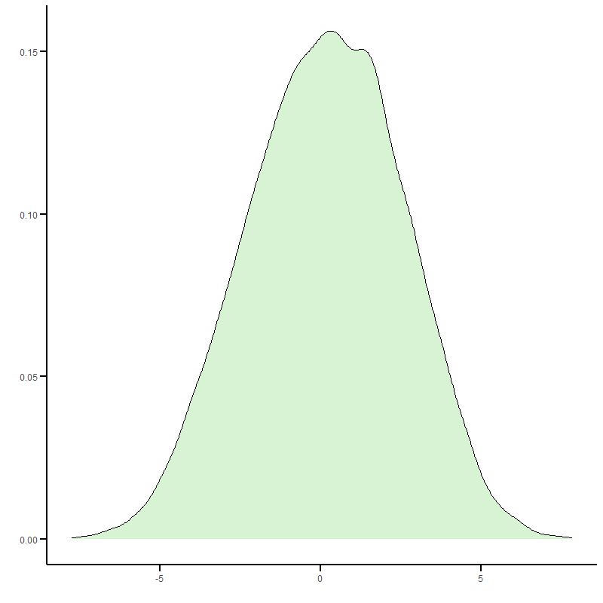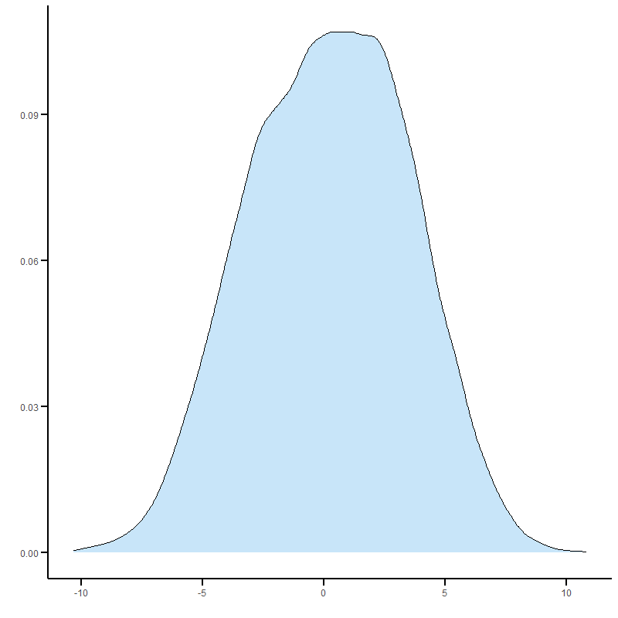
0.9434
0.7897
0.9355
Total
Split1
Split2

eFigure S3: Correlation of subtypes TSN patterns obtained from the training in the split-sample experiment. Inter-subtype differences were consistent across splits (Pearson r = 0.79–0.94).

