Supplemental Information for:

Satellite-derived methane emissions reveal persistent gaps in global oil and gas mitigation performance

Mark Omara^{1,2}, James P. Williams^{1,2}, Anthony Himmelberger², Kaiya Weatherby^{1,2}, Ben Lyke^{1,2}, Jack Warren^{1,2}, Katlyn MacKay^{1,2}, Luis Guanter^{1,3}, Joshua Benmergui^{1,2,4}, Marvin Knapp^{1,2,4}, Christopher C. Miller^{1,2,4}, Sèbastien Roche^{1,2,4}, Jonathan Franklin⁴, Steven P. Hamburg^{1,2}, Steven C. Wofsy⁴, Ritesh Gautam^{1,2}

¹ Environmental Defense Fund, New York, NY 10010, USA
² MethaneSAT, LLC, Austin, TX 78701, USA
³ Research Institute of Water and Environmental Engineering (IIAMA), Universitat Politecnica de Valencia, Valencia, Spain
⁴ Harvard John A. Paulson School of Engineering and Applied Sciences, Harvard University, Cambridge, MA 02138, USA

Correspondence to: Mark Omara (momara@edf.org)

Supplementary Note 1: Alternate methodology for the sectoral attribution of spatially explicit MethaneSAT methane emissions

We adapt the procedure outlined in Shen et al.¹ to proportionally scale MethaneSAT’s spatially explicit methane emissions to individual source sectors, using a Monte Carlo ensemble approach. We use the sectorally-resolved, spatially explicit (25 × 25 km grid) mean posterior methane emissions data from East et al.² as a priori information for the sectoral attribution of spatially explicit MethaneSAT total methane emissions. We use the mean posterior result from the East et al. dataset as an independent, measurement-based source of prior information on the ratios of oil and gas methane emissions to the total methane emissions in each region.

We begin by regridding the East et al. dataset on the MethaneSAT grid (0.04º × 0.04º) using a mass conservation approach. At each grid cell $(i,j)$, we express the posterior total emission as the sum of the sectoral posterior emissions (k):
$$E_{i,j}^{post,total}=\sum_{k}{E_{i,j,k}^{post}}$$
Each sector’s posterior emission is related to its prior emission by a multiplicative scaling factor $f_{i,j,k}$:
$$E_{i,j,k}^{post}=E_{i,j,k}^{prior}×f_{i,j,k}$$
The scaling factors are determined such that the total posterior emission constraint is satisfied, and sectoral adjustments are weighted by their respective uncertainties $(σ_{k})$. Following Shen et al.¹ we assume a 50% uncertainty on sectoral emissions in each region. We define a posterior-to-prior ratio of total methane emissions at each grid cell as:
$$R_{i,j}=\frac{E_{i,j}^{post,total}}{E_{i,j}^{prior,total}}$$

Where:
$$E_{i,j}^{prior,total}=\sum_{k}{E_{i,j,k}^{prior}}$$
We then compute each sectoral scaling factor while ensuring that the posterior total methane emissions match the inversion results for each region.

This approach yields results that are in reasonable agreement within uncertainty of the primary sectoral attribution method outlined in the Main Text. Supplementary Figure 1 shows the comparison the results of oil and gas methane emissions based on these two methods.
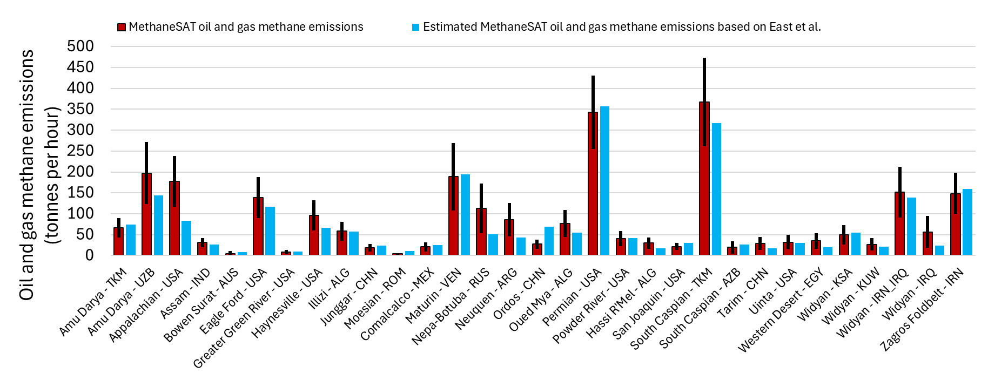

Supplementary Figure 1. A comparison of two methods for sectoral attribution of total methane emissions quantified by MethaneSAT. Red bars show the sectoral attribution based on the methods outlined in the Main Text, incorporating a composite prior dataset based on facility-level or bottom-up datasets (error bars show the 95th percent confidence intervals). Blue bars show the alternative method using the TROPOMI-estimated sectorally-attributed dataset from East et al. The sectoral attribution here follows the methods outlined in Shen et al.¹

Supplementary Note 2: Equivalent energy-normalized methane intensity threshold of 0.2 percent of marketed natural gas production

The Oil and Gas Decarbonization Charter (OGDC; https://www.ogdc.org/oil-gas-decarbonization-charter/) establishes a near-zero upstream methane emissions target for oil and gas operations of 0.2% methane intensity—defined as methane emissions normalized by marketed natural gas production—by 2030. As discussed by Seymour et al.³, gas-production-normalized methane intensities reflect how effectively methane emissions from natural gas production are managed, representing the fraction of produced natural gas that is lost to the atmosphere. However, there are currently no analogous methane intensity targets for systems that predominantly produce oil, even as methane may still be emitted or vented from co-produced natural gas or from inefficient flaring systems. Accordingly, we report both gas-production-normalized methane intensities (percentage of methane emitted relative to methane produced) and energy-normalized methane intensities (methane emitted relative to total oil and gas production, expressed in kilograms per gigajoule) to enable cross-comparison across different regions.

The OGDC methane intensity target of 0.2% is equivalent to 0.03 kg/GJ under the assumption that 100% of total energy production is derived from natural gas, using a methane content of 90%, a methane density of 19.2 kg per 1,000 cubic feet, and a conversion factor of 1 GJ = 26.85 m³ of natural gas. In general, however, most oil and gas fields produce both oil and gas, with wide variation in the share of total energy supplied by gas. We analyzed asset and field-level marketed oil and gas production data from Wood Mackenzie for 2024, covering more than 9,004 assets worldwide (Supplementary Fig. 2). This analysis shows that approximately half of all assets or oil and gas fields (49%) derive less than 5% of their total energy production from gas.

If we assume an oil-only system (95% oil, 5% gas, Sup. Fig. 2) is unable to productively utilize associated gas and instead flare it at a high combustion efficiency of 98%, we estimate the resultant methane intensity at 0.017 kg/GJ. This estimate assumes a natural gas methane content of 90% (for dry marketed gas production) and an energy equivalence of 1 barrel of oil equivalent (boe) = 6,000 cubic feet of natural gas, with 1,000 cubic feet of methane corresponding to 19.2 kg of methane.
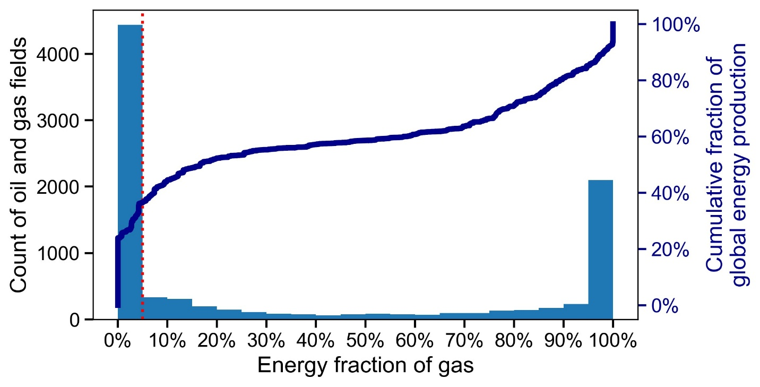
Supplementary Figure 2. A histogram of oil and gas “assets” or fields as functions of the energy fraction of gas (i.e., the proportion of total energy production coming from gas). We analyze 9,004 asset-level or field-level production data from WoodMac and find that roughly half (49%) have less than five percent energy fraction of gas, while accounting for approximately one-third (36%) of the cumulative energy production from all 9,004 assets or fields.

Supplementary Note 3: Adjusting the annual estimates from the spatially-explicit UNFCCC inventory (GFEI v3): 2020—2024

We use the spatially-explicit GFEI v3 inventory (Scarpelli et al.⁴) as the reference bottom-up inventory in our comparison with MethaneSAT emission quantification results. The most recent year for which inventory-based emissions estimates are available is 2020. To facilitate a more robust comparison with MethaneSAT oil and gas methane emissions estimates for 2024–2025, we scale the GFEI v3 emissions data according to the percent change in total oil and gas production between 2020 and 2024 for each region. This approach assumes that regionally estimated bottom-up methane emissions scale proportionally with production, which is reasonable assumption given the strong reliance on inventory emissions on activity data—such as oil and gas production—in the construction of bottom-up inventory estimates.

Supplementary Figure 4 illustrates the difference between estimated oil and gas methane emissions for 2020, as reported by Scarpelli et al.⁴, and the corresponding 2024 values obtained by adjusting emissions based on relative changes in oil and gas production over this period. Marketed oil and gas production data are sourced from Wood Mackenzie. In aggregate, we estimate the 2024 oil and gas methane emissions to be roughly 25% greater than the estimated emissions for 2020.

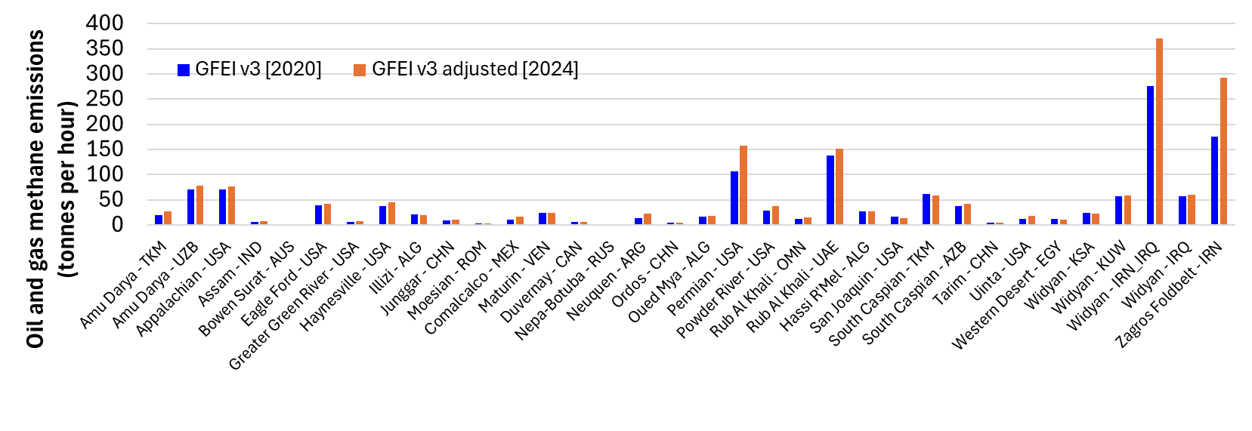
Supplementary Figure 4. Comparison of the UNFCCC oil and gas methane inventory (based on the GFEI inventory) for 2020 versus adjusted values for 2024.

Supplementary Note 4: “Super-emitter” point source emissions in MethaneSAT regions

Guanter et al.⁵ presents a detailed assessment of “super-emitter” methane emissions detected and quantified by MethaneSAT for several key oil and gas production regions globally. While we do not focus on methane “super-emitter” point sources, the results from Guanter et al. provide relevant supplemental information on the prevalence of “super-emitter” emissions (above ~500 kg h⁻¹) in the assessed regions. These regions (n = 9) include the Amu Darya (TKM, UZB), Appalachian (USA), Haynesville (USA), Maturin (VEN), Oued Mya (ALG), Permian Basin (USA), South Caspian (TKM), and Zagros Foldbelt (IRN). Supplementary Fig. 5 shows the distribution of “super-emitter” emissions for each region, as reported in Guanter et al.⁵

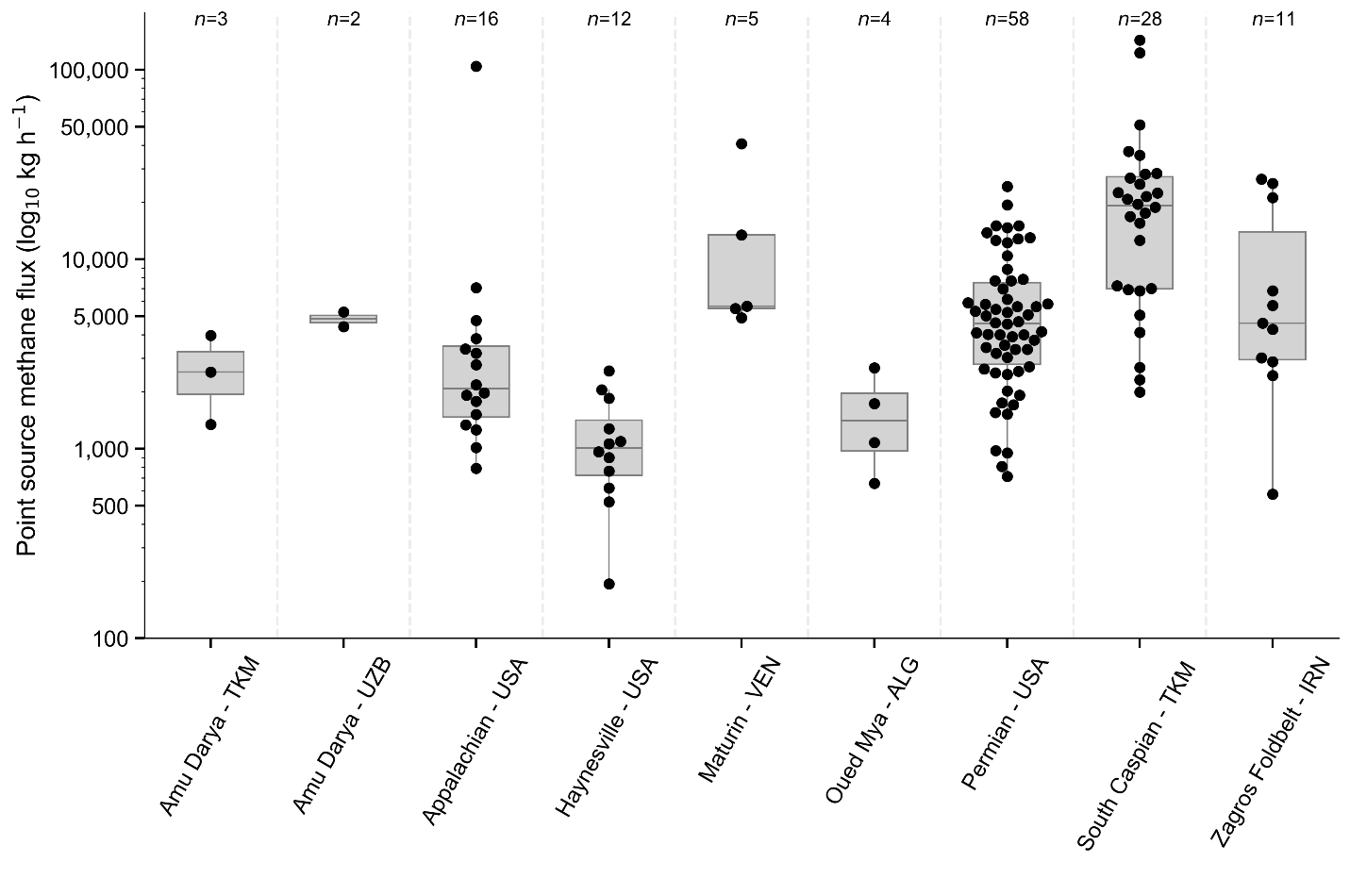
Supplementary Figure 5. Distribution of methane “super-emitters” based on MethaneSAT observations in major oil and gas basins, as reported in Guanter et al.⁵ The numbers on the top x-axis represent the total count of quantified methane “super-emitters”. All methane sectors are included in this assessment.

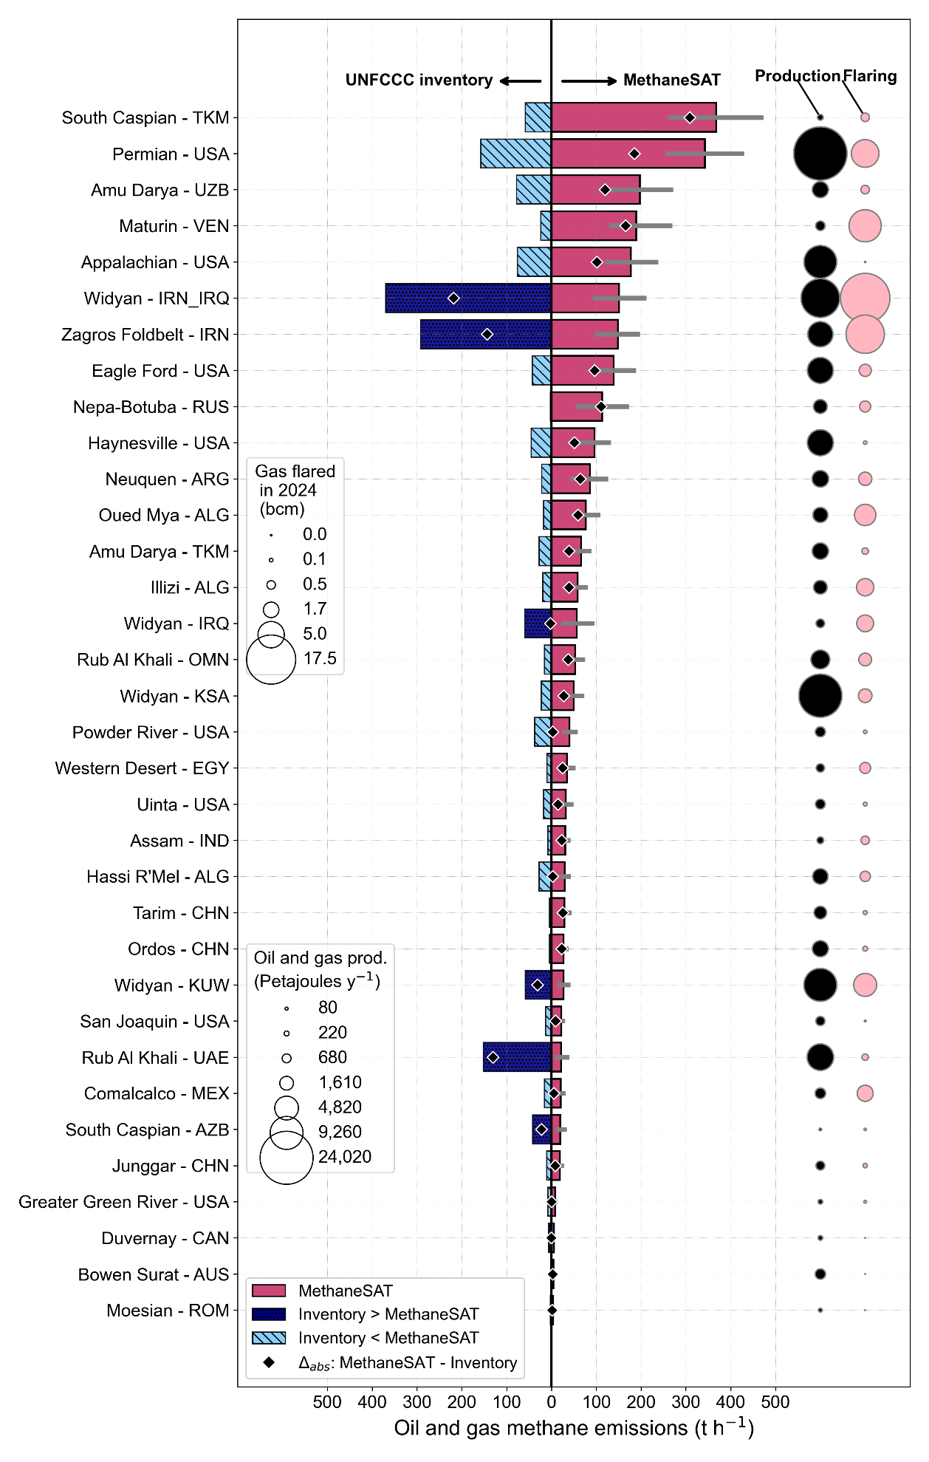Supplementary Figure 6. Comparison of regional oil and gas methane emissions for all 34 regions included in this study. MethaneSAT estimates are shown as purple bars, with error bars indicating the 95% confidence interval of the mean. For all regions, inventory values are derived from the gridded country-reported inventories to the UNFCCC, as reported in the GFEI v3 inventory for 2020 and adjusted to 2024 based on relative changes in total marketed oil and gas production (Supplementary Note 3). Hatched light blue bars indicate regions where MethaneSAT estimates exceed inventory values, while dark blue bars indicate the opposite. Black diamond markers represent the absolute difference between MethaneSAT and inventory estimates. Bubble plots display total oil and gas production in petajoules per year (black symbols) and gas flaring volumes in billion cubic meters based on VIIRS²⁵ estimates (light yellow symbols) for 2024. See Main Text for additional details.

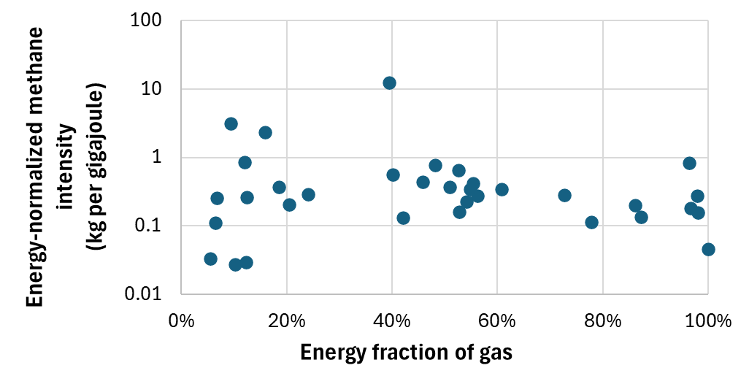

Supplementary Figure 7. Energy-normalized methane intensities as functions of the energy fraction of gas (i.e., the proportion of total energy production that comes from gas production).

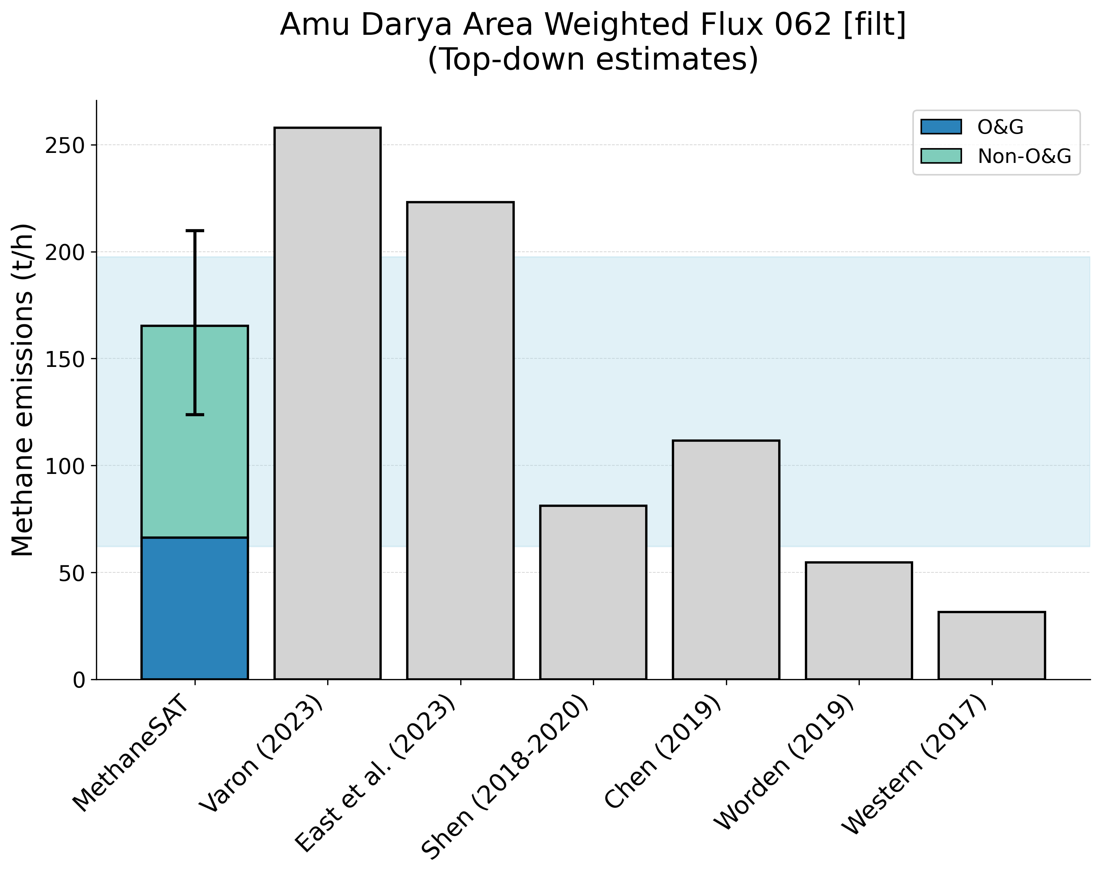

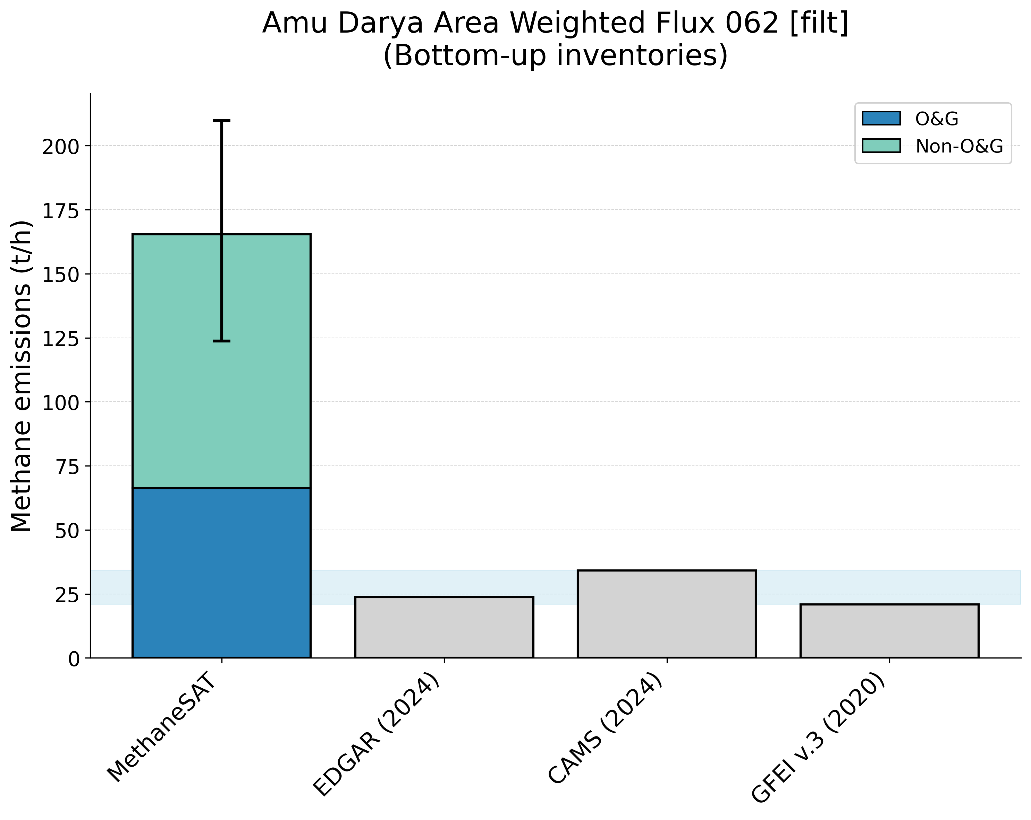
Supplementary Figure 8. Comparison of MethaneSAT total methane emissions estimates with peer-reviewed “top-down” measurements (top panel) and “bottom-up” inventory data (bottom panel). The shaded area shows the representative range of the peer-reviewed data (2.5th, 97.5th percentiles). Amu Darya, Turkmenistan (TKM) region.
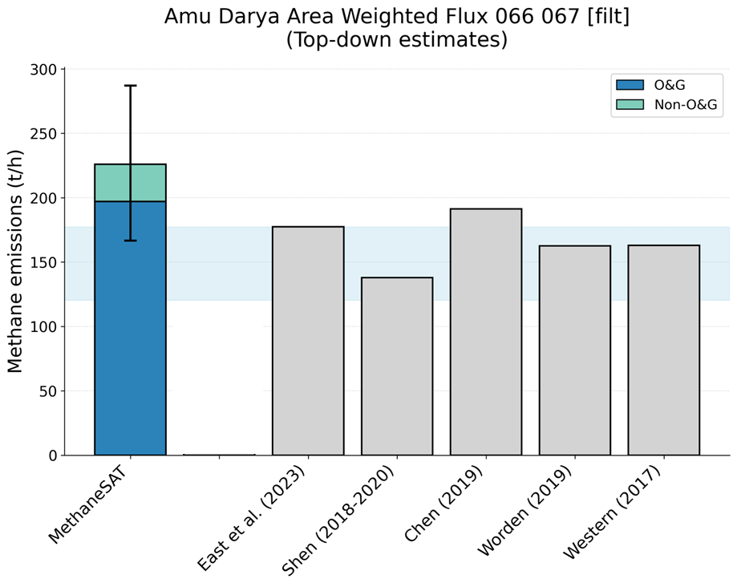
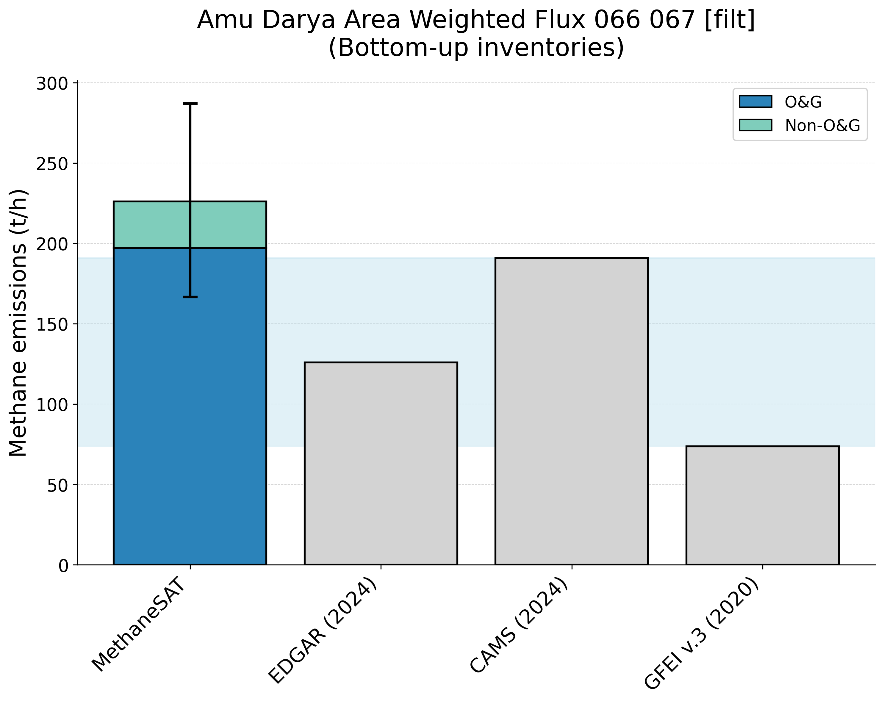

Supplementary Figure 9. Comparison of MethaneSAT total methane emissions estimates with peer-reviewed “top-down” measurements (top panel) and “bottom-up” inventory data (bottom panel). The shaded area shows the representative range of the peer-reviewed data (2.5th, 97.5th percentiles).Amu Darya, Uzbekistan (UZB) region.
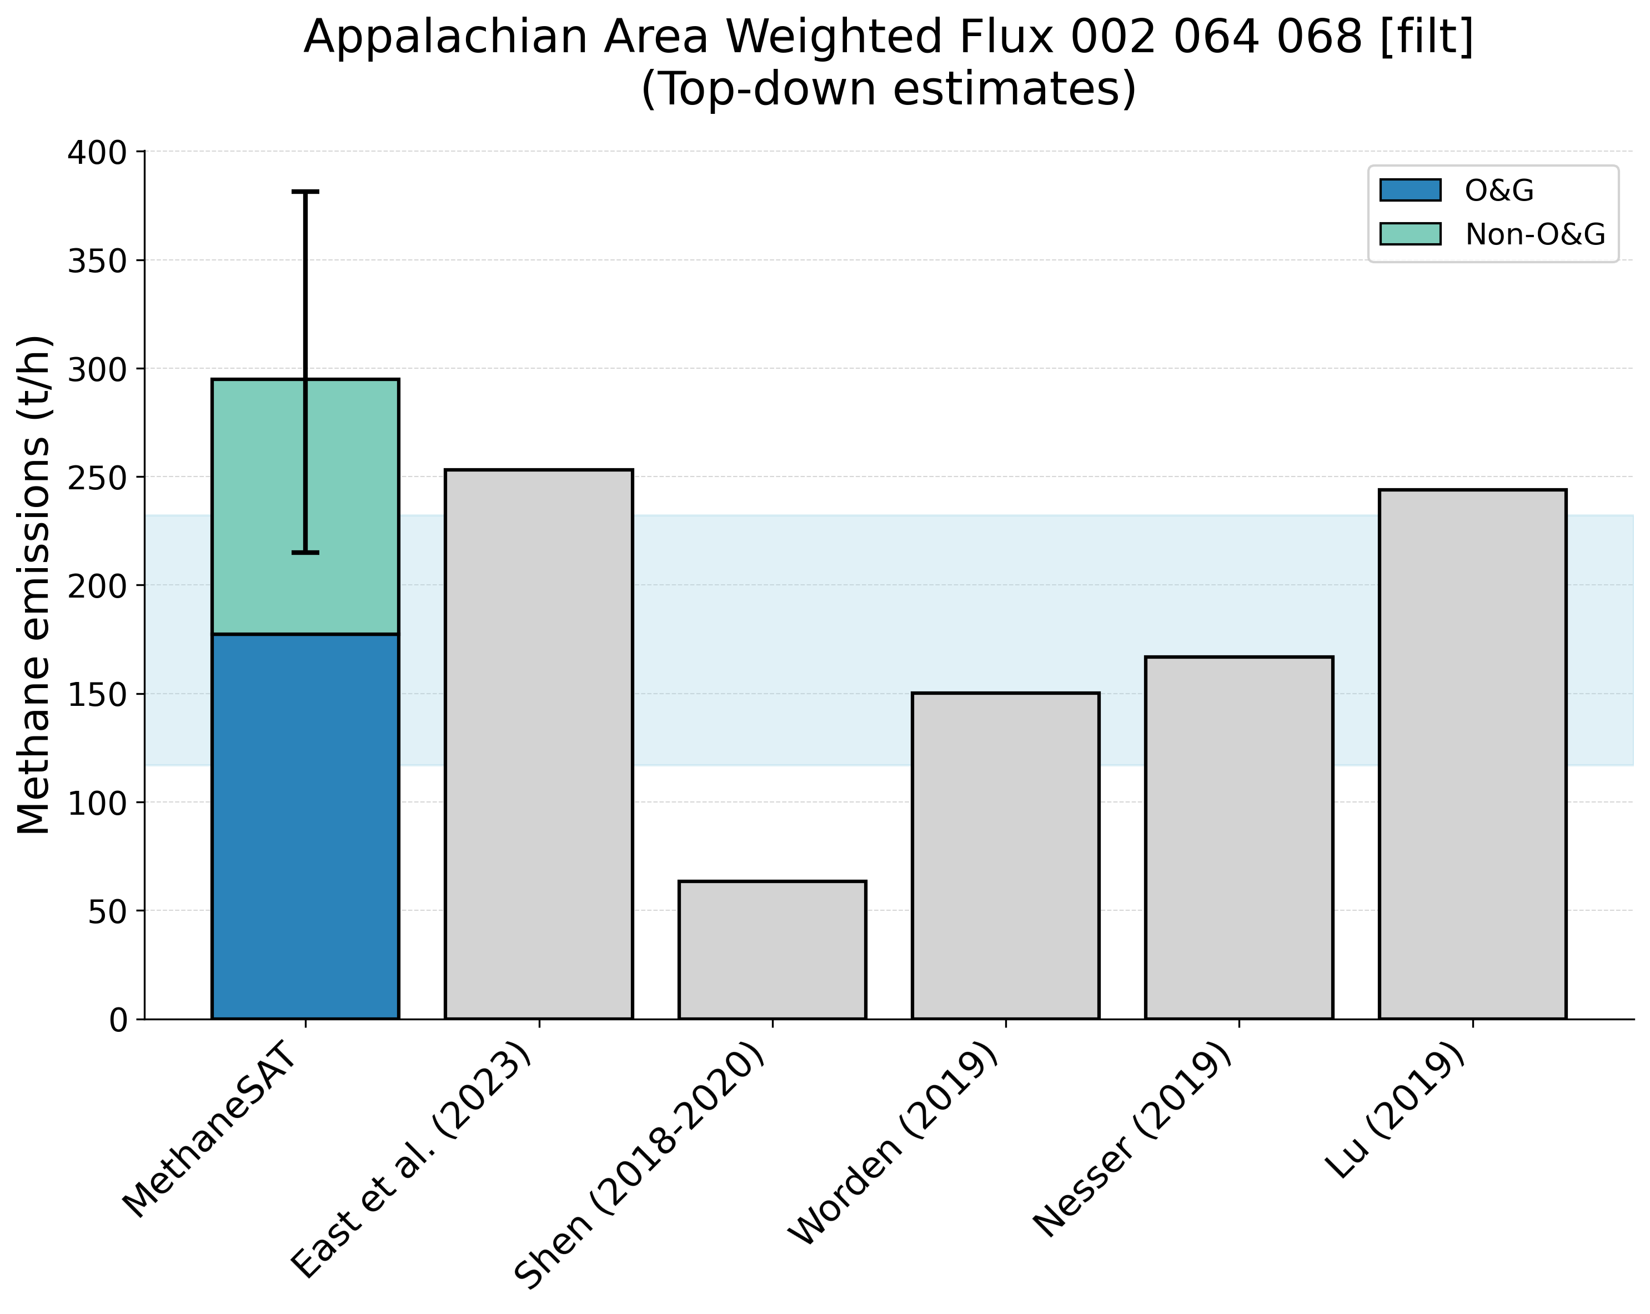
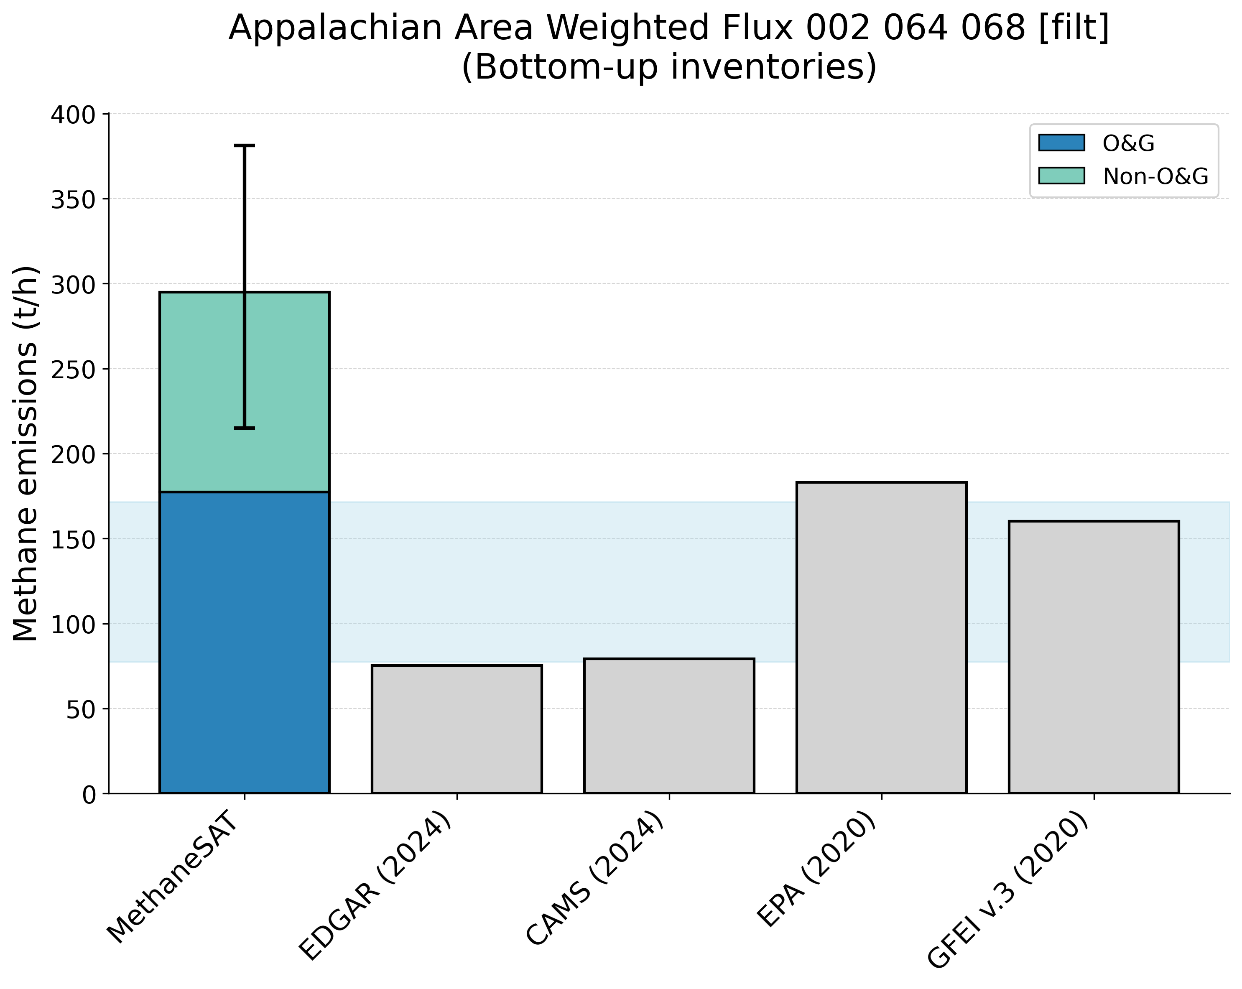
Supplementary Figure 10. Comparison of MethaneSAT total methane emissions estimates with peer-reviewed “top-down” measurements (top panel) and “bottom-up” inventory data (bottom panel). The shaded area shows the representative range of the peer-reviewed data (2.5th, 97.5th percentiles). Appalachian, United States of America (USA) region.

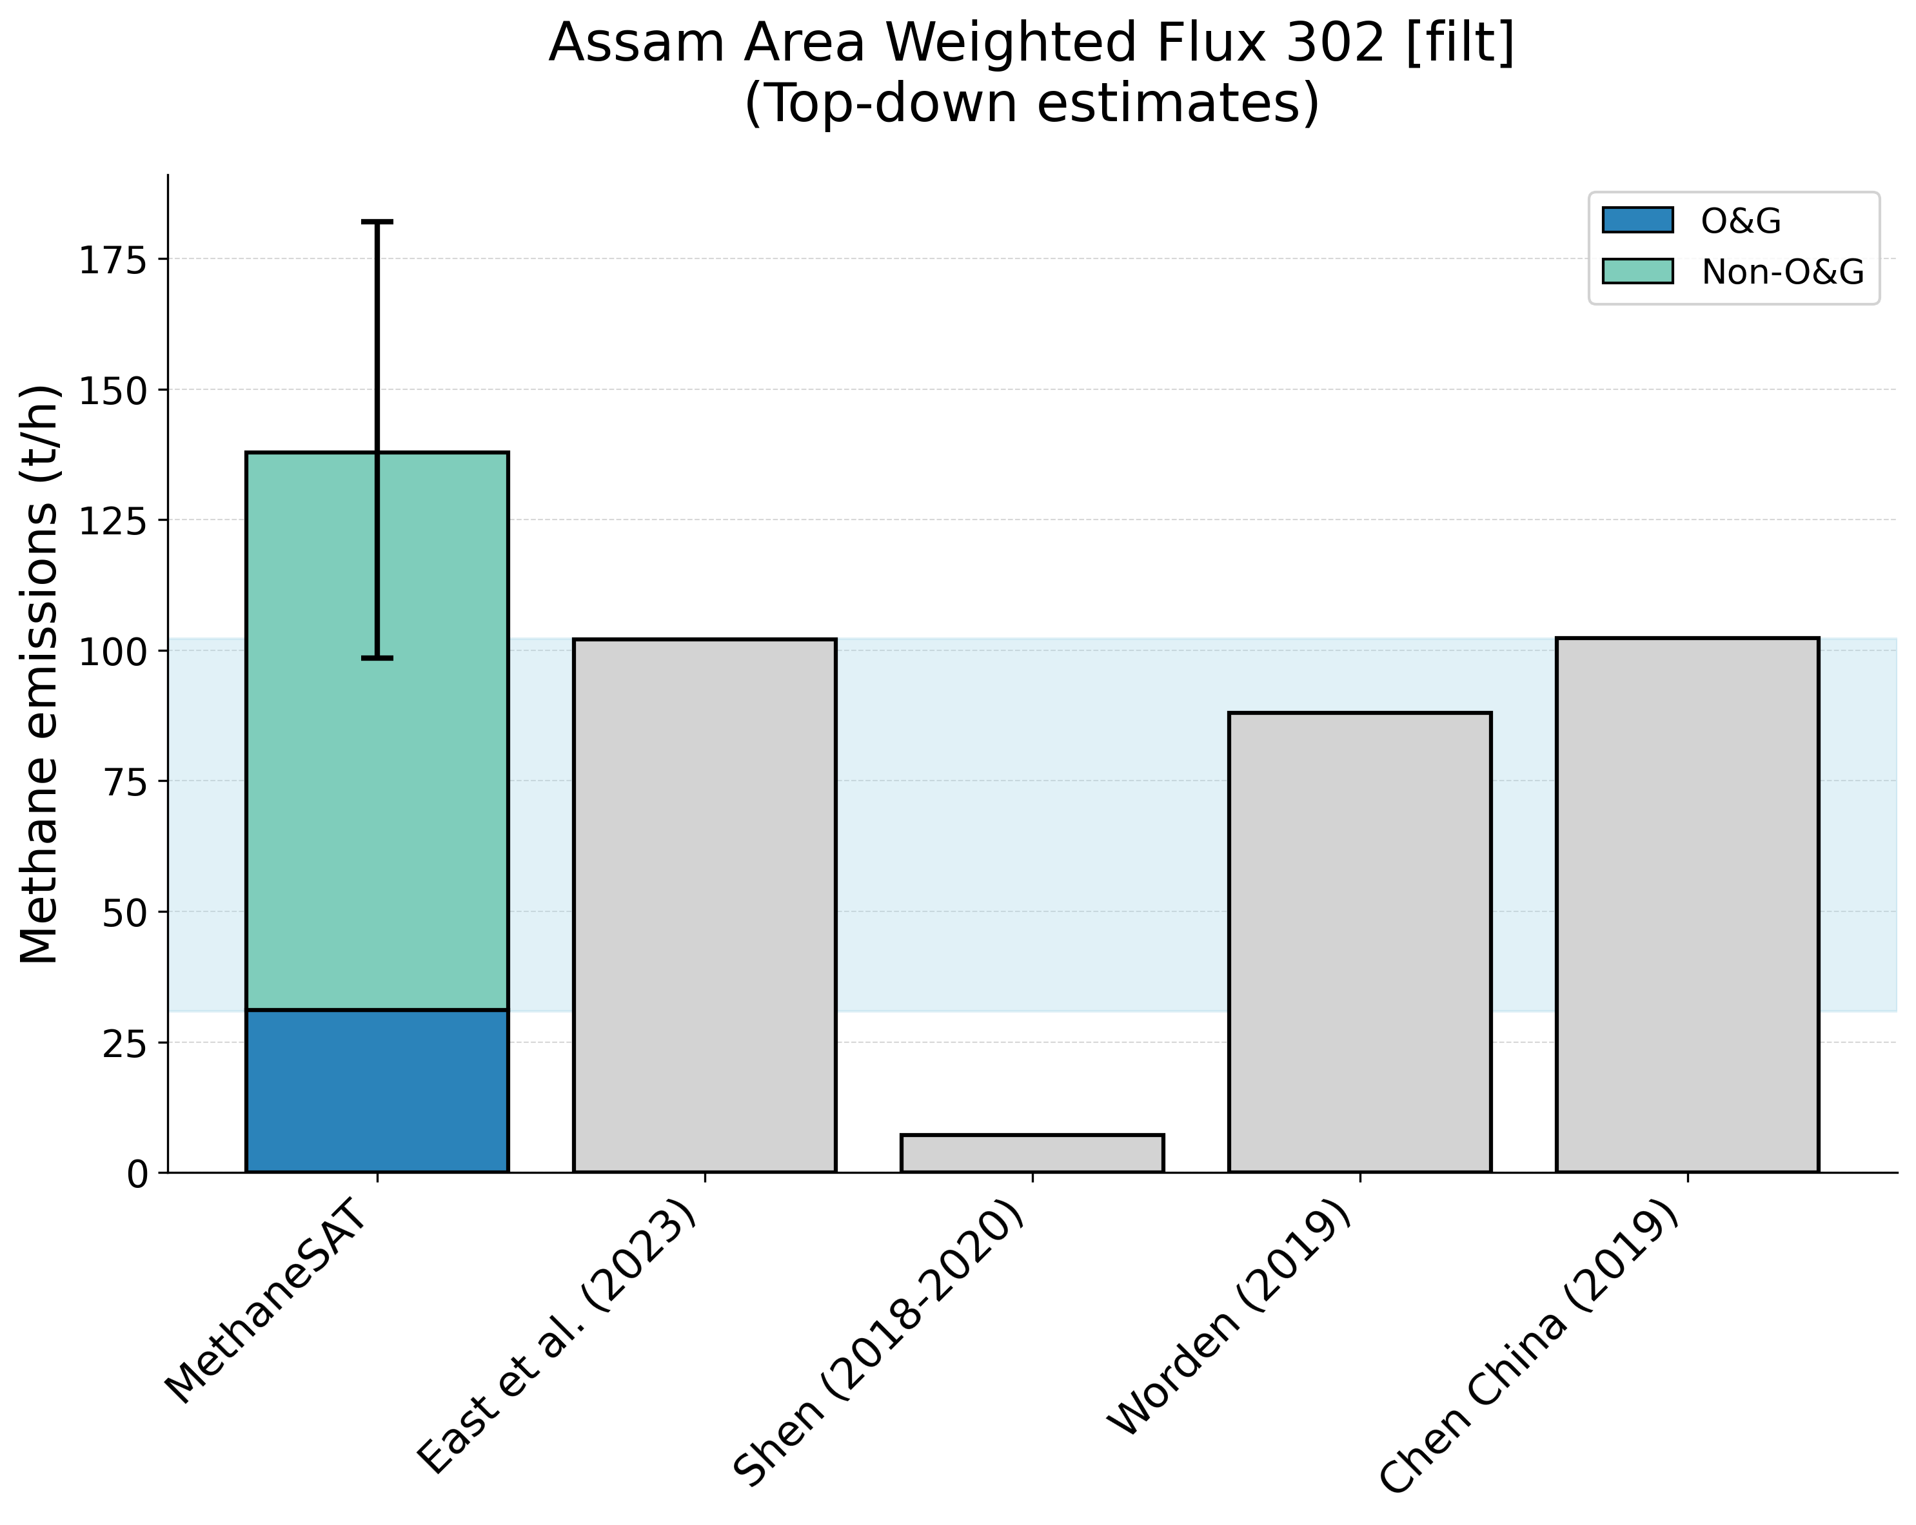
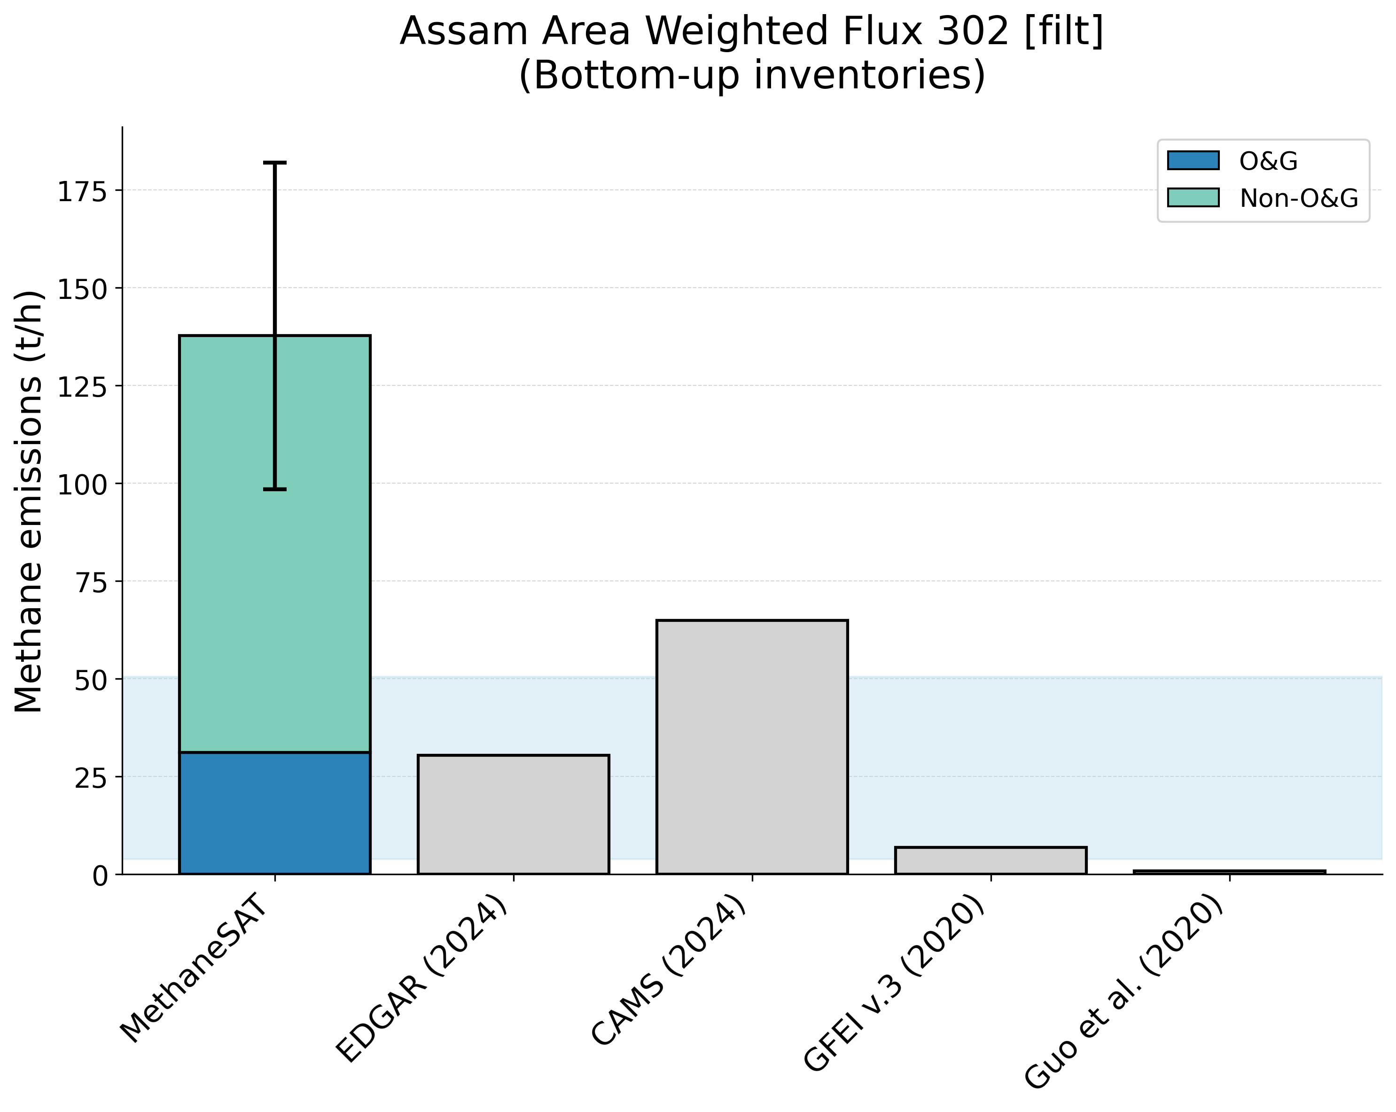
Supplementary Figure 11. Comparison of MethaneSAT total methane emissions estimates with peer-reviewed “top-down” measurements (top panel) and “bottom-up” inventory data (bottom panel). The shaded area shows the representative range of the peer-reviewed data (2.5th, 97.5th percentiles). Assam, India (IND) region.

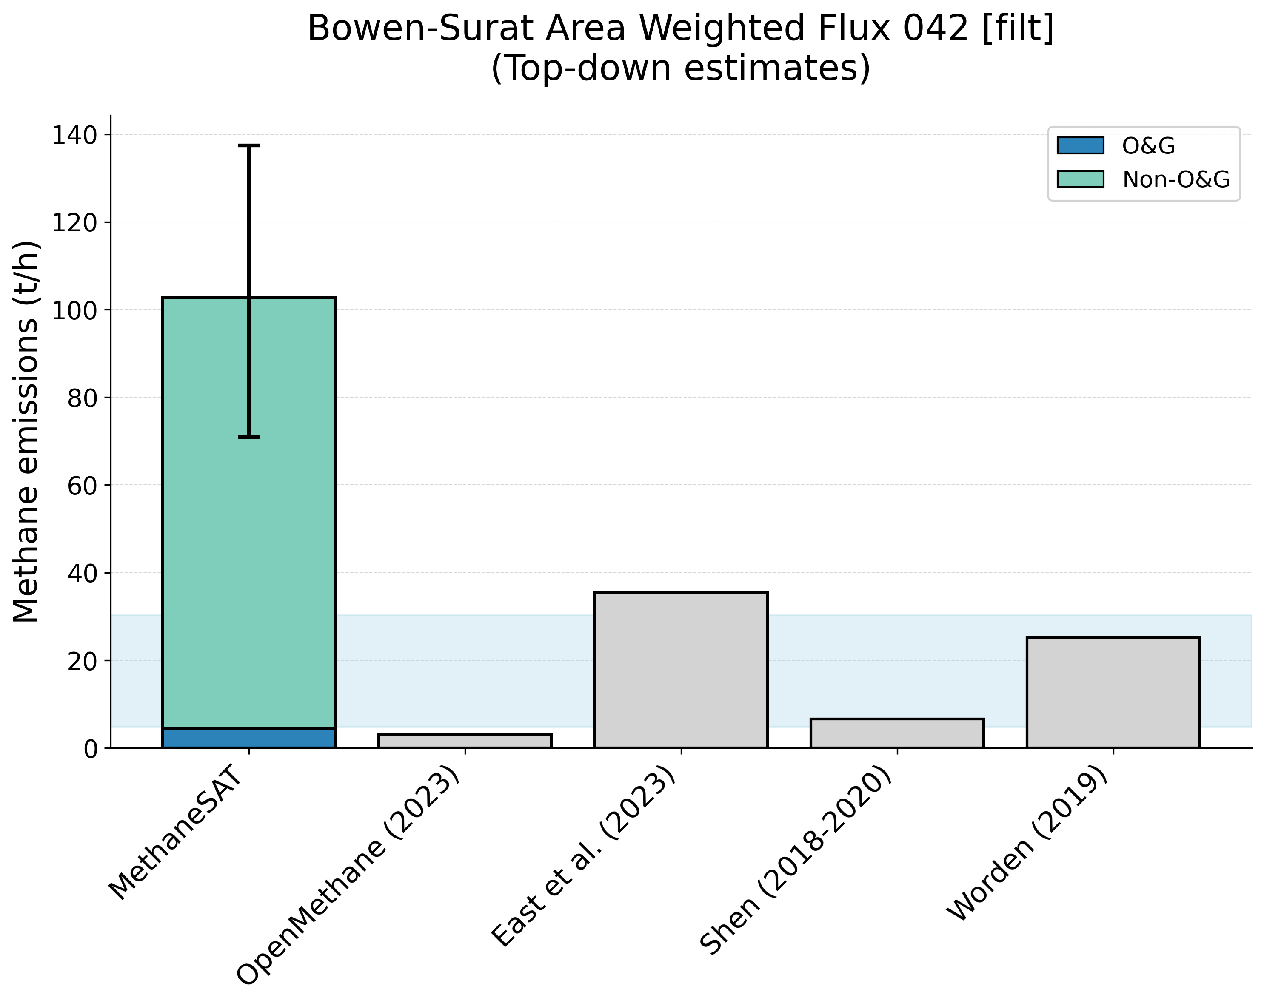
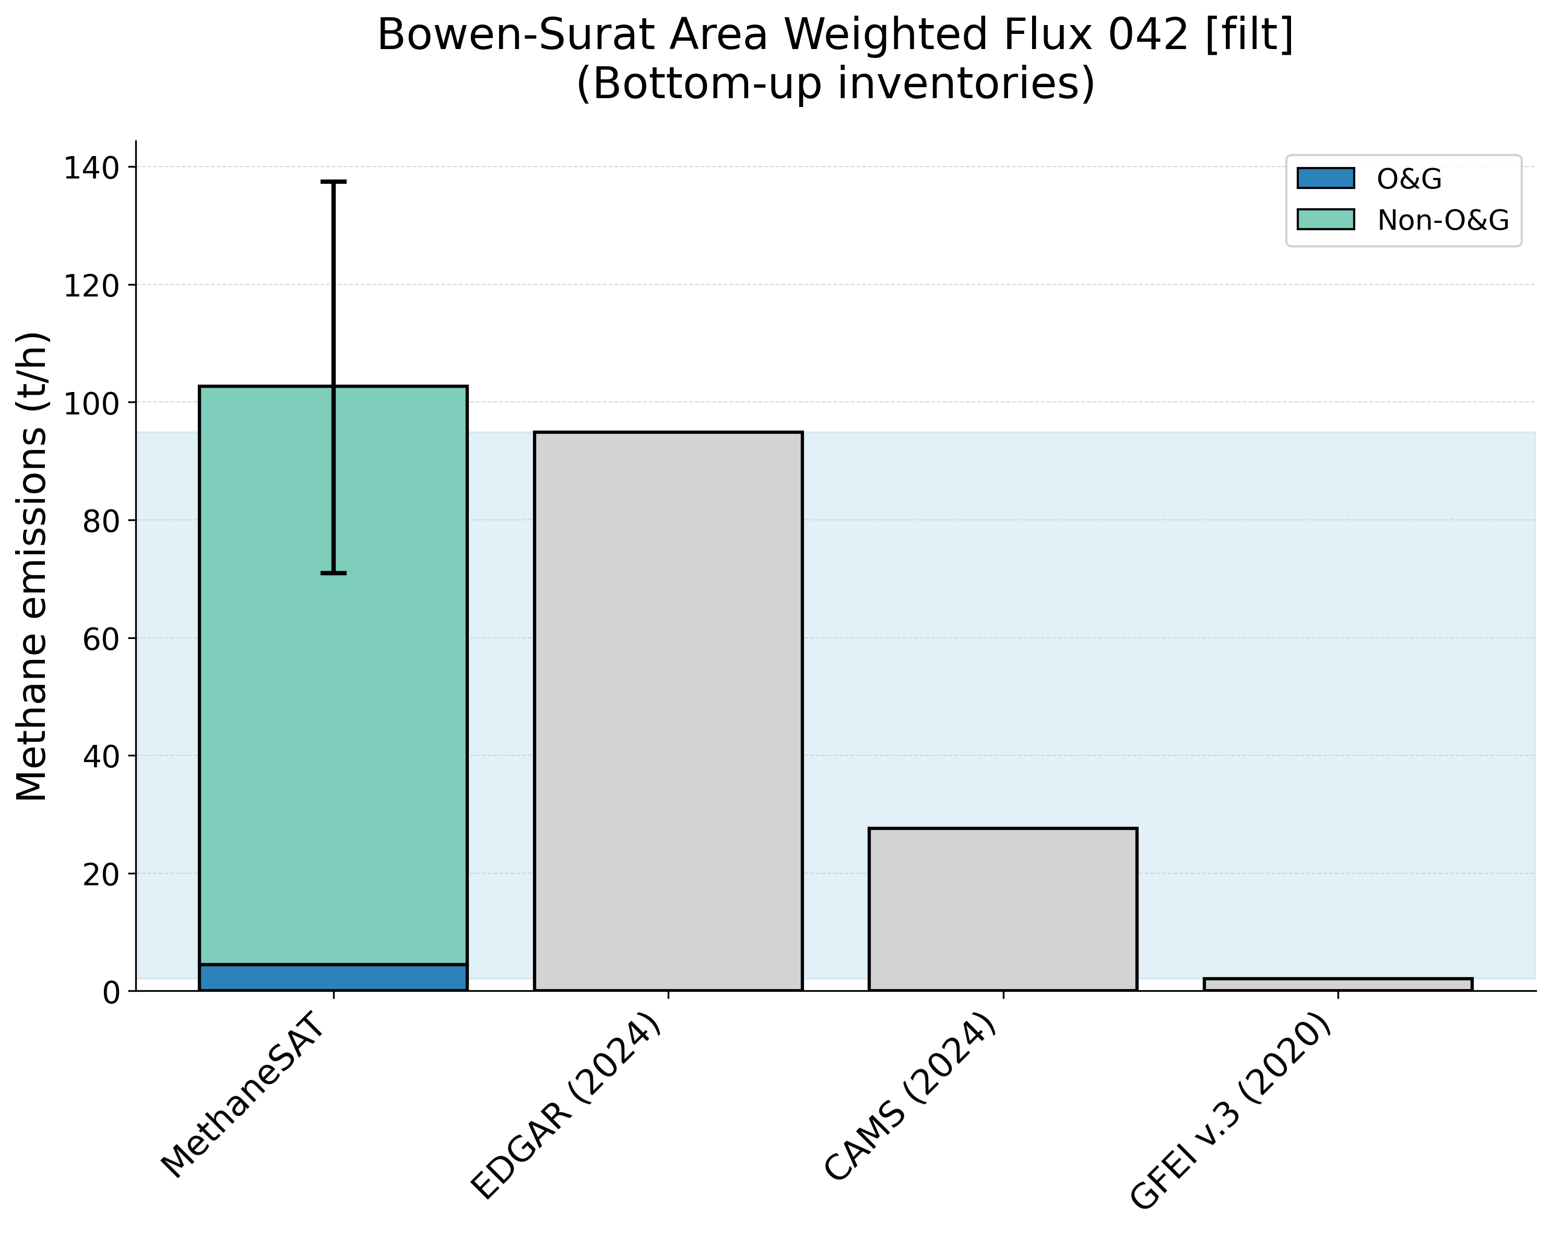
Supplementary Figure 12. Comparison of MethaneSAT total methane emissions estimates with peer-reviewed “top-down” measurements (top panel) and “bottom-up” inventory data (bottom panel). The shaded area shows the representative range of the peer-reviewed data (2.5th, 97.5th percentiles). Bowen Surat, Australia (AUS) region.
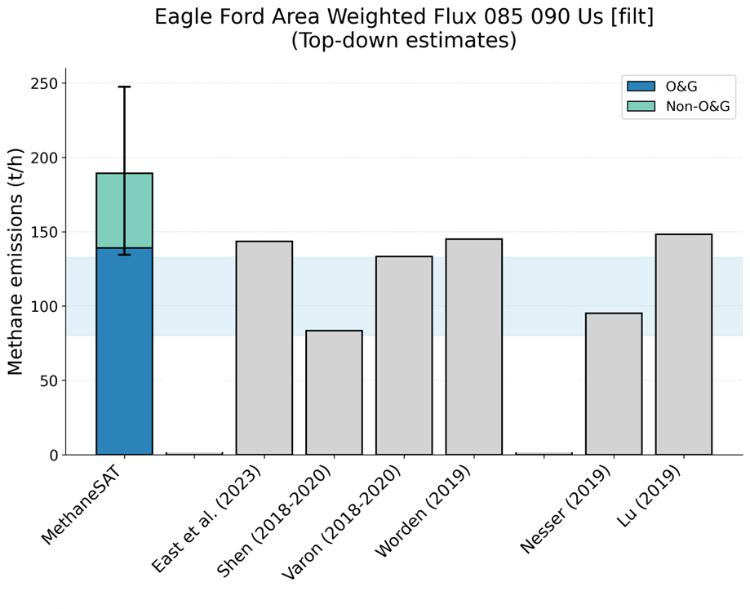
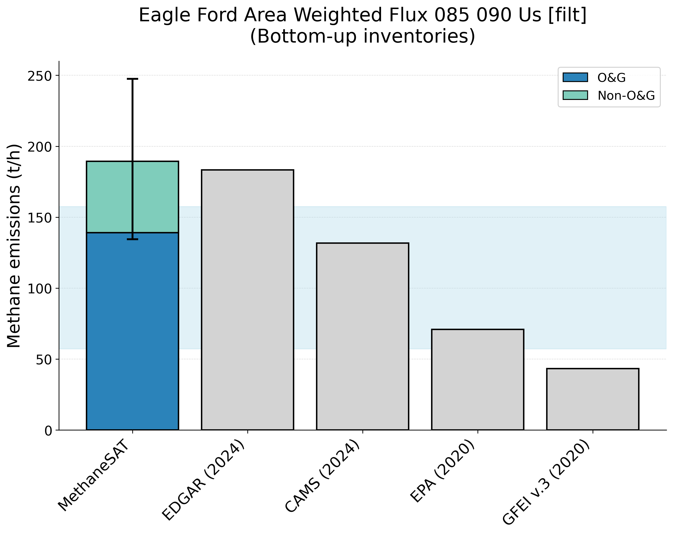
Supplementary Figure 13. Comparison of MethaneSAT total methane emissions estimates with peer-reviewed “top-down” measurements (top panel) and “bottom-up” inventory data (bottom panel). The shaded area shows the representative range of the peer-reviewed data (2.5th, 97.5th percentiles). Eagle Ford, United States (USA) region.
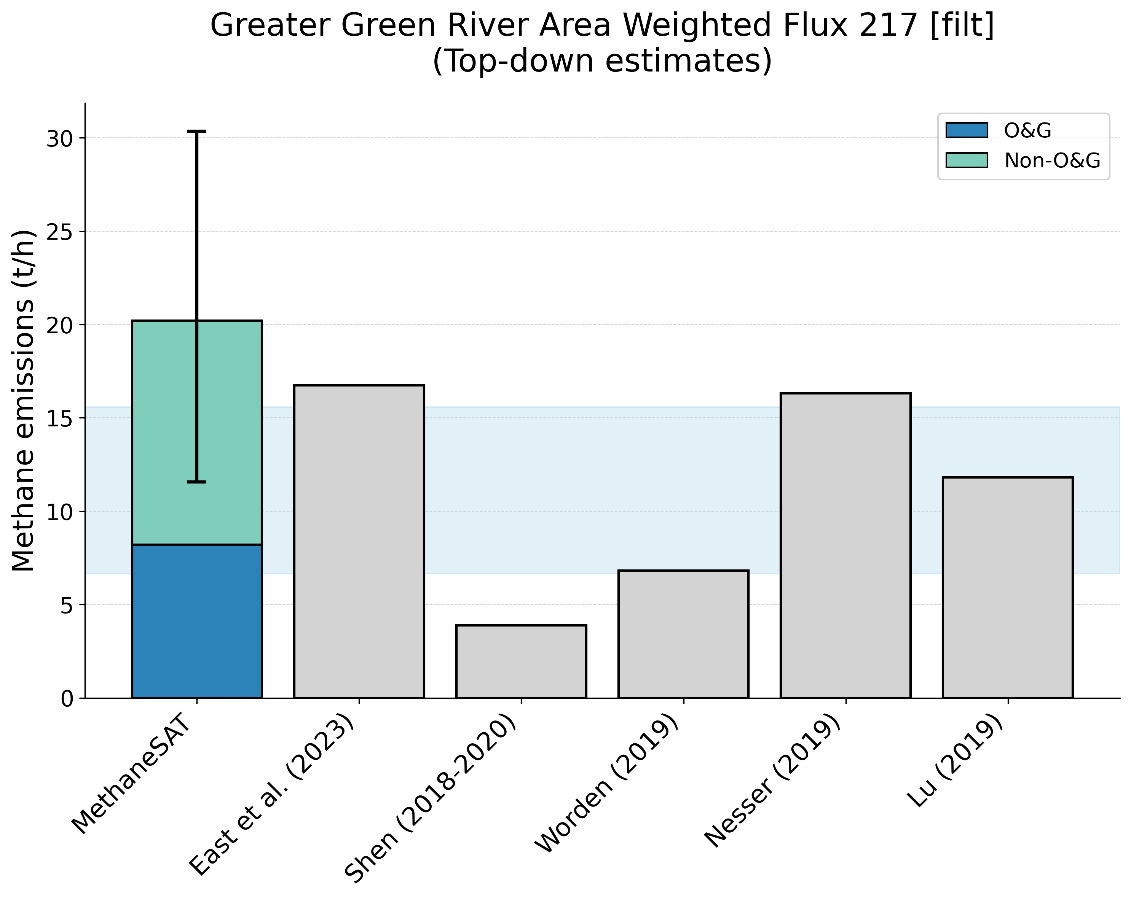
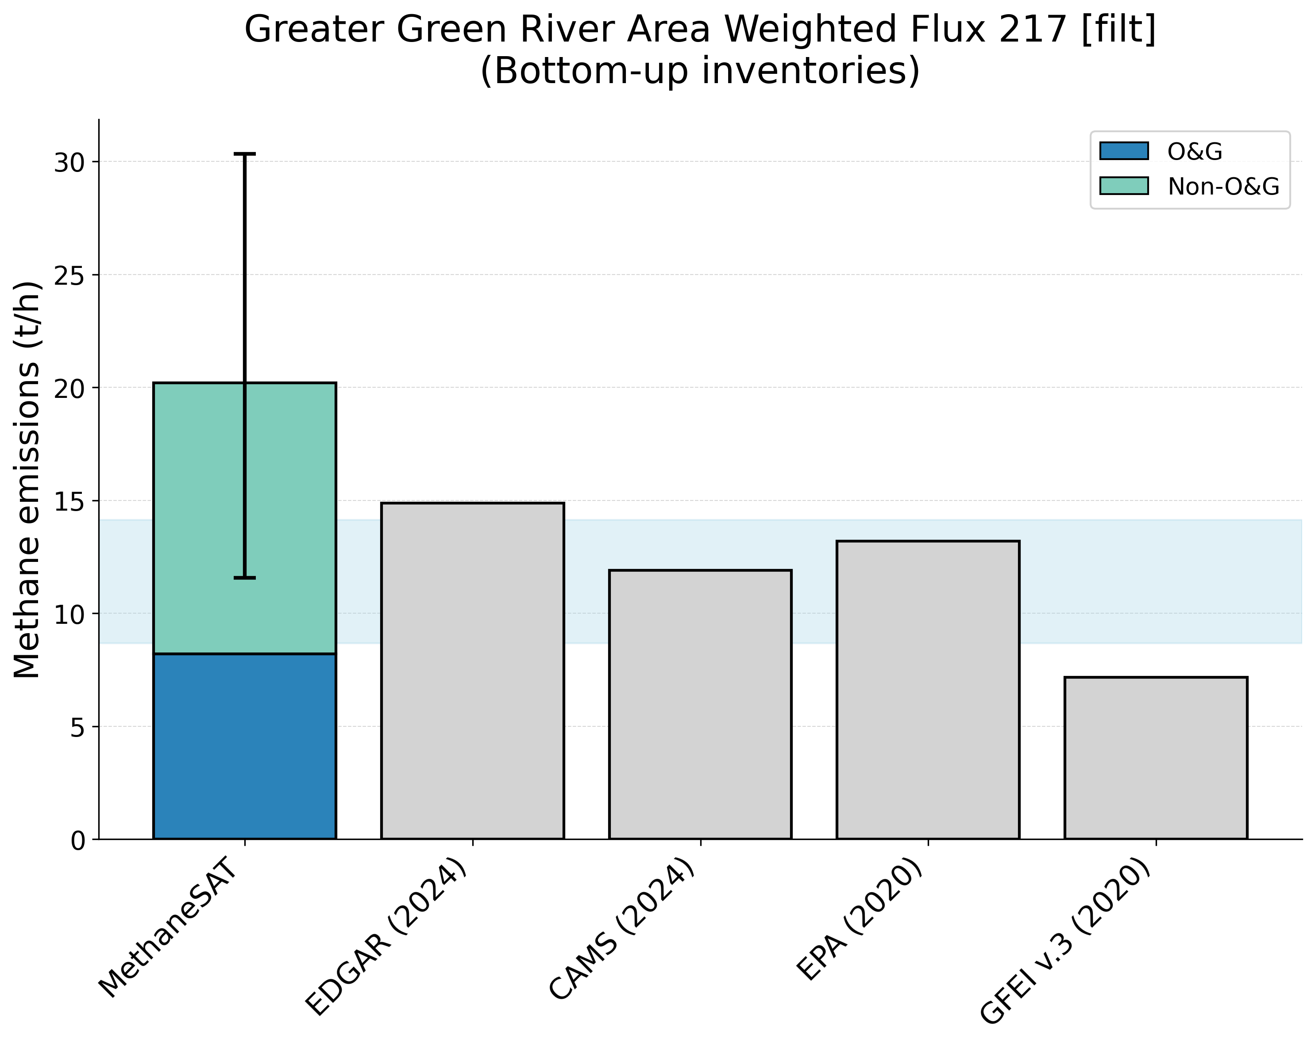
Supplementary Figure 14. Comparison of MethaneSAT total methane emissions estimates with peer-reviewed “top-down” measurements (top panel) and “bottom-up” inventory data (bottom panel). The shaded area shows the representative range of the peer-reviewed data (2.5th, 97.5th percentiles). Greater Green River, United States (USA) region.
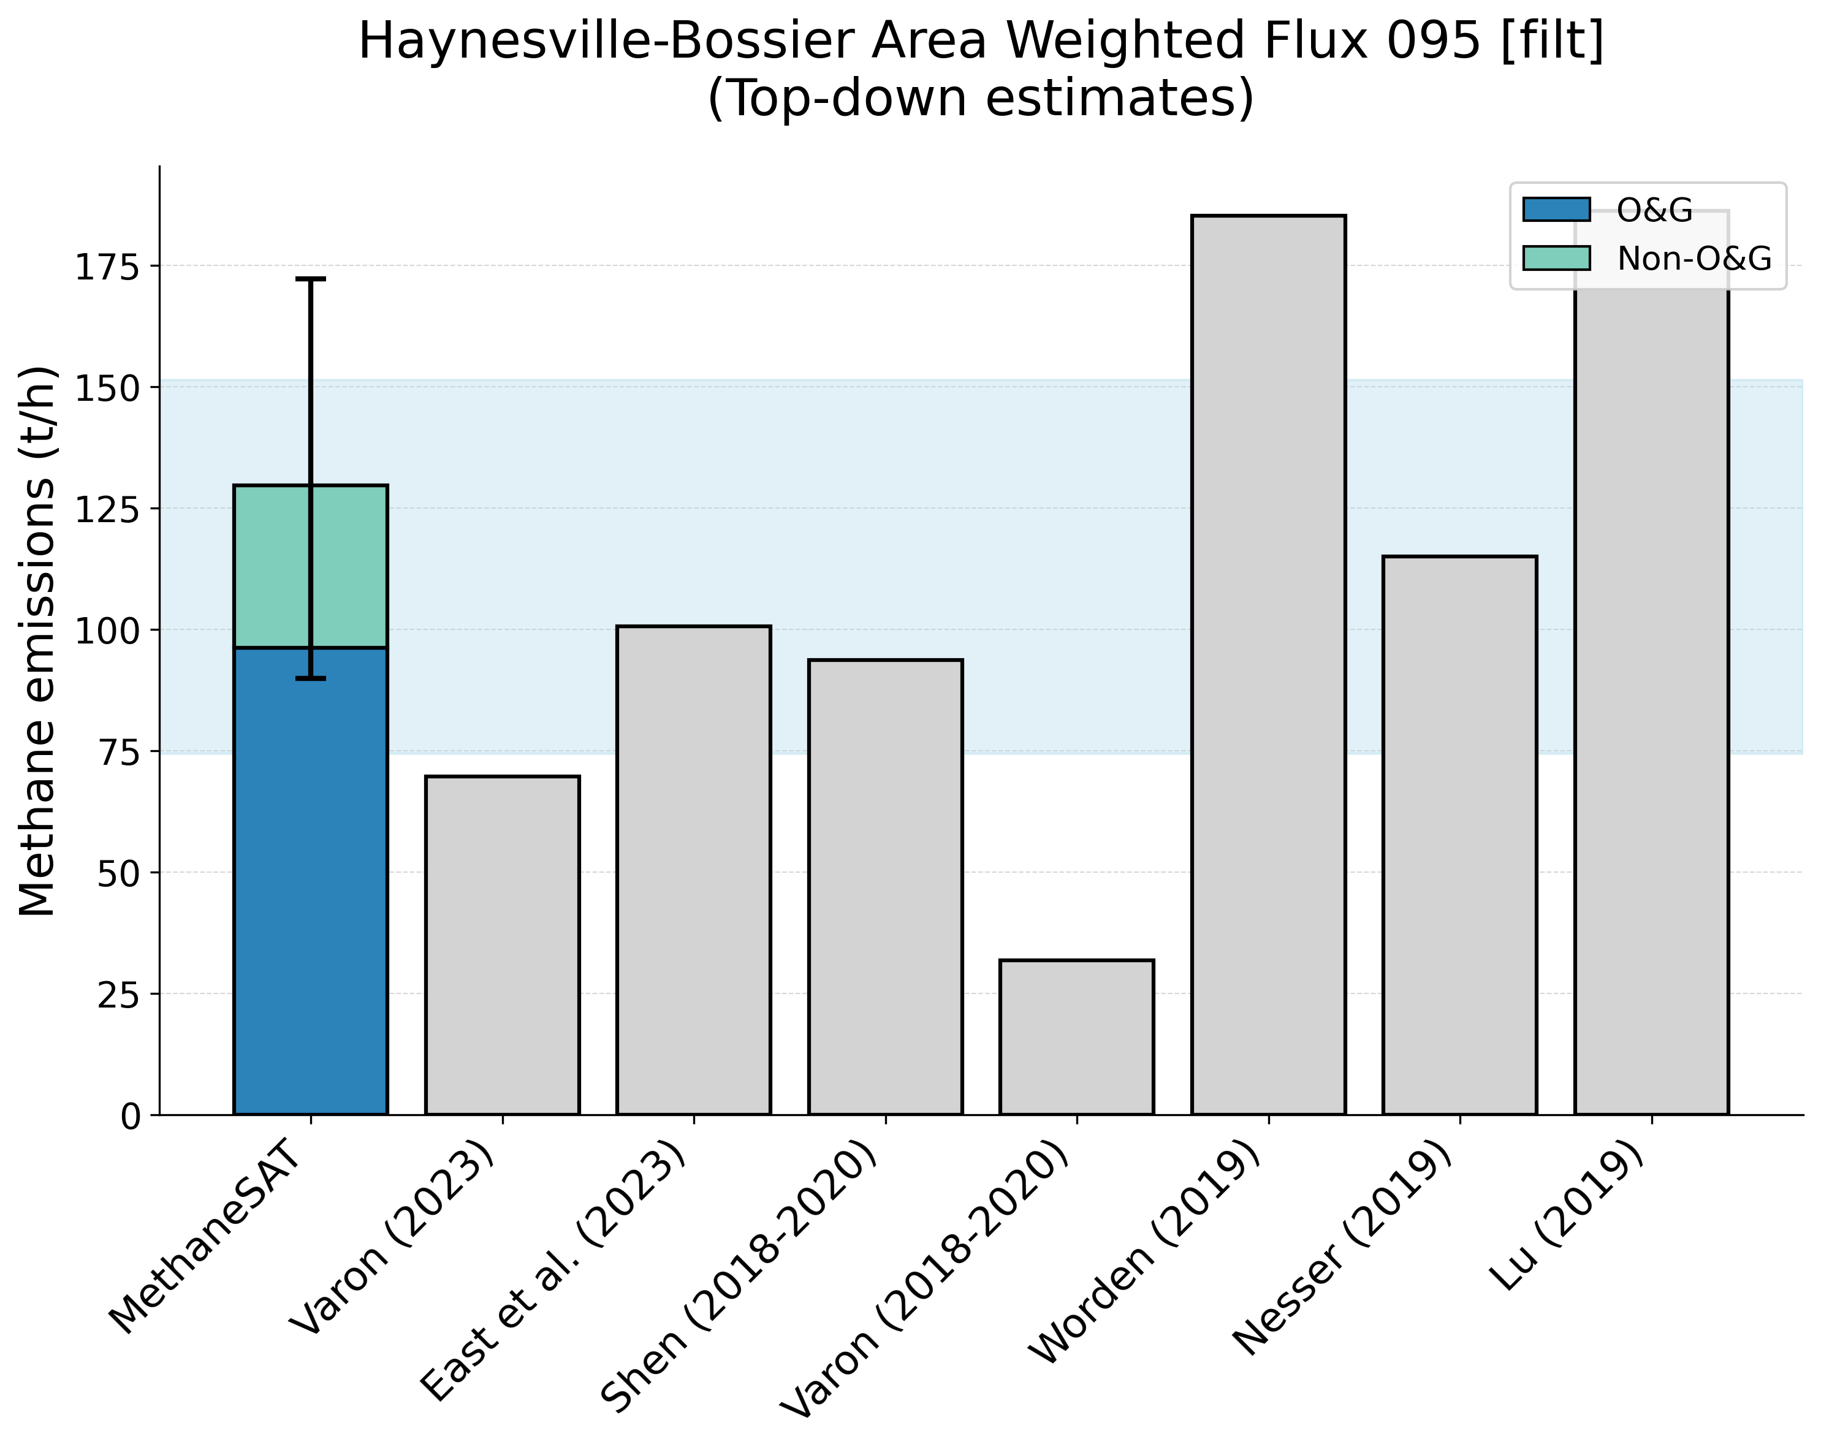
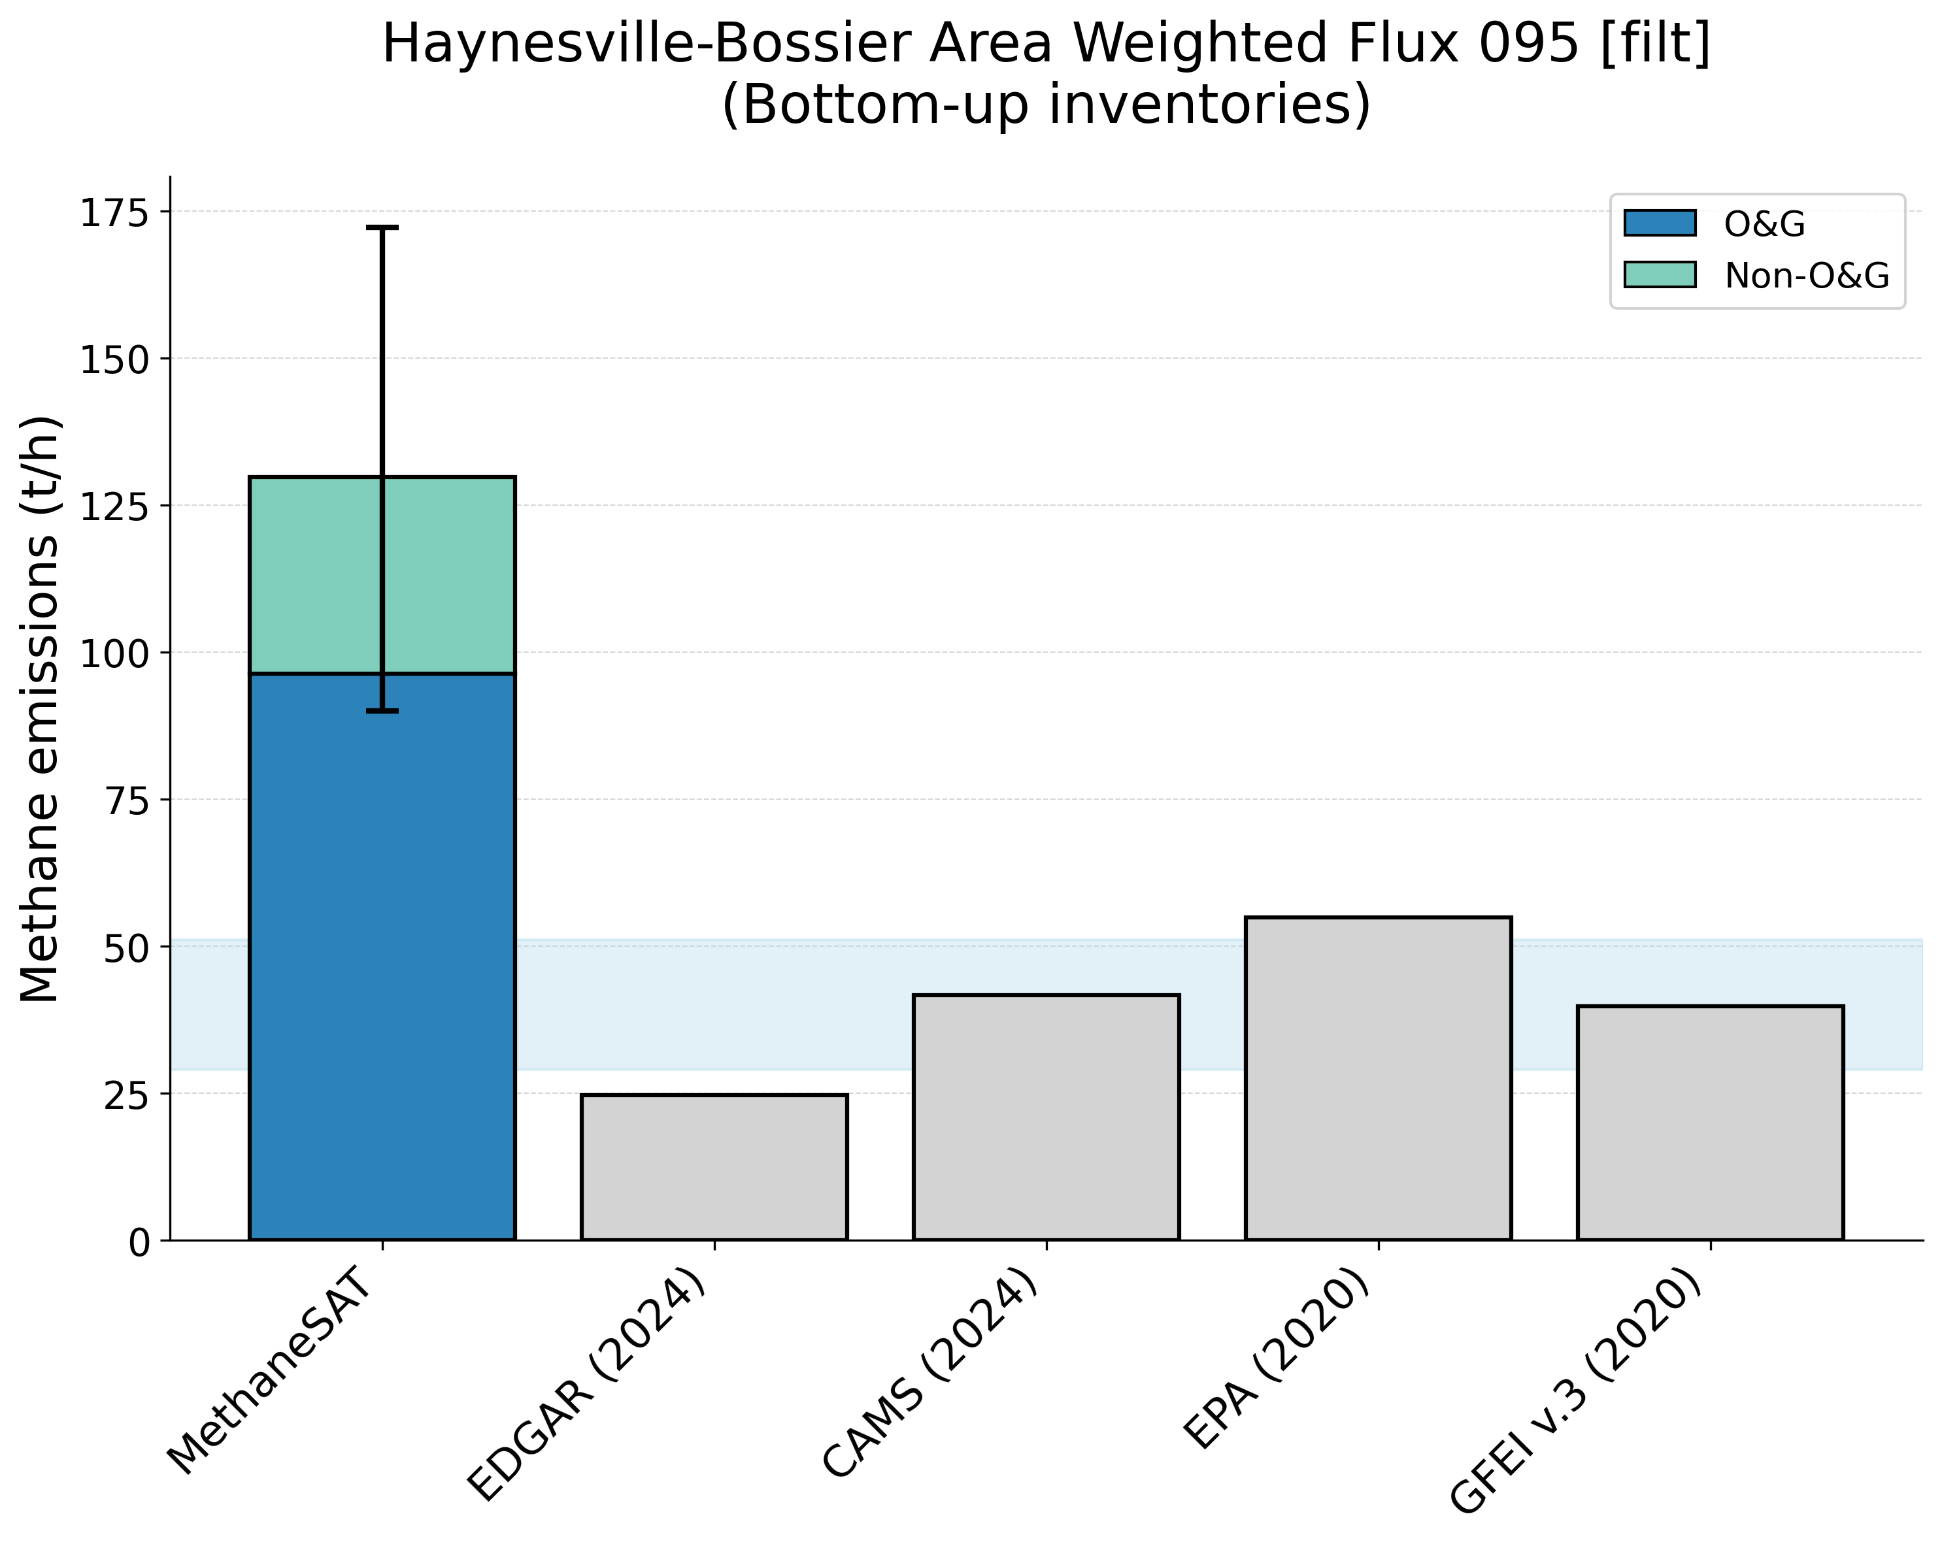
Supplementary Figure 15. Comparison of MethaneSAT total methane emissions estimates with peer-reviewed “top-down” measurements (top panel) and “bottom-up” inventory data (bottom panel). The shaded area shows the representative range of the peer-reviewed data (2.5th, 97.5th percentiles). Haynesville, United States (USA) region.
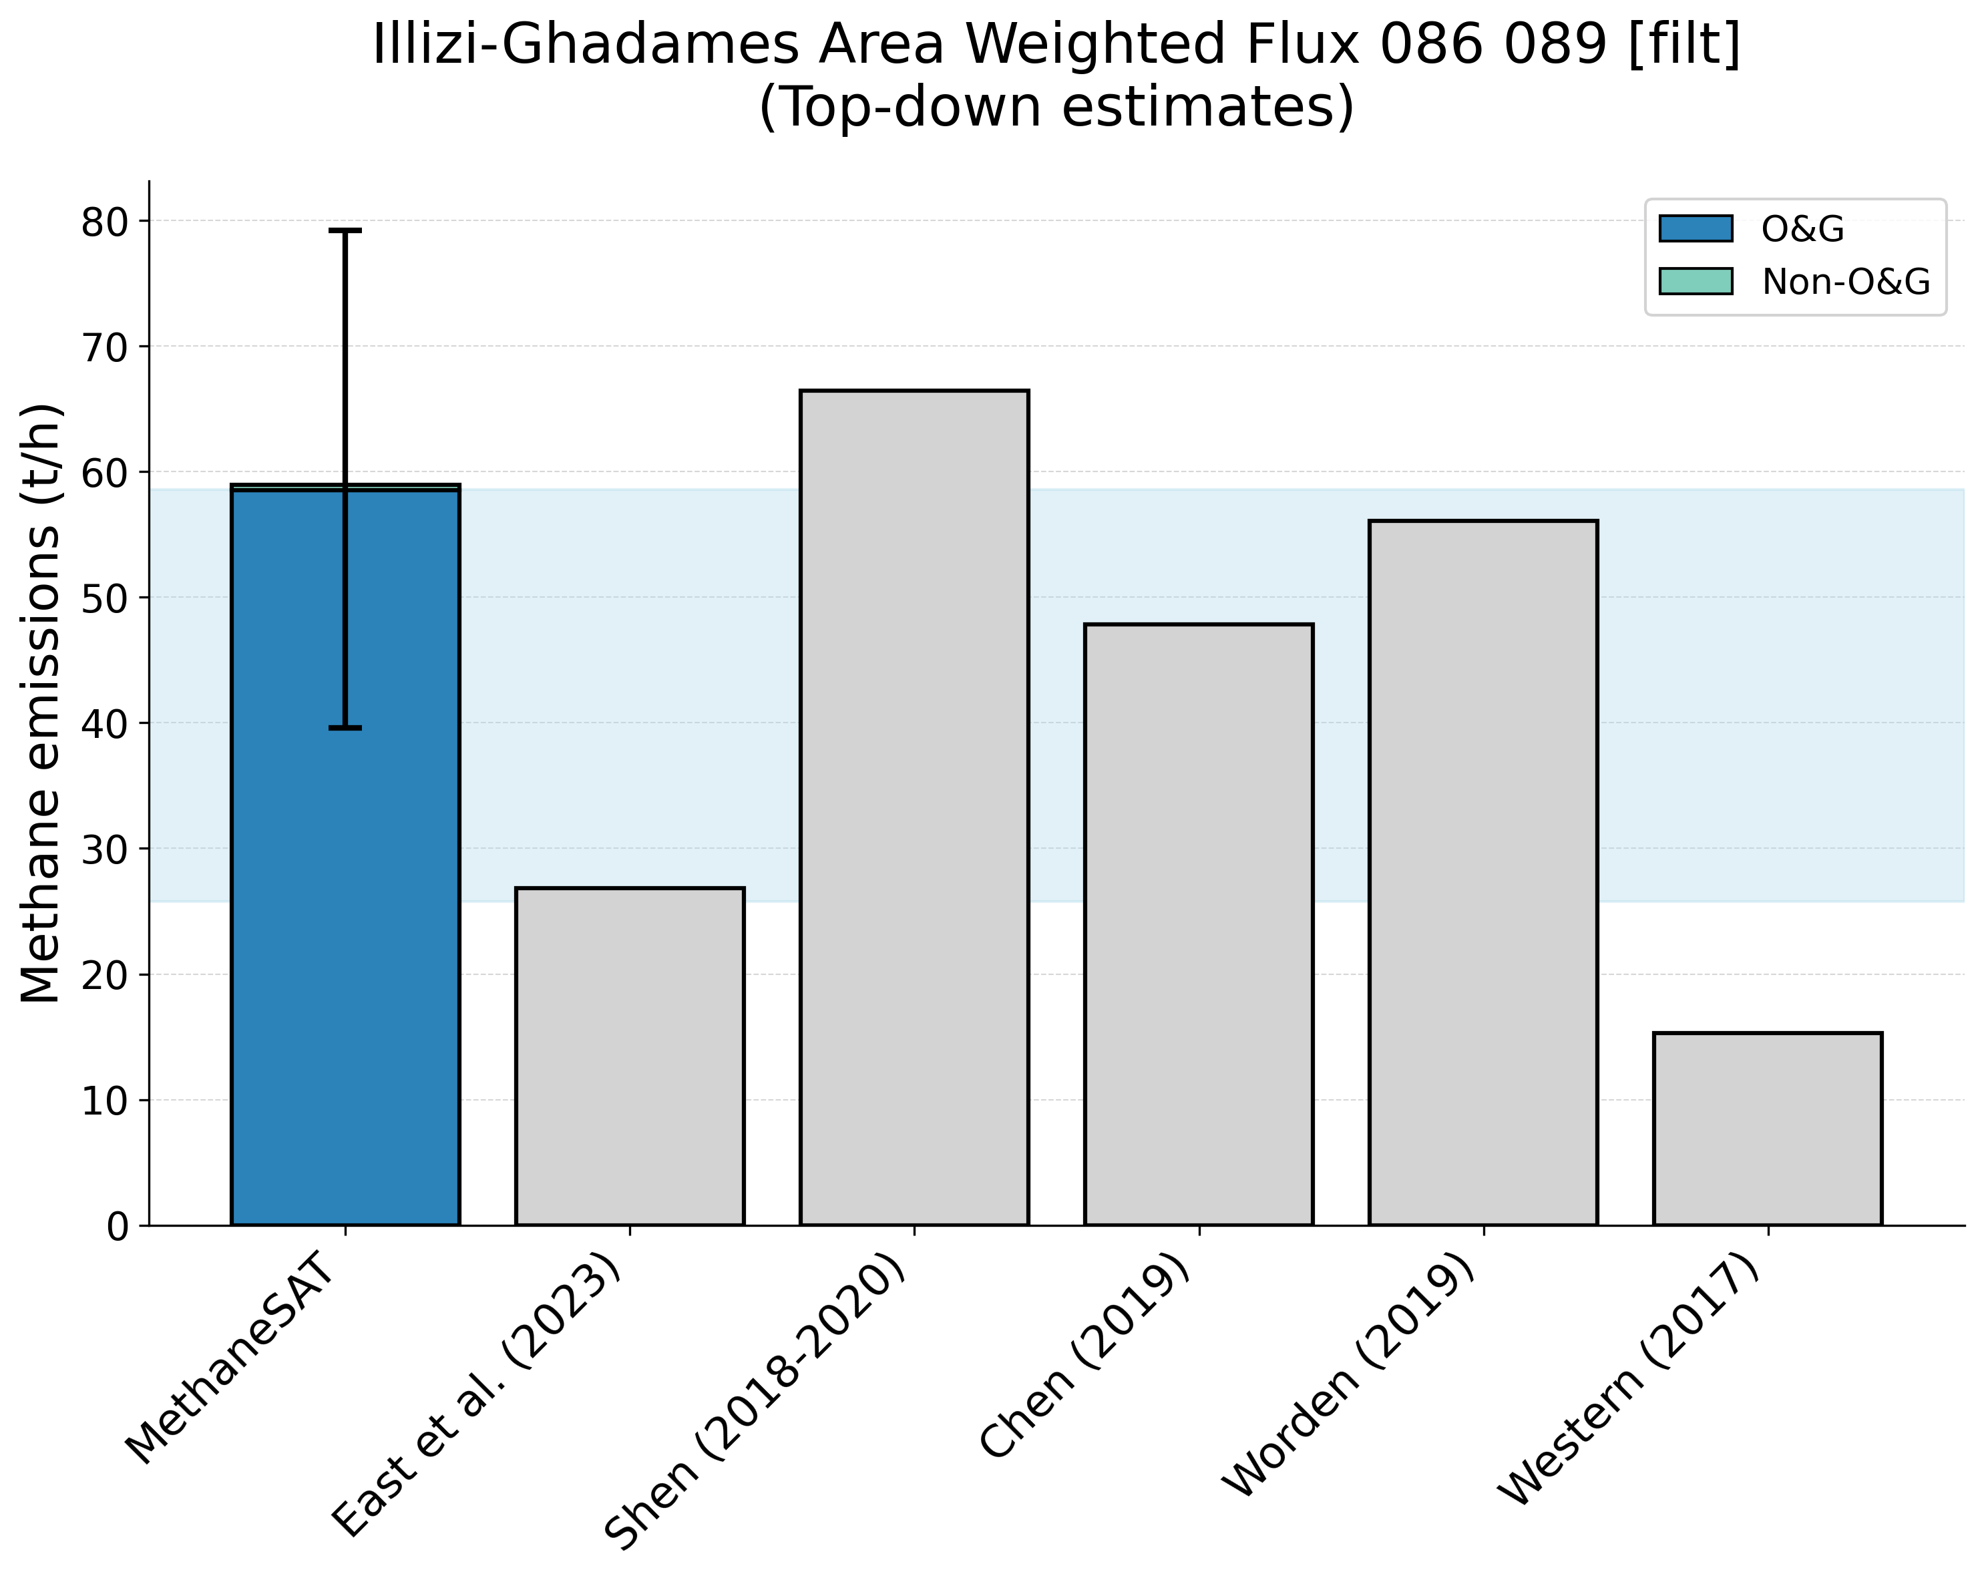
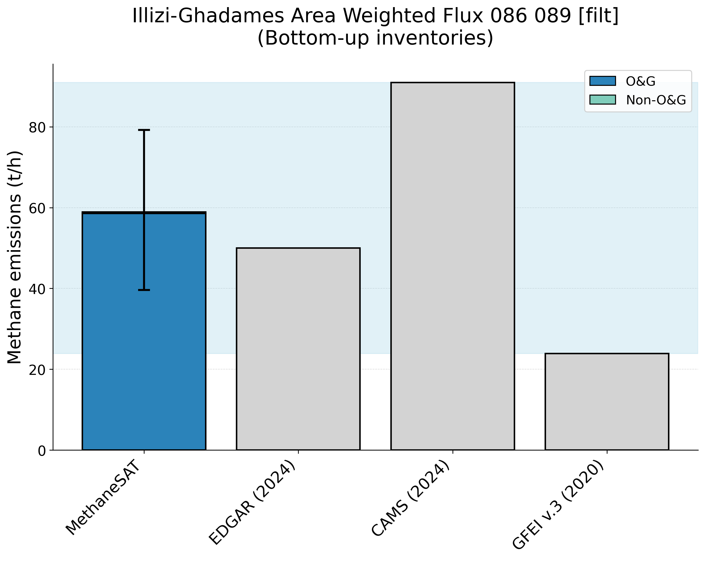
Supplementary Figure 16. Comparison of MethaneSAT total methane emissions estimates with peer-reviewed “top-down” measurements (top panel) and “bottom-up” inventory data (bottom panel). The shaded area shows the representative range of the peer-reviewed data (2.5th, 97.5th percentiles). Illizi Ghadames, Algeria (ALG) region.
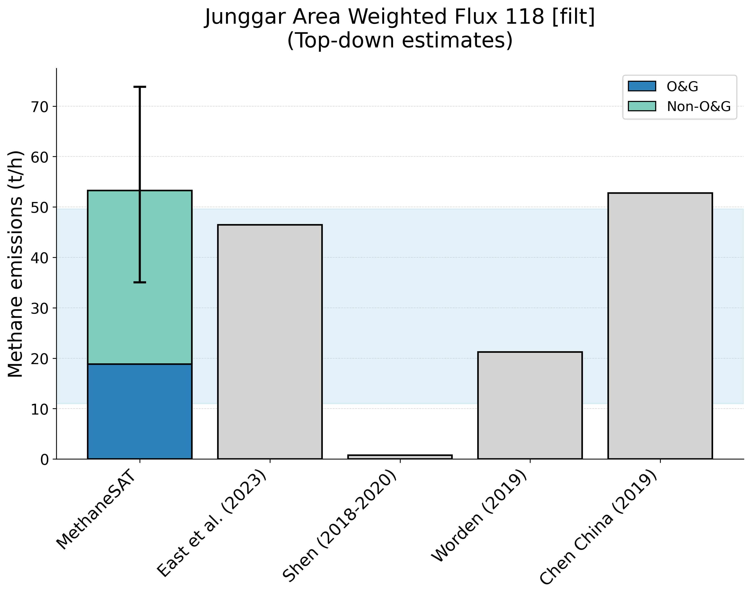
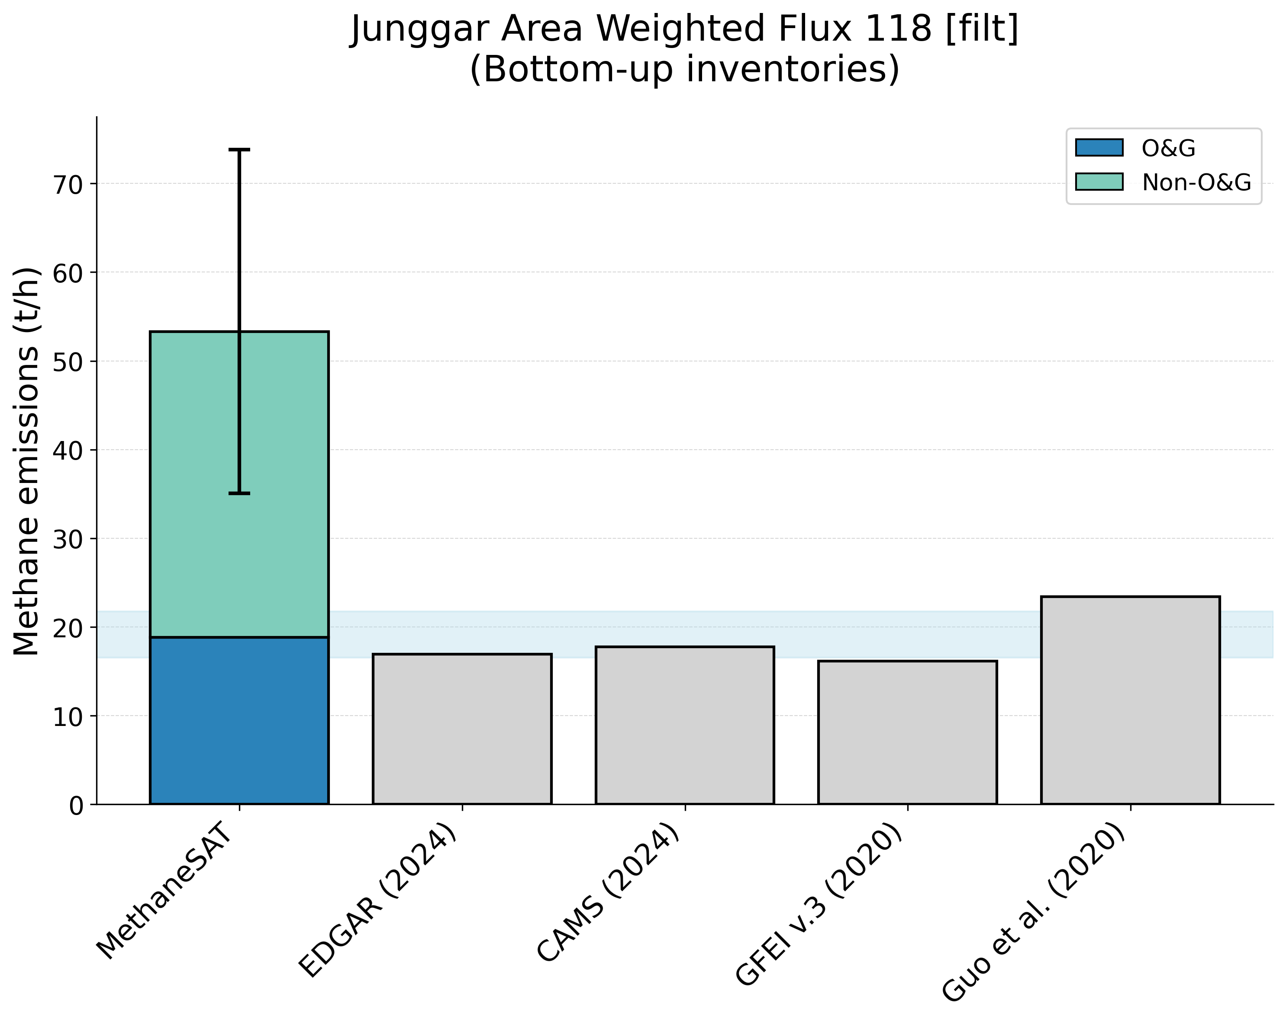
Supplementary Figure 17. Comparison of MethaneSAT total methane emissions estimates with peer-reviewed “top-down” measurements (top panel) and “bottom-up” inventory data (bottom panel). The shaded area shows the representative range of the peer-reviewed data (2.5th, 97.5th percentiles). Illizi Junggar, China (CHN) region.
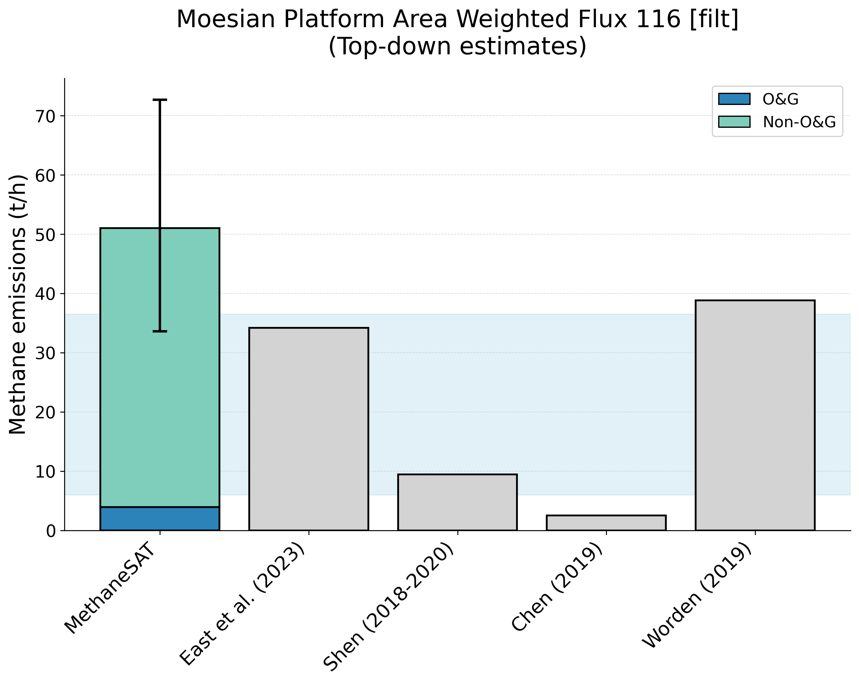
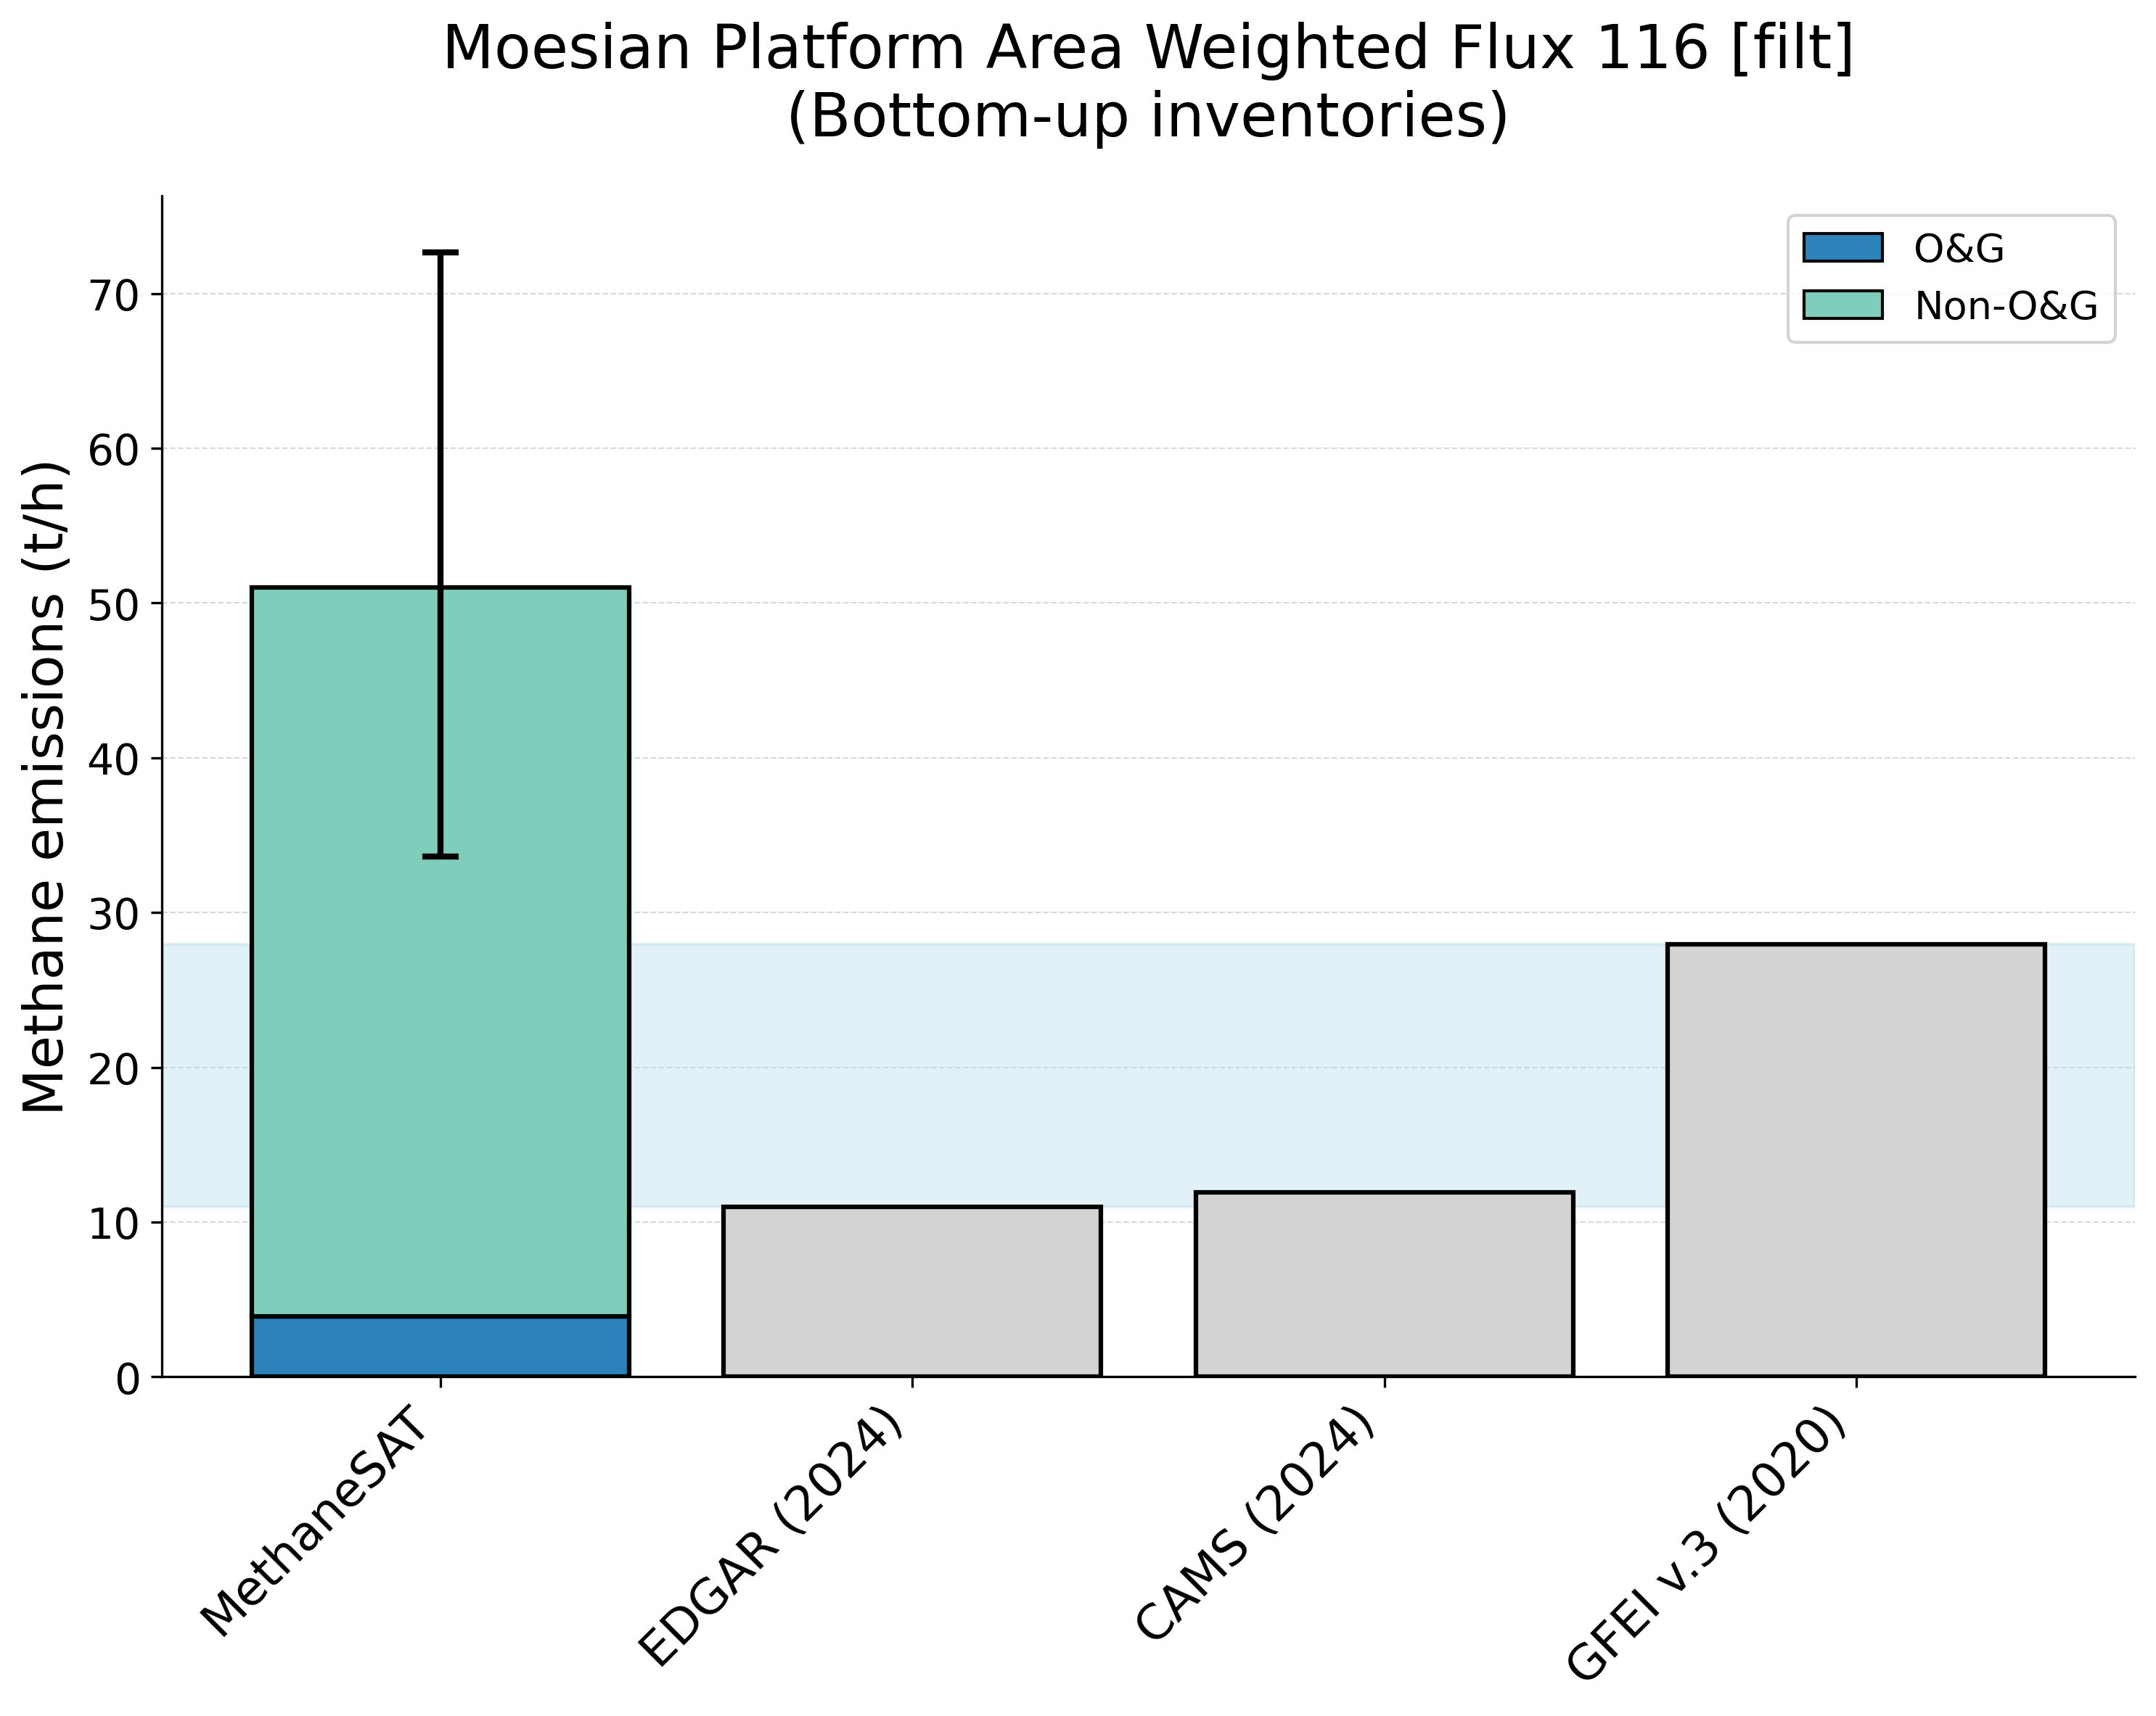
Supplementary Figure 18. Comparison of MethaneSAT total methane emissions estimates with peer-reviewed “top-down” measurements (top panel) and “bottom-up” inventory data (bottom panel). The shaded area shows the representative range of the peer-reviewed data (2.5th, 97.5th percentiles). Moesian Platform, Romania (ROM) region.
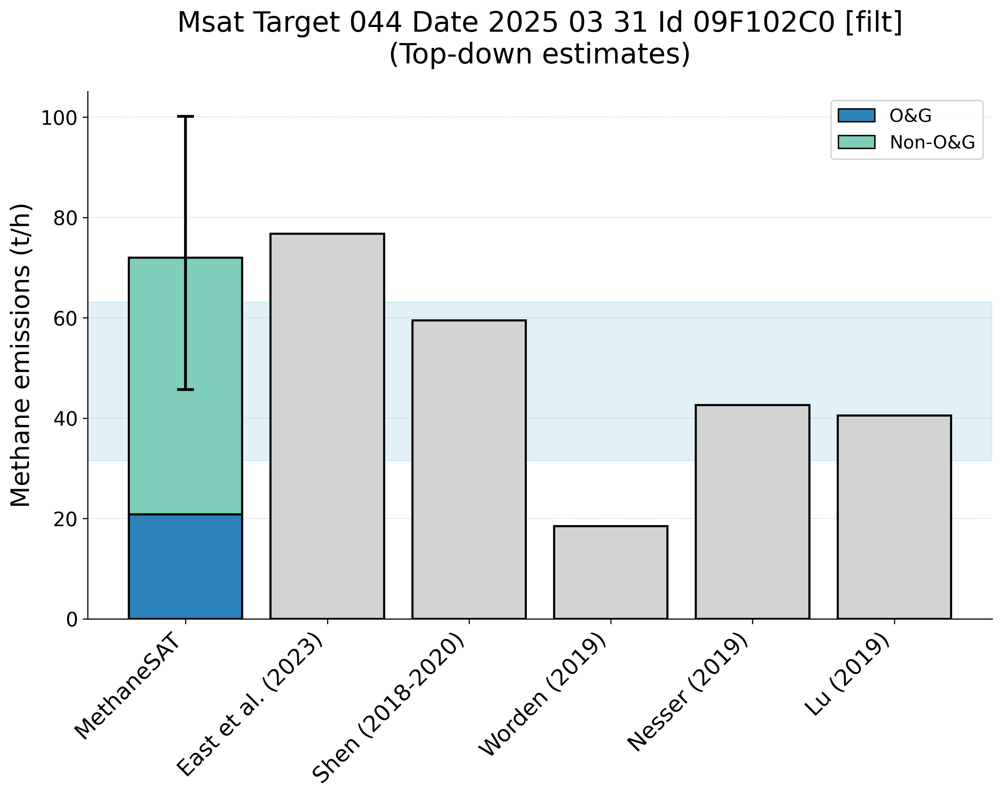
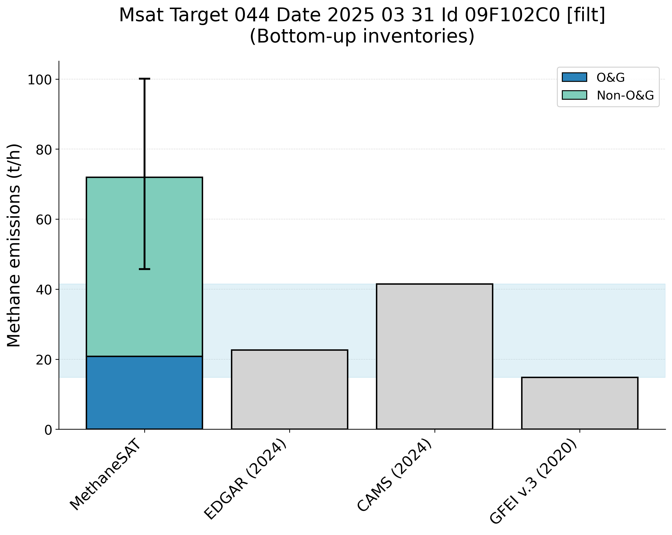
Supplementary Figure 19. Comparison of MethaneSAT total methane emissions estimates with peer-reviewed “top-down” measurements (top panel) and “bottom-up” inventory data (bottom panel). The shaded area shows the representative range of the peer-reviewed data (2.5th, 97.5th percentiles). Comalcalco Basin, Mexico (MEX) region.
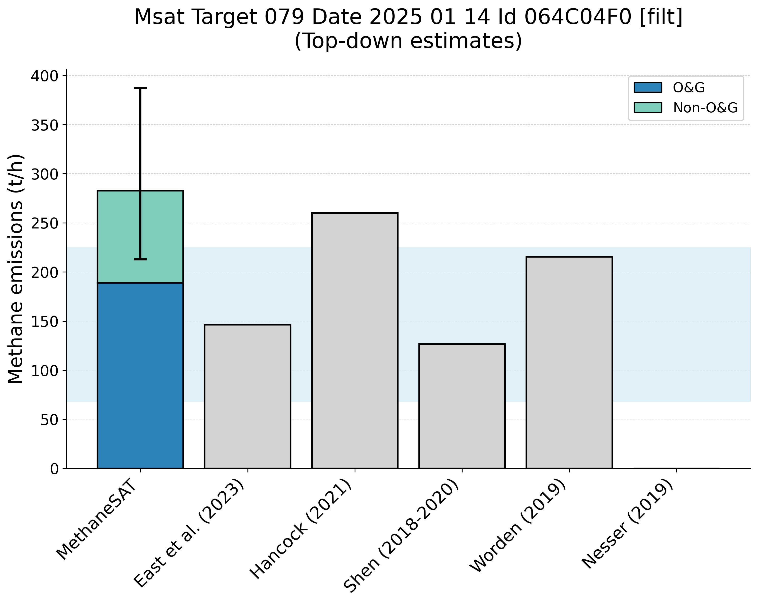
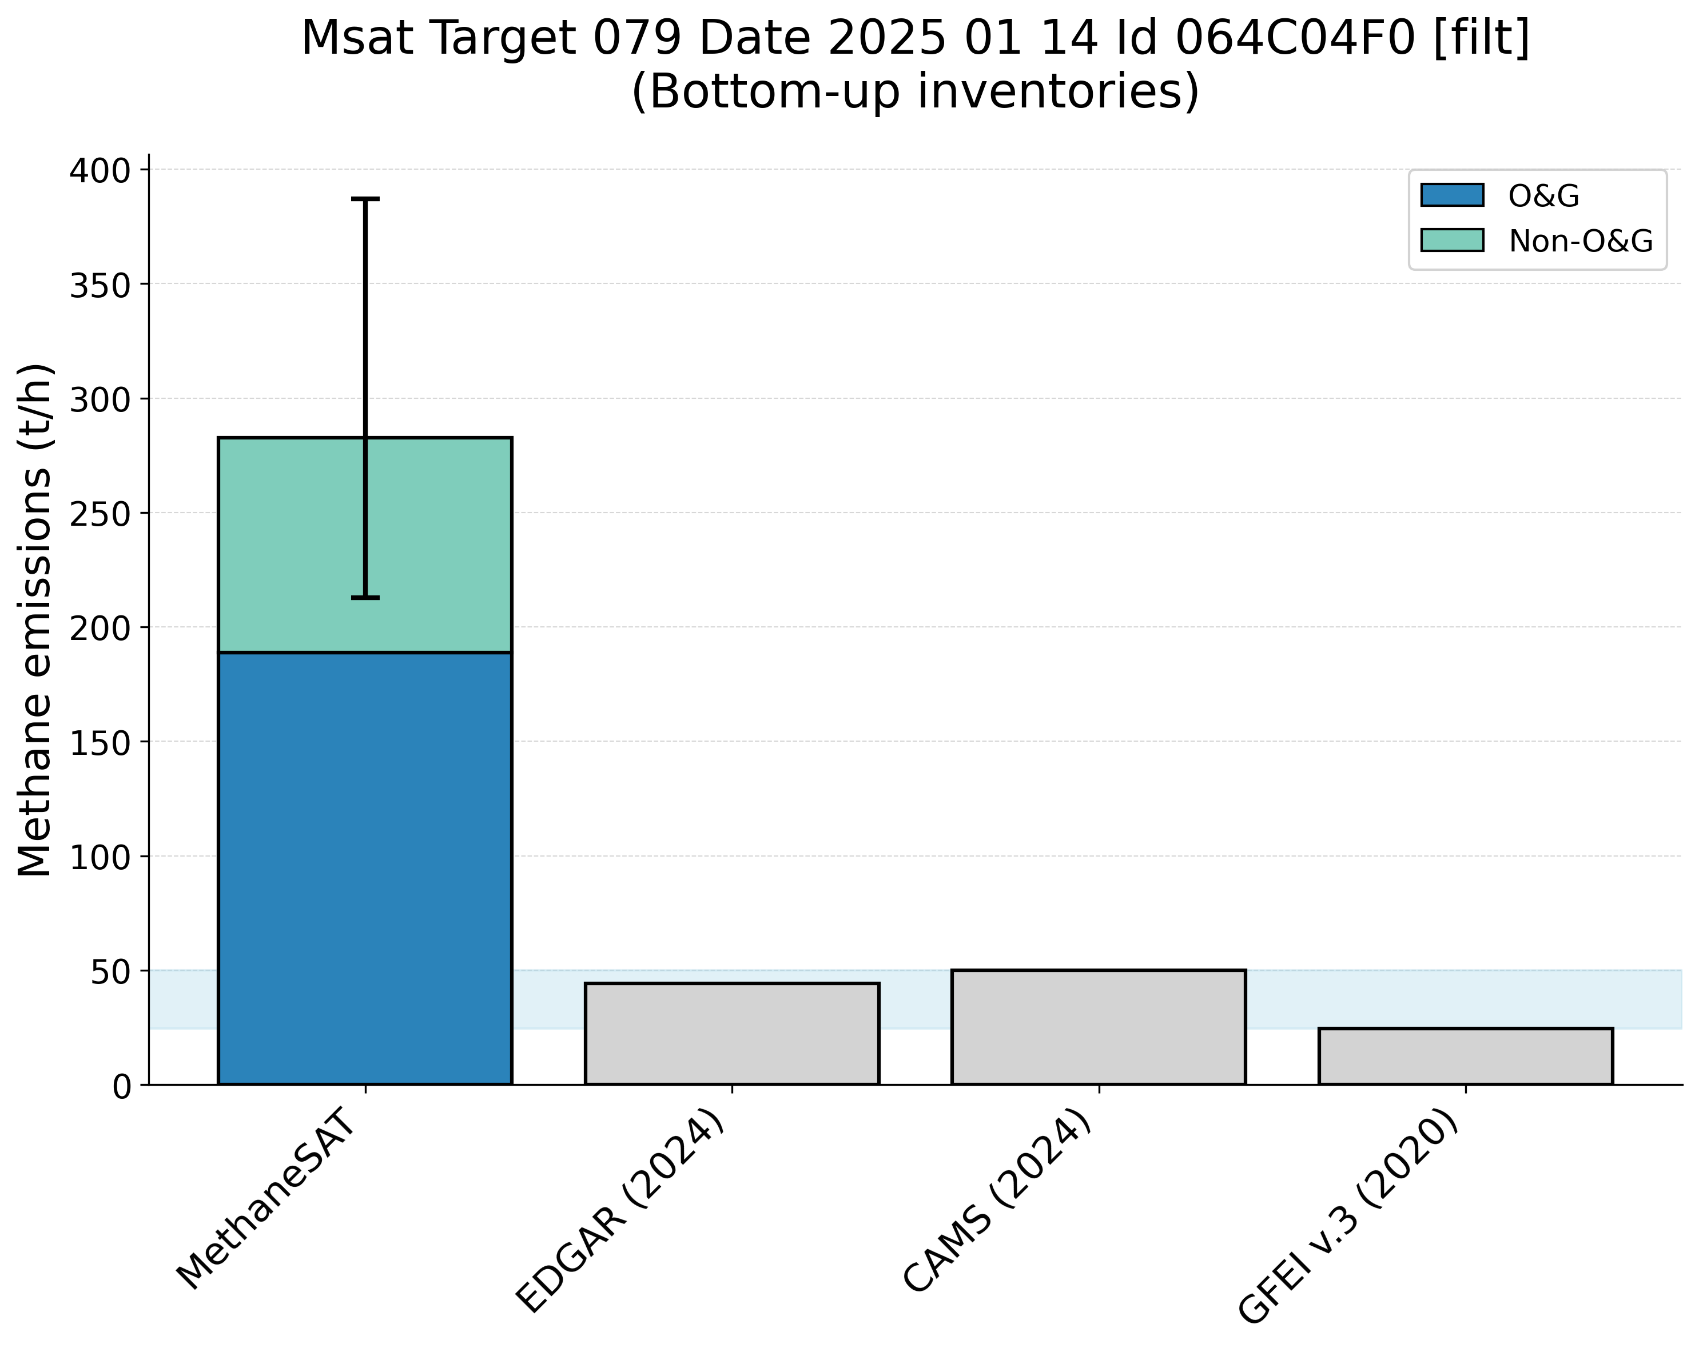
Supplementary Figure 20. Comparison of MethaneSAT total methane emissions estimates with peer-reviewed “top-down” measurements (top panel) and “bottom-up” inventory data (bottom panel). The shaded area shows the representative range of the peer-reviewed data (2.5th, 97.5th percentiles). Maturin Basin, Venezuela (VEN) region.
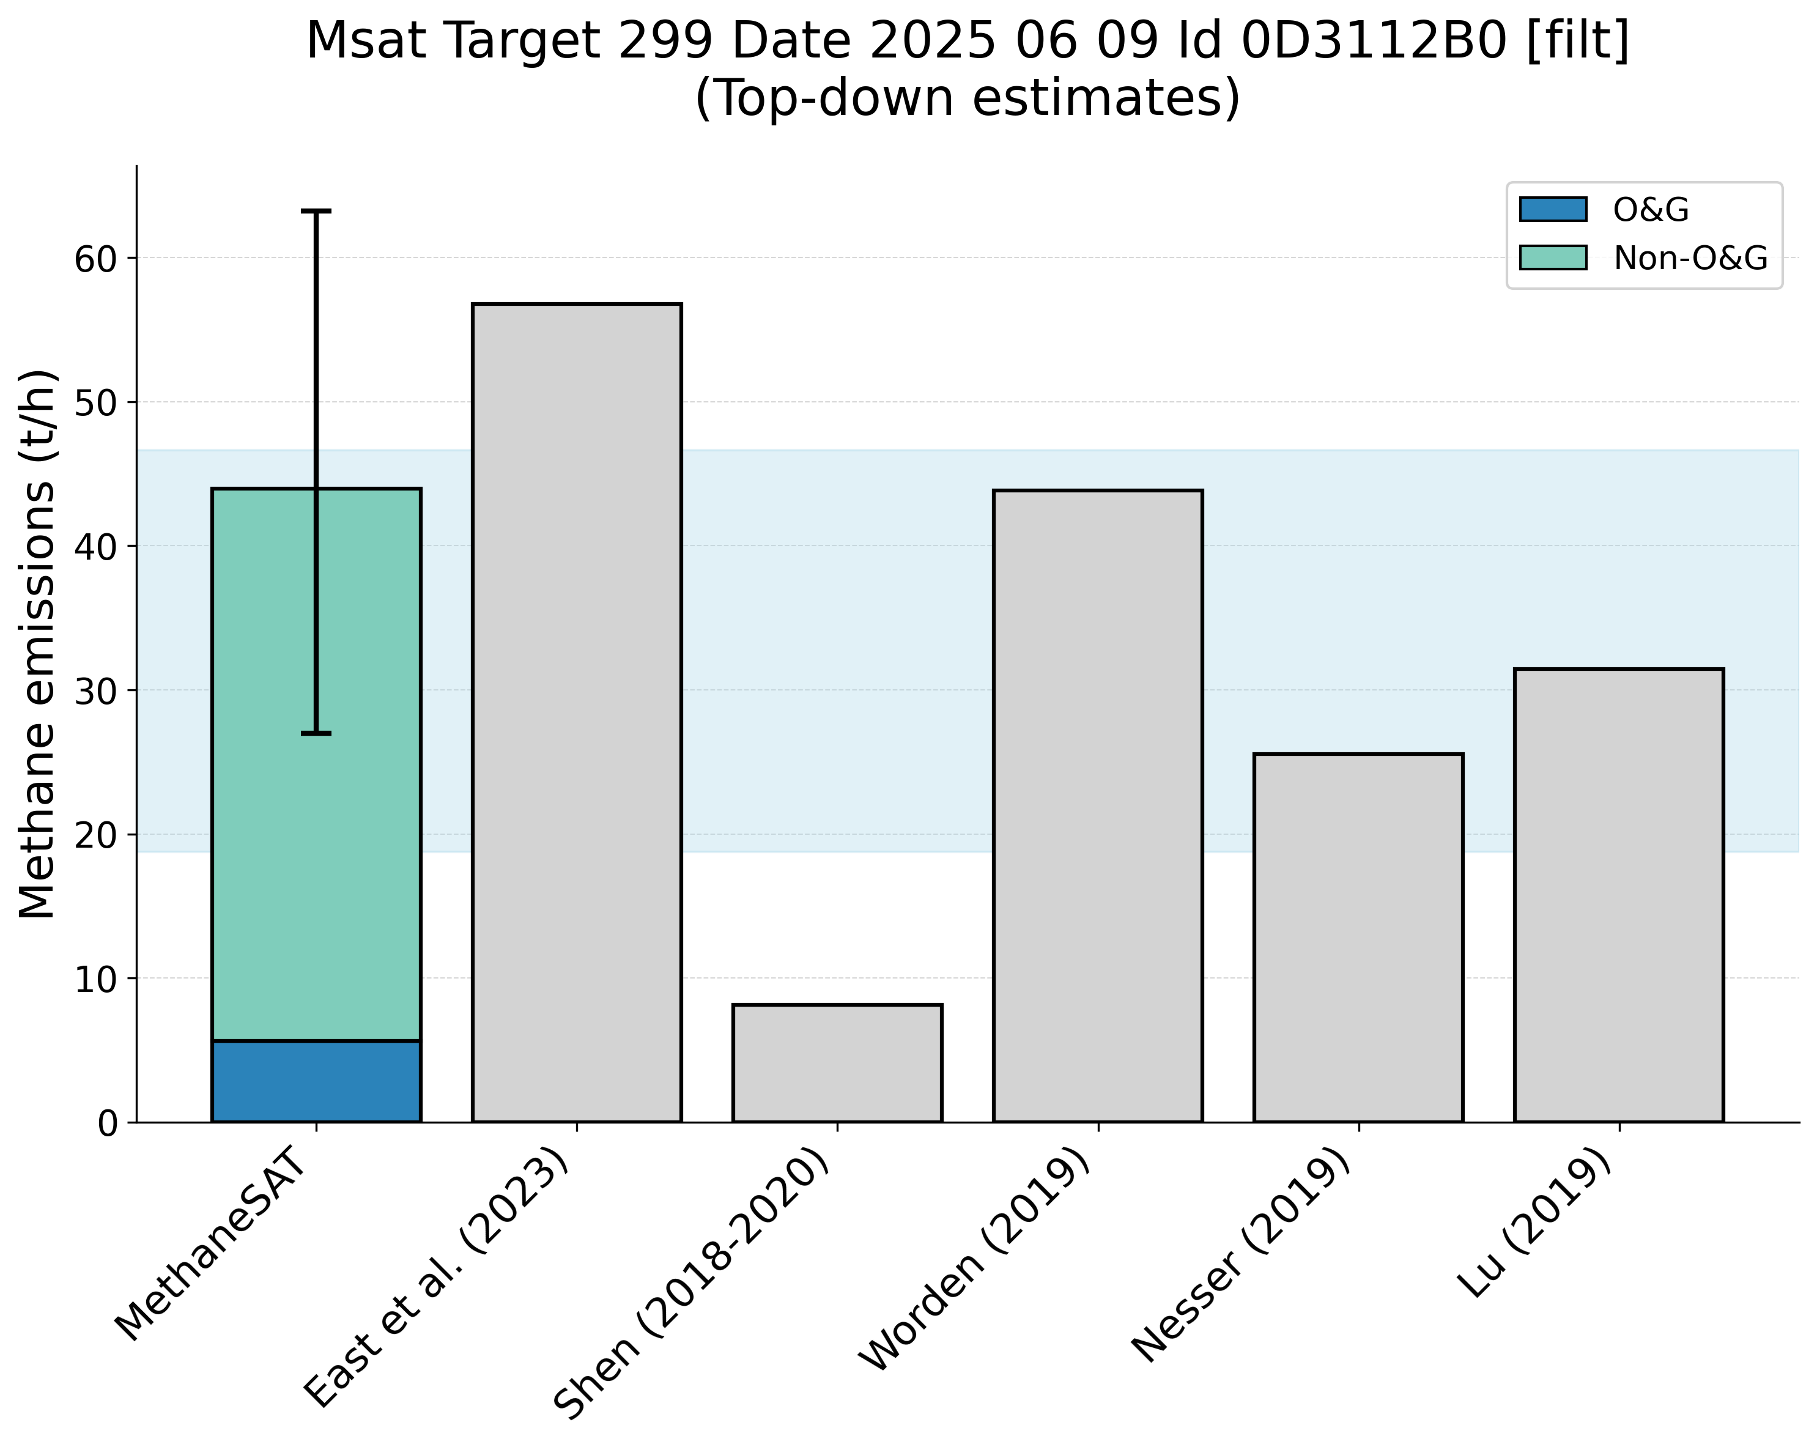
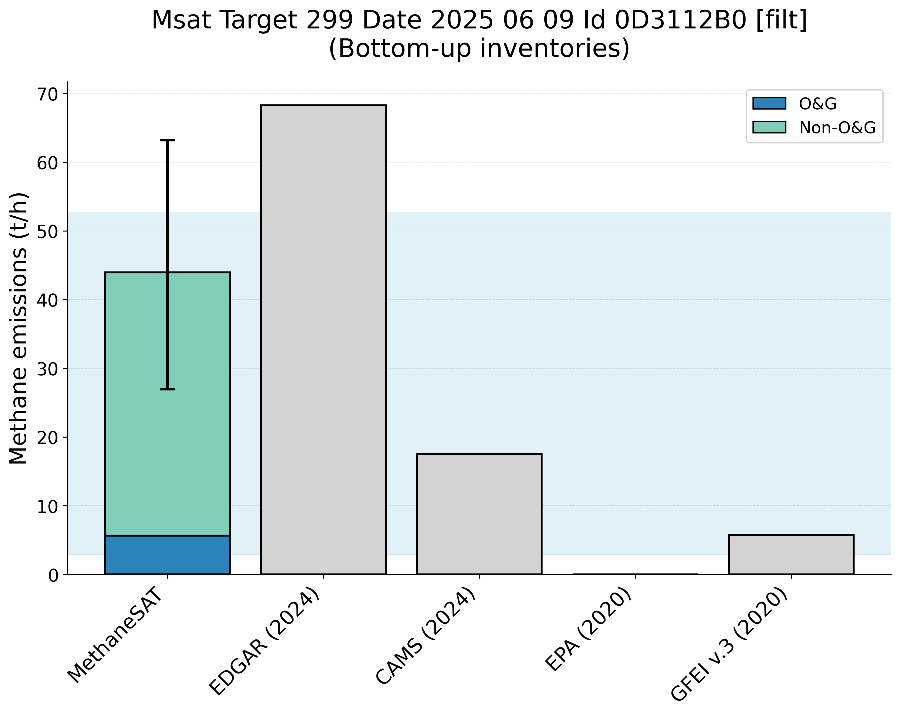
Supplementary Figure 21. Comparison of MethaneSAT total methane emissions estimates with peer-reviewed “top-down” measurements (top panel) and “bottom-up” inventory data (bottom panel). The shaded area shows the representative range of the peer-reviewed data (2.5th, 97.5th percentiles). Duvernay, Canada (CAN) region.

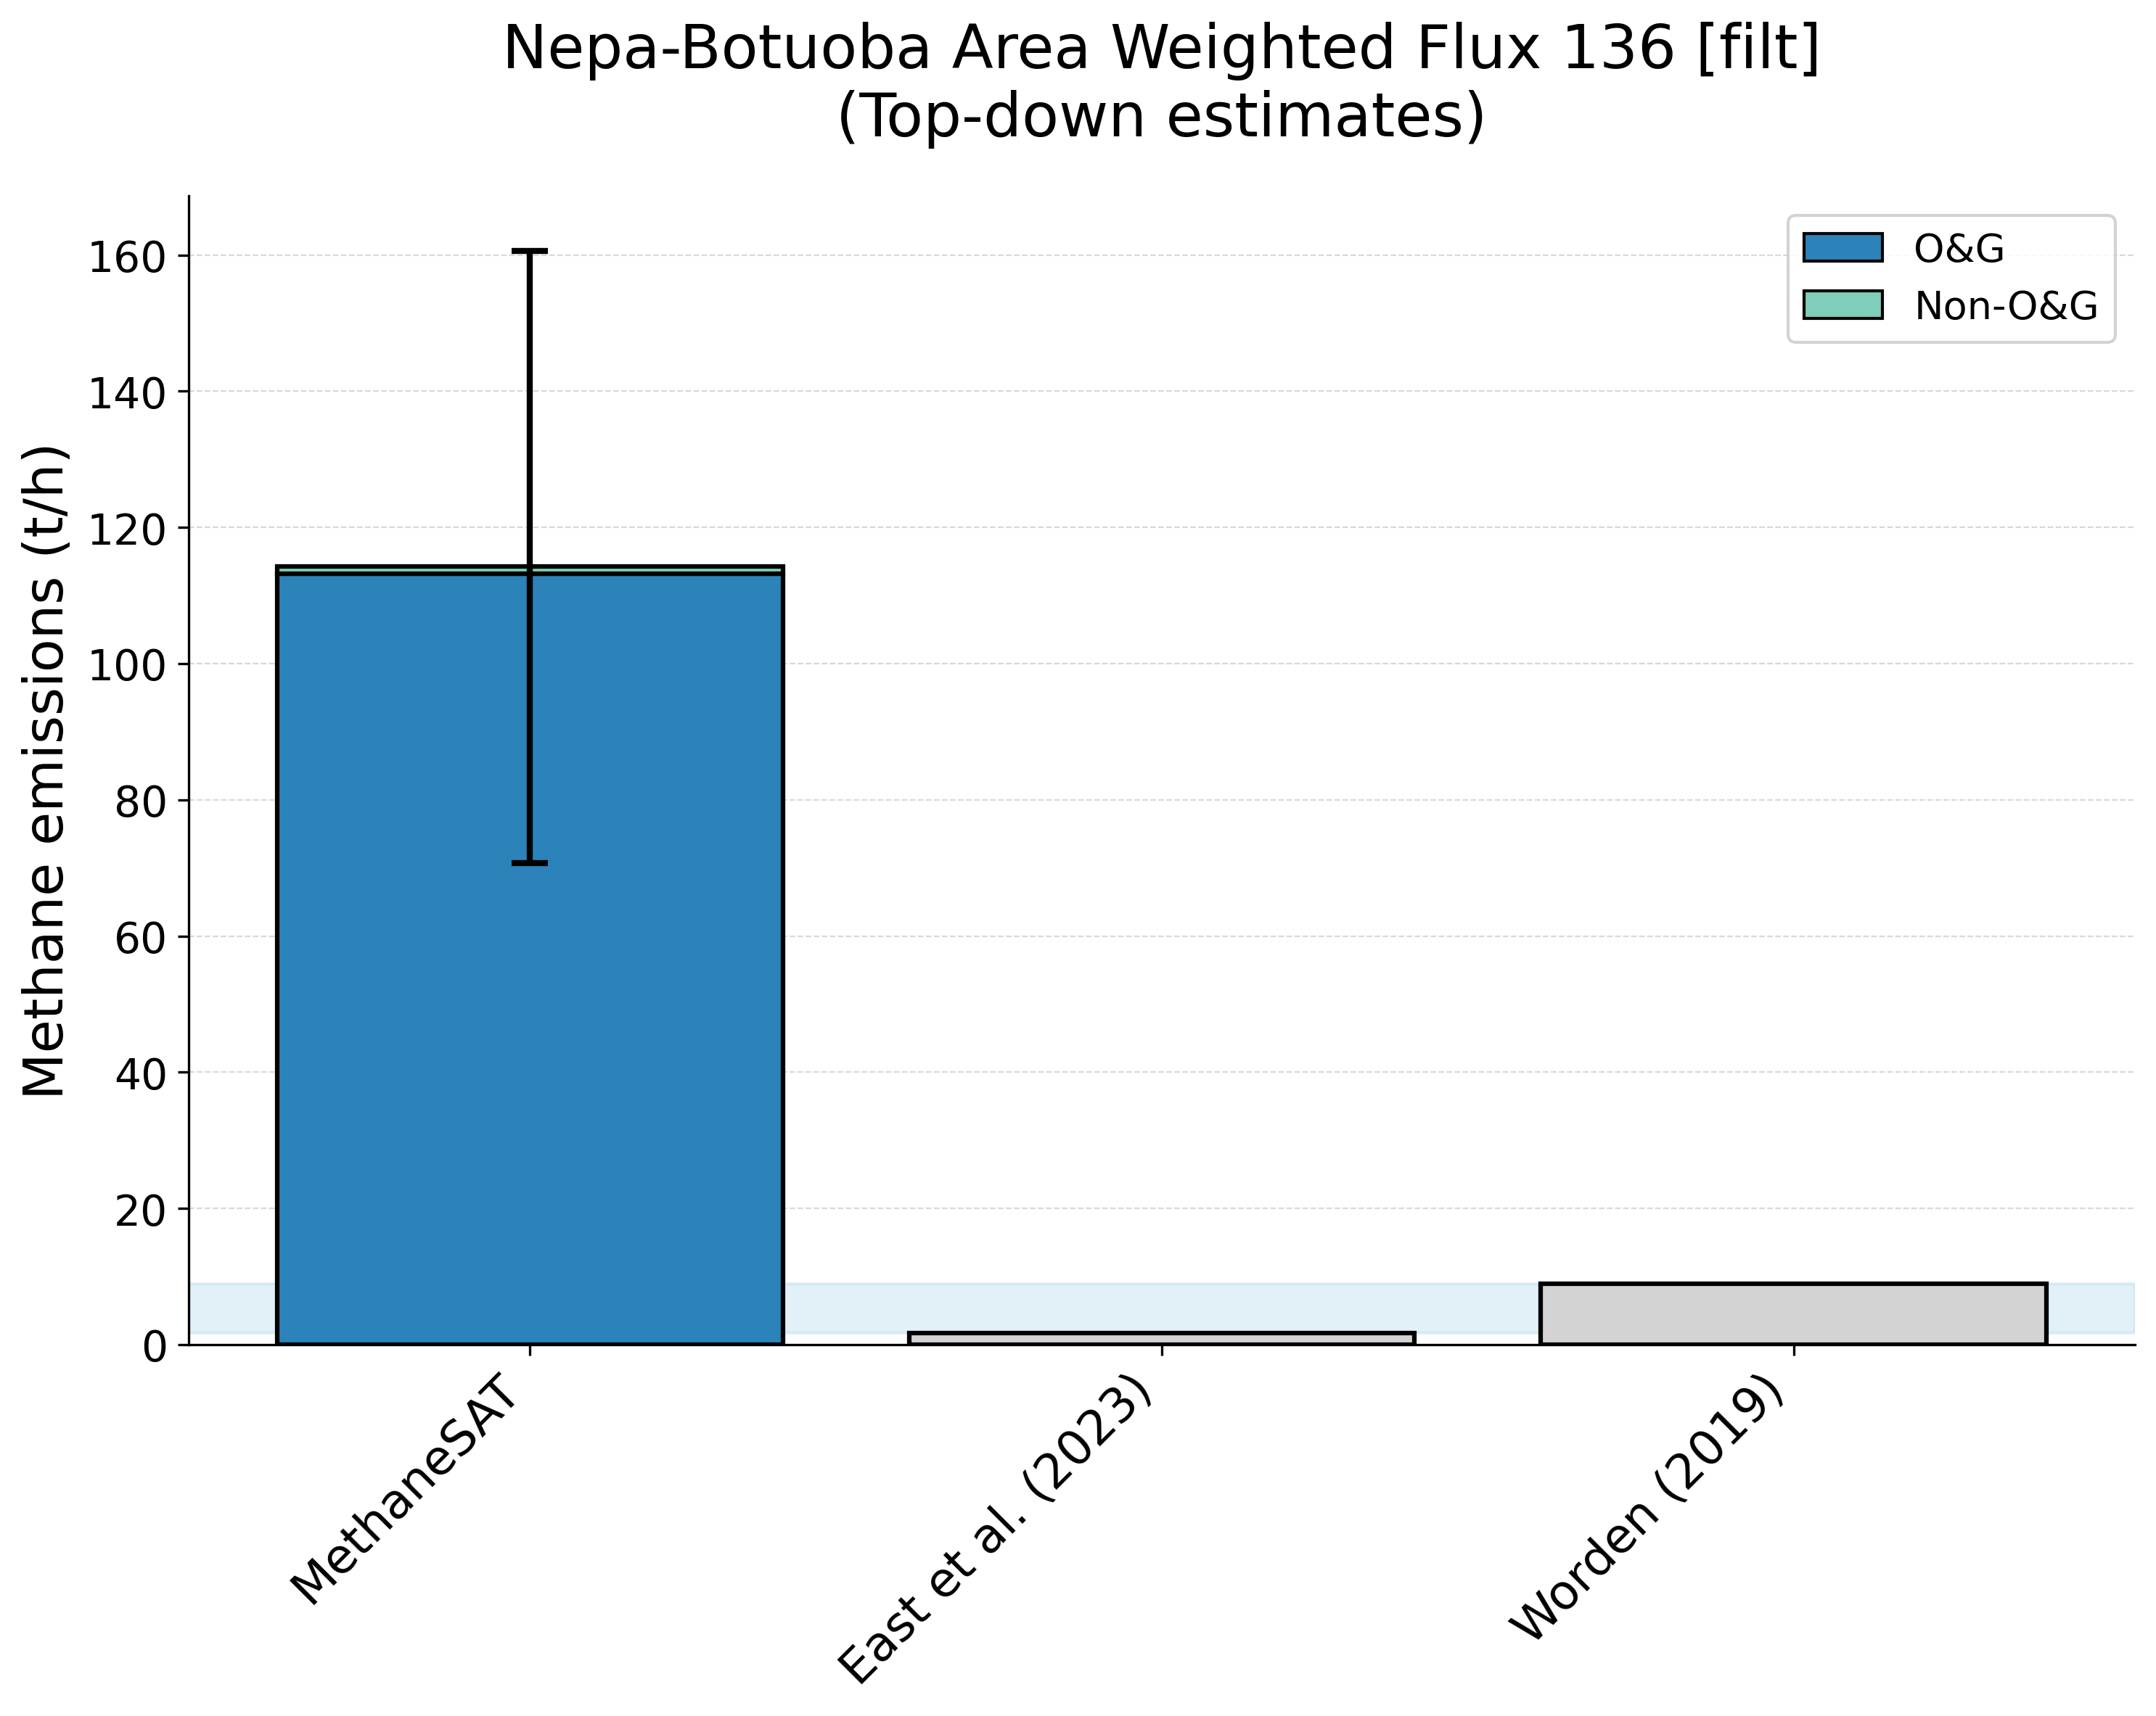
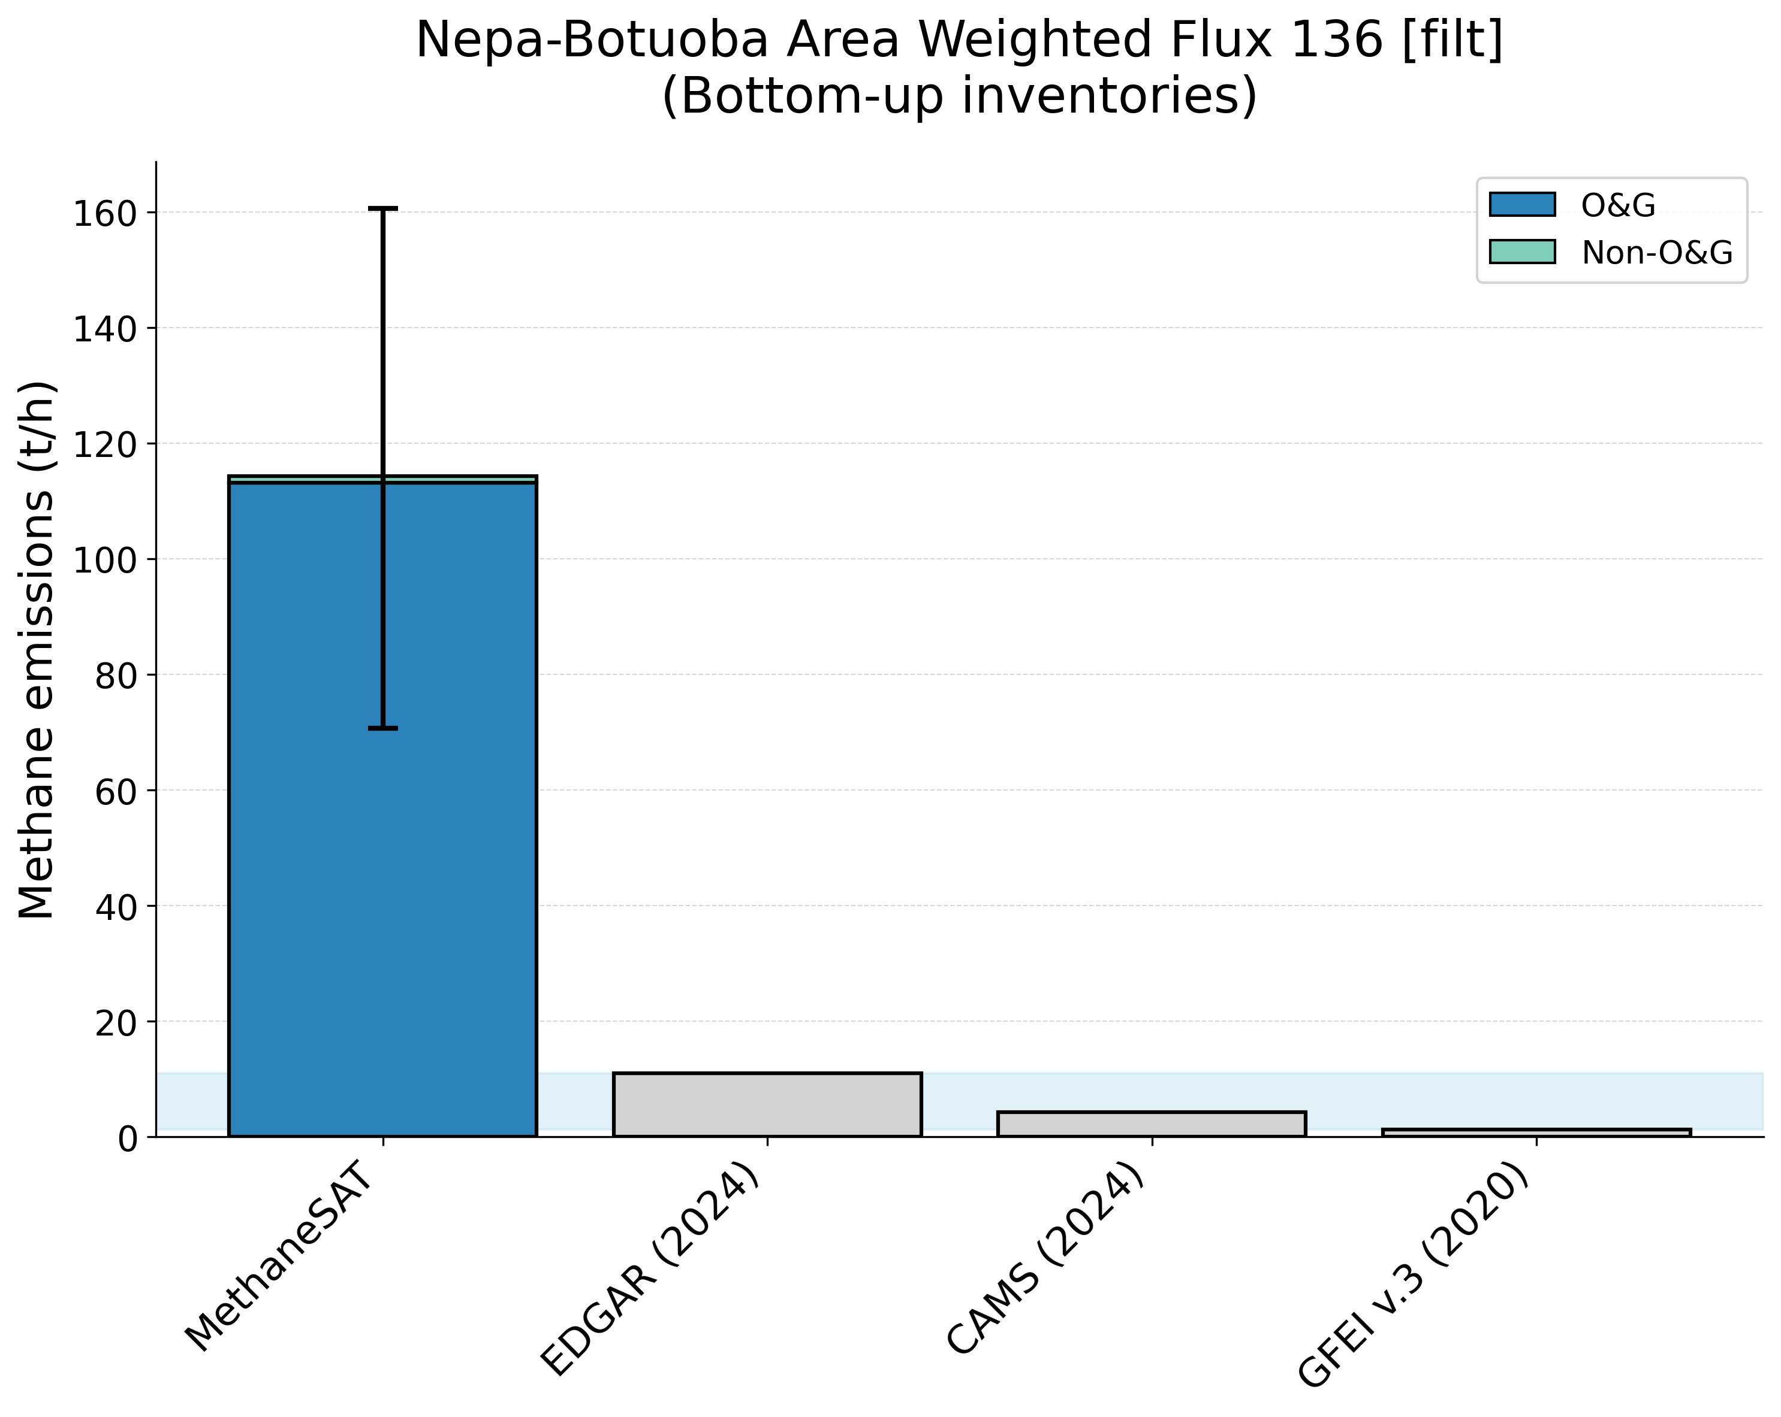

Supplementary Figure 22. Comparison of MethaneSAT total methane emissions estimates with peer-reviewed “top-down” measurements (top panel) and “bottom-up” inventory data (bottom panel). The shaded area shows the representative range of the peer-reviewed data (2.5th, 97.5th percentiles). Nepa Botuoba, Russia (RUS) region.

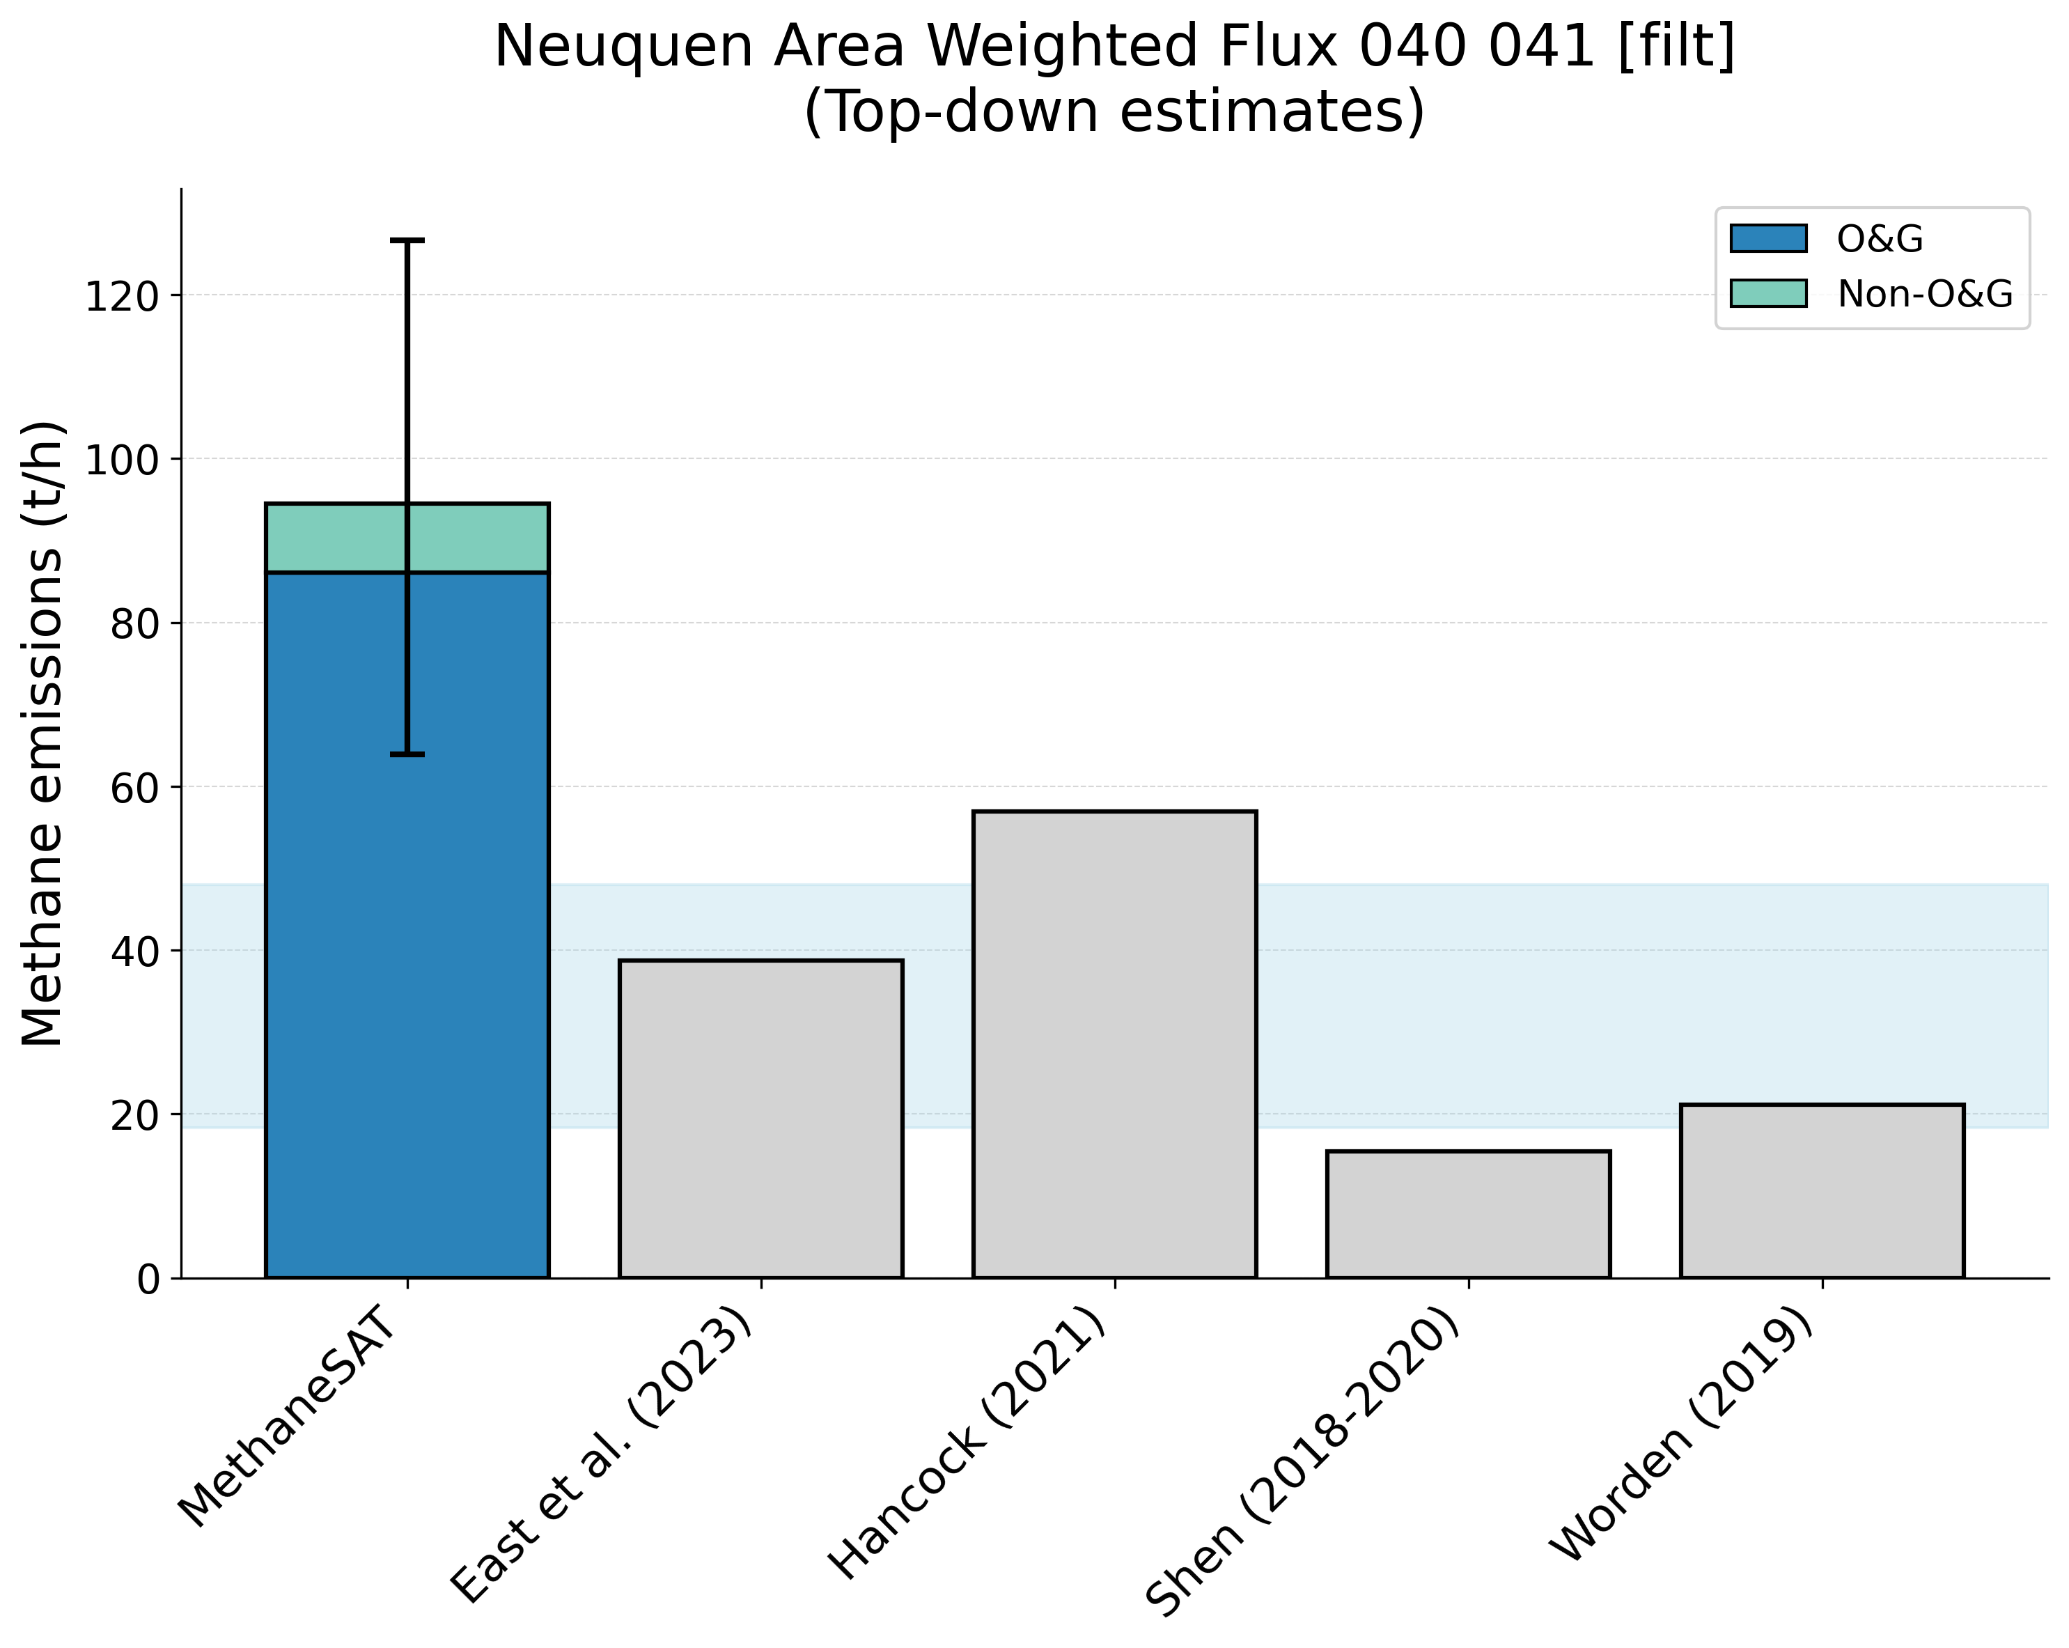
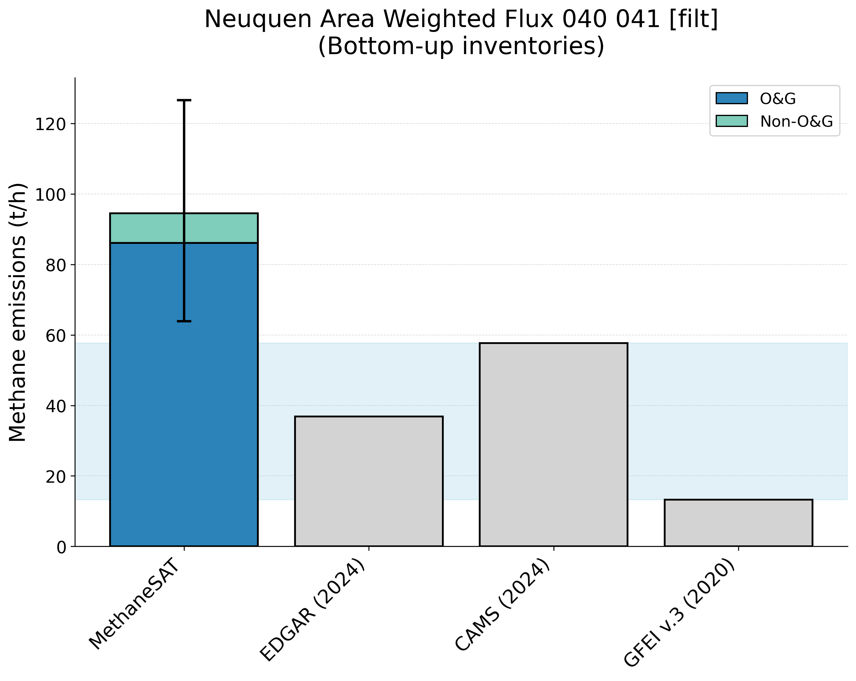
Supplementary Figure 23. Comparison of MethaneSAT total methane emissions estimates with peer-reviewed “top-down” measurements (top panel) and “bottom-up” inventory data (bottom panel). The shaded area shows the representative range of the peer-reviewed data (2.5th, 97.5th percentiles). Neuquen, Argentina (ARG) region.
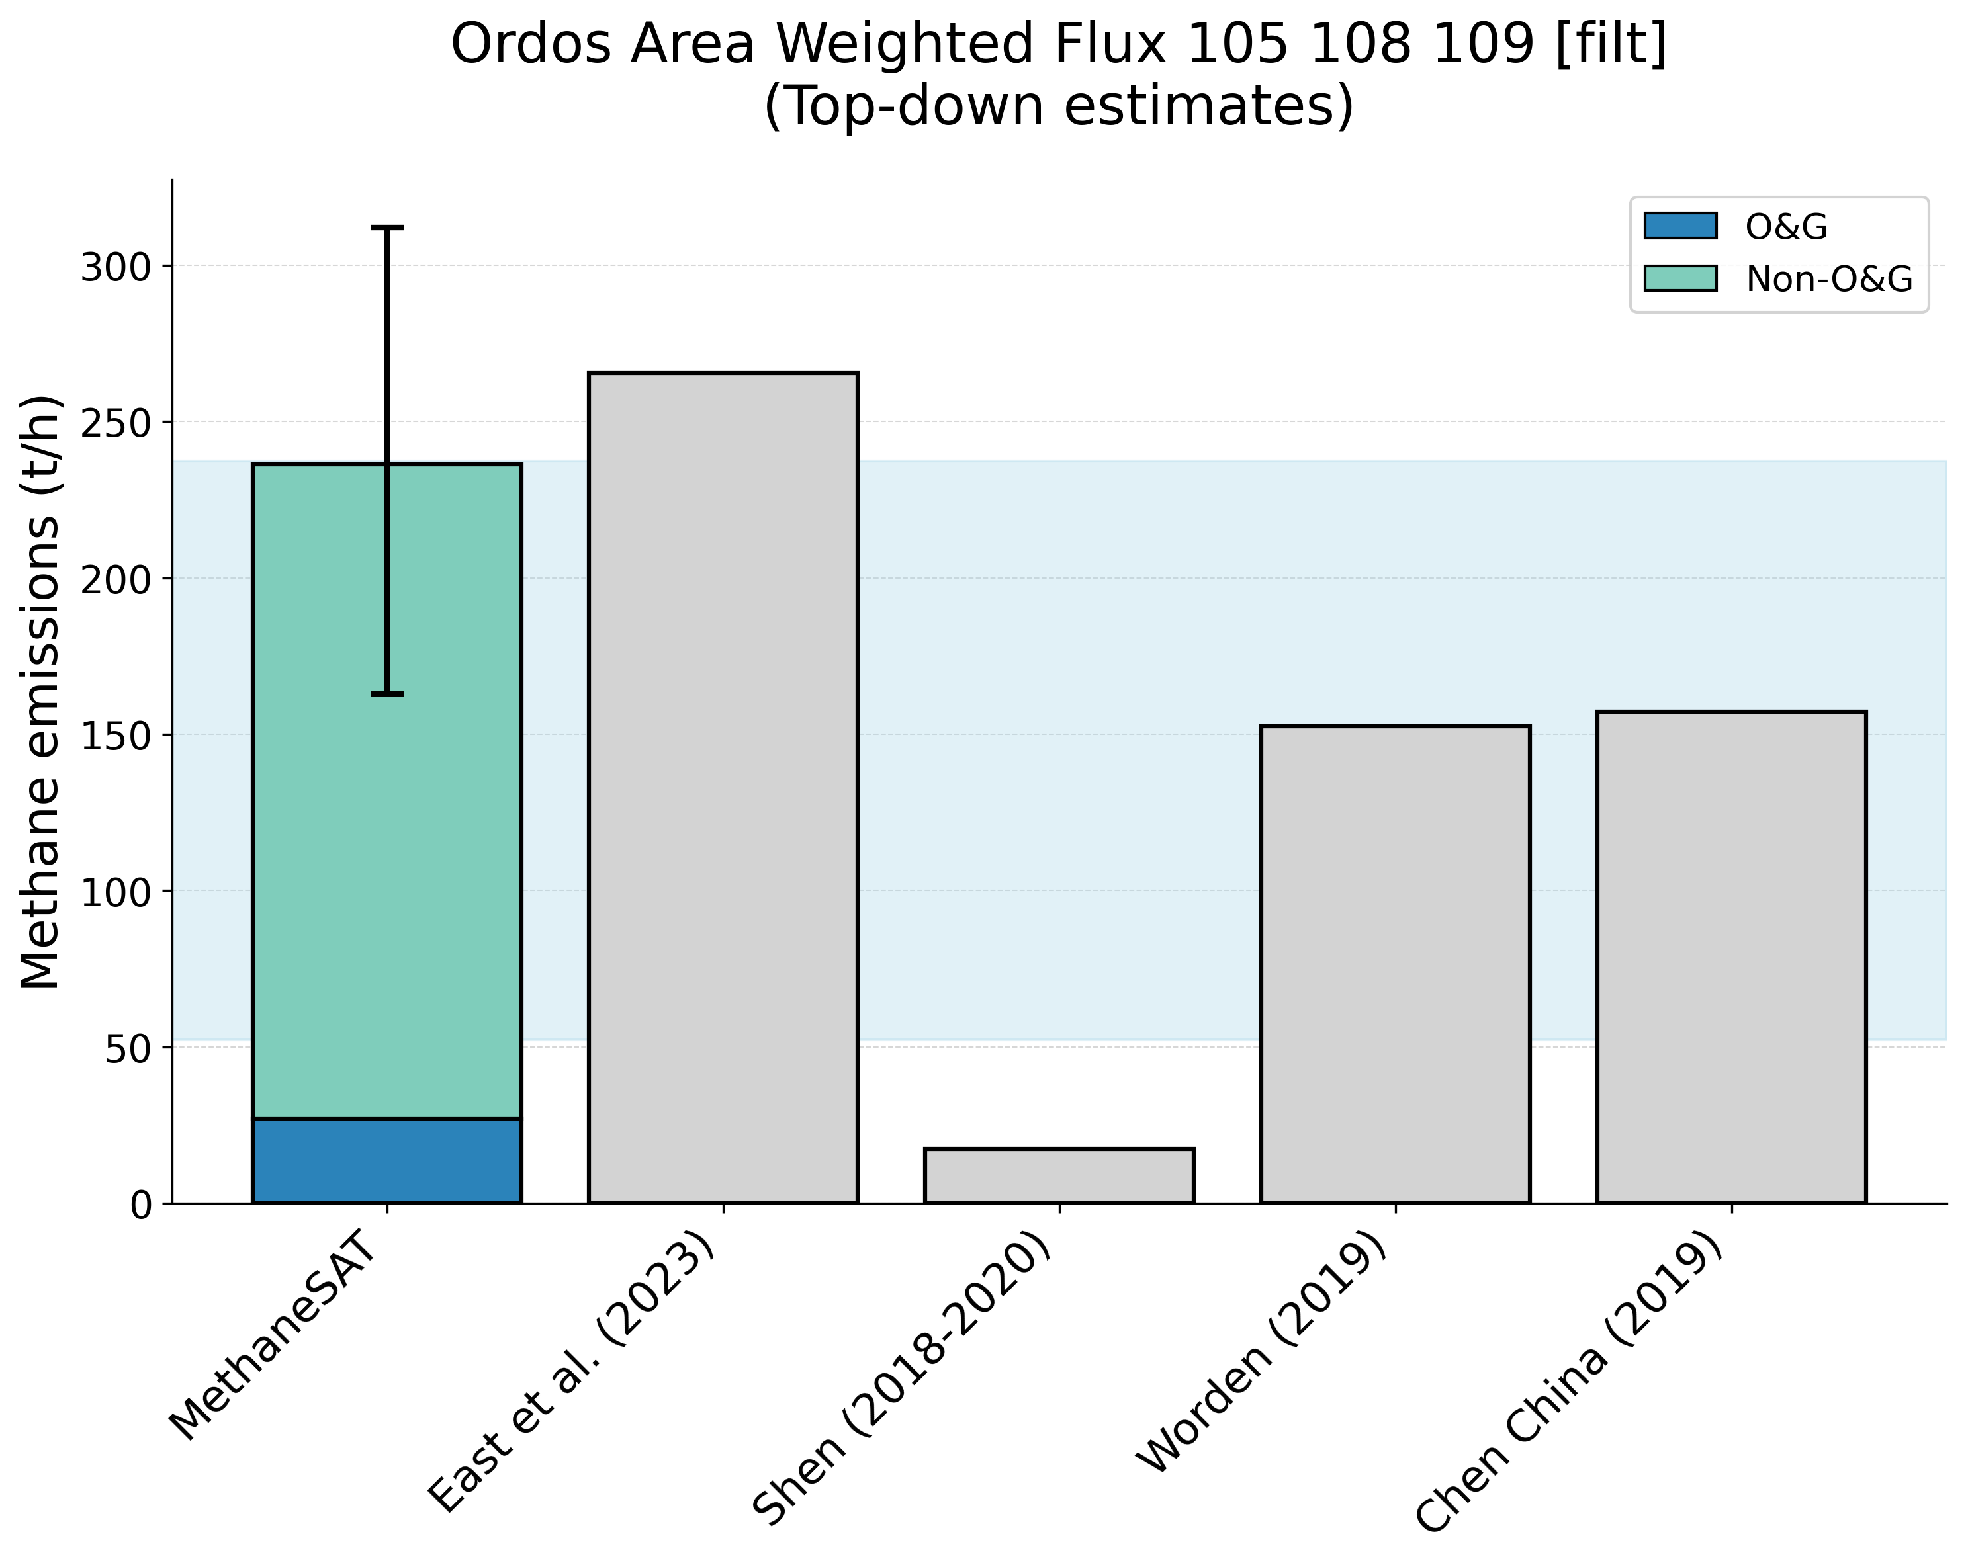
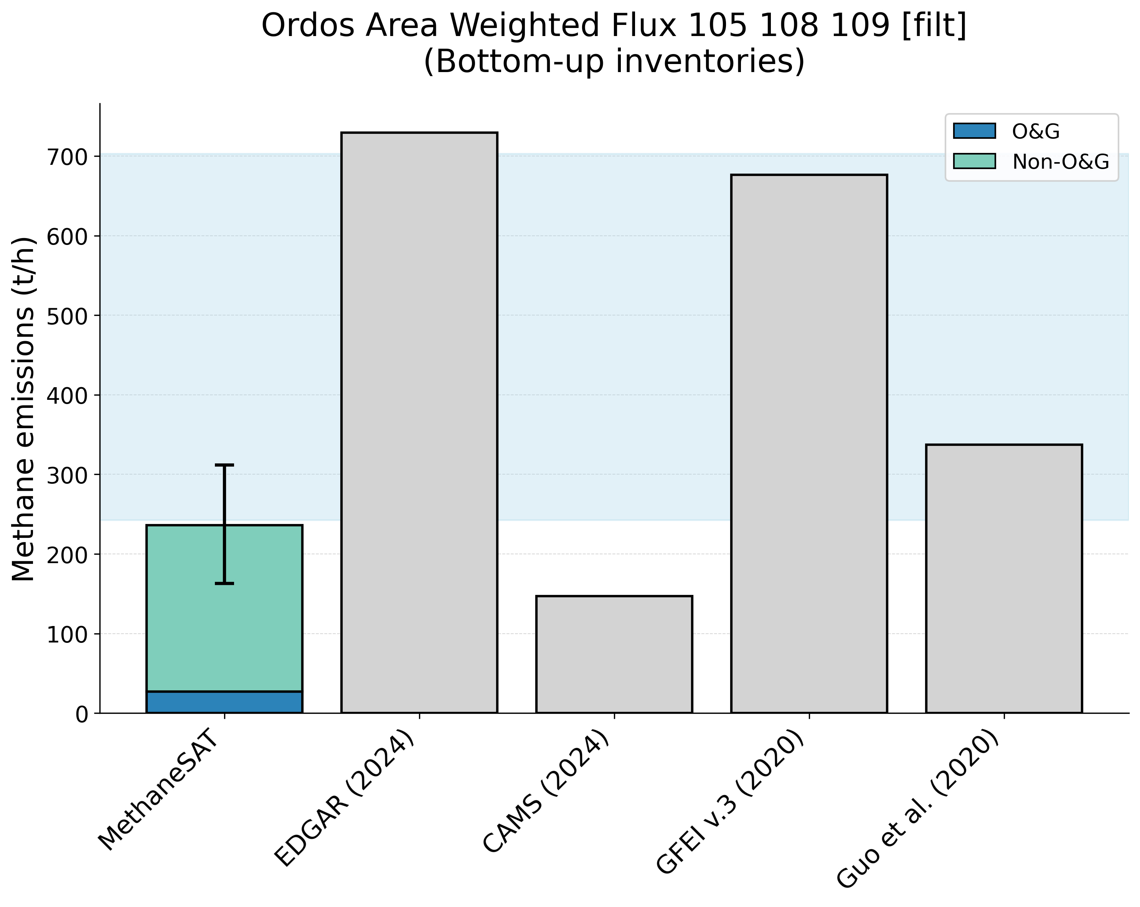
Supplementary Figure 24. Comparison of MethaneSAT total methane emissions estimates with peer-reviewed “top-down” measurements (top panel) and “bottom-up” inventory data (bottom panel). The shaded area shows the representative range of the peer-reviewed data (2.5th, 97.5th percentiles). Ordos, China (CHN) region.
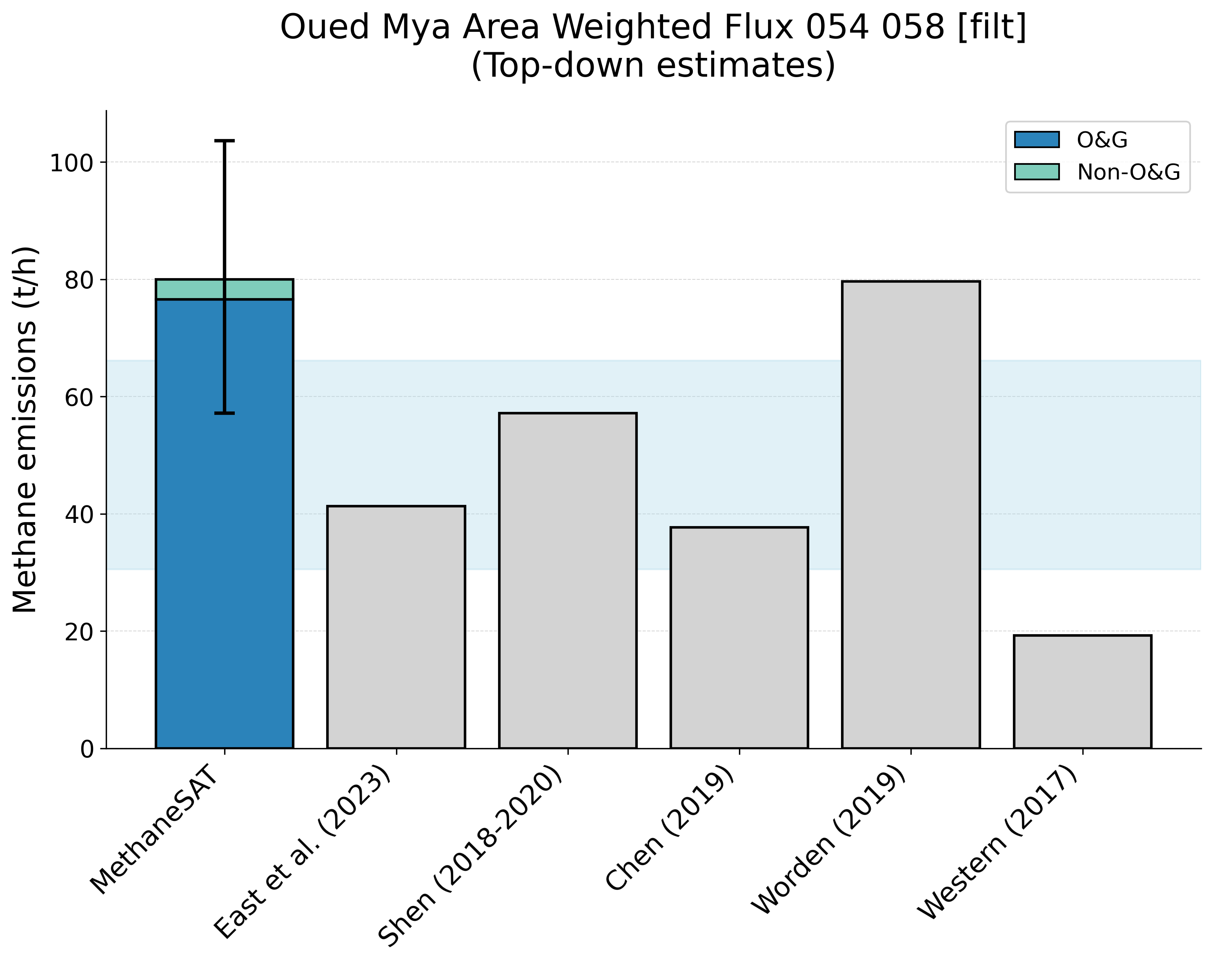
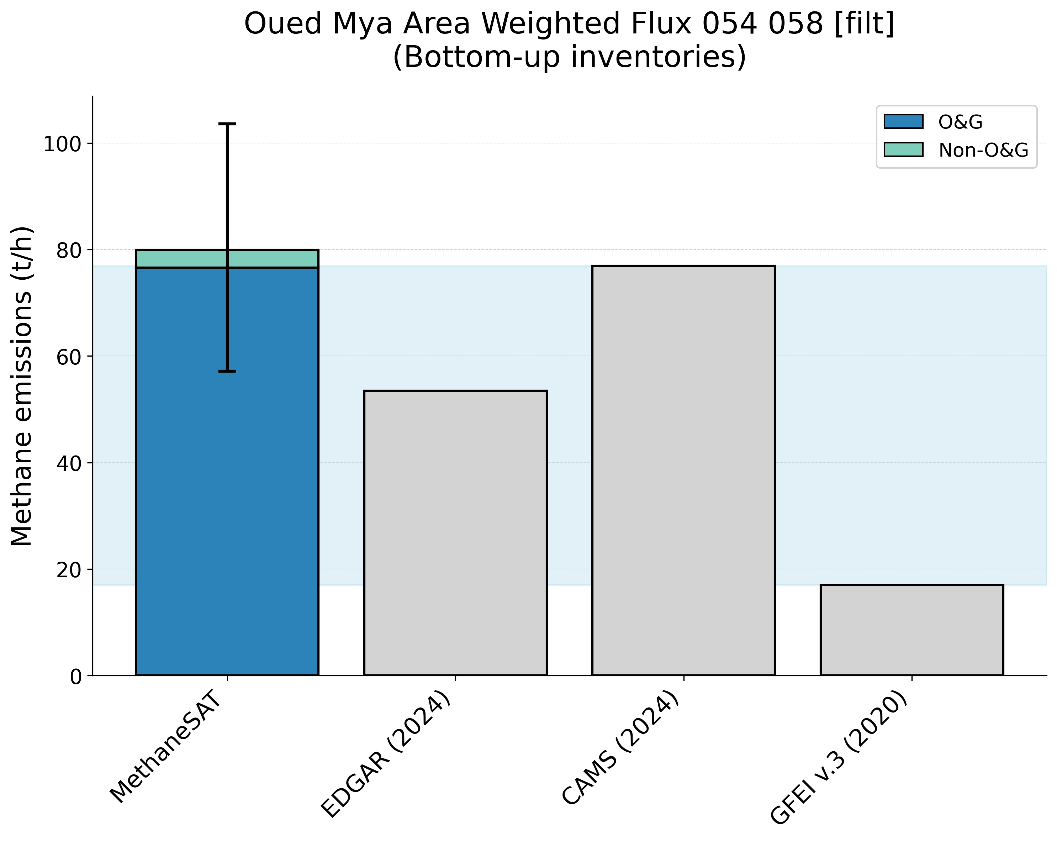
Supplementary Figure 25. Comparison of MethaneSAT total methane emissions estimates with peer-reviewed “top-down” measurements (top panel) and “bottom-up” inventory data (bottom panel). The shaded area shows the representative range of the peer-reviewed data (2.5th, 97.5th percentiles). Oued Mya, Algeria (ALG) region.
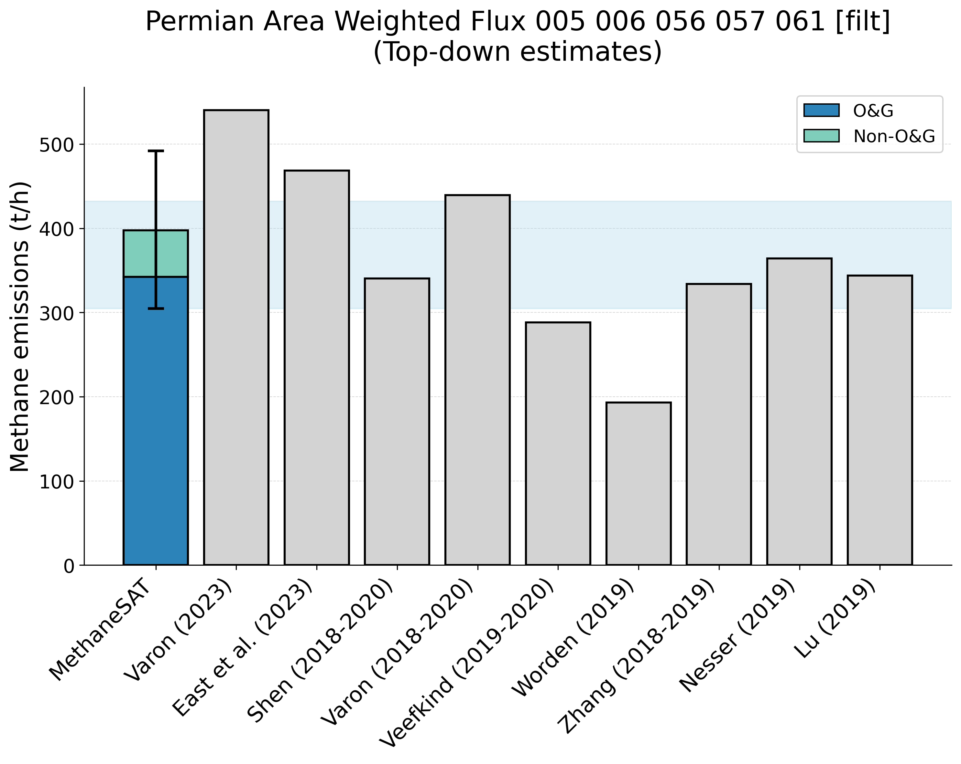
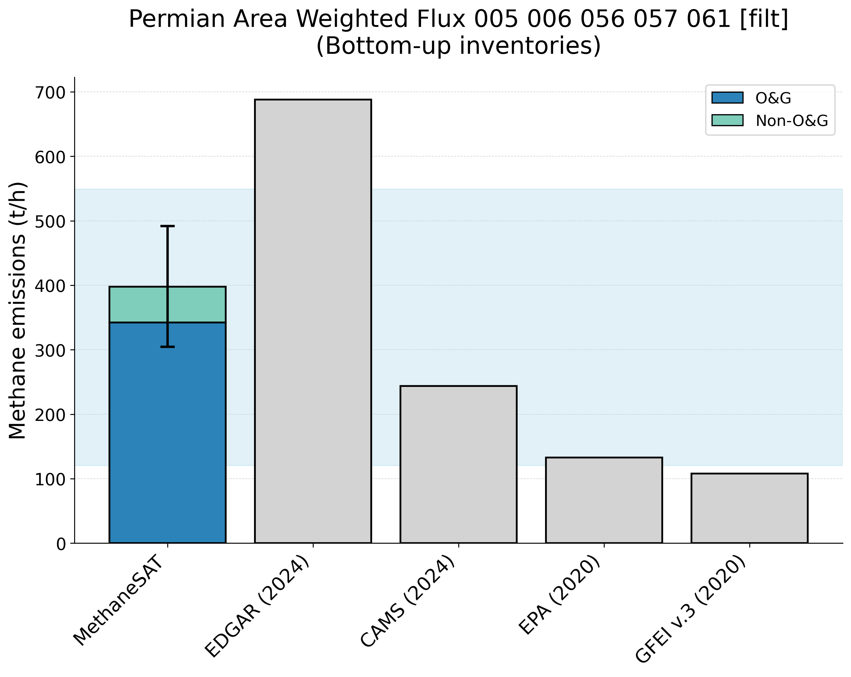
Supplementary Figure 26. Comparison of MethaneSAT total methane emissions estimates with peer-reviewed “top-down” measurements (top panel) and “bottom-up” inventory data (bottom panel). The shaded area shows the representative range of the peer-reviewed data (2.5th, 97.5th percentiles). Permian Basin, United States (USA) region.
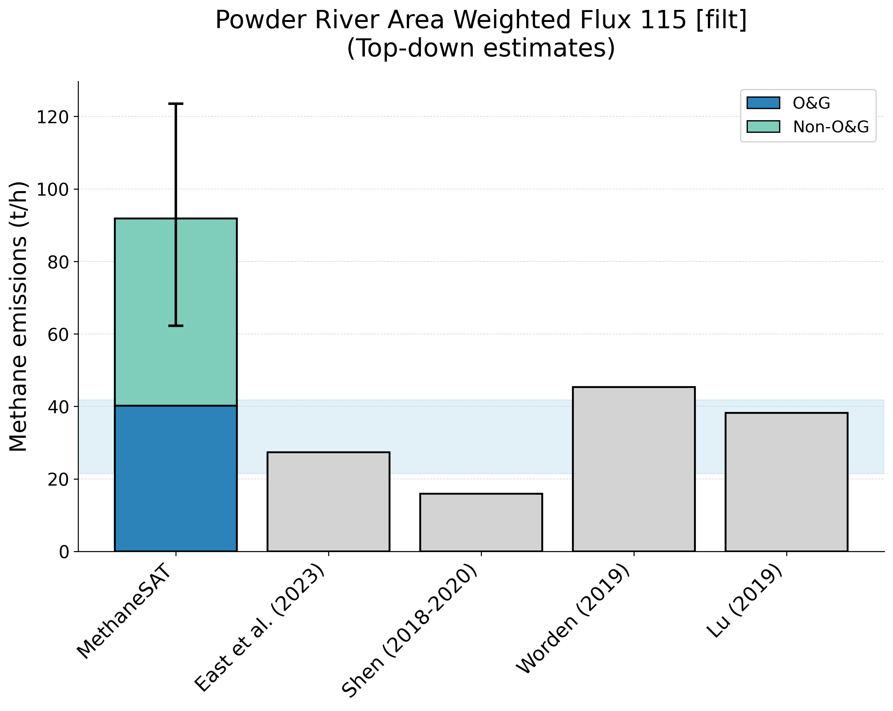
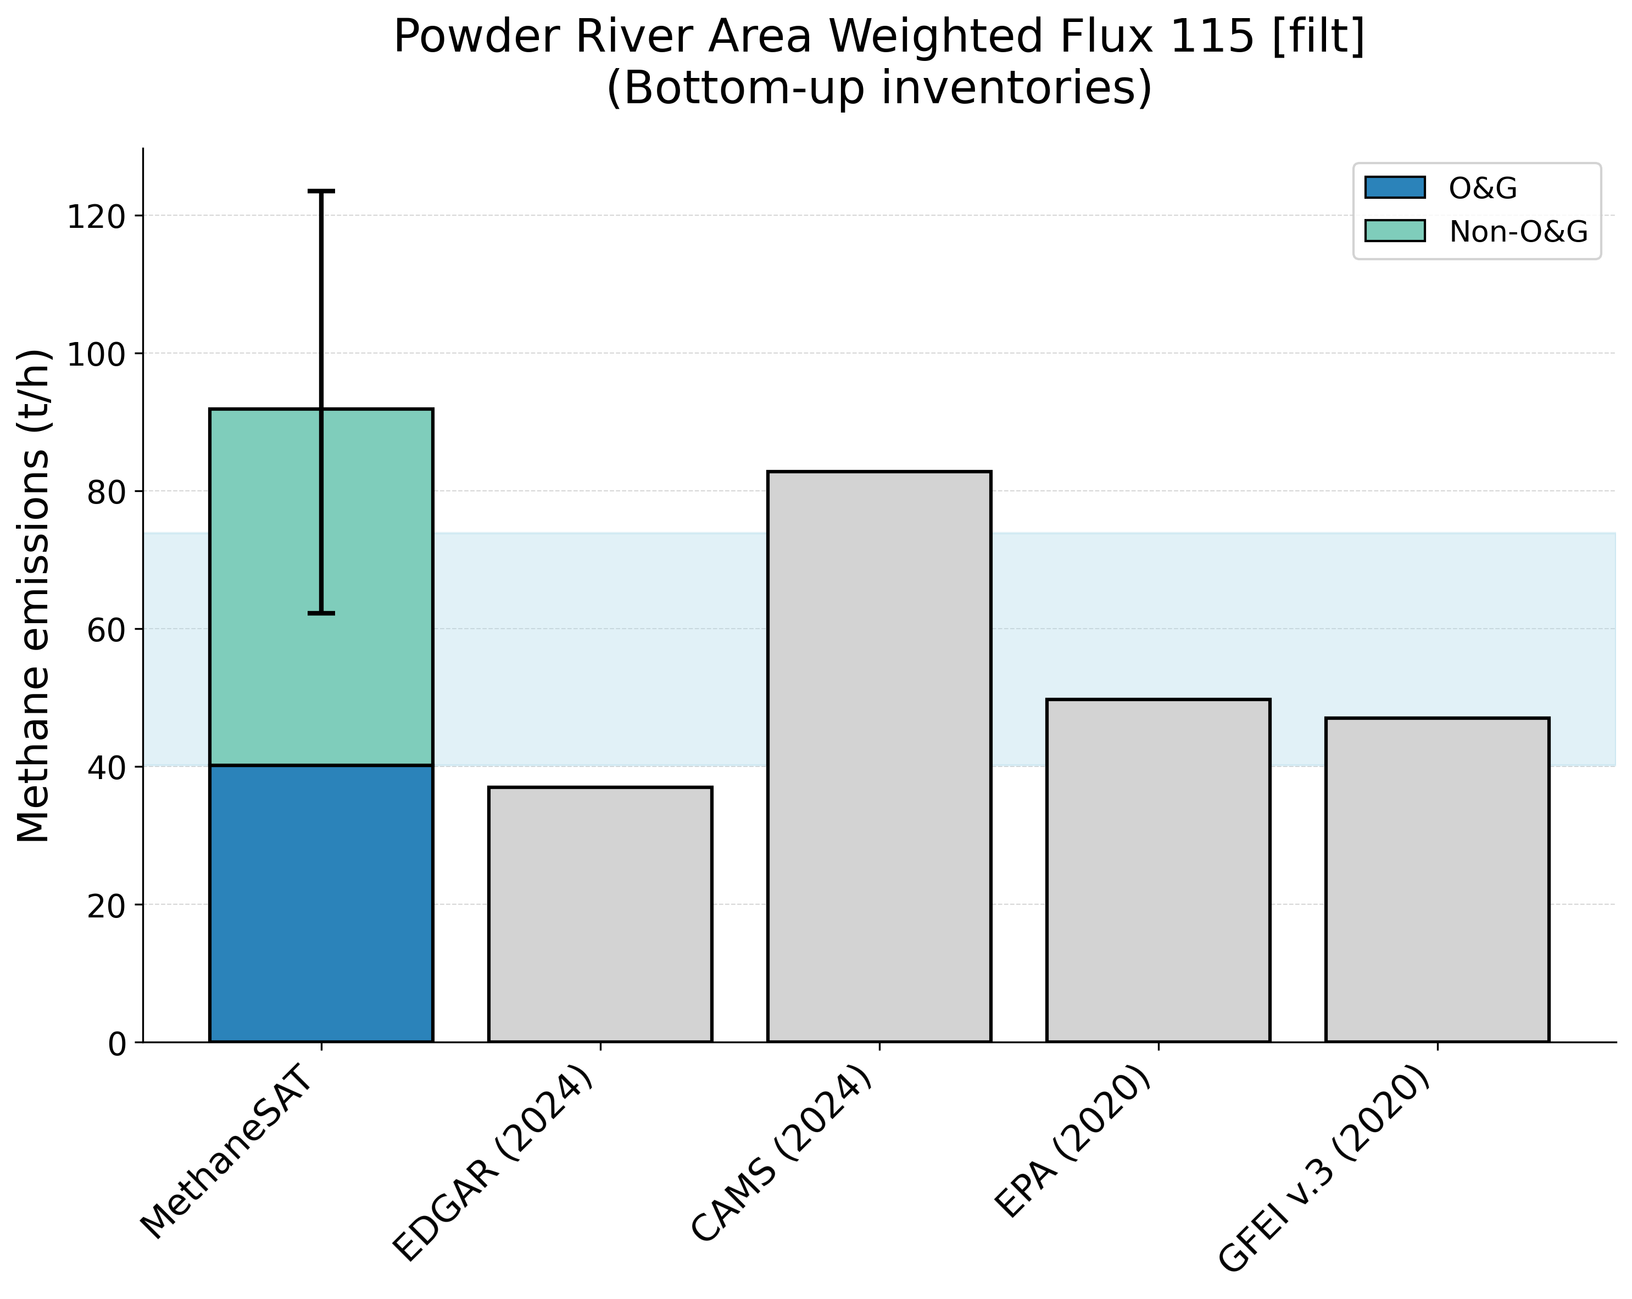
Supplementary Figure 27. Comparison of MethaneSAT total methane emissions estimates with peer-reviewed “top-down” measurements (top panel) and “bottom-up” inventory data (bottom panel). The shaded area shows the representative range of the peer-reviewed data (2.5th, 97.5th percentiles). Powder River, United States (USA) region.
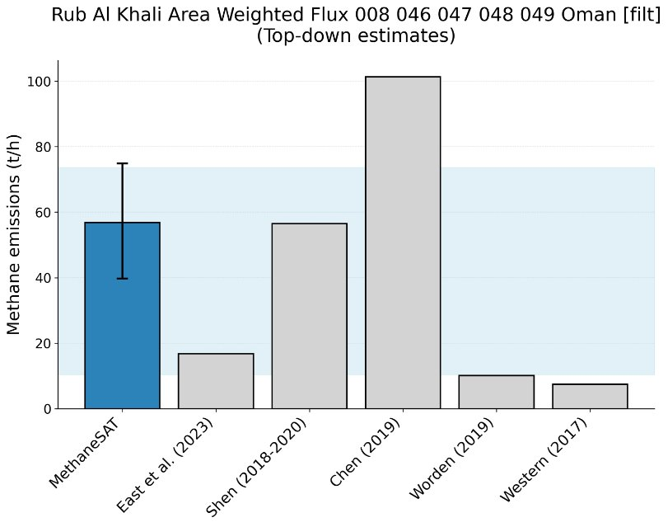
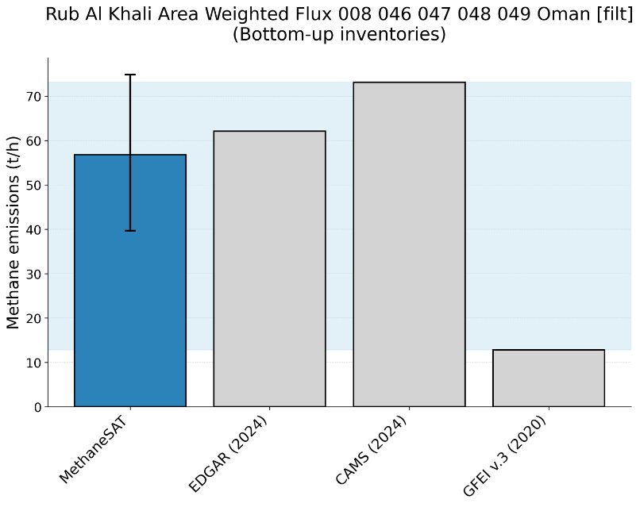
Supplementary Figure 28. Comparison of MethaneSAT total methane emissions estimates with peer-reviewed “top-down” measurements (top panel) and “bottom-up” inventory data (bottom panel). The shaded area shows the representative range of the peer-reviewed data (2.5th, 97.5th percentiles). Rub al Khali, Oman (OMN) region.
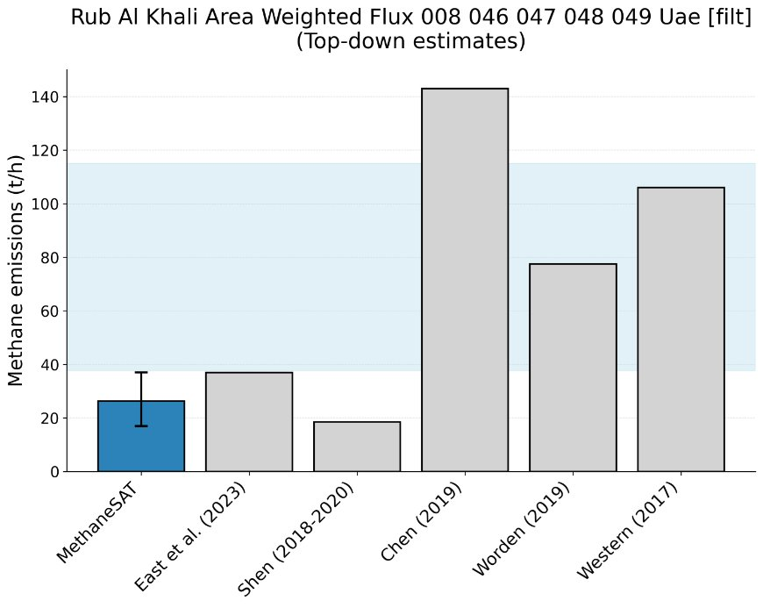
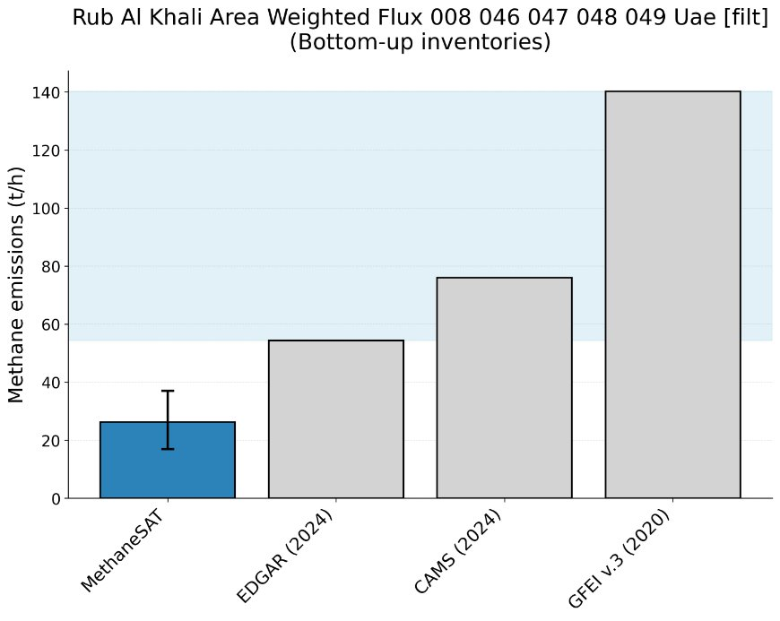
Supplementary Figure 29. Comparison of MethaneSAT total methane emissions estimates with peer-reviewed “top-down” measurements (top panel) and “bottom-up” inventory data (bottom panel). The shaded area shows the representative range of the peer-reviewed data (2.5th, 97.5th percentiles). Rub al Khali, United Arab Emirates (UAE) region.
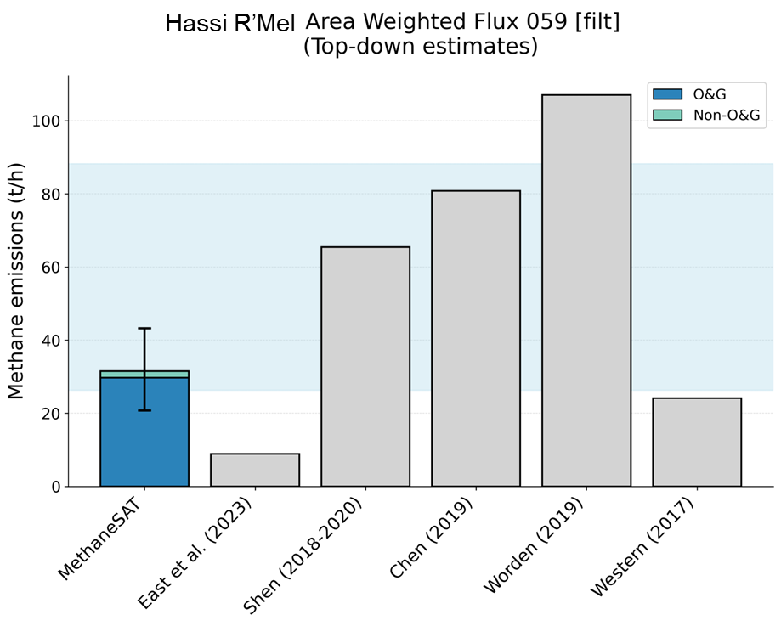
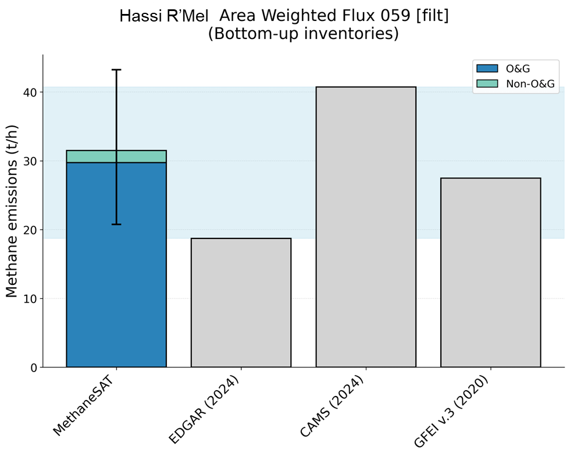
Supplementary Figure 30. Comparison of MethaneSAT total methane emissions estimates with peer-reviewed “top-down” measurements (top panel) and “bottom-up” inventory data (bottom panel). The shaded area shows the representative range of the peer-reviewed data (2.5th, 97.5th percentiles). Hassi R’Mel, Algeria (ALG) region.
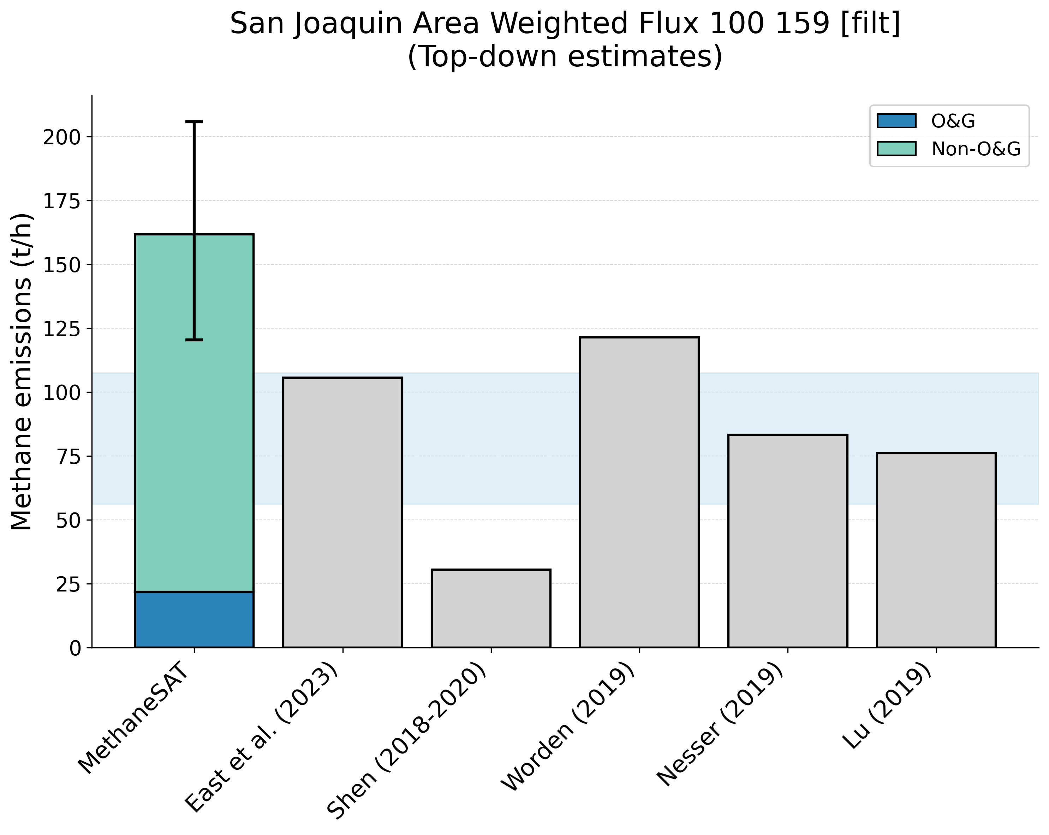
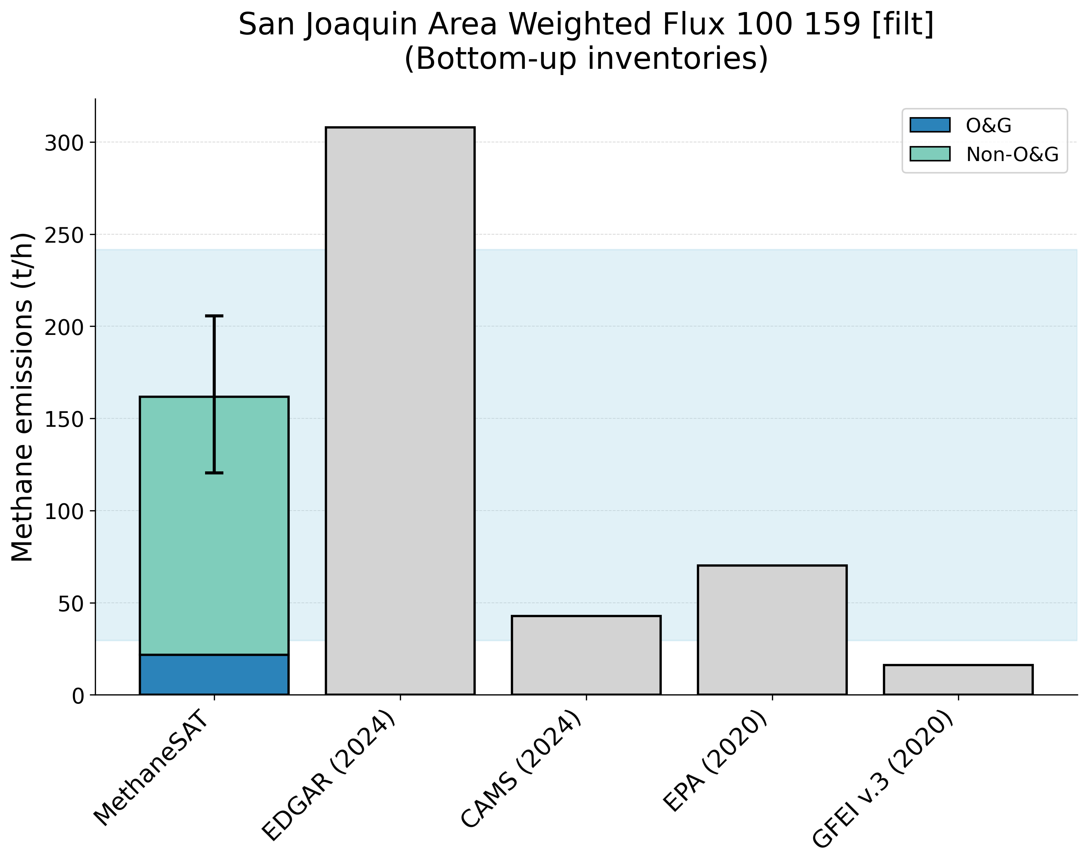
Supplementary Figure 31. Comparison of MethaneSAT total methane emissions estimates with peer-reviewed “top-down” measurements (top panel) and “bottom-up” inventory data (bottom panel). The shaded area shows the representative range of the peer-reviewed data (2.5th, 97.5th percentiles). San Joaquin, United States (USA) region.
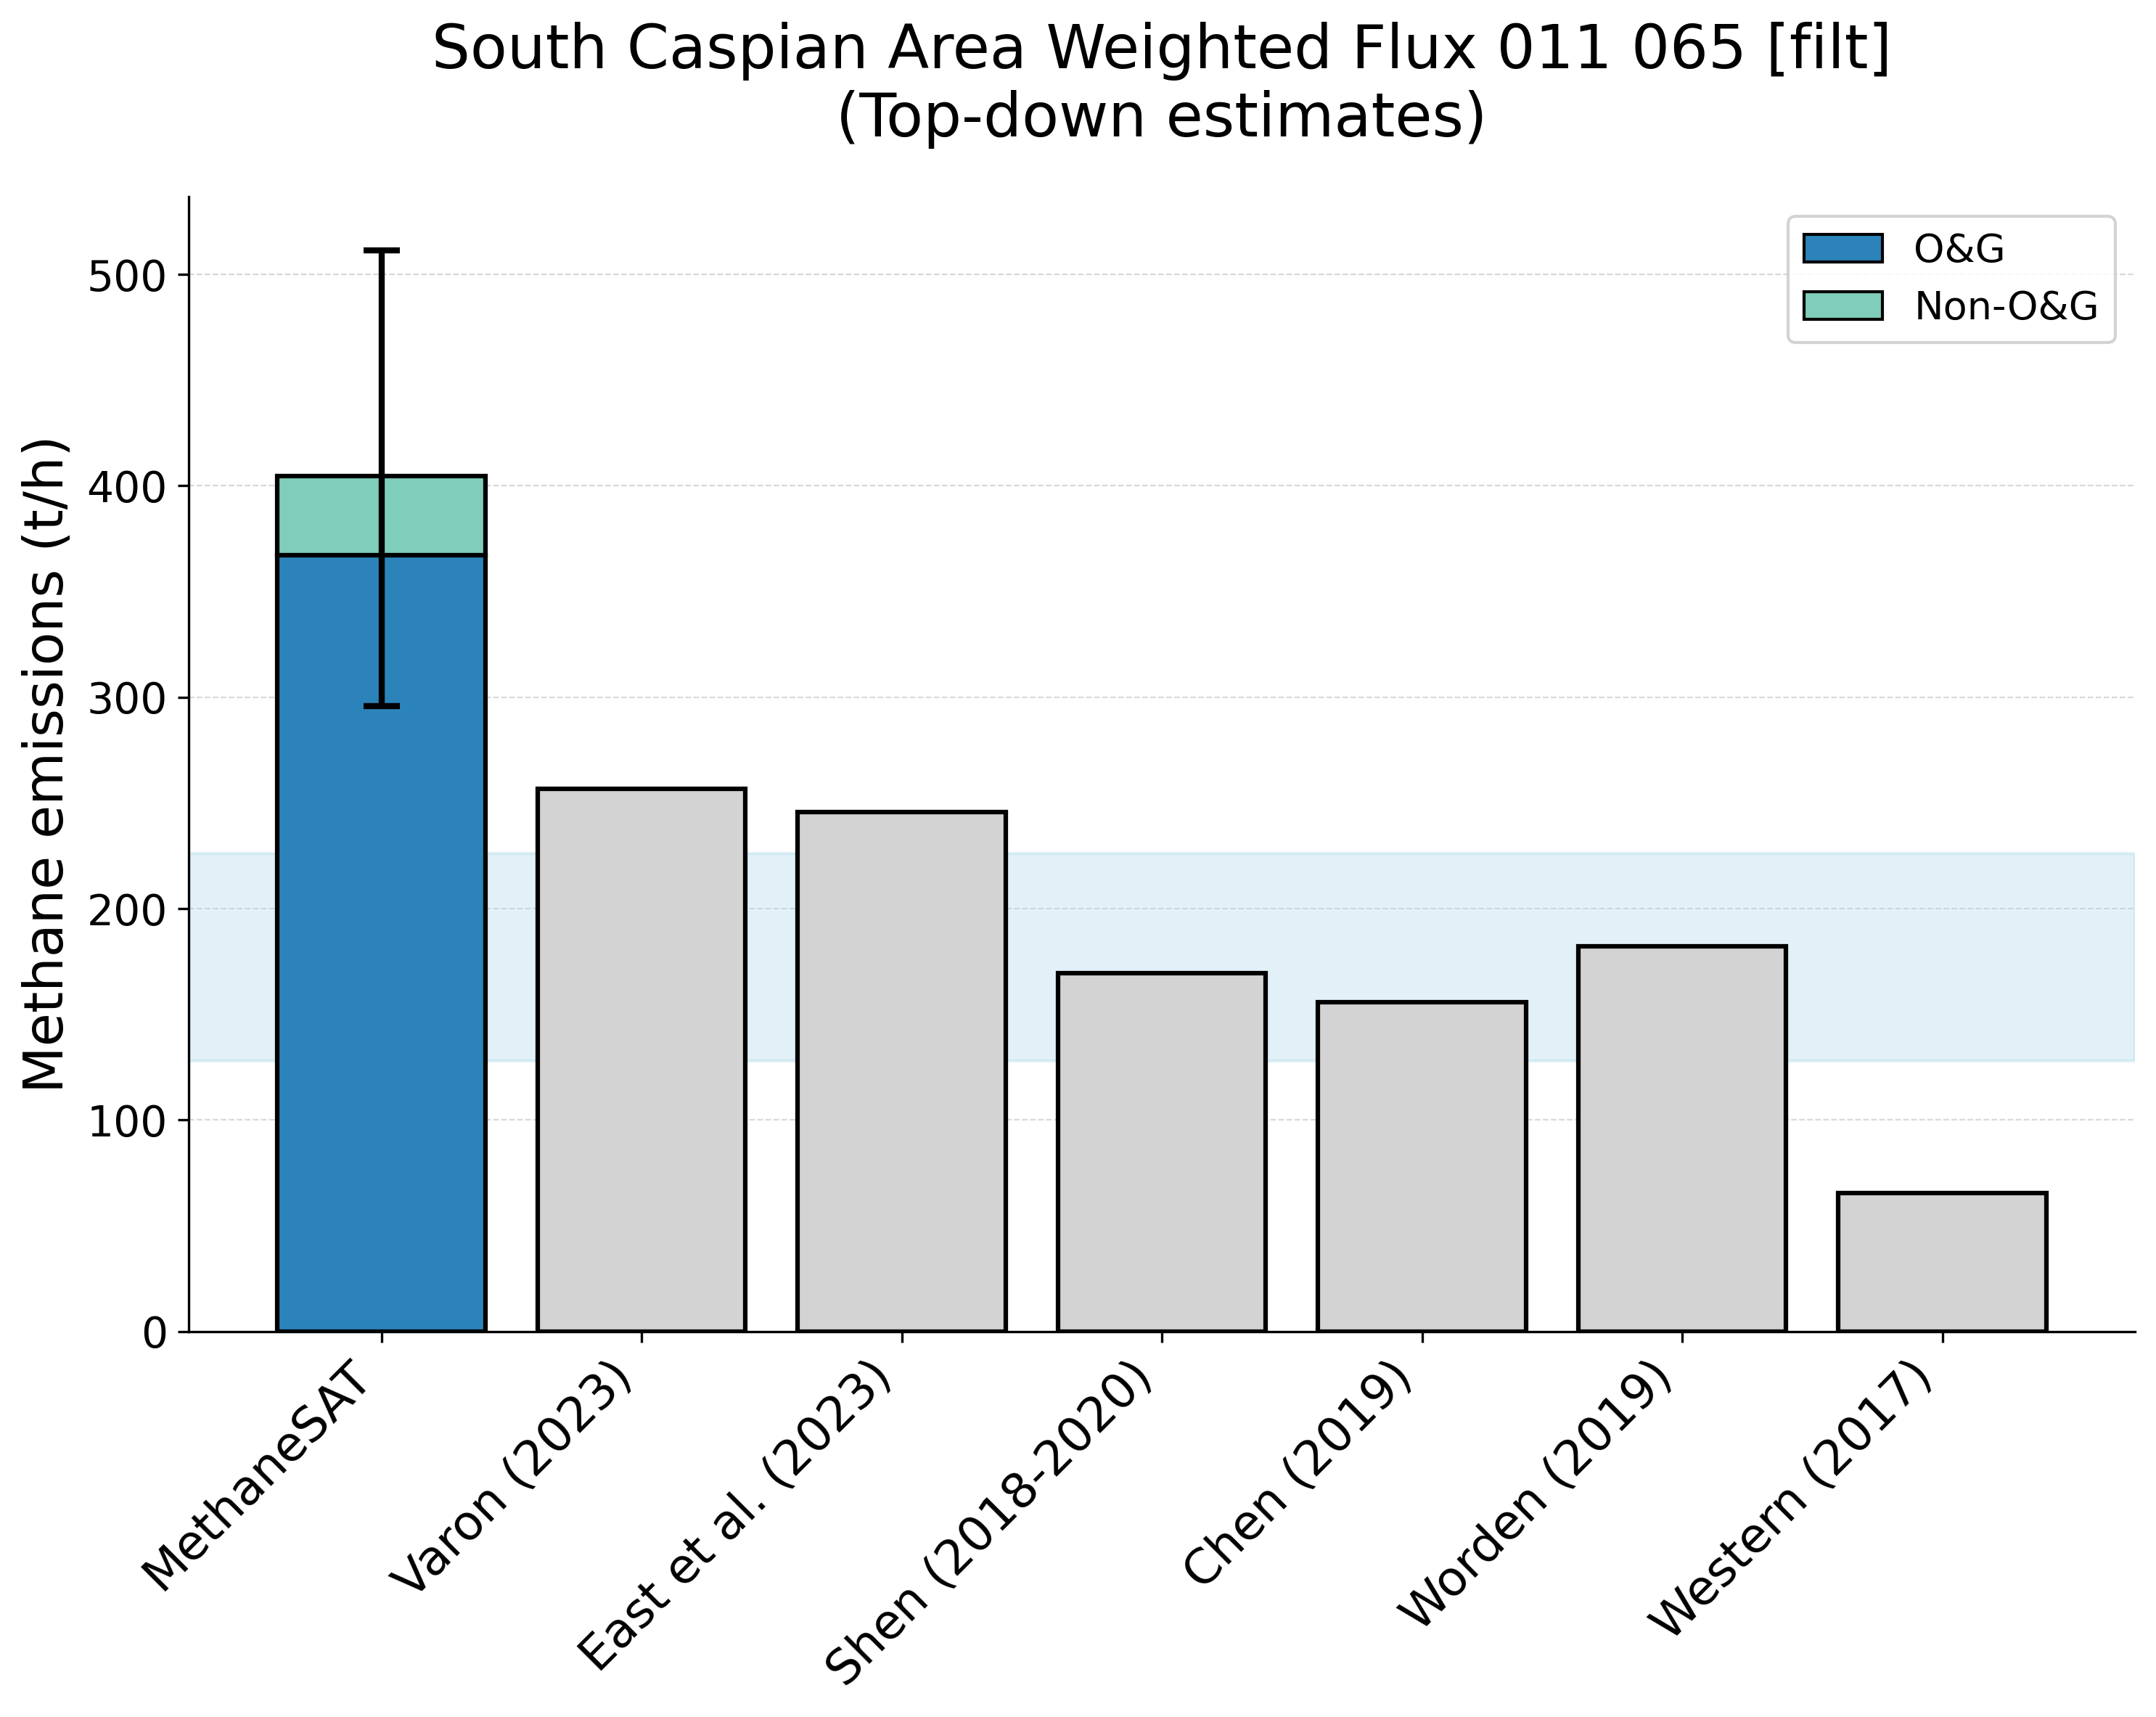
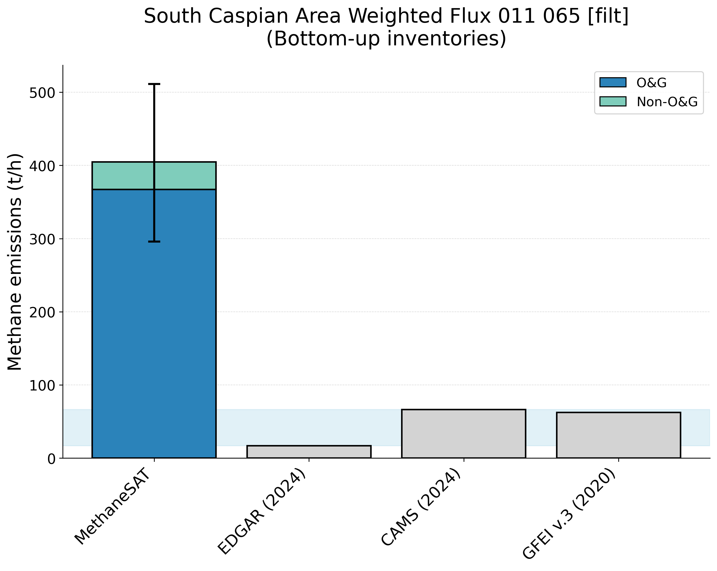
Supplementary Figure 32. Comparison of MethaneSAT total methane emissions estimates with peer-reviewed “top-down” measurements (top panel) and “bottom-up” inventory data (bottom panel). The shaded area shows the representative range of the peer-reviewed data (2.5th, 97.5th percentiles). South Caspian, Turkmenistan (TKM) region.
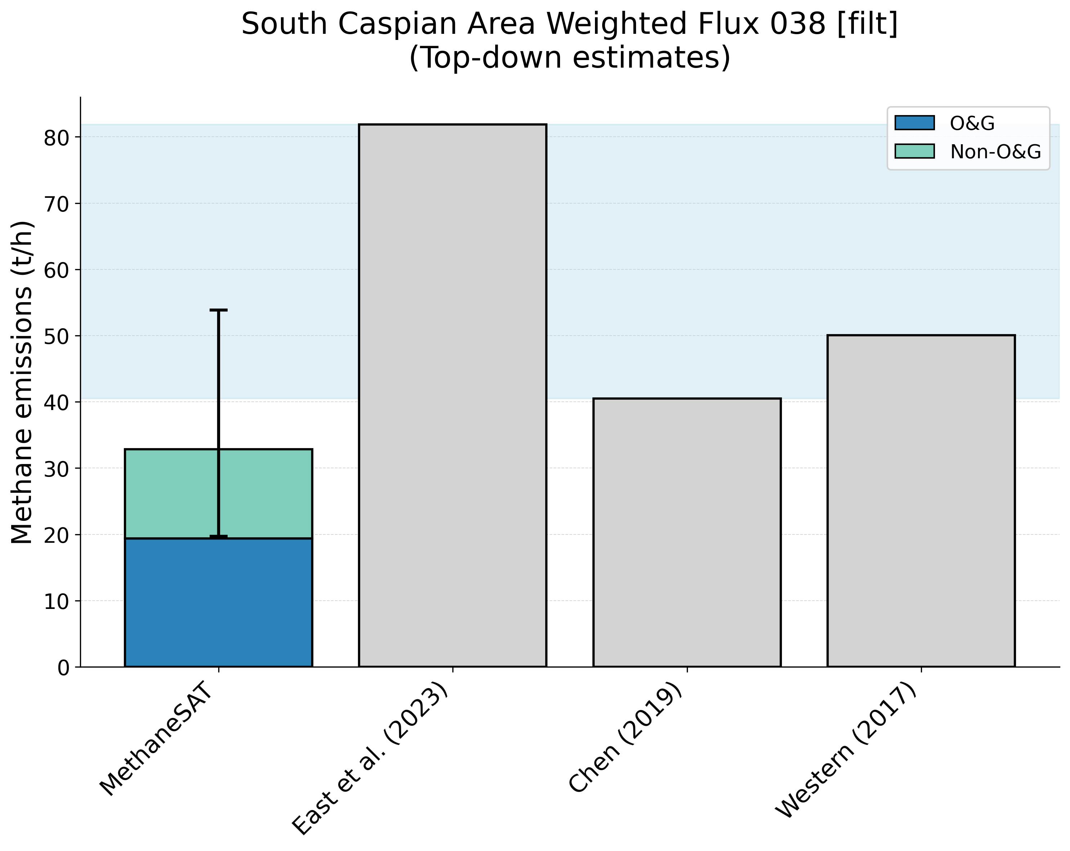
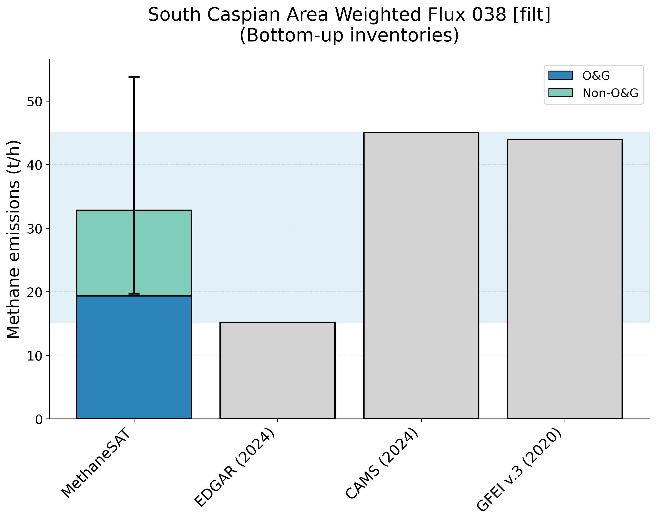
Supplementary Figure 33. Comparison of MethaneSAT total methane emissions estimates with peer-reviewed “top-down” measurements (top panel) and “bottom-up” inventory data (bottom panel). The shaded area shows the representative range of the peer-reviewed data (2.5th, 97.5th percentiles). South Caspian, Azerbaijan (AZB) region.
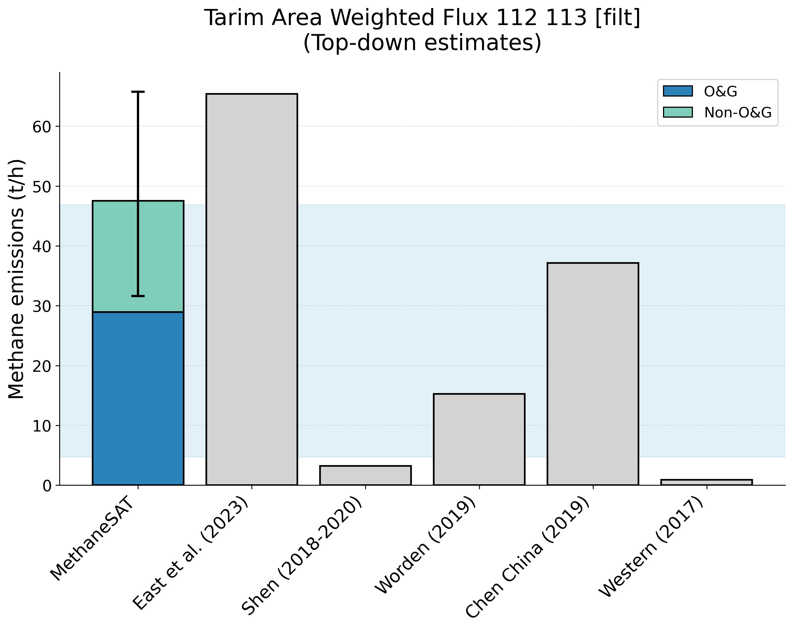
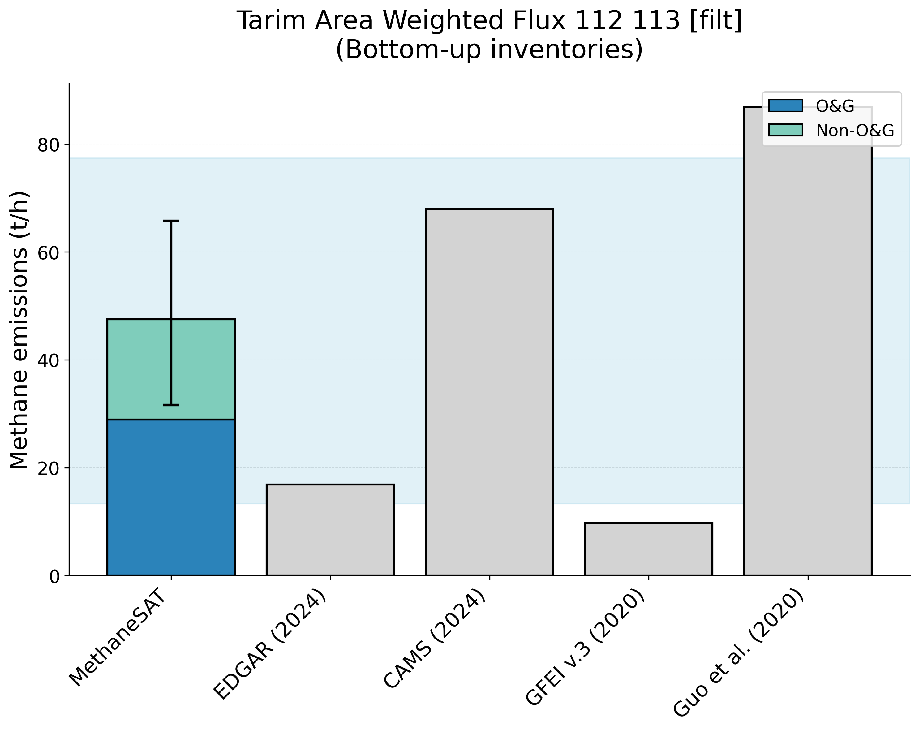
Supplementary Figure 34. Comparison of MethaneSAT total methane emissions estimates with peer-reviewed “top-down” measurements (top panel) and “bottom-up” inventory data (bottom panel). The shaded area shows the representative range of the peer-reviewed data (2.5th, 97.5th percentiles). Tarim, China (CHN) region.
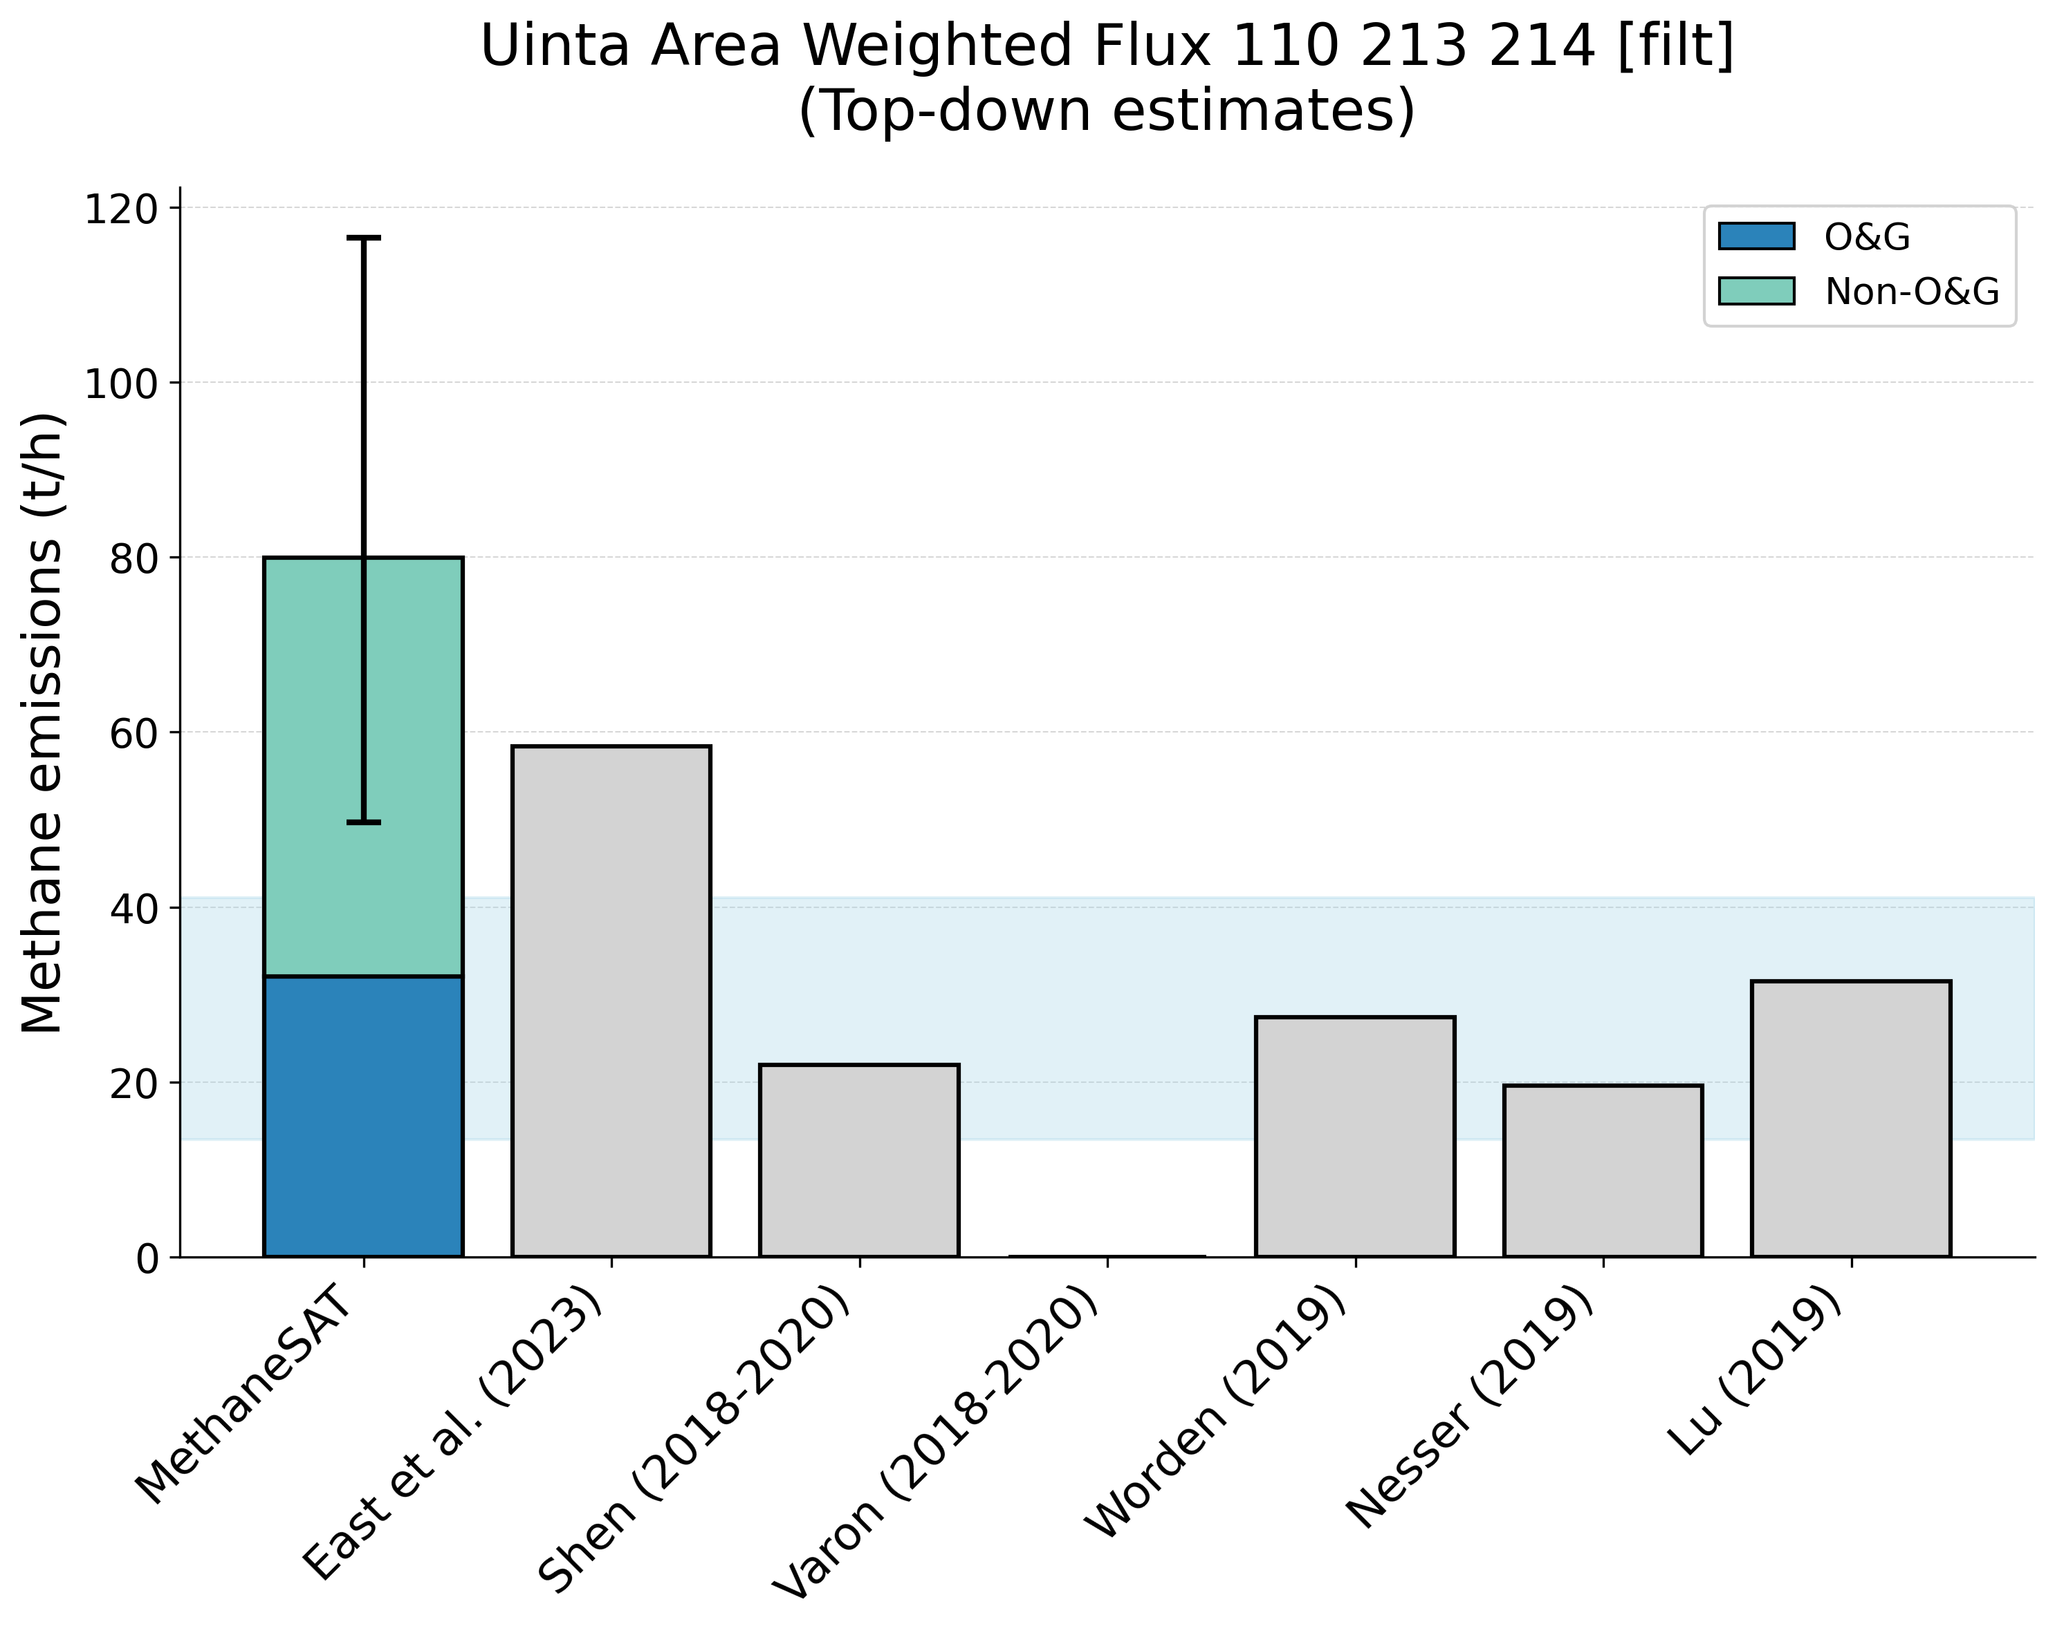
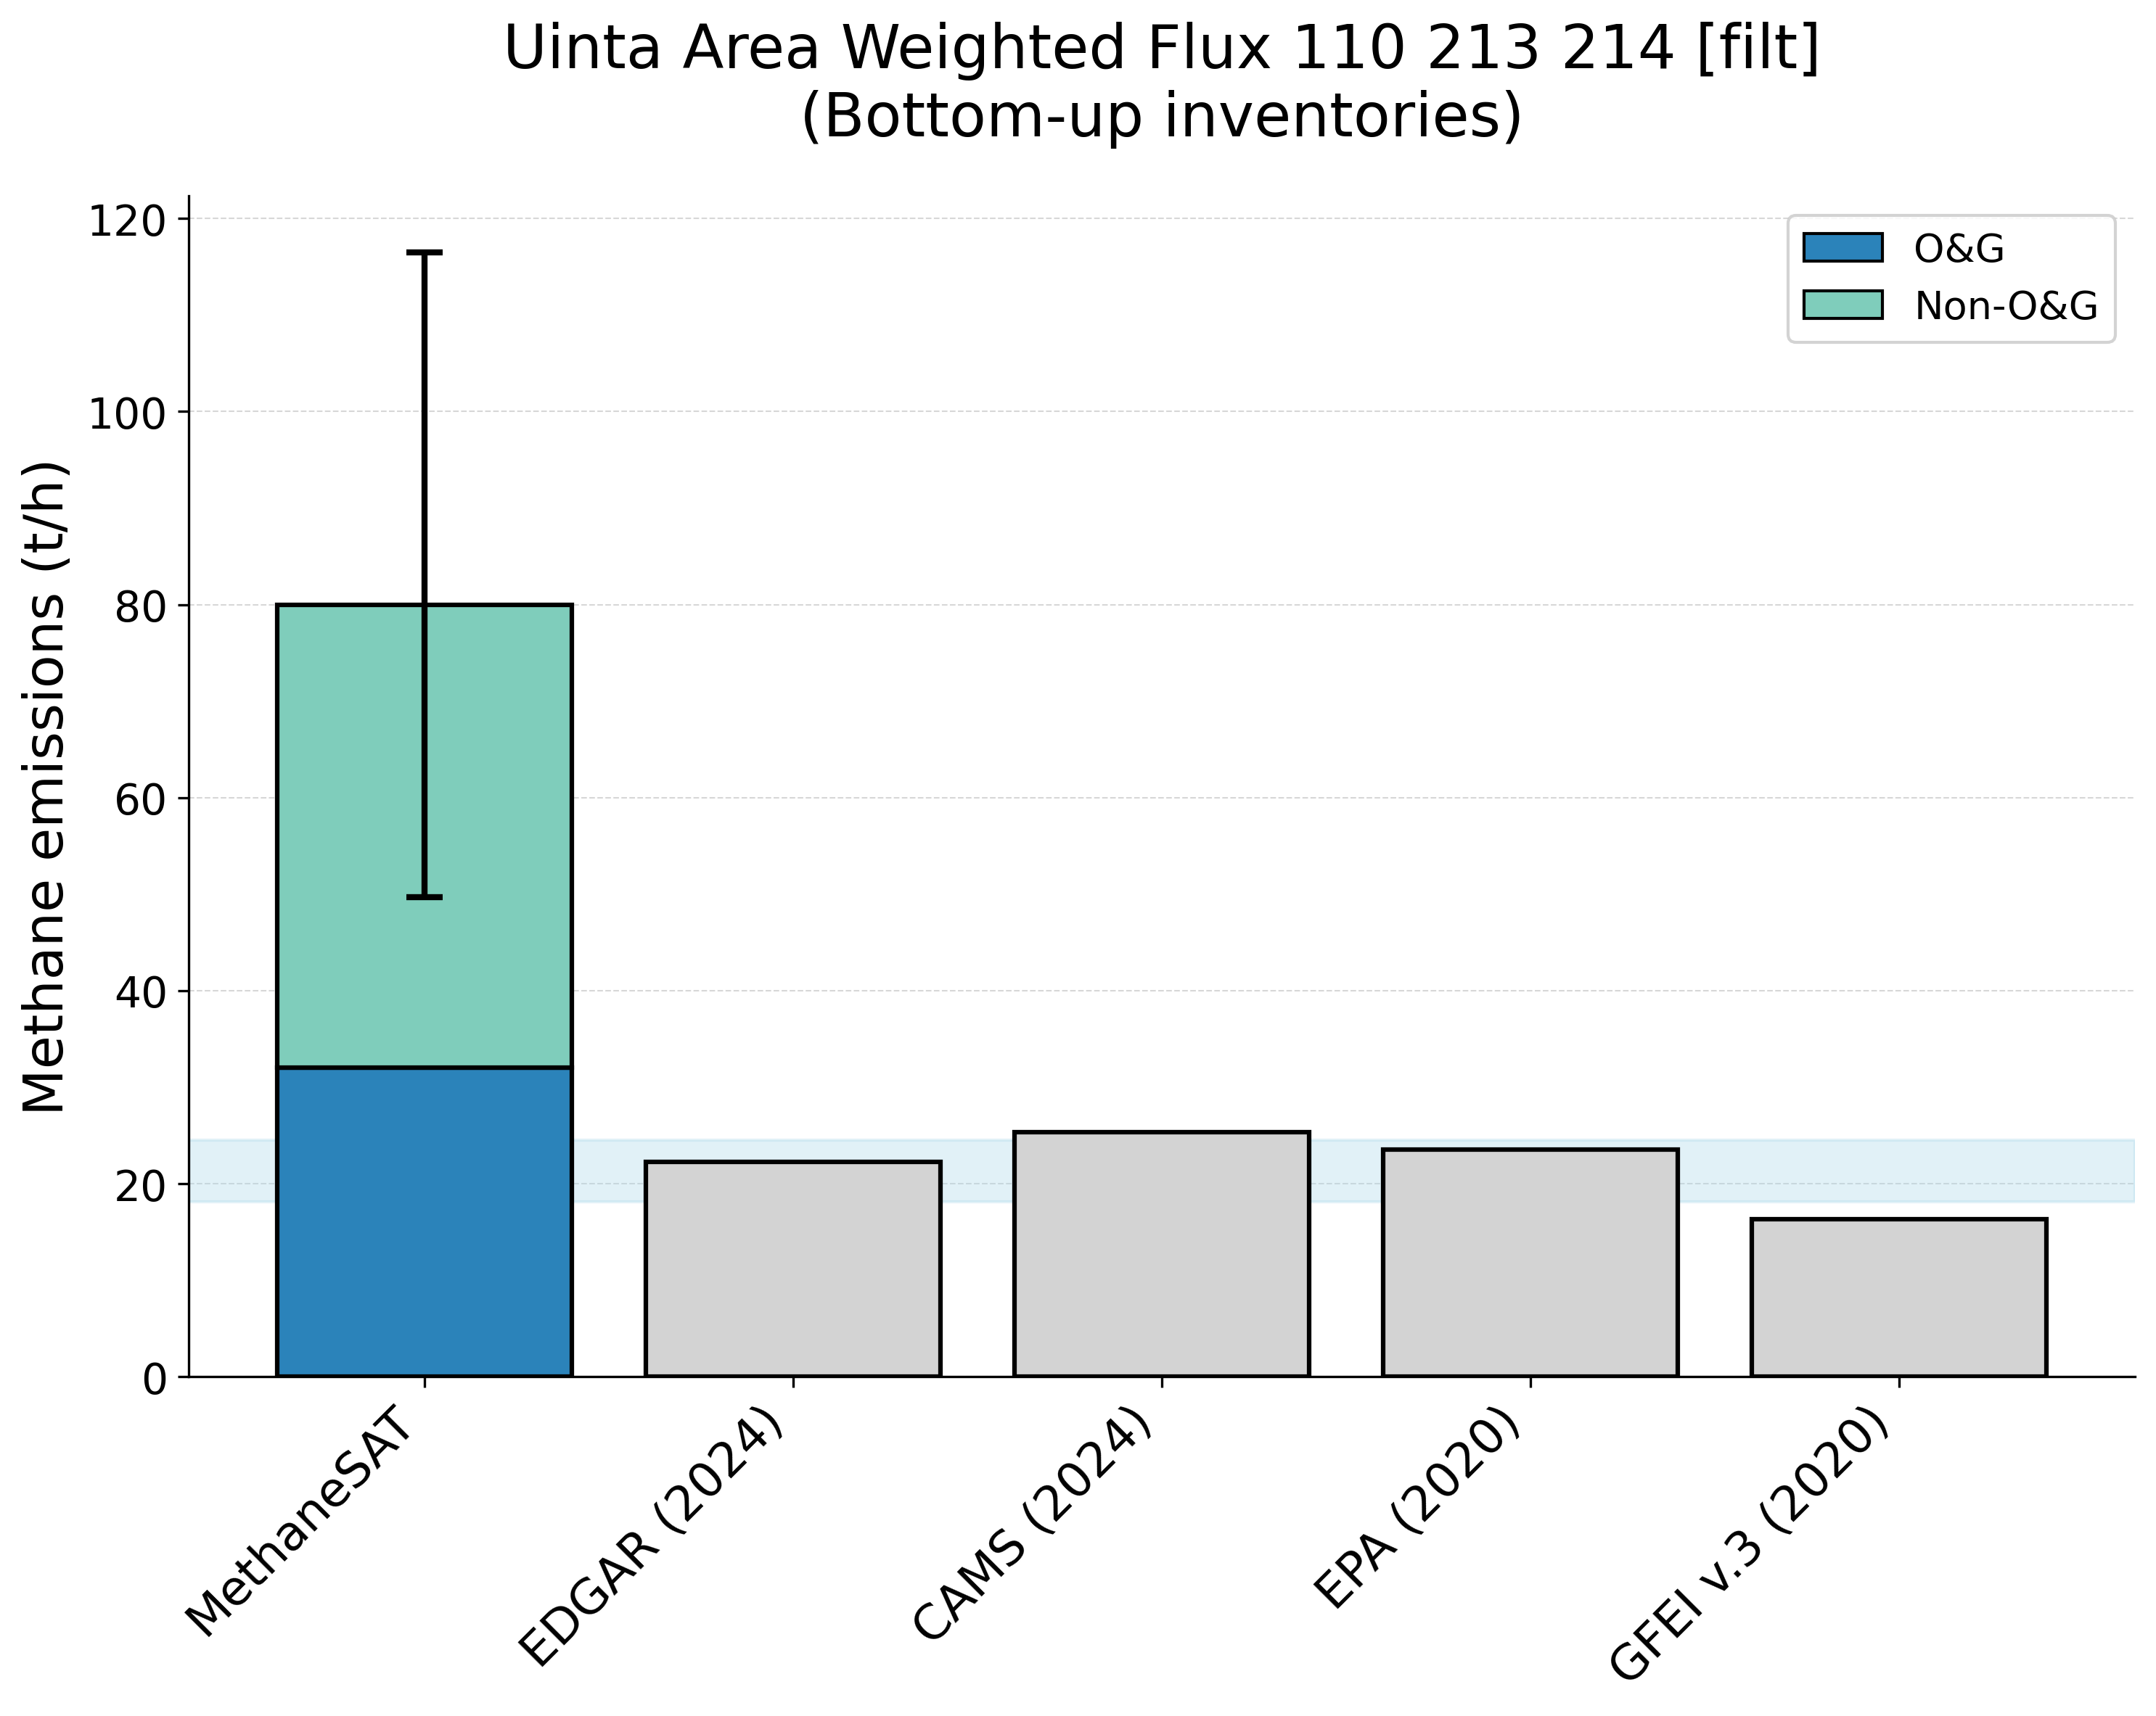
Supplementary Figure 35. Comparison of MethaneSAT total methane emissions estimates with peer-reviewed “top-down” measurements (top panel) and “bottom-up” inventory data (bottom panel). The shaded area shows the representative range of the peer-reviewed data (2.5th, 97.5th percentiles). Uinta, United States (USA) region.
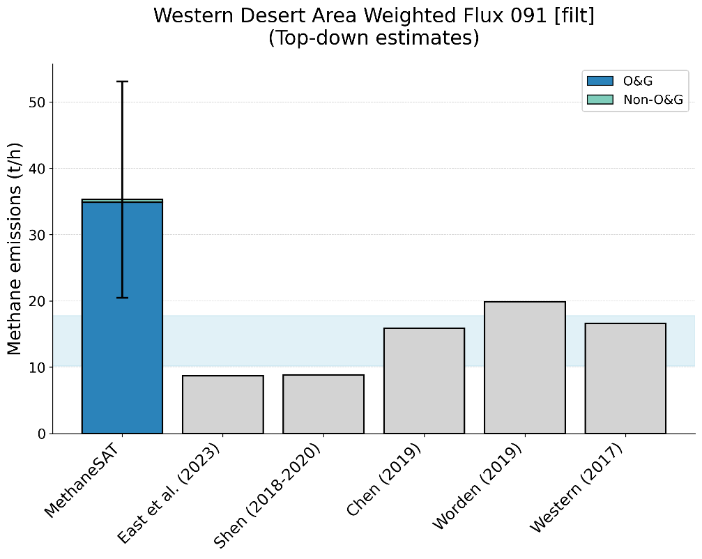

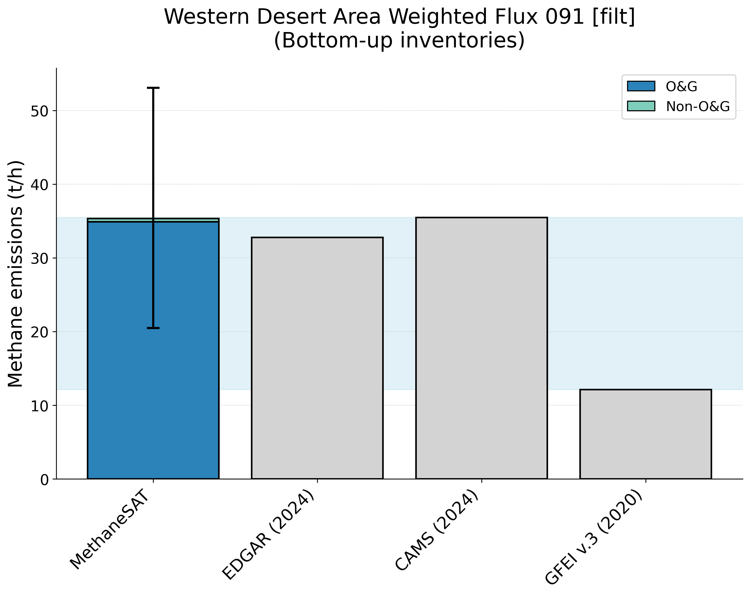
Supplementary Figure 36. Comparison of MethaneSAT total methane emissions estimates with peer-reviewed “top-down” measurements (top panel) and “bottom-up” inventory data (bottom panel). The shaded area shows the representative range of the peer-reviewed data (2.5th, 97.5th percentiles). Western Desert, Egypt (EGY) region.
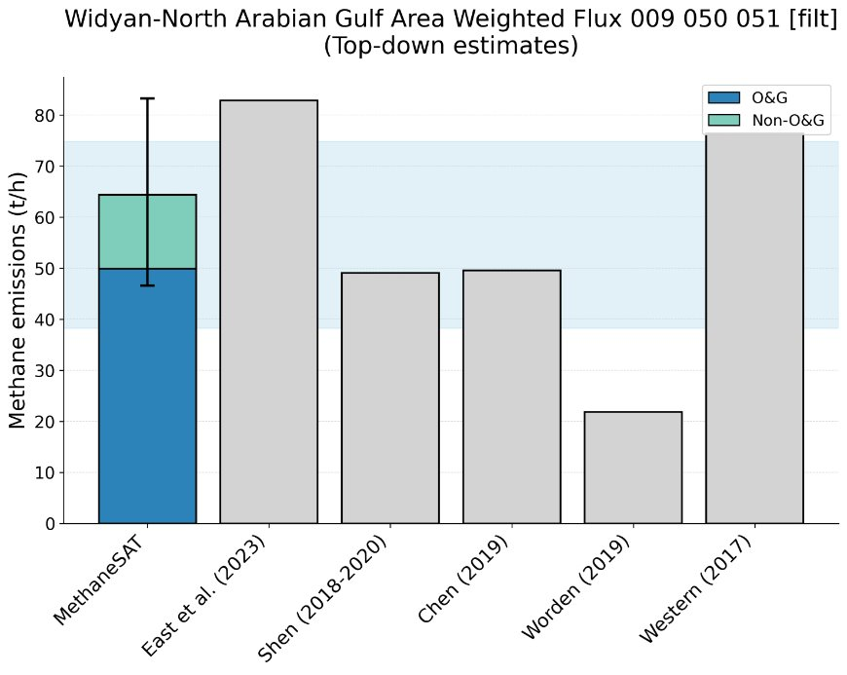
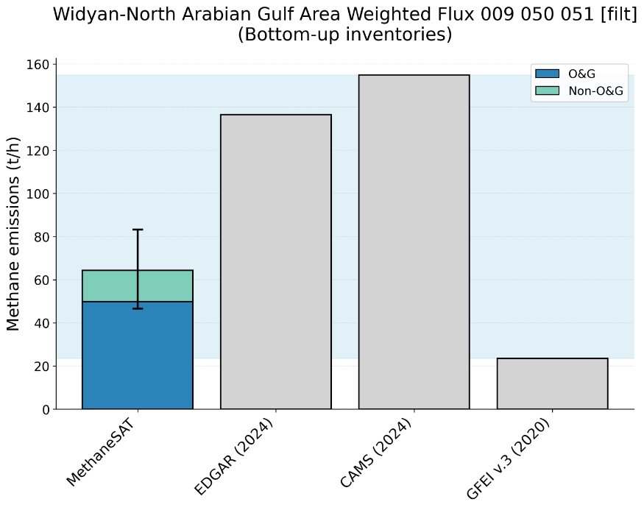
Supplementary Figure 37. Comparison of MethaneSAT total methane emissions estimates with peer-reviewed “top-down” measurements (top panel) and “bottom-up” inventory data (bottom panel). The shaded area shows the representative range of the peer-reviewed data (2.5th, 97.5th percentiles). Widyan, Kingdom of Saudi Arabia (KSA) region.

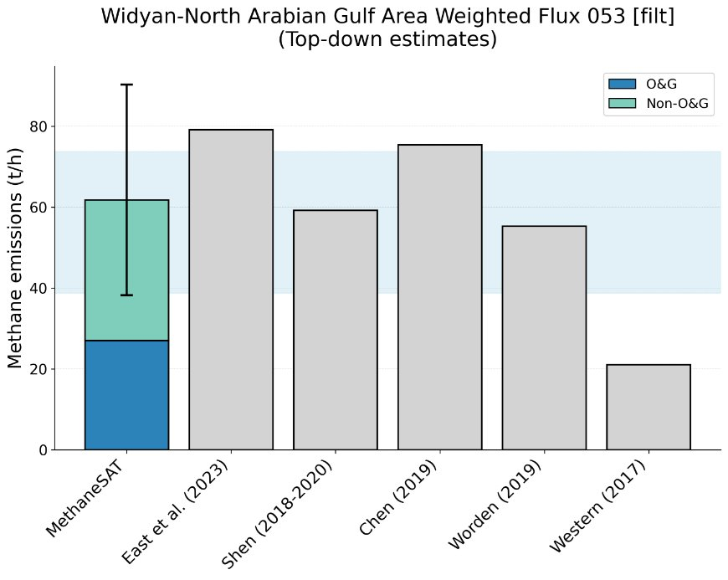
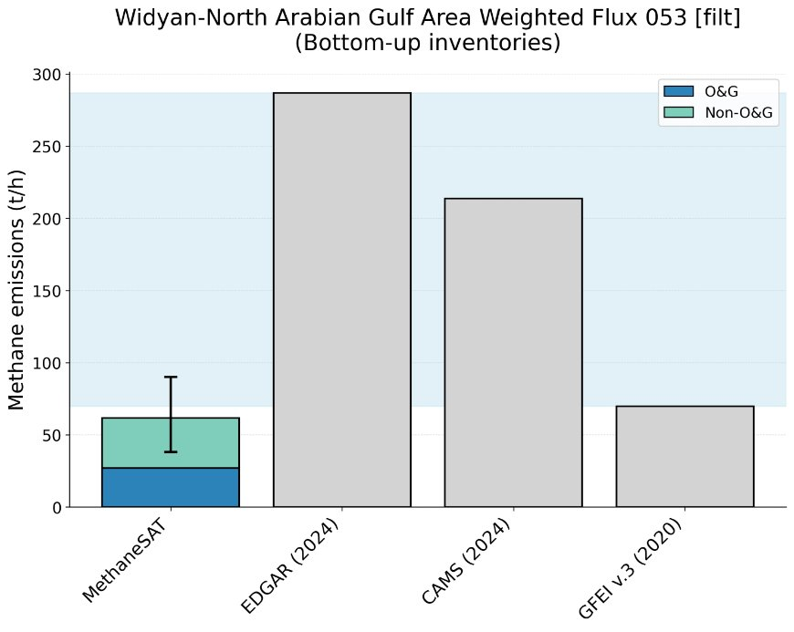
Supplementary Figure 38. Comparison of MethaneSAT total methane emissions estimates with peer-reviewed “top-down” measurements (top panel) and “bottom-up” inventory data (bottom panel). The shaded area shows the representative range of the peer-reviewed data (2.5th, 97.5th percentiles). Widyan, Kuwait (KUW) region.

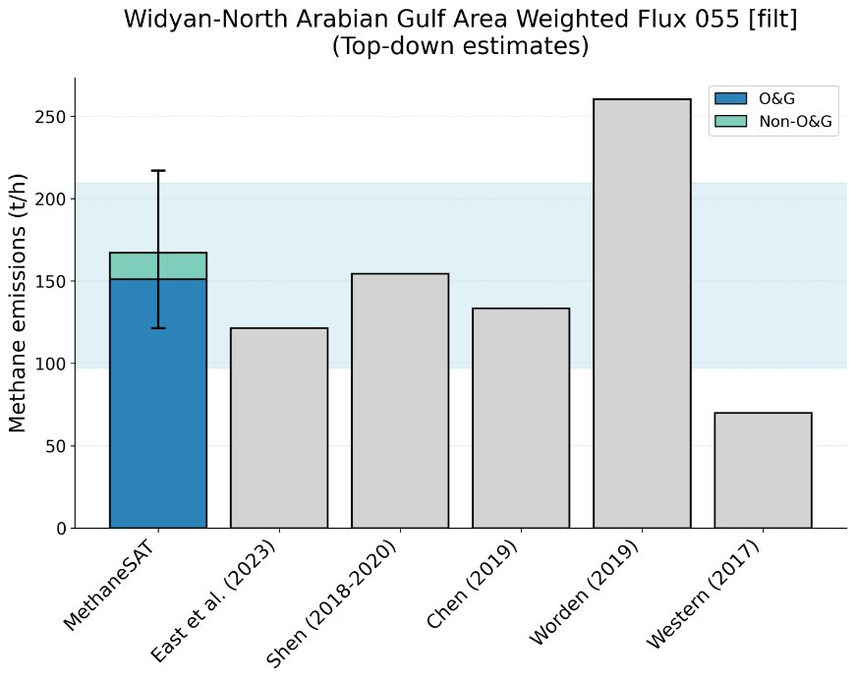
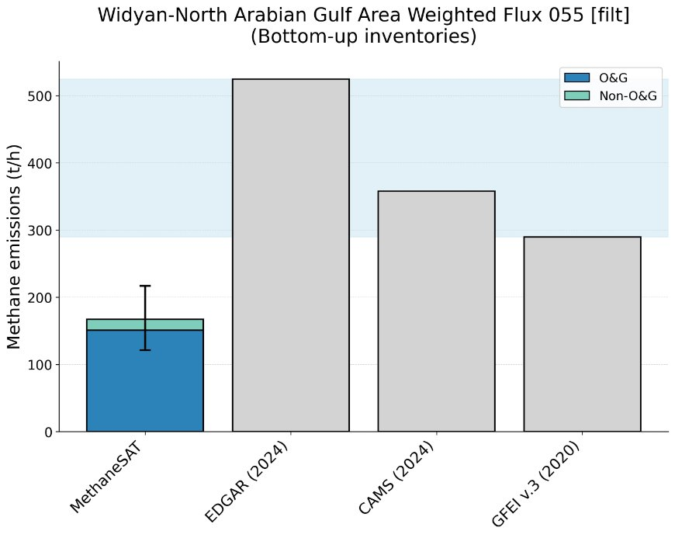
Supplementary Figure 39. Comparison of MethaneSAT total methane emissions estimates with peer-reviewed “top-down” measurements (top panel) and “bottom-up” inventory data (bottom panel). The shaded area shows the representative range of the peer-reviewed data (2.5th, 97.5th percentiles). Widyan, Iran, Iraq (IRN_IRQ) region.

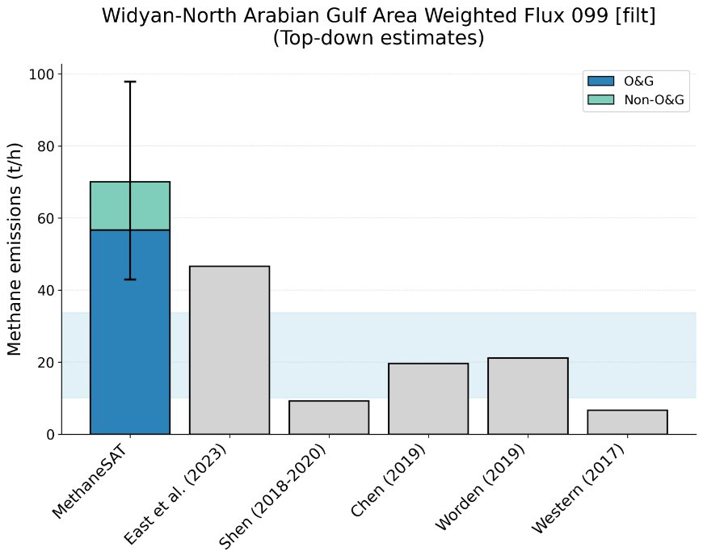
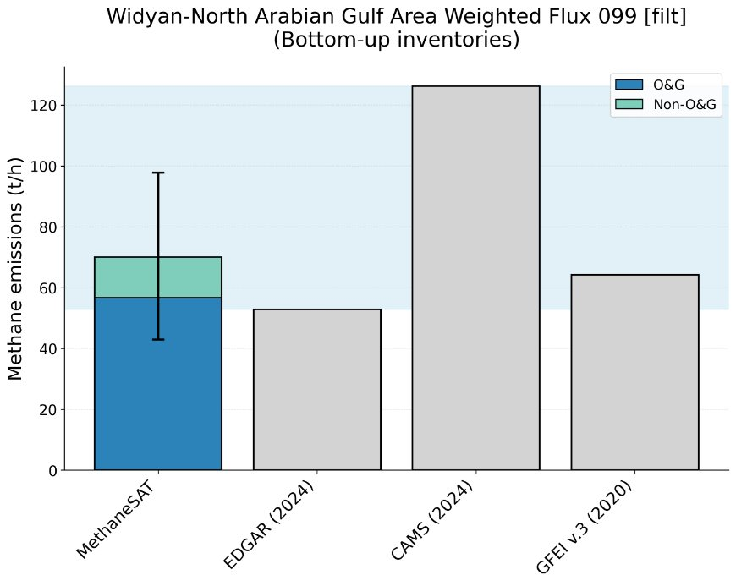
Supplementary Figure 40. Comparison of MethaneSAT total methane emissions estimates with peer-reviewed “top-down” measurements (top panel) and “bottom-up” inventory data (bottom panel). The shaded area shows the representative range of the peer-reviewed data (2.5th, 97.5th percentiles). Widyan, Iraq (IRQ) region.

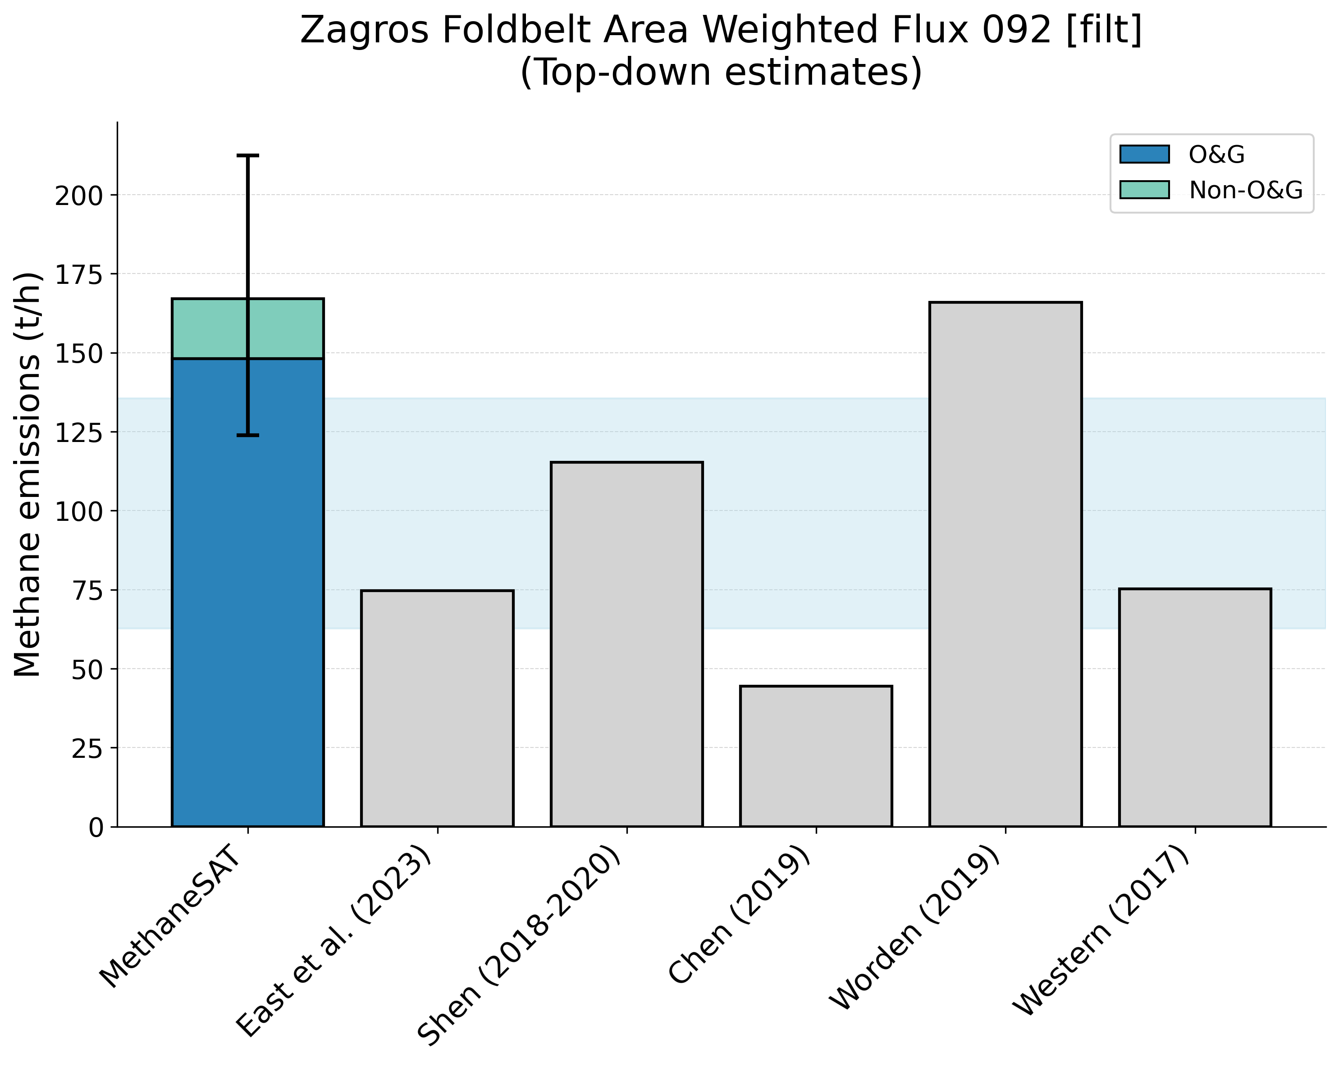
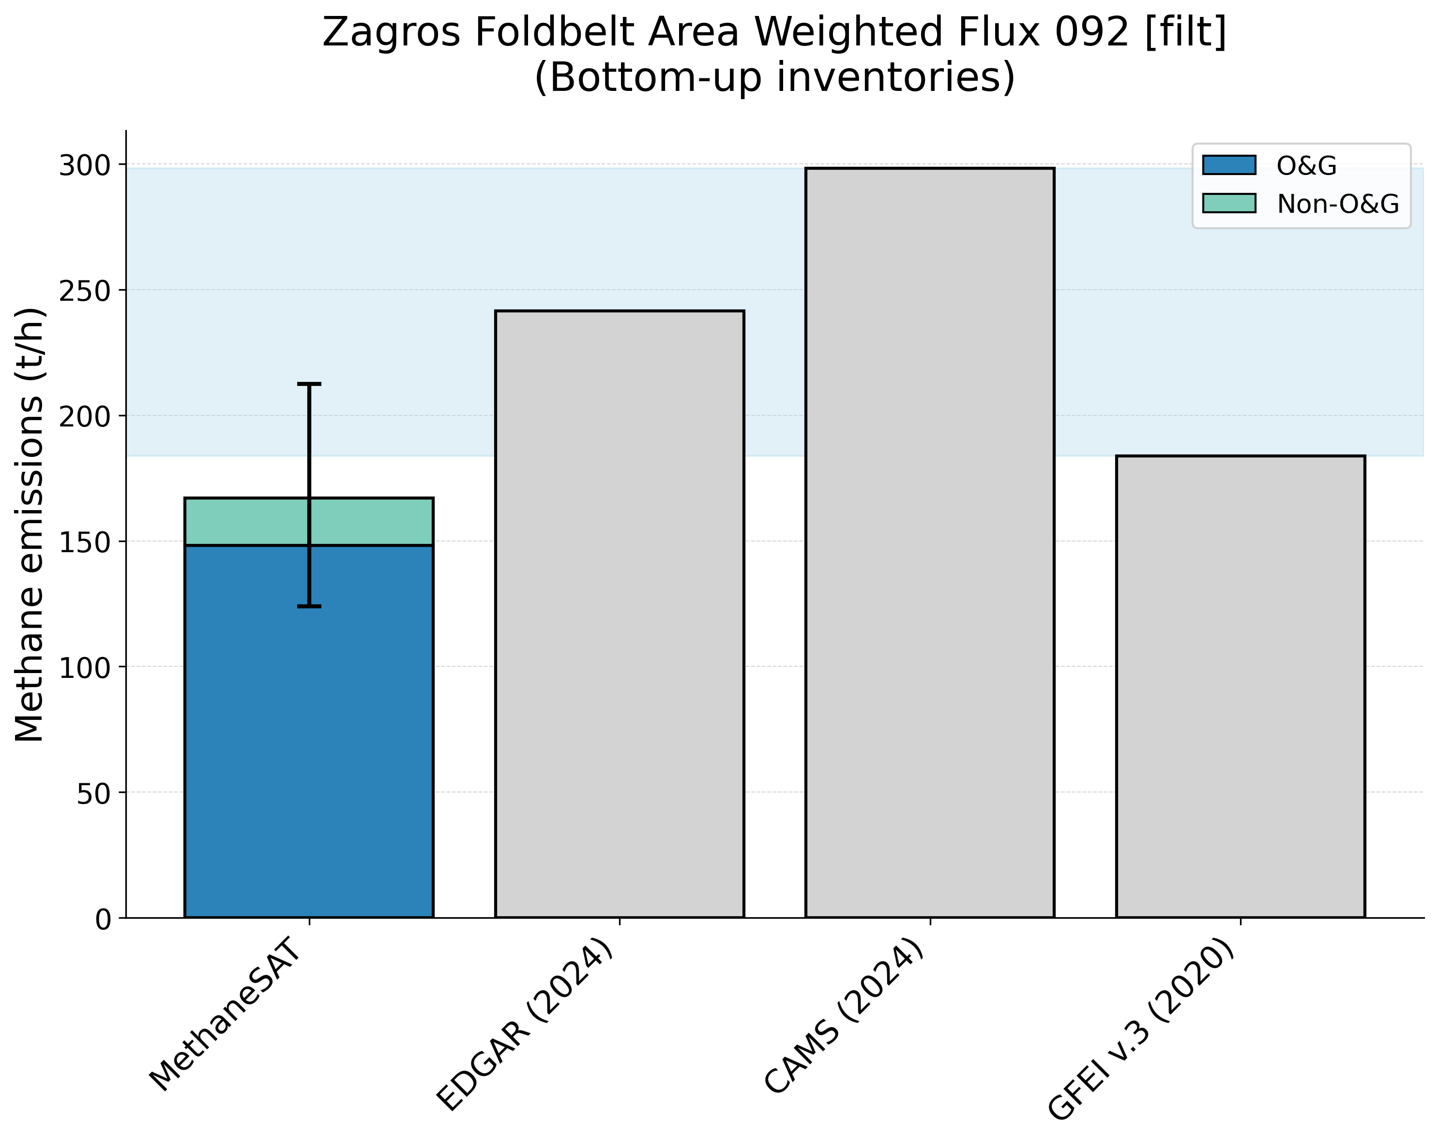
Supplementary Figure 41. Comparison of MethaneSAT total methane emissions estimates with peer-reviewed “top-down” measurements (top panel) and “bottom-up” inventory data (bottom panel). The shaded area shows the representative range of the peer-reviewed data (2.5th, 97.5th percentiles). Zagros Foldbelt, Iran (IRN) region.

References
- Shen et al. Unravelling a large methane emission discrepancy in Mexico using satellite observations. Remote Sens. Env. 260, 112461, https://doi.org/10.1016/j.rse.2021.112461 (2021)
- East, J.D., Jacob, D.J., Jervis, D. et al. Worldwide inference of national methane emissions by inversion of satellite observations with UNFCCC prior estimates. Nat Commun 16, 11004 (2025). https://doi.org/10.1038/s41467-025-67122-8
- Seymour, S.P. et al. Methane intensity metrics: unmasking the trade-offs. [Preprint] https://doi.org/10.21203/rs.3.rs-6753363/v1 (2025)
- Scarpelli, T. R. et al. Using new geospatial data and 2020 fossil fuel methane emissions for the Global Fuel Exploitation Inventory (GFEI) v3. Earth Syst. Sci. Data, 17, 7019–7033, https://doi.org/10.5194/essd-17-7019-2025, 2025.
- Chen, Z. et al. Methane emissions from China: a high-resolution inversion of TROPOMI satellite observations, Atmos. Chem. Phys., 22, 10809–10826, https://doi.org/10.5194/acp-22-10809-2022, 2022.
- Chen, Z. et al. Satellite quantification of methane emissions and oil–gas methane intensities from individual countries in the Middle East and North Africa: implications for climate action, Atmos. Chem. Phys., 23, 5945–5967, https://doi.org/10.5194/acp-23-5945-2023, 2023.
- Climate Trace, Comprehensive Emissions Insight. Available online at https://climatetrace.org/.
- Hancock, S.E. et al. Satellite quantification of methane emissions from South American countries: a high-resolution inversion of TROPOMI and GOSAT observations, Atmos. Chem. Phys., 25, 797–817, https://doi.org/10.5194/acp-25-797-2025, 2025.
- Western, L. Estimates of North African methane emissions from 2010-2017 using GOSAT observations, https://doi.org/10.17605/OSF.IO/CDAE3
- Worden, J.R. et al. The 2019 methane budget and uncertainties at 1° resolution and each country through Bayesian integration Of GOSAT total column methane data and a priori inventory estimates, Atmos. Chem. Phys., 22, 6811–6841, https://doi.org/10.5194/acp-22-6811-2022, 2022.
- van der Gon, H.D. et al. Documentation of the CAMS emission inventory products. Available online at https://atmosphere.copernicus.eu/node/1054 , https://doi.org/ 10.24380/q2si-ti6i (2023)
- Crippa, M. et al. Insights into the spatial distribution of global, national, and subnational greenhouse gas emissions in the Emissions Database for Global Atmospheric Research (EDGAR v8.0), Earth System Science Data, 16, 2811–2830 (2024), https://doi.org/10.5194/essd-16-2811-2024
- Lu, X. et al. Observation-derived 2010-2019 trends in methane emissions and intensities from US oil and gas fields tied to activity metrics. PNAS, https://doi.org/10.1073/pnas.2217900120 (2023)
- Maasakkers, J. D. et al. Gridded Inventory of Annual 2012–2018 U.S. Anthropogenic Methane Emissions, Environ. Sci. Technol., 57, 16276–16288 (2023), https://doi.org/10.1021/acs.est.3c05138.

