Supplemental Figure 1. Overall age adjusted mortality rates in the United States for 1999 to 2020 *Indicates the APC is significantly different from 0.
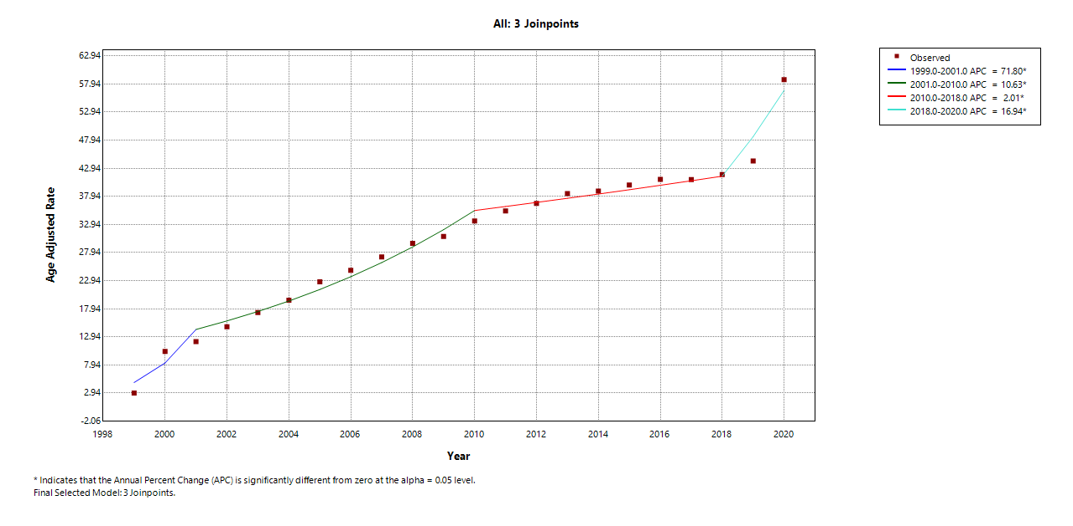
Supplemental Figure 2. Age adjusted mortality rates stratified by gender in the United States for 1999 to 2020 *Indicates the APC is significantly different from 0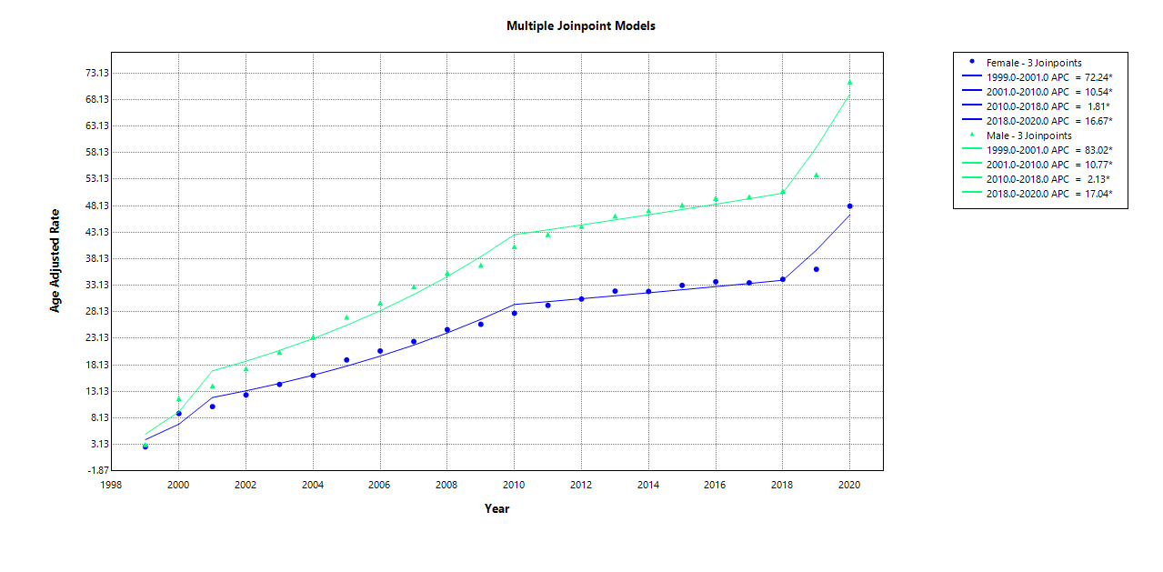

Supplemental Figure 3. Age-adjusted mortality rates stratified by race/ethnicity in the United States for 1999 to 2020 *Indicates the APC is significantly different from 0
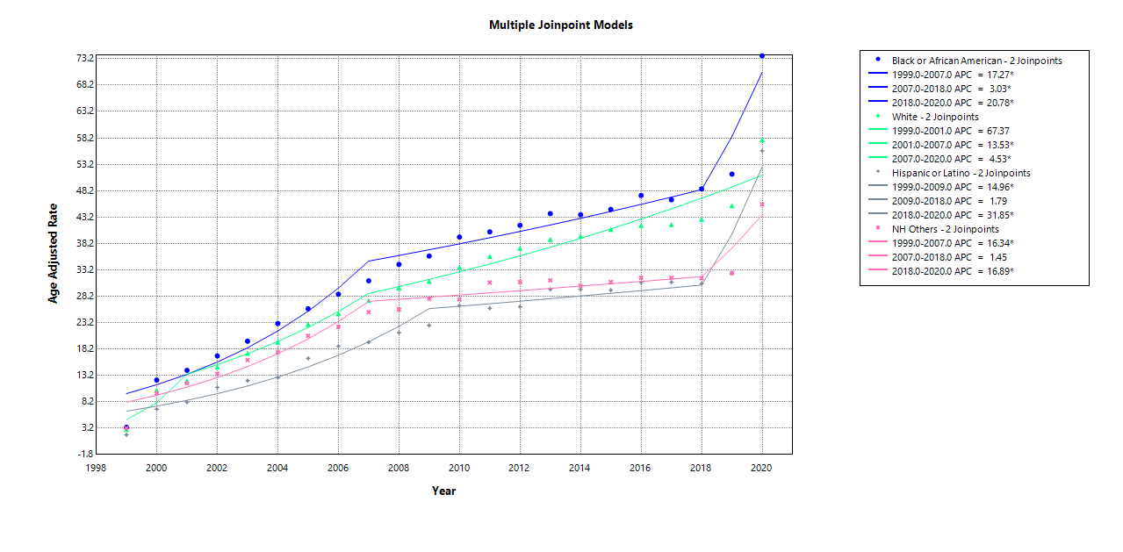
Supplemental Figure 4. COPD-STROKE mortality stratified by census region in the United States from 1999 - 2020