Supplementary Materials：
Figure S1 Time trends of key healthcare expenditure indicators during the COVID-19 pandemic, stratified by cost component.
CPH
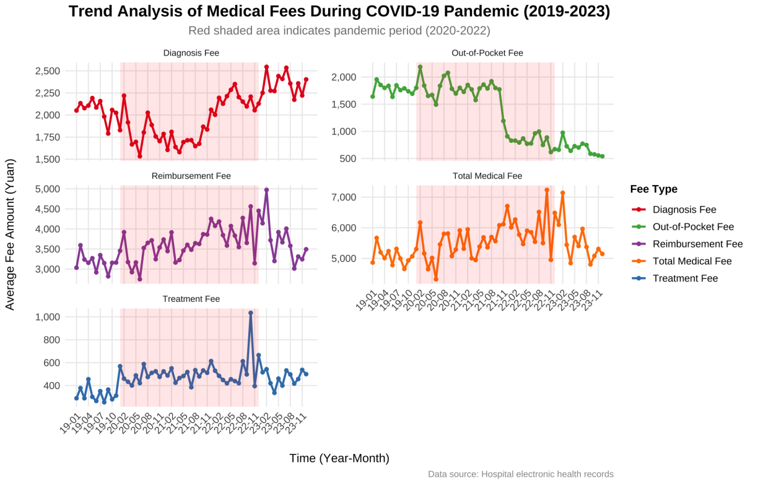
TCMH
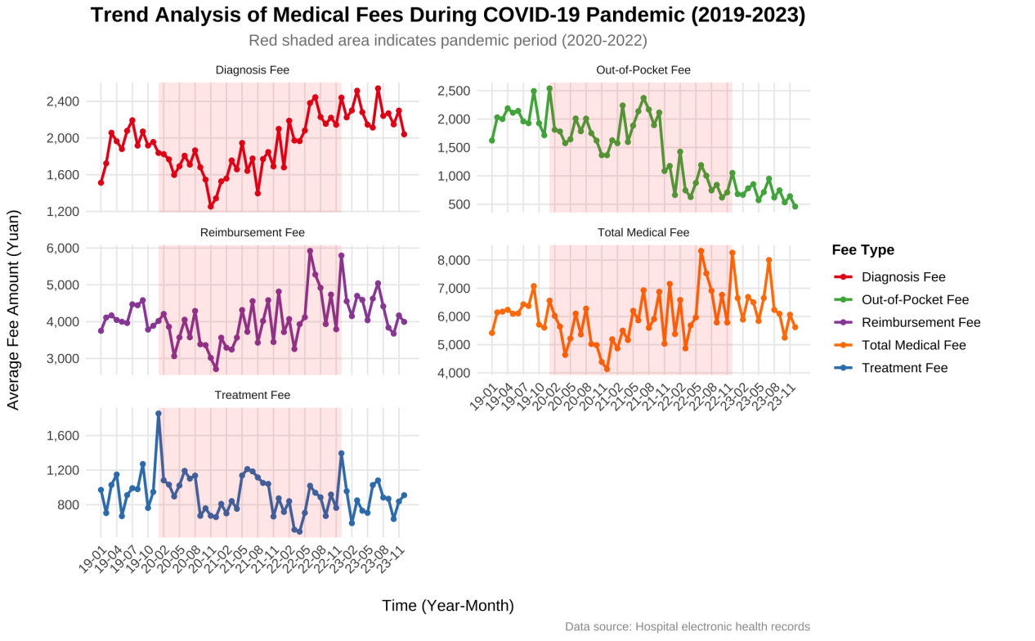

Figure S2 Temporal Trends of Multiple Healthcare Expenditure Indicators During the COVID-19 Pandemic (2019–2023): A Stratified Analysis by Cost Component
CPH
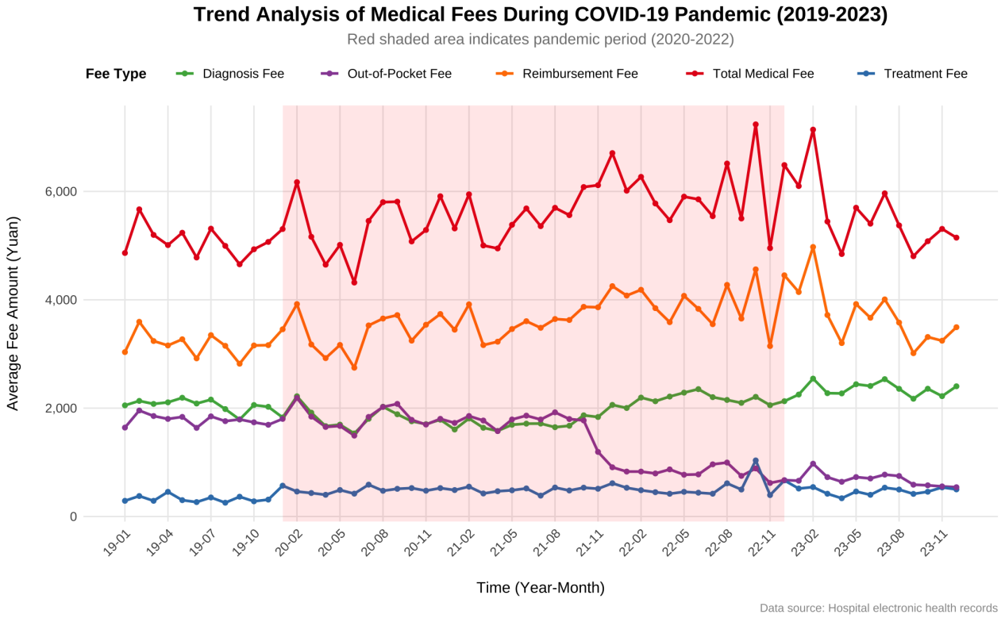
TCMH
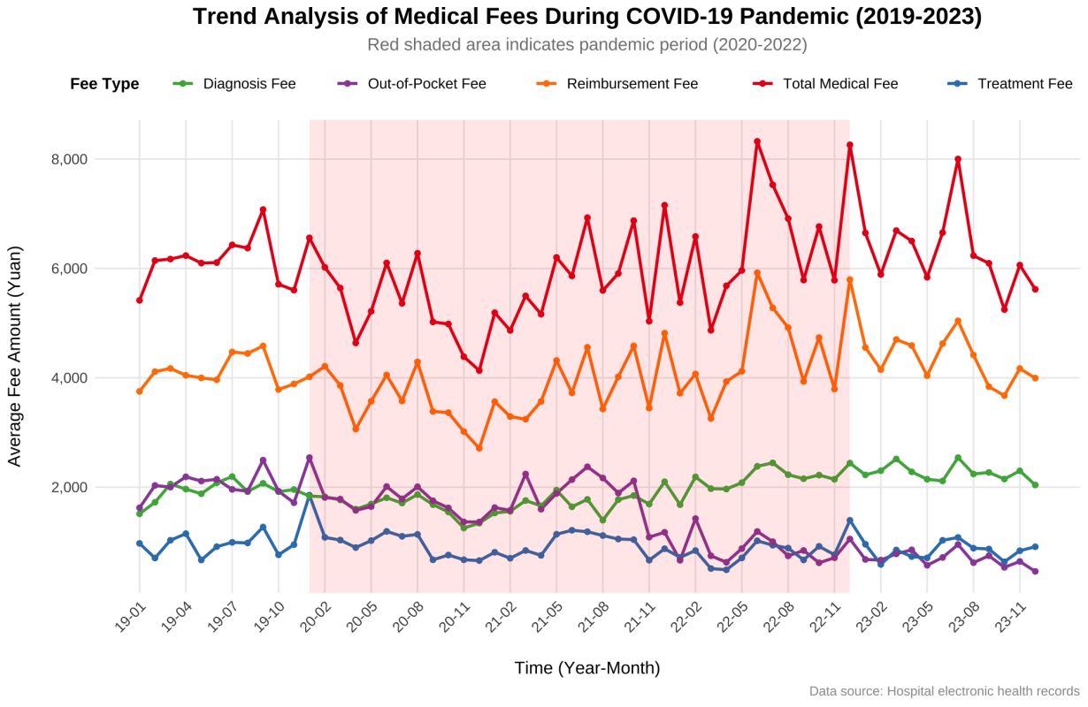

Table S 1 Variable Definitions and Justifications
Variable | Definition | Concept Proxied (with References)
Per-Visit Hospitalization Expenditure | Average hospitalization expenditure per inpatient visit | Reflects overall hospitalization expenditure level and hospital cost control performance
Diagnose Fee | Total expenditure on diagnostic examinations and testing procedures | May reflect diagnostic resource utilization and healthcare service patterns
Treatment Expenditure | Total expenditure on therapeutic and procedural services | Reflects treatment intensity, technical complexity, and healthcare service delivery capacity
Out-of-Pocket Payment | Portion of hospitalization expenditure paid directly by patients after insurance reimbursement | Reflects patients’ financial burden and the effectiveness of financial protection mechanisms
Actual Reimbursement Amount | Amount reimbursed by the medical insurance fund | Reflects insurance coverage and healthcare fund expenditure
Total ACSC-related Expenditure | Total inpatient expenditure for ACSC-related hospitalizations | Reflects the economic burden associated with potentially preventable hospitalizations and healthcare system efficiency

