Supplementary Information
Traffic density and noise shape wildlife movement in the city: insights from modeling blackbird connectivity in a dense city
Journal: Landscape Ecology
Authors: Meret Pundsack₁*, Lisa Merkens₁, Damien Gourmelon₂, Wolfgang W. Weisser₁, Anne Mimet₂
Affiliations
* Corresponding author
¹ Terrestrial Ecology Research Group, Department for Life Science Systems, TUM School of Life Sciences, Technical University of Munich, Freising, Germany
² BIODIVAG, Université d’Angers, Angers, France
Corresponding author e-mail and phone: meret.pundsack@tum.de
- Supplementary Methods
  - Parametrization of Resources
To compute the resource map (stage 2.1), we extended the approach by Merkens et al. (2026) by applying a Principal Component Analysis (PCA) on the proportion of the different vegetation types before running the Classification and Regression Trees (CARTs) (Fig. S1). This step was added to capture and account for spatial correlation among the proportion of the vegetation types, which we identified as causing instability in the structure of the CARTS and obscuring the importance of certain resource types for blackbird presence. With the inclusion of the PCA, the revised resource parametrization now comprises three additional steps before the CARTS are computed (Fig. S1).
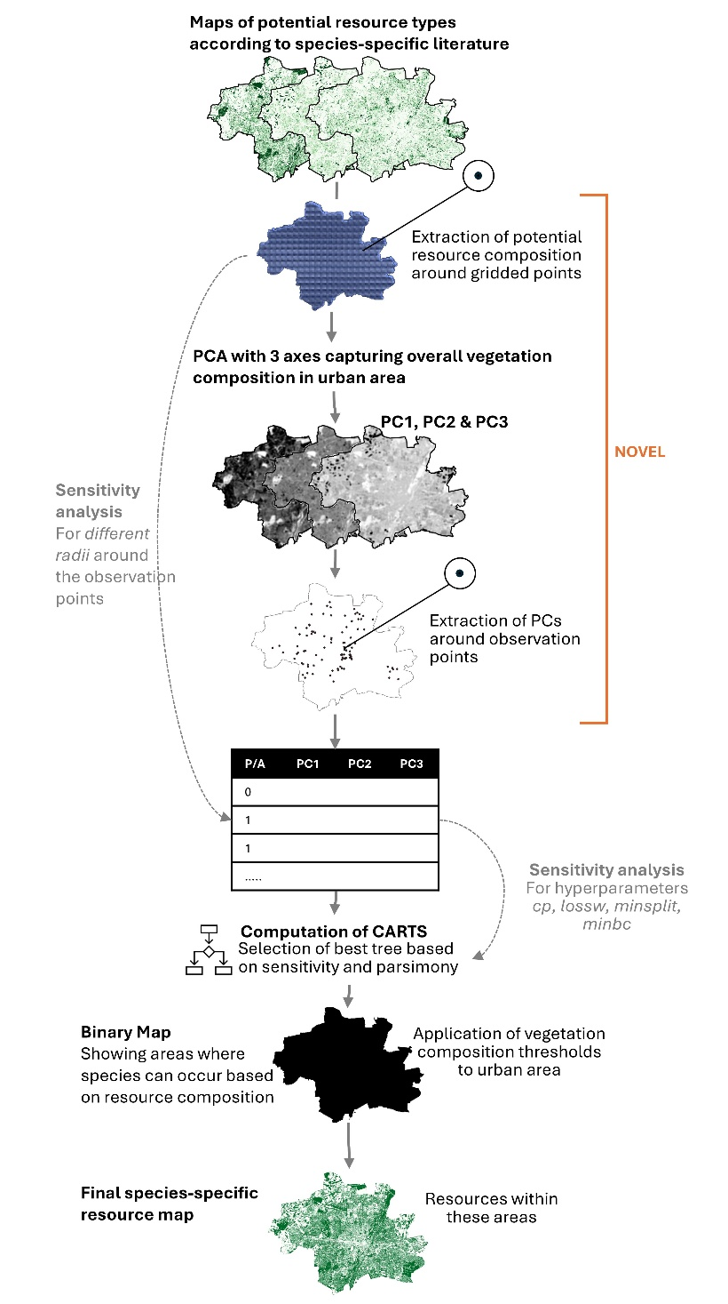
Fig. S1. Conceptual overview of resource parametrization through raster PCA and CARTS based on observational occurrence data. Approach based on Merkens et al. (2026), extended by the PCA. This overview provides a more detailed depiction of stage 2.1, the Resource Parametrization of the urban connectivity model framework shown in Fig. 1 of the main manuscript.
We ran the raster PCA on three a priori-selected land cover types considered potential resources for blackbirds: trees, shrubs, and grass, which provide foraging habitat, shelter, and breeding sites (Schlindwein et al., 2024). The PCA captured overall vegetation heterogeneity across Munich, comprising the three resource layers into three principal components (PC1-PC3).
We then used CARTs (Breiman et al., 1984; Steinberg, 2009) on the PCA components to identify which vegetation composition (PC1-PC3) best predicted blackbird presence/absence (target variable) in Dataset 1. After computing the CARTS, we selected the best decision tree based on the highest sensitivity, accuracy, and lowest parsimony (highest cp, lowest lossw, highest minsplit, and minbc) (Table S1). Sensitivity (the ability to correctly predict presences) was prioritised as the primary selection criterion to ensure that the minimum amount of resources required for blackbird presence was accounted for, reducing the risk of excluding resources that blackbirds depend on. We applied the identified minimum resource thresholds from the best decision tree to Munich's land cover data. Areas meeting these thresholds were classified as generally suitable for blackbirds and resources within were in a subsequent step included in the final resource map (Fig. S1).
Table S1. Hyperparameters set and tested for Classification and Regression Trees (CARTS). Values in bold in the column configurations tested indicate the upper end of the range of values preferred for the highest parsimony of resulting decision trees.
Hyperparameter | Description | Configuration tested
Complexity parameter (cp) | Controls tree complexity by setting the minimum improvement in model fit required for a split to occur; higher values produce simpler trees | 0.05, 0.01, 0.001
Split rule | Defines the statistical criterion used to evaluate and select the best split at each node | gini
Loss weight (lossw) | Penalizes false negatives (missed presences) more heavily than false positives | 1, 5, 10
Minimum bucket size (minbc) | Sets the minimum number of observations required in a terminal node (leaf) | 5 - 12
Minimum split size (minsplit) | Sets the minimum number of observations required in a node before a split is attempted | 5 - 12
To ensure that our identified vegetation thresholds predicting blackbird occurrences were robust, we conducted a sensitivity analysis (Cariboni et al., 2007). As part of our sensitivity analysis, we tested eight spatial scales (radii) ranging from 51 to 170 m, representing 30 % to 100 % of the maximum blackbird home range size in 10 % increments (Ottaviani et al., 2006) to extract vegetation composition fed into the PCA and CARTS. We also tested different values of the hyperparameters including the complexity parameter (cp), split rules, minimum split size (minsplit), minimum bucket size (minbc), and loss weight (lossw), following Zohman et al. (2014). In line with our objective of achieving high sensitivity, we tested higher loss weights prioritising sensitivity over specificity (the ability to correctly predict absences), ensuring that all resources the blackbird depends on are captured (Table S1).
This resource map defined the habitat patches subsequently linked by least-cost paths in the urban connectivity modeling framework. All analyses were conducted in R v. 4.4.3 (R Core Team, 2020) using packages rpart (CART construction) (Therneau et al., 2015), rpart.plot (tree visualization) (Milborrow, 2026), and caret (cross-validation and model evaluation) (Kuhn et al., 2024).

  - Parametrization of Resistances
As part of stage 2.3 of the connectivity modeling framework, resistance maps are created to create the connectivity models. The steps to create the resistance sets including prior data processing as well as how the connectivity models are created are described below.
Traffic data
We used TomTom data (https://www.tomtom.com/) to depict traffic densities on the traffic infrastructure in Munich. TomTom uses in-vehicle sensors to provide a comprehensive picture of traffic, including average speed and congestion levels on traffic infrastructure, which they make available via the TomTom move portal. We utilized the vehicle hits, i.e., the counts of vehicles on each street transect, and conducted preprocessing to utilize them as relative traffic densities in our connectivity modeling framework.
We filtered out tunnel street transects by using auxiliary OpenStreetMap (OSM) data on tunnels extracted with the osmnx package v. 2.1.0 (Boeing, 2017) in Python v. 3.13.3. In case of street transects being flagged as tunnels and thus not presenting a potential on-ground barrier, the street transects and their traffic densities were thus deleted from the dataset using ArcGIS Pro v. 3.5.2. We equally buffered the roads based on their width observed in the urban landscape of Munich. Here, we buffered by a total width ranging from 2 to 10 meters, depending on road type. To avoid artificially inflating the barrier effect of traffic density on street types with a larger street width, such as Motorways, the traffic density per street transect was divided by its assigned buffer width. In this way, the street's spatial extent is reflected in its ground land cover; however, traffic density is not distorted by this aspect.
Before rasterizing the data, we accounted for potential discontinuities that may arise from converting linear elements to a raster format. These discontinuities could hamper the accurate depiction of barriers, leading to false gaps. We used the Remove Overlap (multiple) geoprocessing tool with the Thiessen method in ArcGISPro v. 3.5.2 (Esri, 2025), which divides overlapping polygons (in this case, our buffered street transects) into straight-line segments, assigning approximately equal areas to each street segment. In this way, we ensure that no traffic density prioritization, which might bias our results, is pursued. We then rasterized the dataset to a 10 m spatial resolution in Python using the rasterio package v. 1.4.3 (Gillies et al., 2025).
Creating Traffic Density Resistance Sets
To transform the processed traffic density datasets into resistances, we converted the densities using two different functions. These functions capture different assumed reactions to the barrier's impact on traffic density on the common blackbird.
A. Logistic growth transformation to test graduated sensitivity to threshold sensitivity
$f(h) =10+990×(\frac{1-e^{(-c×h)}}{1-e^{(-c)}})$ (1)
Where h is the normalized traffic density, k is the factor determining the steepness of the curve, and f(h) is the resistance value attributed to it. We set c = 0.25, 3, or 8 to capture different behavioral scenarios: at c = 0.25, we assume proportional avoidance where resistance increases gradually across all traffic density levels; c = 3 assumes an intermediate sensitivity to traffic; c = 8, assumes a threshold-like barrier impact where low-to-moderate traffic poses relatively little resistance but high traffic densities become strong barriers to movement (Fig. 2).
B. Exponential growth transformation to test low to medium sensitivity to traffic
$f(h)=e^{(k×h)}$ (2)
where k is a factor determining the steepness of the slope, here k=3, and 8. The exponential transformations represent scenarios where we assume minimal avoidance of low-to-moderate traffic, with resistance increasing substantially only at the highest traffic densities. As k increases, this delayed response pattern becomes more pronounced (main manuscript, Fig. 3).
The selection of these k and c values allows us to test a wide range of potential behavioral responses: from near-proportional sensitivity across all traffic levels (c = 0.25, k = 3) to strong threshold responses where only high traffic densities substantially impede movement (c = 8, k = 8). Based on the transformation function, resistance values ranging from 10 to 1000 were assigned to each street transect according to its traffic density (main manuscript, Fig. 1). We used Python v. 3.13.3 and the packages rasterio v. 1.4.3 (Gillies and contributors, 2025), numpy v. 2.2.5 (Harris et al., 2020) and matplotlib v. 3.10.3 (Hunter, 2007) to apply and visualize the transformation functions to our traffic density data.
Noise Data
We used modeled road noise to account for traffic infrastructure noise, obtained from the German Aerospace Center (DLR), which produced a high-resolution road noise map for Germany based on strategic urban noise maps (https://geoservice.dlr.de/web; Staab et al., 2025). The data are available as raster data at 10 m spatial resolution, depicting traffic noise in 2017 and its propagation based on adjacent geometries and structures. Noise is expressed by the indicator L_{den}, in dB(A), which averages noise over the entire day, weighting evening and night noise as more severe (Directive 2002/49/EC), and classified into six noise level classes between ≤55 dB(A) and ≥75 dB(A) in 5 dB(A) intervals.
These data were produced as part of an EU directive requiring noise level assessment to map and identify noise priority areas within urban areas (Kephalopoulos et al., 2012). While other studies used actual noise measurements to explore the impact of noise on wildlife (Parris and Schneider, 2009), modeled noise data adjusted for the human ear has the advantage of being available for all major European cities, enabling replication of this framework across cities.
  - Parameters for Constructing Landscape Graphs
To model the connectivity of the urban landscape for the common blackbird, we constructed the landscape graphs (the set of nodes and links connecting the latter) based on the resource map and the different resistance sets by using graph4lg package (Savary et al., 2023) in R v. 4.4.3 that establishes an interface to the Graphab software v. 2.8 (Foltête et al., 2021). This reflects part of stage 2.3 of the connectivity modeling framework. Since we employed a cell-based approach to model daily movements, each resource cell identified in stage 2.1 was represented by a node. To prune the least-cost path links between these resource nodes, we tested different daily movement distances (j), namely 30, 60, 90, and 150 meters, based on literature on the common blackbird (Cresswell, 1999; Ferry et al., 1981; Török and Ludvig, 1988). In total, we thus built four connectivity models per resistance set (251 sets), totalling to an amount of 1004 connectivity models. Because we tested two different approaches for combining the resistance sets, namely maximum resistance value assignment and summing up resistance values, we finally compared 1717 connectivity models. All connectivity models were created following the parameters depicted below (Table S2).
Table S2. Graphab parameters to compute the landscape graphs via graph4lg following Merkens et al. (2026)
graph4lg function | Parameter | Reasoning
graphab_project | maxsize = 10 | The maximum size of habitat patches is set to 10, the resolution of the resource map, to make it a cell-based connectivity model
Graphab_linkset | topo = “planar” | Topology set to planar to facilitate visualization
Graphab_linkset | distance = “cost”  cost = resistance map | Cost values are imported from the resistance map utilizing single-factor, two-factor, and multi-factor resistance sets
Graphab_graph | thr = cost-converted 30, 60, 90, and 150 meters | Threshold to prune links that exceed the maximum movement distance of Turdus merula within their daily movements, the cost-converted distance is taken (the mean cost aggregated when moving through the landscape)
Graphab_metric | prob = 0.01 | Describes the probability of movement between patches, so that the maximum dispersal distance of the species is taken
Graphab_metric | beta = 1 | Describes the patch capacity and was set to 1 to not give further weight to patches
Graphab_metric | k = “BC” | Describes computed connectivity metric
  - Specifications on Statistical Models
GLMM for Model Selection
As described in the main manuscript, we fit Generalized Linear Mixed Models (GLMMs) to compare the suitability of the computed connectivity models for predicting blackbird movement. We generated GLMMs with a binomial distribution and a logit link function using the lme4 package in R v. 4.4.3 (Bates et al., 2015). Model diagnostics, including spatial autocorrelation, overdispersion, zero inflation, and homoscedasticity, were assessed via DHARMa (Hartig et al., 2024).
Models were ranked by AIC (low-to-high), and models with ΔAIC ≤ 2 were considered equally supported (Sutherland et al., 2023). Based on these models and their corresponding resistance sets, along with maximum movement distances, the parametrized connectivity model was created.
GLM for Model Validation
To validate our parametrized connectivity model’s ability to predict blackbird movement (dataset 3), we fit a Generalized Linear Model (GLM). This has been described in detail in the main manuscript; here, we lay out technical details. We generated the model in R v. 4.4.3 using the base R glm() with a binomial distribution and a logit link function. Model diagnostics were again assessed using the DHARMa package (Hartig et al., 2024). The performance of the GLM, and thus the final connectivity map, was evaluated using pseudo-R² and connectivity-predictor significance (p < 0.05).
  - Code for Implementing the Methods
The code to perform the resource map creation based on the raster PCA and the CARTS can be found in the supplementary code file: ResourceParametrization.R
The code to apply the traffic transformation functions to apply the create resistance sets can be found in the supplementary script: TrafficResistanceSets.py
The code to combine the different resistance sets into single-factor, two-factor, and multi-factor resistance sets can be found in: ResistanceSetCombination.py
The code to compute and parametrize the connectivity models based on species-specific knowledge as well as the validation of the parametrized connectivity model, can be found here: ModelSelectionandValidation.R
- Supplementary Results
  - Complete Resource Parametrization Results
The fitted CART that best predicts blackbird presence/absence used a vegetation extraction radius of 51 m to identify the vegetation composition required for blackbird presence (hyperparameters: minsplit = 12, minbucket = 10, cp = 0.05, lossw = 10). The fitted tree achieved an overall accuracy of 0.77, with high sensitivity (0.97), meaning accurate identification of blackbird presences. This high sensitivity is particularly relevant at this stage of the connectivity modeling framework, as the goal is to identify resource requirements for the common blackbird to be present (Fig. S2b).
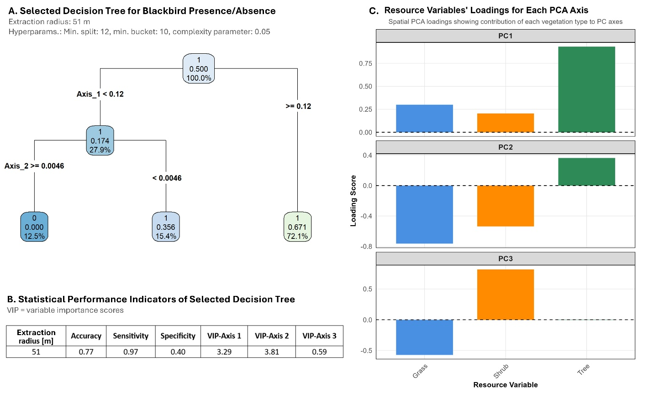
Fig. S2. Selected decision tree for blackbird presence/absence (a), statistical performance indicators of selected decision tree (b), and corresponding resource variables PCA loadings (c).
The fitted decision tree’s structure (A) revealed that Axis 1 (PC1) of the raster PCA was the primary splitting variable (threshold: 0.12), with most observations (72.1 %) classified into the right branch, where blackbird presence probability was 0.671. Examination of the PCA loadings revealed that PC1 was dominated by tree cover, with smaller positive contributions from grass and shrubs (Fig. S2C).
Among the remaining 27.9 % of observations falling below this threshold, Axis 2 (PC2) further discriminated presence from absence: locations with PC2 scores ≥ 0.0046 showed zero predicted presence probability (12.5 % of total observations), while those below this threshold retained a moderate presence probability of 0.356 (15.4 % of observations). PC2 showed contrasting loadings, with tree cover loading positively while grass and shrub loaded negatively, suggesting this axis captured a gradient between tree-dominated and open/shrubby habitats
Variable importance scores indicated that PC2 contributed most strongly to model performance (VIP = 3.81), followed by PC1 (VIP = 3.29), while PC3 had negligible importance (VIP = 0.59). Together, these results suggest that blackbird presence was most strongly associated with high tree cover but also influenced by the contrast between tree-dominated and open or shrubby habitats (PC2), as reflected by the high importance of both PC1 and PC2. Notably, since all three vegetation types contributed to the two most important PCA axes for the selected decision trees, these results indicate that all three potential resources should be considered as relevant resources for the common blackbird rather than excluding grass as done in Merkens et al. (2026).
To further assess whether this decision was justified, we compared connectivity models based on both resource maps, one excluding grass and the other one considering all three potential resource types, and statistically compared their performance as done in Fig. 1, stage 2.3 of the connectivity modeling framework. The results revealed that including grass as a resource led to improved results in terms of predictive ability of our connectivity model for blackbird movement. The findings are reported in the main manuscript.
  - Complete Resistance Parametrization Results
Table S3. Complete statistical results derived from the resistance parametrization based on the Generalized Linear Mixed Model (GLMM) and Dataset 2. Beta-coefficient (coef), their p-values (Pr) and standard error of the beta-coefficient (SE) for each predictor variable, AIC and BIC-values, marginal R² (R²_{m}) and conditional R² (R²_{c}).
- The table is provided in a separate .xls file due to the data size -
Table S4. Parametrized resistance set used to compute the final connectivity model. Geometric mean for resistance values and arithmetic mean for maximum movement distance.
Land cover | R6 | R6 | R6 | R5 | Mean final resistance map
Low Buildings | 100 | 100 | 100 | 100 | 100
Medium Buildings | 100 | 100 | 100 | 1000 | 178
High Buildings | 1000 | 1000 | 1000 | 1000 | 1000
Sealed | 10 | 10 | 10 | 10 | 10
Water | 10 | 10 | 10 | 10 | 10
Agriculture | 10 | 10 | 10 | 10 | 10
Grass | 1 | 1 | 1 | 1 | 1
Shrub | 1 | 1 | 1 | 1 | 1
Tree | 1 | 1 | 1 | 1 | 1
Traffic Density | exp_k8 | exp_k8 | exp_k8 | exp_k8 | exp_k8
Noise  in dB(A) | N3 | N3 | N5 | N5 | N3 & N5
≥ 75 | 100 | 100 | 1000 | 1000 | 316
70 - 75 | 100 | 100 | 1000 | 1000 | 316
65 - 70 | 10 | 10 | 1000 | 1000 | 100
60 - 65 | 10 | 10 | 1000 | 1000 | 100
55 - 60 | 10 | 10 | 10 | 10 | 10
< 55 | 1 | 1 | 1 | 1 | 1
Daily movement distance | 30 | 60 | 60 | 60 | 52

References
Bates, D., Mächler, M., Bolker, B., Walker, S., 2015. Fitting Linear Mixed-Effects Models Using lme4. Journal of Statistical Software 67, 1–48. https://doi.org/10.18637/jss.v067.i01
Boeing, G., 2017. OSMnx: A Python package to work with graph-theoretic OpenStreetMap street networks. Journal of Open Source Software 2, 215. https://doi.org/10.21105/joss.00215
Breiman, L., Friedman, J., Stone, C.J., Olshen, R.A., 1984. Classification And Regression Trees. Taylor & Francis.
Cariboni, J., Gatelli, D., Liska, R., Saltelli, A., 2007. The role of sensitivity analysis in ecological modelling. Ecological Modelling, Special Issue on Ecological Informatics: Biologically-Inspired Machine Learning 203, 167–182. https://doi.org/10.1016/j.ecolmodel.2005.10.045
Cresswell, W., 1999. Travel distance and mass gain in wintering blackbirds. Anim Behav 58, 1109–1116. https://doi.org/10.1006/anbe.1999.1244
Esri, 2025. ArcGIS Pro - Desktop GIS Software.
European Parliament and Council of the European Union, 2002. Directive 2002/49/EC of the European Parliament and of the Council of 25 June 2002 relating to the assessment and management of environmental noise - Declaration by the Commission in the Conciliation Committee on the Directive relating to the assessment and management of environmental noise, OJ L.
Ferry, C., Frochot, B., Leruth, Y., 1981. Territory and Home Range of the Blackcap (sylvia Atricapilla) and Some Other Passerines, Assessed and Compared by Mapping and Capture-recapture. Studies in Avian Biology 6.
Foltête, J.-C., Vuidel, G., Savary, P., Clauzel, C., Sahraoui, Y., Girardet, X., Bourgeois, M., 2021. Graphab: An application for modeling and managing ecological habitat networks. Software Impacts 8, 100065. https://doi.org/10.1016/j.simpa.2021.100065
Gillies, S. and contributors, 2013. Rasterio: geospatial raster I/O for Python programmers. Mapbox. https://github.com/rasterio/rasterio
Harris, C.R., Millman, K.J., Van Der Walt, S.J., Gommers, R., Virtanen, P., Cournapeau, D., Wieser, E., Taylor, J., Berg, S., Smith, N.J., Kern, R., Picus, M., Hoyer, S., Van Kerkwijk, M.H., Brett, M., Haldane, A., Del Río, J.F., Wiebe, M., Peterson, P., Gérard-Marchant, P., Sheppard, K., Reddy, T., Weckesser, W., Abbasi, H., Gohlke, C., Oliphant, T.E., 2020. Array programming with NumPy. Nature 585, 357–362. https://doi.org/10.1038/s41586-020-2649-2
Hartig, F., Lohse, L., leite, M. de S., 2024. DHARMa: Residual Diagnostics for Hierarchical (Multi-Level / Mixed) Regression Models.
Hunter, J.D., 2007. Matplotlib: A 2D Graphics Environment. Comput. Sci. Eng. 9, 90–95. https://doi.org/10.1109/MCSE.2007.55
Kephalopoulos, S., Paviotti, M., Anfosso-Lédée, F., 2012. Common Noise Assessment Methods in Europe (CNOSSOS-EU) [WWW Document]. JRC Publications Repository. https://doi.org/10.2788/32029
Kuhn, M., Benesty, M., Weston, S., Williams, A., Keefer, C., Engelhardt, A., Cooper, T., Mayer, Z., Kenkel, B., R Core Team, Benesty, M., Lescarbeau, R., Ziem, A., Scrucca, L., Tang, Y., Candan, C., Hunt, T., 2024. caret: Classification and Regression Training.
Merkens, L., Bae, S., Eberl, E., Lauppe, E., Mesarek, F., Stauffer-Bescher, D., Hauck, T.E., Weisser, W.W., Mimet, A., 2026. Moving from expert opinion to empirical evidence: Data-driven parametrization of urban connectivity models using movement-proxy data. Landsc Ecol. https://doi.org/10.1007/s10980-026-02332-z
Milborrow, S., 2026. rpart.plot: Plot “rpart” Models: An Enhanced Version of “plot.rpart.”
Ottaviani, D., Cairns, S.C., Oliverio, M., Boitani, L., 2006. Body mass as a predictive variable of home‐range size among Italian mammals and birds.
R Core Team, 2020. R: A language and environment for statistical computing.
Savary, P., Vuidel, G., Rudolph, T., Daniel, A., 2023. graph4lg: Build Graphs for Landscape Genetics Analysis.
Schlindwein, X., Randler, C., Kalb, N., Dvorak, J., Gottschalk, T.K., 2024. Seasonal variation in the diurnal activity pattern of Eurasian blackbirds (Turdus merula) in the forest. J Ornithol 165, 137–146. https://doi.org/10.1007/s10336-023-02096-2
Staab, J., Weigand, M., Schady, A., Droin, A., Cea, D., Dallavalle, M., Nikolaou, N., Valizadeh, M., Wolf, K., Wurm, M., Lakes, T., Taubenböck, H., 2025. National road traffic noise estimation with ensemble learning and multimodal geodata. Transportation Research Part D: Transport and Environment 149, 105063. https://doi.org/10.1016/j.trd.2025.105063
Steinberg, D., 2009. Chapter 10 CART: Classification and Regression Trees.
Sutherland, C., Hare, D., Johnson, P.J., Linden, D.W., Montgomery, R.A., Droge, E., 2023. Practical advice on variable selection and reporting using Akaike information criterion. Proc Biol Sci 290, 20231261. https://doi.org/10.1098/rspb.2023.1261
Therneau, T., Atkinson, B., Ripley, B., Ripley, M.B., 2015. Package ‘rpart.’ Available online: cran. ma. ic. ac. uk/web/packages/rpart/rpart. pdf (accessed on 20 April 2016).
Török, J., Ludvig, É., 1988. Seasonal changes in foraging strategies of nesting blackbirds (Turdus merula L.). Behav Ecol Sociobiol 22, 329–333. https://doi.org/10.1007/BF00295101

