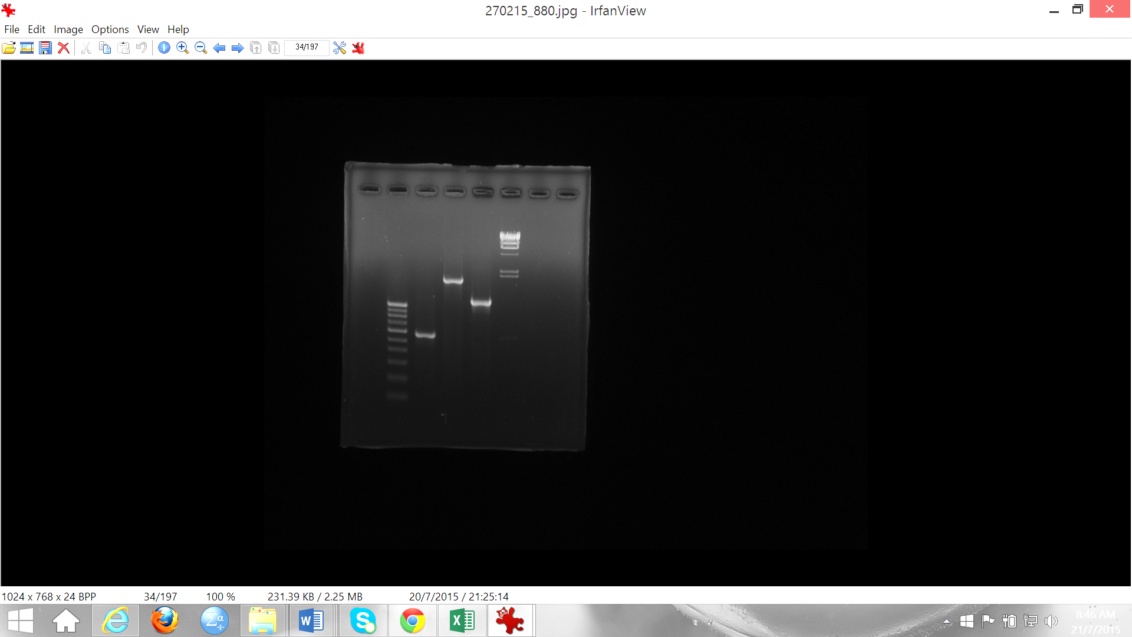
500 bp
600 bp
1000 bp
2027 bp
564 bp
M1 ITS LSU SSU M2

