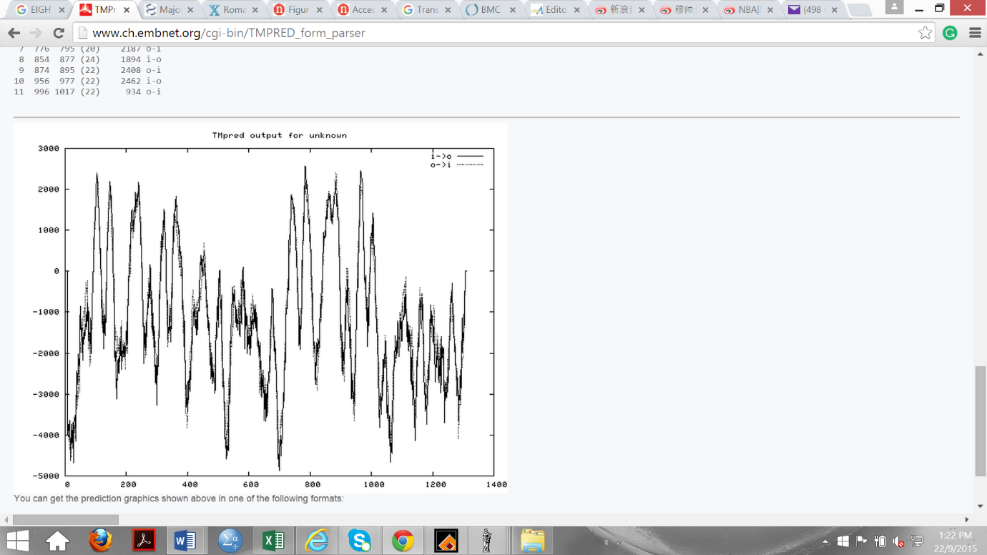
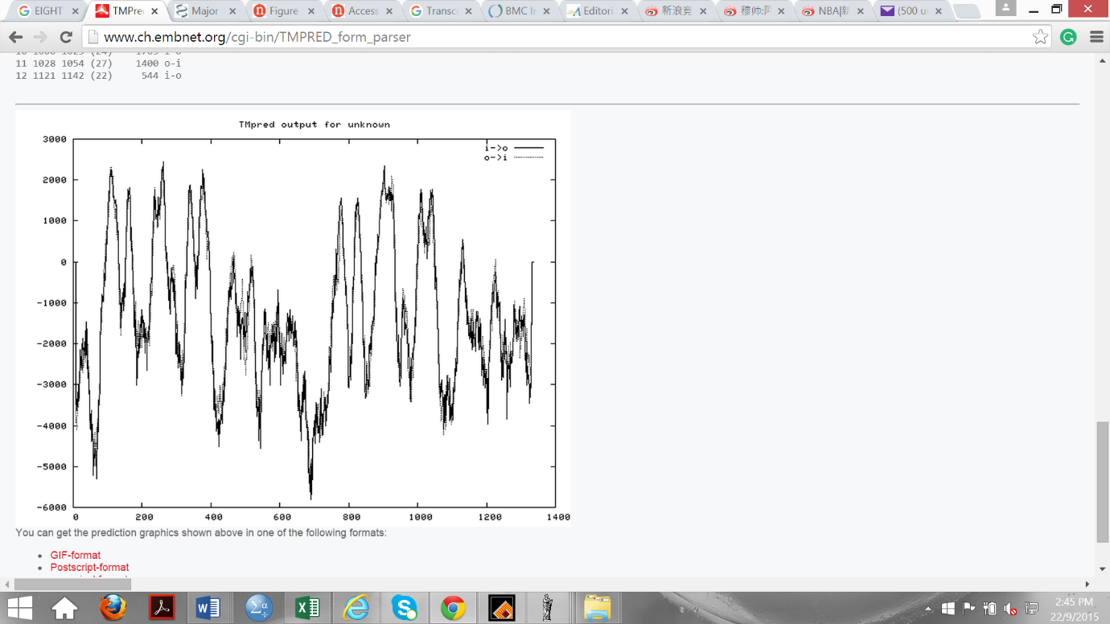
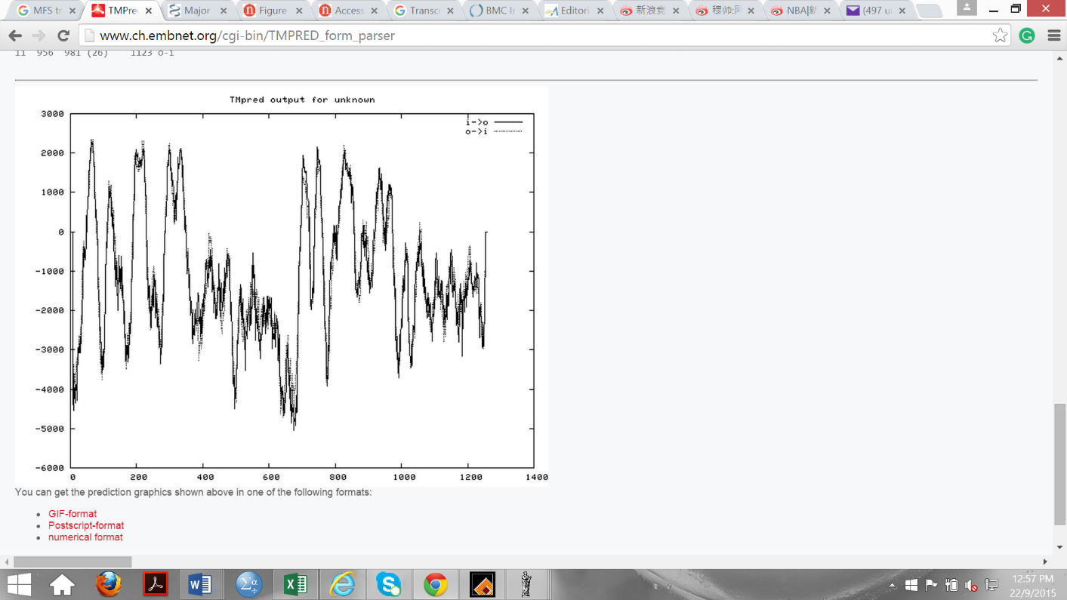
UM880_2808
UM880_9846
XII
XI
X
XI
VII
VIII
VI
V
XI
XII
IX
X
VIII
VII
VI
IV
V
I
II
III
IV
VI
VII
VIII
IX
X
XI
XII
IV
III
II
I
-5000
0
-1000
-2000
-3000
-4000
2000
1000
0
200
400
6000
800
1000
1200
1400
V
III
II
I
UM880_8079
0
200
400
6000
800
1000
1200
1400
0
200
400
6000
800
1000
1200
1400
0
-1000
-2000
-3000
-4000
2000
1000
0
-1000
-2000
-3000
-4000
-5000
2000
1000

