
Associate Professor：Prof. Madya Ts. Dr. Sreetheran Maruthaveeran
Universiti Putra Malaysia
E-mail: sreetheran@upm.edu.my
Highlights
Dear Editor：
• Social media data were used to analyze recreational activities on urban greenways.
• A total of 2,902 Dianping reviews from three Shenzhen greenways were examined.
• LDA–Gibbs topic modeling and NVivo analysis identified key influencing factors.
• Recreational physical activity was shaped by both social and environmental attributes.
• Seasonal and daily variations in greenway usage patterns were revealed.
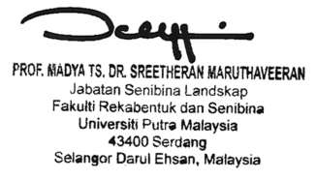

12/5/2026

