Table 1 Patients and Tumor characteristics
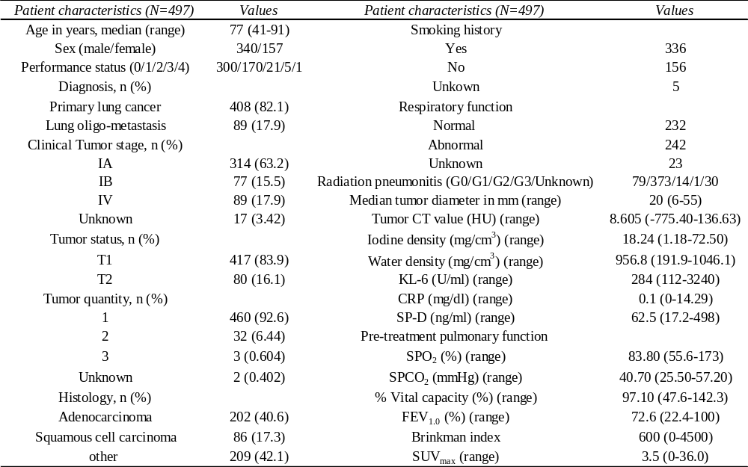

Table 2 Primary Focus
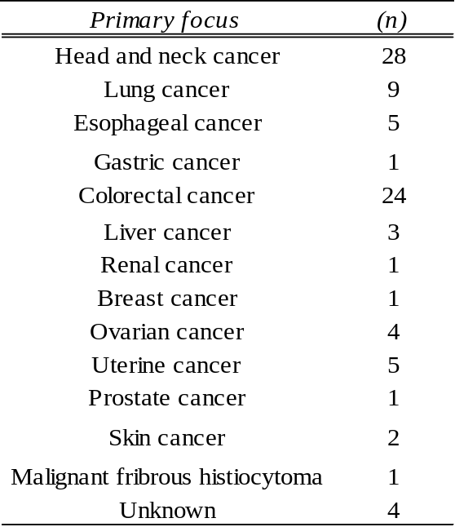

Table 3 Correlation coefficient
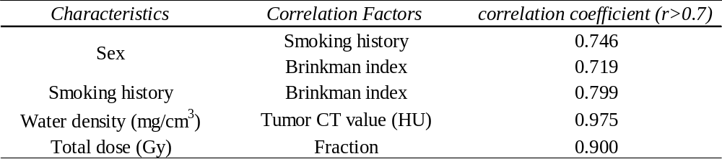
Table 4 Factors related to both OS and LC univariate analysis
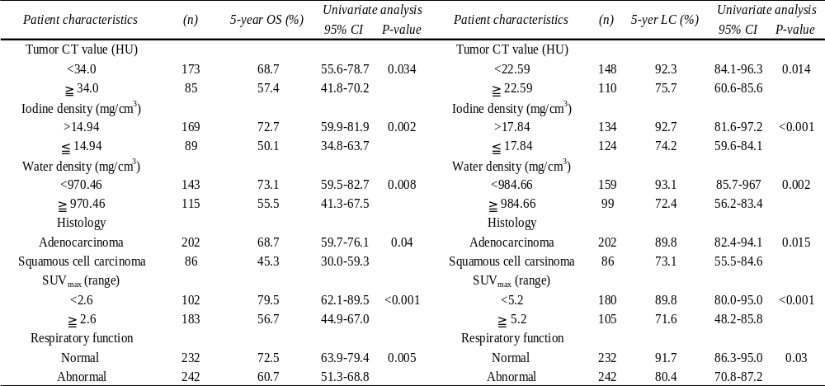
Table 5 Five-year overall survival univariate analysis
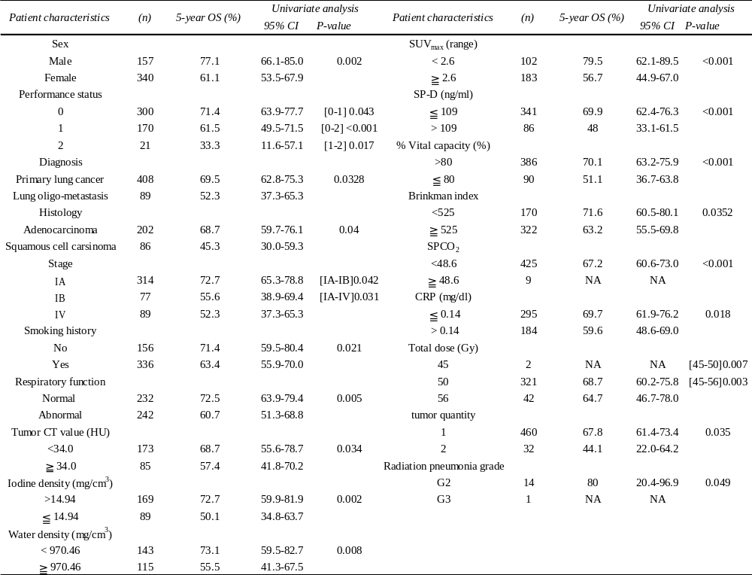
Table 6 Five-year local control univariate analysis
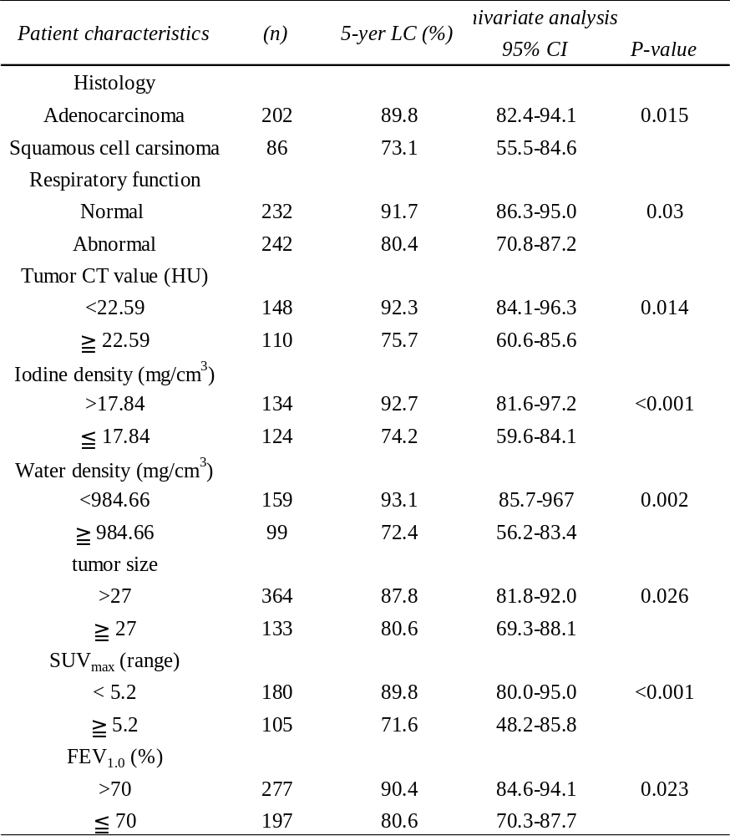

Table 7 Five-year overall survival multivariate analysis
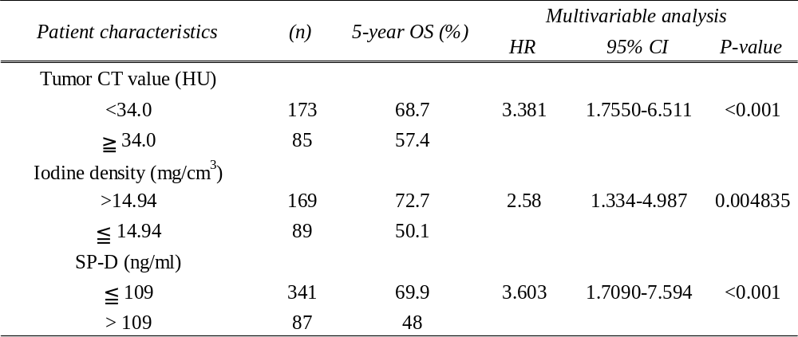
Table 8 Five-year local control multivariate analysis
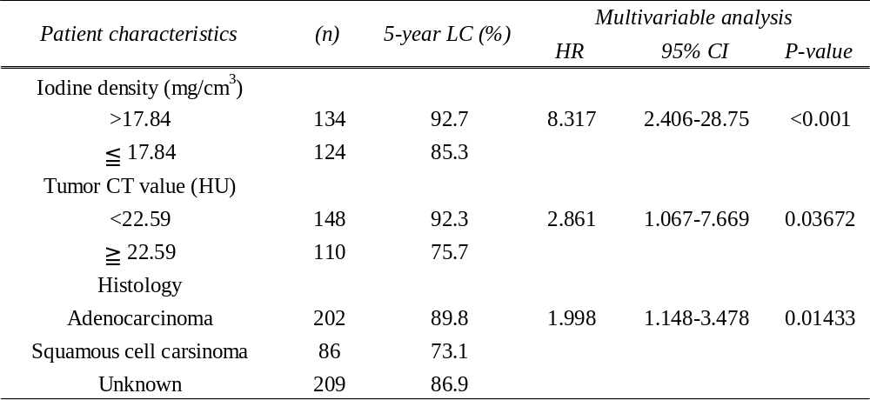
Table 9 Radiation pneumonia grade at SP-D
