Supplementary Files

Rumen-derived Lactococcus lactis bacteriocins inhibit and disrupt Streptococcus biofilms

Arxel Elnar¹, Mylvie Alexis Batican¹, Geun-Bae Kim¹*, Tansol Park¹*
¹ Department of Animal Science and Technology, Chung-Ang University, South Korea

*Corresponding authors:
Tansol Park, Ph.D. (tansol@cau.ac.kr)
Department of Animal Science and Technology, Chung-Ang University,
Anseong (17546), Gyeonggi, South Korea
Telephone: +82-31-670-3256

Geun-Bae Kim, Ph.D. (kimgeun@cau.ac.kr)
Department of Animal Science and Technology, Chung-Ang University,
Anseong (17546), Gyeonggi, South Korea
Telephone: +82-31-670-3027

Supplementary Table 1. Disruption activity of rumen isolate-derived bacteriocins against Streptococcus biofilms.
Isolate | Test Organism¹ | Bacteriocin (Bac) | Nisin  (Nis) | Bac x Nis | Ave | Pooled SEM
RAM-2 | KCTC 3065 | 43.569 | 41.084 | 40.942 | 41.865 | 1.516
RAM-2 | KCTC 5365 | 75.160 | 72.801 | 75.015 | 74.325 | 2.280
RAM-2 | ATCC 25175 | 84.199 | 84.835 | 85.023 | 84.686 | 1.448
RAM-2 | ATCC 700610 | 55.577 | 55.642 | 54.628 | 55.282 | 1.036
RAM-2 | KCTC 3959 | 84.711 | 92.183 | 90.314 | 89.069 | 2.862
RAM-2 | KCTC 21172 | 82.933 | 85.601 | 78.899 | 82.478 | 2.769
RAM-7 | KCTC 3065 | 52.954 | 46.717 | 35.716 | 45.129 | 5.329
RAM-7 | KCTC 5365 | 79.350 | 55.859 | 52.734 | 62.648 | 6.656
RAM-7 | ATCC 25175 | 79.834 | 83.848 | 76.402 | 80.028 | 4.596
RAM-7 | ATCC 700610 | 55.410 | 27.884 | 26.398 | 36.564 | 9.204
RAM-7 | KCTC 3959 | 86.660 | 86.219 | 87.286 | 86.722 | 3.190
RAM-7 | KCTC 21172 | 89.279 | 87.101 | 77.522 | 84.634 | 3.553
RAM-10 | KCTC 3065 | 12.945 | 13.787 | 22.503 | 16.412 | 3.343
RAM-10 | KCTC 5365 | 53.035 | 62.483 | 61.950 | 59.156 | 2.800
RAM-10 | ATCC 25175 | 85.088 | 87.462 | 83.775 | 85.442 | 3.825
RAM-10 | ATCC 700610 | 57.612 | 56.627 | 58.584 | 57.608 | 3.175
RAM-10 | KCTC 3959 | 91.660 | 90.411 | 92.101 | 91.391 | 3.606
RAM-10 | KCTC 21172 | 88.805 | 84.720 | 76.922 | 83.482 | 2.385
¹ KCTC 3065, KCTC 5365, ATCC 25175, and ATCC 700610, are strains of Streptococcus mutans; KCTC 3959, and KCTC 21172 are strains of Streptococcus equinus.
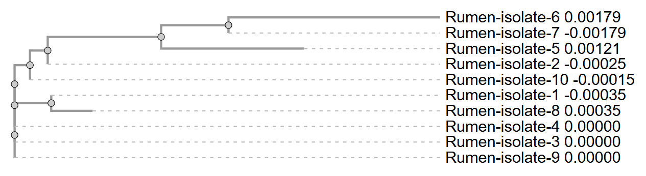
Supplementary Figure 1. Phylogram of the ten rumen isolates based on 16S rRNA gene sequence similarity.
Supplementary Data 1. Sequence alignment of 16S rRNA gene of the ten rumen isolates.
Rumen-isolate-1 --------TGCAGTTGAGCGCTGAGGTTGGTACTTGTACCGACTGGATGAGCAGCGAACG 52
Rumen-isolate-8 CTTATACATGCAGTTGAGCGCTGAGGTTGGTACTTGTACCGACTGGATGAGCAGCGAACG 60
Rumen-isolate-6 -------------------TGGAGGGTTGGTACTTGTACCGACTGGATGAGCAGCGAACG 41
Rumen-isolate-5 -------TGCAAGTTGAGCGCTGAGGTTGGTACTTGTACCGACTGGATGAGCAGCGAACG 53
Rumen-isolate-4 ------CATGCAGTTGAGCGCTGAGGTTGGTACTTGTACCGACTGGATGAGCAGCGAACG 54
Rumen-isolate-3 -----ACATGCAGTTGAGCGCTGAGGTTGGTACTTGTACCGACTGGATGAGCAGCGAACG 55
Rumen-isolate-2 ---------GCAGTTGAGCGCTGAGGTTGGTACTTGTACCGACTGGATGAGCAGCGAACG 51
Rumen-isolate-7 --------------------------------CTTGTACCGACTGGATGAGCAGCGAACG 28
Rumen-isolate-9 ------CATGCAGTTGAGCGCTGAGGTTGGTACTTGTACCGACTGGATGAGCAGCGAACG 54
Rumen-isolate-10 ---------GCAGTTGAGCGCTGAGGTTGGTACTTGTACCGACTGGATGAGCAGCGAACG 51
****************************

Rumen-isolate-1 GGTGAGTAACGCGTGGGGAATCTGCCTTTGAGCGGGGGACAACATTTGGAAACGAATGCT 112
Rumen-isolate-8 GGTGAGTAACGCGTGGGGAATCTGCCTTTGAGCGGGGGACAACATTTGGAAACGAATGCT 120
Rumen-isolate-6 GGTGAGTAACGCGTGGGGAATCTGCCTTTGAGCGGGGGACAACATTTGGAAACGAATGCT 101
Rumen-isolate-5 GGTGAGTAACGCGTGGGGAATCTGCCTTTGAGCGGGGGACAACATTTGGAAACGAATGCT 113
Rumen-isolate-4 GGTGAGTAACGCGTGGGGAATCTGCCTTTGAGCGGGGGACAACATTTGGAAACGAATGCT 114
Rumen-isolate-3 GGTGAGTAACGCGTGGGGAATCTGCCTTTGAGCGGGGGACAACATTTGGAAACGAATGCT 115
Rumen-isolate-2 GGTGAGTAACGCGTGGGGAATCTGCCTTTGAGCGGGGGACAACATTTGGAAACGAATGCT 111
Rumen-isolate-7 GGTGAGTAACGCGTGGGGAATCTGCCTTTGAGCGGGGGACAACATTTGGAAACGAATGCT 88
Rumen-isolate-9 GGTGAGTAACGCGTGGGGAATCTGCCTTTGAGCGGGGGACAACATTTGGAAACGAATGCT 114
Rumen-isolate-10 GGTGAGTAACGCGTGGGGAATCTGCCTTTGAGCGGGGGACAACATTTGGAAACGAATGCT 111
************************************************************

Rumen-isolate-1 AATACCGCATAAAAACTTTAAACACAAGTTTTAAGTTTGAAAGATGCAATTGCATCACTC 172
Rumen-isolate-8 AATACCGCATAAAAACTTTAAACACAAGTTTTAAGTTTGAAAGATGCAATTGCATCACTC 180
Rumen-isolate-6 AATACCGCATAAAAACTTTAAACACAAGTTTTAAGTTTGAAAGATGCAATTGCATCACTC 161
Rumen-isolate-5 AATACCGCATAAAAACTTTAAACACAAGTTTTAAGTTTGAAAGATGCAATTGCATCACTC 173
Rumen-isolate-4 AATACCGCATAAAAACTTTAAACACAAGTTTTAAGTTTGAAAGATGCAATTGCATCACTC 174
Rumen-isolate-3 AATACCGCATAAAAACTTTAAACACAAGTTTTAAGTTTGAAAGATGCAATTGCATCACTC 175
Rumen-isolate-2 AATACCGCATAAAAACTTTAAACACAAGTTTTAAGTTTGAAAGATGCAATTGCATCACTC 171
Rumen-isolate-7 AATACCGCATAAAAACTTTAAACACAAGTTTTAAGTTTGAAAGATGCAATTGCATCACTC 148
Rumen-isolate-9 AATACCGCATAAAAACTTTAAACACAAGTTTTAAGTTTGAAAGATGCAATTGCATCACTC 174
Rumen-isolate-10 AATACCGCATAAAAACTTTAAACACAAGTTTTAAGTTTGAAAGATGCAATTGCATCACTC 171
************************************************************

Rumen-isolate-1 AAAGATGATCCCGCGTTGTATTAGCTAGTTGGTGAGGTAAAGGCTCACCAAGGCGATGAT 232
Rumen-isolate-8 AAAGATGATCCCGCGTTGTATTAGCTAGTTGGTGAGGTAAAGGCTCACCAAGGCGATGAT 240
Rumen-isolate-6 AAAGATGATCCCGCGTTGTATTAGCTAGTTGGTGAGGTAAAGGCTCACCAAGGCGATGAT 221
Rumen-isolate-5 AAAGATGATCCCGCGTTGTATTAGCTAGTTGGTGAGGTAAAGGCTCACCAAGGCGATGAT 233
Rumen-isolate-4 AAAGATGATCCCGCGTTGTATTAGCTAGTTGGTGAGGTAAAGGCTCACCAAGGCGATGAT 234
Rumen-isolate-3 AAAGATGATCCCGCGTTGTATTAGCTAGTTGGTGAGGTAAAGGCTCACCAAGGCGATGAT 235
Rumen-isolate-2 AAAGATGATCCCGCGTTGTATTAGCTAGTTGGTGAGGTAAAGGCTCACCAAGGCGATGAT 231
Rumen-isolate-7 AAAGATGATCCCGCGTTGTATTAGCTAGTTGGTGAGGTAAAGGCTCACCAAGGCGATGAT 208
Rumen-isolate-9 AAAGATGATCCCGCGTTGTATTAGCTAGTTGGTGAGGTAAAGGCTCACCAAGGCGATGAT 234
Rumen-isolate-10 AAAGATGATCCCGCGTTGTATTAGCTAGTTGGTGAGGTAAAGGCTCACCAAGGCGATGAT 231
************************************************************

Rumen-isolate-1 ACATAGCCGACCTGAGAGGGTGATCGGCCACATTGGGACTGAGACACGGCCCAAACTCCT 292
Rumen-isolate-8 ACATAGCCGACCTGAGAGGGTGATCGGCCACATTGGGACTGAGACACGGCCCAAACTCCT 300
Rumen-isolate-6 ACATAGCCGACCTGAGAGGGTGATCGGCCACATTGGGACTGAGACACGGCCCAAACTCCT 281
Rumen-isolate-5 ACATAGCCGACCTGAGAGGGTGATCGGCCACATTGGGACTGAGACACGGCCCAAACTCCT 293
Rumen-isolate-4 ACATAGCCGACCTGAGAGGGTGATCGGCCACATTGGGACTGAGACACGGCCCAAACTCCT 294
Rumen-isolate-3 ACATAGCCGACCTGAGAGGGTGATCGGCCACATTGGGACTGAGACACGGCCCAAACTCCT 295
Rumen-isolate-2 ACATAGCCGACCTGAGAGGGTGATCGGCCACATTGGGACTGAGACACGGCCCAAACTCCT 291
Rumen-isolate-7 ACATAGCCGACCTGAGAGGGTGATCGGCCACATTGGGACTGAGACACGGCCCAAACTCCT 268
Rumen-isolate-9 ACATAGCCGACCTGAGAGGGTGATCGGCCACATTGGGACTGAGACACGGCCCAAACTCCT 294
Rumen-isolate-10 ACATAGCCGACCTGAGAGGGTGATCGGCCACATTGGGACTGAGACACGGCCCAAACTCCT 291
************************************************************

Rumen-isolate-1 ACGGGAGGCAGCAGTAGGGAATCTTCGGCAATGGACGAAAGTCTGACCGAGCAACGCCGC 352
Rumen-isolate-8 ACGGGAGGCAGCAGTAGGGAATCTTCGGCAATGGACGAAAGTCTGACCGAGCAACGCCGC 360
Rumen-isolate-6 ACGGGAGGCAGCAGTAGGGAATCTTCGGCAATGGACGAAAGTCTGACCGAGCAACGCCGC 341
Rumen-isolate-5 ACGGGAGGCAGCAGTAGGGAATCTTCGGCAATGGACGAAAGTCTGACCGAGCAACGCCGC 353
Rumen-isolate-4 ACGGGAGGCAGCAGTAGGGAATCTTCGGCAATGGACGAAAGTCTGACCGAGCAACGCCGC 354
Rumen-isolate-3 ACGGGAGGCAGCAGTAGGGAATCTTCGGCAATGGACGAAAGTCTGACCGAGCAACGCCGC 355
Rumen-isolate-2 ACGGGAGGCAGCAGTAGGGAATCTTCGGCAATGGACGAAAGTCTGACCGAGCAACGCCGC 351
Rumen-isolate-7 ACGGGAGGCAGCAGTAGGGAATCTTCGGCAATGGACGAAAGTCTGACCGAGCAACGCCGC 328
Rumen-isolate-9 ACGGGAGGCAGCAGTAGGGAATCTTCGGCAATGGACGAAAGTCTGACCGAGCAACGCCGC 354
Rumen-isolate-10 ACGGGAGGCAGCAGTAGGGAATCTTCGGCAATGGACGAAAGTCTGACCGAGCAACGCCGC 351
************************************************************

Rumen-isolate-1 GTGAGTGAAGAAGGTTTTCGGATCGTAAAACTCTGTTGGTAGAGAAGAACGTTGGTGAGA 412
Rumen-isolate-8 GTGAGTGAAGAAGGTTTTCGGATCGTAAAACTCTGTTGGTAGAGAAGAACGTTGGTGAGA 420
Rumen-isolate-6 GTGAGTGAAGAAGGTTTTCGGATCGTAAAACTCTGTTGGTAGAGAAGAACGTTGGTGAGA 401
Rumen-isolate-5 GTGAGTGAAGAAGGTTTTCGGATCGTAAAACTCTGTTGGTAGAGAAGAACGTTGGTGAGA 413
Rumen-isolate-4 GTGAGTGAAGAAGGTTTTCGGATCGTAAAACTCTGTTGGTAGAGAAGAACGTTGGTGAGA 414
Rumen-isolate-3 GTGAGTGAAGAAGGTTTTCGGATCGTAAAACTCTGTTGGTAGAGAAGAACGTTGGTGAGA 415
Rumen-isolate-2 GTGAGTGAAGAAGGTTTTCGGATCGTAAAACTCTGTTGGTAGAGAAGAACGTTGGTGAGA 411
Rumen-isolate-7 GTGAGTGAAGAAGGTTTTCGGATCGTAAAACTCTGTTGGTAGAGAAGAACGTTGGTGAGA 388
Rumen-isolate-9 GTGAGTGAAGAAGGTTTTCGGATCGTAAAACTCTGTTGGTAGAGAAGAACGTTGGTGAGA 414
Rumen-isolate-10 GTGAGTGAAGAAGGTTTTCGGATCGTAAAACTCTGTTGGTAGAGAAGAACGTTGGTGAGA 411
************************************************************

Rumen-isolate-1 GTGGAAAGCTCATCAAGTGACGGTAACTACCCAGAAAGGGACGGCTAACTACGTGCCAGC 472
Rumen-isolate-8 GTGGAAAGCTCATCAAGTGACGGTAACTACCCAGAAAGGGACGGCTAACTACGTGCCAGC 480
Rumen-isolate-6 GTGGAAAGCTCATCAAGTGACGGTAACTACCCAGAAAGGGACGGCTAACTACGTGCCAGC 461
Rumen-isolate-5 GTGGAAAGCTCATCAAGTGACGGTAACTACCCAGAAAGGGACGGCTAACTACGTGCCAGC 473
Rumen-isolate-4 GTGGAAAGCTCATCAAGTGACGGTAACTACCCAGAAAGGGACGGCTAACTACGTGCCAGC 474
Rumen-isolate-3 GTGGAAAGCTCATCAAGTGACGGTAACTACCCAGAAAGGGACGGCTAACTACGTGCCAGC 475
Rumen-isolate-2 GTGGAAAGCTCATCAAGTGACGGTAACTACCCAGAAAGGGACGGCTAACTACGTGCCAGC 471
Rumen-isolate-7 GTGGAAAGCTCATCAAGTGACGGTAACTACCCAGAAAGGGACGGCTAACTACGTGCCAGC 448
Rumen-isolate-9 GTGGAAAGCTCATCAAGTGACGGTAACTACCCAGAAAGGGACGGCTAACTACGTGCCAGC 474
Rumen-isolate-10 GTGGAAAGCTCATCAAGTGACGGTAACTACCCAGAAAGGGACGGCTAACTACGTGCCAGC 471
************************************************************

Rumen-isolate-1 AGCCGCGGTAATACGTAGGTCCCGAGCGTTGTCCGGATTTATTGGGCGTAAAGCGAGCGC 532
Rumen-isolate-8 AGCCGCGGTAATACGTAGGTCCCGAGCGTTGTCCGGATTTATTGGGCGTAAAGCGAGCGC 540
Rumen-isolate-6 AGCCGCGGTAATACGTAGGTCCCGAGCGTTGTCCGGATTTATTGGGCGTAAAGCGAGCGC 521
Rumen-isolate-5 AGCCGCGGTAATACGTAGGTCCCGAGCGTTGTCCGGATTTATTGGGCGTAAAGCGAGCGC 533
Rumen-isolate-4 AGCCGCGGTAATACGTAGGTCCCGAGCGTTGTCCGGATTTATTGGGCGTAAAGCGAGCGC 534
Rumen-isolate-3 AGCCGCGGTAATACGTAGGTCCCGAGCGTTGTCCGGATTTATTGGGCGTAAAGCGAGCGC 535
Rumen-isolate-2 AGCCGCGGTAATACGTAGGTCCCGAGCGTTGTCCGGATTTATTGGGCGTAAAGCGAGCGC 531
Rumen-isolate-7 AGCCGCGGTAATACGTAGGTCCCGAGCGTTGTCCGGATTTATTGGGCGTAAAGCGAGCGC 508
Rumen-isolate-9 AGCCGCGGTAATACGTAGGTCCCGAGCGTTGTCCGGATTTATTGGGCGTAAAGCGAGCGC 534
Rumen-isolate-10 AGCCGCGGTAATACGTAGGTCCCGAGCGTTGTCCGGATTTATTGGGCGTAAAGCGAGCGC 531
************************************************************

Rumen-isolate-1 AGGTGGTTTATTAAGTCTGGTGTAAAAGGCAGTGGCTCAACCATTGTATGCATTGGAAAC 592
Rumen-isolate-8 AGGTGGTTTATTAAGTCTGGTGTAAAAGGCAGTGGCTCAACCATTGTATGCATTGGAAAC 600
Rumen-isolate-6 AGGTGGTTTATTAAGTCTGGTGTAAAAGGCAGTGGCTCAACCATTGTATGCATTGGAAAC 581
Rumen-isolate-5 AGGTGGTTTATTAAGTCTGGTGTAAAAGGCAGTGGCTCAACCATTGTATGCATTGGAAAC 593
Rumen-isolate-4 AGGTGGTTTATTAAGTCTGGTGTAAAAGGCAGTGGCTCAACCATTGTATGCATTGGAAAC 594
Rumen-isolate-3 AGGTGGTTTATTAAGTCTGGTGTAAAAGGCAGTGGCTCAACCATTGTATGCATTGGAAAC 595
Rumen-isolate-2 AGGTGGTTTATTAAGTCTGGTGTAAAAGGCAGTGGCTCAACCATTGTATGCATTGGAAAC 591
Rumen-isolate-7 AGGTGGTTTATTAAGTCTGGTGTAAAAGGCAGTGGCTCAACCATTGTATGCATTGGAAAC 568
Rumen-isolate-9 AGGTGGTTTATTAAGTCTGGTGTAAAAGGCAGTGGCTCAACCATTGTATGCATTGGAAAC 594
Rumen-isolate-10 AGGTGGTTTATTAAGTCTGGTGTAAAAGGCAGTGGCTCAACCATTGTATGCATTGGAAAC 591
************************************************************

Rumen-isolate-1 TGGTAGACTTGAGTGCAGGAGAGGAGAGTGGAATTCCATGTGTAGCGGTGAAATGCGTAG 652
Rumen-isolate-8 TGGTAGACTTGAGTGCAGGAGAGGAGAGTGGAATTCCATGTGTAGCGGTGAAATGCGTAG 660
Rumen-isolate-6 TGGTAGACTTGAGTGCAGGAGAGGAGAGTGGAATTCCATGTGTAGCGGTGAAATGCGTAG 641
Rumen-isolate-5 TGGTAGACTTGAGTGCAGGAGAGGAGAGTGGAATTCCATGTGTAGCGGTGAAATGCGTAG 653
Rumen-isolate-4 TGGTAGACTTGAGTGCAGGAGAGGAGAGTGGAATTCCATGTGTAGCGGTGAAATGCGTAG 654
Rumen-isolate-3 TGGTAGACTTGAGTGCAGGAGAGGAGAGTGGAATTCCATGTGTAGCGGTGAAATGCGTAG 655
Rumen-isolate-2 TGGTAGACTTGAGTGCAGGAGAGGAGAGTGGAATTCCATGTGTAGCGGTGAAATGCGTAG 651
Rumen-isolate-7 TGGTAGACTTGAGTGCAGGAGAGGAGAGTGGAATTCCATGTGTAGCGGTGAAATGCGTAG 628
Rumen-isolate-9 TGGTAGACTTGAGTGCAGGAGAGGAGAGTGGAATTCCATGTGTAGCGGTGAAATGCGTAG 654
Rumen-isolate-10 TGGTAGACTTGAGTGCAGGAGAGGAGAGTGGAATTCCATGTGTAGCGGTGAAATGCGTAG 651
************************************************************

Rumen-isolate-1 ATATATGGAGGAACACCGGTGGCGAAAGCGGCTCTCTGGCCTGTAACTGACACTGAGGCT 712
Rumen-isolate-8 ATATATGGAGGAACACCGGTGGCGAAAGCGGCTCTCTGGCCTGTAACTGACACTGAGGCT 720
Rumen-isolate-6 ATATATGGAGGAACACCGGTGGCGAAAGCGGCTCTCTGGCCTGTAACTGACACTGAGGCT 701
Rumen-isolate-5 ATATATGGAGGAACACCGGTGGCGAAAGCGGCTCTCTGGCCTGTAACTGACACTGAGGCT 713
Rumen-isolate-4 ATATATGGAGGAACACCGGTGGCGAAAGCGGCTCTCTGGCCTGTAACTGACACTGAGGCT 714
Rumen-isolate-3 ATATATGGAGGAACACCGGTGGCGAAAGCGGCTCTCTGGCCTGTAACTGACACTGAGGCT 715
Rumen-isolate-2 ATATATGGAGGAACACCGGTGGCGAAAGCGGCTCTCTGGCCTGTAACTGACACTGAGGCT 711
Rumen-isolate-7 ATATATGGAGGAACACCGGTGGCGAAAGCGGCTCTCTGGCCTGTAACTGACACTGAGGCT 688
Rumen-isolate-9 ATATATGGAGGAACACCGGTGGCGAAAGCGGCTCTCTGGCCTGTAACTGACACTGAGGCT 714
Rumen-isolate-10 ATATATGGAGGAACACCGGTGGCGAAAGCGGCTCTCTGGCCTGTAACTGACACTGAGGCT 711
************************************************************

Rumen-isolate-1 CGAAAGCGTGGGGAGCAAACAGGATTAGATACCCTGGTAGTCCACGCCGTAAACGATGAG 772
Rumen-isolate-8 CGAAAGCGTGGGGAGCAAACAGGATTAGATACCCTGGTAGTCCACGCCGTAAACGATGAG 780
Rumen-isolate-6 CGAAAGCGTGGGGAGCAAACAGGATTAGATACCCTGGTAGTCCACGCCGTAAACGATGAG 761
Rumen-isolate-5 CGAAAGCGTGGGGAGCAAACAGGATTAGATACCCTGGTAGTCCACGCCGTAAACGATGAG 773
Rumen-isolate-4 CGAAAGCGTGGGGAGCAAACAGGATTAGATACCCTGGTAGTCCACGCCGTAAACGATGAG 774
Rumen-isolate-3 CGAAAGCGTGGGGAGCAAACAGGATTAGATACCCTGGTAGTCCACGCCGTAAACGATGAG 775
Rumen-isolate-2 CGAAAGCGTGGGGAGCAAACAGGATTAGATACCCTGGTAGTCCACGCCGTAAACGATGAG 771
Rumen-isolate-7 CGAAAGCGTGGGGAGCAAACAGGATTAGATACCCTGGTAGTCCACGCCGTAAACGATGAG 748
Rumen-isolate-9 CGAAAGCGTGGGGAGCAAACAGGATTAGATACCCTGGTAGTCCACGCCGTAAACGATGAG 774
Rumen-isolate-10 CGAAAGCGTGGGGAGCAAACAGGATTAGATACCCTGGTAGTCCACGCCGTAAACGATGAG 771
************************************************************

Rumen-isolate-1 TGCTAGATGTAGGGAGCTATAAGTTCTCTGTATCGCAGCTAACGCAATAAGCACTCCGCC 832
Rumen-isolate-8 TGCTAGATGTAGGGAGCTATAAGTTCTCTGTATCGCAGCTAACGCAATAAGCACTCCGCC 840
Rumen-isolate-6 TGCTAGATGTAGGGAGCTATAAGTTCTCTGTATCGCAGCTAACGCAATAAGCACTCCGCC 821
Rumen-isolate-5 TGCTAGATGTAGGGAGCTATAAGTTCTCTGTATCGCAGCTAACGCAATAAGCACTCCGCC 833
Rumen-isolate-4 TGCTAGATGTAGGGAGCTATAAGTTCTCTGTATCGCAGCTAACGCAATAAGCACTCCGCC 834
Rumen-isolate-3 TGCTAGATGTAGGGAGCTATAAGTTCTCTGTATCGCAGCTAACGCAATAAGCACTCCGCC 835
Rumen-isolate-2 TGCTAGATGTAGGGAGCTATAAGTTCTCTGTATCGCAGCTAACGCAATAAGCACTCCGCC 831
Rumen-isolate-7 TGCTAGATGTAGGGAGCTATAAGTTCTCTGTATCGCAGCTAACGCAATAAGCACTCCGCC 808
Rumen-isolate-9 TGCTAGATGTAGGGAGCTATAAGTTCTCTGTATCGCAGCTAACGCAATAAGCACTCCGCC 834
Rumen-isolate-10 TGCTAGATGTAGGGAGCTATAAGTTCTCTGTATCGCAGCTAACGCAATAAGCACTCCGCC 831
************************************************************

Rumen-isolate-1 TGGGGAGTACGACCGCAAGGTTGA-ACTCAAAGGAATTGACGGGGGCCCGCACAAGCGGT 891
Rumen-isolate-8 TGGGGAGTACGACCGCAAGGTTGAAACTCAAAGGAATTGACGGGGGCCCGCACAAGCGGT 900
Rumen-isolate-6 TGGGGAGTACGACCGCAAGGTTGAAACTCAAAGGAATTGACGGGGGCCCGCACAAGCGGT 881
Rumen-isolate-5 TGGGGAGTACGACCGCAAGGTTGAAACTCAAAGGAATTGACGGGGGCCCGCACAAGCGGT 893
Rumen-isolate-4 TGGGGAGTACGACCGCAAGGTTGAAACTCAAAGGAATTGACGGGGGCCCGCACAAGCGGT 894
Rumen-isolate-3 TGGGGAGTACGACCGCAAGGTTGAAACTCAAAGGAATTGACGGGGGCCCGCACAAGCGGT 895
Rumen-isolate-2 TGGGGAGTACGACCGCAAGGTTGAAACTCAAAGGAATTGACGGGGGCCCGCACAAGCGGT 891
Rumen-isolate-7 TGGGGAGTACGACCGCAAGGTTGAAACTCAAAGGAATTGACGGGGGCCCGCACAAGCGGT 868
Rumen-isolate-9 TGGGGAGTACGACCGCAAGGTTGAAACTCAAAGGAATTGACGGGGGCCCGCACAAGCGGT 894
Rumen-isolate-10 TGGGGAGTACGACCGCAAGGTTGAAACTCAAAGGAATTGACGGGGGCCCGCACAAGCGGT 891
************************ ***********************************

Rumen-isolate-1 GGAGCATGTGGTTTAATTCGAAGCAACGCGAAGAACCTTACCAGGTCTTGACATACTCGT 951
Rumen-isolate-8 GGAGCATGTGGTTTAATTCGAAGCAACGCGAAGAACCTTACCAGGTCTTGACATACTCGT 960
Rumen-isolate-6 GGAGCATGTGGTTTAATTCGAAGCAACGCGAAGAACCTTACCAGGTCTTGACATACTCGT 941
Rumen-isolate-5 GGAGCATGTGGTTTAATTCGAAGCAACGCGAAGAACCTTACCAGGTCTTGACATACTCGT 953
Rumen-isolate-4 GGAGCATGTGGTTTAATTCGAAGCAACGCGAAGAACCTTACCAGGTCTTGACATACTCGT 954
Rumen-isolate-3 GGAGCATGTGGTTTAATTCGAAGCAACGCGAAGAACCTTACCAGGTCTTGACATACTCGT 955
Rumen-isolate-2 GGAGCATGTGGTTTAATTCGAAGCAACGCGAAGAACCTTACCAGGTCTTGACATACTCGT 951
Rumen-isolate-7 GGAGCATGTGGTTTAATTCGAAGCAACGCGAAGAACCTTACCAGGTCTTGACATACTCGT 928
Rumen-isolate-9 GGAGCATGTGGTTTAATTCGAAGCAACGCGAAGAACCTTACCAGGTCTTGACATACTCGT 954
Rumen-isolate-10 GGAGCATGTGGTTTAATTCGAAGCAACGCGAAGAACCTTACCAGGTCTTGACATACTCGT 951
************************************************************

Rumen-isolate-1 GCTATTCCTAGAGATAGGAAGTTCCTTCGGGACACGGGATACAGGTGGTGCATGGTTGTC 1011
Rumen-isolate-8 GCTATTCCTAGAGATAGGAAGTTCCTTCGGGACACGGGATACAGGTGGTGCATGGTTGTC 1020
Rumen-isolate-6 GCTATTCCTAGAGATAGGAAGTTCCTTCGGGACACGGGATACAGGTGGTGCATGGTTGTC 1001
Rumen-isolate-5 GCTATTCCTAGAGATAGGAAGTTCCTTCGGGACACGGGATACAGGTGGTGCATGGTTGTC 1013
Rumen-isolate-4 GCTATTCCTAGAGATAGGAAGTTCCTTCGGGACACGGGATACAGGTGGTGCATGGTTGTC 1014
Rumen-isolate-3 GCTATTCCTAGAGATAGGAAGTTCCTTCGGGACACGGGATACAGGTGGTGCATGGTTGTC 1015
Rumen-isolate-2 GCTATTCCTAGAGATAGGAAGTTCCTTCGGGACACGGGATACAGGTGGTGCATGGTTGTC 1011
Rumen-isolate-7 GCTATTCCTAGAGATAGGAAGTTCCTTCGGGACACGGGATACAGGTGGTGCATGGTTGTC 988
Rumen-isolate-9 GCTATTCCTAGAGATAGGAAGTTCCTTCGGGACACGGGATACAGGTGGTGCATGGTTGTC 1014
Rumen-isolate-10 GCTATTCCTAGAGATAGGAAGTTCCTTCGGGACACGGGATACAGGTGGTGCATGGTTGTC 1011
************************************************************

Rumen-isolate-1 GTCAGCTCGTGTCGTGAGATGTTGGGTTAAGTCCCGCAACGAGCGCAACCCCTATTGTTA 1071
Rumen-isolate-8 GTCAGCTCGTGTCGTGAGATGTTGGGTTAAGTCCCGCAACGAGCGCAACCCCTATTGTTA 1080
Rumen-isolate-6 GTCAGCTCGTGTCGTGAGATGTTGGGTTAAGTCCCGCAACGAGCGCAACCCCTATTGTTA 1061
Rumen-isolate-5 GTCAGCTCGTGTCGTGAGATGTTGGGTTAAGTCCCGCAACGAGCGCAACCCCTATTGTTA 1073
Rumen-isolate-4 GTCAGCTCGTGTCGTGAGATGTTGGGTTAAGTCCCGCAACGAGCGCAACCCCTATTGTTA 1074
Rumen-isolate-3 GTCAGCTCGTGTCGTGAGATGTTGGGTTAAGTCCCGCAACGAGCGCAACCCCTATTGTTA 1075
Rumen-isolate-2 GTCAGCTCGTGTCGTGAGATGTTGGGTTAAGTCCCGCAACGAGCGCAACCCCTATTGTTA 1071
Rumen-isolate-7 GTCAGCTCGTGTCGTGAGATGTTGGGTTAAGTCCCGCAACGAGCGCAACCCCTATTGTTA 1048
Rumen-isolate-9 GTCAGCTCGTGTCGTGAGATGTTGGGTTAAGTCCCGCAACGAGCGCAACCCCTATTGTTA 1074
Rumen-isolate-10 GTCAGCTCGTGTCGTGAGATGTTGGGTTAAGTCCCGCAACGAGCGCAACCCCTATTGTTA 1071
************************************************************

Rumen-isolate-1 GTTGCCATCATTAAGTTGGGCACTCTAACGAGACTGCCGGTGATAAACCGGAGGAAGGTG 1131
Rumen-isolate-8 GTTGCCATCATTAAGTTGGGCACTCTAACGAGACTGCCGGTGATAAACCGGAGGAAGGTG 1140
Rumen-isolate-6 GTTGCCATCATTAAGTTGGGCACTCTAACGAGACTGCCGGTGATAAACCGGAGGAAGGTG 1121
Rumen-isolate-5 GTTGCCATCATTAAGTTGGGCACTCTAACGAGACTGCCGGTGATAAACCGGAGGAAGGTG 1133
Rumen-isolate-4 GTTGCCATCATTAAGTTGGGCACTCTAACGAGACTGCCGGTGATAAACCGGAGGAAGGTG 1134
Rumen-isolate-3 GTTGCCATCATTAAGTTGGGCACTCTAACGAGACTGCCGGTGATAAACCGGAGGAAGGTG 1135
Rumen-isolate-2 GTTGCCATCATTAAGTTGGGCACTCTAACGAGACTGCCGGTGATAAACCGGAGGAAGGTG 1131
Rumen-isolate-7 GTTGCCATCATTAAGTTGGGCACTCTAACGAGACTGCCGGTGATAAACCGGAGGAAGGTG 1108
Rumen-isolate-9 GTTGCCATCATTAAGTTGGGCACTCTAACGAGACTGCCGGTGATAAACCGGAGGAAGGTG 1134
Rumen-isolate-10 GTTGCCATCATTAAGTTGGGCACTCTAACGAGACTGCCGGTGATAAACCGGAGGAAGGTG 1131
************************************************************

Rumen-isolate-1 GGGATGACGTCAAATCATCATGCCCCTTATGACCTGGGCTACACACGTGCTACAATGGAT 1191
Rumen-isolate-8 GGGATGACGTCAAATCATCATGCCCCTTATGACCTGGGCTACACACGTGCTACAATGGAT 1200
Rumen-isolate-6 GGGATGACGTCAAATCATCATGCCCCTTATGACCTGGGCTACACACGTGCTACAATGGAT 1181
Rumen-isolate-5 GGGATGACGTCAAATCATCATGCCCCTTATGACCTGGGCTACACACGTGCTACAATGGAT 1193
Rumen-isolate-4 GGGATGACGTCAAATCATCATGCCCCTTATGACCTGGGCTACACACGTGCTACAATGGAT 1194
Rumen-isolate-3 GGGATGACGTCAAATCATCATGCCCCTTATGACCTGGGCTACACACGTGCTACAATGGAT 1195
Rumen-isolate-2 GGGATGACGTCAAATCATCATGCCCCTTATGACCTGGGCTACACACGTGCTACAATGGAT 1191
Rumen-isolate-7 GGGATGACGTCAAATCATCATGCCCCTTATGACCTGGGCTACACACGTGCTACAATGGAT 1168
Rumen-isolate-9 GGGATGACGTCAAATCATCATGCCCCTTATGACCTGGGCTACACACGTGCTACAATGGAT 1194
Rumen-isolate-10 GGGATGACGTCAAATCATCATGCCCCTTATGACCTGGGCTACACACGTGCTACAATGGAT 1191
************************************************************

Rumen-isolate-1 GGTACAACGAGTCGCGAGACAGTGATGTTTAGCTAATCTCTTAAAACCATTCTCAGTTCG 1251
Rumen-isolate-8 GGTACAACGAGTCGCGAGACAGTGATGTTTAGCTAATCTCTTAAAACCATTCTCAGTTCG 1260
Rumen-isolate-6 GGTACAACGAGTCGCGAGACAGTGATGTTTAGCTAATCTCTTAAAACCATTCTCAGTTCG 1241
Rumen-isolate-5 GGTACAACGAGTCGCGAGACAGTGATGTTTAGCTAATCTCTTAAAACCATTCTCAGTTCG 1253
Rumen-isolate-4 GGTACAACGAGTCGCGAGACAGTGATGTTTAGCTAATCTCTTAAAACCATTCTCAGTTCG 1254
Rumen-isolate-3 GGTACAACGAGTCGCGAGACAGTGATGTTTAGCTAATCTCTTAAAACCATTCTCAGTTCG 1255
Rumen-isolate-2 GGTACAACGAGTCGCGAGACAGTGATGTTTAGCTAATCTCTTAAAACCATTCTCAGTTCG 1251
Rumen-isolate-7 GGTACAACGAGTCGCGAGACAGTGATGTTTAGCTAATCTCTTAAAACCATTCTCAGTTCG 1228
Rumen-isolate-9 GGTACAACGAGTCGCGAGACAGTGATGTTTAGCTAATCTCTTAAAACCATTCTCAGTTCG 1254
Rumen-isolate-10 GGTACAACGAGTCGCGAGACAGTGATGTTTAGCTAATCTCTTAAAACCATTCTCAGTTCG 1251
************************************************************

Rumen-isolate-1 GATTGTAGGCTGCAACTCGCCTACATGAAGTCGGAATCGCTAGTAATCGCGGATCAGCAC 1311
Rumen-isolate-8 GATTGTAGGCTGCAACTCGCCTACATGAAGTCGGAATCGCTAGTAATCGCGGATCAGCAC 1320
Rumen-isolate-6 GATTGTAGGCTGCAACTCGCCTACATGAAGTCGGAATCGCTAGTAATCGCGGATCAGCAC 1301
Rumen-isolate-5 GATTGTAGGCTGCAACTCGCCTACATGAAGTCGGAATCGCTAGTAATCGCGGATCAGCAC 1313
Rumen-isolate-4 GATTGTAGGCTGCAACTCGCCTACATGAAGTCGGAATCGCTAGTAATCGCGGATCAGCAC 1314
Rumen-isolate-3 GATTGTAGGCTGCAACTCGCCTACATGAAGTCGGAATCGCTAGTAATCGCGGATCAGCAC 1315
Rumen-isolate-2 GATTGTAGGCTGCAACTCGCCTACATGAAGTCGGAATCGCTAGTAATCGCGGATCAGCAC 1311
Rumen-isolate-7 GATTGTAGGCTGCAACTCGCCTACATGAAGTCGGAATCGCTAGTAATCGCGGATCAGCAC 1288
Rumen-isolate-9 GATTGTAGGCTGCAACTCGCCTACATGAAGTCGGAATCGCTAGTAATCGCGGATCAGCAC 1314
Rumen-isolate-10 GATTGTAGGCTGCAACTCGCCTACATGAAGTCGGAATCGCTAGTAATCGCGGATCAGCAC 1311
************************************************************

Rumen-isolate-1 GCCGCGGTGAATACGTTCCCGGGCCTTGTACACACCGCCCGTCACACCACGGGAGTTGGG 1371
Rumen-isolate-8 GCCGCGGTGAATACGTTCCCGGGCCTTGTACACACCGCCCGTCACACCACGGGAGTTGGG 1380
Rumen-isolate-6 GCCGCGGTGAATACGTTCCCGGGCCTTGTACACACCGCCCGTCACACCACGGGAGTTGGG 1361
Rumen-isolate-5 GCCGCGGTGAATACGTTCCCGGGCCTTGTACACACCGCCCGTCACACCACGGGAGTTGGG 1373
Rumen-isolate-4 GCCGCGGTGAATACGTTCCCGGGCCTTGTACACACCGCCCGTCACACCACGGGAGTTGGG 1374
Rumen-isolate-3 GCCGCGGTGAATACGTTCCCGGGCCTTGTACACACCGCCCGTCACACCACGGGAGTTGGG 1375
Rumen-isolate-2 GCCGCGGTGAATACGTTCCCGGGCCTTGTACACACCGCCCGTCACACCACGGGAGTTGGG 1371
Rumen-isolate-7 GCCGCGGTGAATACGTTCCCGGGCCTTGTACACACCGCCCGTCACACCACGGGAGTTGGG 1348
Rumen-isolate-9 GCCGCGGTGAATACGTTCCCGGGCCTTGTACACACCGCCCGTCACACCACGGGAGTTGGG 1374
Rumen-isolate-10 GCCGCGGTGAATACGTTCCCGGGCCTTGTACACACCGCCCGTCACACCACGGGAGTTGGG 1371
************************************************************

Rumen-isolate-1 AGTACCCGAAGTAGGTTGCCTAACCGCAAGGAGGGCG------ 1408
Rumen-isolate-8 AGTACCCGAAGTAGGTTGCCTAACCGCAAGGAGGGCGCTTC-- 1421
Rumen-isolate-6 AGTACCCGAAGTAGGTTGCCTAACCGCAAGGAGGGCG------ 1398
Rumen-isolate-5 AGTACCCGAAGTAGGTTGCCTAACCGCAAGGAGGGCGCTC--- 1413
Rumen-isolate-4 AGTACCCGAAGTAGGTTGCCTAACCGCAAGGAGGGCGCTCCT- 1416
Rumen-isolate-3 AGTACCCGAAGTAGGTTGCCTAACCGCAAGGAGGGCGCTC--- 1415
Rumen-isolate-2 AGTACCCGAAGTAGGTTGCCTAACCGCAAGGAGGGCGCTCCTA 1414
Rumen-isolate-7 AGTACCCGAAGTAGGTTGCCTAACCGCAAGGA----------- 1380
Rumen-isolate-9 AGTACCCGAAGTAGGTTGCCTAACCGCAAGGAGGGCGCTCCTA 1417
Rumen-isolate-10 AGTACCCGAAGTAGGTTGCCTAACCGCAAGGAGGGCGCTCCTA 1414
********************************

Supplementary Data 2. Individual synteny maps of garvicin, lactococcin, sactipeptides, nisin, enterocin and enterolysin, and carnolysin and lacticin. Individual files (html) containing the interactive synteny maps are uploaded separately as supplementary materials.
Legends: Arrows represent open reading frames. Green, core peptides; Red, immunity/transport proteins; Pink, Transport/leader cleavage proteins; Blue, modification; Purple, protease; Yellow, regulation; Light green, ComC regulatory proteins; Gray, no function associated with bacteriocin production.
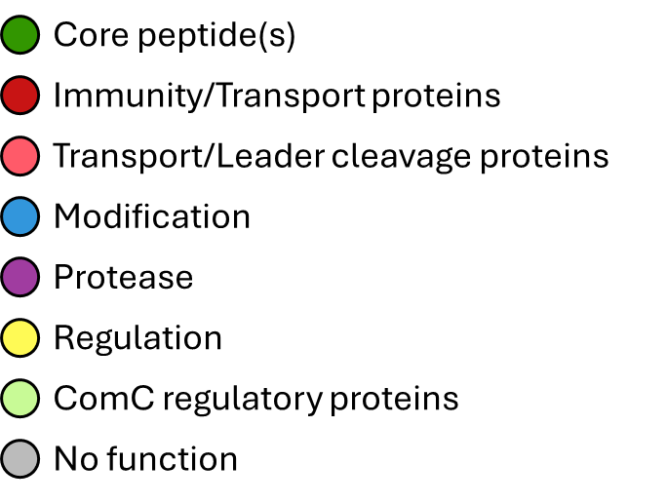
(A) Garvicin
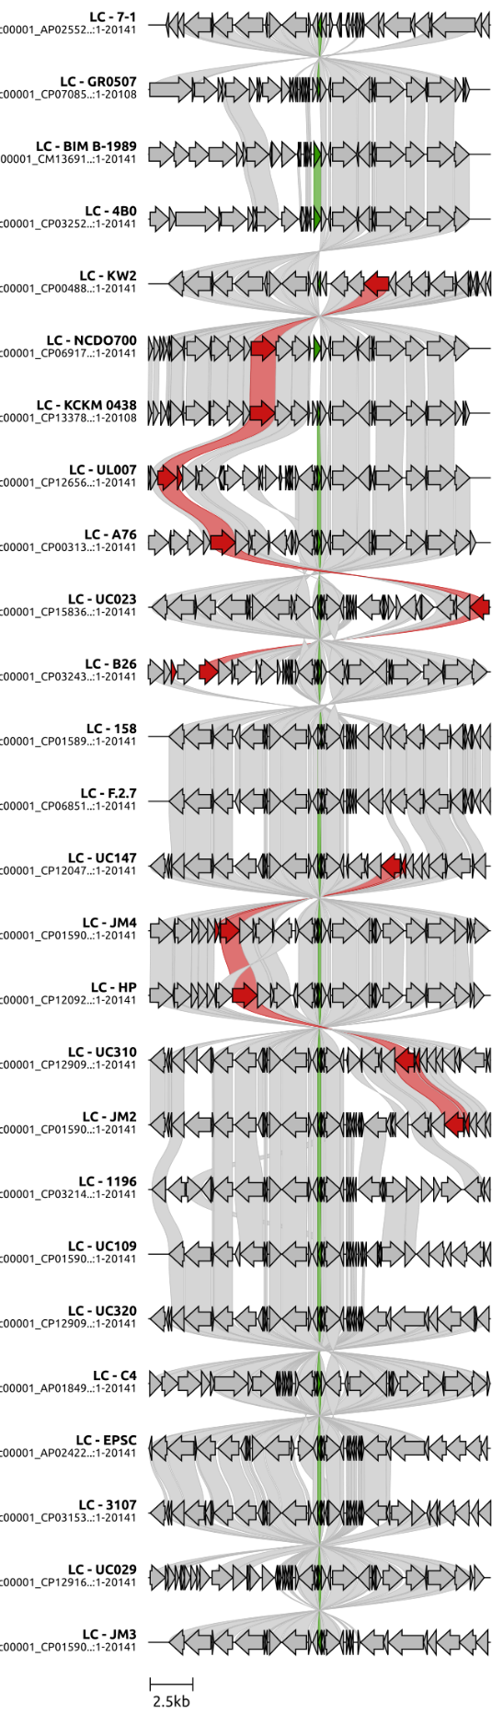
(B) Lactococcin
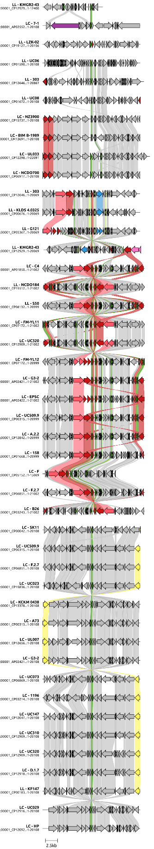
(C) Sactipeptides
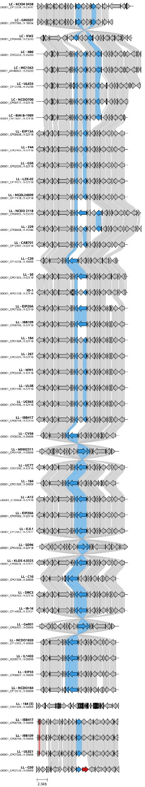
(D) Nisin
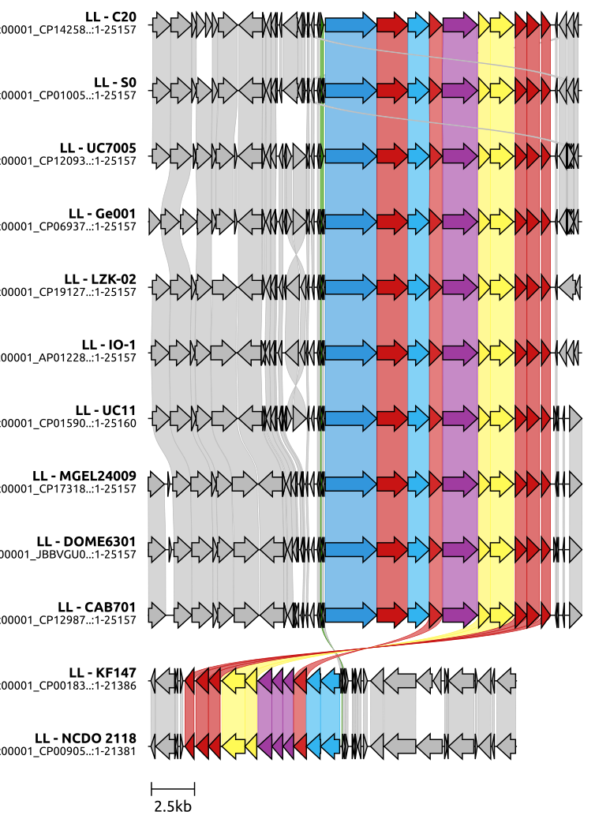
(E) Enterocin and enterolysin
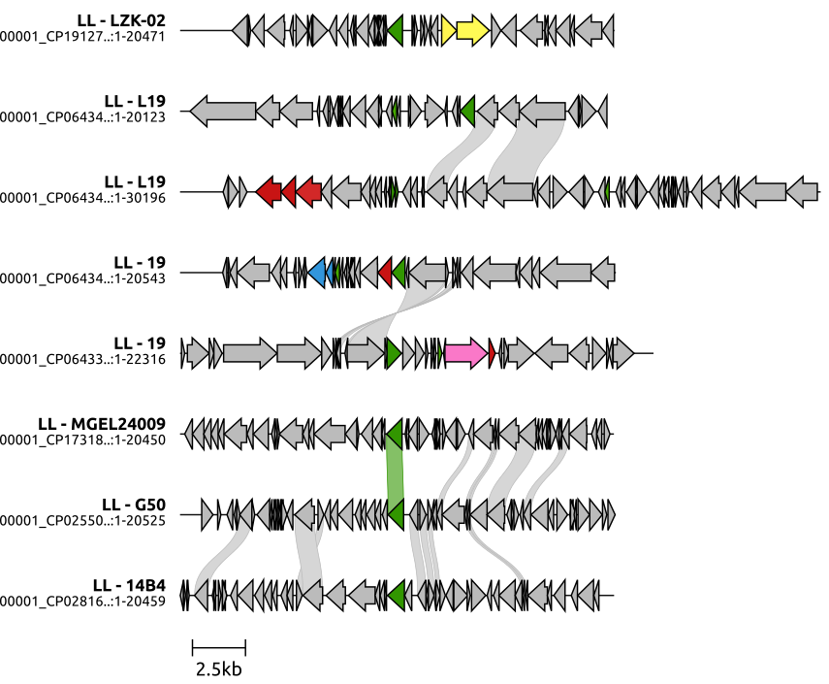
(F) Carnolysin and lacticin
