Extended Data

Extended Figure 1. Clinical Sites.
Participating clinics were districted nationally at 8 academic or private neurology clinics specializing in ALS clinical care and research.
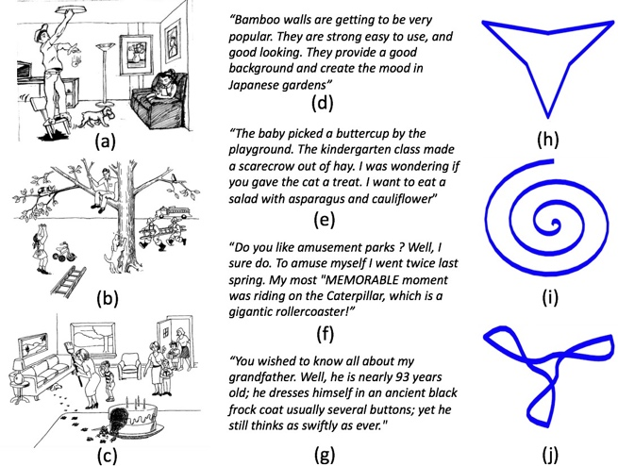

Extended Figure 2: Examples of speech and fine motor tasks performed by the smartphone app study participants. Data are collected with an app called “Help us Answer ALS”. Each week, the app asks the participant to perform different tasks. The tasks involve motor control in the upper body, speech and cognition. Each task is performed once per week. The speech tasks include describing a picture (a,b,c), reading a passage (d,e,f), and counting until the subject runs out of breath (not represented). Describing a picture also serves as a cognition task. The motor task involves tracing 3 different contours in sequential order (h,i,j), alternating hand each day of the week.

Extended Figure 3. Summary of variants for the AALS cohort of 830 sequences. A) Graph of total number of variants per participant. B) Graph of total variants per participant based on ethnic origin. C) Graph of total exonic variants. D) Graph of nonsynonymous variant types. Each dot represents a participant.

Extended Figure 4. PCA plot reveals how the Answer ALS samples cluster among various ancestry groups of the 1000 genomes project dataset. “Ad Mixed American” includes Mexicans, Puerto Ricans, Colombians and Peruvians; “African” includes Yoruba, Luhya, Gambian, Mende, Esan, Americans of African Ancestry in SW USA, and African Caribbeans in Barbados; “East Asian” includes Chinese, Japanese, and Vietnamese; “European” includes Utah residents (CEPH) with Northern and Western European ancestry, Toscans (Italy), Finns, British (England and Scotland), and Iberians (Spain); “South Asian” includes Indian, Pakistani, Bengali, and Sri Lankan.

Extended Figure 5. Size of the repeat expansion in C9orf72 (top) and ATXN2 (bottom) for the AALS cohort. The graphs are based on Expansion Hunter¹ reads for 601 sequences out of the AALS 830 samples. Top) 41 ALS cases and 4 individuals that are Pre-fALS have expansions greater than 26 repeats. Bottom) 35 ALS cases have ATXN2 expansions, while 4 normal controls and 1 uncharacterized individual have ATXN2 expansions greater than 26 repeats.

Extended Figure 6. Relationship between repeat size in C9orf72 (top) or ATXN2 (bottom) and age of ALS onset.

1 Dolzhenko, E. et al. Detection of long repeat expansions from PCR-free whole-genome sequence data. Genome Res 27, 1895-1903, doi:10.1101/gr.225672.117 (2017).

Extended Figure 7: Heatmap and hierarchical clustering of current AALS samples. A & B – Heatmap and clustering of current AALS samples using SERE values from the (A) RNA-seq and (B) ATAC-seq data. Samples are annotated with gender, genotype, and C9orf72 mutation. No distinct clustering separates samples by these categories, but BTC samples cluster together. C. Spearman correlation matrix plot for the AALS proteomics data.

Extended Figure 8: ATACSeq data. A & B- Number of all peaks (A) and promoter peaks (B) that are common to different numbers of samples. C. Genome occupancy at the PLEKHG4B locus. (Left) ATAC-seq read density upstream of the PLEKHG4B gene for ALS (middle) and CTR (bottom) samples. Average coverage for each group is shown at the top. (Right) Zoomed in region around the starred peak.

