Supplementary Figures and Tables

Figure S1 LASSO coefficient profiles of clinical variables against log(λ)
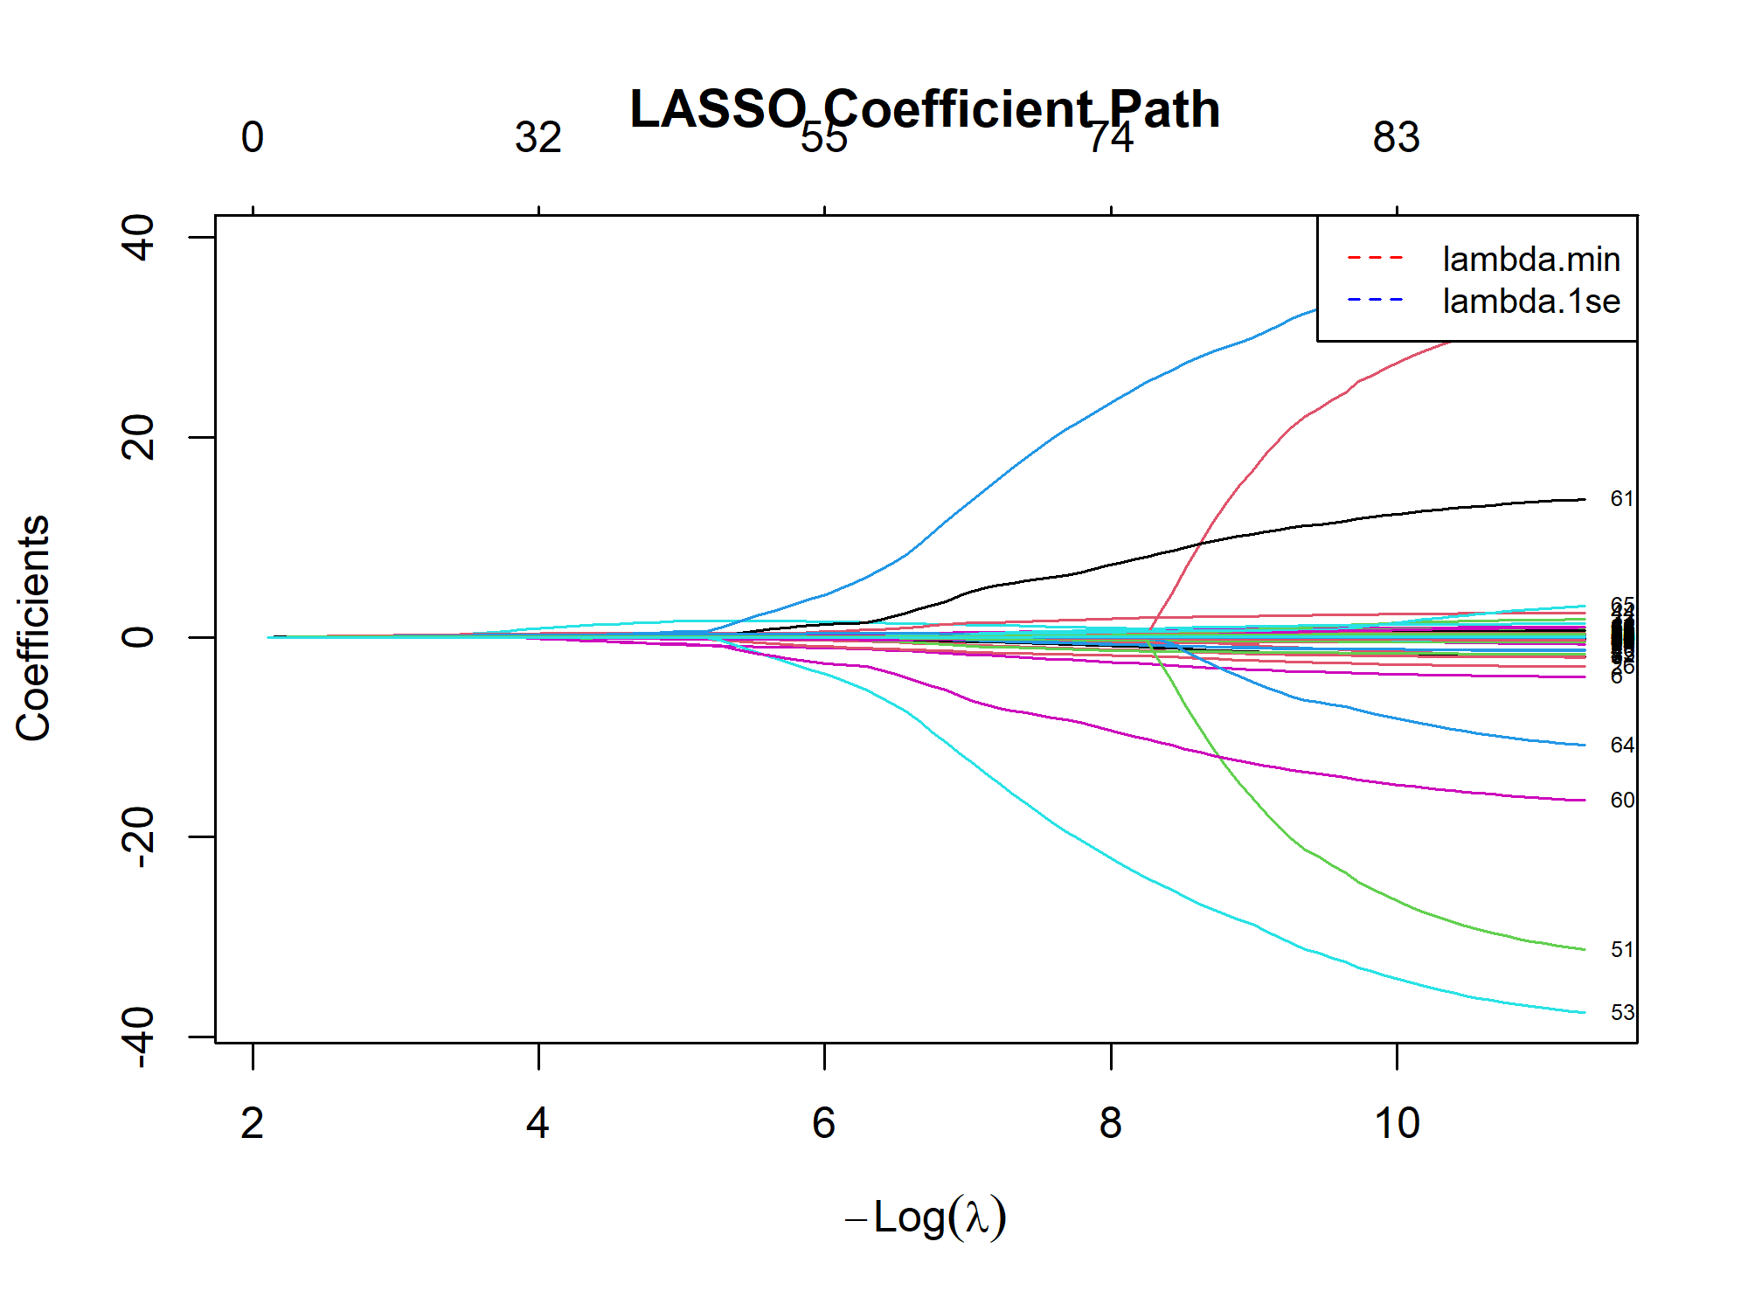
The x-axis shows log(λ), and the y-axis shows the values of the regression coefficients. Each colored line represents a candidate variable. As λ increases, coefficients shrink toward zero. Variables that retain non-zero coefficients at the selected λ.1se (right dashed line) are included in the subsequent stepwise logistic regression. This plot illustrates the variable selection process and the relative contributions of predictors.

Figure S2 LASSO cross-validation curve for penalty parameter λ selection
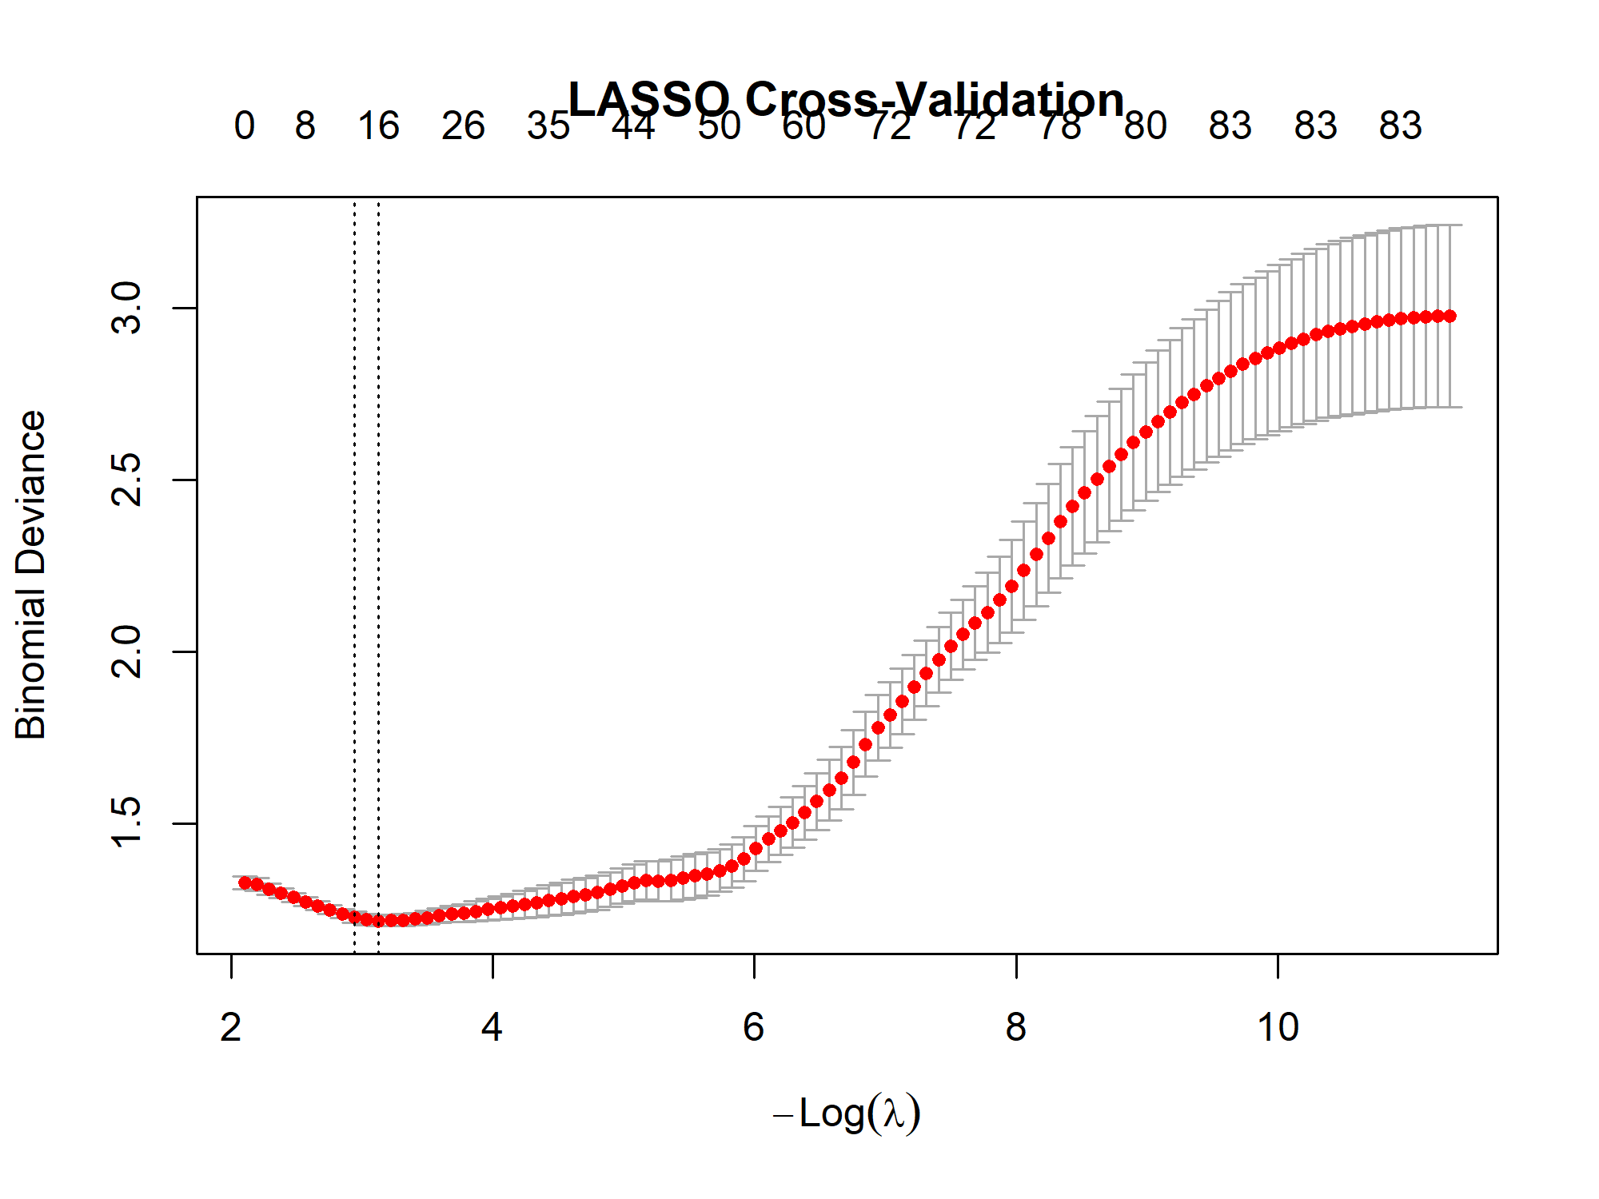

The x-axis represents log(λ), and the y-axis represents the binomial deviance (a measure of model fit). The left dashed vertical line indicates λ.min (the λ value that minimizes the cross-validated deviance). The right dashed vertical line indicates λ.1se (the largest λ within one standard error of λ.min). Variables with non-zero coefficients at λ.1se were retained for subsequent modeling. The numbers at the top indicate the number of predictors with non-zero coefficients at each λ.

Table S1 Variance inflation factor (VIF) for the 11 predictors in the final model
Variable | VIF
creatinine_min | 1.089
inr_min | 1.306
bicarbonate_max | 1.348
age | 1.081
rrmax | 1.095
ck_mb_max | 1.064
hrmin | 1.199
ptt_min | 1.351
bloodglucosemin | 1.053
ld_ldh_max | 1.053
hemoglobin_max | 1.194

VIF values below 2 indicate no significant multicollinearity among the predictors. This supports the stability of the final logistic regression model.

