Supplementary material
Targeting Post-Stroke Depression: Urine-derived Stem Cells Reverse Neuroinflammation by Macrophage Reprogramming
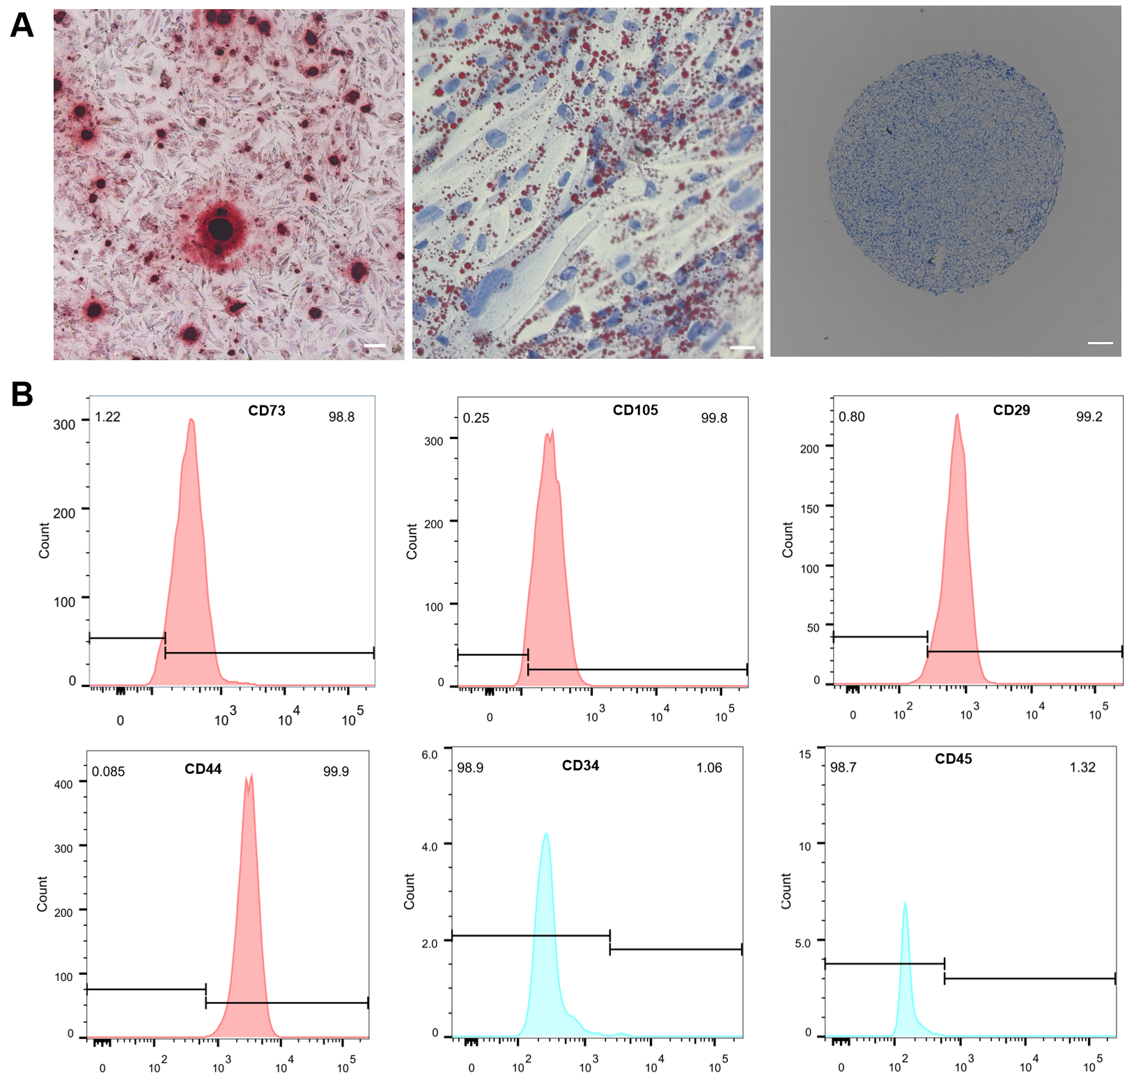
Figure S1. (A)Trilineage differentiation potential of USCs into osteogenic, adipogenic, and chondrogenic lineages. (B) Flow cytometric analysis of surface marker expression in USCs.

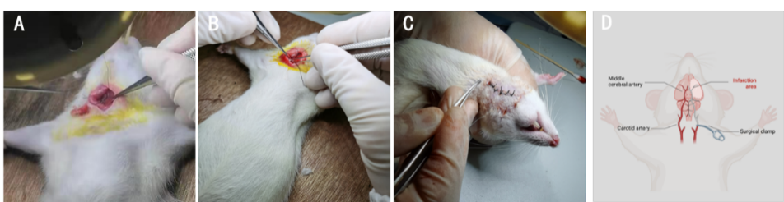
Figure S2. Surgical procedure for the middle cerebral artery occlusion (MCAO) rat model. (A) Surgical dissection; (B) Suture insertion; (C) Suture withdrawal; (D) Schematic diagram of the dissection.

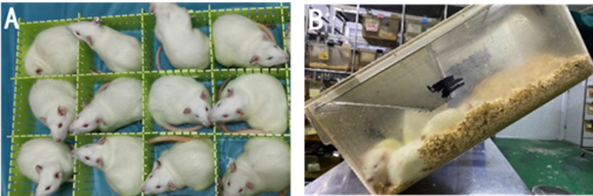
Figure S3. Procedures for the CUMS model. (A) Physical restraint; (B) 45° cage tilting.

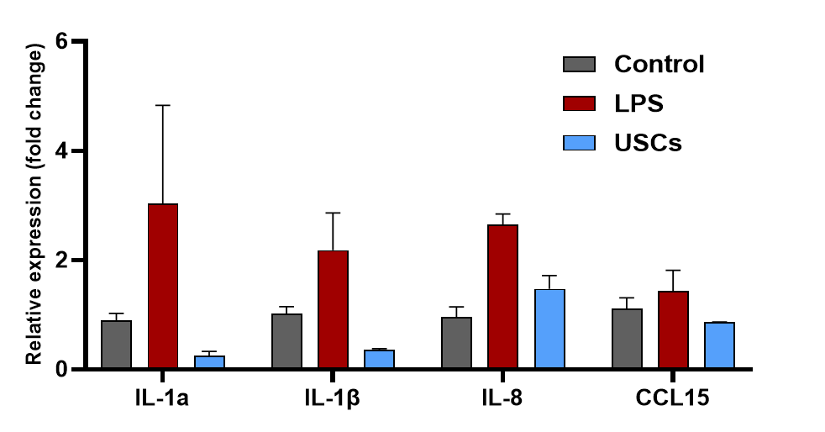
Figure S4. RT-qPCR analysis of pro-inflammatory gene expression (TNF-α and IL-6).

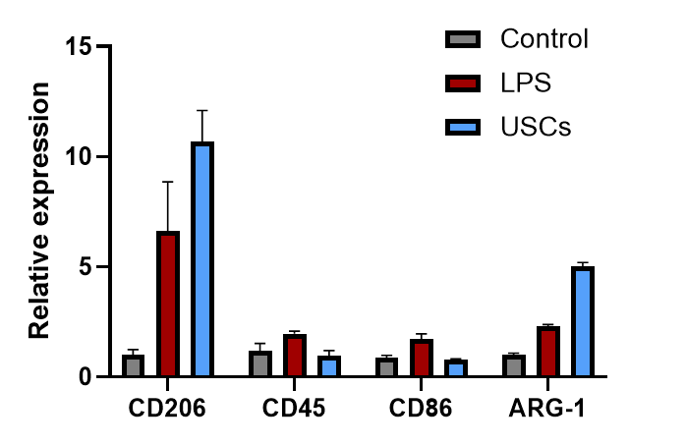
Figure S5. RT-qPCR analysis of M1 (CD86, CD45) and M2 (CD206, ARG-1) markers.

Table S1. Longa scale scoring criteria
Score | Symptoms
0 | No neurological deficit
1 | Failure to fully extend the contralateral forepaw; tail-hanging
2 | Circling towards the paralyzed side
3 | Falling to the paralyzed side during movement.
4 | No spontaneous walking, reduced consciousness

Table S2. Chronic unpredictable mild stress (CUMS) procedures
Stressor | Symptoms
Food deprivation | Food was withdrawn starting at 07:00 and lasting until 07:00 the following day (24h total).
Water deprivation | Water was withdrawn starting at 07:00 and lasting until 07:00 the following day (24h total).
45° cage tilt | The rat cages were tilted at a 45° from 07:00 until 19:00 (12h total).
Tail pinch | The rat was immobilized with the tail exposed. A hemostatic forceps was used to pinch the tail approximately 1 cm from the base for 1 min before returning the rat to its cage.
Wet bedding | Water was sprayed onto the cage bedding to maintain a damp environment. After 8h, the damp bedding was replaced with fresh, dry bedding.
Restraint | The rat was placed in a specialized restraint tube for 1h to restrict physical activity.

Table 3. List of antibody
Antibody name | Purchasing companies | Cat No
TNF-a | Cell Signaling technology | 8184T
IL-6 | Proteintech | 66146
CD206 | Abcam | Ab64693
CD86 | Cell Signaling technology | 91882T
NF-kB | Cell Signaling technology | 8242T

Table 4. List of primer sequences for RT-PCR analysis
Primer name | Sequences (5′-3′)
hGAPDH-F | ACATCGCTCAGACACCATG
hGAPDH-R | TGTAGTTGAGGTCAATGAAG
hIL-1β-F | ATGATGGCTTATTACAGTGGCAA
hIL-1β-R | GTCGGAGATTCGTAGCTGGA
hIL-6-F | ACTCACCTCTTCAGAACGAATTG
hTNF-a-F | CAAAGTAGACCTGCCCAGAC
hTNF-a-R | GACCTCTCTCTAATCAGCCC
hCD206-F | TCCGGGTGCTGTTCTCCTA
hCD206-R | CCAGTCTGTTTTTGATGGCACT
hCD45-F | ACCACAAGTTTACTAACGCAAGT
hCD45-R | TTTGAGGGGGATTCCAGGTAAT
hCD86-F | GGAAATGCCACGGTTCATCCA
hCD86-R | TGGGGTTCAGTACAGAGATGC
hARG-1-F | GTGGAAACTTGCATGGACAAC
hARG-1-R | AATCCTGGCACATCGGGAATC
mIL-6-F | TAGTCCTTCCTACCCCAATTTCC
mIL-6-R | TTGGTCCTTAGCCACTCCTTC
mTNF-a-F | AGCCCACGTCGTAGCAAACCAC
mTNF-a-R | TCATCCAAATACTCCACACGC

