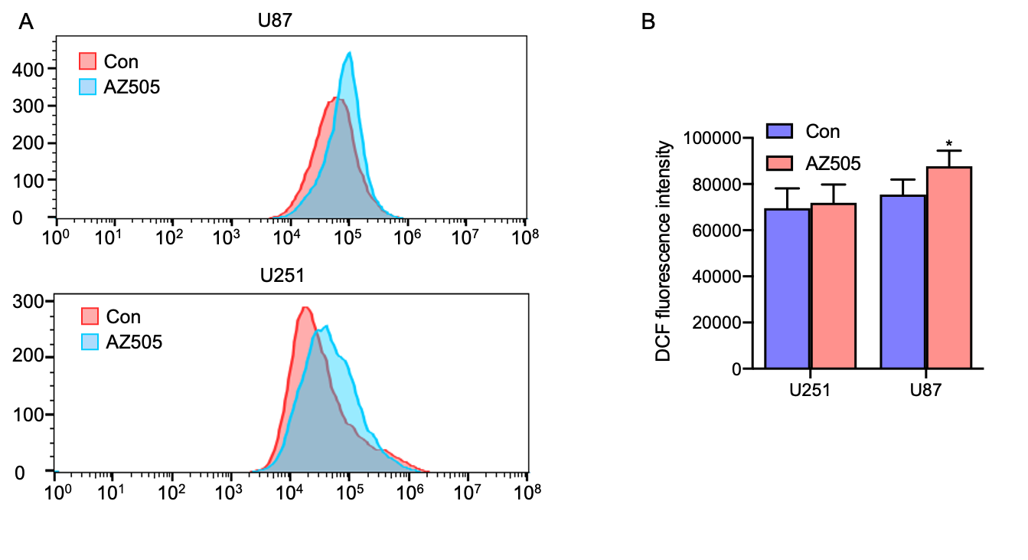
Fig. S1. The reactive oxygen species (ROS) assay in glioma cells.
(A) Flow cytometric analysis following DCFH-DA reaction in AZ505-treated U251 and U87 cells. (B)The ROS rate was qualified. Data are shown as mean ± SD. *P < 0.05.
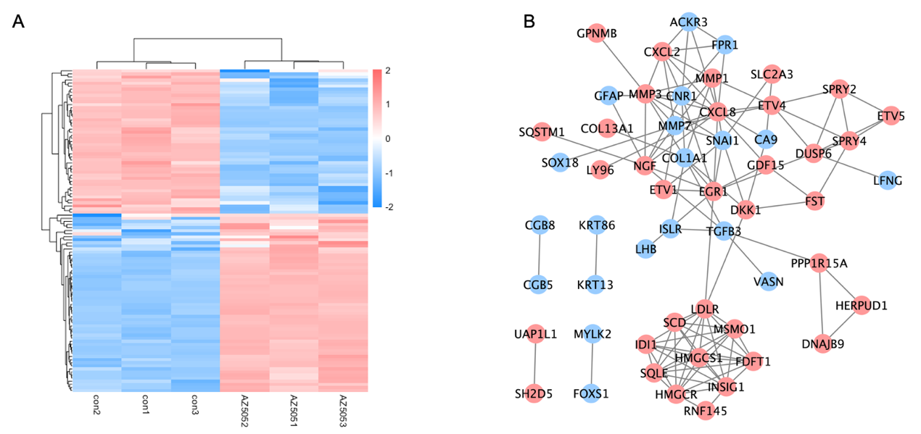
Fig. S2. The downstream mechanisms of SMYD2.
(A) Heat maps of significantly differentially expressed genes. (B) The PPI network of DEGs.

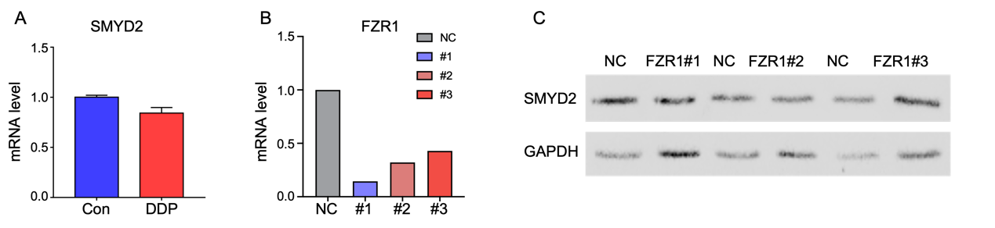

Fig. S3. The modulation of SMYD2 protein level.
- SMYD2 mRNA level in DDP-treated and control cells. (B) FZR1 mRNA levels in si-RNA treated cells. (C) The expression of SMYD2 after the knockdown of FZR1.

