Appendix A1. Pairwise contrasts between conditions (N–N, CCI–N, CNCI–N) across time windows in the eye-tracking analysis.
 |  | Juhuri |  |  |  | Russian
Time window (ms) | Contrast | Estimate | SE | z | p | Estimate | SE | z | p
-970–0 | N-N – CCI-N | 0.095 | 0.1 | 0.93 | 0.62 | -0.095 | 0.09 | -1.1 | 0.53
-970–0 | N-N – CNCI-N | 0.105 | 0.1 | 1.02 | 0.57 | -0.053 | 0.09 | -0.6 | 0.82
-970–0 | CCI-N – CNCI-N | 0.009 | 0.12 | 0.08 | 1 | 0.042 | 0.1 | 0.42 | 0.91
0–500 | N-N – CCI-N | 0.076 | 0.1 | 0.76 | 0.73 | -0.155 | 0.09 | -1.8 | 0.17
0–500 | N-N – CNCI-N | 0.055 | 0.1 | 0.55 | 0.85 | -0.014 | 0.09 | -0.2 | 0.99
0–500 | CCI-N – CNCI-N | -0.021 | 0.12 | -0.2 | 0.98 | 0.142 | 0.1 | 1.42 | 0.33
500–1000 | N-N – CCI-N | 0.064 | 0.1 | 0.63 | 0.8 | -0.195 | 0.09 | -2.2 | 0.071
500–1000 | N-N – CNCI-N | 0.023 | 0.1 | 0.23 | 0.97 | 0.012 | 0.09 | 0.13 | 0.99
500–1000 | CCI-N – CNCI-N | -0.041 | 0.12 | -0.4 | 0.93 | 0.207 | 0.1 | 2.05 | 0.1
1000–1500 | N-N – CCI-N | 0.052 | 0.1 | 0.5 | 0.87 | -0.233 | 0.09 | -2.5 | 0.03
1000–1500 | N-N – CNCI-N | -0.008 | 0.1 | -0.1 | 1 | 0.036 | 0.09 | 0.39 | 0.92
1000–1500 | CCI-N – CNCI-N | -0.06 | 0.12 | -0.5 | 0.87 | 0.269 | 0.1 | 2.59 | 0.026
1500–2000 | N-N – CCI-N | 0.04 | 0.11 | 0.36 | 0.93 | -0.274 | 0.1 | -2.8 | 0.014
1500–2000 | N-N – CNCI-N | -0.041 | 0.11 | -0.4 | 0.92 | 0.063 | 0.1 | 0.64 | 0.8
1500–2000 | CCI-N – CNCI-N | -0.081 | 0.12 | -0.7 | 0.79 | 0.337 | 0.11 | 3.09 | 0.006

Appendix A2. Mixed-effects logistic regression model predicting overall target-looking from condition, Juhuri proficiency, and their interaction.
 | Juhuri
Predictors | Odds Ratios | CI | p
(Intercept) | 1.52 | 1.15 – 2.02 | 0.003
CBI-N | 0.54 | 0.43 – 0.68 | <0.001
NCBI-N | 0.56 | 0.44 – 0.70 | <0.001
JUPROF | 0.96 | 0.89 – 1.03 | 0.265
CBI-N × JUPROF | 1.15 | 1.11 – 1.19 | <0.001
NCBI-N × JUPROF | 1.15 | 1.11 – 1.19 | <0.001
Random Effects
σ² | 3.29
τ₀₀ _{Target} | 0.06
τ₀₀ _{ParticipantID} | 0.05
ICC | 0.03
N _{ParticipantID} | 38
N _{Target} | 40
Observations | 66572
Marginal R² / Conditional R² | 0.003 / 0.036

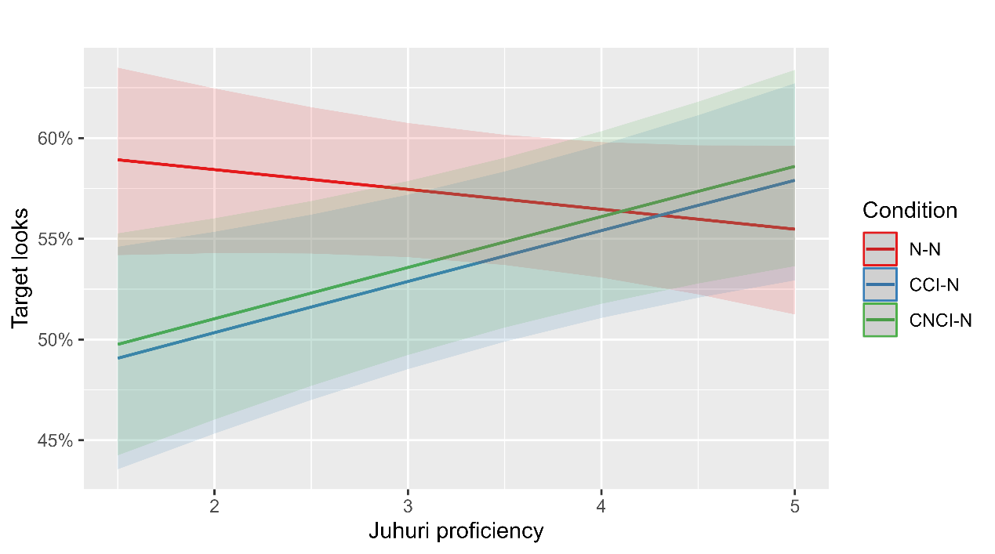
Appendix A3. Target looks across conditions in Juhuri as a function of proficiency.

