Supplementary data

Table 1: Table 1S: List of 3D structure of compounds used for QSAR Modeling
SN | Structure | pKi(M)
1 | 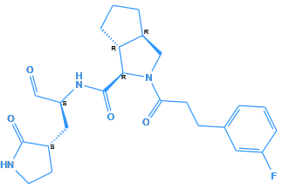 | 8.154902
2 | 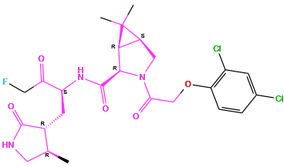 | 8.045757
3 | 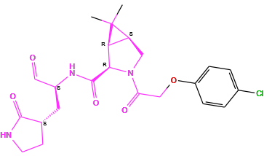 | 8.045757
4 | 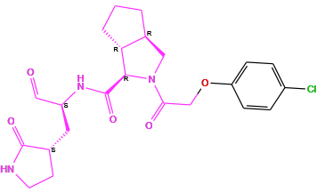 | 8.045757
5 | 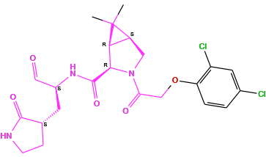 | 8
6 | 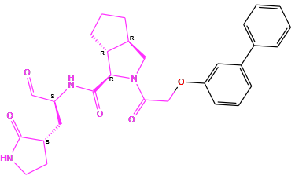 | 8
7 | 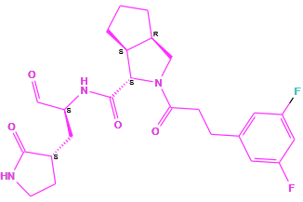 | 7.958607
8 | 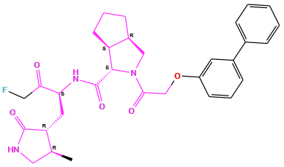 | 7.958607
9 | 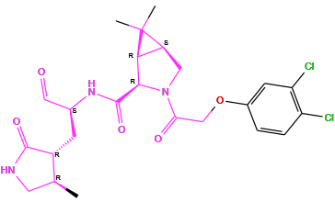 | 7.958607
10 | 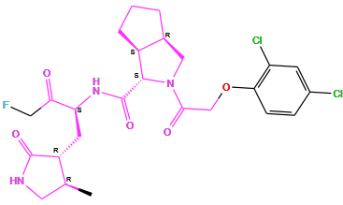 | 7.920819
11 | 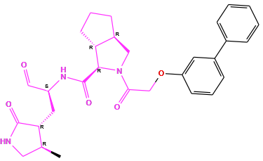 | 7.920819
12 | 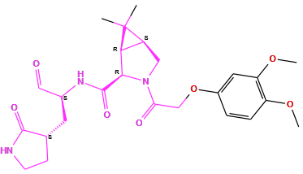 | 7.920819
13 | 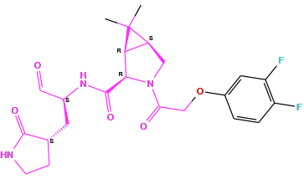 | 7.886057
14 | 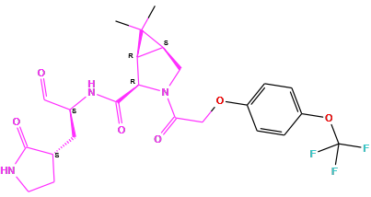 | 7.853872
15 | 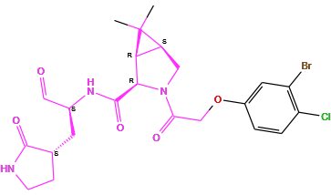 | 7.853872
16 | 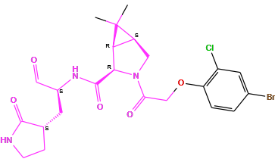 | 7.823909
17 | 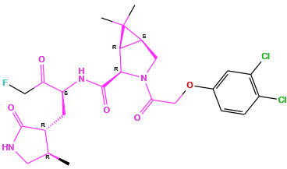 | 7.823909
18 | 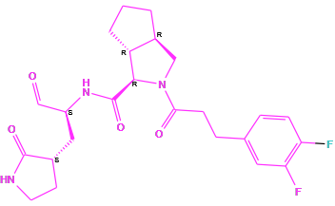 | 7.79588
19 | 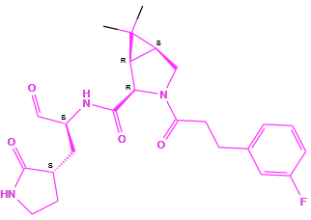 | 7.79588
20 | 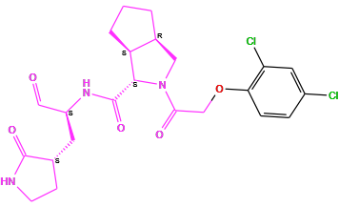 | 7.79588
21 | 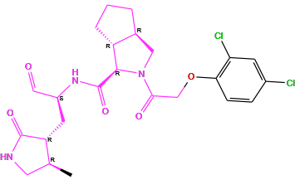 | 7.769551
22 | 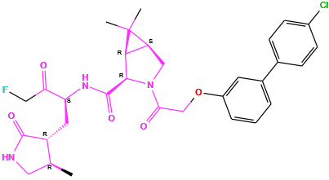 | 7.769551
23 | 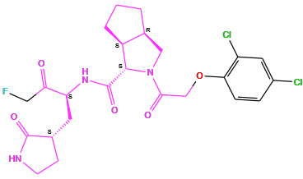 | 7.744727
24 | 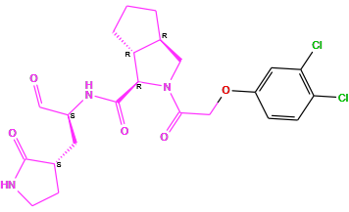 | 7.721246
25 | 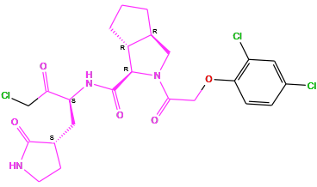 | 7.721246
26 | 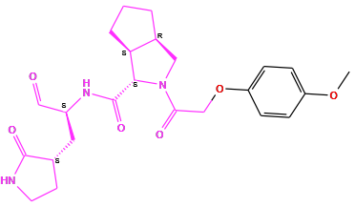 | 7.69897
27 | 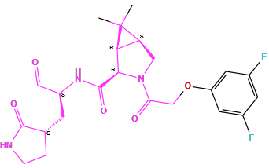 | 7.69897
28 | 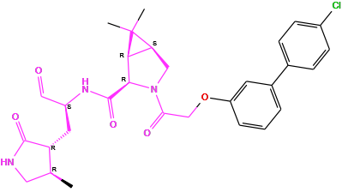 | 7.657577
29 | 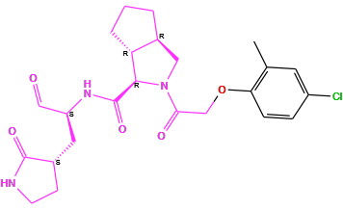 | 7.657577
30 | 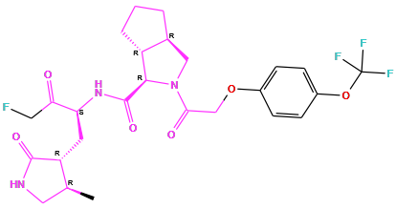 | 7.638272
31 | 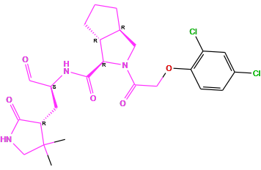 | 7.619789
32 | 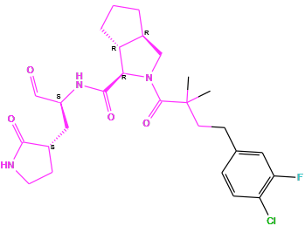 | 7.585027
33 | 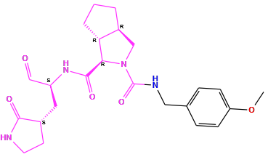 | 7.585027
34 | 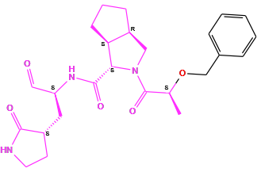 | 7.552842
35 | 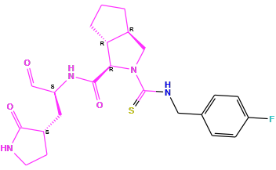 | 7.522879
36 | 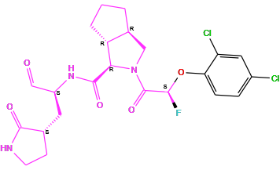 | 7.508638
37 | 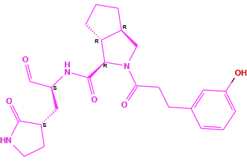 | 7.508638
38 | 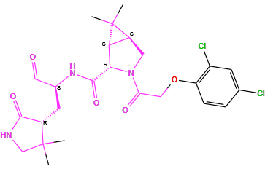 | 7.508638
39 | 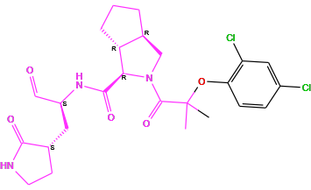 | 7.481486
40 | 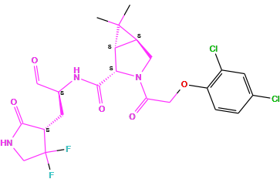 | 7.481486
41 | 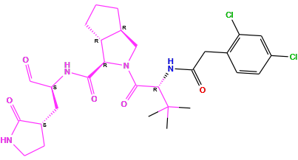 | 7.481486
42 | 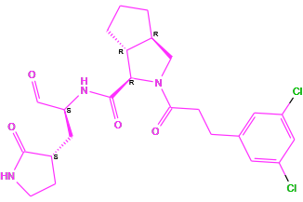 | 7.481486
43 | 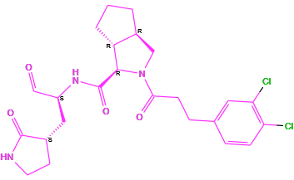 | 7.455932
44 | 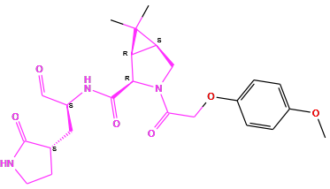 | 7.443697
45 | 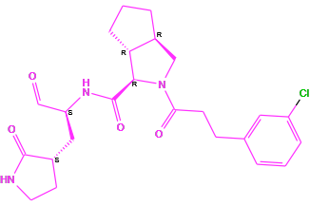 | 7.443697
46 | 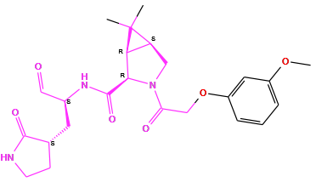 | 7.431798
47 | 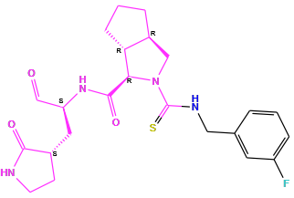 | 7.431798
48 | 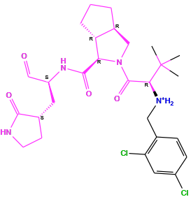 | 7.408935
49 | 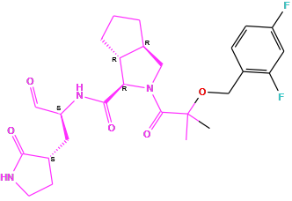 | 7.39794
50 | 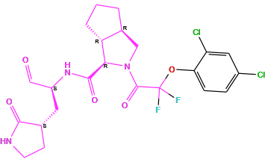 | 7.39794
51 | 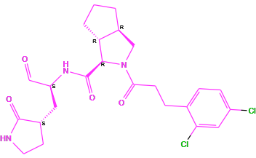 | 7.39794
52 | 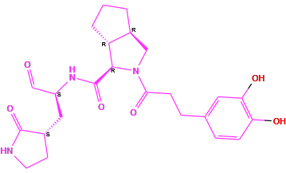 | 7.387216
53 | 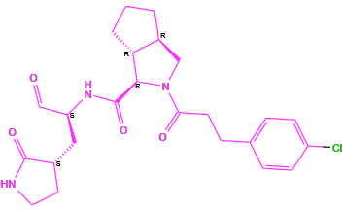 | 7.356547
54 | 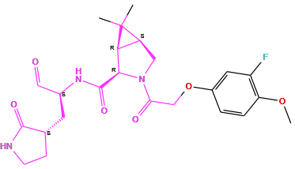 | 7.327902
55 | 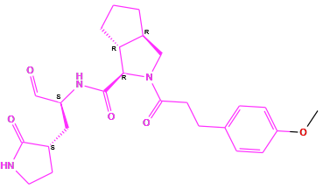 | 7.29243
56 | 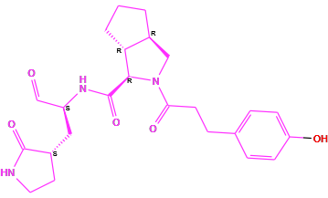 | 7.29243
57 | 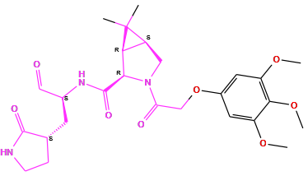 | 7.29243
58 | 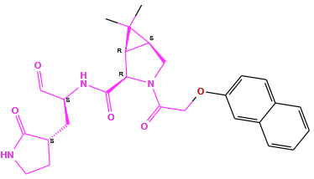 | 7.267606
59 | 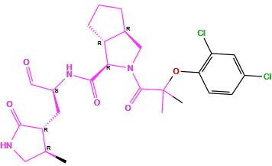 | 7.251812
60 | 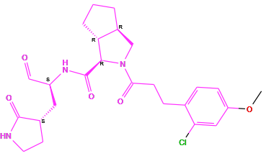 | 7.251812
61 | 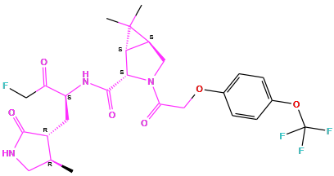 | 7.187087
62 | 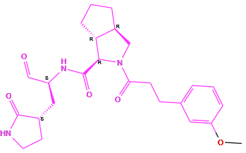 | 7.167491
63 | 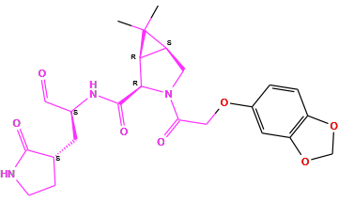 | 7.136677
64 | 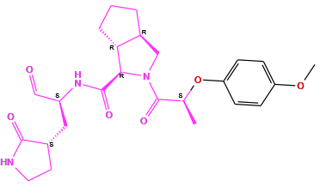 | 7.107905
65 | 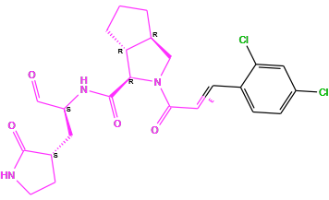 | 7.091515
66 | 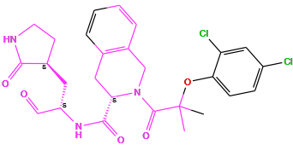 | 7.040959
67 | 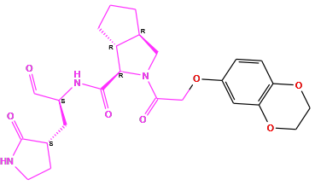 | 7.031517
68 | 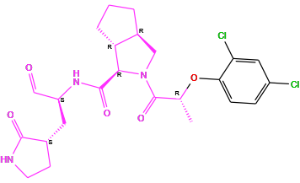 | 6.970616
69 | 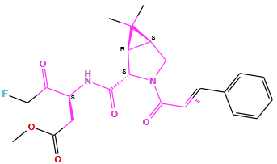 | 6.958607
70 | 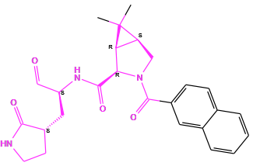 | 6.464706
71 | 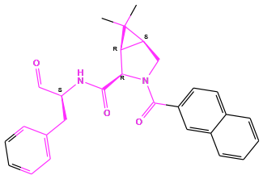 | 6.232844
72 | 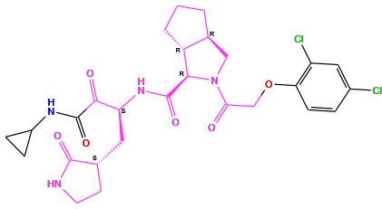 | 6.057992
73 | 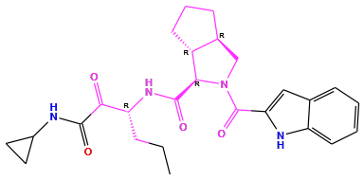 | 6.017729
74 | 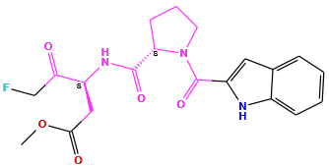 | 5.958607
75 | 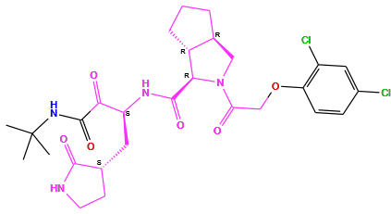 | 5.924453
76 | 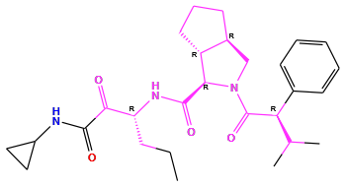 | 4.771343
77 | 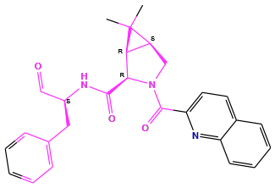 | 4.615467
78 | 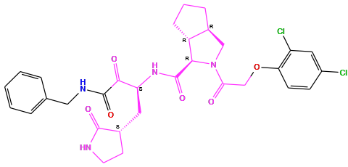 | 4.297656
79 | 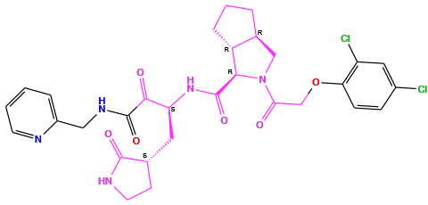 | 4.200039
80 | 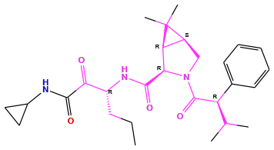 | 4.082284

Table 2S: Observed Vs. Predicted Activity (in pKi) Using KPLS Model
ID | Set | Y(Obs) | Y(Pred) | Error
1 | train | 8.1549 | 8.1632 | 0.0083
2 | train | 8.0458 | 8.0088 | -0.037
3 | test | 8.0458 | 7.7581 | -0.2877
4 | train | 8.0458 | 7.7795 | -0.2663
5 | test | 8 | 7.5791 | -0.4209
6 | train | 8 | 7.9739 | -0.0261
7 | test | 7.9586 | 7.844 | -0.1146
8 | train | 7.9586 | 8.3249 | 0.3663
9 | train | 7.9586 | 8.0527 | 0.0941
10 | train | 7.9208 | 7.8929 | -0.0279
11 | train | 7.9208 | 8.1813 | 0.2605
12 | train | 7.9208 | 7.4314 | -0.4895
13 | test | 7.8861 | 7.6918 | -0.1943
14 | train | 7.8539 | 7.7028 | -0.151
15 | train | 7.8539 | 7.7983 | -0.0556
16 | test | 7.8239 | 7.5038 | -0.3201
17 | train | 7.8239 | 8.1749 | 0.3509
18 | train | 7.7959 | 7.9067 | 0.1109
19 | train | 7.7959 | 7.9909 | 0.195
20 | train | 7.7959 | 7.407 | -0.3889
21 | train | 7.7696 | 7.6432 | -0.1263
22 | test | 7.7696 | 8.1305 | 0.3609
23 | train | 7.7447 | 7.4941 | -0.2506
24 | test | 7.7212 | 7.6887 | -0.0325
25 | train | 7.7212 | 7.1734 | -0.5479
26 | train | 7.699 | 7.5819 | -0.117
27 | test | 7.699 | 7.67 | -0.029
28 | train | 7.6576 | 8.085 | 0.4275
29 | train | 7.6576 | 7.4611 | -0.1965
30 | test | 7.6383 | 7.9355 | 0.2973
31 | train | 7.6198 | 7.4453 | -0.1745
32 | train | 7.585 | 7.7045 | 0.1194
33 | train | 7.585 | 7.2143 | -0.3707
34 | train | 7.5528 | 6.9475 | -0.6054
35 | test | 7.5229 | 7.2725 | -0.2504
36 | train | 7.5086 | 7.3194 | -0.1892
37 | train | 7.5086 | 7.5571 | 0.0485
38 | test | 7.5086 | 7.5437 | 0.035
39 | train | 7.4815 | 7.3682 | -0.1132
40 | train | 7.4815 | 7.573 | 0.0915
41 | train | 7.4815 | 7.292 | -0.1895
42 | test | 7.4815 | 7.4838 | 0.0023
43 | test | 7.4559 | 7.5577 | 0.1018
44 | train | 7.4437 | 7.5216 | 0.0779
45 | train | 7.4437 | 7.5942 | 0.1505
46 | train | 7.4318 | 7.6366 | 0.2048
47 | train | 7.4318 | 7.3677 | -0.0641
48 | test | 7.4089 | 7.3005 | -0.1084
49 | train | 7.3979 | 7.5619 | 0.164
50 | train | 7.3979 | 7.403 | 0.005
51 | test | 7.3979 | 7.3457 | -0.0522
52 | train | 7.3872 | 7.4201 | 0.0329
53 | train | 7.3565 | 7.3936 | 0.037
54 | train | 7.3279 | 7.4674 | 0.1395
55 | test | 7.2924 | 7.4012 | 0.1087
56 | train | 7.2924 | 7.2743 | -0.0181
57 | test | 7.2924 | 7.3865 | 0.0941
58 | train | 7.2676 | 7.4537 | 0.1861
59 | train | 7.2518 | 7.4048 | 0.153
60 | train | 7.2518 | 7.3175 | 0.0657
61 | test | 7.1871 | 7.8599 | 0.6729
62 | train | 7.1675 | 7.5483 | 0.3808
63 | test | 7.1367 | 7.4443 | 0.3077
64 | train | 7.1079 | 7.2475 | 0.1396
65 | train | 7.0915 | 7.1977 | 0.1061
66 | train | 7.041 | 6.8936 | -0.1474
67 | train | 7.0315 | 7.354 | 0.3225
68 | test | 6.9706 | 7.3102 | 0.3395
69 | train | 6.9586 | 6.5172 | -0.4414
70 | train | 6.4647 | 6.5408 | 0.0761
71 | train | 6.2328 | 5.6947 | -0.5382
72 | test | 6.058 | 5.9526 | -0.1053
73 | train | 6.0177 | 5.2965 | -0.7212
74 | train | 5.9586 | 6.1513 | 0.1927
75 | test | 5.9245 | 5.9626 | 0.0382
76 | test | 4.7713 | 5.0027 | 0.2314
77 | train | 4.6155 | 5.1943 | 0.5788
78 | train | 4.2977 | 4.6772 | 0.3796
79 | test | 4.2 | 5.0994 | 0.8993
80 | train | 4.0823 | 4.8702 | 0.788

Table 3S: Observed Vs. Predicted Activity (in pKi) Using Based field Model
Ligand Name | QSAR Set | Activity | Predicted Activity | Prediction Error
1 | training | 8.155 | 7.75258 | -0.402326
2 | test | 8.046 | 7.09889 | -0.94687
3 | training | 8.046 | 7.89871 | -0.147048
4 | test | 8.046 | 7.66697 | -0.378792
5 | training | 8 | 7.95282 | -0.0471781
6 | training | 8 | 8.10419 | 0.104189
7 | training | 7.959 | 7.87493 | -0.0836749
8 | training | 7.959 | 7.84512 | -0.113489
9 | training | 7.959 | 7.91753 | -0.0410811
10 | test | 7.921 | 7.80695 | -0.113864
11 | training | 7.921 | 7.85876 | -0.0620561
12 | test | 7.921 | 7.07843 | -0.842386
13 | training | 7.886 | 7.67402 | -0.212035
14 | training | 7.854 | 7.8921 | 0.0382278
15 | training | 7.854 | 7.83813 | -0.0157435
16 | training | 7.824 | 7.97278 | 0.148868
17 | test | 7.824 | 7.57018 | -0.253732
18 | test | 7.796 | 7.73917 | -0.0567074
19 | training | 7.796 | 7.77092 | -0.0249577
20 | training | 7.796 | 7.83978 | 0.0439041
21 | training | 7.77 | 7.76729 | -0.00226108
22 | training | 7.77 | 7.8144 | 0.0448495
23 | test | 7.745 | 7.8829 | 0.138169
24 | test | 7.721 | 7.62091 | -0.10034
25 | training | 7.721 | 7.59703 | -0.124219
26 | training | 7.699 | 7.80113 | 0.102162
27 | training | 7.699 | 7.78525 | 0.08628
28 | training | 7.658 | 7.64191 | -0.0156649
29 | test | 7.658 | 7.43445 | -0.223125
30 | training | 7.638 | 7.77145 | 0.133175
31 | training | 7.62 | 7.61559 | -0.00420015
32 | test | 7.585 | 7.26189 | -0.323142
33 | training | 7.585 | 7.41371 | -0.171317
34 | training | 7.553 | 7.53591 | -0.0169321
35 | training | 7.523 | 7.5228 | -8.35574E-05
36 | training | 7.509 | 7.48714 | -0.021497
37 | training | 7.509 | 7.54406 | 0.0354251
38 | test | 7.509 | 6.91741 | -0.591232
39 | training | 7.481 | 7.22135 | -0.260135
40 | training | 7.481 | 7.42698 | -0.0545023
41 | training | 7.481 | 7.45352 | -0.0279631
42 | test | 7.481 | 7.71073 | 0.229246
43 | test | 7.456 | 7.80791 | 0.351977
44 | training | 7.444 | 7.39522 | -0.0484747
45 | test | 7.444 | 7.78393 | 0.34023
46 | test | 7.432 | 7.4131 | -0.0187006
47 | training | 7.432 | 7.55951 | 0.127716
48 | training | 7.409 | 7.49286 | 0.0839279
49 | training | 7.398 | 7.36906 | -0.0288836
50 | training | 7.398 | 7.31241 | -0.0855332
51 | training | 7.398 | 7.51275 | 0.114807
52 | test | 7.387 | 7.39322 | 0.00600462
53 | training | 7.357 | 7.50826 | 0.151712
54 | training | 7.328 | 7.42218 | 0.0942779
55 | training | 7.292 | 7.34889 | 0.0564621
56 | training | 7.292 | 7.32378 | 0.0313492
57 | test | 7.292 | 6.83594 | -0.456487
58 | training | 7.268 | 7.34722 | 0.0796088
59 | test | 7.252 | 7.48156 | 0.229744
60 | training | 7.252 | 7.36408 | 0.112271
61 | training | 7.187 | 7.14882 | -0.038265
62 | test | 7.167 | 7.4391 | 0.271604
63 | training | 7.137 | 7.14423 | 0.00754816
64 | training | 7.108 | 7.20526 | 0.0973566
65 | training | 7.092 | 7.22324 | 0.13172
66 | test | 7.041 | 6.40194 | -0.639016
67 | training | 7.032 | 6.94647 | -0.0850446
68 | training | 6.971 | 7.32432 | 0.353706
69 | test | 6.959 | 6.3999 | -0.558712
70 | training | 6.465 | 6.57076 | 0.106056
71 | training | 6.233 | 5.87046 | -0.362383
72 | training | 6.058 | 5.99223 | -0.0657595
73 | test | 6.018 | 7.27353 | 1.2558
74 | test | 5.959 | 5.92873 | -0.0298736
75 | training | 5.924 | 6.03381 | 0.109358
76 | training | 4.771 | 4.75506 | -0.0162818
77 | training | 4.615 | 4.89777 | 0.282302
78 | test | 4.298 | 4.06921 | -0.22845
79 | training | 4.2 | 4.08335 | -0.116689
80 | training | 4.082 | 4.1007 | 0.018419

Table 4S: Applicability Domain Summary (Leverage & Mahalanobis Distance)
Index | Leverage | WarningLeverage_h* | MahalanobisDistance | MD_Threshold(97.5%)
0 | 0.070961 | 0.45 | 2.149057 | 5.190961
1 | 0.075088 | 0.45 | 2.223605 | 5.190961
2 | 0.049473 | 0.45 | 1.709058 | 5.190961
3 | 0.073101 | 0.45 | 2.188023 | 5.190961
4 | 0.062662 | 0.45 | 1.990676 | 5.190961
5 | 0.159414 | 0.45 | 3.406794 | 5.190961
6 | 0.154625 | 0.45 | 3.350798 | 5.190961
7 | 0.122161 | 0.45 | 2.94333 | 5.190961
8 | 0.063111 | 0.45 | 1.999565 | 5.190961
9 | 0.079035 | 0.45 | 2.29266 | 5.190961
10 | 0.109768 | 0.45 | 2.772038 | 5.190961
11 | 0.133126 | 0.45 | 3.08698 | 5.190961
12 | 0.098525 | 0.45 | 2.606908 | 5.190961
13 | 0.241864 | 0.45 | 4.256727 | 5.190961
14 | 0.284713 | 0.45 | 4.637327 | 5.190961
15 | 0.069512 | 0.45 | 2.122246 | 5.190961
16 | 0.278384 | 0.45 | 4.583105 | 5.190961
17 | 0.052473 | 0.45 | 1.777039 | 5.190961
18 | 0.103467 | 0.45 | 2.68074 | 5.190961
19 | 0.131153 | 0.45 | 3.061634 | 5.190961
20 | 0.293928 | 0.45 | 4.715172 | 5.190961
21 | 0.054765 | 0.45 | 1.827282 | 5.190961
22 | 0.100561 | 0.45 | 2.637571 | 5.190961
23 | 0.109062 | 0.45 | 2.761951 | 5.190961
24 | 0.054125 | 0.45 | 1.813386 | 5.190961
25 | 0.075655 | 0.45 | 2.233658 | 5.190961
26 | 0.138955 | 0.45 | 3.160684 | 5.190961
27 | 0.029894 | 0.45 | 1.17223 | 5.190961
28 | 0.19838 | 0.45 | 3.832036 | 5.190961
29 | 0.265196 | 0.45 | 4.467994 | 5.190961
30 | 0.113242 | 0.45 | 2.821107 | 5.190961
31 | 0.148926 | 0.45 | 3.28293 | 5.190961
32 | 0.120071 | 0.45 | 2.915154 | 5.190961
33 | 0.081285 | 0.45 | 2.33109 | 5.190961
34 | 0.276957 | 0.45 | 4.570791 | 5.190961
35 | 0.136904 | 0.45 | 3.134952 | 5.190961
36 | 0.094193 | 0.45 | 2.540428 | 5.190961
37 | 0.073181 | 0.45 | 2.189483 | 5.190961
38 | 0.064865 | 0.45 | 2.033914 | 5.190961
39 | 0.161145 | 0.45 | 3.426794 | 5.190961
40 | 0.142463 | 0.45 | 3.204224 | 5.190961
41 | 0.077722 | 0.45 | 2.26992 | 5.190961
42 | 0.065615 | 0.45 | 2.04844 | 5.190961
43 | 0.077669 | 0.45 | 2.269006 | 5.190961
44 | 0.064446 | 0.45 | 2.025759 | 5.190961
45 | 0.084368 | 0.45 | 2.382767 | 5.190961
46 | 0.26558 | 0.45 | 4.471389 | 5.190961
47 | 0.169156 | 0.45 | 3.51793 | 5.190961
48 | 0.113547 | 0.45 | 2.82537 | 5.190961
49 | 0.061306 | 0.45 | 1.963578 | 5.190961
50 | 0.180005 | 0.45 | 3.637704 | 5.190961
51 | 0.090287 | 0.45 | 2.478941 | 5.190961
52 | 0.066529 | 0.45 | 2.065993 | 5.190961
53 | 0.060762 | 0.45 | 1.952617 | 5.190961
54 | 0.234044 | 0.45 | 4.18354 | 5.190961
55 | 0.071536 | 0.45 | 2.159593 | 5.190961
56 | 0.065233 | 0.45 | 2.041062 | 5.190961
57 | 0.099202 | 0.45 | 2.617142 | 5.190961
58 | 0.131107 | 0.45 | 3.061035 | 5.190961
59 | 0.049148 | 0.45 | 1.701532 | 5.190961
60 | 0.265984 | 0.45 | 4.474954 | 5.190961
61 | 0.063854 | 0.45 | 2.014192 | 5.190961
62 | 0.25766 | 0.45 | 4.400864 | 5.190961
63 | 0.075501 | 0.45 | 2.230942 | 5.190961
64 | 0.085677 | 0.45 | 2.404364 | 5.190961
65 | 0.229264 | 0.45 | 4.138162 | 5.190961
66 | 0.272308 | 0.45 | 4.530438 | 5.190961
67 | 0.050494 | 0.45 | 1.732501 | 5.190961
68 | 0.352549 | 0.45 | 5.18304 | 5.190961
69 | 0.181478 | 0.45 | 3.653666 | 5.190961
70 | 0.345806 | 0.45 | 5.131394 | 5.190961
71 | 0.216207 | 0.45 | 4.011594 | 5.190961
72 | 0.237097 | 0.45 | 4.212263 | 5.190961
73 | 0.557316 | 0.45 | 6.560521 | 5.190961
74 | 0.177791 | 0.45 | 3.613583 | 5.190961
75 | 0.26617 | 0.45 | 4.476596 | 5.190961
76 | 0.25516 | 0.45 | 4.378375 | 5.190961
77 | 0.235412 | 0.45 | 4.19643 | 5.190961
78 | 0.3954 | 0.45 | 5.499918 | 5.190961
79 | 0.305241 | 0.45 | 4.809007 | 5.190961

