Appendix
FACES WILL BE DELETED UPON FINAL PUBLICATION IN LINE WITH DATABASE USE BUT ARE INCLUDED FOR REVIEW
Target patient images (FabLab Database, University of Chicago: Division of Decision Research)

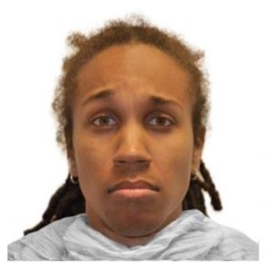
A: 0.62 B: 0.61 C: 0.6 D: 0.61
(BF06_SC) (WF02_SC) (WM02_SC) (BM17_SC)
Practice patient images
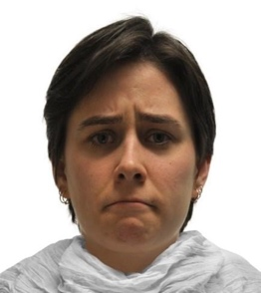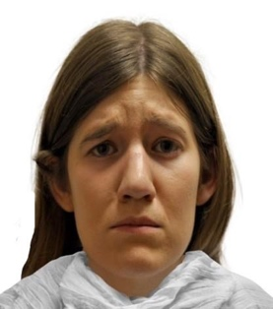
E: 0.82. F: 0.74
(WF06_SC) (WF10_SC)

Experimental Vignette 1: The last few months I’ve skipped a lot of my classes. I can’t even get myself into my car to drive to school anymore because I get so tired when I wake up, and I don’t want to leave my bed. I am not doing as well as I used to… I know that. Teachers used to always count on me to participate in their classes, but not anymore. I can’t find the confidence to raise my hand or even talk to any of my own friends. I don’t know what happened to me. I’m not myself anymore. So, I stopped going to school altogether. I feel like I should just be alone. I’m not worth talking to right now.

Experimental Vignette 2: I’m feeling hopeless lately. I haven’t been showing up to work. I keep waking up way past my alarm and deciding not to go, it’s not worth it. I don’t feel good enough to perform well anymore. Everyday just feels heavy and getting the day started has been really tough on me. I don’t know what to do because I think even my friends have noticed something change in me. They don’t talk to me anymore, I haven’t had enough energy to hangout with them, so I am starting to lose them. I know it’s because I’ve been so lazy. This isn’t me but it feels like it might be who I am now… I don’t know what to do. Staying at home is okay, but it also makes me sad and lonely.

Experimental Vignette 3: I constantly think of death and I don’t know how to cope with it anymore. I know people don’t think about death this much, it’s not normal. Every time I see my mom’s face I think about how devastated and disappointed she would be if I died tomorrow. I just want to see her face and not think of my own death. I can’t even drive a car without thinking about all the bad things that could happen on the road. I actually avoid my car so I don’t have to have these thoughts, but they don’t go away. I also lose focus in school because I get lost in the fact that I would hurt my friends if I died. My grades and social life are plummeting because I can’t think about anything else. I feel lost.

Experimental Vignette 4: I can’t stop thinking about how people view me. Every time I hangout with my friends, I feel like they hate me and are judging me. I can never focus on what they’re saying because I can’t stop thinking about if they like me or not. My friends mean a lot to me and I just feel like I am disappointing them because I am so awkward. I have started to stay at home more because I figure the less time I spend with them, the less time they have to hate me. However, I feel like they probably hate me more for not talking to them. These thoughts won’t go away, I constantly think the worst of myself and I am at a loss.

Practice Vignette 1: My sibling and I are not in a good place. We used to be so close, now we can barely stand each other being in the same room. I know it’s causing me to feel really down. I never see them anymore, so I have no one to hang out with either. Without them a part of my life, I feel lonely and have no motivation to do the things I used to do. I don’t go out on Friday’s anymore or talk to anyone at all. I end up getting really upset and yelling at them on the phone. This happens at least a few times a week. I don’t like myself anymore because I can’t control how upset I get over this.

Practice Vignette 2: My co-worker and I do not get along. It is starting to become a real problem. Every time we have to work on something together, we end up in really heated arguments. One time I yelled at them and rushed out of the building. It’s to the point where I can’t even see them in the hallways without getting visibly upset. It is really starting to make me sad about going to work everyday. I used to enjoy my time there. Now, it just feels like I have to avoid everyone just in case it’s them. I am starting to hate how I act around my co-workers now because I am always on edge.

