Supporting Information
CD105 Nb-Functionalized Layered Double Hydroxides for Synergistic Phototherapy and Reprogramming of the Tumor Immune Microenvironment

Xuandong Lin^{1,2*†}, Sandar Moe Moe Sint^{1†}, Qing Huang^{1†}, Shuai Li¹, Xueling Ma¹, Liji Mo¹, Hao Zhang^{1,2}, Jindong Long¹, Xintong Xie¹, Fangfang Xie^{1*}, Xiaomei Yang^{2*}, Hongbing Liao^{1*}

¹ Guangxi Key Laboratory of Oral and Maxillofacial Rehabilitation and Reconstruction, College & Hospital of Stomatology, Guangxi Medical University, Nanning, Guangxi 530021, China.
² Guangxi Key Laboratory of Nanobody Research, Guangxi Nanobody Engineering Research Center, College of Stomatology, Hospital of Stomatology, Guangxi Medical University, Nanning, Guangxi, 530021, China.

†Xuadong Lin, Sandar Moe Moe Sint, and Qing Huang contributed equally to this work.
*Corresponding Authors
Xuandong Lin
linxuandong@live.com
Fangfang Xie
xiedualfang@163.com
Xiaomei Yang
yangxiaomei6009@sina.com
Hongbing Liao
hongbing_liao@gxmu.edu.cn

Figures S1-S18, Table S1,

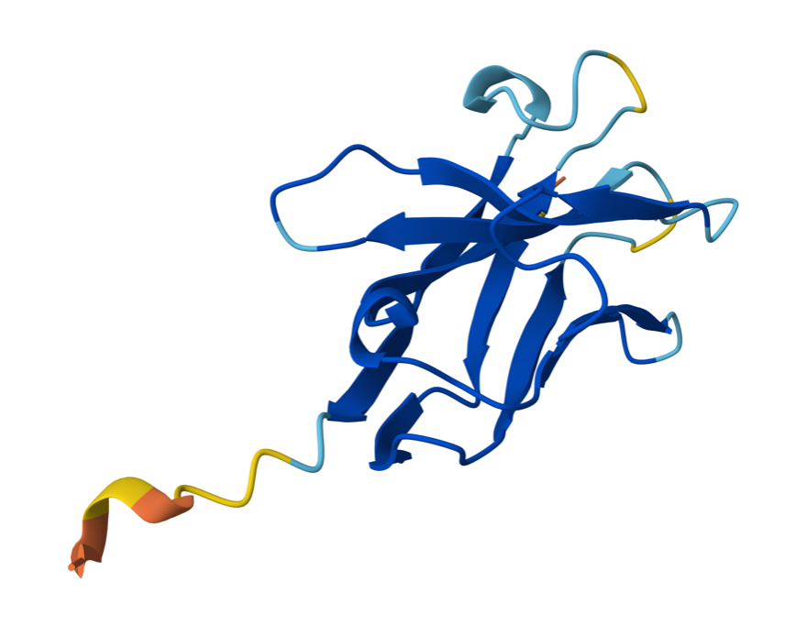
Figure S1. Illustration of CD105 Nb generated using the AlphaFold server
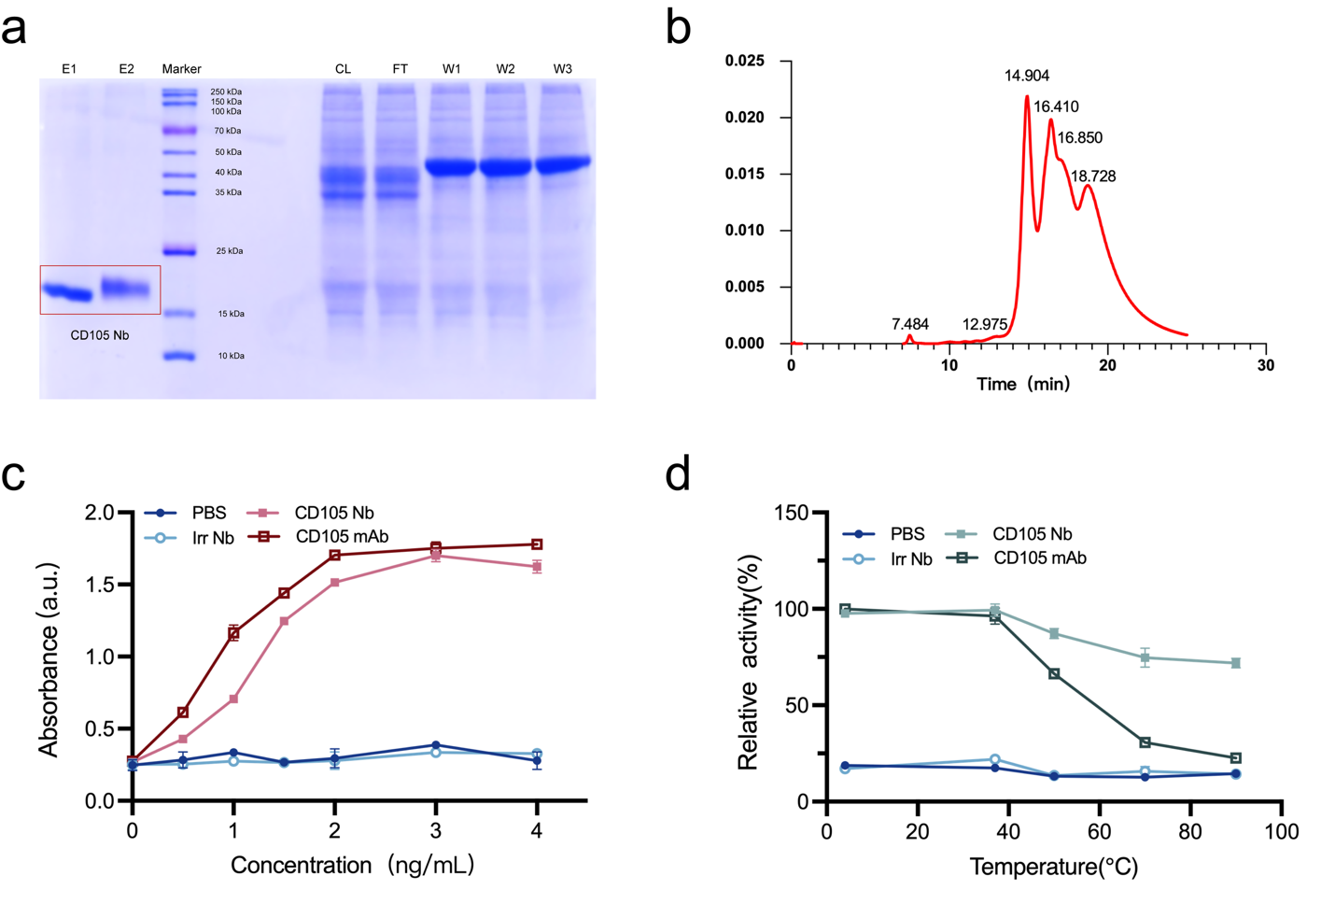
Figure S2. Purification and characterization of CD105 Nb. (a) 12% SDS-PAGE analysis of purified CD105 Nb. (b) HPLC chromatogram demonstrating nanobody purity. (c) Concentration-dependent binding of Irr Nb, CD105 Nb, and CD105 mAb compared to PBS control. (d) Thermostability assessment of the indicated formulations following incubation at various temperatures (4–90 °C).
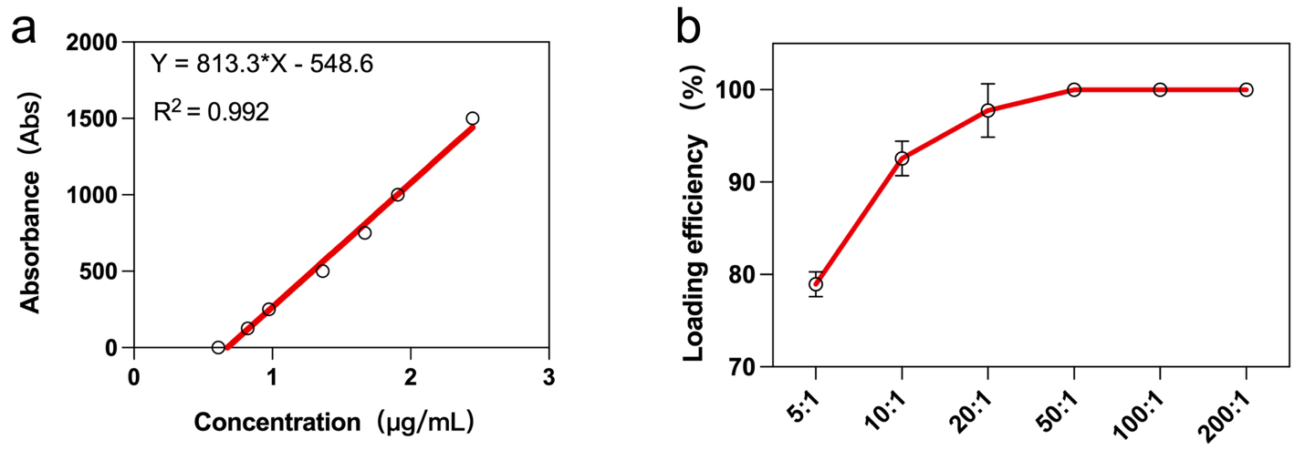
Figure S3. (a) The standard curve of UV absorption at 820 nm with varying concentrations (0.6–2.4 μg mL⁻¹). (b) Loading efficiency of CD105 Nb on LI with various mass ratios of LDH to CD105 Nb (5:1, 10:1, 20:1, 50:1, 100:1, and 200:1).

Table 1. XRD analysis and interlayer spacing calculated using Bragg’s law.
Sample | 2𝜃  (degrees) | Interlayer spacing  𝑑006  (Å) | Changes from LDH
LDH | 22.666° | 3.920 Å | Reference
LI | 22.529° | 3.943 Å | +0.046 Å
CD105 Nb-LIN | 22.450° | 3.957 Å | +0.074 Å
Bragg’s Law
nλ = 2dsinθ
n = Number (Order of Reflection)
λ = Wavelength
d = Distance (Interplanar Spacing)
θ = Angle
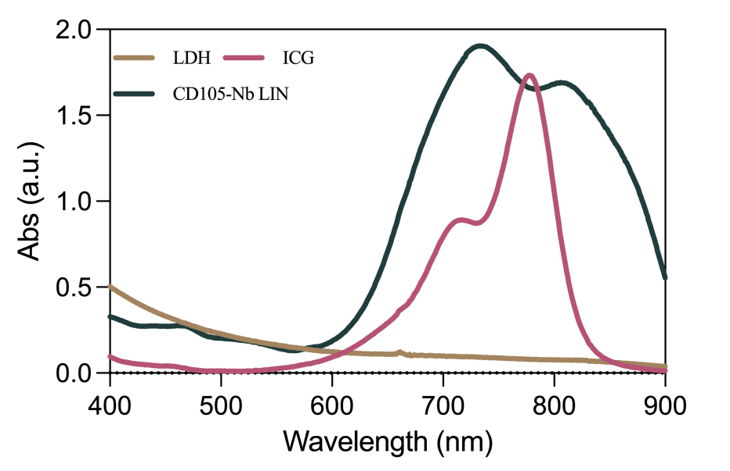
Figure S4. UV–vis absorption spectra of LDH, ICG, and CD105 Nb-LIN.
Figure S5. UV–vis absorption spectra of ICG and CD105 Nb-LIN recorded over a period of four days, stored at room temperature in the absence of light, and absorbance-reducing rate as a function of time.
Figure S6. pH-dependent ¹O₂ generation of CD105 Nb-LIN. DPBF absorbance decay at 410 nm under different pH conditions (7.4 vs. 5.0) with or without 808 nm NIR irradiation.

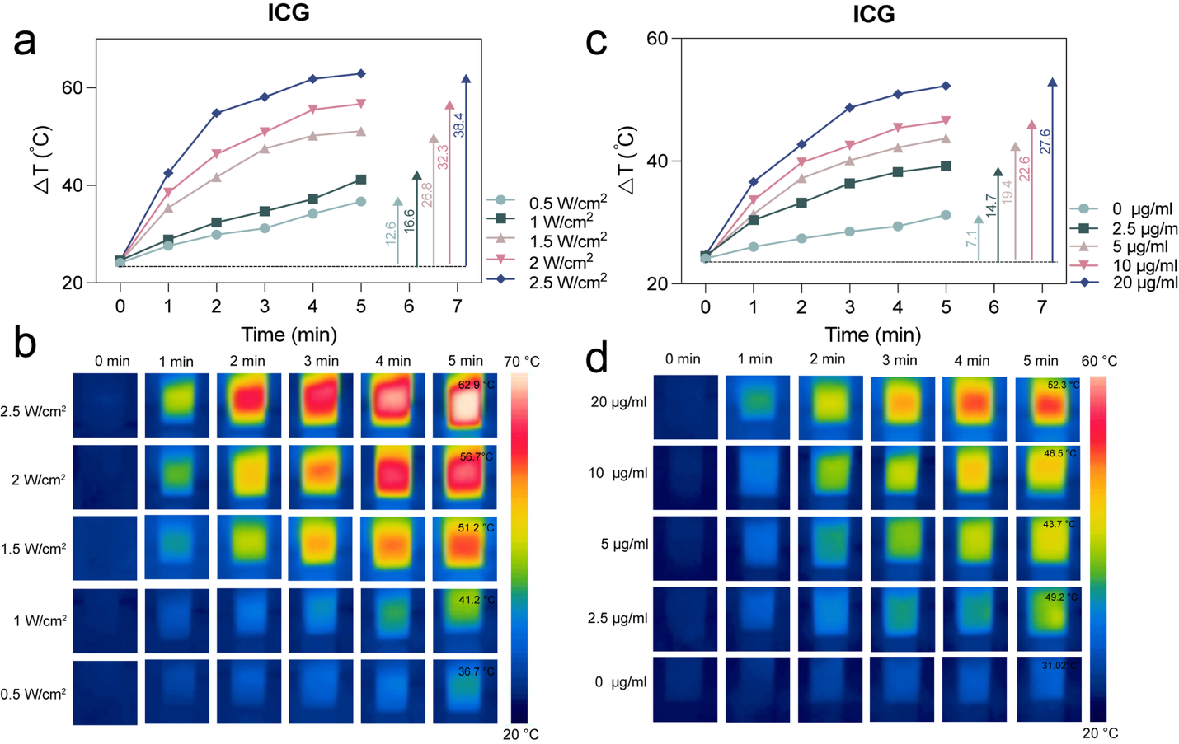
Figure S7. (a) Temperature-time curves of ICG (20 μg/mL) at different laser power densities. (b) FLIR thermal images of ICG following 5 min of irradiation at different NIR power densities. (c) Temperature-time profiles of ICG solutions at varying concentrations (ICG = 0, 2.5, 5, 10, and 20 μg/mL). (d) FLIR thermal images of ICG following 5 min of irradiation at different concentrations.
Figure S8. CD105 expression on CD105‑positive (HepG2, PANC‑1, HUVECs, HemECs) and CD105‑negative (VE) cell lines assessed by flow cytometry.
Figure S9. Optimization of CD105 Nb loading to LDH in VE cells. Left: representative flow cytometry histograms; right: quantitative analysis of ICG-positive cells after 4 h incubation with CD105 Nb-LIN at different LDH-to-CD105 Nb mass ratios (5:1–200:1), in comparison to LI and free ICG. The ICG concentration was fixed at 10 μg/mL. ns, not significant; *p < 0.05, **p < 0.01.
Figure S10. Optimization of CD105 Nb loading to LDH in HepG2 cells. Left: representative flow cytometry histograms; right: quantitative analysis of ICG-positive cells after 4 h incubation with CD105 Nb-LIN at different LDH-to-CD105 Nb mass ratios (5:1–200:1), in comparison to LI and free ICG. The ICG concentration was fixed at 10 μg/mL. ns, not significant; **p < 0.01, ***p < 0.001, ****p < 0.0001.
Figure S11. Optimization of CD105 Nb loading to LDH in PANC-1 cells. Left: representative flow cytometry histograms; right: quantitative analysis of ICG-positive cells after 4 h incubation with CD105 Nb-LIN at different LDH-to-CD105 Nb mass ratios (5:1–200:1), in comparison to LI and free ICG. The ICG concentration was fixed at 10 μg/mL. ns, not significant; *p < 0.05, ****p < 0.0001.
Figure S12. Optimization of CD105 Nb loading to LDH in HemECs cells. Left: representative flow cytometry histograms; right: quantitative analysis of ICG-positive cells after 4 h incubation with CD105 Nb-LIN at different LDH-to-CD105 Nb mass ratios (5:1–200:1), in comparison to LI and free ICG. The ICG concentration was fixed at 10 µg/mL. ns, not significant; *p < 0.05, ****p < 0.0001.

Figure S13. FLIR thermal images of HUVECs treated with CD105 Nb-LIN, LI, free ICG, or PBS at varying ICG concentrations (0–20 μg/mL) under 808 nm NIR laser irradiation.
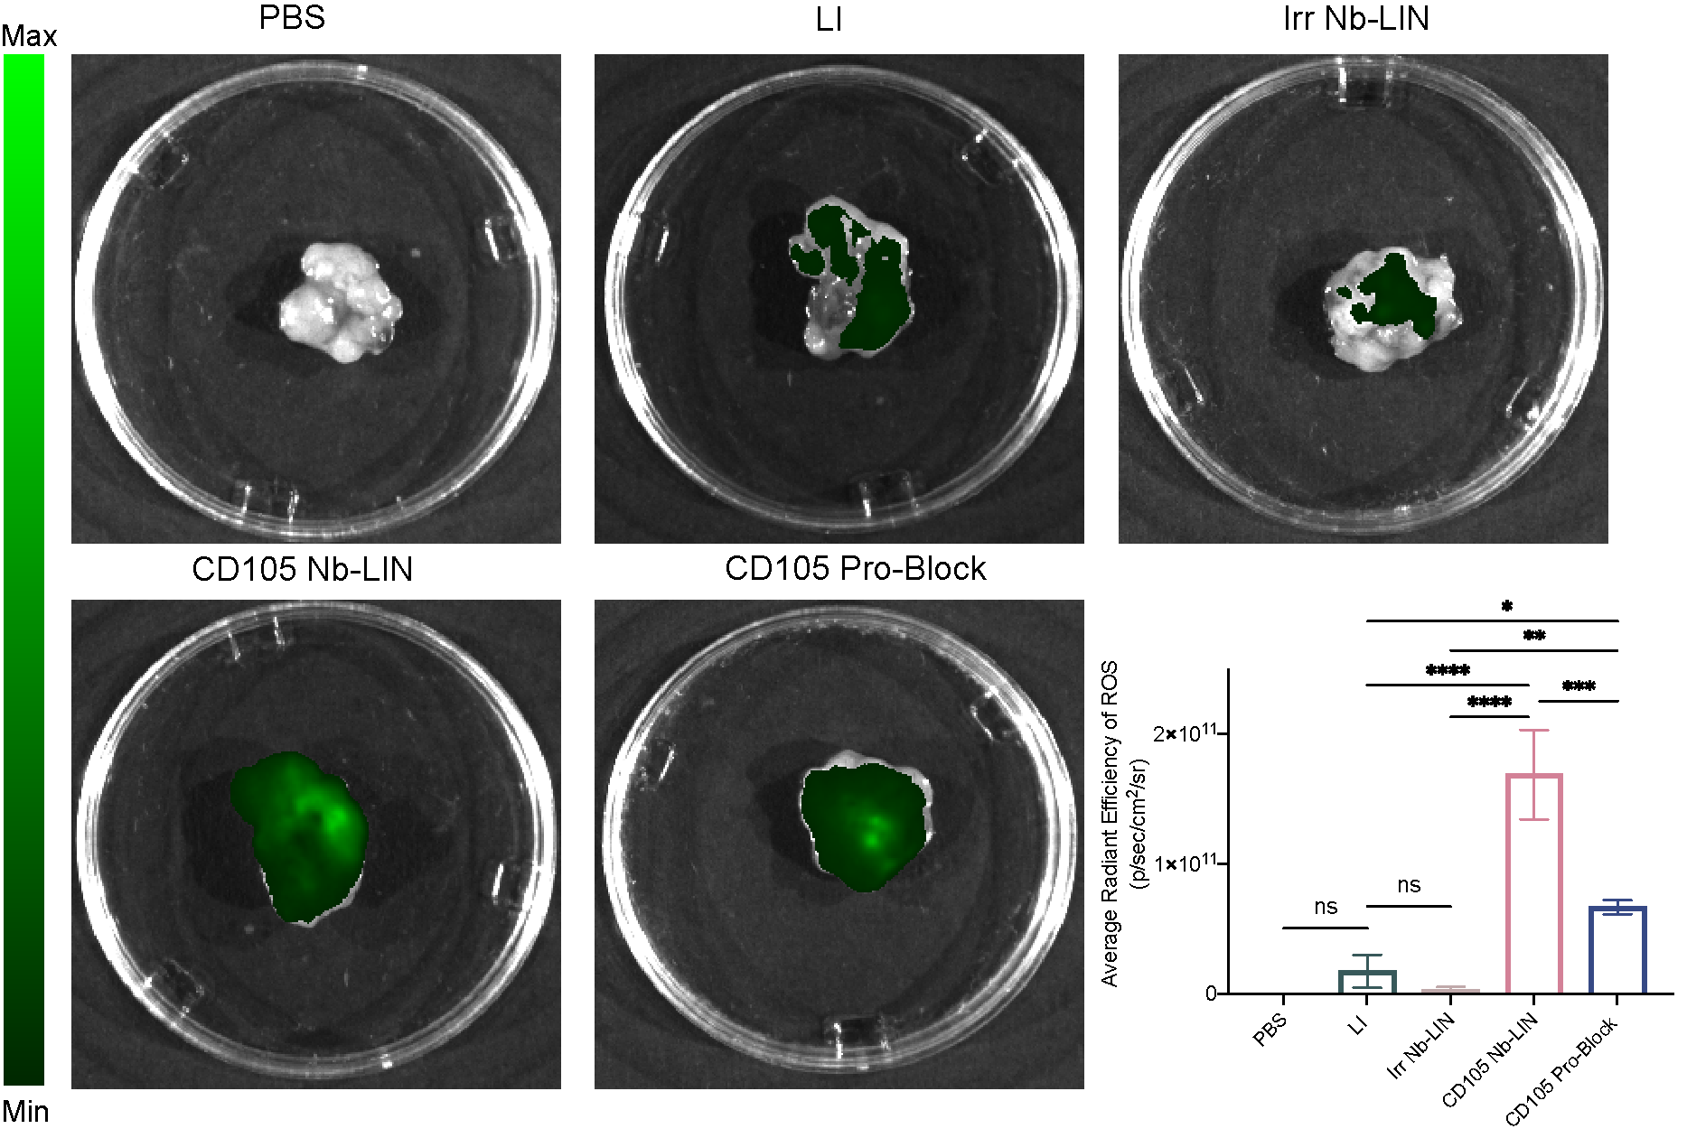
Figure S14. Ex vivo fluorescence imaging and quantification of ROS generation (average radiance: photons s⁻¹ cm⁻² sr⁻¹) in tumor tissues excised from mice following the indicated treatments. Data are presented as mean ± SD (n = 3). Statistical significance: ns, not significant; *p < 0.05, **p < 0.01, ***p < 0.001, and ****p < 0.0001.
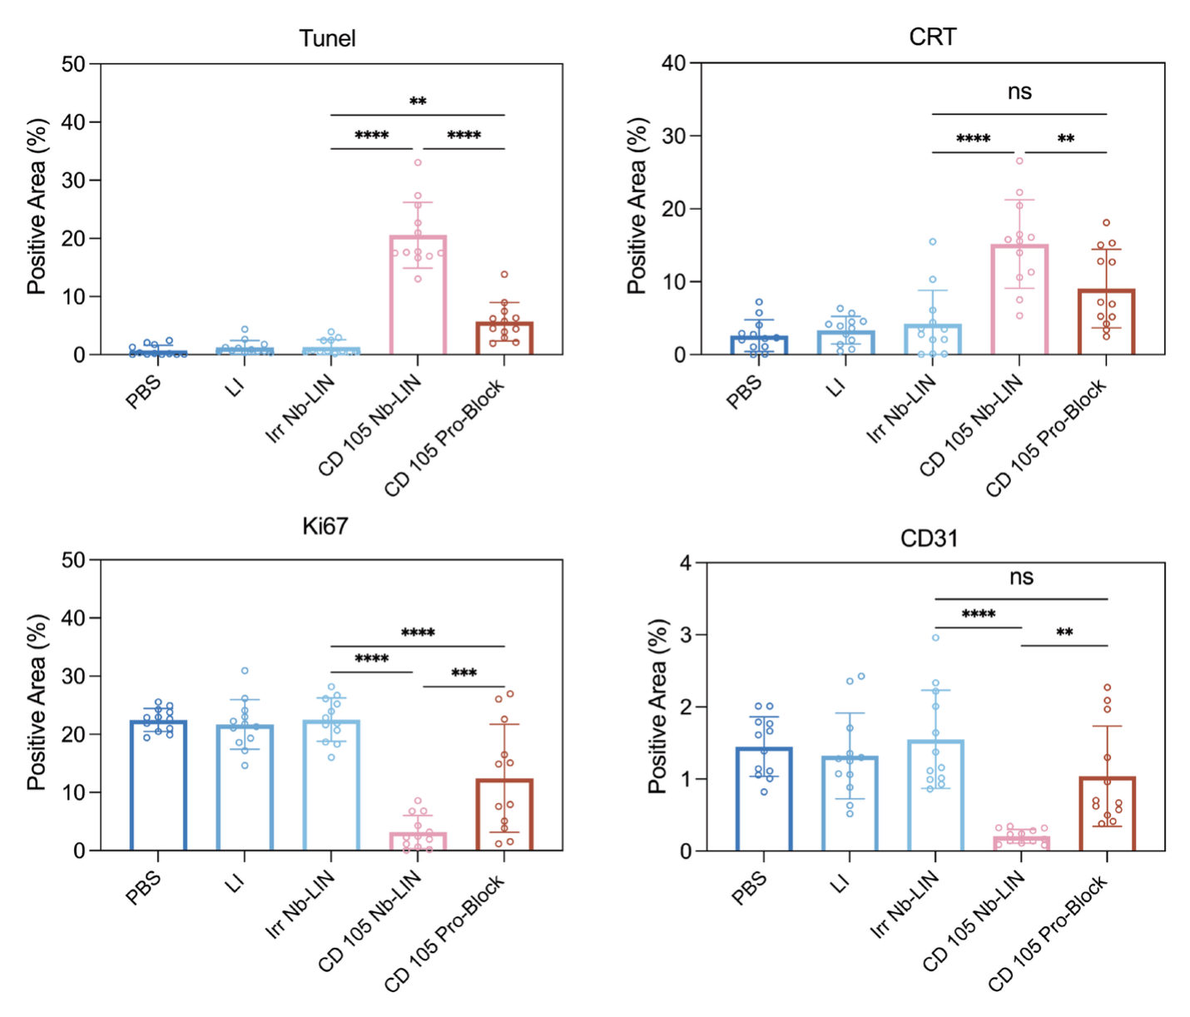 Figure S15. Quantitative analysis of the positive areas for TUNEL, Ki67, CRT, and CD31. Data are presented as mean ± SD (n = 3). Statistical significance: ns, not significant; **p < 0.01, ***p < 0.001, and ****p < 0.0001.

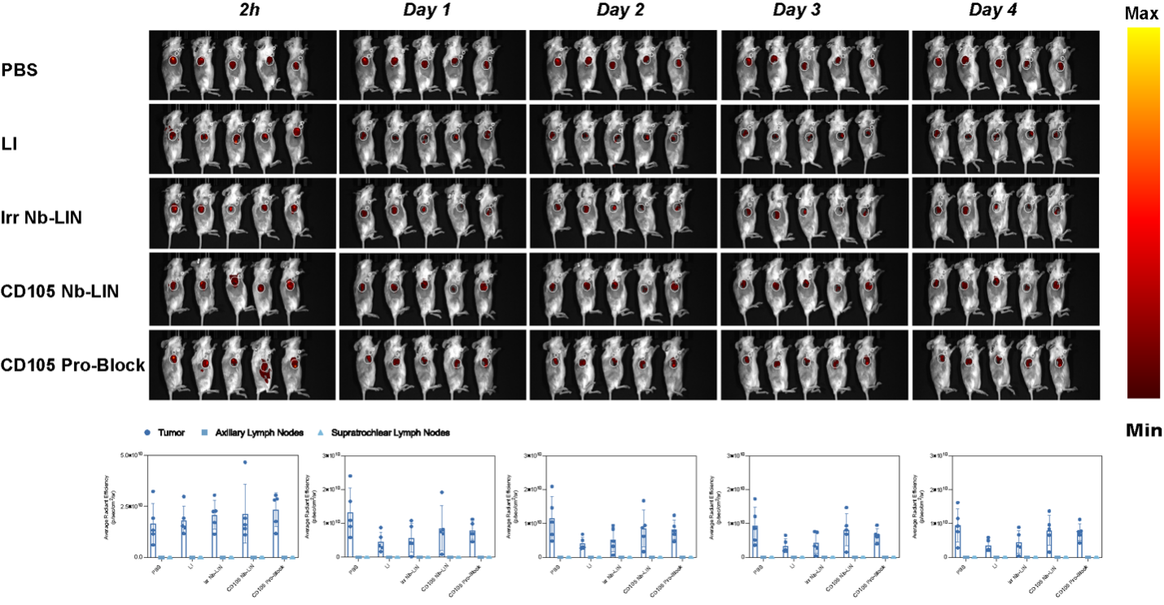
Figure S16. Representative fluorescence images showing dendritic cell (DC) tracking in mice following different treatments. Regions of interest are indicated by white circles; fluorescence intensity is quantified as radiance (photons s⁻¹ cm⁻² sr⁻¹). Data are presented as mean ± SD (n = 3). ns, not significant.
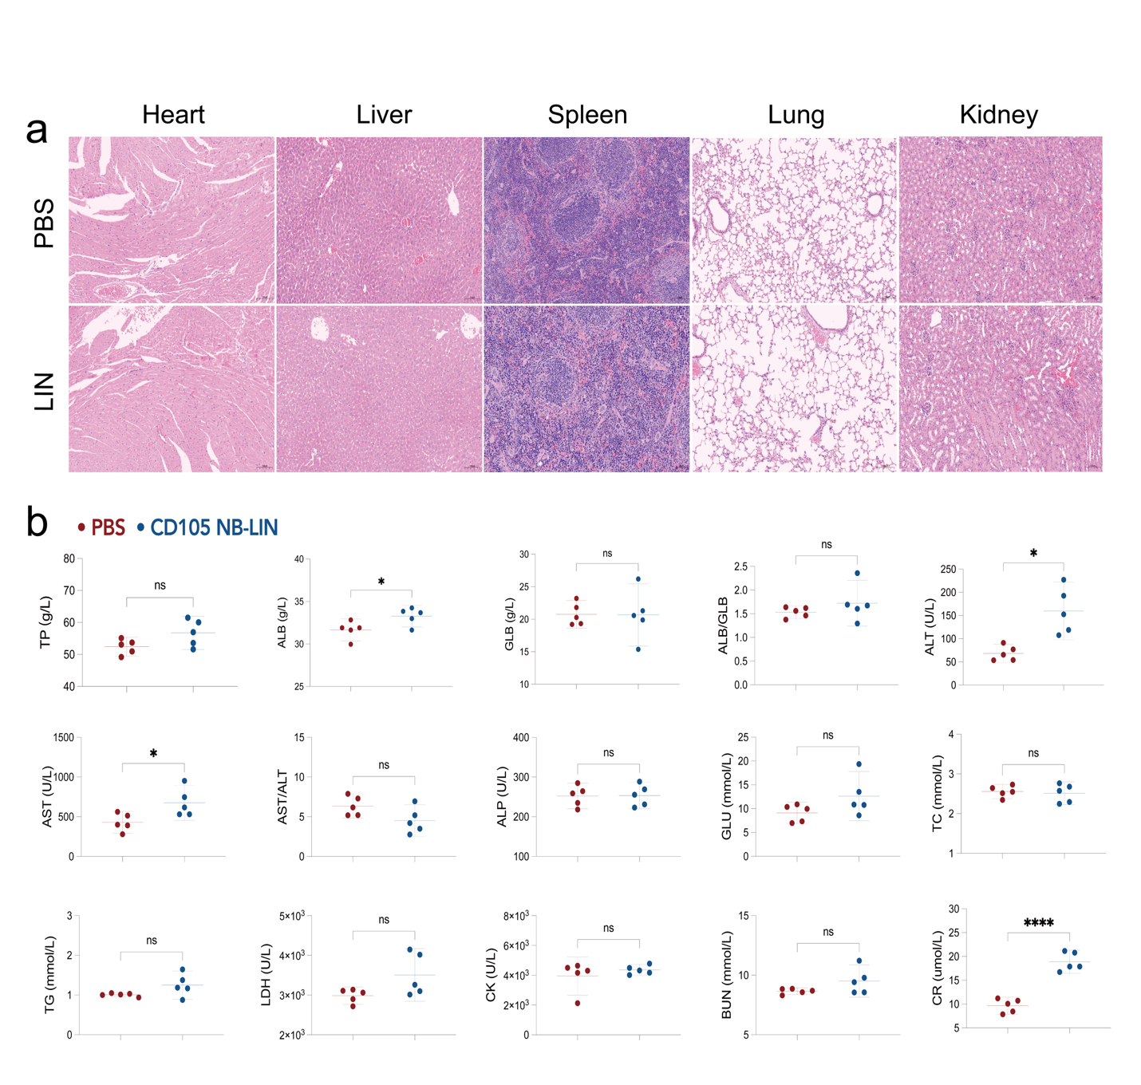Figure S17. In vivo biosafety analysis. (A) H&E staining of the major organs (heart, liver, spleen, lung, and kidney) collected from healthy mice treated with PBS and CD105 Nb-LIN. (B) Serum biochemical parameters were analyzed to assess systemic toxicity, including liver function markers (TP, ALB, GLB, ALT, AST, ALP), metabolic indicators (GLU, TC, TG), kidney function markers (BUN and CR), and myocardial enzymes (CK and LDH). Data are presented as mean ± SD (n = 5). ns, not significant; *p < 0.05, ****p < 0.0001.

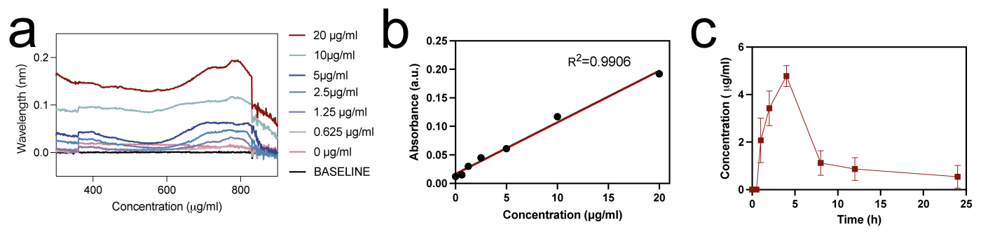
Figure S18. Pharmacokinetic study of CD105 Nb-LIN (a) UV–vis absorbance spectra of CD105 Nb-LIN in plasma at reference concentrations. (b) The standard curve of UV absorption at 780 nm over various concentrations of CD105 Nb-LIN (ICG = 0–20 µg/mL). (c) Drug concentration-time curve of CD105 Nb-LIN in SD rats within 24 h after drug administration (n = 3).

