TABLES

Table 1: Characteristics of the study population and job categories assigned based on information furnished to the laboratory on test requesting documents.

Occupation | Main Duties | Total (n) |  | Exposure Category
Occupation | Main Duties | men | women | Exposure Category
Fitter | - Assemble, install and maintain pipe systems & supports, and related hydraulic & pneumatic equipment for oil, steam and hot water for industrial production & processing systems.  - Remove blockages, water or other fluids from the ground or other areas in which they are unwanted.  - Rectify any potential material failures that may be caused by cracks or leaks in the pipeline. | 2 | 0 | High
Mechanic | - Repair, install, adjust or maintain industrial production and processing machinery or refinery and pipeline distribution systems. Test new machinery before use or installation.  - Conduct regular inspections to identify faulty equipment (e.g. pumps, engines, turbines, etc.) | 1 | 0 | High
Boiler Operator | - Maintain heating systems in the boiler, engines and mechanical rooms. | 3 | 1 | High
Process Controller | - Engineer responsible for plant monitoring, sampling, start-up and shutdown, commissioning & decommissioning of equipment. | 9 | 4 | High
Senior Process Controller | - Senior engineer responsible for creating or maintaining automation processes.  - Controls plant performance, supervising, guiding and addressing priorities or performance related deviations. | 1 | 0 | High
Supervisor | - Oversees the workflow, supervises the work of others while coaching, resolving issues and serving as a link between subordinates and upper management. | 3 | 0 | High
Artisan (Hand) | - Responsible for installing, repair and maintenance work. | 1 | 0 | Moderate
Welder | - Operate welding equipment to fuse metals using various cutting, gouging and welding processes on pipelines, plants and facilities. | 1 | 0 | Moderate
Transport workshop | - Servicing and/or repairing of vehicles. | 2 | 0 | Moderate
Lab Technician | - Prepares reagents for laboratory and refinery use. Maintains and repairs laboratory equipment as necessary.  - Performs quality assurance testing on refinery stream samples and finished products, to ensure compliance with Federal, State and company regulations. | 1 | 1 | Moderate
Chemist | - Petroleum characterization, developing and improving oil based products, including fuel and polymers.  - Developing catalysts for use in refining and creating new polymers for fibers and resins. | 1 | 1 | Moderate
Transport Manager | - Administrative work, managing execution, direction, and coordination of all transportation matters within the organization. | 1 | 0 | Low
Transport clerk | - Office work; organize shipping, handling, storage and transportation of goods and provide logistic services. | 1 | 0 | Low
Branch Manager | - Office work; responsible for all of the functions of a branch location; hiring employees, finances, marketing, public and customer relations. | 1 | 0 | Low
Laboratory cleaner | - Cleans facilities and grounds using proper cleaning procedures, transport waste materials to designated collection points. | 1 | 1 | Low
Total |  | 21 | 8
Age ranges (years) |  | 30 to 65 | 32 to 57

Table 2: The results of various urine tests (phenol, o-cresol and methylhippuric acid) requested by a petroleum refinery from Analytical Services laboratory at the National Institute for Occupational Health.

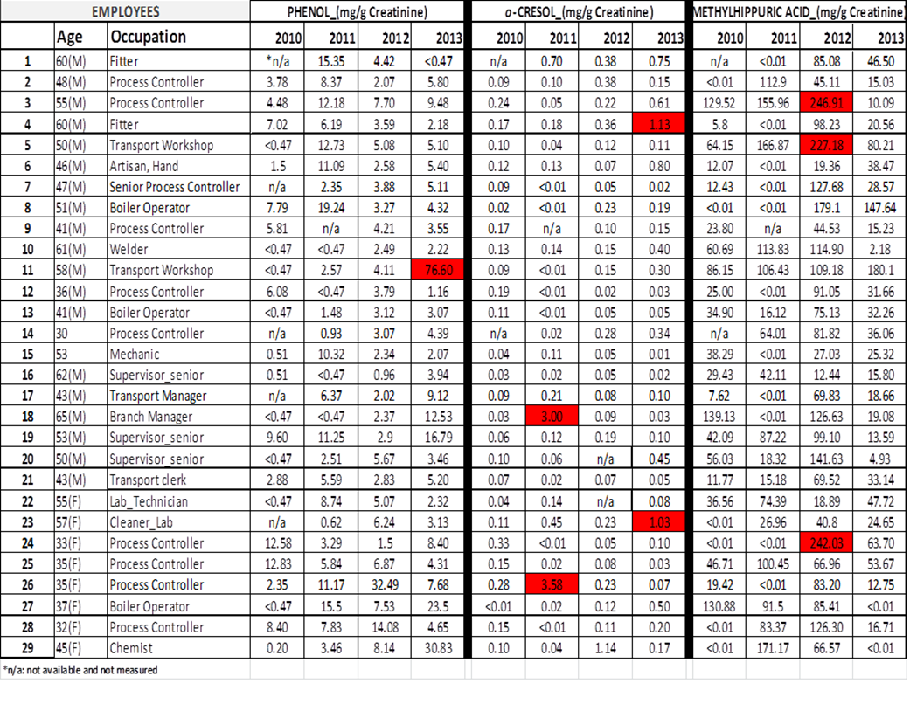

Table 3: Chemical exposure levels believed to be safe for workers (16).

Chemical | Biomarker in urine | Unexposed person | Biological Exposure Index (post shift)
Benzene | phenol | ≤ 20 mg/g creatinine | 50 mg/g creatinine
Toluene | o-cresol | ≤ 0.3 mg/g creatinine | 1 mg/g creatinine
Xylene | methylhippuric acid | ≤ 12 mg/g creatinine | 1500 mg/g creatinine

Table 4: Comparison of urinary phenol levels among the petroleum refinery workers in the low, moderate and high benzene exposure job categories using the Tukey-Kramer post-hoc test.
Tukey-Kramer test
Comparison | Absolute difference | Critical Value | Results* | Conclusion
Low/Moderate | 0.5200 | 4.7442 | The means are not significantly different. | Workers in these job categories have the same level of benzene exposure.
Low/ §High | 3.2596 | 4.1682 | The means are not significantly different | Workers in these job categories have the same level of benzene exposure
Moderate/ §High | 3.7796 | 3.1419 | The means are significantly different | The level of benzene exposure is not the same (one group is more exposed).
§ Workers in this category are more exposed |  |  | * when: [Abs difference] > [Crit value] then (The means are different)

Table 5: Results of the comparison of urinary methylhippuric acid levels among workers in the low, moderate and high xylene exposure job categories using the Tukey-Kramer post-hoc test.

Tukey-Kramer test
Comparison | Absolute difference | Critical Range | Results* | Conclusion
Low/§Moderate | 94.91 | 76.32 | The means are significantly different | The level of xylene exposure is not the same (one group is more exposed).
Low/High | 30.09 | 65.04 | The means are not significantly different | Workers in these job categories have the same level of xylene exposure
§Moderate/High | 64.82 | 55.37 | The means are significantly different | The level of xylene exposure is not the same (one group is more exposed).
§Workers in this category are more exposed |  |  | * when: [Abs difference] > [Crit value] then the means are different

