APPENDICES

APPENDIX ONE

INSTRUMENT-QUESTIONNAIRE
UNIVERSITY OF IBADAN
DEPARTMENT OF PSYCHOLOGY

Dear respondent,
I am Folarin Olawale Amir, a final year student of the department of Psychology, University of Ibadan. I am conducting this research on ‘Workplace bullying and moral disengagement as predictors of emotional exhaustion among correctional facility workers in Oyo state, Nigeria’ for my final year project. Your participation in this study is voluntary and you may withdraw at any time without penalty. Kindly read and follow the instructions in each section and also provide sincere responses to the questions in each section. The responses provided by you would ONLY be used for the purpose of my final year project. Therefore, confidentiality is guaranteed.
By completing this questionnaire, you indicate your consent to participate in this study.
Thank You.
SECTION A: DEMOGRAPHICS
Age------------
Gender-------- Male { } Female { }
Religion—Christianity { } Islam { } Other { }
Ethnicity----Yoruba { } Igbo { } Hausa { } Other {please Specify} ---------
Marital Status: Single { } Married { } Divorce { } Widowed { }
Highest Educational Qualification --------------------------------
Job Status---------------------------------
Job Role: -------------------------------
Years of Work Experience in Correctional Service: ---------------------------
Length of Service at Current Facility: --------------------------------------------

SECTION B
Kindly respond to the following statements by ticking which of the scales ranging from NEVER to DAILY that best describes your response to the statements. Thank you.
S/N | ITEMS | NEVER | NOW AND  THEN | MONTHLY | WEEKLY | DAILY
1 | Someone withholding information that affects your performance
2 | Being humiliated or ridiculed in connection with your work
3 | Being ordered to do work below your level of competence
4 | Having key areas of responsibility removed or replaced with more trivial or unpleasant tasks
5 | Spreading of gossip or rumors about you
6 | Being ignored or excluded
7 | Having insulting or offensive remarks made about your person, your attitudes, or your private life
8 | Being shouted at or being the target of spontaneous anger
9 | Intimidating behaviors such as finger-pointing, invasion of personal space, shoving, blocking your way
10 | Hints or signals from others that you should quit your job
11 | Repeated reminders of your errors or mistakes
12 | Being ignored or facing a hostile reaction when you approach
13 | Persistent criticism of your errors or mistakes
14 | Having your opinions ignored
15 | Practical jokes carried out by people you don’t get along with
16 | Being given tasks with unreasonable deadlines
17 | Having allegations made against you
18 | Excessive monitoring of your work
19 | Pressure not to claim something to which by right you are entitled
20 | Being the subject of excessive teasing and sarcasm
21 | Being exposed to an unmanageable workload
22 | Threats of violence or physical abuse or actual abuse

SECTION C
Kindly read each of the following statements and indicate the number that best reflects your agreement with the statement. Thank you. Not at all agree = 1 , slightly agree = 2 Somewhat agree = 3 , Agree = 4 , Completely agree = 5.

S/N | ITEMS | 1 | 2 | 3 | 4 | 5
1 | In this organization, it is considered acceptable to be conservative with the truth to help protect our reputation
2 | In this organization, it is acceptable to cheat a little to help save jobs.
3 | In this organization, omitting information or exaggerating is considered to be just part of ‘playing the game’ when negotiating
4 | In this organization, ‘glossing over’ certain facts to clients/customers is just our standard working practice
5 | Considering the ways our competitors grossly misrepresent their products/services, it is no big deal for my organizations to inflate the credentials of our products/ services a bit
6 | Compared with the illegal activities of many other companies, the slight irregularities in how we implement the regulations are not ;8really a concern
7 | In this organization, it is ok to do something questionable, as we are simply following the rules and procedures
8 | In this organization, an employee is not considered responsible for engaging in questionable behavior if they are simply following the request of their of their manager
9 | In this organization, it is often unclear how decisions were made so no one can be held accountable for any harmful consequences
10 | In this organization, responsibilities are often split up so that no one can be held accountable for possible wrongdoing
11 | It is no big deal to tell small lies on behalf of the company, because no one gets hurt
12 | In this organization, questionable shortcuts are fine since there is no proof of their negative consequences
13 | The end users are just faceless numbers to us, so we don’t have to worry about them or how our activities affect them
14 | In this organization, customers/clients are seen more as ‘cash cows’ than people and it doesn’t matter how we treat them as long as we sell our goods/products/services
15 | If this company’s activities cause any problems for users, it’s probably because they have not read or followed the advice/instructions properly
16 | If this company misuses people’s data, it is their own fault because they should have taken precautions to protect their privacy

SECTION D
Kindly read each of the following statements and indicate the number that best reflects your agreement with the statement. Thank you. Never= 0 , A few times a year or less = 1, Once a month or less = 2 , A few times a month = 3 , Once a week= 4 , A few times a week= 5 , Every day= 6.
S/N | ITEMS | 0 | 1 | 2 | 3 | 4 | 5 | 6
1 | Feeling emotionally drained from work
2 | Feel used up at the end of the workday
3 | Feel fatigued when getting up in the morning
4 | Can easily understand patients’ problems
5 | Treat patients as impersonal ‘objects’
6 | Working with people puts too much stress
7 | Deal effectively with the patients’ problems
8 | Feel burned out from work
9 | Feel positively influencing people’s lives
10 | Become more callous toward people
11 | Worry that job is hardening emotionally
12 | Feel very energetic
13 | Feel frustrated by job
14 | Feel working too hard on the job
15 | Don’t really care what happens to patients
16 | Working with patients is a strain
17 | Can easily create a relaxed atmosphere
18 | Feel exhilarated after working with patients
19 | Have accomplished worthwhile things in job
20 | Feel like at the end of the rope
21 | Deal with emotional problems calmly
22 | Feel patients blame me for their problems

APPENDIX TWO
INFORMED CONSENT FORM

Title of the research: WORKPLACE BULLYING AND MORAL DISENGAGEMENT AS PREDICTORS OF EMOTIONAL EXHAUSTION AMONG CORRECTIONAL FACILITY WORKERS IN OYO STATE.

Name(s) and affiliation(s) of researcher(s) of applicant(s): This study is being conducted by Folarin Olawale Amir of the Department of Psychology, University of Ibadan, Nigeria.
Sponsor(s) of research: Mr and Mrs Folarin
Purpose(s) of research: The study is in partial fulfillment of the award of a Bachelor of Science degree in Psychology.
Procedure of the research, what shall be required of each participant and approximate total number of participants that would be involved in the research: To establish ethical Issues in Informed Consent and Respect for persons I intend to rely on quantitative methods to gather useful information that will address the questions raised and the objectives of the study. In this regard therefore, the study will focus on correctional facility workers at Agodi maximum prison, Childcare, rescue abandoned children and juvenile correctional institution and Abolongo correctional centre, the estimated sample of researchers to be used for the study is 200.
Expected duration of research and of participant(s)’ involvement: In total, it is expected that the data collection should take 3 weeks.
Risk(s): There are no risk associated with the study
Costs to the participants, if any, of joining the research: Your participation in this research will not require any financial or material cost.
Benefit(s):

Confidentiality: All information collected in this study will be given code numbers and no name will be recorded. This cannot be linked to you in any way and your name or any identifier will not be used in any publication or reports from this study. As part of my responsibility to conduct this research properly, officials from NHREC and SSHE ethics committee in University of Ibadan, Research Officer may have access to these records.

Voluntariness: Your participation in this research is entirely voluntary.

Due inducement(s): You may be compensated for lost time i.e. cost of time spent participating in the interview.

Consequences of participants’ decision to withdraw from research and procedure for orderly termination of participation: You can also choose to withdraw from the research at any time. Please note that some of the information that has been obtained about you before you chose to withdraw may have been modified or used in reports and publications. These cannot be removed anymore. However the researcher promise to make good faith effort to comply with your wishes as much as is practicable

What happens to research participants and communities when the research is over: The researcher will inform you, as a way of feedback mechanism and as a partner in this study, of the outcome of the research through community advocacy, a news bulletin. During the course of this research, you will be informed about any information that may affect your continued participation.

Statement of person obtaining informed consent:
I have fully explained this research to ____________________________________ and have given sufficient information, including about risks and benefits, to make an informed decision.

DATE: _____________________ SIGNATURE: _______________________________
NAME: ______________________________________________

Statement of person giving consent:
I have read the description of the research or have had it translated into language I understand. I have also talked it over with my family or friend to my satisfaction. I understand that my participation is voluntary. I know enough about the purpose, methods, risks and benefits of the research study to judge that I want to take part in it. I understand that I may freely stop being part of this study at any time. I have received a copy of this consent form and additional information sheet to keep for myself.

DATE: ___________________ SIGNATURE: _________________________________
NAME: _____________________________________________
WITNESS’ SIGNATURE (if applicable): ___________________________
WITNESS’ NAME (if applicable): ______________________________________

Detailed contact information including contact address, telephone, fax, e-mail and any other contact information of researcher(s), institutional HREC and head of the institution: This research has been approved by the Research Ethics Committee of the University of Ibadan and the Chairman of this Committee can be contacted at Room 140, Dean’s floor, Faculty of the Social Sciences, University of Ibadan. Email: sshrecui@gmail.com In addition, if you have any question about your participation in this research, you can contact the Principal Investigator, =========
Department of --------- University of -------, Nigeria.
Phone number ----------- and email:

PLEASE KEEP A COPY OF THE SIGNED INFORMED CONSENT.

APPENDIX FOUR
ETHICAL APPROVAL FROM THE SOCIAL SCIENCES AND HUMANITIES ETHICS RESEARCH COMMITTEE
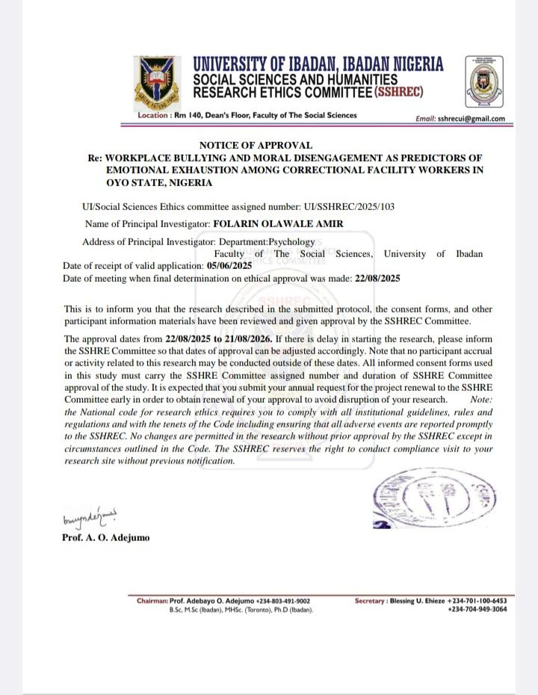

RESULTS
This chapter presents the results of the data analysis in tabular format and the interpretation of finding. The demographic information of the respondents are reported while the stated hypotheses are tested using appropriate statistical tools.
4.1 Inter-correlations among Demographic Variables of Study
Table 4.1: presents the zero-order correlations, means, and standard deviations among the demographic and study variables.
Zero Order Correlation Summary, Showing The Correlation Of Age, Gender, Religion, Ethnicity, Marital Status, Highest Educational Qualification, Years of Work Experience in Correctional Service, Length of Service at Current Facility, Job Status, Workplace Bullying, Moral Disengagement, and Emotional Exhaustion
Variable | M | SD | 1 | 2 | 3 | 4 | 5 | 6 | 7 | 8
1. Age | 40.81 | 7.63 | - | - | - | - | - | - | - | -
2.Gender | 1.41 | .49 | -.17* | - | - | - | - | - | - | -
3. Marital Status | 1.89 | .54 | .52** | -.08 | - | - | - | - | - | -
4. Highest Educational Qualifications | 4.29 | 1.72 | .20* | -.49** | .17* | - | - | - | - | -
5. Job Status | 7.44 | 4.11 | .07 | -.56** | .04 | .44** | - | - | - | -
6. Workplace Bullying | 59.07 | 19.79 | .10 | .01 | .05 | -.06 | -.03 | - | - | -
7. Moral Disengagement | 48.2 | 12.45 | .09 | .11 | .12 | -.05 | -.16 | .63** | - | -
8. Emotional Exhaustion | 39.15 | 14.19 | .022** | .12 | .21* | -.04 | -.13 | .71** | .69** | -
;significant at p<0.05 * significant at p<0.01 ** significant at p<0.001***

4.2 Hypothesis Testing

Hypothesis One
Hypothesis one stated that Workplace bullying will significantly influence emotional exhaustion among correctional facility workers in Oyo state. The stated hypothesis is tested using simple linear regression and presented in Table 4.2.
Table 4.2
Simple Linear Regression analysis summary table showing the results of the Influence of Workplace Bullying on Emotional Exhaustion Among Correctional Facility Workers in Oyo State
Variable | β | t | R | R² | F | p
Workplace Bullying | 1.743 | 12.1 | .711 | .51 | 145.38 | <.001
Dependent Variable: Emotional Exhaustion
The results as presented by Table 4.3 shows that there is a significant influence of workplace bullying on emotional exhaustion.
Hypothesis Two
Hypothesis two stated that moral disengagement will predict emotional exhaustion among correctional facility workers in Oyo state. The stated hypothesis is tested using simple linear regression and presented in Table 4.3.
Table 4.3
Simple Linear Regression analysis summary table showing the results of the Influence of Moral Disengagement in Emotional Exhaustion Among Correctional Facility Workers in Oyo State
Variable | β | t | R | R² | F | p
Moral Disengagement | .784 | 11.35 | .688 | .47 | 128.79 | <.001
Dependent Variable: Emotional Exhaustion
The results as presented by Table 4.3 shows that there is a significant influence of moral disengagement on emotional exhaustion.
Hypothesis Three
Hypothesis three stated that workplace bullying and moral disengagement will jointly and independently predict emotional exhaustion among correctional facility workers in Oyo state. The stated hypothesis is tested using multiple regression analysis and presented in Table 4.4.
Table 4.4
Multiple regression analysis summary table showing results on the influence of Workplace Bullying and Moral Disengagement on Emotional Exhaustion Among Correctional Facility Workers in Oyo State
 | Factor | β | t | p | R | R² | F | p
Model b | Moral Disengagement | .440 | 5.65 | <.001 | .773 | .597 | 104.56 | <.001
 | Workplace Bullying | .333 | 6.84 | <.001
Dependent Variable: Emotional Exhaustion
The results showed workplace bullying and moral disengagement jointly and independently significantly predict emotional exhaustion (R² = .597; F _{(2, 141)} = 104.56; p<.001). The independent variables had an R value of 0.773 and an R² change of 0.597, thus 59.7% of the change in emotional exhaustion was accounted for by workplace bullying and moral disengagement.
Hypothesis Four
Hypothesis four stated that male correctional facility workers will report significantly higher levels of emotional exhaustion compared to female correctional facility workers in Oyo state. The stated hypothesis is tested using t-test and presented in Table 4.5.
Table 4.5
T-test for independent samples summary table showing results on gender differences on Emotional Exhaustion among Correctional Facility Workers in Oyo State.
 | N | M | SD | df | t | p | F
Emotional Exhaustion  Male  Female | 88  62 | 29.65  33.17 | 13.8  14.6 | 117.61 | -1.45 | >.05 | 2.590

The results displayed in Table 4.5 revealed that there is no significant difference in the level of emotional exhaustion reported by male and female correctional facility workers in Oyo state.

