Table 1: Spearman’s correlation (Rho) matrix across demographic and behavioral variables.
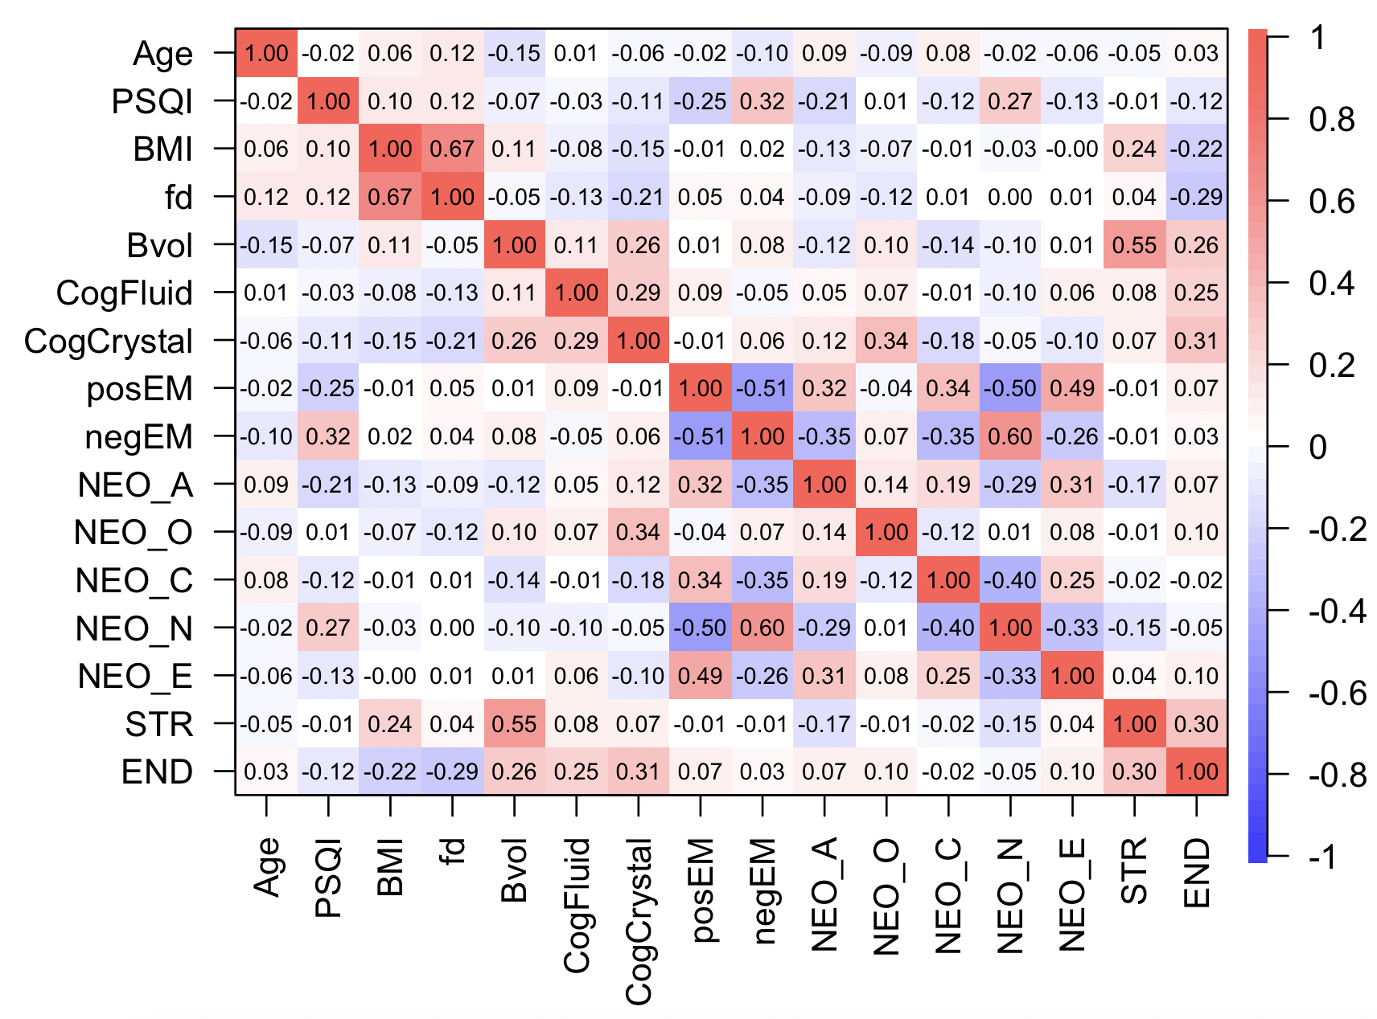
BMI = body mass index, PSQI = Pittsburgh Sleep Quality Index (total score), fd = mean framewise displacement, Bvol = brain volume, EM are emotional scores from a PCA of the NIH toolbox.

Table 2: Hierarchical regression results for all models.
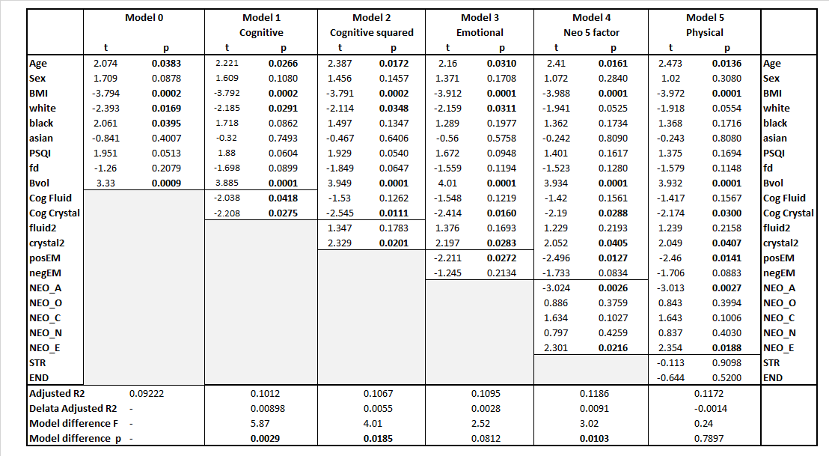
Note. BMI = body mass index, PSQI = Pittsburgh Sleep Quality Index (total score), fd = mean framewise displacement, Bvol = brain volume, fluid2 and crustal2 are squared cognitive scores, EM are emotional scores from a PCA of the NIH toolbox.

Table 3: Model 4 repeated in only males (n = 460) and only females (n = 527).
