Supplementary Figure 1
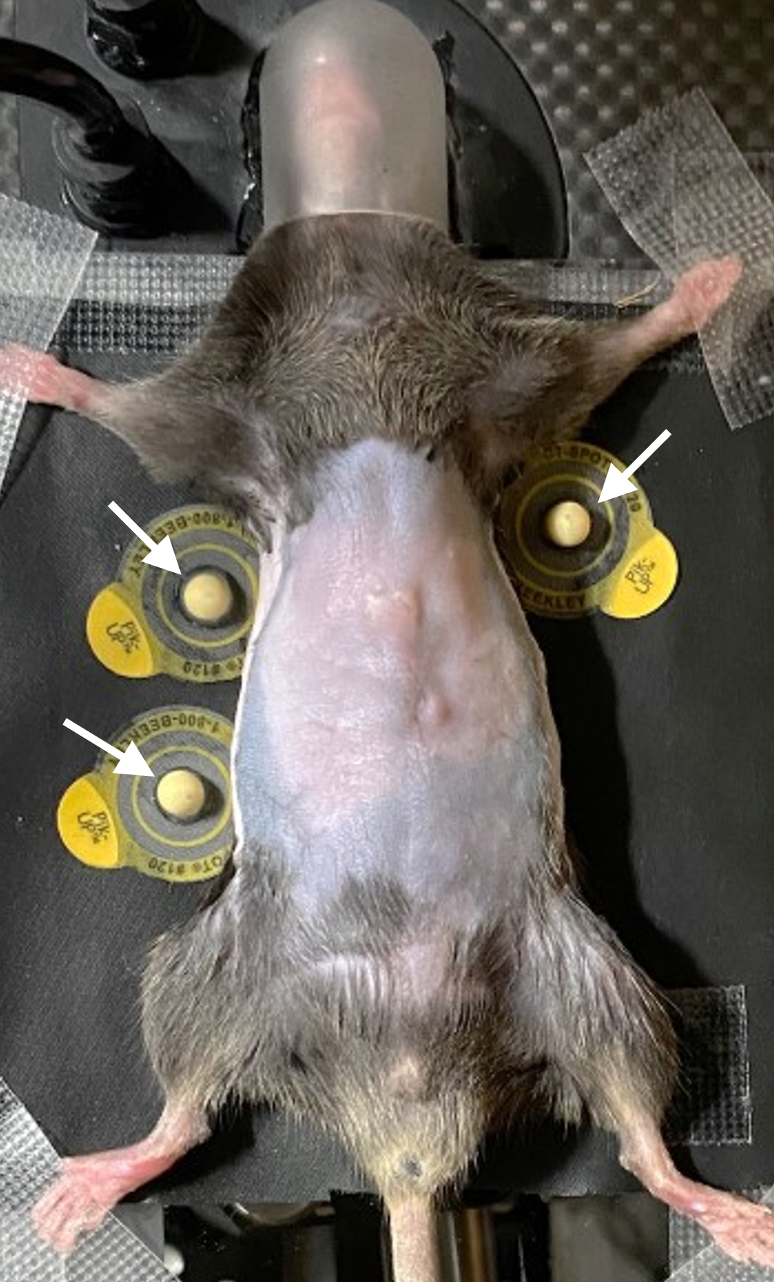
Supplementary Figure 1: Photograph of a representative mouse under anesthesia and on the imaging stage. The torso was shaved by applying a thin layer of Nair on both the dorsal and ventral surfaces. The ventral surface is facing the camera. The arrows indicated the locations of three CT fiducials.

Supplementary Table 1: In situ fluorescence intensity data
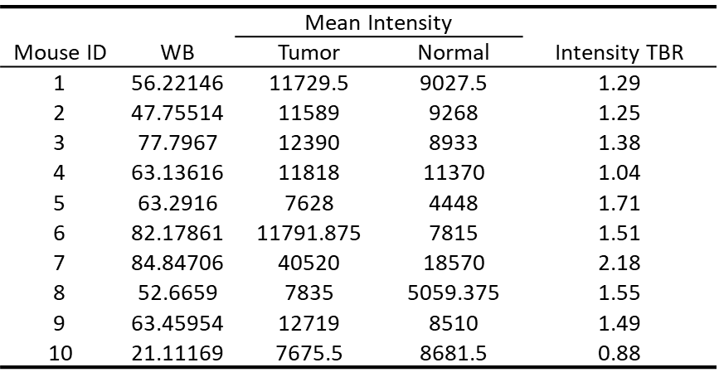
Supplementary Table 2: In situ FLT data
