Mass-Manufacturable Germanium Photodetectors for Beyond-448-Gbps-Class Operation on a Monolithic Silicon Photonics Platform

Yusheng Bian^{1,6,*}, Sujith Chandran^{1,6}, Qidi Liu^{1,6}, Abdelsalam Aboketaf^{1,6}, Won Suk Lee^{1,6}, Michelle Zhang^{1,6}, Teodor Stanev^{1,6}, Hanyi Ding^{1,6}, James Garofolo^{1,6}, Brian Popielarski^{1,6}, Madhuchhanda Brahma¹, Shaun Benjamin¹, Crystal Hedges¹, Jason Kim¹, Zahidur Chowdhury¹, Koushik Ramachandran¹, Massimo Sorbara¹, Shantanu Pal¹, Takako Hirokawa¹, Judson Holt¹, Michal Rakowski¹, Ming Gong¹, Kevin Dezfulian¹, Mrunal Shah¹, Helen Wong¹, Paul Diglio¹, Ben Cadieux¹, Daniel Smith¹, Javier Ayala¹, Asli Sahin¹, Eric Snow¹, Ken Giewont¹, Bob Mulfinger¹, Ryan Sporer¹, Lukas Chrostowski², Graham Reed³, Keren Bergman⁴, and John E. Bowers⁵
¹GlobalFoundries, 400 Stone Break Rd Ext., Malta, NY 12020, USA
²Department of Electrical & Computer Engineering, University of British Columbia, 2332 Main Mall, Vancouver V6T1Z4 BC, Canada
³Optoelectronics Research Centre, University of Southampton, Southampton, UK
⁴Department of Electrical Engineering, Columbia University, New York, NY, USA
⁵Department of Electrical & Computer Engineering, University of California Santa Barbara, Santa Barbara 93106 CA, USA
⁶These authors contributed equally

†e-mail: yusheng.bian@gf.com [corresponding author(s)are marked with dagger(s)† in the author list]

Abstract

The explosive growth of artificial intelligence (AI) and high‑performance computing (HPC) workloads is placing increasingly stringent demands on optical interconnects for fast, reliable, and mass‑manufacturable photonic receivers. Germanium (Ge)-on-silicon (Si) photodetectors have demonstrated impressive bandwidth and responsivity, yet large-signal operation beyond 400 Gbps per wavelength has remained largely inaccessible in foundry-compatible platforms. Here we show that a mass-manufacturable 300-mm monolithic complementary metal-oxide-semiconductor (CMOS) silicon photonics (SiPh) platform can overcome this limitation. An O‑band Ge‑on‑Si lateral photodetector achieves large‑signal data rates exceeding 448 Gbps per wavelength with four‑level pulse‑amplitude modulation (PAM4) and 520 Gbps with six‑level pulse‑amplitude modulation (PAM6) at a photocurrent of ~2 mA. This performance is enabled by an optoelectronic bandwidth of up to ~215 GHz, near‑unity quantum efficiency, and a record bandwidth-responsivity product exceeding ~217 GHz·A W⁻¹ - more than 2 times higher than the previous best of 108 GHz·A W⁻¹ for waveguide‑coupled Ge photodiodes - while sustaining optical input powers up to 2.8 mW and maintaining sub‑38 nA dark current at -1 V bias. Crucially, these metrics are attained without inductive peaking, avalanche gain, or transimpedance-amplifier (TIA) integration, with uniform high-speed characteristics across a full 300 mm wafer, underscoring production-level reproducibility. The same platform supports high-speed depletion-mode, travelling-wave Si Mach-Zehnder modulators (MZMs) capable of ≥400-Gbps per wavelength operation without digital signal processing (DSP), precision silicon nitride (SiN) wavelength-division-multiplexing (WDM) filters with sub-1.5 nanometre channel stability, low-loss detachable fibre-chip input-output (I/O) (~1 dB per facet), co-integrated CMOS circuits using ≥350-GHz-class f_{t} transistors, and advanced wafer-level packaging features. To the best of our knowledge, this is the first monolithic CMOS silicon photonics foundry platform uniting ≥400 Gbps-class transmitter and receiver functions on a single substrate, providing a scalable foundation for next-generation pluggable, near- and co-packaged (NPO/CPO) optical interconnects in AI/HPC systems.

S1. Monolithic silicon photonics platform capability

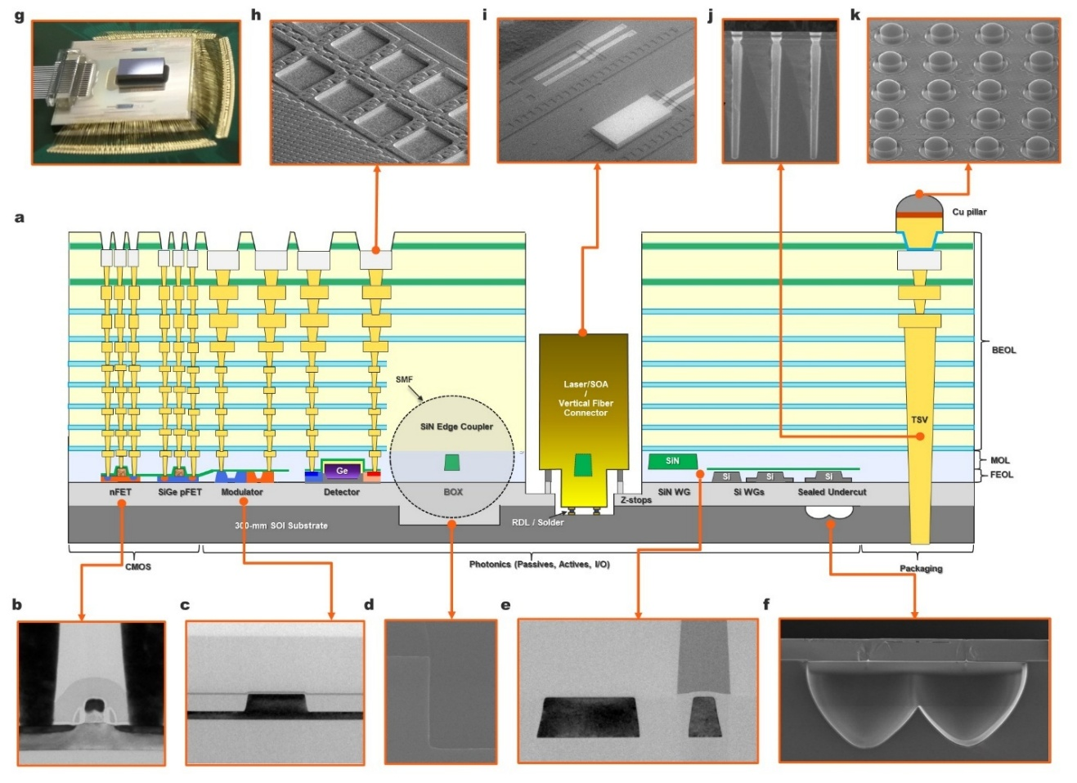

Supplementary Fig. 1 | Monolithic silicon photonics platform integrating advanced photonics, CMOS and packaging features on a single SOI substrate. a, Schematic cross-section of the 300-mm platform showing co-integration of 45-nm CMOS transistors alongside silicon and silicon nitride-based passive and active components, beneath a multi-level BEOL interconnect stack fully compatible with standard CMOS manufacturing and optional electronic-photonic co-integration. b-f, Additional CMOS and photonics device features in addition to high speed Ge photodetectors: high-speed transistors (b), pure-silicon modulators (MZM, MRM) (c), edge coupler with oxide-filled trench (d), silicon and silicon nitride passives including hybrid components such as the polarization splitter and rotator (PSR) (e), and sealed-undercut structure for optical and thermal isolations (f). g, Photograph of a packaged module with an electronic integrated circuit (EIC) flip-chip attached on top of the photonic integrated circuit (PIC), illustrating chip-to-chip electrical interconnects and V-groove-based optical I/O enabled by the platform's packaging infrastructure. h-k, Advanced packaging features, including top-level aluminium (Al) pads that serve as bond sites for wire bonding and as landing pads for on-wafer electrical probing and test access, copper pillar and copper receive pad interconnects (100–150 µm pitch, with ≤55 µm pitch in development), through-silicon vias (TSVs), and lithographically defined cavities for flip-chip attachment of III–V lasers and semiconductor optical amplifiers.

Supplementary Fig. 1 | Monolithic silicon photonics platform integrating advanced photonics, CMOS and packaging features on a single SOI substrate.
a, Schematic cross-section of the 300-mm platform showing co-integration of 45-nm CMOS transistors alongside silicon- and silicon nitride-based passive and active components, beneath a multi-level BEOL interconnect stack supporting up to nine metallization layers for high-frequency signal routing and electronic–photonic co-integration compatibility. For standalone PIC implementations, the backend stack can be simplified to ≤5 metallization layers to reduce process complexity and cost while preserving photonic functionality. b-f, Additional CMOS and photonics device features beyond high-speed Ge photodetectors: high-speed transistors (b), pure-silicon modulators (MZM, MRM) (c), edge coupler with oxide-filled trench (d), silicon and silicon nitride passives including hybrid components such as the polarization splitter and rotator (PSR) (e), and sealed-undercut structures for optical and thermal isolation (f). g, Photograph of a packaged module with an electronic integrated circuit (EIC) flip-chip attached on top of the photonic integrated circuit (PIC), illustrating chip-to-chip electrical interconnects and V-groove-based optical I/O enabled by the platform's packaging infrastructure. h-k, Advanced packaging features, including top-level aluminium pads for wire bonding and probing, copper pillar and copper receive pad interconnects (100–150 µm pitch and ≤55 µm pitch), through-silicon vias (TSVs), and lithographically defined cavities for flip-chip attachment of III–V lasers and semiconductor optical amplifiers.

S2. Wafer level measurement details including ILOTs, small and large signal measurements

S2.1 Responsivity and dark current measurement methodology
Accurate extraction of photodetector responsivity and dark current at wafer scale requires careful consideration of optical coupling variability and test structure design. Several measurement approaches are commonly employed in silicon photonics, including the use of dedicated input/output grating couplers per device/optical cutback structure, or shared coupling schemes combined with reference devices or dedicated optical cutbacks. Each approach involves different tradeoffs between accuracy, robustness, and suitability for high volume process monitoring.

Dark current measurement considerations
Dark current is measured electrically under reverse bias with the optical input blocked. Since dark current does not depend on optical coupling efficiency, it can be extracted directly without de-embedding. Measurements are performed at wafer level across multiple dies to assess distribution, outliers, and uniformity. The combination of low dark current and tight wafer scale distributions provides an important indicator of Ge material quality and junction integrity in a manufacturable process environment.

Responsivity measurement and extraction procedure
Calculating the responsivity of a photodiode requires a measurement of net photocurrent (total current under illumination - dark current) and an estimation of the optical power illuminating the junction, so as to populate the equation

$R=\frac{I_{photo}}{P_{PD}}$ (1)

This requires multiple measurements, and careful consideration regarding potential variations in test conditions between those measurements. At a minimum, this requires one optical-to-optical measurement for path loss, as well as one optical-to-electrical measurement for photocurrent in conjunction with the dark current measurement taken with the optical power supply shuttered.

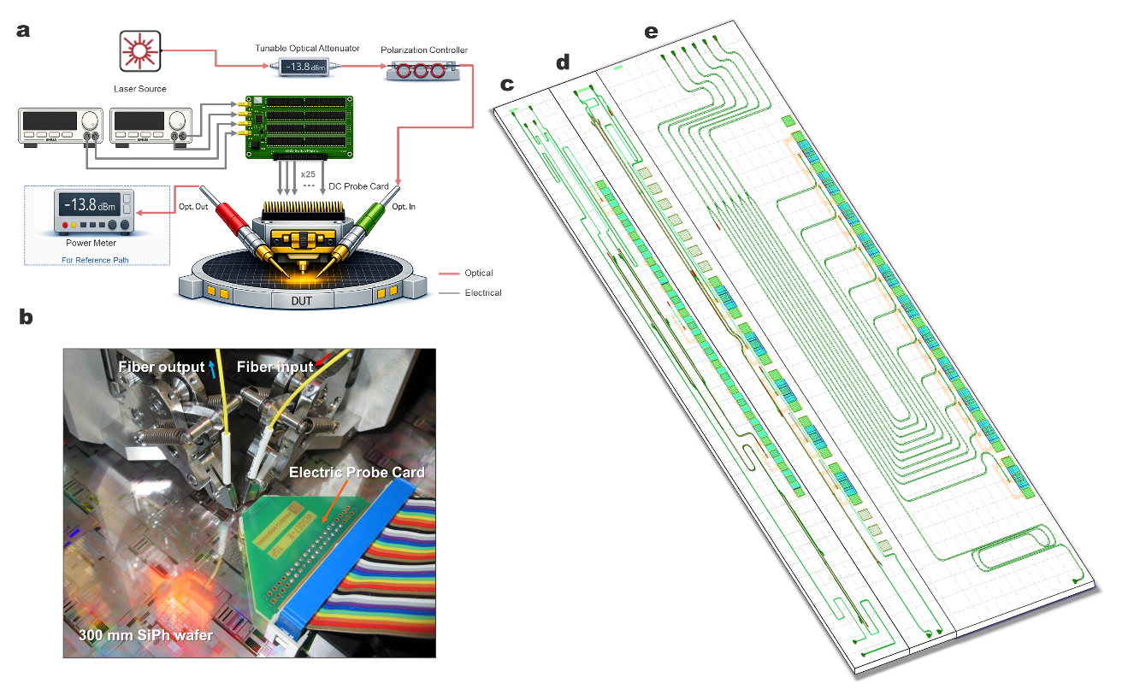

Supplementary Fig. 2 | Wafer-level ILOTS measurement setup and optimized test structures for Ge-on-Si photodetector characterization.
a, Schematic of the in-line optical test system (ILOTS) used for wafer-level electrical and optoelectronic characterization, incorporating calibrated optical source, attenuation and polarization control, together with electrical probing of the device under test. b, Photograph of the wafer-level measurement configuration, showing fiber-based optical coupling and electrical probe card contact on a 300-mm silicon photonics wafer. c, Conventional test structure employing paired photodiode and loss-matched reference paths, requiring independent optical alignment for each device under test. d, Optimized shared-alignment test structure enabling simultaneous reference and device measurement within a single optical alignment. e, ILOTS macro design adopted in this work for ultra-high-speed Ge PD measurements, combining a shared reference path with multiple photodetectors and on-chip splitting to reduce alignment steps while maintaining measurement accuracy, enabling efficient wafer-scale statistical characterization.

The measurement system used in this work is shown in Supplementary Fig.2 a-b. The system consists of a single-in-single-out optical probe pair, alongside a 25-pin DC cantilever probe card. The front-end-hardware is contained within a light box designed to comply with ANSI Z136.2 standards on laser safety for optical communication systems [1] as well as to shield the device under test from foreign materials and ambient lighting that may corrupt the measurement. Beside the prober is a test equipment rack, containing continuous-wave and tunable laser sources for both Oband and Cband, as well as a visible laser used in assisting with automated optical alignment. The equipment rack also contains two dual-channel source-measurement units (SMUs), a tunable attenuator, an 8x1 optical multiplexer switch, a 2x2 directional control switch, an optical fiber polarization controller and a 4-channel optical power meter. All of the optical equipment is connected using standard FC-APC single-mode fiber, and all of the optical paths are routinely calibrated to de-embed system losses for both the forward ($L_{TesterFWD}$) and return ($L_{TesterReturn}$) paths. This calibration is necessary for providing an accurate estimation of the power at the photodiode, which is derived using the optical power loss through the reference structure in Extended Data Eq. 2

$L_{RefPath}=10\log_{10}{(\frac{P_{Out}}{P_{In}}})-L_{TesterFWD}-L_{TesterReturn}$ (2)

In this equation, $P_{In}$ is measured using the tunable attenuator’s internal powermeter, and set to a value low enough as to not incur highly nonlinear loss through the silicon grating coupler. $P_{Out}$ is measured at the optical powermeter after using the motor controllers to execute a series of high-precision rasters for optimal alignment to the input and output gratings. The calibration constants are removed from the measured loss to yield a decible value for the loss of the cutback. With a cutback that is carefully designed to be double the optical path loss of the path to the photodiode under test, the power that will reach the photodiode under optimal alignment can then be estimated as

$P_{PD}={10}^{\left(\frac{10\log_{10}\left(P_{In}\right)+L_{TesterFWD}+\frac{L_{RefPath}}{2}}{10}\right)}$ (3)

Equipped with a power estimate, the tester can then bias the photodiode under test, move the input lens to the photodiode path, realign to the new grating by optimizing the measured current, and calculate the photocurrent for the diode as

$I_{Photo}=I_{Total}-I_{Dark}$ (4)

Where $I_{Dark}$ is the dark current for the diode, measured previously with the laser source shuttered. With these measurements and calculations, the tester is able to produce a single estimation of responsivity for a single device under test using Extended Data Eq. 1.

Design considerations for measurement robustness and relevance for wafer-scale statistics

Supplementary Fig.2c is an illustration of a relatively simple experimental design that is commonly used to characterize new photodiode designs. It consists of two pairs of optical paths, each with one photodiode and one loss-matched cutback path. While the solution is elegant and robust to varying path length, it comes with some drawbacks that necessitate further innovation. First, this strategy for designing test structures requires 2N optical alignments, where N is the number of photodiodes under test, which can add up to a large amount of time when scaled to wafer level statistical experiments. Second, each alignment comes with some variability due to slight mismatches in alignment optimality. This variability can dominate the variance of the measurement, leading to a high spread on a well-controlled manufacturing process.

To circumvent these challenges, the strategies shown in Supplementary Fig.2d-e are adopted to measure the responsivity of the ultra-fast Ge photodetector presented in this work. Supplementary Fig.2d solves the alignment time drawback, utilizing a single optical-to-optical alignment to ensure optimality for both the reference path and photodiode path; however, this methodology is still vulnerable to alignment variations in the output lens. For a compromise between speed and statistical robustness, this work adopts the strategy shown in Supplementary Fig.2e. This design consists of a single reference path alongside two photodiodes under test, fed by a 1x2MMI alongside two reference photodiodes of constant geometry and doping profile. Testing this circuit would require N+1 optical alignments compared to the 2N required in Supplementary Fig.2c, saving valuable time for large scale statistical device qualification experiments. The layout discussed in this work, depicted in Supplementary Fig.2e, consists of 5 photodiode experiments, and thus benefits from a 40% reduction in testing time from this methodology over the methodology used in Supplementary Fig.2c.

The reference photodiode selected for this work is manufactured and measured routinely in the GlobalFoundries 45SPCLO technology in circuits similar to Supplementary Fig.2c, granting access to a large historical dataset of trends across time, manufacturing tool, test tool and doping split. This allows experiments to leverage the robust statistics of the photodiode to normalize out the subtle differences in alignment or path length from DUT-to-DUT using the equation

$R_{DUT}=\frac{I_{DUT_Photo}}{P_{PD}}×\frac{R_{RefPD}P_{PD}}{I_{Ref_Photo}}$ (5)

By selecting $R_{RefPD}$ equal to the median across the technology, this approach allows for the fast and robust extraction of relative responsivity between devices that is necessary for high volume manufacturing. Selecting $R_{RefPD}$ equal to the wafer median would also make this extraction fabrication-aware, as the independent extraction of $R_{RefPD}$ using Extended Data Eq. 1 provides a reference for the absolute responsivity as it responds to manufactured geometries and implant conditions.

High-power measurement and role of silicon nitride routing
For measurements involving elevated input optical power, silicon nitride (SiN) waveguides are used in the optical routing path prior to the photodetector. SiN exhibits low nonlinear absorption and high-power handling capability, ensuring that optical loss, thermal effects, or nonlinearities in the routing waveguides do not distort the delivered power or affect the extracted responsivity. Compared to Si waveguide-based testing macros, this approach allows the intrinsic linearity and power handling limits of the photodetector itself to be evaluated, rather than those of the surrounding photonic circuitry.

S2.2 Bandwidth and Eye Diagram measurement methodology
Measuring the high frequency behavior of a photodiode requires careful consideration of the impedances of test equipment, which can vary heavily with tester configuration. To compensate for this variability, a strict procedure for electrical calibration must be followed to allow for accurate characterization of impedance mismatch. This approach allows for the de-embedding of environmental non-idealities, and enables clean extraction of device performance independent of surrounding circuitry.

Calibration of LCA/PNA for Bandwidth measurement
The setup for bandwidth measurement is shown in Supplementary Fig.3. To ensure proper de-embedding of all of the system impedances, the calibration procedure for bandwidth measurement is broken into three steps. Each step will produce an S2P calibration file, which can be cascaded with the next to produce the full system calibration constants.

First, the impedances of the cabling and LCA connections are measured using a 2 arm open-short-load calibration with a N4694-60003 electrical calibration module. During this process, it is critical to position the cables with long bend radii, and place the bends in positions along the length that will losely represent the assembled tester, as bending radius and location can significantly impact the cable impedance when measuring in the range of >50GHz.

Once the LCA and cable calibrations are complete, the cabling can be connected to the probe card for de-embedding of the probes and connector. This is done using a 101-190C ICC precision calibration structure with shorted, open and loaded padsets to model the effects of the RF probes in contact with a wafer. To select the proper over-travel, first contact is made with the calibration structure visually, and then over travel is increased gradually until the impedance begins to stabilize. This ensures a repeatable connection between the probe card and the wafer, which is necessary for wafer level testing where connections must be broken and remade frequently while gathering statistics.

Finally, to ensure highly accurate extraction of device characteristics, a third calibration can be done with open and shorted padsets matching the geometry of the high-speed wiring for the device under test. This allows for de-embedding of the metal stackup and dielectric constants of the technology, along with any mismatches in the wiring, leaving only the bandwidth characteristics of the device under test.

For small signal analysis, it is important to measure for a variety of optical powers to examine the thermal response and carrier screening effects on photodiode bandwidth. For accurate and efficient power setting during high-speed test, the device under test will first undergo responsivity measurement on a dedicated higher pinout DC tester. This will allow the high-speed test system to assume a responsivity value for the diode and tune optical power for a desired photocurrent, removing the need for precise optical calibration and loopback measurement. Once power is properly set, the LCA internal reference modulator can be enabled and the measurement can proceed.

Calibration of AWG and Oscilloscope for Bandwidth measurement

In the eyediagram measurement circuit (Fig. 3a), the oscilloscope clock reference is delivered through a controlled impedance path matched to the instrument termination, ensuring a stable timing reference for calibration and de-emphasis optimization across the electrical signal chain.
To optimize the connection between the AWG and the reference modulator, the modulator is driven with an external laser, and the optical output is connected to the optical input of the sampling oscilloscope. Once the driver settings are optimized out to the input of the reference modulator, the input cable can be connected to the cabling that connects the probe card to the oscilloscope to remove the added effects of the return circuitry from the measurement. Unlike with bandwidth measurement, this methodology cannot account for the effects of the probes and metal stackup without corrupting the measurement with aA posteriori knowledge of the device, so those effects are left uncompensated for in the resulting measurement.

Once the de-emphasis settings have been optimized, they are frozen for measurement and the setup is reassembled as shown in the schematic. After contacting the device under test, the optical power is set in the same photocurrent-driven manner as in the bandwidth methodology detailed in Supplementary S3. For large signal analysis of photodiodes, the ideal optical power should be set well above the dark current level while remaining below the carrier screening limitation of the device for the targeted Nyquist frequency of operation. Once the power is set correctly for the desired data rate, the AWG can begin driving the reference modulator, and the sampling oscilloscope can begin periodically sampling the higher frequency signal until the waveform is representatively sampled, averaging 32 periods of the pseudo-random binary sequence to produce the final eye histogram and relevant statistics on symbol error rate, outer modulation amplitude, rise/fall time, and TDECQ if applicable.

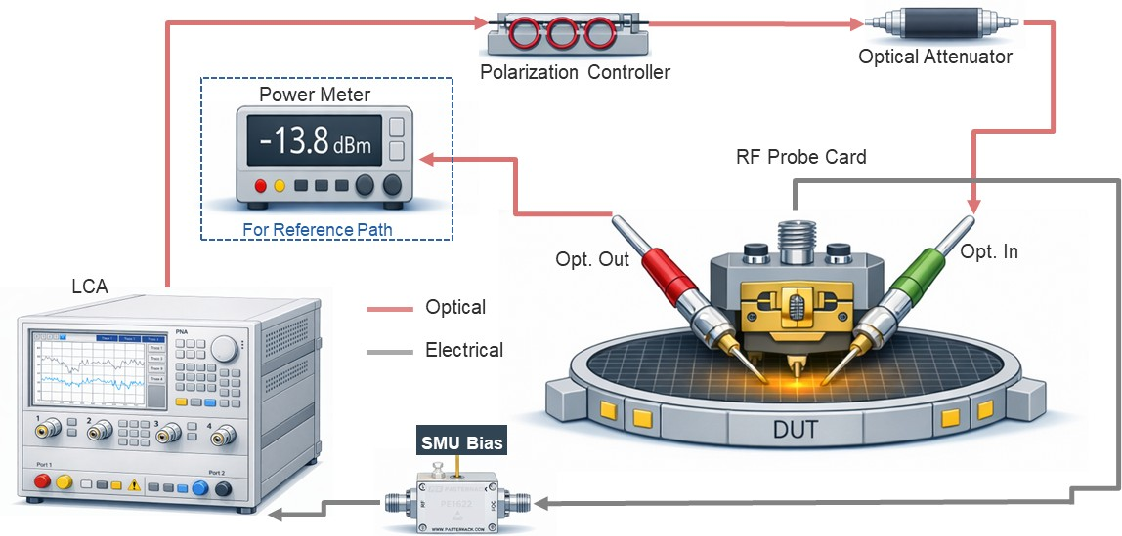
Supplementary Fig. 3 | Measurement setup for small‑signal optoelectronic bandwidth extraction up to 110 GHz.
Schematic of the calibrated on‑wafer measurement configuration used for small‑signal optoelectronic S‑parameter characterization. The setup comprises a lightwave component analyser (LCA) integrated with a vector network analyser, optical source path with polarization control and variable attenuation, and a calibrated reference power path. The device under test (DUT) is probed using ground–signal–ground (GSG) RF probes and biased via a source measurement unit under reverse‑bias conditions. Optical and electrical measurement paths are independently calibrated, and the measured S‑parameters are de‑embedded to remove cable, probe, pad and interconnect parasitics. The 3‑dB optoelectronic bandwidth is extracted from the S21 response, with direct measurement limited by the ~110 GHz bandwidth of the test system.

S3. Additional wafer‑scale electrical and RF characteristics of Ge‑on‑Si photodetectors

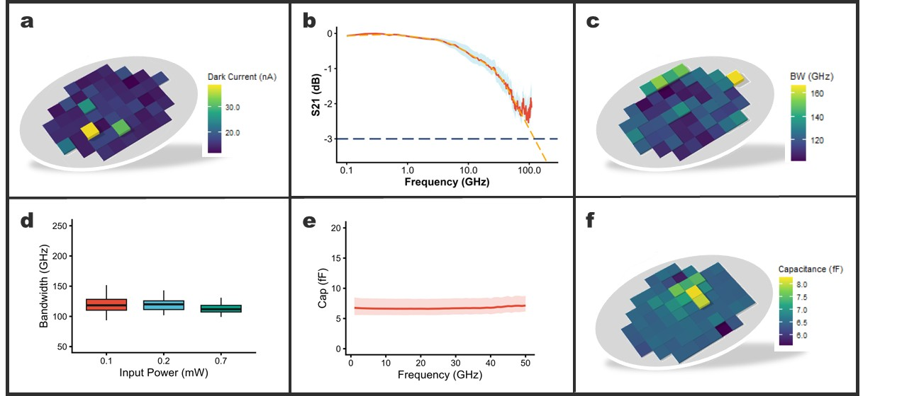

Supplementary Fig. 4 | Wafer-scale electrical and RF characterization of ultra-high-speed Ge PD at −1 V bias.
a, Dark-current wafer map measured at -1 V, showing wafer-scale leakage distribution (colour scale in nA). b, Small-signal optoelectronic frequency response (S21) at −1 V, plotted to the measurement limit; the −3 dB reference is indicated, and additional traces/data points are overlaid for completeness. c, Wafer map of extracted 3-dB optoelectronic bandwidth at -1 V (colour scale in GHz). d, Junction capacitance versus frequency at -1 V, showing stable capacitance across the measurement band (shaded region indicates variation across additional data points). f, Capacitance wafer map at -1 V (colour scale in fF), illustrating wafer-scale uniformity of the extracted capacitance.

S4. High‑frequency electrical modelling and RF characterization of the Ge PD
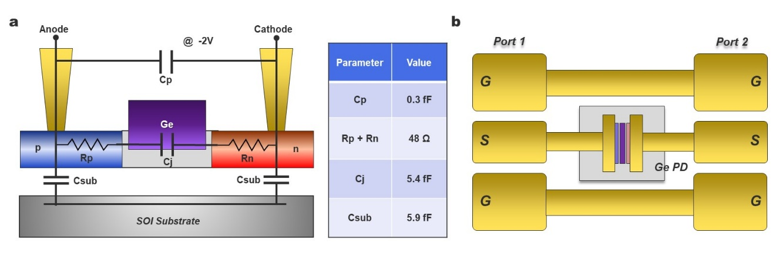
Supplementary Fig. 5| Equivalent circuit model and RF characterization of the Ge photodetector.
a, Extracted small‑signal equivalent circuit under -2 V reverse bias, including the intrinsic junction capacitance of the Ge absorption region, series resistances of the p‑ and n‑type regions, parasitic electrode‑to‑substrate capacitances, and an anode–cathode parasitic capacitance. Extracted parameter values are indicated. b, Schematic of the ground–signal–ground (GSG) two‑port test structure used for calibrated on‑wafer S‑parameter measurements, with the Ge photodetector integrated between coplanar transmission lines.

The high‑frequency electrical response of the Ge photodetector was characterized using calibrated on‑wafer two‑port S‑parameter measurements under a -2 V reverse bias. As shown in Supplementary Fig. 5b, the device was measured in a coplanar ground–signal–ground (GSG) configuration to ensure broadband impedance matching and well‑defined RF return paths. The RF probes were calibrated at the probe tips, and the measured data were subsequently de‑embedded using dedicated open and short test structures to remove pad and interconnect parasitics. The de‑embedded S‑parameters were fitted using the equivalent circuit model shown in Supplementary Fig. 5a. The extracted parameters capture the dominant electrical contributions governing high‑frequency behavior, including the intrinsic Ge junction capacitance, series resistances of the p‑ and n‑type regions, and parasitic capacitances to the substrate and between electrodes. This framework enables quantitative assessment of resistance-capacitance limitations and supports predictive evaluation of device performance in integrated photonic circuits.

S5. RC-transit‑time analysis and optoelectronic bandwidth estimation

Supplementary Table 1 | Estimation of the -3 dB bandwidth for Ge photodetectors considering carrier transit time and RC effects

Values at -2V | Ref [2] | This work
Nominal width (nm) | 100 | 350
Effective width (nm) | ~80 | 350
Depletion width (nm) | ~90–100 | ~200
Resistance R (Ω) | 59 | 48
Capacitance C (fF) | 6.5 | 5.7
Calculated $f_{RC}$ (GHz) | 415 | 582
Calculated $f_{TT}$ (GHz) | 358 | 222
Calculated $f_{3-dB}$ (GHz) | 271 | 207
Measured $f_{3-dB}$ (GHz) | 265 | 215
Responsivity [A/W] | 0.3 | 1.01
BW-Responsivity product [GHZ A/W] | 80 | 217

S6. Polarization-independent ORL reduction for Ge PD using reflection-cancellation

Beyond raw speed and BW, additional innovations are introduced to enhance key FoMs without degrading DC or AC performance. In addition to optical confinement features, side-coupled architectures, and integrated reflectors, we demonstrate a polarization-independent reflection-cancellation circuit that significantly reduces optical return loss (ORL). As illustrated in Supplementary Fig.6a, this compact circuit employs a polarization-independent coupler and a dual-input PD architecture with a short, engineered delay path in one arm to destructively interfere reflected signals, without introducing excess loss or BW penalties. Measurement results in Supplementary Fig.6b, confirm a simultaneous >10 dB ORL reduction for both TE and TM polarizations. This universal approach is applicable to a wide range of Ge-PD designs and can be combined with chamfered PD geometries [3] to suppress reflections well beyond IEEE requirements [4].

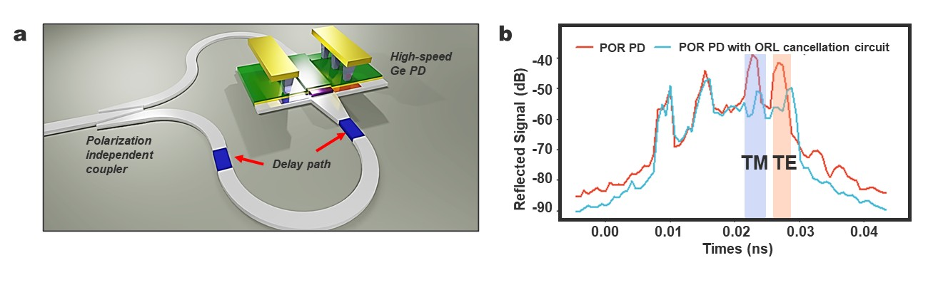
Supplementary Fig. 6 | Polarization‑independent reflection‑cancellation circuit for optical return loss (ORL) suppression.
a, Schematic of the polarization‑independent reflection‑cancellation architecture integrated with a high‑speed Ge‑on‑Si photodetector. A compact interferometric configuration incorporating a polarization‑independent coupler and an engineered delay path enables destructive interference of reflected optical signals, suppressing back‑reflections without introducing excess loss or bandwidth penalties. b, Measured time‑domain reflected signal for a reference photodetector (POR PD) and a photodetector incorporating the ORL‑cancellation circuit. The reduced reflection amplitude is observed for both TE and TM polarization states, demonstrating effective polarization‑independent suppression.

S7. Additional insertion loss data for detachable optical I/O

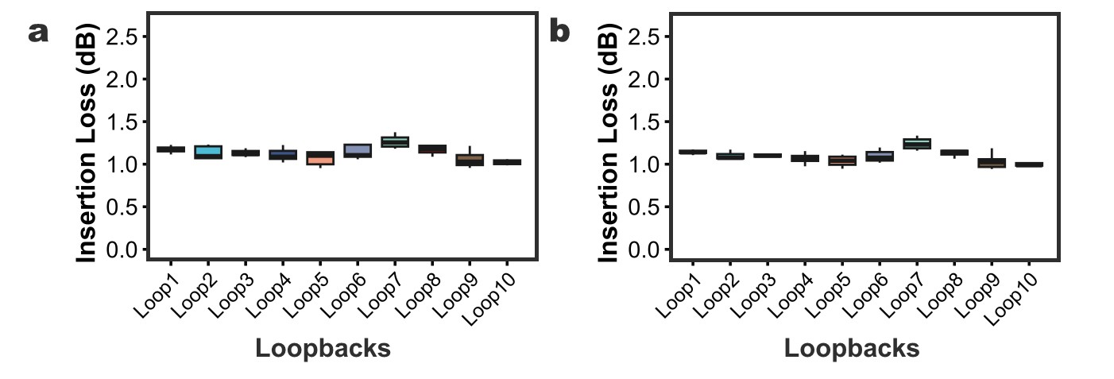

Supplementary Fig. 7 | Insertion loss per facet for detachable optical I/O before and after adhesive alignment.
a, Measured insertion loss per facet across multiple loopback paths under initial die‑alignment conditions (no adhesive), showing consistent low‑loss coupling during active alignment. b, Insertion loss per facet measured after permanent adhesive alignment of the receptacle interface. Comparable loss levels are maintained across all loopbacks, indicating stable optical coupling with no degradation following permanent attachment.

In addition to the through-band insertion loss measurements described in the main text, we further evaluated coupling performance across multiple loopback paths before and after adhesive alignment. The measured insertion loss remains consistently close to ~1 dB per facet as illustrated in Supplementary Fig. 7a and 7b, confirming stable low-loss coupling with no observable degradation upon permanent attachment.

S8. System-level implications and scalability of ≥448 Gbps Ge photodetectors

The demonstrated ≥448 Gbps large-signal operation establishes a system-relevant performance regime aligned with current and emerging datacom standards, in which high symbol rates (~224 GBd for PAM4) place stringent requirements on receiver bandwidth, linearity and signal fidelity. Beyond bandwidth alone, the ability to sustain clean eye openings at high photocurrent levels is critical for maintaining signal-to-noise ratio under realistic link conditions.

The combination of high responsivity and robust large-signal linearity directly benefits link budget and system margins. High responsivity reduces the required optical power at the receiver, relaxing constraints on transmitter output, fiber loss, and passive component insertion loss. At the same time, operation at milliwatt-level optical power with near-constant responsivity mitigates signal compression and distortion, preserving eye opening and enabling reliable detection at high data rates.

These attributes are particularly important in dense wavelength-division multiplexed (WDM) systems, where cumulative losses and limited per-channel power can constrain receiver performance. The demonstrated tolerance to high optical power and linear response provides additional margin for multi-channel operation without compromising bandwidth or signal integrity.

From a system design perspective, the intrinsic large-signal capability of the photodetector reduces reliance on aggressive electronic equalization or optical amplification, simplifying receiver architectures and improving overall energy efficiency. The demonstrated performance, achieved without transimpedance amplifier integration, further indicates that a substantial portion of the receiver functionality can be fulfilled at the photonic device level.

Collectively, these results show that Ge-on-Si photodetectors, when co-optimized with a manufacturable silicon photonics platform, can meet the combined requirements of ≥448 Gbps operation, high responsivity, and large-signal linearity, providing a practical pathway toward scalable multi-terabit optical interconnects [5].

References
[1] Laser Institute of America, ANSI Z136.2-2022 – American National Standard for Safe Use of Optical Fiber Communication Systems Utilizing Laser Diode and LED Sources. American National Standards Institute, (2022).
[2] Lischke, S. et al. Ultra-fast germanium photodiode with 3-dB bandwidth of 265 GHz. Nat. Photonics 15, 925–931 (2021).
[3] Bian, Y. et al. Monolithically integrated high‑performance Ge‑on‑Si PIN photodetectors with nearly 60 GHz EO bandwidth, 0.95 A W⁻¹ responsivity, <30 nA dark current and −36 dB optical return loss enabled by Ge shape optimization. In Optical Fiber Communication Conference (OFC), Th3E.6 (Optica Publishing Group, 2025).
[4] IEEE Standard for Ethernet - Amendment 3: Media Access Control Parameters for 50 Gb/s and Physical Layers and Management Parameters for 50 Gb/s, 100 Gb/s, and 200 Gb/s Operation. IEEE Std 8023cd-2018 Amend. IEEE Std 8023-2018 Amend. IEEE Std 8023cb-2018 IEEE Std 8023bt-2018 1–401 (2019) doi:10.1109/IEEESTD.2019.8649797
[5] Baehr-Jones, T. et al. Monolithically integrated 112 Gbps PAM4 optical transmitter and receiver in a 45 nm CMOS–silicon photonics process. Opt. Express 31, 24926–24938 (2023).

