SUPPLEMENTARY MATERIALS

Table S1. Theory-Informed Acoustic and Linguistic Features (n = 48)
A. Acoustic Features (n = 25)
Feature | Description
ac_theory_f0env_mean | Mean fundamental frequency envelope (pitch contour)
ac_theory_f0env_std | Variability of pitch contour
ac_theory_intensity_de_mean | Mean change in intensity (energy dynamics)
ac_theory_intensity_de_std | Variability of intensity change
ac_theory_loudness_mean | Average perceived loudness
ac_theory_loudness_range | Range of loudness
ac_theory_loudness_slope | Temporal change in loudness
ac_theory_loudness_std | Variability in loudness
ac_theory_mfcc1_de_mean | Mean change in MFCC1 (spectral dynamics)
ac_theory_mfcc1_de_std | Variability of MFCC1 changes
ac_theory_mfcc1_mean | Mean MFCC1 (spectral shape)
ac_theory_mfcc1_std | Variability of MFCC1
ac_theory_mfcc2_mean | Mean MFCC2
ac_theory_mfcc3_mean | Mean MFCC3
ac_theory_mfcc4_mean | Mean MFCC4
ac_theory_pitch_mean | Average pitch
ac_theory_pitch_range | Range of pitch
ac_theory_pitch_sd_std | Variability of pitch standard deviation
ac_theory_pitch_slope | Temporal change in pitch
ac_theory_pitch_std | Variability of pitch
ac_theory_voice_prob_mean | Mean voicing probability
ac_theory_voice_prob_slope | Change in voicing probability
ac_theory_voice_prob_std | Variability of voicing
ac_theory_zcr_mean | Mean zero-crossing rate (signal noisiness)
ac_theory_zcr_std | Variability of zero-crossing rate
Note: Acoustic features derived from openSMILE emobase (Functionals level)
B. Linguistic Features (n = 23)
Feature | Description
ling_ling_all_or_nothing | Frequency of all-or-nothing thinking
ling_ling_anxiety_total | Total anxiety-related word usage
ling_ling_avoidance | Frequency of avoidance-related language
ling_ling_catastrophizing | Frequency of catastrophic thinking
ling_ling_confidence | Confidence-related language
ling_ling_coping_reappraisal | Cognitive reappraisal/coping language
ling_ling_depression_total | Total depression-related language
ling_ling_fear | Fear-related word usage
ling_ling_filler_ratio | Ratio of filler words (e.g., “um”, “uh”)
ling_ling_first_person | First-person pronoun usage
ling_ling_hedge_ratio | Use of hedging language (uncertainty)
ling_ling_insight | Insight-related language
ling_ling_nervousness | Nervousness-related language
ling_ling_positive_total | Positive emotion word usage
ling_ling_self_focus | Degree of self-referential language
ling_ling_sentiment_shift | Variability in sentiment across sentences
ling_ling_should_statements | Frequency of “should/must” statements
ling_ling_subjectivity | Subjectivity of language
ling_ling_type_token_ratio | Lexical diversity
ling_ling_uncertainty | Uncertainty-related language
ling_ling_vader_compound | Overall sentiment polarity
ling_ling_word_count | Total word count
ling_ling_worry | Worry-related language
Note: Derived from a natural language processing pipeline informed by cognitive behavioral theory and psychological linguistics.
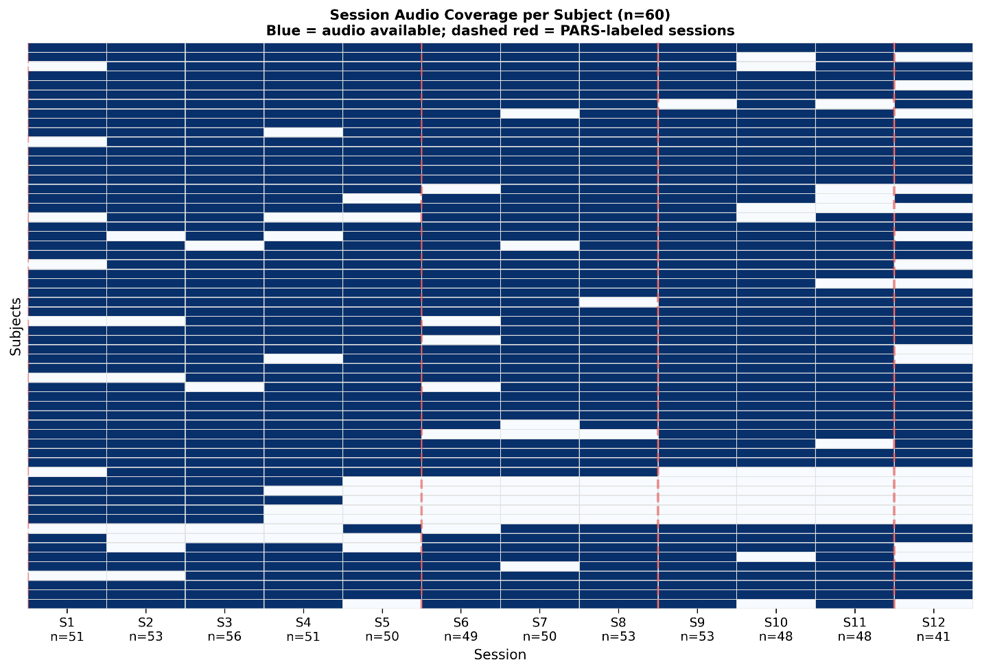

Figure S1. Session-level availability of audio recordings across participants. Heatmap showing the presence of usable audio recordings for each participant (rows) across the 12-session EF-CBT protocol (columns). Blue cells indicate sessions with available audio recordings; light gray cells indicate sessions without usable audio data. Red dashed vertical lines mark sessions with Pediatric Anxiety Rating Scale (PARS) assessments (Sessions 1, 6, 9, and 12). The number of participants contributing usable audio at each session is shown along the x-axis.

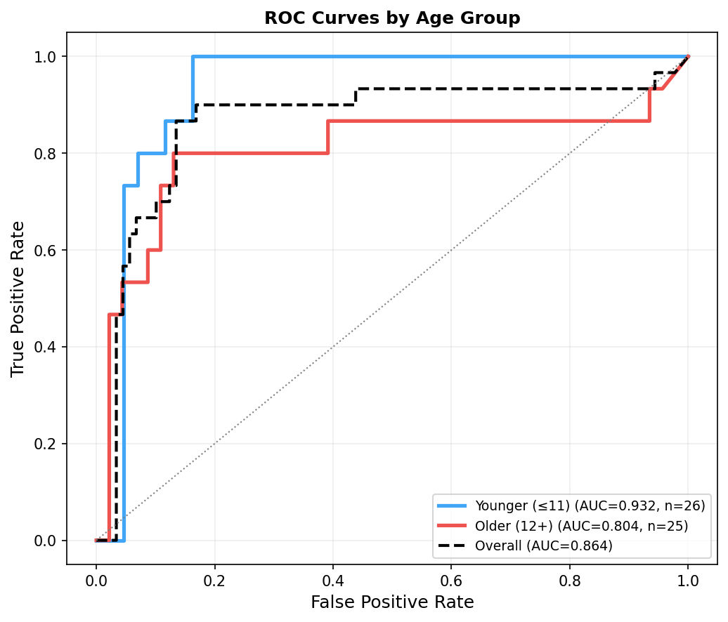
Figure S2. Receiver operating characteristic (ROC) curves by age group for prediction of anxiety improvement. ROC curves comparing model performance between younger (≤11 years) and older (≥12 years) participants using the best-performing model (Random Forest with later-session features in mid-to-late session pairs). The model demonstrated higher discrimination in younger participants (AUC = 0.93; n = 26) compared with older participants (AUC = 0.80; n = 25), although performance remained above chance in both groups. The dashed line represents overall model performance across all participants (AUC = 0.86).

