Allosteric crosstalk between Fc glycans and Fab regions in full-length IgG2 and IgG4 antibodies

 | Identities | Positives
Heavy Chains | 59% | 75%
Light Chains | 62% | 76%
Table S1: Metrics from the structure alignment between heavy chains and light chains between PMB and Mab231. Computed using the Needleman-Wunsh algorithm from NCBI.

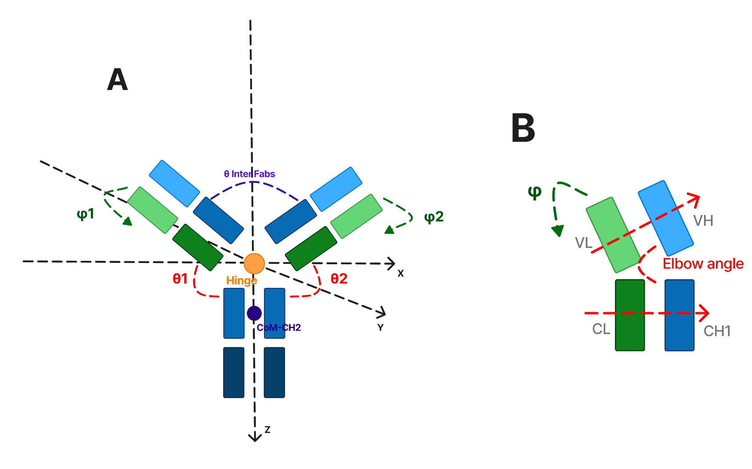
Figure S1: Definition of the angular descriptors used to characterize antibody conformational states. (A) Schematic representation of the full IgG antibody with the coordinate system used to define Fab orientation relative to the Fc domain. The origin is placed at the center of mass of the Hinge domain (CoM-Hinge, orange dot). The z-axis is defined as the vector from the hinge region to CoM-CH2, oriented toward the Fc C-terminus. The x-axis lies in the plane of the antibody and is perpendicular to z, while the y-axis completes the right-handed coordinate system. The polar angles θ₁ and θ₂ (red dashed arcs) measure the angle between the z-axis and the principal inertia axis of Fab1 and Fab2, respectively. The azimuthal angles φ₁ and φ₂ (green dashed arrows) describe the out-of-plane rotation of each Fab arm around the Fc long axis. The inter-Fab angle θ InterFabs (blue dashed arc) is defined as the angle between the two Fab principal inertia axes. The hinge region is indicated by the orange circle. Heavy chain domains (VH, CH1, CH2, CH3) are shown in shades of blue; light chain domains (VL, CL) are shown in shades of green. (B) Close-up of a single Fab domain illustrating the elbow angle (red dashed lines), defined as the angle between the VH→VL center-of-mass vector and the CH1→CL center-of-mass vector. This angle quantifies the degree of bending between the variable and constant regions of the Fab, providing a measure of intra-Fab rigidity. The azimuthal angle φ (green dashed arrow) is also indicated for reference.

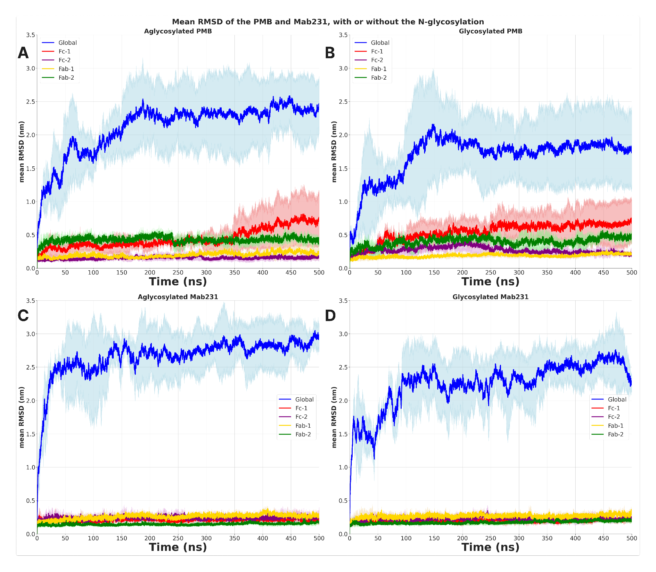
Figure S2: Evolution of the mean RMSD on each replicate for PMB without (A) and with (B) the carbohydrates. And Mab231 without (C) and with (D) the N-glycosylation. The blue curve is the RMSD of the full backbone of the antibody. The red is the Fc-1 chain. The purple is the Fc-2 chain. The green is the Fab-2 region. And the yellow is the Fab-1 region.

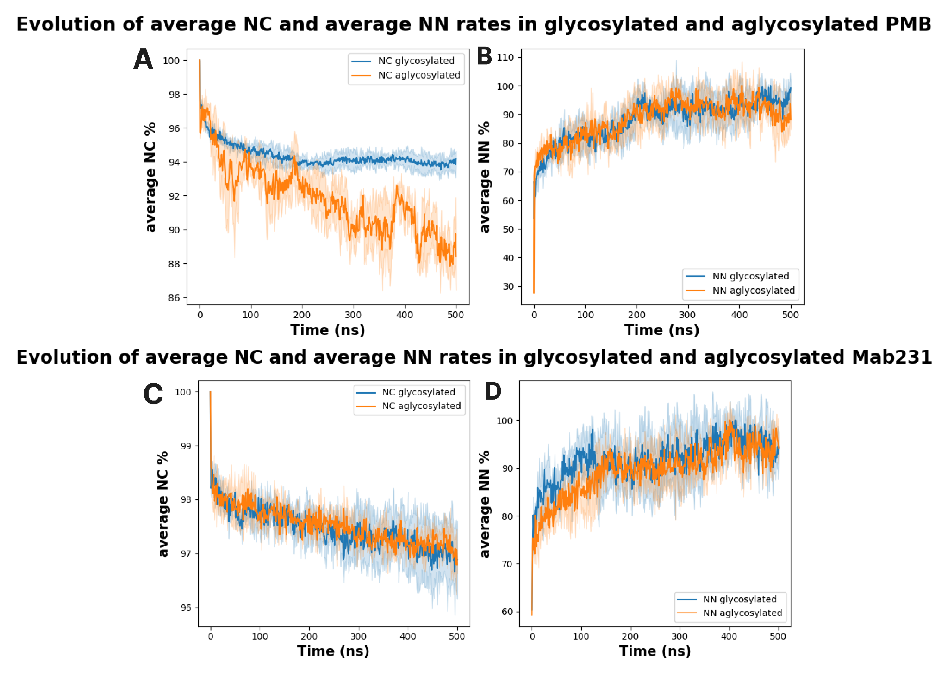
Figure S3: Evolution of the rate of the average native contacts (NC, A & C) and non-natives contacts (NN, B & D). Glycosylated systems are represented in blue and aglycosylated systems are represented in orange in each plot. This is calculated for both Pembrolizumab (A & B) and Mab231 (C & D).
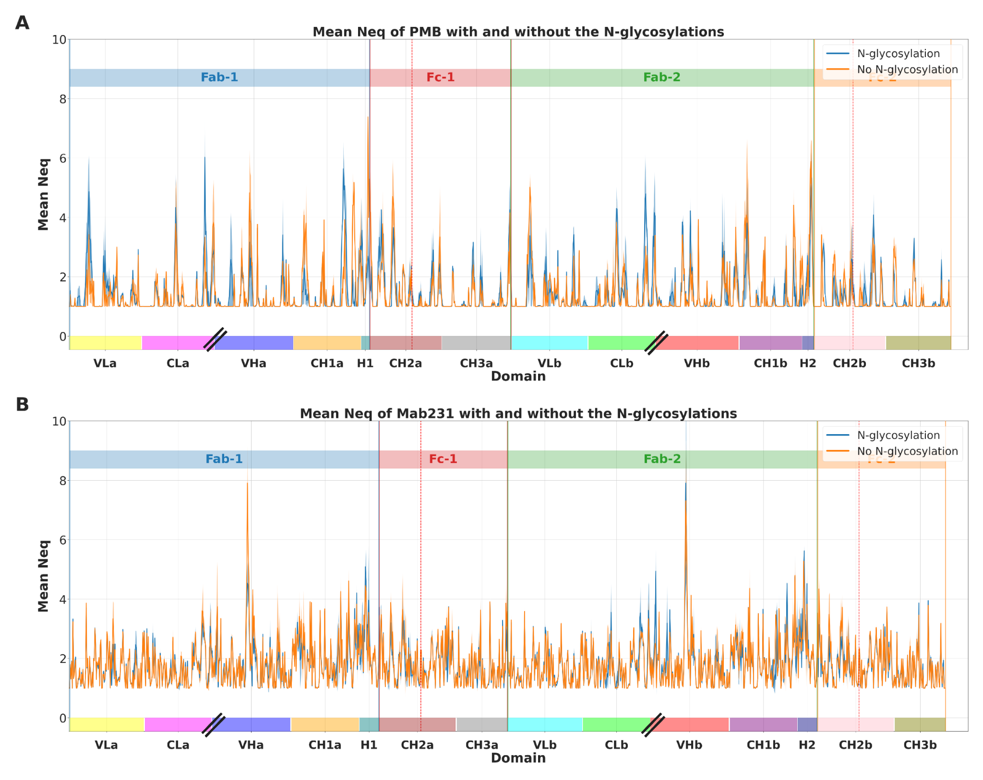Figure S4: Measure of the mean N_{eqs} for PMB (A) and Mab231 (B) for both conditions. The orange curve represents the mean Neq without the N-glycosylation and the blue one, with the N-glycosylation. Each red line represents the position of the residue linked to the carbohydrate. Dash represents two domains that are disconnected in the structure.
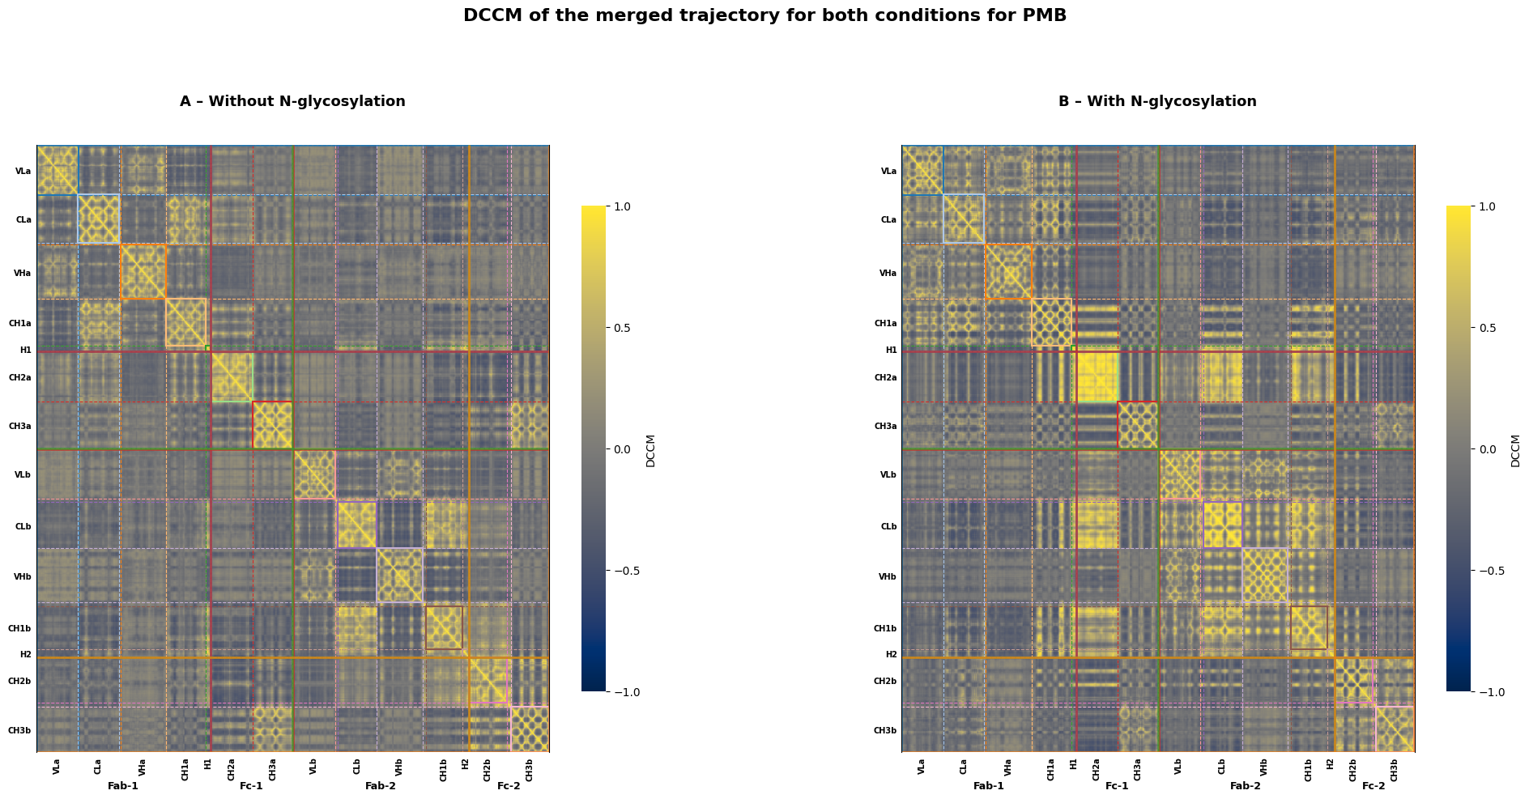
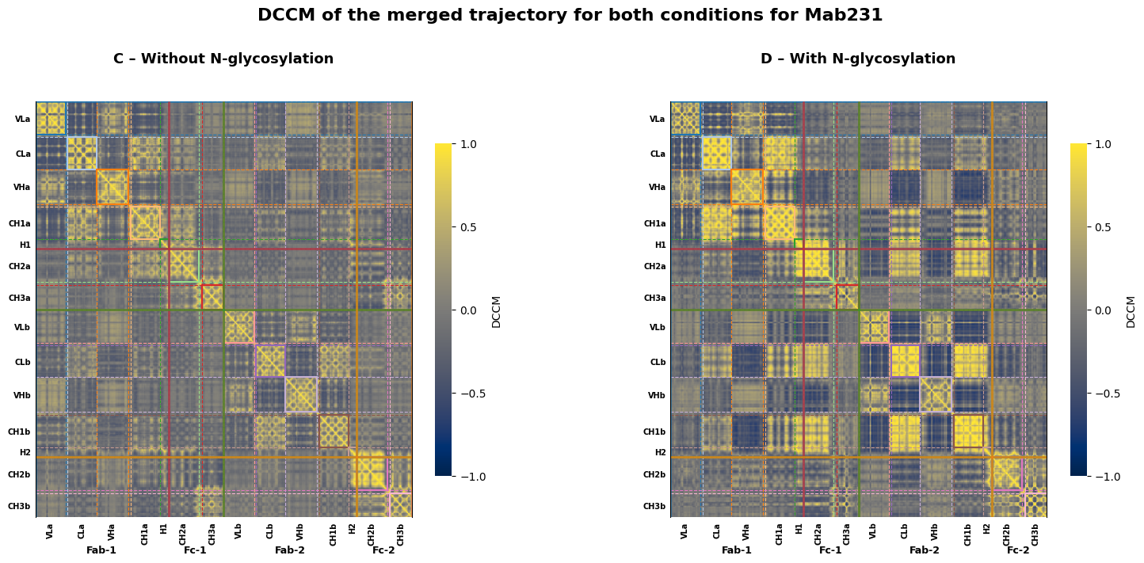
Figure S5: DCCM for PMB (A) and (B) and Mab231 (C) and (D). With and without the N-glycosylation. The values go from -1 to 1. The X and Y axis represent the amino acids composing the protein. The orange square represents the amino acids from the Fab-1. The green square represents the amino acids from Fab-2. The red square represents the amino acids from the Fc-1. The pink square represents the amino acids from the Fc-2.

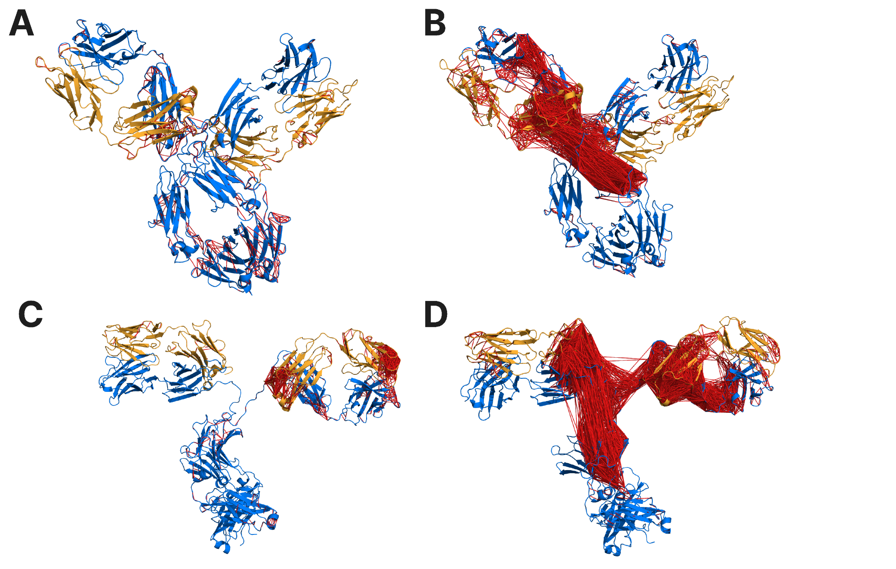
Figure S6: Projection on the structure of the amino acids which have correlated movements between each other. With and without the presence of the N-glycosylation. PMB is represented without the glycosylation in A and with B. Mab231 is represented without the glycosylation in C and with D. A red link exists when the correlation is between 0.8 and 1 between two amino acids.

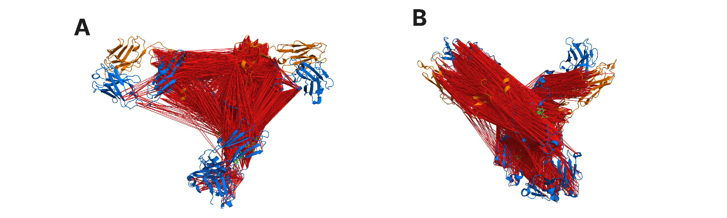
Figure S7: Projection of the pairs of residues that present the difference in the difference DCCM for Mab231 (A) and PMB (B).

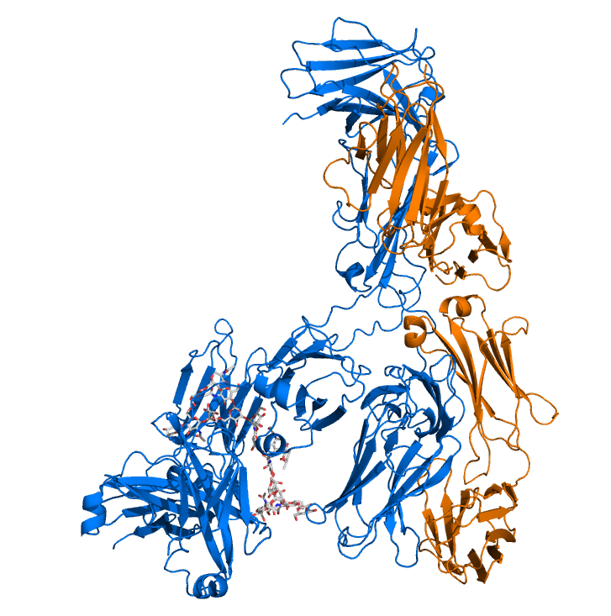
Figure S8: 𝛌 conformation obtained by Mab231 in the simulations. The blue chains are the heavy chains and the orange chains are the light chains. The glycans are represented in grey licorices.
A
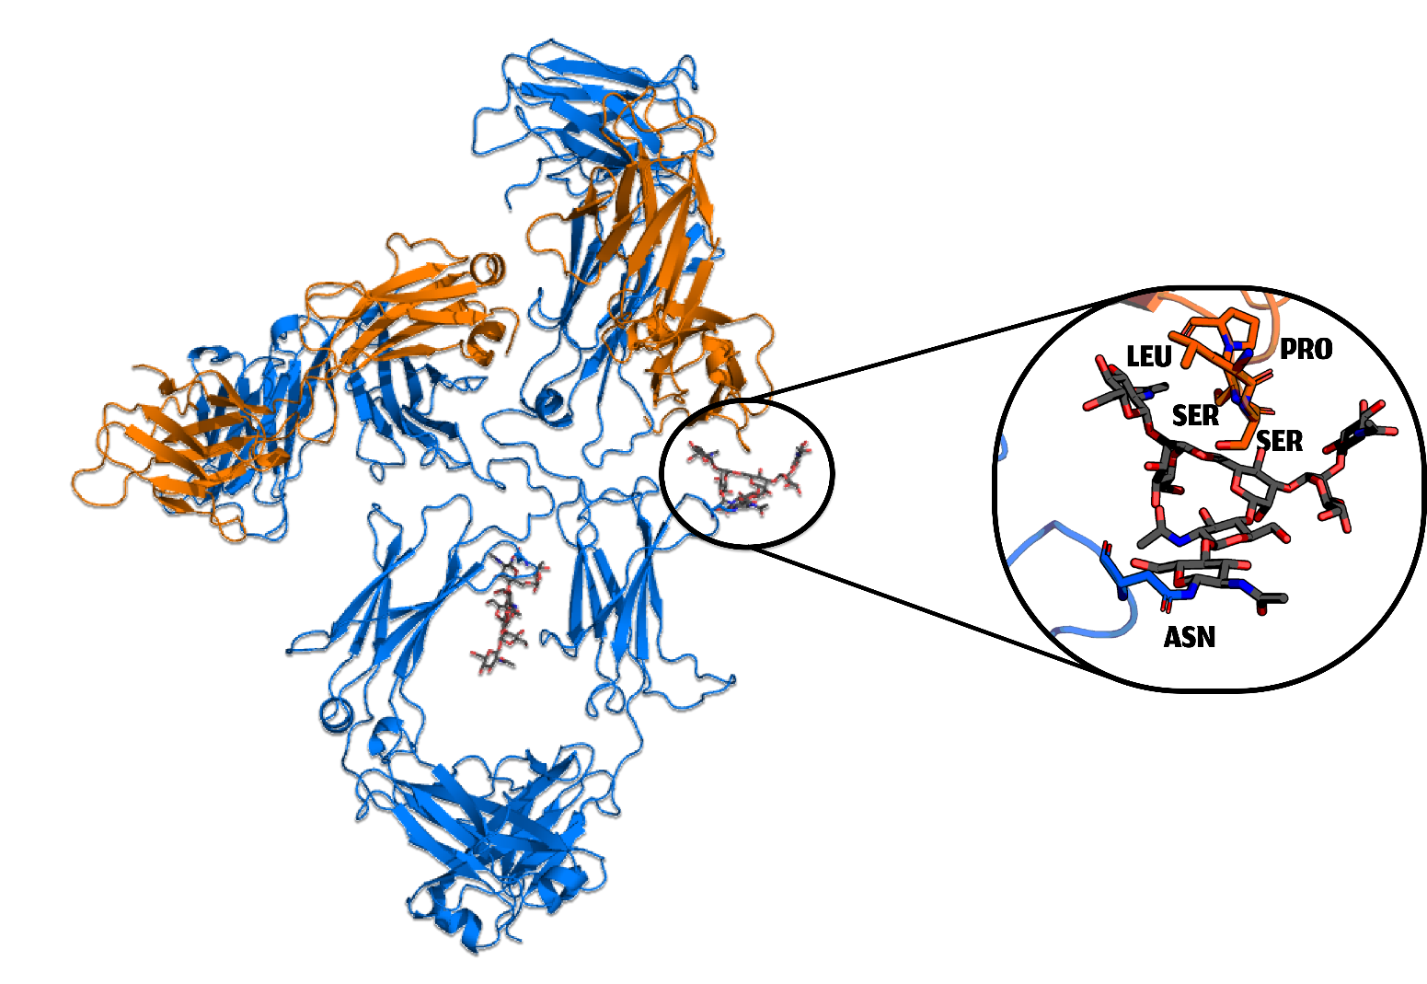
B
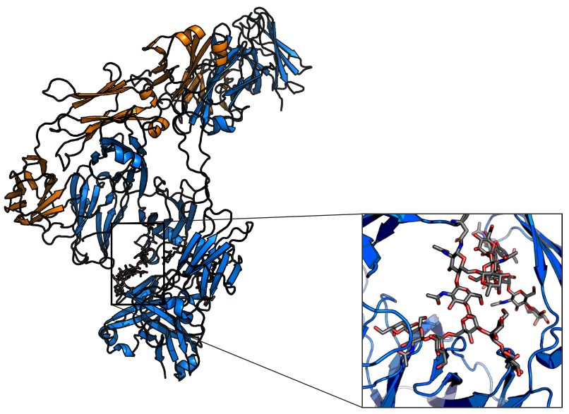
Figure S9: Examples of conformations where Fabs get closer to the carbohydrates, for PMB (A) and Mab231 (B)

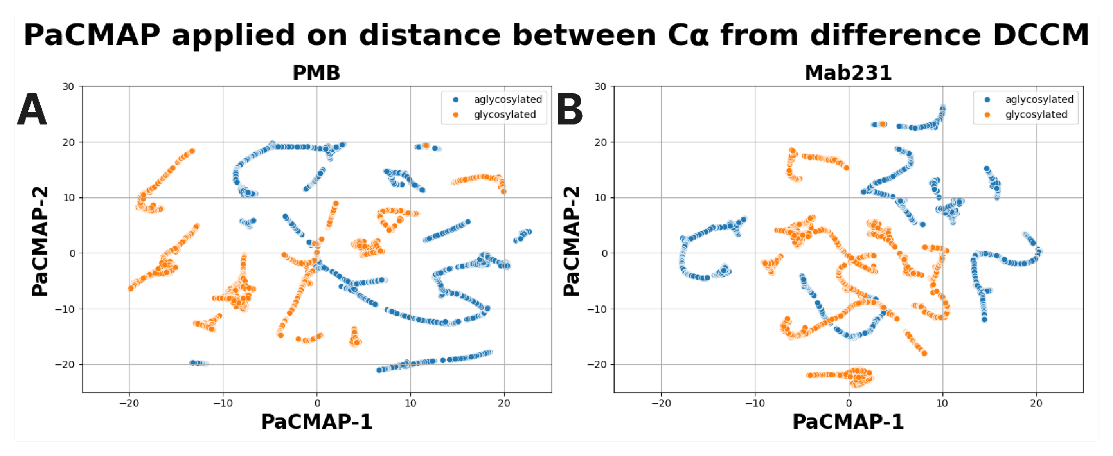
Figure S10: PaCMAP analysis applied on Cɑ-Cɑ distance evolution. The orange dots are the glycosylated data. The blue dots are aglycosylated data.

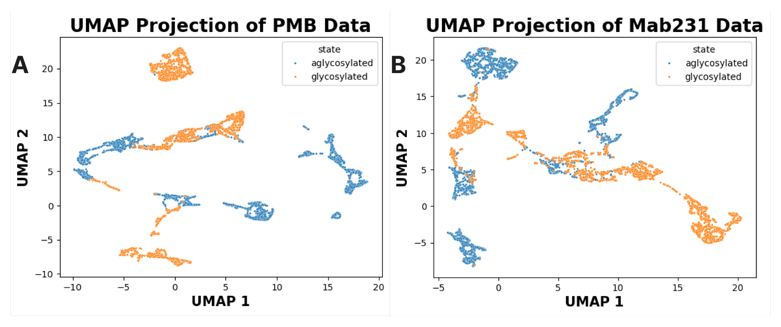
Figure S11: UMAP realised data from the difference DCCM. For PMB (A) and Mab231 (B). The blue dots are the aglycosylated data, the orange dots are the glycosylated data.

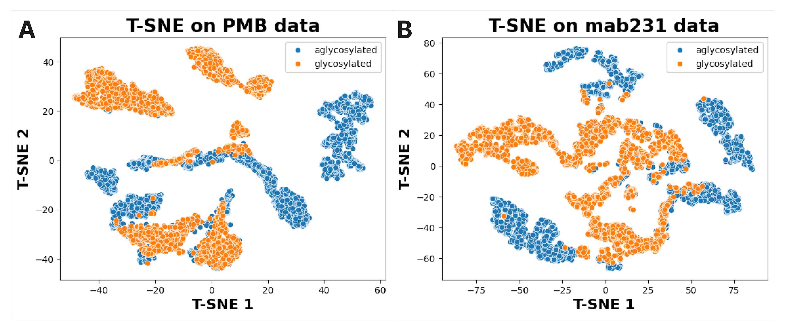Figure S12: T-SNE realised data from the difference DCCM. For PMB (A) and Mab231 (B). The blue dots are the aglycosylated data, the orange dots are the glycosylated data.

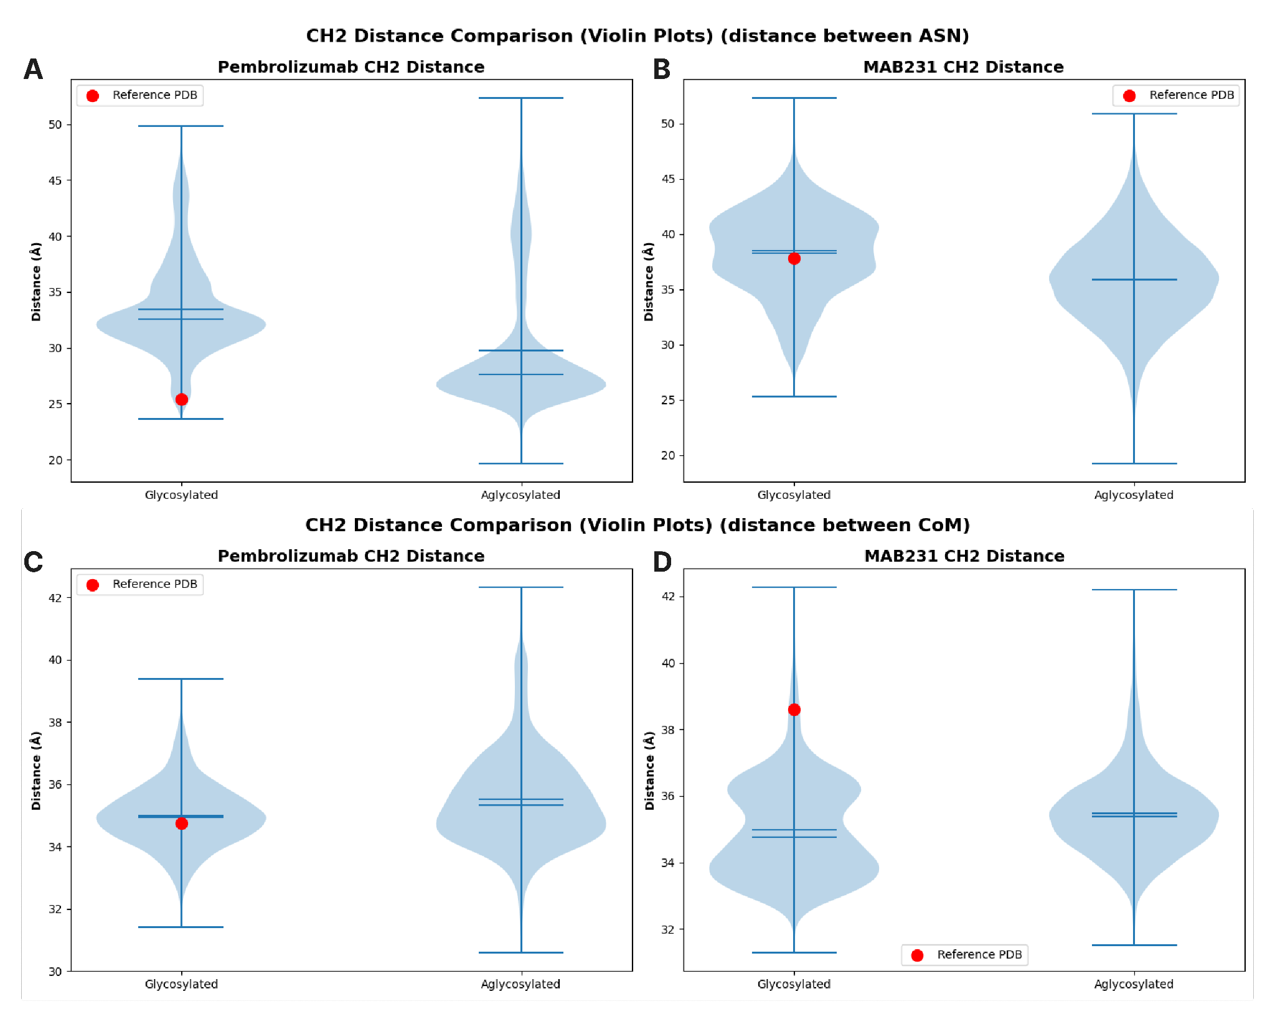
Figure S13: Violin plots of the distribution of the distances between top) the Asn residues bearing the glycosylation and bottom) the center of mass of the Fc domains, glycosylated and aglycosylated. For PMB (A) and Mab231 (B) using ASN distances. And PMB (C) and Mab231 (D) using CH2 CoM distances.

Column | Test | Statistic | p-value
theta F1 | Mann-Whitney U | 1.07 × 10¹⁰ | 3.81 × 10⁻¹⁰²
theta F2 | Mann-Whitney U | 1.51 × 10¹⁰ | ≈ 0
theta inter Fab | Mann-Whitney U | 1.48 × 10¹⁰ | ≈ 0
theta F1 | Watson U² | 620.76 | ≈ 0
theta F2 | Watson U² | 3320.95 | ≈ 0
theta inter Fab | Watson U² | 221.63 | ≈ 0
Table S2: PMB summary statistic test and p-values on the angles adopted by the Fabs.

Column | Test | Statistic | p-value
theta F1 | Mann-Whitney U | 5.67 × 10⁹ | ≈ 0
theta F2 | Mann-Whitney U | 1.36 × 10¹⁰ | ≈ 0
theta inter Fab | Mann-Whitney U | 1.14 × 10¹⁰ | 2.5 × 10⁻⁴
theta F1 | Watson U² | 1030.90 | ≈ 0
theta F2 | Watson U² | 2244.22 | ≈ 0
theta inter Fab | Watson U² | 444.63 | ≈ 0
Table S3: Mab231 summary statistic test and p-values on the angles adopted by the Fabs.

