Supplementary Information
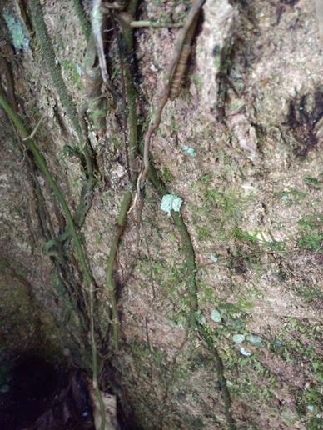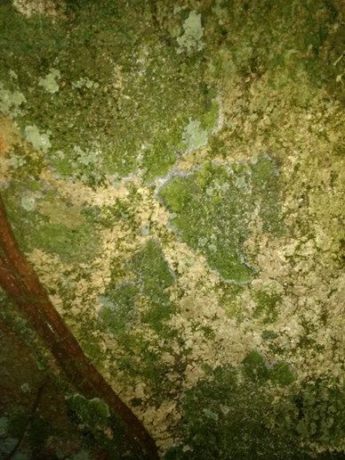

b
a
Figure S1 Photographs of tree bark from the dry and rainy season: (a) from 14 May, shows a green lacewing larva, circled in red, with a largely white cargo; (b) from 24 July, shows increased algal and other growth on the tree bark. The two photographs are located on different Licania platypus trees but are representative of changes seen on tree bark during that time period.

