Supplemental Tables:
Table S1. Mean topography and stand characteristics of Masson pine forest in the study area.
Stand Condition | Shady slopes | Sunny sloeps
Elevation (m) | 152.82 | 184.96
Aspect (◦) | 18.00 | 21.83
Tree height (m) | 8.34 | 7.27
Diameter at breast height (cm) | 11.96 | 11.01
Bole height to the first branch (m) | 3.06 | 2.75
Canopy density (%) | 40.00 | 24.17

Table S2. Gradients of weather factors used for comparing SFFMC.
Weather factors | Gradients | Values
Temperature (℃) | Low | <15
Temperature (℃) | Moderate | 15≤x＜20
Temperature (℃) | High | >30
RH (%) | Low | 30≤x＜55
RH (%) | Moderate | 55≤x＜75
RH (%) | High | >75
Wind speed (m/s) | Low | 0.3≤x＜1
Wind speed (m/s) | Moderate | 1≤x＜1.5
Wind speed (m/s) | High | >1.5
Illumination (lux) | Lower | 0≤x＜1500
Illumination (lux) | Low | 1500≤x＜3000
Illumination (lux) | Moderate | 3000≤x＜5000
Illumination (lux) | High | >5000
Vapor Pressure Deficit | Low | 0≤x＜0.02
Vapor Pressure Deficit | Moderate | 0.02 ≤ x ＜ 0.035
Vapor Pressure Deficit | High | >0.035
Vapor Pressure Deficit | No precipitation | 0
Precipitation | Low | 0≤ x ＜5
Precipitation | Moderate | 5≤ x ＜15
Precipitation | High | 15≤ x ＜30
Precipitation | Extreme precipitation | ＞30

Table. S3 XGBoost vs. Random Forest: Key Hyperparameter Comparison.
Hyperparameter Comparison
Parameter | XGBoost | Random Forest
Model Type | Gradient Boosting | Random Forest
Number of Trees | 1000 | 1000
Learning Rate | 0.1 | -
Max Depth | 8 | Unlimited
Row Sampling Ratio | 0.9 | 1.0 (bootstrap)
Column Sampling | 0.9 (colsample_bytree) | 3 (mtry)
Min Loss Reduction | 0.1 (gamma) | -
Min Child Weight | 1 | -
L2 Regularization | 0.5 (lambda) | -
L1 Regularization | 0 (alpha) | -
Min Samples per Node | - | 5 (nodesize)
Early Stopping Rounds | 20 | -
Feature Importance | SHAP values | Gini importance

Supplemental Figures:
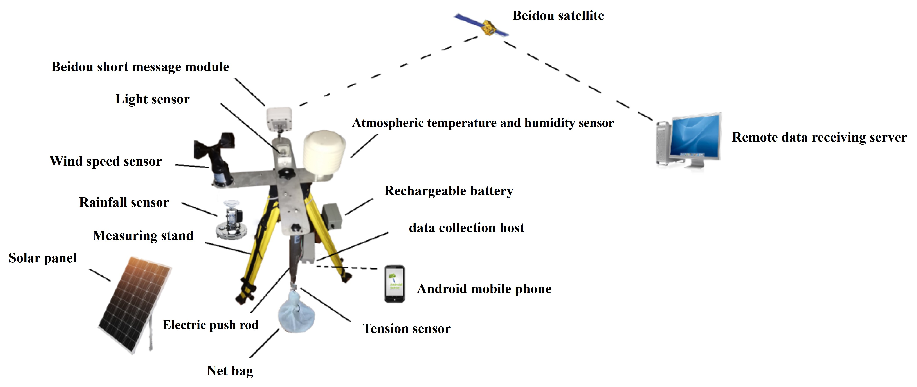
Fig. S1 Fuel moisture content monitoring equipment System structure diagram.

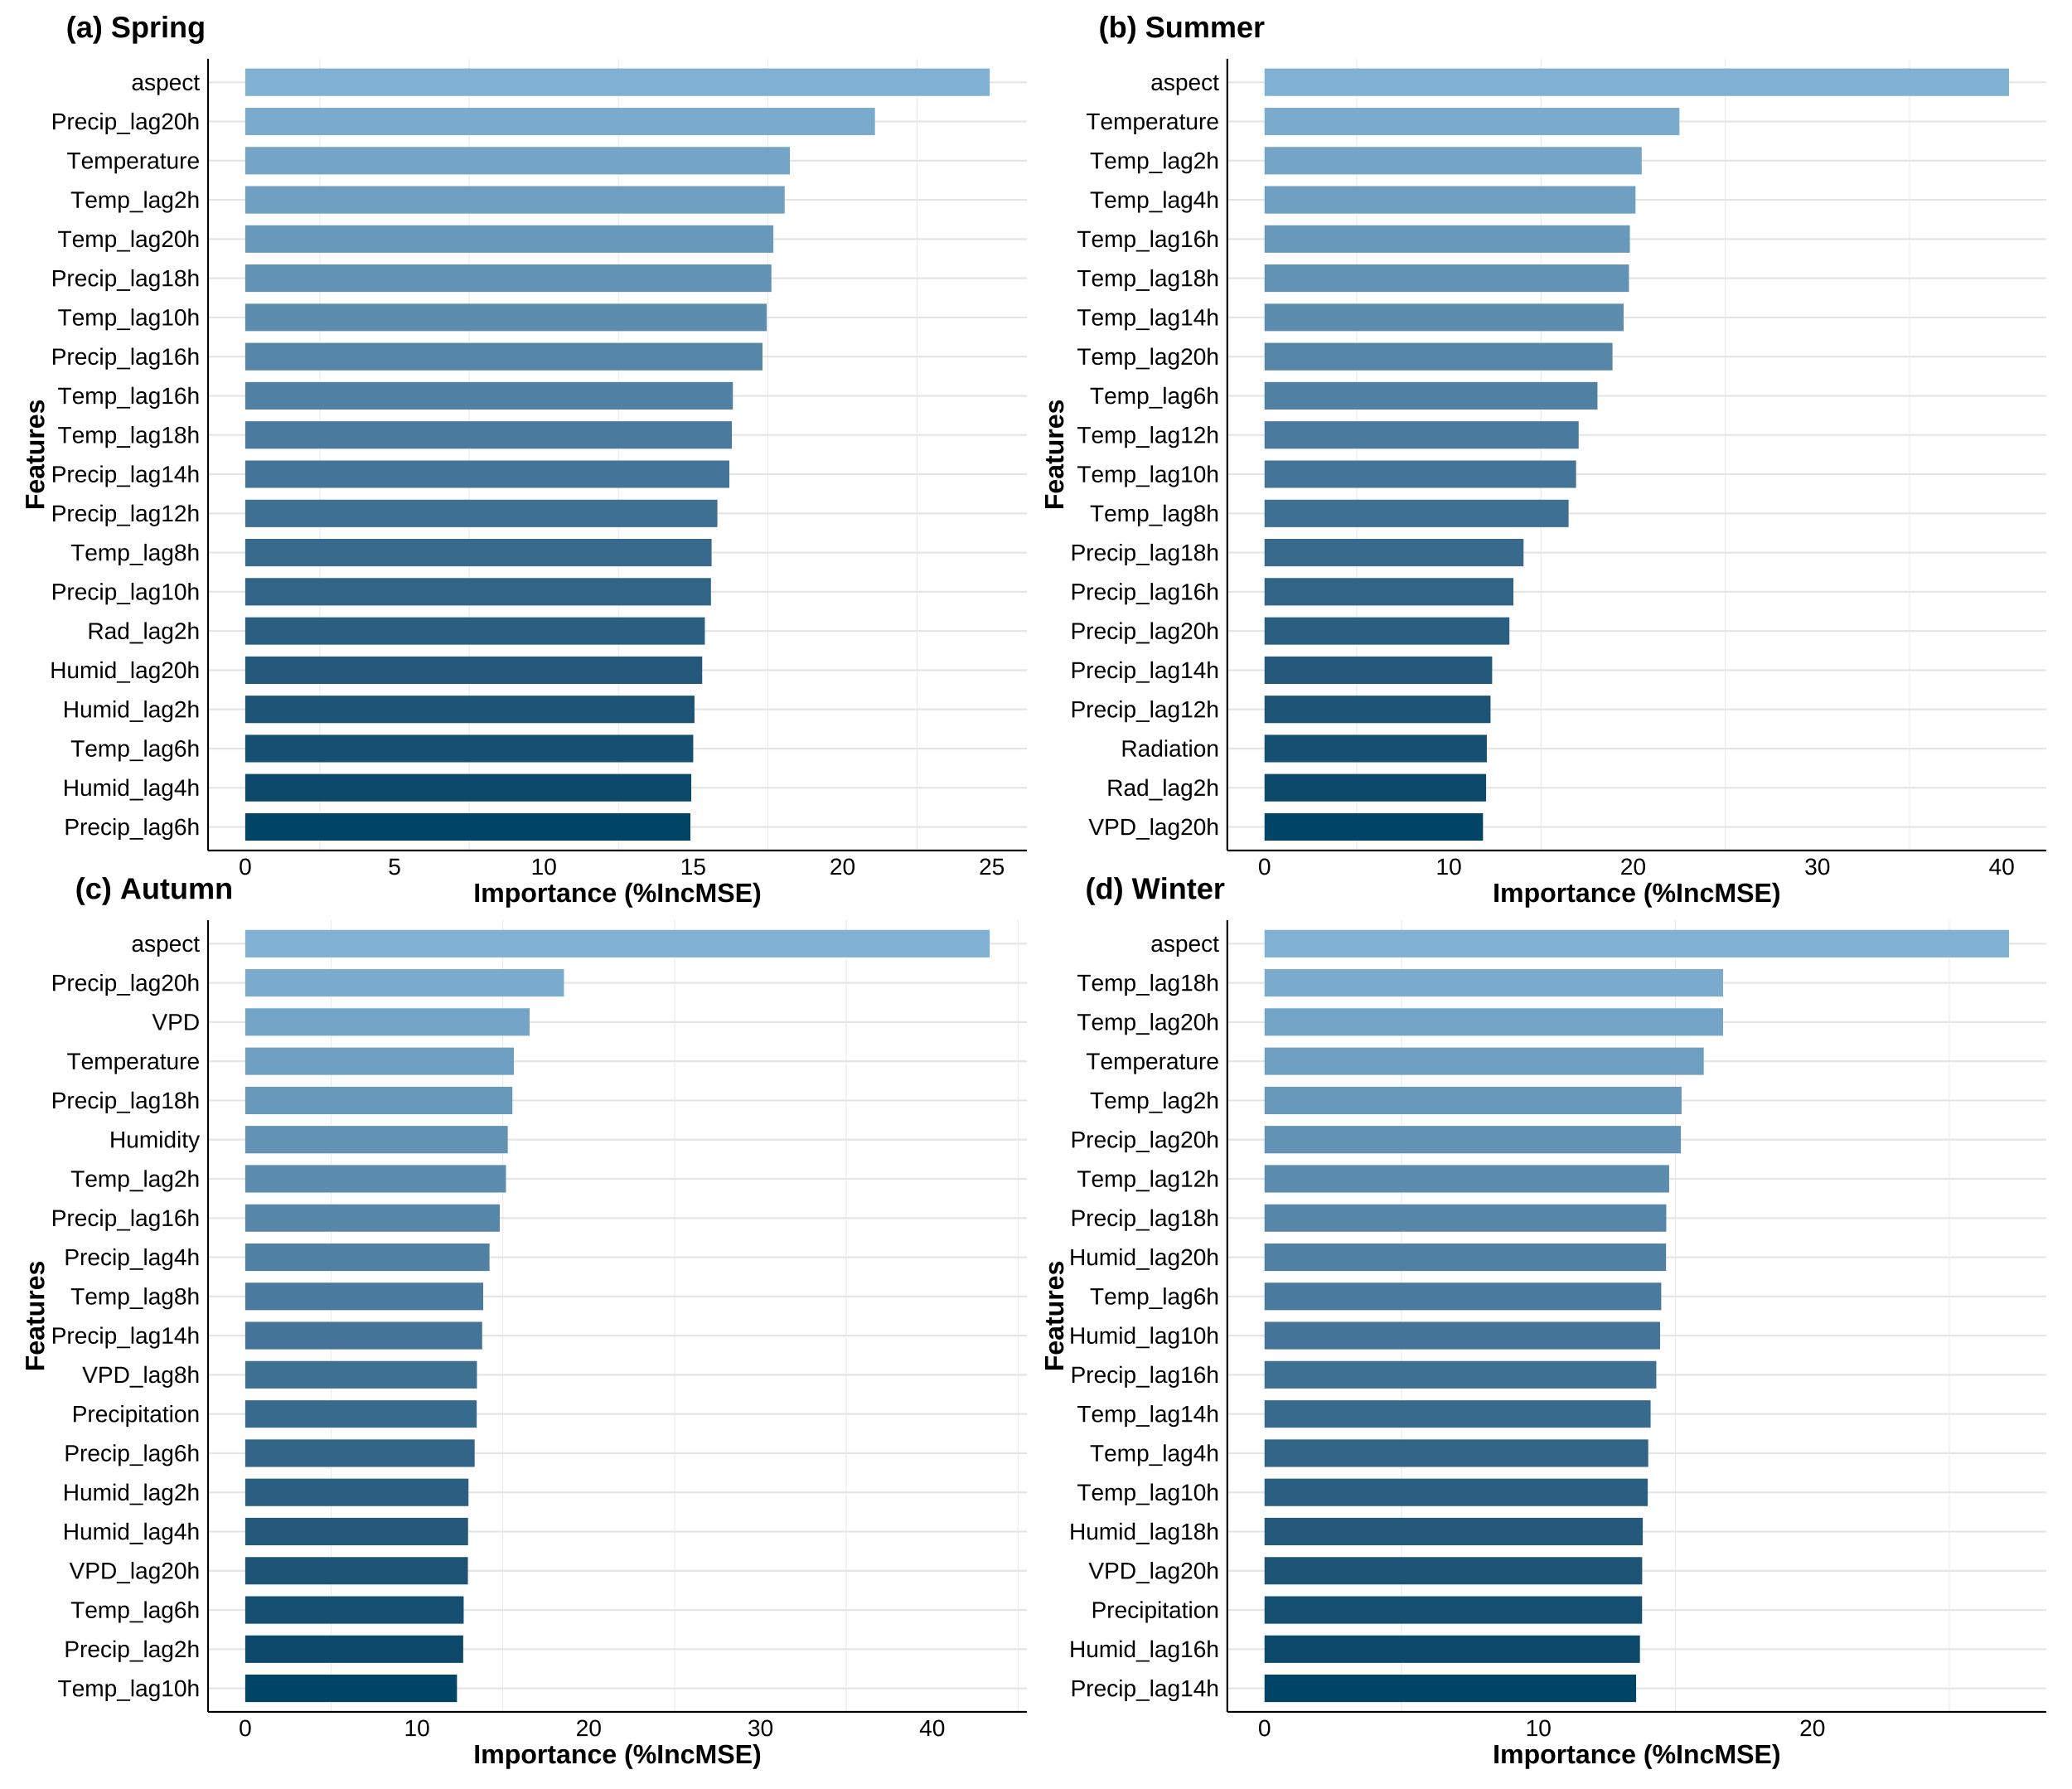
Fig S2 Seasonal Random Forest-based feature screening of candidate predictors for SFFMC modeling.
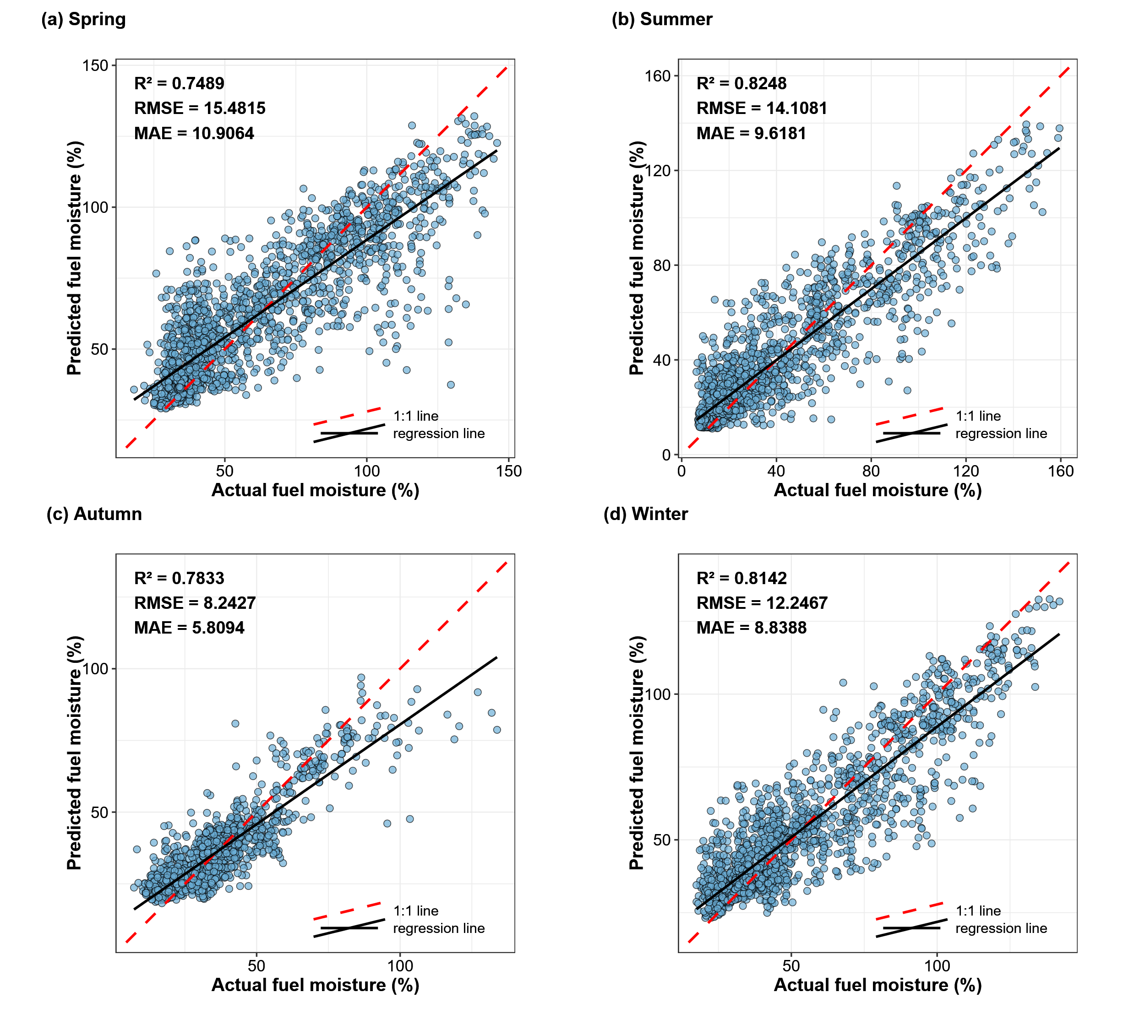
Fig. S3 Random Forest Model 1:1 Verification Graph.

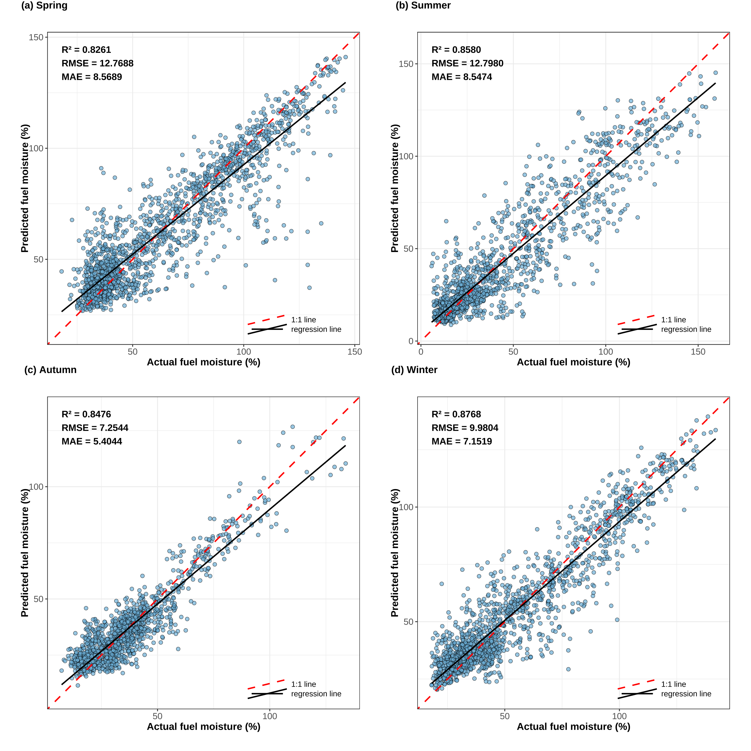
Fig. S4 XGBoost Model 1:1 Verification Graph.
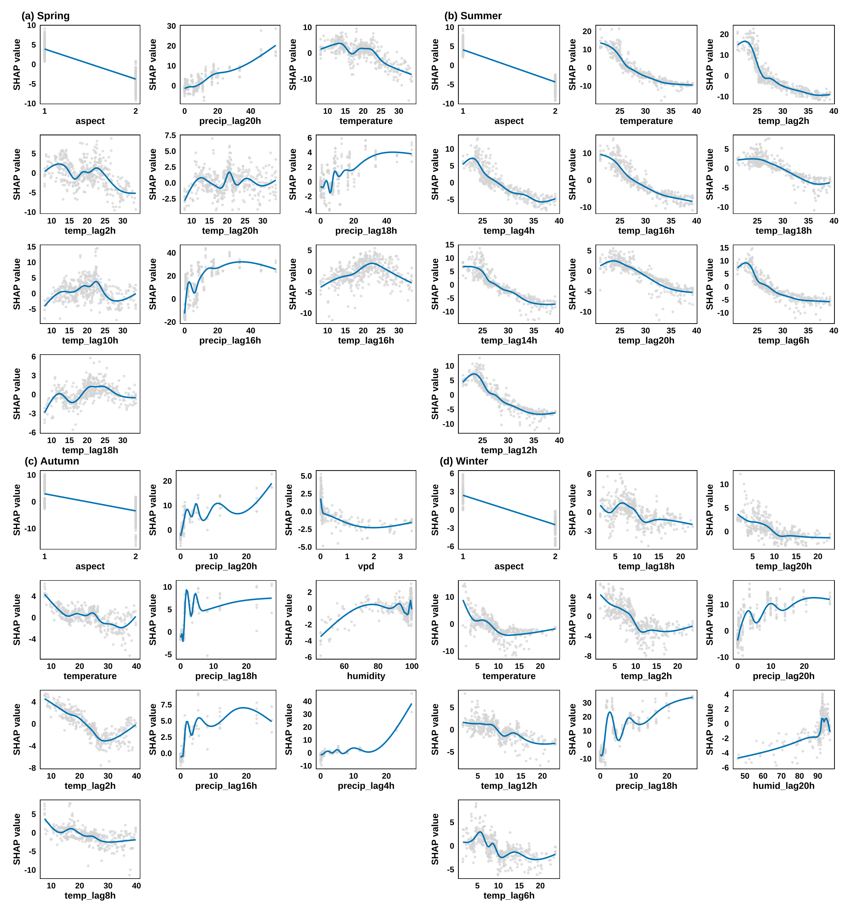
Fig. S5 XGBoost Model Partial Correlation Dependence Graph.

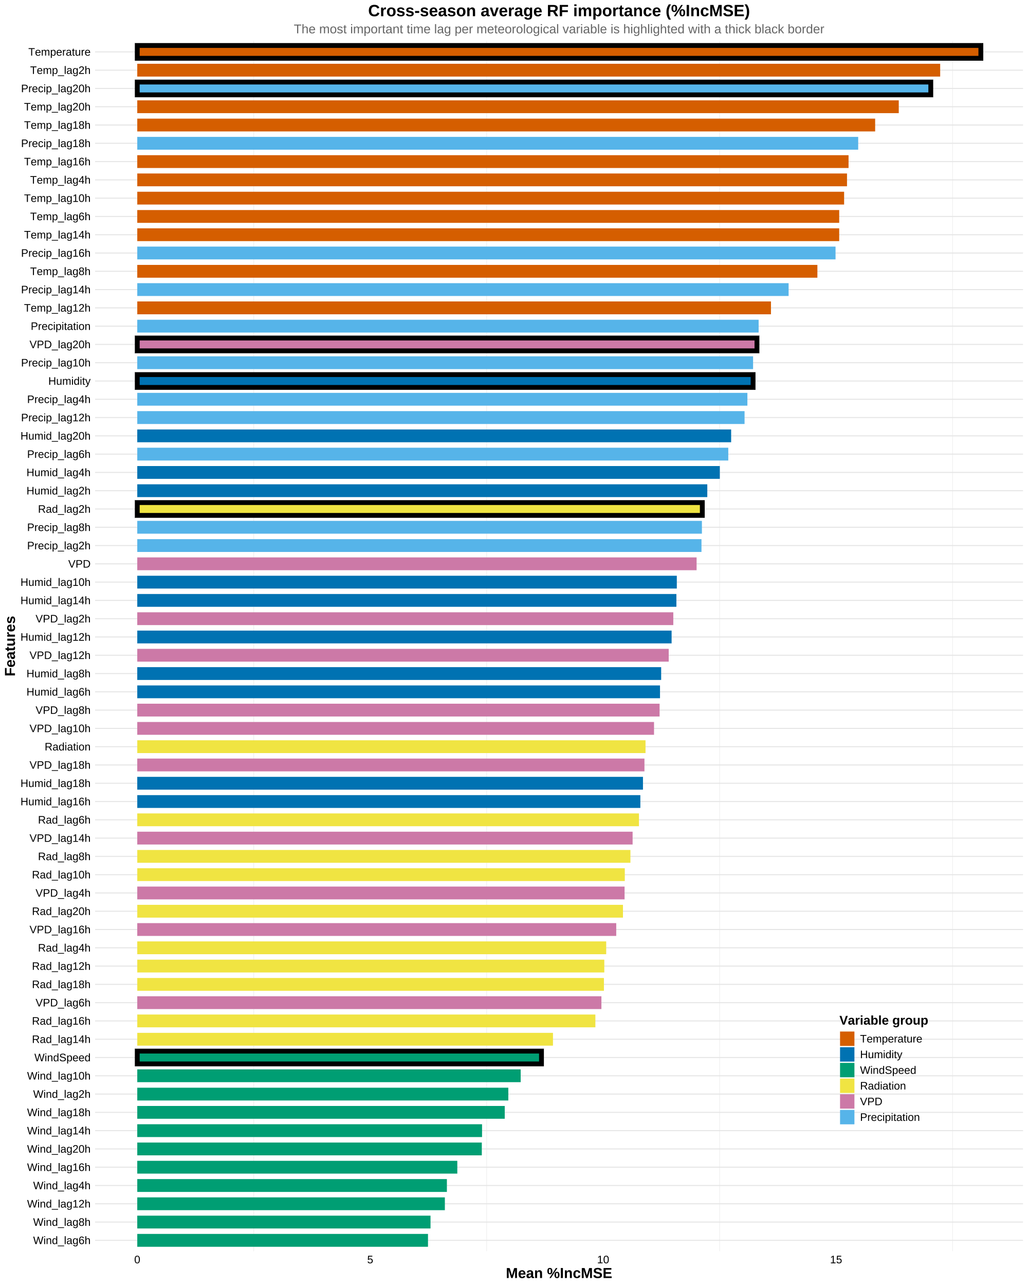
Fig S6. Random Forest-based selection of representative meteorological predictors for structural equation modeling

