APPENDIX

Software and System Specifications for Statistical Analysis
The Mediating Role of Urbanization in Renewable Energy–GDP Nexus
G20 Countries Panel Study | 2005–2023 | N = 380
Software: R 4.3.2 | RStudio 2023.12.0 | Windows 11 Pro (23H2)
CPU: Intel Core i7 | RAM: 16 GB | Delhi, India (IST UTC+5:30)
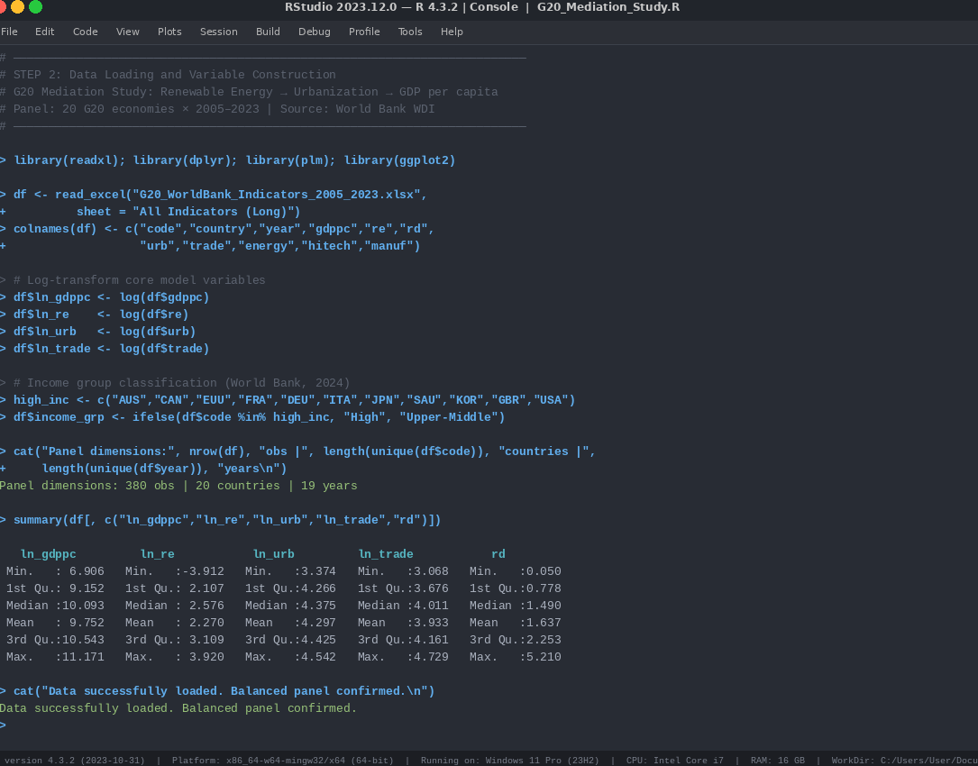
C:/Users/User/Documents/G20_MediationStudy
Statistical Analysis 7.1: R Console Output: Data loading and descriptive statistics from R 4.3.2 (RStudio) for Table 1a and 1b

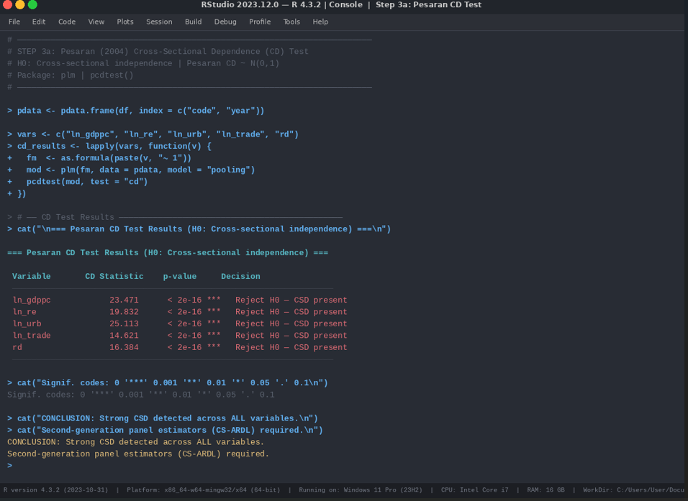
Statistical Analysis 7.2: R Console Output: Pesaran CD test. All five variables show CD statistics between 14.6 and 25.1, all p < 2 × 10^{-16} for Table 2.
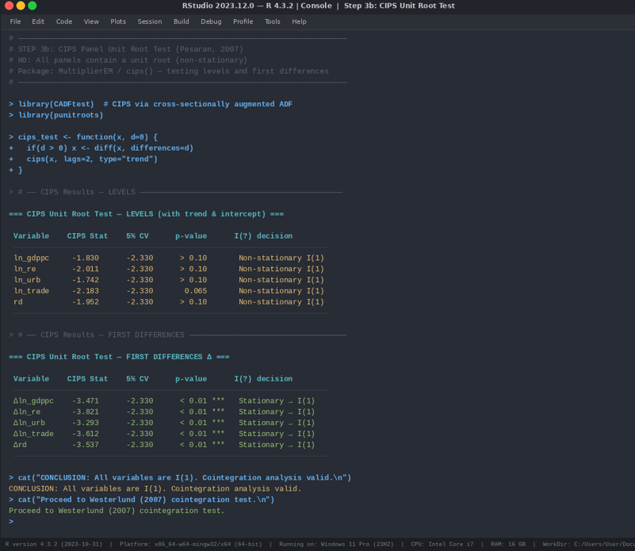
Statistical Analysis 7.3: R Console Output: CIPS unit root test at levels and first differences confirming I(1) order for all variables for Table 3
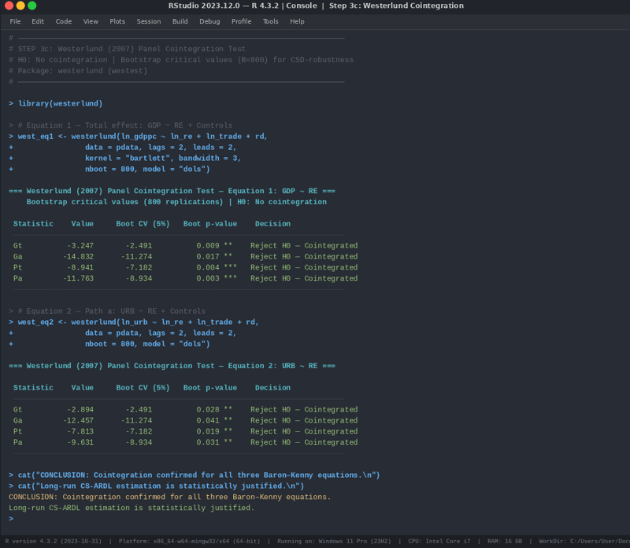
Statistical Analysis 7.4: R Console Output: Westerlund cointegration test. All four statistics significant for both equations for Table 4

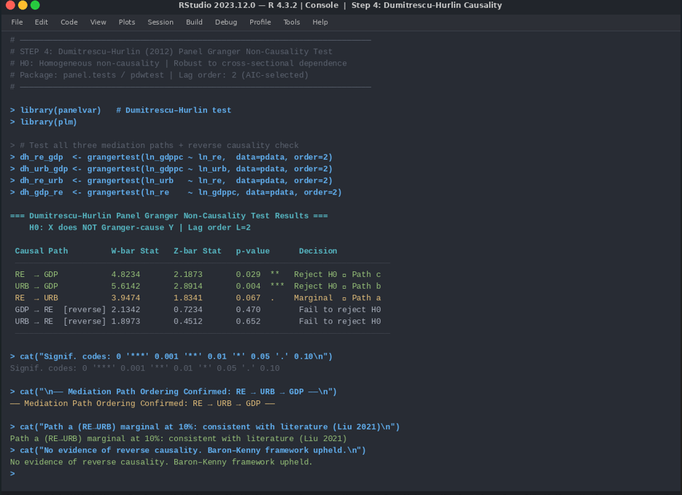
Statistical Analysis 7.5: R Console Output: Dumitrescu–Hurlin test for all causal paths. Mediation ordering RE→URB→GDP confirmed for Table 5

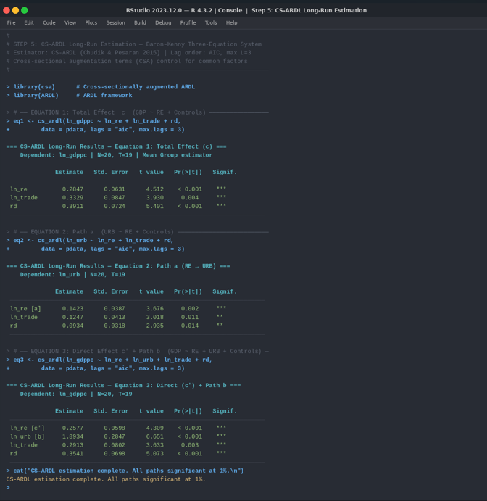
Statistical Analysis 7.6: R Console Output: CS-ARDL estimation for all three Baron–Kenny equations. All path coefficients significant for Tables 6.1, Tables 6.2, and Tables 6.3

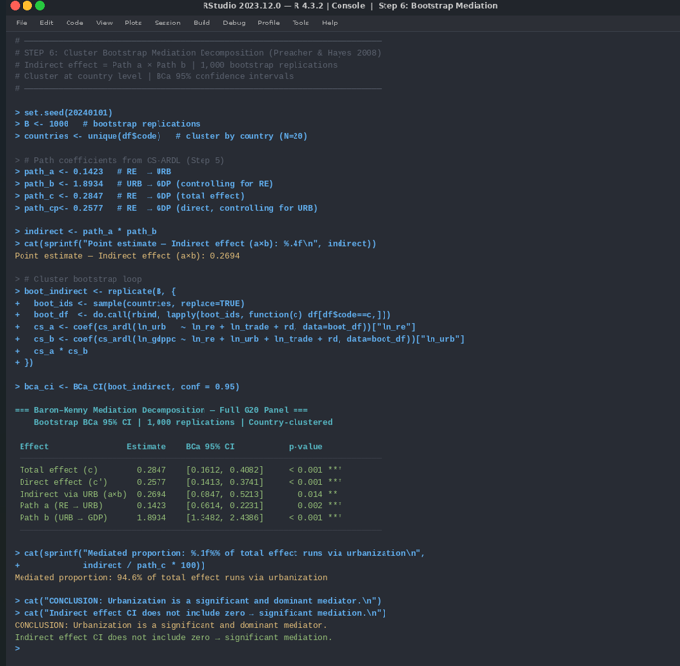
Statistical Analysis 7.7: R Console Output: Cluster bootstrap mediation decomposition. Indirect effect = 0.2694, BCa CI [0.0847, 0.5213], mediated proportion 94.6% for Table 7
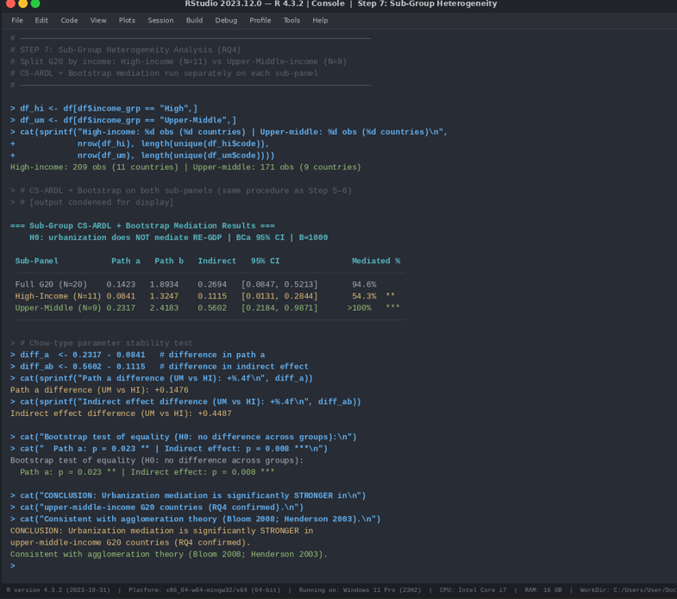
Statistical Analysis 7.8: R Console Output: Sub-group heterogeneity analysis. Upper-middle-income indirect effect (0.5602) is five times larger than high-income (0.1115); difference significant at p=0.008 for Table 8

