Heavy Metals Contamination and Associated Health Risks: Consumer Perceptions and Policy Implications in the Mining City of Lubumbashi, DR Congo
Adam Salifu¹, Jonas Lwalaba Wa Lwalaba² and Arsene Mushagalusa Balasha³

Supplementary file

Table S1. Sampled vegetable species and their common names from the six markets in Lubumbashi.
Table S2. knowledge, perception, and practices of consumers with respect to heavy metal contamination in vegetables
Table S3. Ordinal logistic regression analysis of factors influencing the perception level of consumers.
Figure S1. Consumers most preferred the vegetable species

Table S1. Sampled vegetable species and their common names from the six markets in Lubumbashi.

Vegetable species | English/French | Family | Swahili name | Edible parts | Mode of preparation | Photo
Spinacia oleacera | Spinach/Epinards | Amaranthaceae | Mchicha | Leaves | Boiled with condiments | 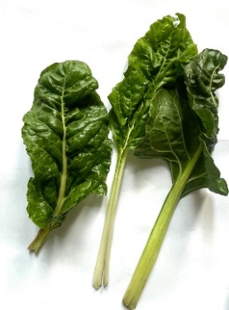
Brassica chinensis | Chinese cabbage/  chou chinois | Brassicaceae | Kabichi ya majani | Leaves | Boiled with condiments | 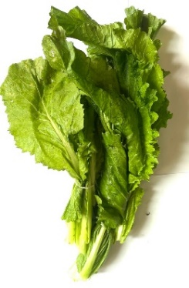
Amaranthus vulgaris | Amaranth/Amaranthe | Amaranthaceae | Lenga lenga | Leaves | Boiled with condiments | 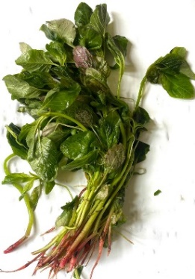
Manihot esculenta | Cassava/Manioc | Euphorbiaceae | Sombe | Leaves/tubers  Leaves sampled for present study | Boil to cook with condiments | 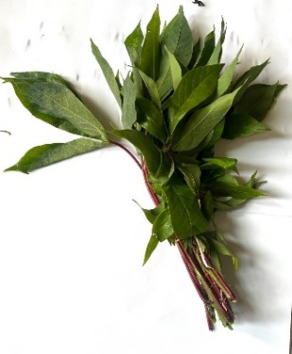
Allium cepa | Onion/Oignon | Liliaceae | Kitungulu | Bulbs/leaves | In salads, in soups as condiments | 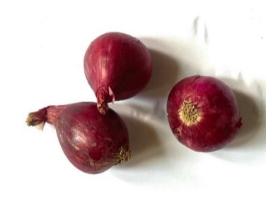
Solanum lycopersicum | Tomato/tomate | Solanaceae | Nyanya | Fruits | Ripe raw in salads, as a condiment in soups | 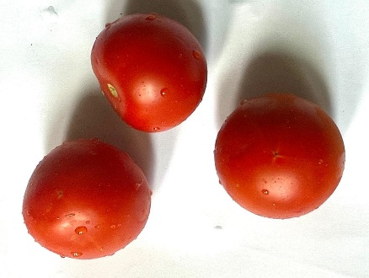

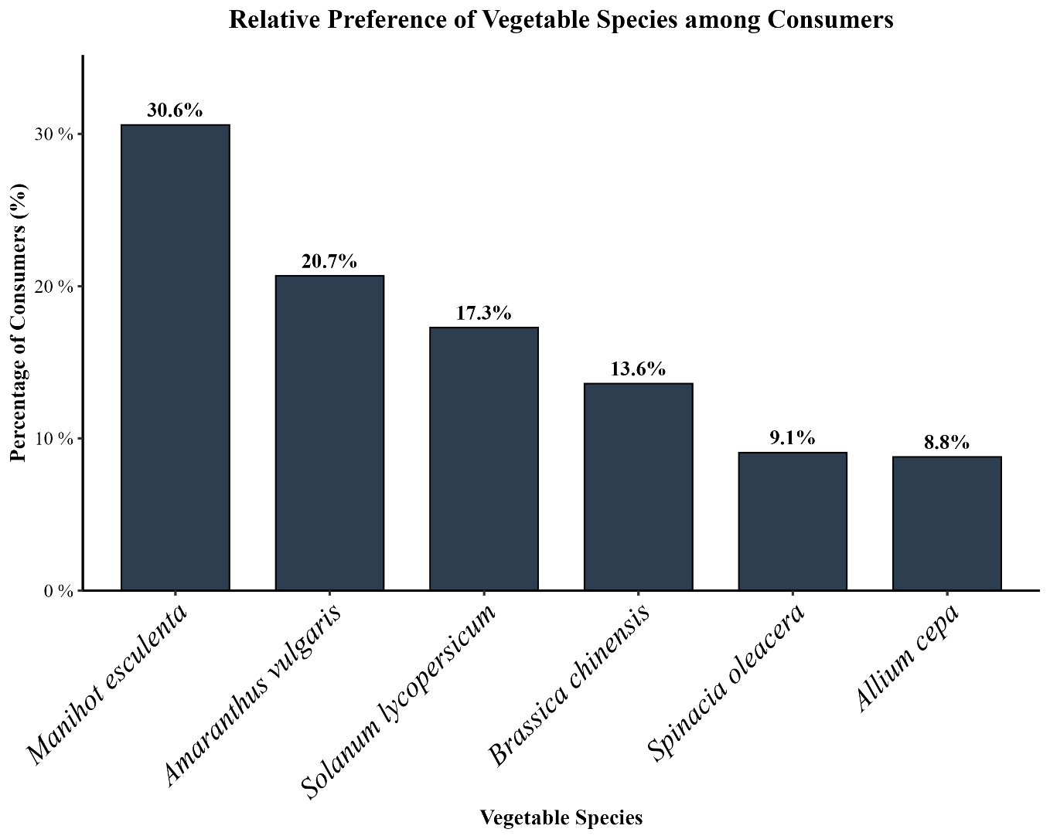
Figure S1. Consumers most preferred vegetable species

Table S2. knowledge, perception, and practices of consumers with respect to heavy metal contamination in vegetables
Variables
Knowledge | Responses | N (%)
1. Being in a mining city, are you aware that vegetables can absorb heavy metals (such as lead, copper, cobalt) from polluted soil or water? | Yes | 236 (66.9)
 | No | 31 (8.78)
 | I don’t know | 86 (24.4)
2. What do you think are possible sources of vegetable contamination in Lubumbashi? | Mining activities | 163 (46.2)
 | Industrial waste | 130 (36.8)
 | Road traffic/dust | 21(5.95)
 | Use of pesticides | 8 (2.27)
 | I don’t know | 31(8.78)
3. Do you know if the vegetables sold in your market are grown near mining areas or industrial sites? | Yes | 106 (30.0)
 | No | 101(28.6)
 | I do not know | 146 (41.4)
Perception
4. Consuming vegetables contaminated with heavy metals can cause serious health problems. | Strongly agree | 260 (73.6 )
 | Agree | 47 (13.3)
 | Disagree | 15 (4.25)
 | Not sure | 31 (8.78)
5. Which health problems do you associate with heavy metal contamination in food? | Stomach pains/diarrhea | 175 (49.6)
 | Cancer | 74 (21.0)
 | Kidney/liver problems | 39 (11.0)
 | Developmental issues in children | 32 (9.07)
 | I do not know | 33 (9.35)
6. Do you think washing or cooking can completely remove heavy metals from vegetables? | Yes | 172 (48.7)
 | No | 98 (27.8)
 | Not sure | 83 (23.5)
Practices
7. When buying vegetables, do you consider the place of cultivation before purchasing? | Always | 74 (20.96)
 | Sometimes | 109 (30.88)
 | Rarely | 92 (26.06)
 | Never | 78 (22.10)
8. If you know vegetables come from a polluted area, would you avoid buying them? | Yes | 234 (66.29)
 | No | 70 (19.83)
 | I don’t know | 49 (13.83)
9. Since vegetables are exposed to pollutants (heavy metals, pesticides), did this affect your vegetable washing pattern? | Very much | 255 (72.24)
 | A little | 60 (17.0)
 | Not at all | 38 (10.76)
10. How many times do you wash? | 1-2 times | 130 (36.83)
10. How many times do you wash? | 3-4 times | 201(56.94)
10. How many times do you wash? | ≥5 times | 22 (6.23)

Table S3. Ordinal logistic regression analysis of factors influencing the perception level of consumers.
Predictors |  | Knowledge |  |  | Perception |  |  | Practice
Variables | Ref | OR_{a} | 95% CI | P-value | OR_{a} | 95% CI | P-value | OR_{a} | 95% CI | P-value
Gender | Female | 1.91 | 1.28-2.86 | 0.002⁎ | 0.81 | 0.54-1.21 | 0.307 | 1.25 | 0.84-1.85 | 0.274
Age (years) | 30-44 | 1.17 | 0.73-1.87 | 0.517 | 1.5 | 0.96-2.49 | 0.072 | 1.24 | 0.78-1.97 | 0.363
Age (years) | 45-59 | 0.48 | 0.19-1.24 | 0.131 | 1.78 | 0.75-4.22 | 0.191 | 2.33 | 0.91-5.95 | 0.077
Age (years) | ≥60 | 0.07 | 0.01-0.45 | 0.005⁎ | 0.76 | 0.10-5.60 | 0.789 | 0.30 | 0.05-1.70 | 0.175
Education level | Primary | 0.05 | 0.01-0.30 | 0.001⁎ | 0.19 | 0.03-1.07 | 0.059 | 0.28 | 0.05-1.45 | 0.13
Education level | Secondary | 0.25 | 0.05-1.23 | 0.088 | 0.39 | 0.09-1.61 | 0.192 | 0.43 | 0.10-1.77 | 0.242
Education level | University | 0.15 | 0.03-0.72 | 0.018 | 0.35 | 0.09-1.38 | 0.133 | 0.31 | 0.08-1.23 | 0.095
Main occupation | Government worker | 2.34 | 0.95-5.81 | 0.066 | 1.35 | 0.58-3.15 | 0.491 | 3.34 | 1.35-8.25 | 0.009⁎
Main occupation | Private sector | 1.82 | 0.86-3.85 | 0.116 | 0.81 | 0.40-1.67 | 0.574 | 2.98 | 1.40-6.33 | 0.005⁎
Main occupation | Student | 2.15 | 0.99-4.68 | 0.054 | 1.44 | 0.67-3.08 | 0.348 | 3.87 | 1.75-8.57 | 0.001⁎
Main occupation | Unemployed | 2.28 | 0.86-6.04 | 0.096 | 1.04 | 0.40-2.71 | 0.936 | 5.58 | 2.16-14.39 | 0.000⁎⁎
Length of stay in Lubumbashi (years) | 6-10 | 0.57 | 0.32-1.02 | 0.058 | 0.56 | 0.31-1.02 | 0.056 | 0.99 | 0.55-1.79 | 0.982
Length of stay in Lubumbashi (years) | 10 > years | 0.55 | 0.34-0.91 | 0.02⁎ | 0.86 | 0.52-1.44 | 0.576 | 0.87 | 0.53-1.43 | 0.586
Have heard about heavy metal contamination before | No | 7.22 | 4.34-12.02 | 0.000⁎⁎ | 3.87 | 2.38-6.29 | 0.000⁎⁎ | 2.20 | 1.37-3.55 | 0.001⁎
Significant at *<0.05; **<0.001; CI confidence interval; OR_{a} adjusted odds ratio, ref reference

