Supplementary Material

Supplementary Figures and Tables

Supplementary Figures
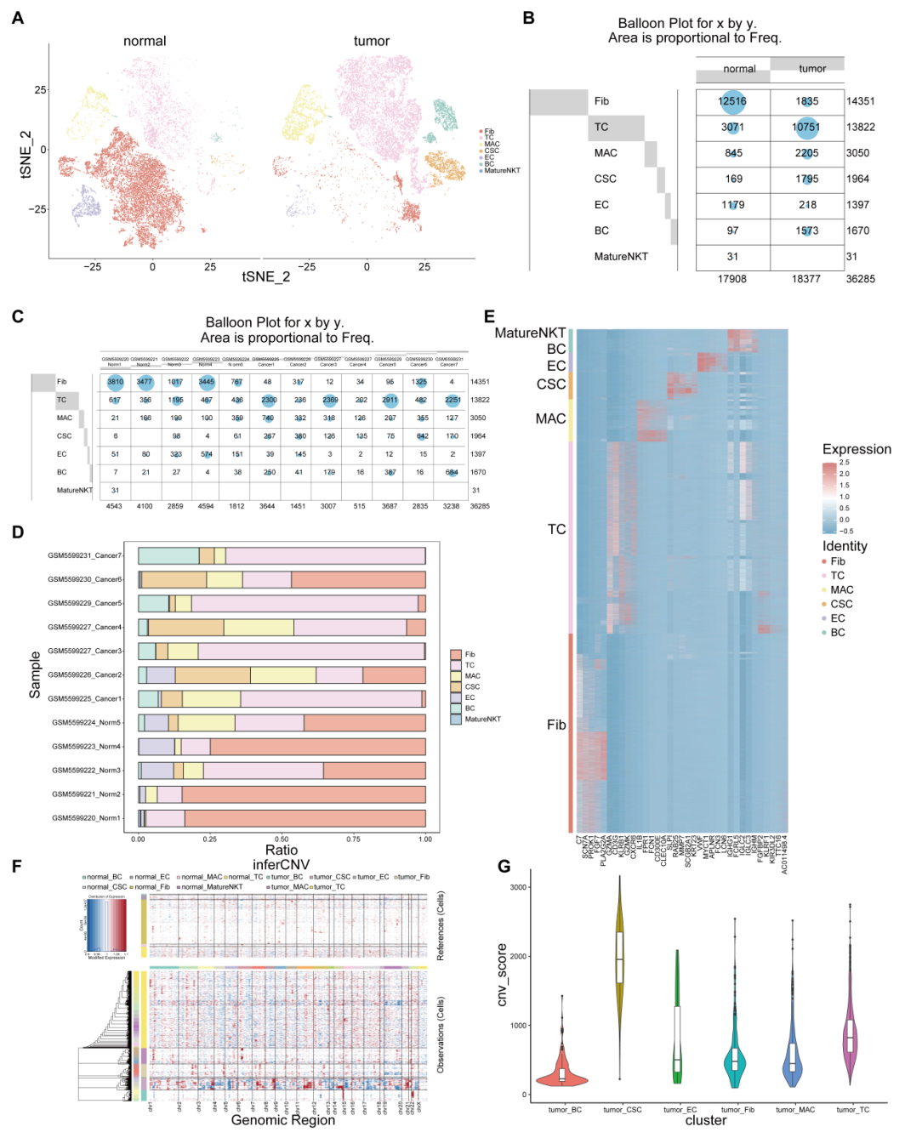
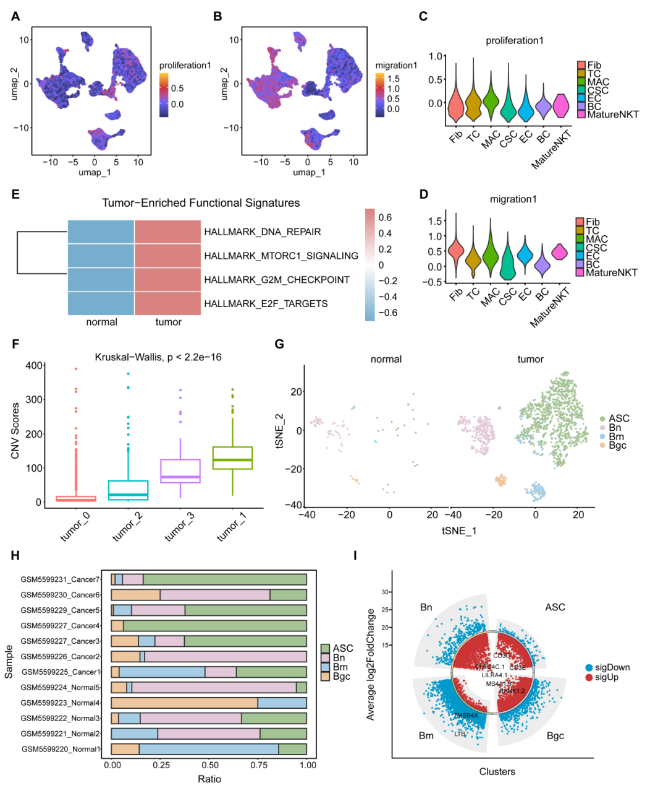
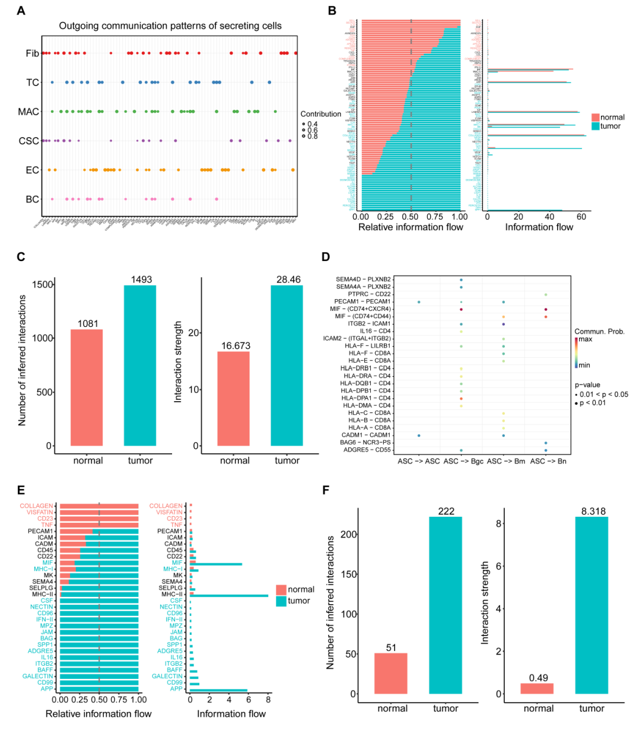

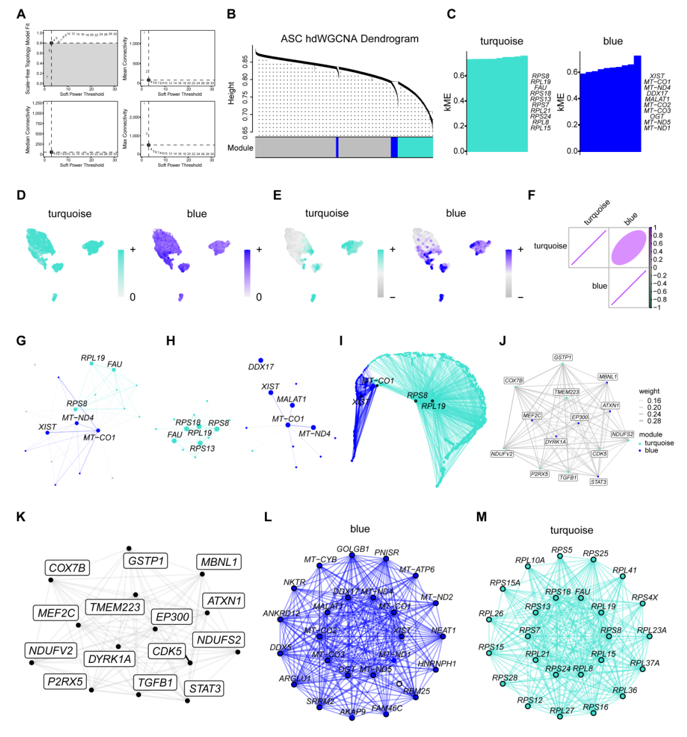
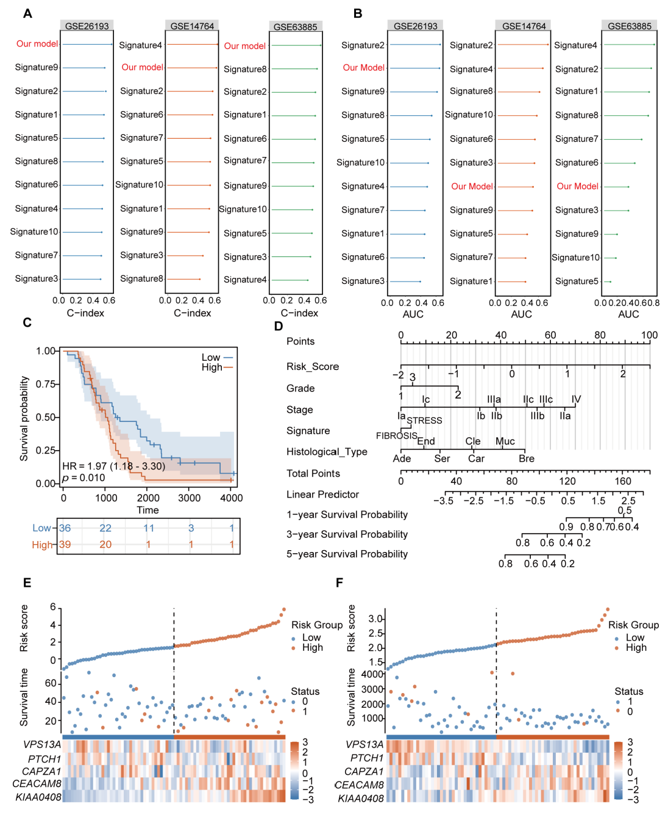
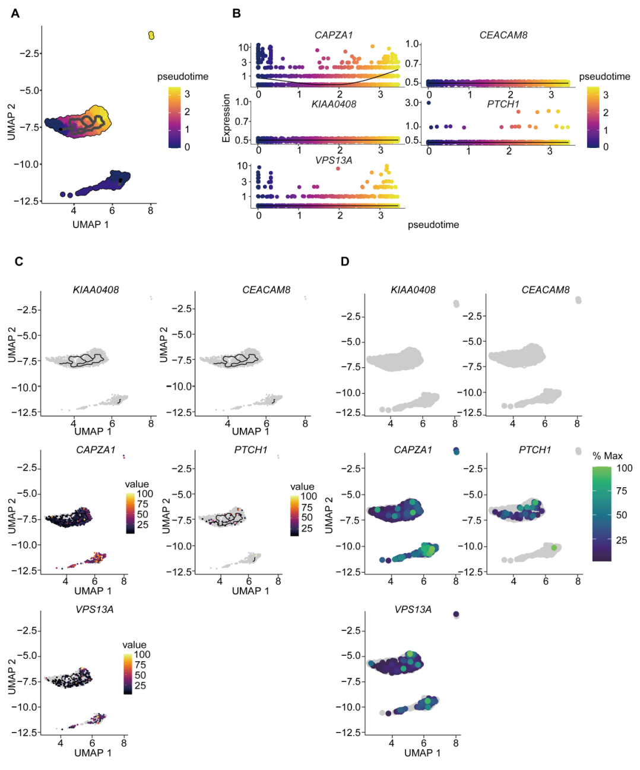
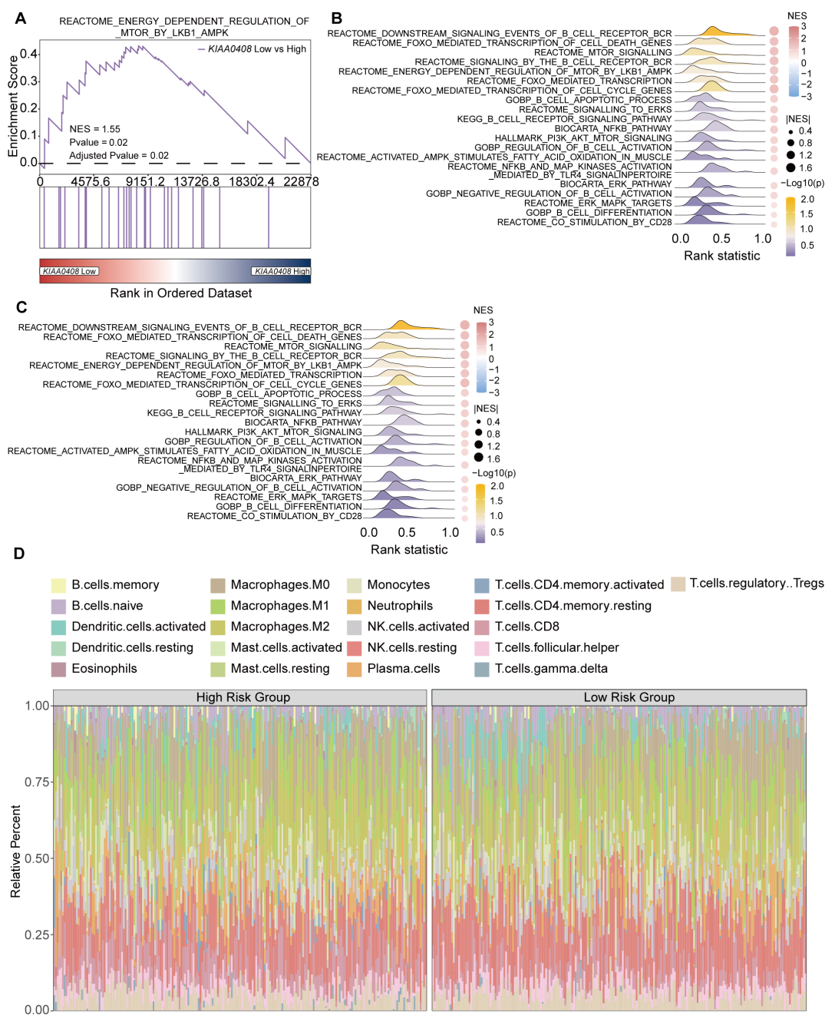
Supplementary Figure 1. scRNA-seq clustering and CNV analysis in the GSE184880 cohort. (A) Comparative display of t-SNE distribution differences among various cell types in the normal and tumor groups. (B) Number of each cell type in the normal and tumor groups. (C) Number of each cell type in individual samples. (D) Cell proportion plots for each cell type in individual samples. (E) Heatmap of DEGs via FindAllMarkers for each cell type. (F) Heatmap of CNV analysis for each cell type in the normal and tumor groups. (G) Violin plot of CNV scores for each cell type in the tumor group.
Supplementary Figure 2. Single-cell landscape of the GSE184880 cohort and systematic dissection of B-cell subsets. (A, B) UMAP plots of single-cell proliferation and migration scores in the GSE184880 cohort based on the AddModuleScore function. (C, D) Proliferation and migration scores for each cell type. (E) Heatmap of GSVA-enriched functional features in normal versus tumor cohorts. (F) CNV scores for B cell subpopulations in the tumor cohort. (G) Comparative display of t-SNE distribution differences between normal and tumor cohort B cell subpopulations. (H) Cell proportion plots for B cell subpopulations in individual samples. (I) Chord plots of gene differential expression analysis for B cell subpopulations.
Supplementary Figure 3. Cellular communication analysis of the GSE184880 cohort and B cell subtypes. (A) Contribution of six cell types to different cell-to-cell communication patterns. (B) Relative and absolute information flow of cellular communication across tissues among six cell types. (C) Number and strength of cellular interactions among six cell types in normal and tumor tissues. (D) Heatmap of ligand-receptor interactions between ASC and other B cell subtypes. (E) Relative and absolute information flow of cellular communication cross tissues among three B cell subtypes. (F) Number and strength of cell interactions among B cell subtypes in normal and tumor tissues.
Supplementary Figure 4. hdWGCNA reveals co-expression modules in ASCs (A) Scale-free topological model fitting index and connectivity curves as a function of soft threshold. (B) ASC hdWGCNA gene clustering dendrogram and module partitioning. (C) Connectivity scores of characteristic genes within each module. (D, E) Expression distribution of characteristic genes from each module in the B cell UMAP dimensionality reduction space. (F) Correlation matrix between gene modules. (G, H, I) Interaction networks of core genes within each module. (J, K) Interaction networks of characteristic genes within each module. (L, M) Interaction network of characteristic genes in the blue and turquoise modules.
Supplementary Figure 5. Independent validation and performance evaluation of the machine learning model. (A) C-index ranking of our model versus published features in the validation cohort. (B) AUC ranking of this model versus published features in the validation cohort. (C) Survival analysis in the GSE63885 cohort. (D) Prognostic prediction nomogram integrating risk scores and clinical-pathological features. (E) Risk score plot in the GSE14764 cohort. (F) Risk score plot in the GSE63885 cohort.
Supplementary Figure 6. Pseudotemporal dynamics of model gene expression. (A) Pseudotime trajectory plot of B cells. (B) Dynamic expression changes of model genes along pseudotime. (C) Differentiation trajectories and expression distributions of model genes in the B cell UMAP dimensionality reduction space. (D) Percentage distribution of model gene expression in the B cell UMAP dimensionality reduction space.
Supplementary Figure 7. Model gene enrichment analysis and immune infiltration analysis. (A) GSEA of KIAA0408 high-expression and low-expression groups in the GSE26193 cohort. (B, C) Significant GSEA pathway maps related to KIAA0408 in the GSE14764 and GSE63885 cohorts. (D) Stacked bar chart showing the proportion of immune cell composition between high-risk and low-risk groups.

Supplementary Tables

