Supplementary Figure 1: Recruitment poster
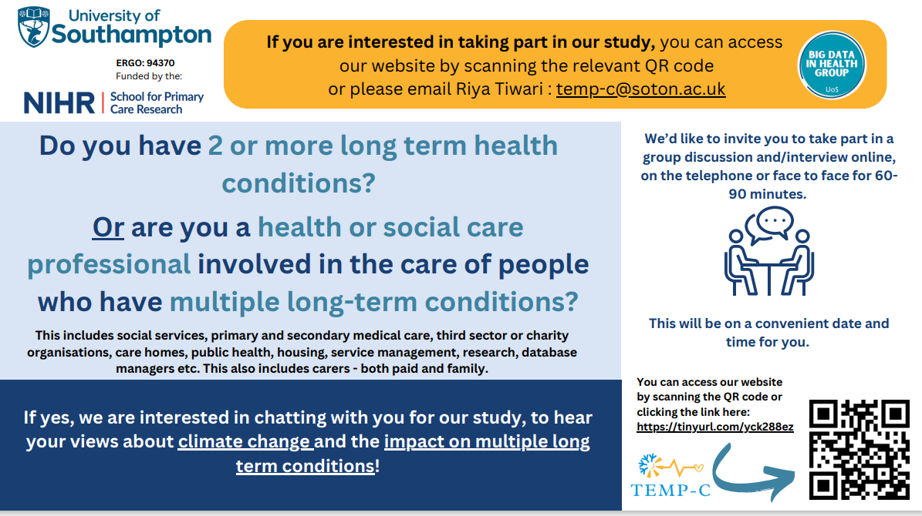

Supplementary File 2
Screening questionnaire for Qualtrics:
    - Please identify yourself
    - What multiple long term conditions do you have?
    - Please state your relationship to the individual living with multiple long term conditions below (e.g. partner, daughter, friend, paid carer, etc).
    - Please state your primary care profession title below.
    - Please state your profession in the field of climate change and temperature extremes below (e.g. researcher, climatologist, etc.)
    - Please provide your contact information below. – Name
    - Please provide your contact information below. - Telephone Number
    - Please provide your contact information below. - Email address
    - Please provide your contact information below. - What times and days of the week would be best for us to contact you on?
    - Please provide your contact information below. - What is your postcode?
    - Please provide your contact information below. - Which region do you live in? (E.g. Greater London, North East, South West, etc.)
    - What is your biological sex? (We will ask a separate question about gender identity next)
    - What is your gender identity? - Selected Choice
    - What is your gender identity? - Prefer to self describe (please do so below) – Text
    - What is your gender identity? - Please describe your gender identity if it is not listed above: - Text
    - What is your ethnicity? – Selected Choice
    - What is the highest level of school you have completed or the highest degree you have received? - Selected Choice
    - What is the highest level of school you have completed or the highest degree you have received? - Other (please state): - Text
    - Please tell us how you heard about this study: - Selected Choice
    - Please tell us how you heard about this study: - Other (please specify): - Text

