Supplementary Information

A charge-regulated framework for microplastic aggregation and removal

Brijitta Joseph^{1,2*}, Christian Lang³, Armin Kriele⁴, Koichi Mayumi⁵, Andreas Gabriel³, Ulrich Kubinger³, Stephan Förster^{6,7}, Aurel Radulescu^{1*}
¹Jülich Centre for Neutron Science at Heinz Maier-Leibnitz Zentrum, Forschungszentrum Jülich GmbH, 85748 Garching, Germany
²Soft Matter Laboratory, Centre for Nanoscience and Nanotechnology,
Sathyabama Institute of Science and Technology, Chennai 600 119, Tamil Nadu, India
³VTA Institute for Health & Environment, Umweltpark 1, 4681 Rottenbach, Austria
⁴German Engineering Materials Science Centre (GEMS) at Heinz Maier-Leibnitz Zentrum (MLZ), Helmholtz-Zentrum Hereon GmbH, 85748 Garching, Germany
⁵The Institute for Solid State Physics (ISSP), The University of Tokyo, 5-1-5 Kashiwanoha, Kashiwa, Chiba 277-8581 Japan.
⁶Jülich Centre for Neutron Science (JCNS-1/IBI-8), Forschungszentrum Jülich, 52425 Jülich, Germany
⁷Institute of Physical Chemistry, RWTH Aachen University, Aachen 52074, Germany

Email: b.joseph.boniface@fz-juelich.de;
a.radulescu@fz-juelich.de

Details of the Domestic WWTPs
In WWTP 1, which serves approximately 60,000 population equivalents (p.e.) and primarily treats communal (urban) wastewater, mechanical treatment begins with screening to remove coarse solids. In the subsequent aerated grit chamber, the flow velocity of the wastewater is reduced, allowing grit and heavier materials to settle. The collected materials are dewatered and stored in a landfill. The primary clarifier functions as a settling tank, where lighter substances such as fats and oils rise to the surface and are removed by scrapers. These materials are then pumped into the digester as a sludge mixture, which is thickened by dehydration. Biological treatment takes place in five adjacent aeration tanks consisting of aerated and non-aerated sections. The activated sludge settles at the bottom of the two secondary clarifiers, from which it is partly returned to the aeration system as return sludge. The remaining excess sludge is mechanically pre-dewatered in the thickener before being fed into the digester.
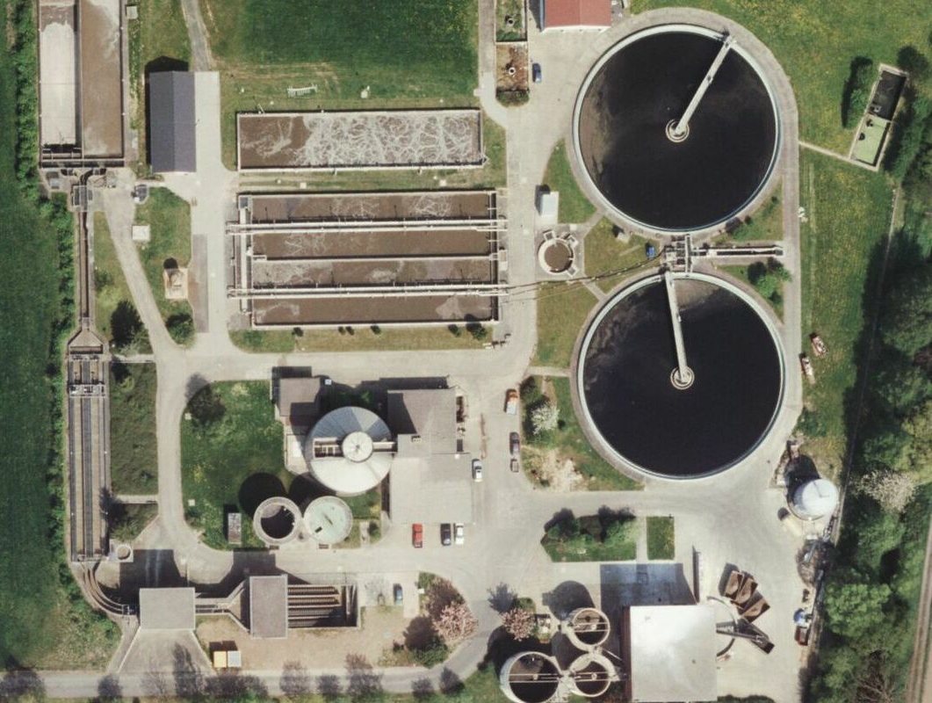
Fig SI.1. Ariel photograph of domestic WWTP1.
In WWTP 2, which serves approximately 60,000 population equivalents (p.e.) and primarily treats domestic wastewater, mechanical treatment is performed using screens, grit chambers, and primary clarification. Biological treatment occurs in two aeration tanks with upstream denitrification, followed by secondary clarification. Phosphate removal is achieved simultaneously in the aeration tanks through chemical precipitation. The plant treats an annual wastewater volume of approximately 3 million m³.
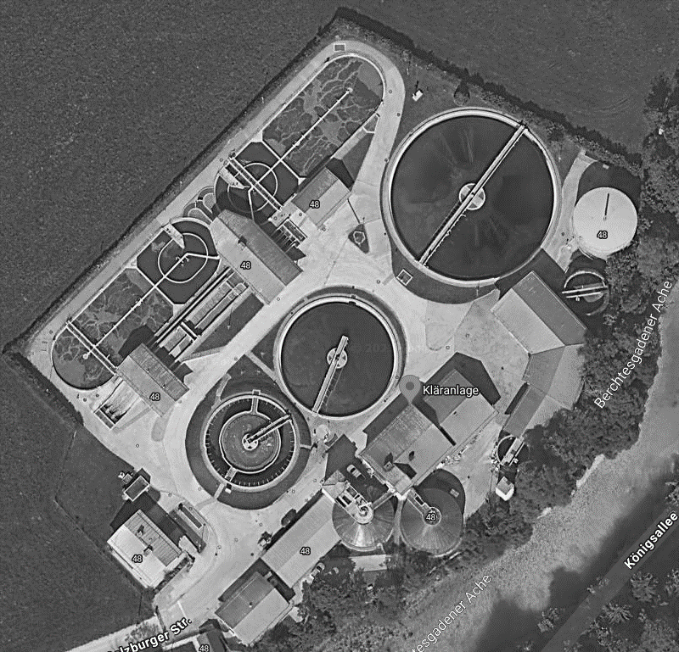
Fig SI.2. Ariel photograph of domestic WWTP2.
In WWTP 3, which serves approximately 28,000 population equivalents (p.e.) and treats a mixture of 60% communal wastewater and 40% industrial wastewater (from the chemical industry), mechanical treatment begins with an 8 mm automatic screen system followed by a grit trap located downstream of the screen. In the primary clarifier, lighter particles float to the surface and are collected in a storage tank, from which they are pumped into the digester for further treatment. Biological treatment is carried out in a two-lane aeration system, where each aeration tank is equipped with independent measuring and control devices for oxygen, temperature, pH, ammonium nitrogen, nitrate nitrogen, and phosphate. From the aeration tanks, the mixed liquor flows into the secondary settling tank, allowing the activated sludge to settle and separate from the treated water. A portion of the settled sludge is returned to the aeration tanks as return sludge, while the excess sludge is pumped to the excess sludge thickening unit. The excess sludge is mixed with a polymer to promote solid-liquid separation. The separated water is returned to the aeration tanks, and the thickened sludge is fed into the digestion tower, which has a capacity of 1,200 m³ and features external circulation. During digestion, raw and excess sludge produce sewage gas, which is utilized in a combined heat and power (CHP) plant. The CHP system covers most of the plant’s electricity demand and supplies heat to both the digester and the operating building. Additionally, the generated sewage gas is used to continuously meet the base-load electricity demand, while the CHP subsidy provides revenue for the electricity consumed on-site and, for electricity fed into the public grid.
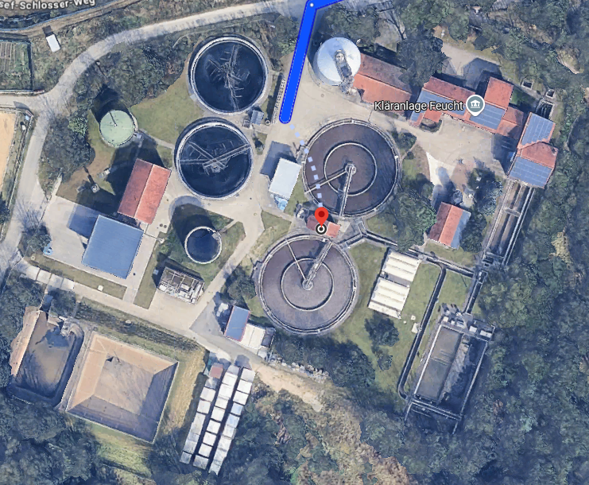
Fig SI.3. Ariel photograph of domestic WWTP3.
Details of the Industrial Wastewater Treatment Plants
In WWTP 4 (fibres), which serves approximately 350,000 population equivalents (p.e.) and treats starch production wastewater with 5% municipal (urban) influent, primary treatment includes anaerobic digestion combined with four-lined preliminary flotation units. Biological treatment consists of high-load treatment units operating in nitrification mode, followed by eight low-load treatment units functioning in intermittent denitrification/nitrification mode. The treated wastewater then passes through two secondary settlers, where the activated sludge is separated from the effluent.
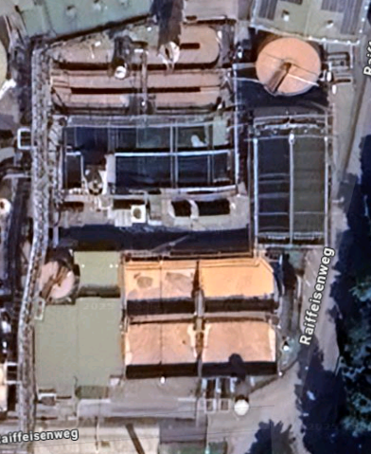
Fig SI.4. Ariel photograph of Industrial WWTP4.
In WWTP 5 (papermill), which serves approximately 100,000 population equivalents (p.e.) and treats papermill production wastewater with 10% communal influent, mechanical treatment includes a grit chamber. The biological treatment is carried out in a two-line setup with primary settlers and thickeners for primary sludge, followed by anaerobic pretreatment and subsequent aerobic treatment and settling in four sequencing batch reactors (SBRs). The secondary sludge is dewatered using screw presses and subsequently digested, while the plant operates CHP plants to supply energy and heat for the treatment processes.
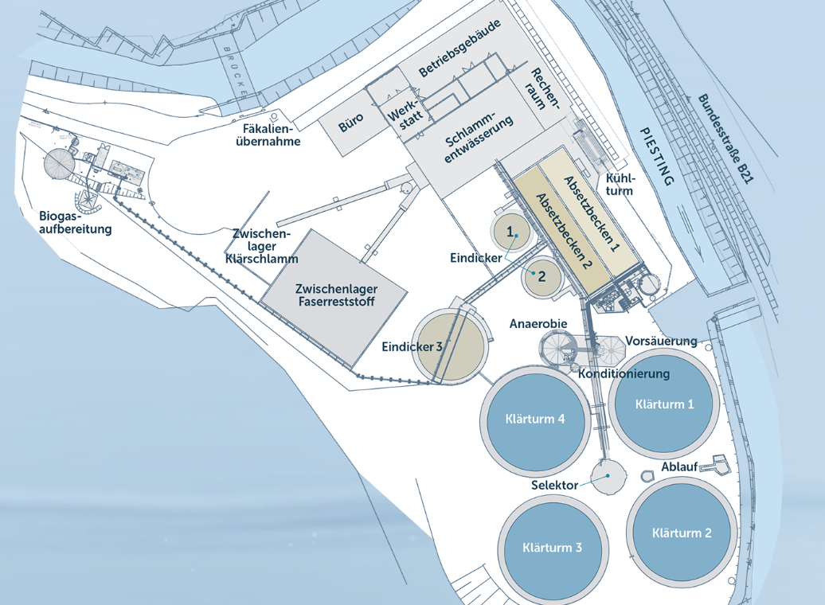
Fig SI.5. Ariel scheme of the industrial WWTP5.
Fig SI.6. (a, b) Scatter plot of MP width versus height; size distribution of individual particles detected, and (c, d) aspect ratio distribution of different MPs detected in the influent and effluent of domestic WWTP2.
Fig SI.7. (a, b) Scatter plot of MP width versus height; size distribution of individual particles detected, and (c, d) aspect ratio distribution of different MPs detected in the influent and effluent of domestic WWTP3.
Fig SI.8. (a, b) Scatter plot of MP width versus height; size distribution of individual particles detected, and (c, d) aspect ratio distribution of different MPs detected in the influent and effluent of industrial WWTP4.
Fig SI.9. (a, b) Scatter plot of MP width versus height; size distribution of individual particles detected, and (c, d) aspect ratio distribution of different MPs detected in the influent and effluent of domestic industrial WWTP5.

Table SI. 1. Sample compositions used to optimize the aggregation of polystyrene microplastics. The water content was fixed at 6 mL for all samples, while the polystyrene (PS) and Nanofloc® (NF) concentrations were systematically varied.
S. Label | φ_{PS} | NF content
a1 | 2.60 × 10⁻⁴ | 10 μL
a2 | 5.21 × 10⁻⁴ | 20 μL
a3 | 7.80 × 10⁻⁴ | 30 μL
a4 | 1.04 × 10⁻³ | 40 μL
a5 | 1.30 × 10⁻³ | 50 μL

Supplementary Video: S. Video 1

