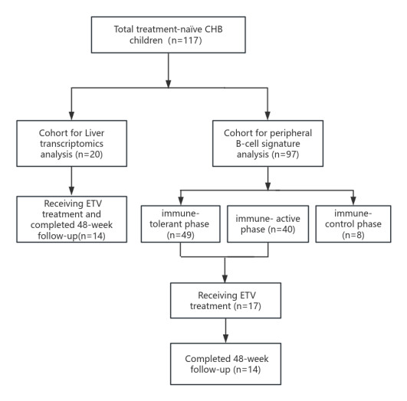
Supplementary figure 1. Patients Enrollment and Follow-up Flowchart.

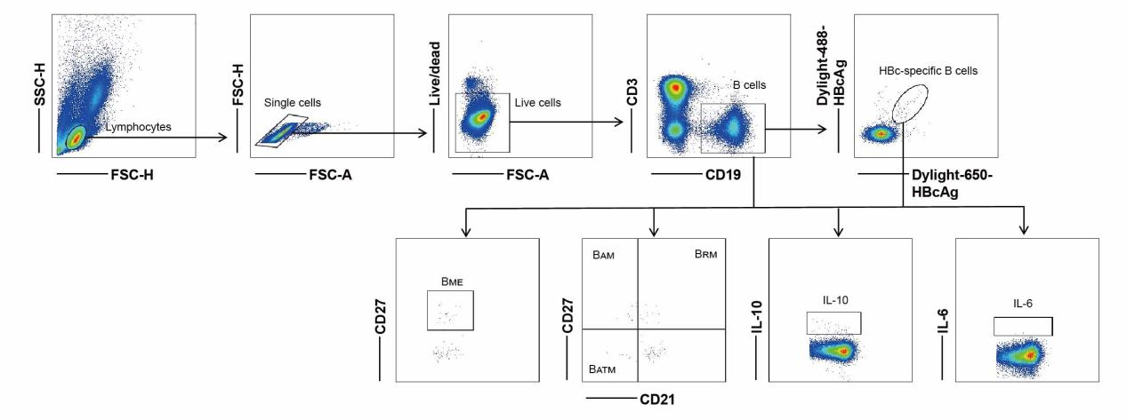
Supplementary figure 2. Flow cytometry gating strategy of peripheral circulating total B and HBc-B cells.
B_{ME}, memory B cells; B_{RM}, resting memory B cells; B_{AM}, activated memory B cells; B_{ATM}, atypical memory B cells.

Supplementary figure 3. Percentages of IL-10+ and IL-6+ B cells or HBc-B cells in IT, IA, or IC CHB children.

Supplementary figure 4. Correlation analysis among total B cells, HBc-B cells, their subsets, HBcAb SFC, and HBcAb levels.

Supplementary table 1. Laboratory parameters of 14 CHB children included in liver transcriptome analysis at baseline and at week 48 after antiviral therapy with Entecavir
Patient  ID | Age (years) | Sex | The grade of liver inflammation  (G) | The stage of liver fibrosis  (S) | At baseline |  |  |  |  | At week 48 of Entecavir treatment
 |  |  |  |  | ALT (×ULN) | HBV DNA  (log₁₀ IU/mL) | HBsAg  (log₁₀ IU/mL) | HBeAg  (log₁₀ s/co) |  | ALT (×ULN) | HBV DNA  (log₁₀ IU/mL) | HBsAg  (log₁₀ IU/mL) | HBeAg  (log₁₀ s/co)
P01 | 10 | boy | 2 | 2 | 9.28 | 8.01 | 4.59 | 3.00 |  | 0.65 | < LLOQ | 3.29 | 1.53
P02 | 10 | girl | 1 | 1 | 1.50 | 6.08 | 2.30 | 2.89 |  | 0.55 | < LLOQ | 1.32 | 1.96
P03 | 16 | boy | 1 | 1 | 2.03 | 7.99 | 4.62 | 3.01 |  | 0.70 | 4.31 | 4.13 | 2.56
P04 | 9 | girl | 1 | 2 | 3.30 | 8.16 | 4.70 | 2.93 |  | 0.53 | < LLOQ | 3.49 | 1.00
P05 | 12 | girl | 1 | 2 | 7.18 | 8.04 | 4.06 | 3.06 |  | 0.55 | < LLOQ | 1.56 | 0.81
P06 | 7 | girl | 1 | 1 | 4.55 | 8.46 | 4.25 | 3.02 |  | 0.43 | < LLOQ | 3.44 | 0.60
P07 | 4 | girl | 1 | 1 | 3.43 | 7.53 | 4.27 | 3.07 |  | 1.58 | < LLOQ | 3.88 | 2.83
P08 | 3 | boy | 1 | 1 | 1.83 | 8.46 | 4.67 | 3.09 |  | 0.38 | < LLOQ | -2.00 | -0.17
P09 | 12 | girl | 1 | 2 | 3.83 | 7.84 | 4.10 | 1.73 |  | 0.50 | < LLOQ | 3.72 | -0.42
P10 | 3 | boy | 2 | 2 | 2.08 | 6.96 | 2.90 | 3.14 |  | 0.63 | 2.77 | 3.13 | 2.56
P11 | 6 | boy | 2 | 2 | 7.73 | 7.56 | 4.00 | 3.18 |  | 0.35 | < LLOQ | 2.28 | -0.39
P12 | 3 | girl | 1 | 1 | 0.50 | 8.36 | 4.73 | 3.21 |  | 0.58 | 4.92 | 4.58 | 3.10
P13 | 9 | girl | 2 | 1 | 4.55 | 7.18 | 1.47 | 3.16 |  | 0.35 | < LLOQ | -2.00 | 0.64
P14 | 4 | boy | 2 | 1 | 1.88 | 7.19 | 4.35 | 3.17 |  | 0.50 | < LLOQ | 1.71 | -0.24
ALT, alanine aminotransferase; HBV, hepatitis B virus; HBsAg, Hepatitis B surface antigen; HBeAg, Hepatitis B e antigen; IU, international unit; LLOQ, lower limit of quantitation of HBV DNA (400 IU/mL); ULN, upper limit of normal (40 U/L); s/co, signal-to-cutoff ratio

Supplementary table 2. Laboratory parameters of 14 CHB children included in the analysis of peripheral HBc-B cells at baseline and at week 12 and 48 after anti-viral therapy with Entecavir
 |  |  | At baseline |  |  |  |  | At week 12 of Entecavir treatment |  |  |  |  | At week 48 of Entecavir treatment
Patient ID | Age (years) | Sex | ALT (×ULN) | HBV DNA  (log₁₀ IU/mL) | HBsAg  (log₁₀ IU/mL) | HBeAg  (log₁₀ s/co) |  | ALT (×ULN) | HBV DNA  (log₁₀ IU/mL) | HBsAg  (log₁₀ IU/mL) | HBeAg  (log₁₀ s/co) |  | ALT (×ULN) | HBV DNA  (log₁₀ IU/mL) | HBsAg  (log₁₀ IU/mL) | HBeAg  (log₁₀ s/co)
P01 | 12 | girl | 3.13 | 7.84 | 4.10 | 2.45 |  | 0.55 | 3.46 | 3.74 | 0.72 |  | 0.50 | < LLOQ | 3.72 | -0.42
P02 | 12 | girl | 0.75 | 7.97 | 4.04 | 1.43 |  | 0.45 | 3.27 | 3.67 | 0.33 |  | 0.45 | < LLOQ | 3.57 | 0.44
P03 | 6 | girl | 1.50 | 6.00 | 3.52 | 2.05 |  | 0.58 | 2.60 | 3.52 | -0.27 |  | 0.53 | < LLOQ | 3.65 | -0.42
P04 | 10 | boy | 1.58 | 9.29 | 5.10 | 2.96 |  | 1.80 | 4.43 | 4.96 | 2.82 |  | 0.73 | 3.91 | 4.46 | 2.93
P05 | 7 | girl | 2.83 | 7.37 | 3.81 | 2.83 |  | 0.75 | 2.60 | 3.90 | 2.74 |  | 1.75 | < LLOQ | 3.78 | 2.32
P06 | 13 | boy | 5.45 | 8.21 | 3.97 | 1.37 |  | 1.83 | 3.35 | 3.30 | 0.03 |  | 1.23 | < LLOQ | 3.33 | -0.28
P07 | 8 | boy | 1.33 | 8.00 | 4.33 | 2.83 |  | 1.83 | 3.16 | 4.36 | 2.80 |  | 2.88 | < LLOQ | 3.61 | 2.84
P08 | 11 | boy | 2.20 | 8.73 | 4.57 | 2.83 |  | 0.88 | 4.20 | 4.48 | 2.81 |  | 1.28 | 3.61 | 4.29 | 2.95
P09 | 5 | boy | 2.25 | 4.86 | 2.38 | 0.06 |  | 1.00 | 2.60 | 2.98 | 0.36 |  | 1.60 | < LLOQ | 0.38 | 0.87
P10 | 15 | girl | 1.73 | 8.07 | 4.59 | 2.72 |  | 1.10 | 4.30 | 4.41 | 2.85 |  | 1.45 | 3.25 | 4.14 | 2.64
P11 | 3 | girl | 1.75 | 6.12 | 3.12 | 3.08 |  | 1.35 | 2.60 | 3.10 | 2.83 |  | 0.95 | < LLOQ | 3.07 | 2.90
P12 | 4 | girl | 1.33 | 7.81 | 3.85 | 3.10 |  | 1.13 | 3.00 | 3.21 | 2.82 |  | 0.53 | < LLOQ | 2.32 | -0.40
P13 | 12 | girl | 1.20 | 8.43 | 4.99 | 2.92 |  | 0.73 | 4.94 | 4.77 | 2.79 |  | 0.68 | 3.32 | 4.47 | 2.92
P14 | 11 | girl | 1.80 | 8.22 | 4.93 | 2.86 |  | 0.73 | 3.45 | 4.79 | 2.71 |  | 0.55 | 3.73 | 4.49 | 2.92
ALT, alanine aminotransferase; HBV, hepatitis B virus; HBsAg, Hepatitis B surface antigen; HBeAg, Hepatitis B e antigen; IU, international unit; LLOQ, lower limit of quantitation of HBV DNA (400 IU/mL); ULN, upper limit of normal (40 U/L); s/co, signal-to-cutoff ratio

