Supplementary Table 1 Clinical codelists for diseases.
Disease | Self-report | ICD-9 Codes | ICD-10 Codes | Read V2 | Read CTV3
Psoriasis | 131742 | 6960、6961 | L40 | 12H2. | 12H2.
Type 1 diabetes | 130706 | 25001、25011 | E10 | C10E. | X40J4
Type 2 diabetes | 130708 | 25000、25010 | E11 | C10F. | X40J5
Diabetes, unspecified type | 130712、130714 | 25009、25019、25029、25099、2503、2504、2505 | E13、E14

Supplementary Table 2 Baseline characteristics of the study population according to prevalent psoriasis status.
Characteristic | Overall  N = 401770¹ | Non-psoriasis  N = 388659¹ | Psoriasis  N = 13111¹ | p-value²
Age (years) | 56.6 ± 8.1 | 56.5 ± 8.1 | 56.9 ± 8.0 | <0.001
Sex |  |  |  | <0.001
Male | 185,540 (46.2%) | 178,929 (46.0%) | 6,611 (50.4%)
Female | 216,230 (53.8%) | 209,730 (54.0%) | 6,500 (49.6%)
Ethnicity |  |  |  | <0.001
White | 379,800 (94.5%) | 367,159 (94.5%) | 12,641 (96.4%)
non-white | 16,200 (4.0%) | 15,882 (4.1%) | 318 (2.4%)
Missing | 5,770 (1.4%) | 5,618 (1.4%) | 152 (1.2%)
Townsend Deprivation Index |  |  |  | <0.001
1(least deprived) | 101,507 (25.3%) | 98,405 (25.3%) | 3,102 (23.7%)
2 | 100,746 (25.1%) | 97,627 (25.1%) | 3,119 (23.8%)
3 | 100,760 (25.1%) | 97,432 (25.1%) | 3,328 (25.4%)
4(most deprived) | 98,268 (24.5%) | 94,721 (24.4%) | 3,547 (27.1%)
Missing | 489 (0.1%) | 474 (0.1%) | 15 (0.1%)
Education Level |  |  |  | <0.001
Degree | 129,474 (32.2%) | 125,557 (32.3%) | 3,917 (29.9%)
Below degree | 267,578 (66.6%) | 258,521 (66.5%) | 9,057 (69.1%)
Missing | 4,718 (1.2%) | 4,581 (1.2%) | 137 (1.0%)
Smoking Status |  |  |  | <0.001
Never | 218,293 (54.3%) | 212,510 (54.7%) | 5,783 (44.1%)
Current | 42,321 (10.5%) | 40,370 (10.4%) | 1,951 (14.9%)
Previous | 139,162 (34.6%) | 133,846 (34.4%) | 5,316 (40.5%)
Missing | 1,994 (0.5%) | 1,933 (0.5%) | 61 (0.5%)
Alcohol Intake |  |  |  | <0.001
Never | 17,400 (4.3%) | 16,914 (4.4%) | 486 (3.7%)
Current | 369,089 (91.9%) | 357,043 (91.9%) | 12,046 (91.9%)
Previous | 14,336 (3.6%) | 13,786 (3.5%) | 550 (4.2%)
Missing | 945 (0.2%) | 916 (0.2%) | 29 (0.2%)
Physical Activity |  |  |  | <0.001
Yes | 296,263 (73.7%) | 286,893 (73.8%) | 9,370 (71.5%)
No | 14,678 (3.7%) | 14,061 (3.6%) | 617 (4.7%)
Missing | 90,829 (22.6%) | 87,705 (22.6%) | 3,124 (23.8%)
Comorbidities
T1DM | 4,163 (1.0%) | 4,061 (1.0%) | 102 (0.8%) | <0.001
T2DM | 33,045 (8.2%) | 32,404 (8.3%) | 641 (4.9%) | <0.001
Hypertension | 167,910 (41.8%) | 161,489 (41.6%) | 6,421 (49.0%) | <0.001
CVD | 24,432 (6.1%) | 23,346 (6.0%) | 1,086 (8.3%) | <0.001
PRS |  |  |  | <0.001
Low risk | 63,512 (15.8%) | 62,046 (16.0%) | 1,466 (11.2%)
Intermediate risk | 273,109 (68.0%) | 264,271 (68.0%) | 8,838 (67.4%)
High risk | 62,995 (15.7%) | 60,245 (15.5%) | 2,750 (21.0%)
Missing | 2,154 (0.5%) | 2,097 (0.5%) | 57 (0.4%)
TG(mg/dL) | 131.5 (92.7, 190.4) | 131.3 (92.6, 190.0) | 140.1 (98.1, 204.1) | <0.001
TC(mg/dL) | 220.2 ± 44.2 | 220.3 ± 44.2 | 218.2 ± 45.1 | <0.001
HDL-C(mg/dL) | 56.0 ± 14.8 | 56.1 ± 14.8 | 54.3 ± 14.7 | <0.001
LDL-C(mg/dL) | 137.7 ± 33.6 | 137.8 ± 33.6 | 136.9 ± 34.1 | 0.002
ALT(U/L) | 20.2 (15.4, 27.4) | 20.1 (15.4, 27.4) | 21.3 (16.0, 29.4) | <0.001
AST(U/L) | 24.4 (21.0, 28.8) | 24.4 (21.0, 28.8) | 25.0 (21.4, 29.9) | <0.001
Scr(mg/dL) | 0.8 (0.7, 0.9) | 0.8 (0.7, 0.9) | 0.8 (0.7, 0.9) | 0.263
CRP(mg/dL) | 0.1 (0.1, 0.3) | 0.1 (0.1, 0.3) | 0.2 (0.1, 0.4) | <0.001
eGDR | 9.9 ± 2.5 | 9.9 ± 2.5 | 9.4 ± 2.6 | <0.001
VAI | 1.7 (1.1, 2.7) | 1.7 (1.0, 2.7) | 1.9 (1.2, 3.0) | <0.001
TyG | 8.7 ± 0.6 | 8.7 ± 0.6 | 8.8 ± 0.6 | <0.001
TyG-BMI | 240.0 ± 49.7 | 239.7 ± 49.6 | 249.3 ± 53.2 | <0.001
TyG-WC | 790.7 ± 147.6 | 789.6 ± 147.2 | 821.9 ± 154.4 | <0.001
TyG-WHtR | 4.7 ± 0.8 | 4.7 ± 0.8 | 4.9 ± 0.9 | <0.001
LAP | 42.0 (23.1, 72.4) | 41.8 (23.0, 72.0) | 49.0 (27.3, 82.7) | <0.001
METS-IR | 40.3 ± 9.4 | 40.2 ± 9.3 | 42.1 ± 10.1 | <0.001
AIP | 0.9 ± 0.7 | 0.9 ± 0.7 | 1.0 ± 0.7 | <0.001
¹Normally distributed continuous variables are presented as mean ± standard deviation; non-normally distributed continuous variables are presented as median (interquartile range); categorical variables are presented as n (%).
²Welch Two Sample t-test; Pearson's Chi-squared test; Wilcoxon rank sum test.
Abbreviations:TG, Triglycerides; TC, Total Cholesterol; HDL-C, High-Density Lipoprotein Cholesterol; LDL-C, Low-Density Lipoprotein Cholesterol; ALT, Alanine Aminotransferase; AST, Aspartate Aminotransferase; Scr, Serum Creatinine; CRP, C-Reactive Protein; T1DM; Type 1 Diabetes Mellitus; T2DM; Type 2 Diabetes Mellitus; CVD, Cardiovascular Disease; PRS, Polygenic Risk Score; eGDR, estimated Glucose Disposal Rate; VAI, Visceral Adiposity Index; TyG, Triglyceride-Glucose; TyG-BMI, TyG-Body Mass Index; TyG-WC, TyG-Waist Circumference; TyG-WHtR, TyG-Waist To Height Ratio; LAP, Lipid Accumulation Product; METS-IR, Metabolic Score For Insulin Resistance; AIP, Atherogenic Index Of Plasma.

 | Model0 |  | Model1 |  | Model2 |  | Model3
Indicators | OR(95%CI) | P | OR(95%CI) | P | OR(95%CI) | P | OR(95%CI) | P
eGDR | 0.810 (0.796–0.824) | <0.001 | 0.816 (0.801–0.832) | <0.001 | 0.763 (0.748–0.778) | <0.001 | 0.797 (0.780–0.814) | <0.001
VAI | 1.117 (1.100–1.134) | <0.001 | 1.103 (1.086–1.120) | <0.001 | 1.106 (1.089–1.124) | <0.001 | 1.098 (1.080–1.116) | <0.001
TyG | 1.138 (1.119–1.158) | <0.001 | 1.112 (1.092–1.132) | <0.001 | 1.134 (1.113–1.155) | <0.001 | 1.173 (1.140–1.208) | <0.001
TyG-BMI | 1.195 (1.176–1.214) | <0.001 | 1.176 (1.157–1.195) | <0.001 | 1.211 (1.189–1.232) | <0.001 | 1.186 (1.161–1.211) | <0.001
TyG-WC | 1.232 (1.212–1.253) | <0.001 | 1.219 (1.196–1.241) | <0.001 | 1.260 (1.235–1.286) | <0.001 | 1.256 (1.226–1.288) | <0.001
TyG-WHtR | 1.229 (1.209–1.250) | <0.001 | 1.209 (1.188–1.230) | <0.001 | 1.249 (1.225–1.273) | <0.001 | 1.246 (1.217–1.275) | <0.001
LAP | 1.162 (1.145–1.179) | <0.001 | 1.138 (1.121–1.156) | <0.001 | 1.149 (1.130–1.168) | <0.001 | 1.193 (1.164–1.223) | <0.001
METS-IR | 1.202 (1.183–1.221) | <0.001 | 1.181 (1.162–1.201) | <0.001 | 1.221 (1.199–1.243) | <0.001 | 1.193 (1.166–1.222) | <0.001
AIP | 1.153 (1.133–1.173) | <0.001 | 1.126 (1.105–1.147) | <0.001 | 1.125 (1.104–1.146) | <0.001 | 1.115 (1.093–1.138) | <0.001
Model 0: Crude model.
Model 1: Adjusted for age, sex, ethnicity, townsend deprivation index and educational background.
Model 2: Adjusted for model 1 plus smoking status, alcohol status, physical activity, diabetes, hypertension, CVD and PRS.
Model 3: Adjusted for model 2 plus TG, TC, HDL-C, LDL-C, ALT, AST, Scr and CRP.
Abbreviations: OR, Odds Ratio; CI, Confidence Intervale; eGDR, estimated Glucose Disposal Rate; VAI, Visceral Adiposity Index; TyG, Triglyceride-Glucose; TyG-BMI, TyG-Body Mass Index; TyG-WC, TyG-Waist Circumference; TyG-WHtR, TyG-Waist To Height Ratio; LAP, Lipid Accumulation Product; METS-IR, Metabolic Score For Insulin Resistance; AIP, Atherogenic Index Of Plasma; CVD, Cardiovascular Disease; PRS, Polygenic Risk Score; TG, Triglycerides; TC, Total Cholesterol; HDL-C, High-Density Lipoprotein Cholesterol; LDL-C, Low-Density Lipoprotein Cholesterol; ALT, Alanine Aminotransferase; AST, Aspartate Aminotransferase; Scr, Serum Creatinine; CRP, C-Reactive Protein.
ORs are presented as per 1 SD increase in the IR surrogate indexes for psoriasis risk.
Supplementary Table 3 Association of insulin resistance surrogate indices with prevalent psoriasis: results from multivariable logistic regression models.

Supplementary Table 4 Association between insulin resistance surrogate indices and psoriasis risk in different age and gender groups: results from multivariable logistic regression models.

Indicators | Age |  |  |  | Sex
 | Subgroup | OR (95% CI) | P | P-int | Subgroup | OR (95% CI) | P | P-int
eGDR |  | 0.801 (0.784–0.817) | <0.001 | 0.64 |  | 0.796 (0.779–0.813) | <0.001 | 0.005
 | <60 | 0.791 (0.769–0.814) | <0.001 |  | Male | 0.777 (0.754–0.801) | <0.001
 | >=60 | 0.806 (0.780–0.833) | <0.001 |  | Female | 0.816 (0.792–0.841) | <0.001
VAI |  | 1.098 (1.080–1.116) | <0.001 | 0.055 | Sex | 1.099 (1.081–1.117) | <0.001 | 0.153
 | <60 | 1.110 (1.086–1.134) | <0.001 |  | Male | 1.089 (1.065–1.114) | <0.001
 | >=60 | 1.081 (1.054–1.110) | <0.001 |  | Female | 1.110 (1.083–1.138) | <0.001
TyG |  | 1.171 (1.139–1.205) | <0.001 | 0.208 | Sex | 1.173 (1.139–1.207) | <0.001 | 0.314
 | <60 | 1.178 (1.134–1.224) | <0.001 |  | Male | 1.166 (1.120–1.213) | <0.001
 | >=60 | 1.168 (1.118–1.220) | <0.001 |  | Female | 1.183 (1.135–1.234) | <0.001
TyG-BMI |  | 1.185 (1.161–1.210) | <0.001 | 0.857 | Sex | 1.177 (1.152–1.201) | <0.001 | 0.013
 | <60 | 1.171 (1.140–1.204) | <0.001 |  | Male | 1.214 (1.175–1.253) | <0.001
 | >=60 | 1.199 (1.160–1.239) | <0.001 |  | Female | 1.174 (1.141–1.207) | <0.001
TyG-WC |  | 1.256 (1.225–1.287) | <0.001 | 0.802 | Sex | 1.255 (1.225–1.286) | <0.001 | 0.314
 | <60 | 1.248 (1.207–1.289) | <0.001 |  | Male | 1.261 (1.217–1.307) | <0.001
 | >=60 | 1.261 (1.214–1.309) | <0.001 |  | Female | 1.258 (1.215–1.303) | <0.001
TyG-WHtR |  | 1.243 (1.215–1.273) | <0.001 | 0.578 | Sex | 1.245 (1.216–1.274) | <0.001 | 0.027
 | <60 | 1.240 (1.202–1.279) | <0.001 |  | Male | 1.267 (1.223–1.312) | <0.001
 | >=60 | 1.247 (1.204–1.292) | <0.001 |  | Female | 1.238 (1.199–1.277) | <0.001
LAP |  | 1.193 (1.164–1.223) | <0.001 | 0.479 | Sex | 1.192 (1.164–1.222) | <0.001 | 0.002
 | <60 | 1.189 (1.151–1.228) | <0.001 |  | Male | 1.163 (1.125–1.202) | <0.001
 | >=60 | 1.195 (1.151–1.241) | <0.001 |  | Female | 1.245 (1.199–1.293) | <0.001
METS-IR |  | 1.192 (1.165–1.221) | <0.001 | 0.811 | Sex | 1.187 (1.159–1.215) | <0.001 | 0.112
 | <60 | 1.173 (1.137–1.209) | <0.001 |  | Male | 1.223 (1.181–1.267) | <0.001
 | >=60 | 1.214 (1.169–1.260) | <0.001 |  | Female | 1.175 (1.138–1.214) | <0.001
AIP |  | 1.115 (1.093–1.138) | <0.001 | 0.103 | Sex | 1.122 (1.100–1.145) | <0.001 | 0.164
 | <60 | 1.126 (1.096–1.156) | <0.001 |  | Male | 1.105 (1.076–1.135) | <0.001
 | >=60 | 1.100 (1.066–1.135) | <0.001 |  | Female | 1.132 (1.097–1.168) | <0.001
Each subgroup was adjusted for age, sex, ethnicity, townsend deprivation index, educational background, smoking status, alcohol status, physical activity, diabetes, hypertension, CVD, PRS, TG, TC, HDL-C, LDL-C, ALT, AST, Scr and CRP.
Abbreviations: OR, Odds Ratio; CI, Confidence Intervale; eGDR, estimated Glucose Disposal Rate; VAI, Visceral Adiposity Index; TyG, Triglyceride-Glucose; TyG-BMI, TyG-Body Mass Index; TyG-WC, TyG-Waist Circumference; TyG-WHtR, TyG-Waist To Height Ratio; LAP, Lipid Accumulation Product; METS-IR, Metabolic Score For Insulin Resistance; AIP, Atherogenic Index Of Plasma; CVD, Cardiovascular Disease; PRS, Polygenic Risk Score; TG, Triglycerides; TC, Total Cholesterol; HDL-C, High-Density Lipoprotein Cholesterol; LDL-C, Low-Density Lipoprotein Cholesterol; ALT, Alanine Aminotransferase; AST, Aspartate Aminotransferase; Scr, Serum Creatinine; CRP, C-Reactive Protein.

ORs are presented as per 1 SD increase in the IR surrogate indexes for psoriasis risk.

Supplementary Table 5 Time-dependent ROC analysis of insulin resistance surrogate indices for predicting incident psoriasis at 1, 3, and 5 years.

Indicators | AUC | P value | P for comparison | Optimal cutoff value | Sensitivity | Specificity
eGDR | 0.627 | <0.001 | Reference | 0.031 | 61.2 | 56.9
VAI | 0.624 | <0.001 | <0.001 | 0.032 | 59.2 | 58.9
TyG | 0.624 | <0.001 | <0.001 | 0.032 | 59.3 | 58.7
TyG-BMI | 0.627 | <0.001 | 0.228 | 0.032 | 61.2 | 57.2
TyG-WC | 0.628 | <0.001 | 0.064 | 0.031 | 63.8 | 54.7
TyG-WHtR | 0.629 | <0.001 | 0.007 | 0.031 | 63.1 | 55.5
LAP | 0.626 | <0.001 | 0.011 | 0.033 | 57.9 | 60.5
METS-IR | 0.627 | <0.001 | 0.346 | 0.032 | 58.7 | 59.7
AIP | 0.624 | <0.001 | <0.001 | 0.033 | 56.6 | 61.5
Abbreviations: ROC, Receiver Operating Characteristic; AUC, Area Under The Curve; eGDR, estimated Glucose Disposal Rate; VAI, Visceral Adiposity Index; TyG, Triglyceride-Glucose; TyG-BMI, TyG-Body Mass Index; TyG-WC, TyG-Waist Circumference; TyG-WHtR, TyG-Waist To Height Ratio; LAP, Lipid Accumulation Product; METS-IR, Metabolic Score For Insulin Resistance; AIP, Atherogenic Index Of Plasma.

Supplementary Table 6 Time-dependent ROC analysis of insulin resistance surrogate indices for predicting incident psoriasis at 1, 3, and 5 years.

 | 1year |  |  | 3year |  |  | 5year
Indicators | AUC | P value | P for comparison | AUC | P value | P for comparison | AUC | P value | P for comparison
eGDR | 0.632 | <0.001 | Reference | 0.624 | <0.001 | Reference | 0.621 | <0.001 | Reference
VAI | 0.628 | <0.001 | 0.219 | 0.622 | <0.001 | 0.304 | 0.618 | <0.001 | 0.051
TyG | 0.629 | <0.001 | 0.347 | 0.623 | <0.001 | 0.644 | 0.619 | <0.001 | 0.095
TyG-BMI | 0.631 | <0.001 | 0.551 | 0.622 | <0.001 | 0.09 | 0.62 | <0.001 | 0.232
TyG-WC | 0.633 | <0.001 | 0.686 | 0.625 | <0.001 | 0.59 | 0.621 | <0.001 | 0.621
TyG-WHtR | 0.633 | <0.001 | 0.495 | 0.624 | <0.001 | 0.744 | 0.621 | <0.001 | 0.672
LAP | 0.63 | <0.001 | 0.224 | 0.623 | <0.001 | 0.239 | 0.62 | <0.001 | 0.071
METS-IR | 0.632 | <0.001 | 0.764 | 0.622 | <0.001 | 0.145 | 0.62 | <0.001 | 0.211
AIP | 0.629 | <0.001 | 0.273 | 0.622 | <0.001 | 0.348 | 0.618 | <0.001 | 0.041
Abbreviations: ROC, Receiver Operating Characteristic; AUC, Area Under The Curve; eGDR, estimated Glucose Disposal Rate; VAI, Visceral Adiposity Index; TyG, Triglyceride-Glucose; TyG-BMI, TyG-Body Mass Index; TyG-WC, TyG-Waist Circumference; TyG-WHtR, TyG-Waist To Height Ratio; LAP, Lipid Accumulation Product; METS-IR, Metabolic Score For Insulin Resistance; AIP, Atherogenic Index Of Plasma.

Supplementary Table 7 Association of insulin resistance surrogate indices with incident psoriasis after exclusion of participants with suspected diabetes at baseline.

 | Model0 |  | Model1 |  | Model2 |  | Model3
Indicators | HR(95%CI) | P | HR(95%CI) | P | HR(95%CI) | P | HR(95%CI) | P
eGDR | 0.742 (0.720–0.765) | <0.001 | 0.755 (0.731–0.781) | <0.001 | 0.758 (0.731–0.786) | <0.001 | 0.775 (0.745–0.805) | <0.001
VAI | 1.125 (1.096–1.155) | <0.001 | 1.105 (1.075–1.135) | <0.001 | 1.060 (1.030–1.091) | <0.001 | 1.052 (1.021–1.084) | <0.001
TyG | 1.141 (1.107–1.177) | <0.001 | 1.104 (1.069–1.139) | <0.001 | 1.055 (1.020–1.090) | 0.002 | 1.059 (1.008–1.114) | 0.024
TyG-BMI | 1.227 (1.193–1.262) | <0.001 | 1.195 (1.160–1.230) | <0.001 | 1.142 (1.106–1.180) | <0.001 | 1.136 (1.094–1.179) | <0.001
TyG-WC | 1.263 (1.226–1.301) | <0.001 | 1.244 (1.203–1.285) | <0.001 | 1.177 (1.136–1.221) | <0.001 | 1.190 (1.139–1.243) | <0.001
TyG-WHtR | 1.267 (1.230–1.305) | <0.001 | 1.226 (1.189–1.265) | <0.001 | 1.164 (1.125–1.205) | <0.001 | 1.172 (1.125–1.222) | <0.001
LAP | 1.180 (1.151–1.211) | <0.001 | 1.152 (1.122–1.184) | <0.001 | 1.102 (1.070–1.134) | <0.001 | 1.158 (1.110–1.209) | <0.001
METS-IR | 1.231 (1.196–1.266) | <0.001 | 1.201 (1.166–1.237) | <0.001 | 1.146 (1.110–1.184) | <0.001 | 1.139 (1.093–1.188) | <0.001
AIP | 1.152 (1.117–1.188) | <0.001 | 1.120 (1.084–1.158) | <0.001 | 1.066 (1.031–1.103) | <0.001 | 1.018 (0.913–1.134) | 0.753
Model 0: Crude model.
Model 1: Adjusted for age, sex, ethnicity, townsend deprivation index and educational background.
Model 2: Adjusted for model 1 plus smoking status, alcohol status, physical activity, diabetes, hypertension, CVD and PRS.
Model 3: Adjusted for model 2 plus TG, TC, HDL-C, LDL-C, ALT, AST, Scr and CRP.
Abbreviations: HR, Hazard Ratio; CI, Confidence Intervale; eGDR, estimated Glucose Disposal Rate; VAI, Visceral Adiposity Index; TyG, Triglyceride-Glucose; TyG-BMI, TyG-Body Mass Index; TyG-WC, TyG-Waist Circumference; TyG-WHtR, TyG-Waist To Height Ratio; LAP, Lipid Accumulation Product; METS-IR, Metabolic Score For Insulin Resistance; AIP, Atherogenic Index Of Plasma; CVD, Cardiovascular Disease; PRS, Polygenic Risk Score; TG, Triglycerides; TC, Total Cholesterol; HDL-C, High-Density Lipoprotein Cholesterol; LDL-C, Low-Density Lipoprotein Cholesterol; ALT, Alanine Aminotransferase; AST, Aspartate Aminotransferase; Scr, Serum Creatinine; CRP, C-Reactive Protein.
HRs are presented as per 1 SD increase in the IR surrogate indexes for psoriasis risk.

Supplementary Table 8 Association of insulin resistance surrogate indices with incident psoriasis after exclusion of participants with other baseline comorbid conditions.
 | Model0 |  |  | Model1 |  |  | Model2 |  |  | Model3
Indicators | HR(95%CI) | P |  | HR(95%CI) | P |  | HR(95%CI) | P |  | HR(95%CI) | P
eGDR | 0.717 (0.648–0.793) |  | <0.001 | 0.712 (0.636–0.798) |  | <0.001 | 0.733 (0.654–0.821) |  | <0.001 | 0.756 (0.665–0.859) |  | <0.001
VAI | 1.117 (1.065–1.171) |  | <0.001 | 1.103 (1.051–1.158) |  | <0.001 | 1.084 (1.032–1.138) |  | 0.001 | 1.078 (1.024–1.135) |  | 0.004
TyG | 1.097 (1.044–1.153) |  | <0.001 | 1.070 (1.015–1.127) |  | 0.012 | 1.052 (0.998–1.108) |  | 0.060 | 1.059 (0.976–1.149) |  | 0.171
TyG-BMI | 1.176 (1.116–1.239) |  | <0.001 | 1.157 (1.097–1.221) |  | <0.001 | 1.151 (1.091–1.215) |  | <0.001 | 1.163 (1.090–1.241) |  | <0.001
TyG-WC | 1.183 (1.123–1.246) |  | <0.001 | 1.184 (1.117–1.256) |  | <0.001 | 1.166 (1.099–1.238) |  | <0.001 | 1.194 (1.108–1.286) |  | <0.001
TyG-WHtR | 1.201 (1.140–1.266) |  | <0.001 | 1.177 (1.114–1.244) |  | <0.001 | 1.161 (1.099–1.228) |  | <0.001 | 1.187 (1.107–1.273) |  | <0.001
LAP | 1.168 (1.112–1.226) |  | <0.001 | 1.150 (1.093–1.211) |  | <0.001 | 1.131 (1.074–1.191) |  | <0.001 | 1.223 (1.130–1.324) |  | <0.001
METS-IR | 1.177 (1.117–1.241) |  | <0.001 | 1.169 (1.106–1.234) |  | <0.001 | 1.161 (1.099–1.227) |  | <0.001 | 1.161 (1.079–1.250) |  | <0.001
AIP | 1.101 (1.049–1.155) |  | <0.001 | 1.087 (1.032–1.145) |  | 0.002 | 1.068 (1.014–1.125) |  | 0.013 | 0.941 (0.797–1.110) |  | 0.470
Model 0: Crude model.
Model 1: Adjusted for age, sex, ethnicity, townsend deprivation index and educational background.
Model 2: Adjusted for model 1 plus smoking status, alcohol status, physical activity and PRS.
Model 3: Adjusted for model 2 plus TG, TC, HDL-C, LDL-C, ALT, AST, Scr and CRP.
Abbreviations: HR, Hazard Ratio; CI, Confidence Intervale; eGDR, estimated Glucose Disposal Rate; VAI, Visceral Adiposity Index; TyG, Triglyceride-Glucose; TyG-BMI, TyG-Body Mass Index; TyG-WC, TyG-Waist Circumference; TyG-WHtR, TyG-Waist To Height Ratio; LAP, Lipid Accumulation Product; METS-IR, Metabolic Score For Insulin Resistance; AIP, Atherogenic Index Of Plasma; PRS, Polygenic Risk Score; TG, Triglycerides; TC, Total Cholesterol; HDL-C, High-Density Lipoprotein Cholesterol; LDL-C, Low-Density Lipoprotein Cholesterol; ALT, Alanine Aminotransferase; AST, Aspartate Aminotransferase; Scr, Serum Creatinine; CRP, C-Reactive Protein.
HRs are presented as per 1 SD increase in the IR surrogate indexes for psoriasis risk.

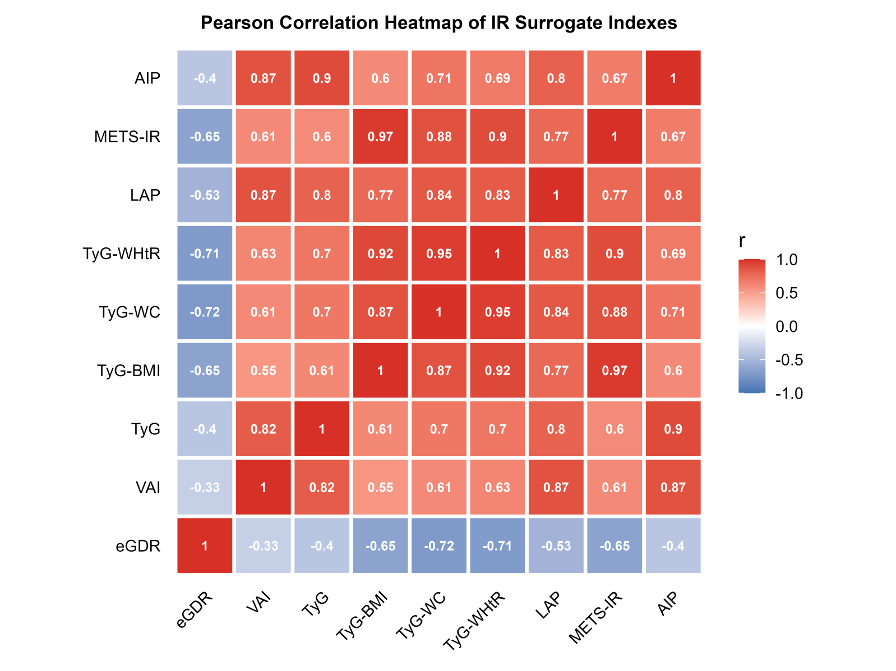
Supplemnetary Figure 1 Pearson correlation heatmap of insulin resistance surrogate indexes. eGDR, estimated Glucose Disposal Rate; VAI, Visceral Adiposity Index; TyG, Triglyceride-Glucose; TyG-BMI, TyG-Body Mass Index; TyG-WC, TyG-Waist Circumference; TyG-WHtR, TyG-Waist To Height Ratio; LAP, Lipid Accumulation Product; METS-IR, Metabolic Score For Insulin Resistance; AIP, Atherogenic Index Of Plasma.Colors range from blue (negative correlation) to red (positive correlation), with darker shades indicating stronger correlations. Diagonal values are 1, representing perfect self-correlation.

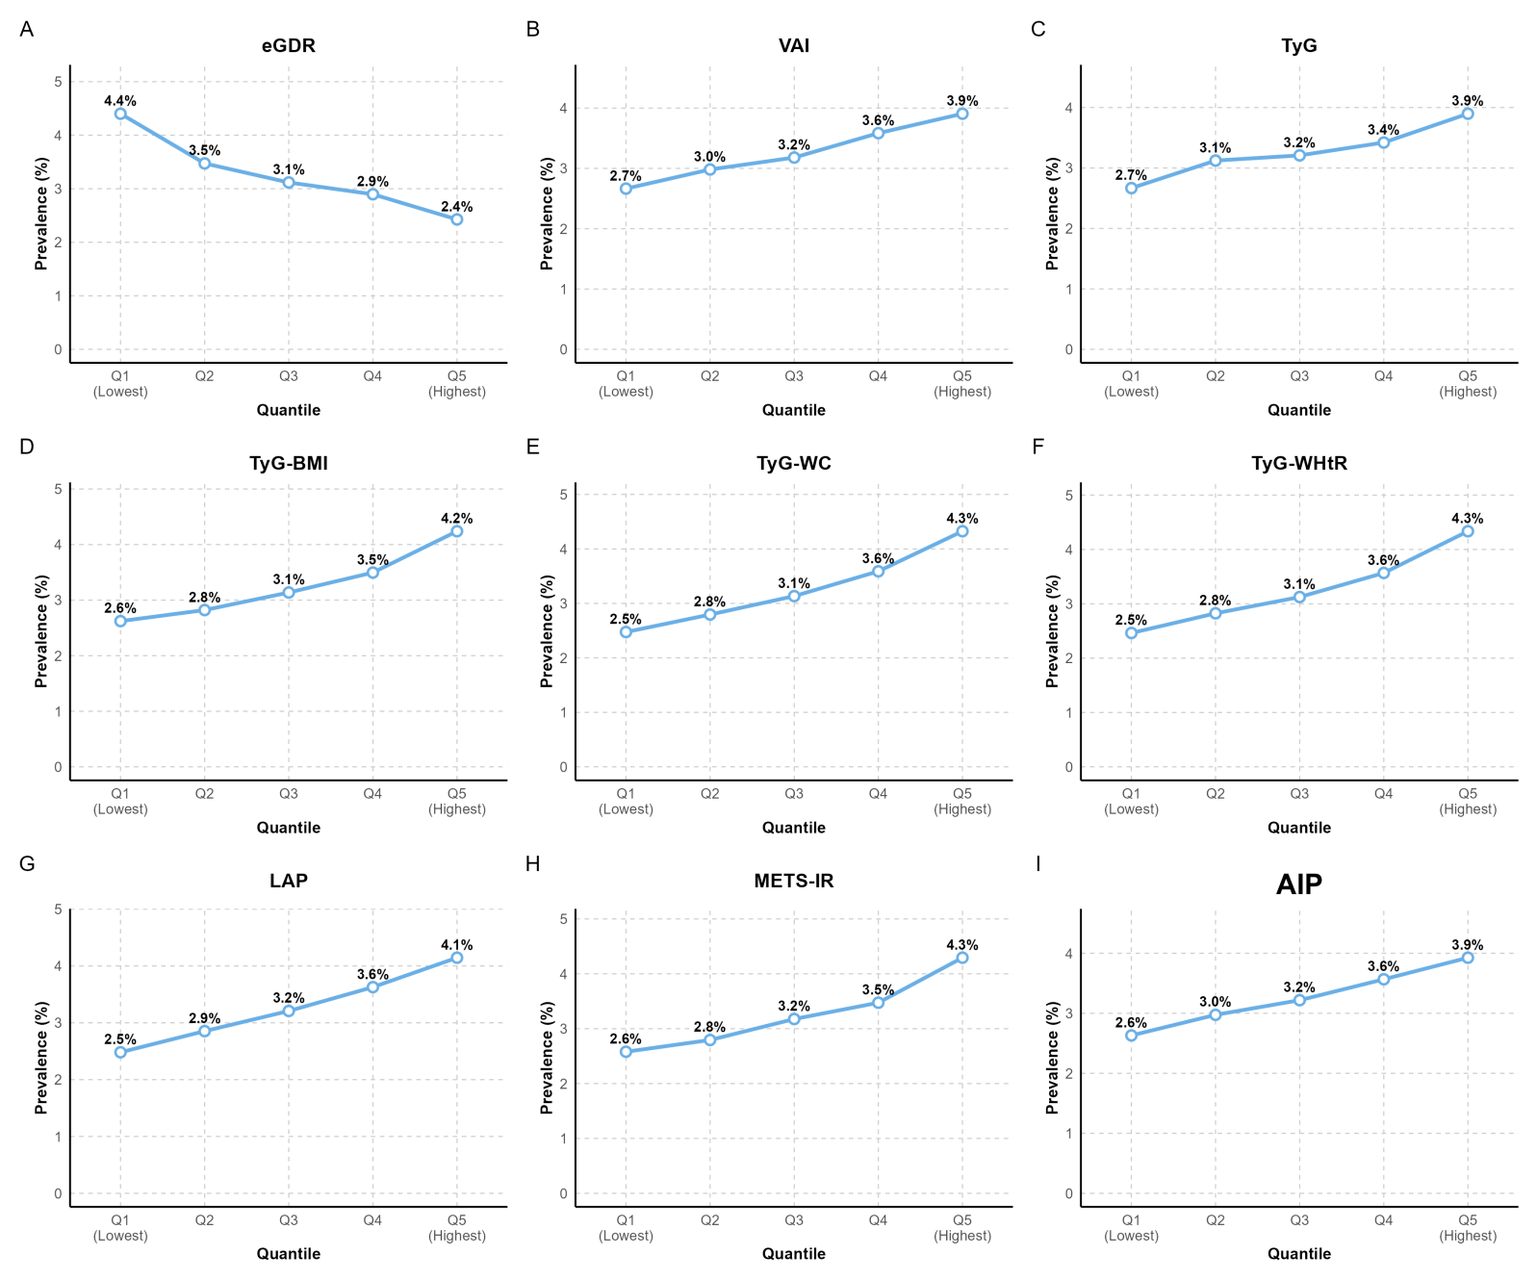
Supplemnetary Figure 2 Trend of insulin resistance prevalence across quintiles of insulin resistance surrogate indices among patients with psoriasis. eGDR, estimated Glucose Disposal Rate; VAI, Visceral Adiposity Index; TyG, Triglyceride-Glucose; TyG-BMI, TyG-Body Mass Index; TyG-WC, TyG-Waist Circumference; TyG-WHtR, TyG-Waist To Height Ratio; LAP, Lipid Accumulation Product; METS-IR, Metabolic Score For Insulin Resistance; AIP, Atherogenic Index Of Plasma

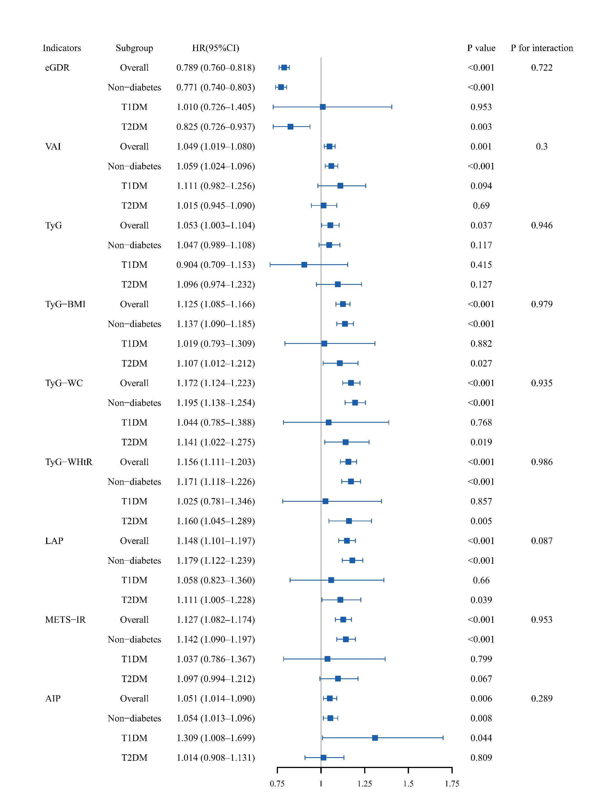
Supplemnetary Figure 3 Association between insulin resistance surrogate indices and psoriasis risk in different subgroups of diabetes.Forest plot showing hazard ratios (HR) and 95% confidence intervals (CI) for the association of each insulin resistance surrogate index with psoriasis risk, stratified by diabetes status (non-diabetes, type 1 diabetes [T1DM], type 2 diabetes [T2DM]), along with the overall estimate. The X-axis represents HR values (range 0.75 to 1.75). P values for interaction are also shown.
Abbreviations: eGDR, estimated Glucose Disposal Rate; VAI, Visceral Adiposity Index; TyG, Triglyceride-Glucose; TyG-BMI, TyG-Body Mass Index; TyG-WC, TyG-Waist Circumference; TyG-WHR, TyG-Waist to Hip Ratio; LAP, Lipid Accumulation Product; METS-IR, Metabolic Score for Insulin Resistance; AIP, Atherogenic Index of Plasma.

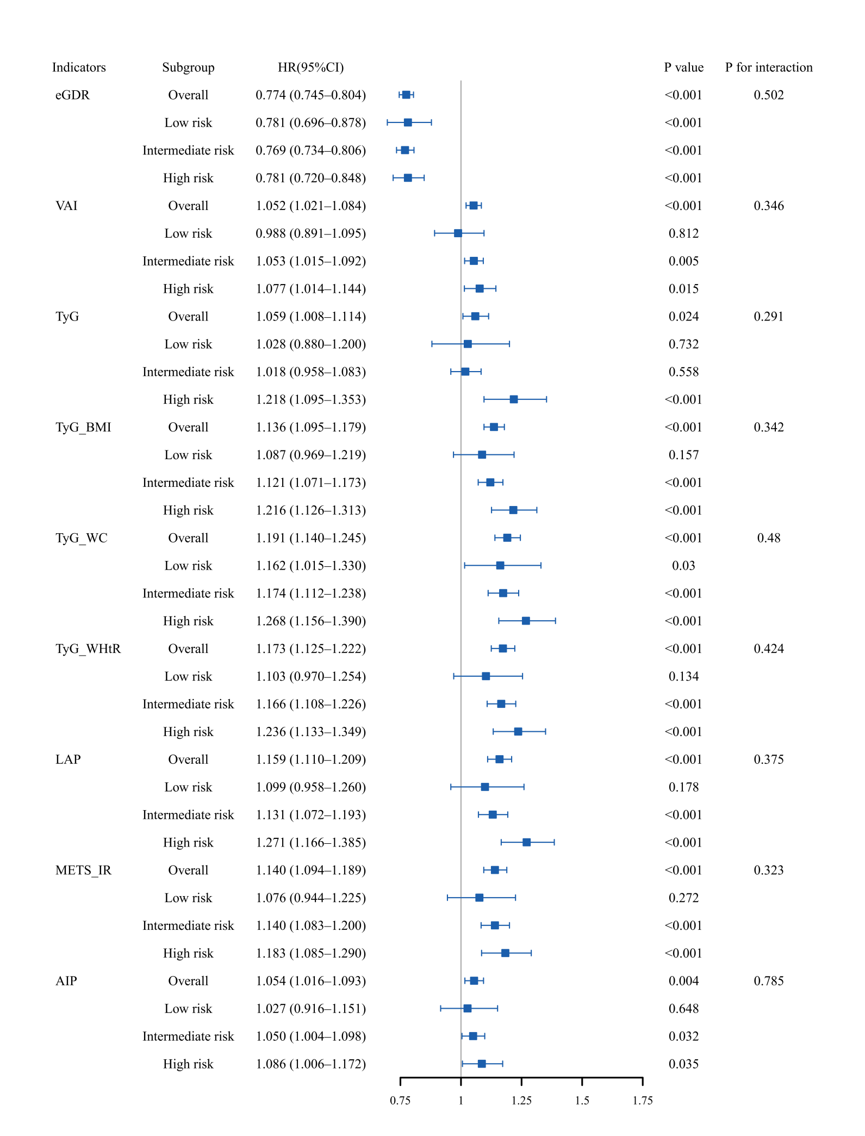
Supplemnetary Figure 4 Association between insulin resistance surrogate indices and psoriasis risk in different subgroups of PRS.Forest plot showing hazard ratios (HR) and 95% confidence intervals (CI) for the association of each insulin resistance surrogate index with psoriasis risk, stratified by diabetes status (non-diabetes, type 1 diabetes [T1DM], type 2 diabetes [T2DM]), along with the overall estimate. The X-axis represents HR values (range 0.75 to 1.75). P values for interaction are also shown.
Abbreviations: eGDR, estimated Glucose Disposal Rate; VAI, Visceral Adiposity Index; TyG, Triglyceride-Glucose; TyG-BMI, TyG-Body Mass Index; TyG-WC, TyG-Waist Circumference; TyG-WHR, TyG-Waist to Hip Ratio; LAP, Lipid Accumulation Product; METS-IR, Metabolic Score for Insulin Resistance; AIP, Atherogenic Index of Plasma.

