Supplementary materials

A Recurrent Neural Network Model of a Scalable Representation of Time in the Hippocampus

1 Control Experiments in a Fixed-Reward and Cue-Dependent T-maze
To evaluate how task structure and contextual guidance influence the emergence of temporal representations capable of scaling, we designed two control experiments using the same T-maze environment described previously. Both tasks preserved the overall network architecture and training protocol, but in both cases the reward location was independent of the duration of the waiting phase.

Experiment 1: Fixed-reward condition. In the first control experiment, the reward was consistently located on the left arm of the maze, irrespective of the duration of the waiting phase. Thus, the waiting time was behaviorally irrelevant, and the agent only needed to remember a fixed spatial goal. Training was performed across three blocks following the same scaling and reversal schedule used in the main temporal bisection task (Block 1: 10 and 20 time steps; Block 2: 20 and 40; Block 3: 10 and 20). The agent rapidly converged and achieved a success rate of 100% for both short and long delays in the test episodes (Block 1: 365 episodes; Block 2: 11; Block 3: 11).
Despite similar behavioral performance, neural dynamics differed markedly from those observed in the temporal version of the task. After training, at the single-cell level, the shape of activity patterns during the short delay became stable shortly after an early transient phase, exhibiting minimal progressive evolution over time (Fig. S1a). This pattern was also reflected in the population code: the ordered sequence of activation peaks ranging from zero up to the maximum duration in the temporal-bisection task were largely absent here (Fig. S1b). Temporal scaling across blocks was less prominent (Fig. S1c) (λ₁₂: mean = 1.03, std = 0.51 λ₁₃: mean = 1.21, std = 0.62), (k = 0.30, p = 9.91×10⁻⁶; Kolmogorov–Smirnov test).
Principal component analysis (PCA) of population activity further confirmed these observations. The trajectories were short and rapidly converged to a stable subspace, indicating little temporal evolution beyond the short-duration terminal point (Fig. S2b-c). The trajectory speed decreased monotonically over time, contrasting with the speed profiles observed in the duration-dependent task, particularly for long intervals (Fig. S2e). The rate of speed decay was comparable across blocks. However, Block 2 exhibited a greater number of near-zero-speed time steps, consistent with its longer temporal window: because all trajectories decayed toward zero speed at approximately the same rate, the prolonged trajectory in Block 2 resulted in more samples near this asymptotic regime (Fig. S2d).
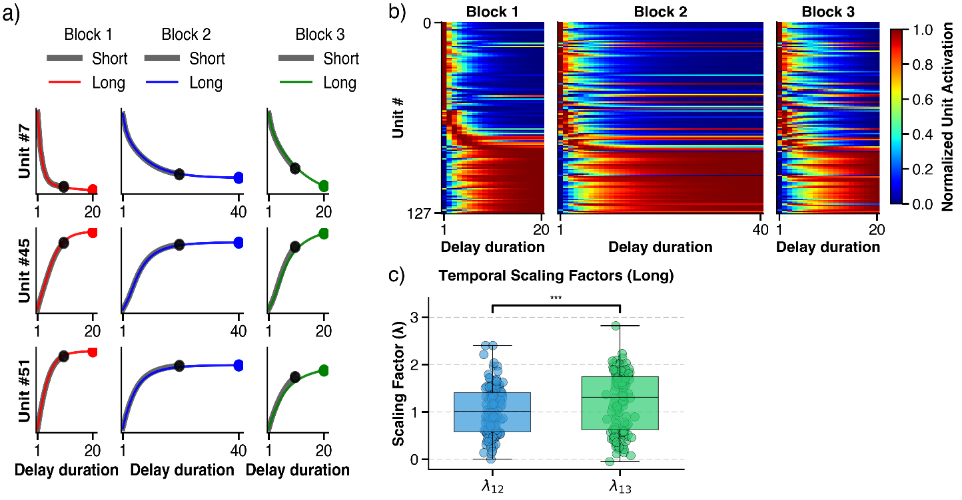
Fig. S1. Neural activity in the fixed-reward control task. (a) Example single-unit activity patterns showing stable, non-scaling activity during long and short delay periods. (b) Population activity heatmap sorted by peak activation time, revealing the absence of sequential organization across time. (c) Distribution of scaling factors across blocks (Kolmogorov–Smirnov test, ***p < 0.001).
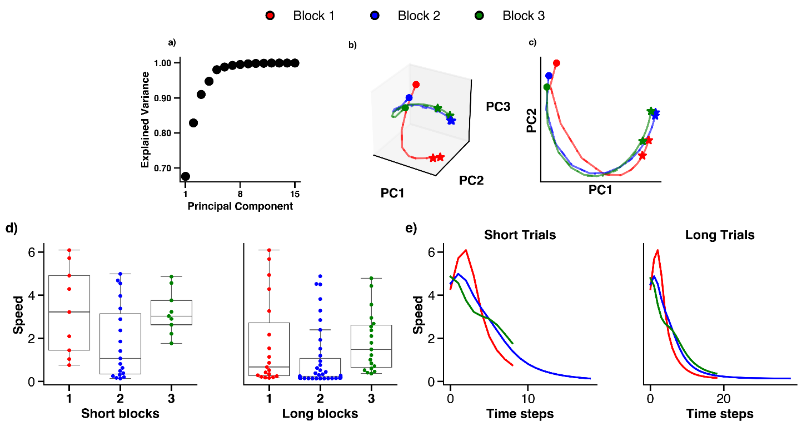

Fig. S2. population activity analysis in fixed-reward control task. (a) Cumulative explained variance of the first 15 principal components (PCs). (b-c) Principal component trajectories of population activity across short and long delays. (d) Box plots illustrate the distribution of the speed along each trajectory for the first three principal components for short and long blocks. (e) Temporal profiles of trajectory speed showing monotonic decay over time, reflecting reduced temporal evolution compared with the main temporal bisection task.

Experiment 2: Cue-dependent condition. In the second control experiment, we introduced an additional binary input indicating the reward location. This signal was concatenated to the standard spatial input, mimicking explicit sensory cues (e.g., visual or auditory stimuli) often used to guide behavior in animal tasks. Crucially, the cue assignment was randomized with respect to the delay duration (sampled uniformly across short and long episodes). This orthogonality ensured that the cue predicted the reward location regardless of the waiting period.
The agent achieved a 100% success rate for both short and long delays in Block 1 and adapted rapidly to Block 2 and Block 3 (Block 1: 807 episodes; Blocks 2–3: 11). Crucially, the network weights were not frozen during the test phase; instead, weight adjustments allowed the internal state to drift while maintaining the optimal output.
Under this condition, the RNN maintained stable behavioral performance, yet its internal representations again differed qualitatively from those observed in the temporal bisection task (Fig. S3a-b, Fig. S4a-b). We found no evidence of temporal scaling, despite a significant difference in the scaling distributions between the two groups. (Fig. S4c), (λ₁₂: mean = 0.82, std = 0.44 λ₁₃: mean = 0.97, std = 0.65), (k = 0.22, p = 3.97×10⁻³; Kolmogorov–Smirnov test), (Fig. S5c), (λ₁₂: mean = 0.86, std = 0.30 λ₁₃: mean = 1.06, std = 0.59), (k = 0.43, p = 1.64×10⁻¹⁰; Kolmogorov–Smirnov test). As in the fixed-reward condition, the population trajectories corresponding to long delays did not extend beyond those of short delays, exhibiting only limited temporal evolution (Fig. 5b, c). The trajectory speed along the first three PCs decreased monotonically over time (Fig. 5e), confirming that temporal modulation of trajectory dynamics depends critically on the presence of duration-dependent reward in the temporal bisection task.
To further assess how contextual information organized the neural state space, we conducted a PCA analysis of the population activity averaged separately for each unique task condition (defined by the combination of blocks (1, 2, 3), delay duration (short or long), and cue identity (0 or 1), resulting in 12 distinct trajectories). This analysis revealed two distinct sets of trajectories that were clearly segregated in low-dimensional space (Fig. S5b, c). The divergence between these trajectories indicates that the sensory cue acted as the dominant organizing variable, partitioning the network’s internal dynamics into discrete subspaces regardless of the delay duration. The trajectory speed along the first three PCs decreased monotonically over time (Fig. S5e), confirming that temporal modulation of trajectory dynamics depends critically on the presence of duration-dependent reward in the temporal bisection task.

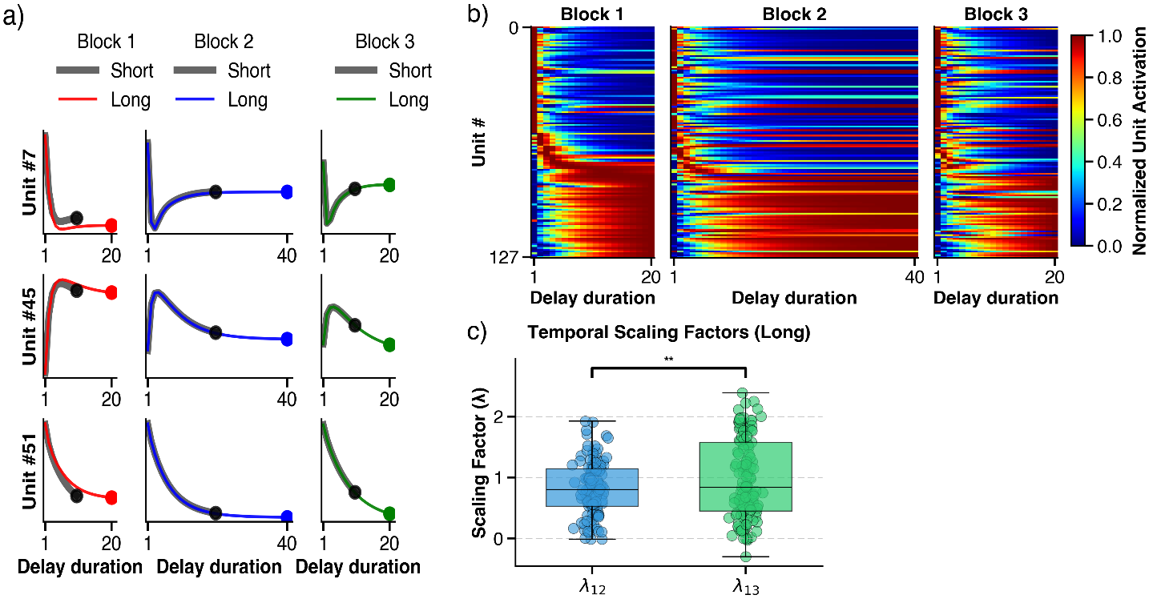
Fig. S3: Neural activity in the cue-dependent control task (cue=1). (a) Example unit activity showing stable temporal responses driven by external cue signals. The activity rapidly reaches a steady state (saturation point) and maintains that constant level for the remainder of the delay. (b) Population activity heatmap showing lack of progressive temporal organization. (c) Distribution of scaling factors across blocks (Kolmogorov–Smirnov test, **p < 0.01).

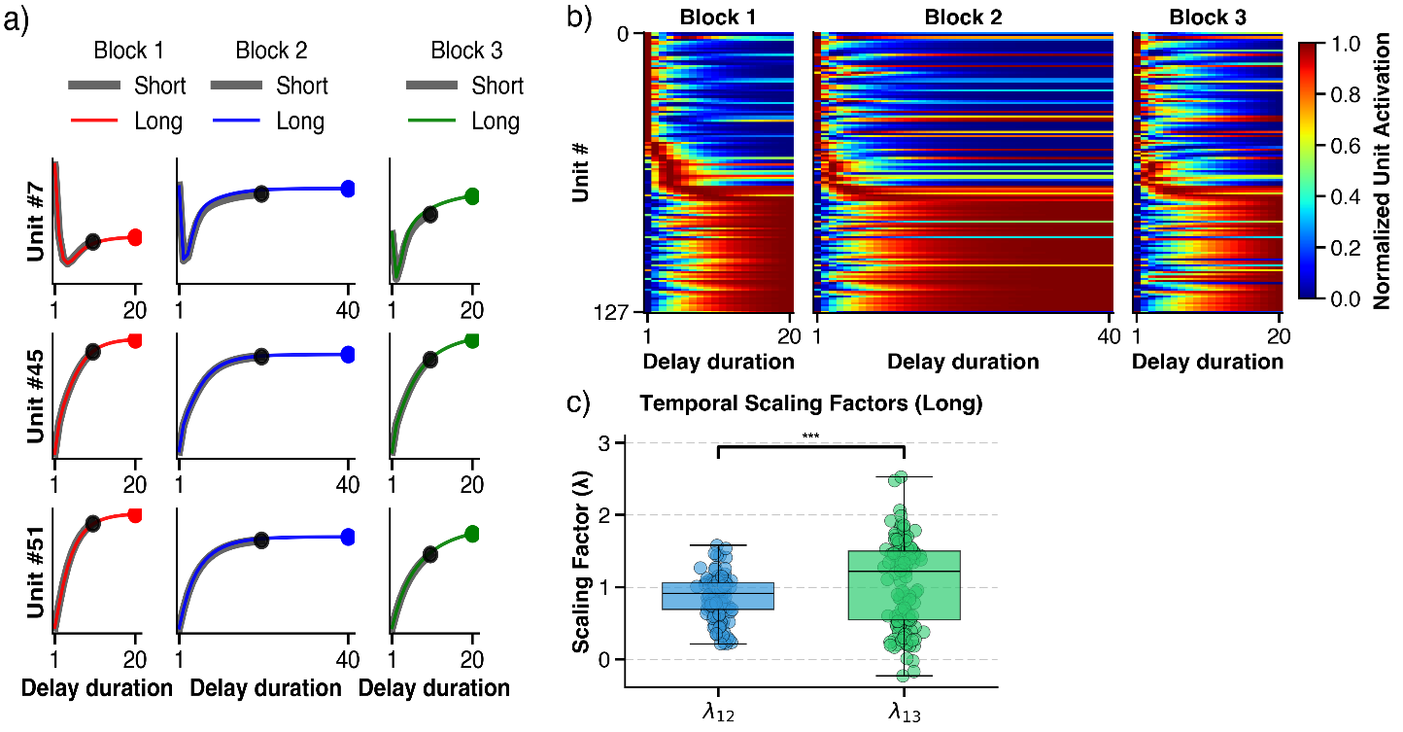
Fig. S4: Neural activity in the cue-dependent control task (cue=0). (a) Example unit activity showing stable temporal responses driven by external cue signals. The activity rapidly reaches a steady state (saturation point) and maintains that constant level for the remainder of the delay. (b) Population activity heatmap showing lack of progressive temporal organization. (c) Distribution of scaling factors across blocks (Kolmogorov–Smirnov test, ***p < 0.001).
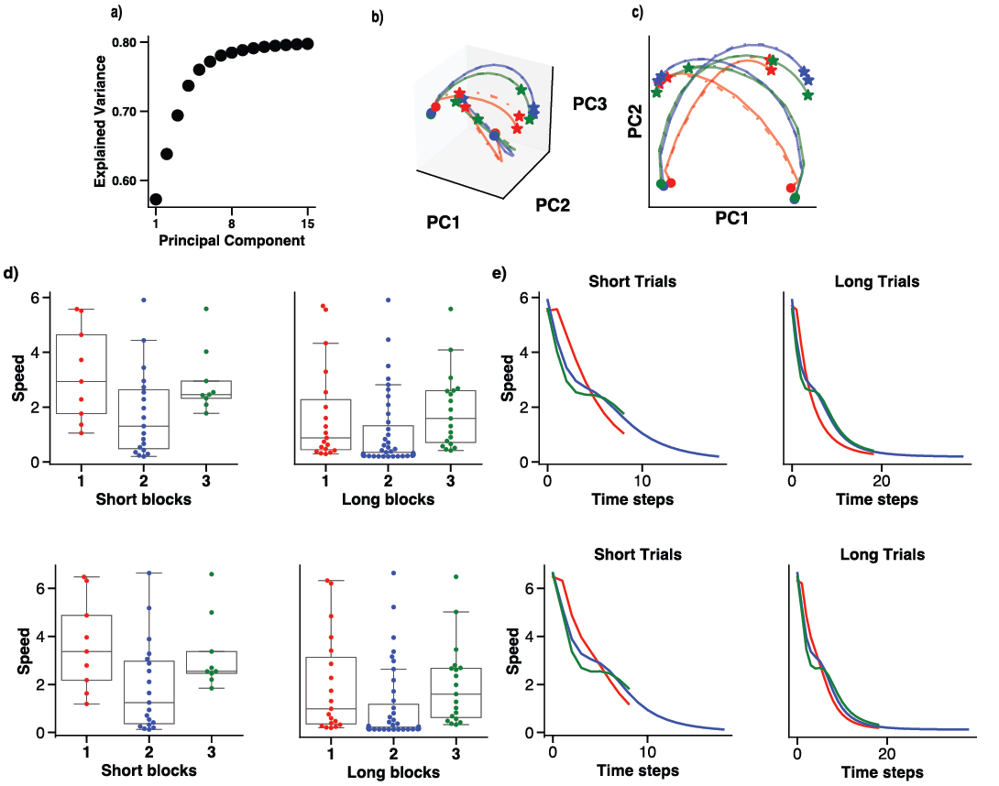

Fig. S5: Population activity analysis in cue-dependent delay condition. (a) Cumulative explained variance of the first 15 principal components (PCs). (b) Principal component trajectories averaged across cue identity, revealing distinct and well-separated subspaces organized by the external cue signal. (c) Projection onto the two first principal component over time, illustrating saturation of neural dynamics. (d) Comparison of mean trajectory speeds across the three training blocks (top panel: cue=1, bottom panel: cue=0) (e) Speed profiles of trajectories, highlighting a monotonic decrease of trajectory speed over time across all blocks (top panel: cue=1, bottom panel: cue=0).
2. RNN Population Activity during Navigation in the Plus-maze trisection task and T-maze trisection task

The Rastermap analysis for the Plus-maze trisection task reveals a complex organization of neural activity during the navigation phase, rather than three distinct and mutually exclusive clusters. The single-cell activities show significant heterogeneity. Some neurons, such as neuron 20, modulate their activity levels based on the duration (short, medium, or long), altering their level of activity to reflect the specific interval context. Others display overlap between conditions; for instance, neuron 70 exhibits a unimodal peak activity that is similar for both short and medium delays, while showing reduced activity during the long delay, indicating overlapping selectivity across conditions. Also, neurons like neuron 88 are highly selective, becoming active only during a single condition (the short delay). At the population level, this results in at least two visually dominant clusters, one largely active during long intervals and another showing mixed activity for medium and short intervals, demonstrating that the network does not simply form three mutually exclusive clusters but instead encodes the three delays through a distributed and overlapping representation (Fig. S6).
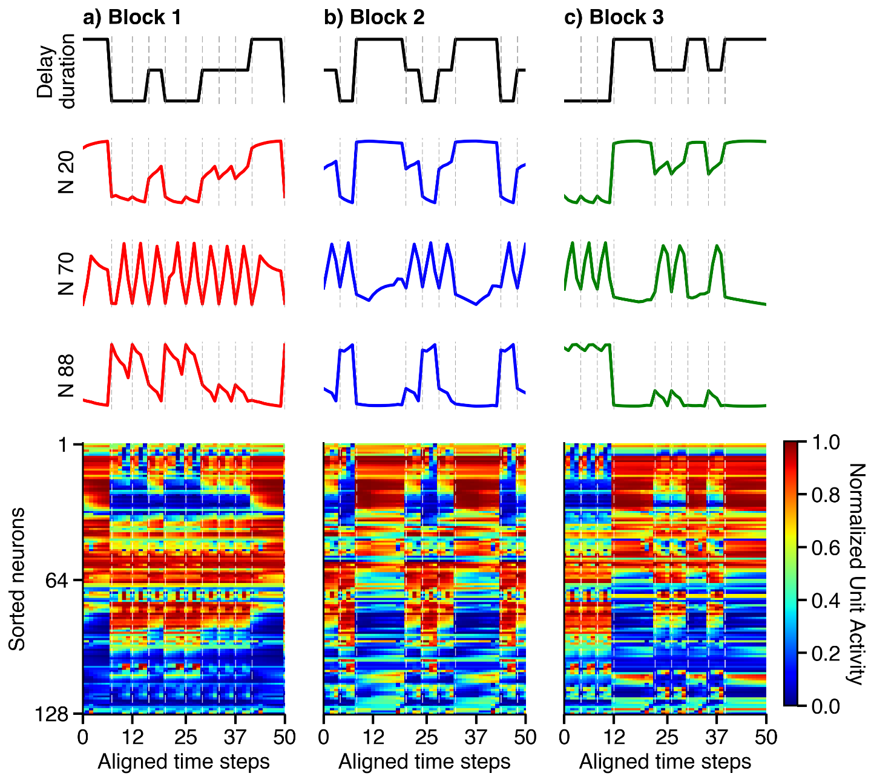
Fig. S6. Navigation phase population dynamics in the Plus-maze trisection task. Rastermap visualization of RNN unit activity during the navigation phase across Blocks 1 (a), 2 (b), and 3 (c).

Similarly, Rastermap analysis of population activity during the navigation phase in the T-maze trisection task revealed heterogeneous single-cell responses and a distributed population code rather than three mutually exclusive clusters. At the single-neuron level, cells modulated their activity as a function of interval context in diverse ways. For example, neuron 20 primarily encoded context by adjusting its overall level of activity across short, medium, and long intervals. Neuron 70 was active during both short and medium contexts but remained largely silent during long intervals, indicating overlapping selectivity across two conditions. In contrast, neuron 115 exhibited high activity during short intervals, ramped down during medium intervals, and was effectively inactive during long intervals, demonstrating graded context dependence (Fig. S7).
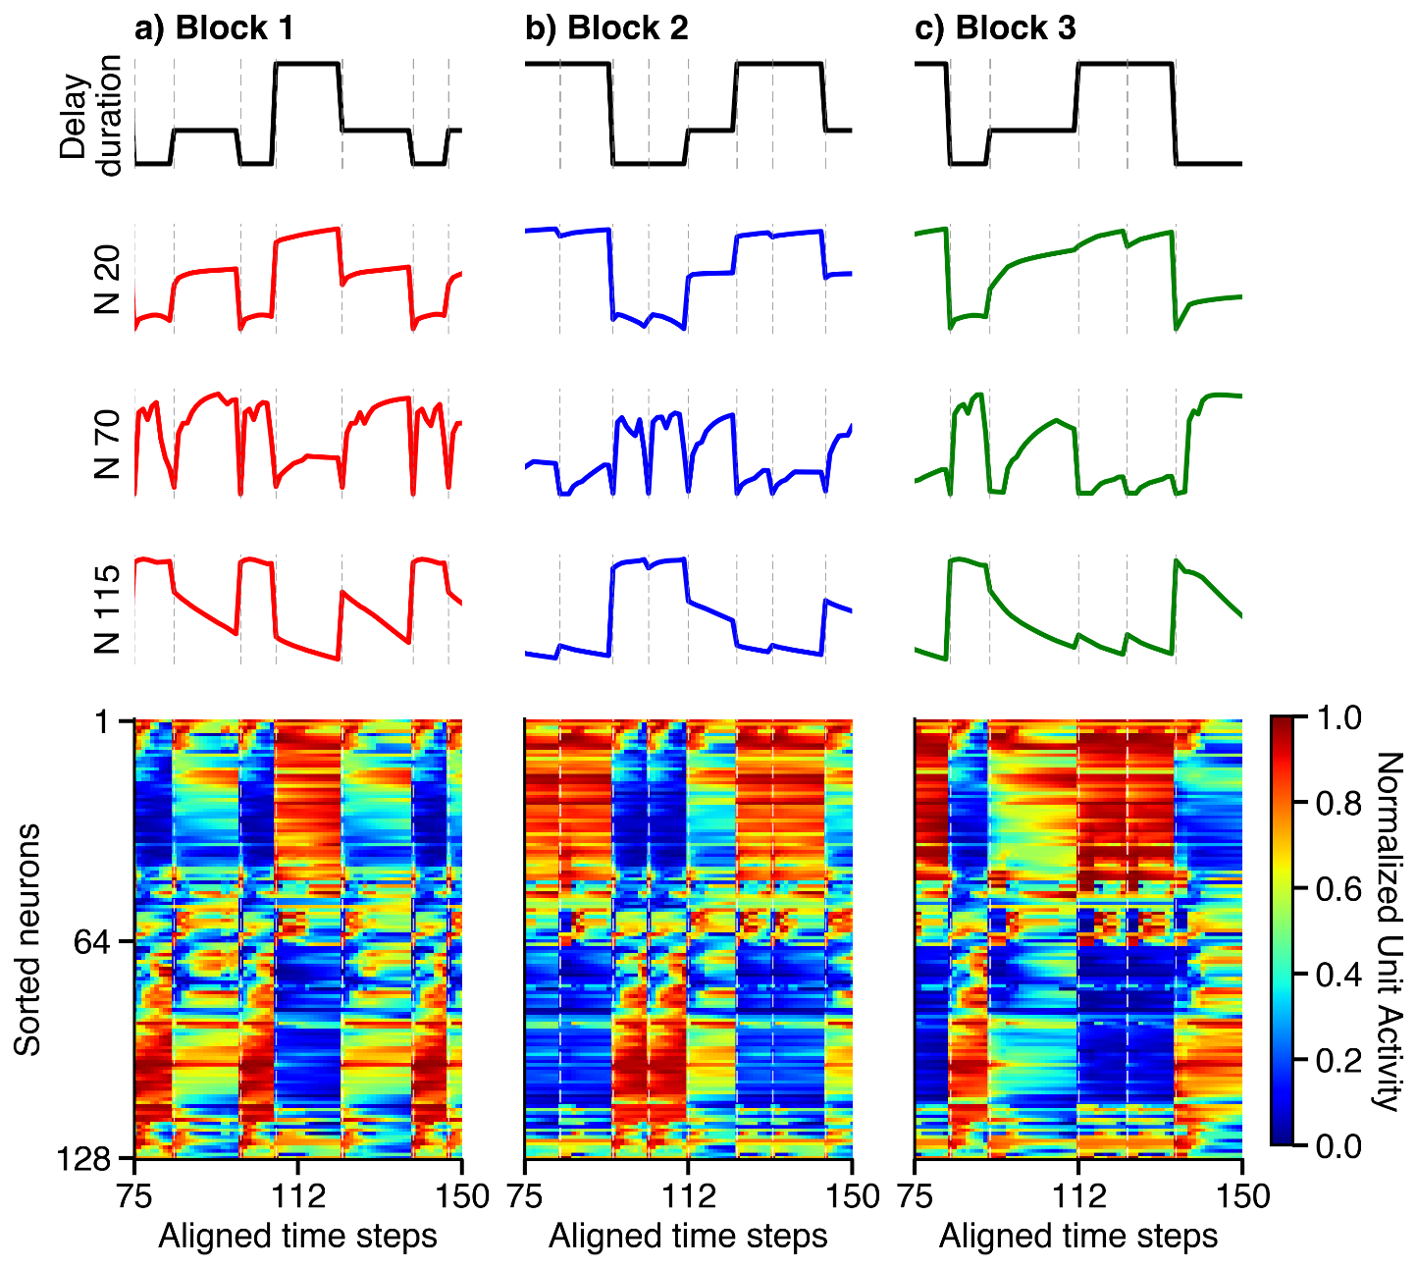
Fig. S7. Navigation phase population dynamics in the T-maze trisection task. Rastermap visualization of RNN unit activity during the navigation phase across Blocks 1 (a), 2 (b), and 3 (c).

Despite this heterogeneity, context-dependent activity patterns were stable across blocks. Neurons that were selective for a given interval in Block 1 preserved that selectivity in subsequent blocks (e.g., neurons active during short intervals in Block 1 remained active during short intervals in Blocks 2 and 3), indicating robust single-cell stability. At the population level, neurons were sorted based on their activity in Block 1, and this same ordering was applied to Blocks 2 and 3 without re-sorting. The persistence of similar activity patterns across blocks demonstrates that population-level organization remained stable across contexts and this stability was observed for both the trisection T-maze and the Plus-maze tasks.

Video 1. Temporal bisection task across scaled duration blocks in the T-maze.

This video illustrates the temporal bisection task performed by the trained deep reinforcement learning agent across three consecutive blocks with different waiting-period durations. In each episode, the agent is confined to the waiting room for either a short or a long delay before being released to navigate the T-maze. In Block 1, short and long delays are 10 and 20 time steps, respectively; in Block 2, these delays are scaled to 20 and 40 time steps; and in Block 3, the original durations (10 and 20 time steps) are reinstated. Following the waiting phase, the agent navigates toward the left or right arm depending on the experienced delay. The video shows representative short- and long-delay trials from each block, demonstrating accurate task performance and highlighting how the same behavioral structure is preserved while the temporal scale of the waiting phase changes across blocks.

